Supplementary Information

Fully 3D Printed Flexible, Conformal and Multi-directional Tactile Sensor with Integrated Biomimetic and Auxetic Structure

¹Department of Mechanical, Aerospace and Civil Engineering, School of Engineering, The University of Manchester, Manchester, M13 9PY, UK
²Key Laboratory of Bionic Engineering, Ministry of Education, Jilin University, China
³School of Science, Engineering and Environment, University of Salford, Manchester, M5 4BR, UK
Yuyang Wei-1, Bingqian Li-2, Marco Domingos-1, Zhihui Qian-2, Yiming Zhu-1, Lingyun Yan-1, Lei Ren*-1,2 and Guowu Wei*-3
*Correspondence: lei.ren@manchester.ac.uk and g.wei@salford.ac.uk

List of Contents
Supplementary Figures 1-8
Supplementary Table 1
Supplementary Movies 1-4

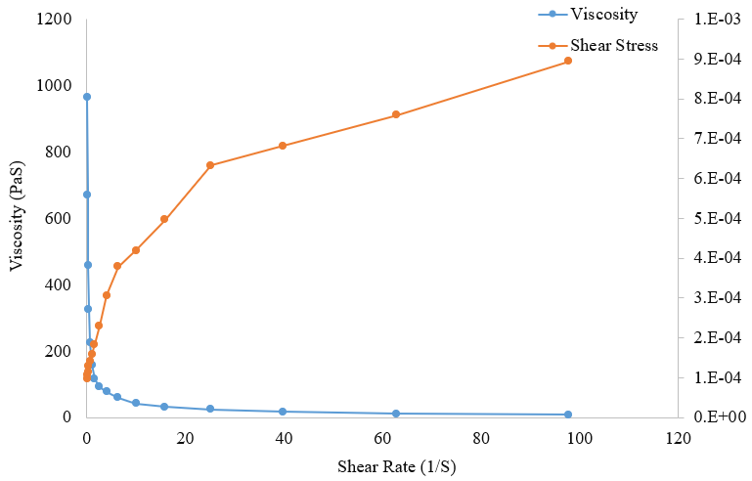
Supplementary Figure 1 | The viscosity and shear rate of Copper-Silicone composite as a function of shear rate. The viscosity was decreasing under shear strain (shear thinning) which means this composite could be applied for 3D printing. This amplitude sweep test was carried out by using DHR-30 hybrid rheometer (TA Instruments).

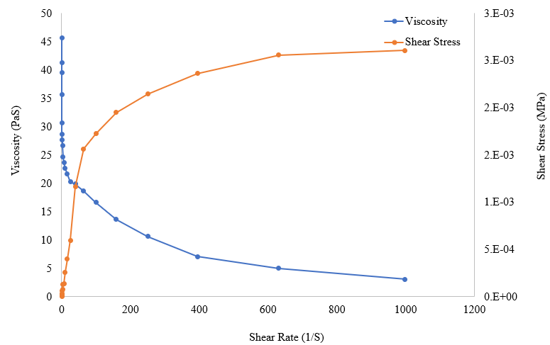
Supplementary Figure 2 | The viscosity and shear stress of CNT/Graphene/Silicone rubber composite as a function of shear rate. The viscosity was decreasing under shear strain (shear thinning) which means this composite could be applied for 3D printing.

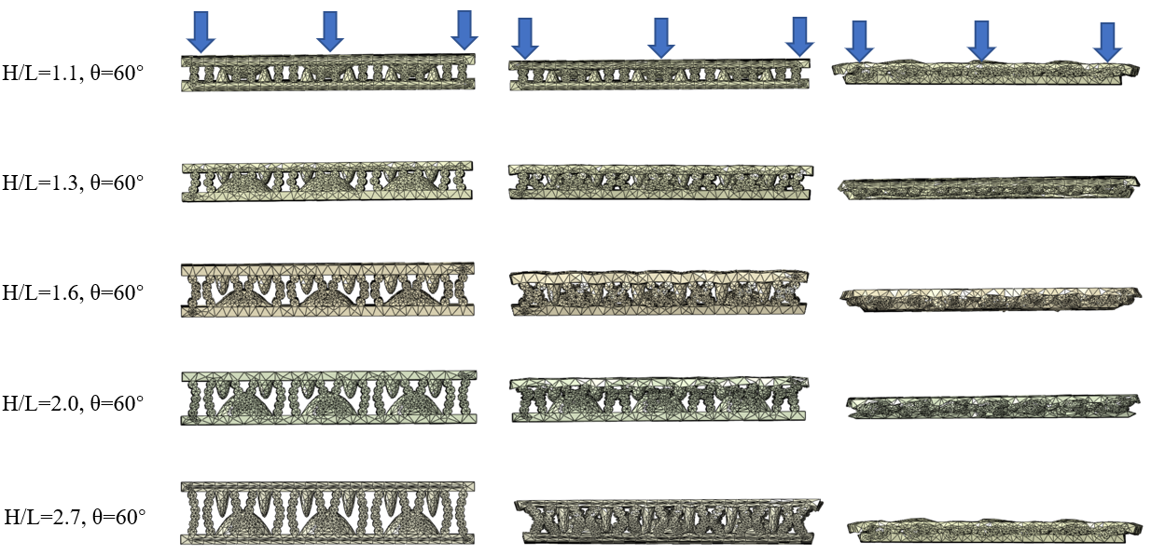 Supplementary Figure 3 | The simulation results for optimizing the auxetic structure of the sensor. The simulation results of the sensors with re-entrant angle of 60º and different H/L ratios are presented. The sensors before, during and after the compression were shown.

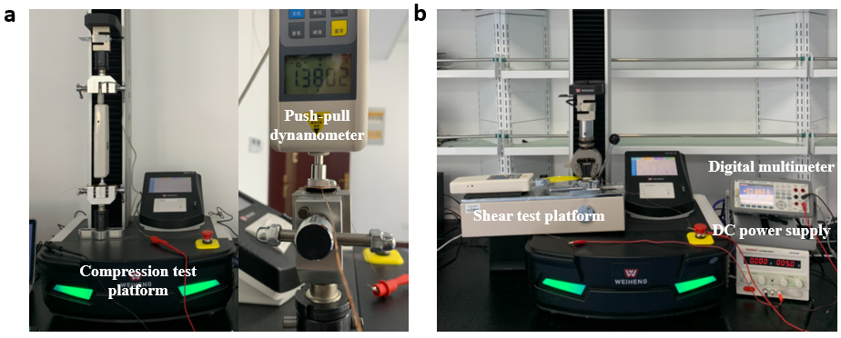
Supplementary Figure 4 | The testing platform for characterization in terms of the pressure sensor (a) The compression test platform for evaluating normal sensitivity. The universal testing machine and a push-pull dynamometer were used to produce compression force onto the tactile sensor. (b) The shear test platform for quantifying shear sensitivity. The horizontal shear test platform with a push-pull dynamometer was mounted on the universal test machine. The push-pull dynamometer produced shear force while the universal testing machine provided normal compression. A DC-power supply was used to produce 5V voltage for the sensor and a digital multimeter was employed to record the current flow over the sensor during the test.

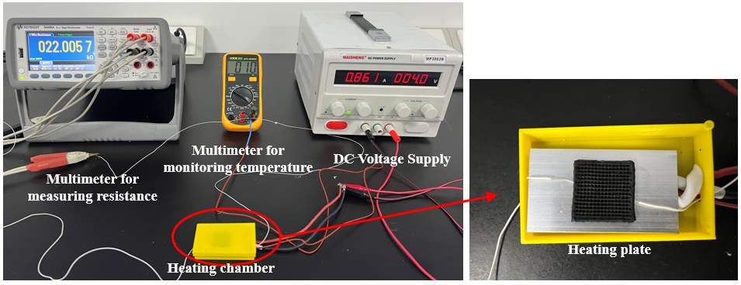
Supplementary Figure 5 | The testing platform for characterization in terms of the temperature sensor. A heating chamber consisting of the a plastic box with the dimension of 7.53cm³and a heating plate powered by DC voltage supply was developed to provide a stable temperature variation. The hot plate was powered and heated by a DC voltage supply. The variation of the resistance was recorded by multimeter (Keysight 34465A, Keysight Ltd., HK) at the frequency of 500Hz while the temperature was monitoring by another multimeter.

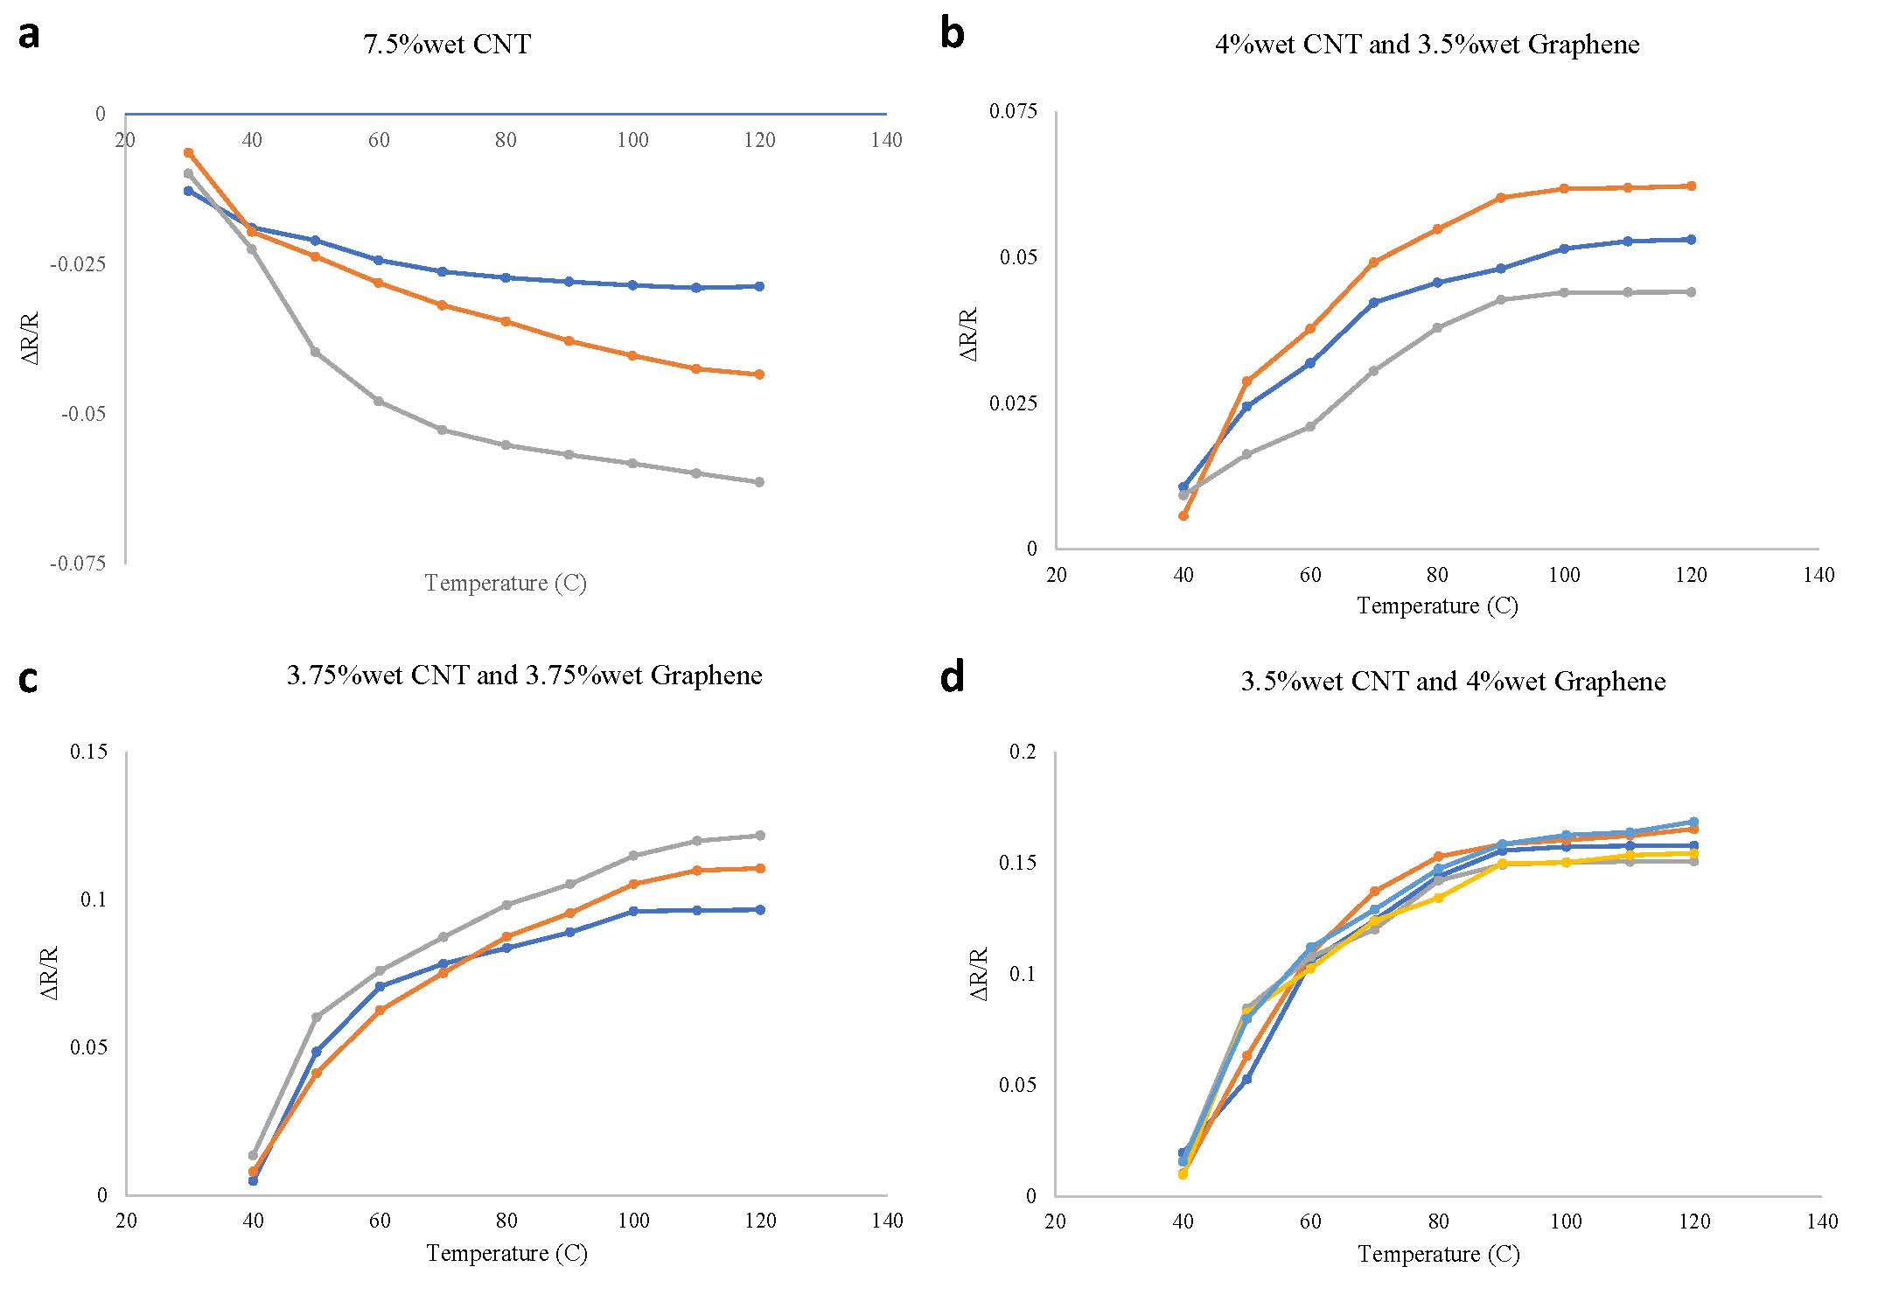
Supplementary Figure 6 | The optimization of the weight ratio of carbon nano tube to graphene. (a) The response of the sensor based on the composite material contains 7.5% wt of CNT. Negative temperature coefficient of resistance (TCR) was presented. Unstable signal response were obtained based on three sensor samples. (b) The response of the sensor based on the composite material contains 4% wt of CNT and 3.5% wt of graphene. The TCR values varied largely among the three sensor samples. (c) The response of the sensor based on the composite material contains 3.75% wt of CNT and 3.75% wt of graphene. The TCR values are still varied largely among the three sensor samples. (d) The response of the sensor based on the composite material contains 3.5% wt of CNT and 3.75% wt of graphene. The TCR values were improved while unstable thermoresistive properties were observed based on the responses of three sensor samples.

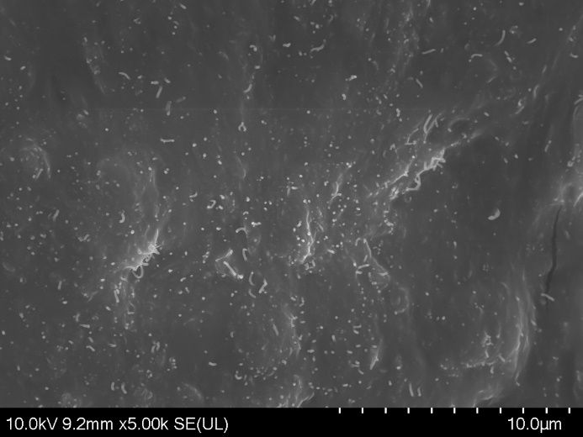
b
a
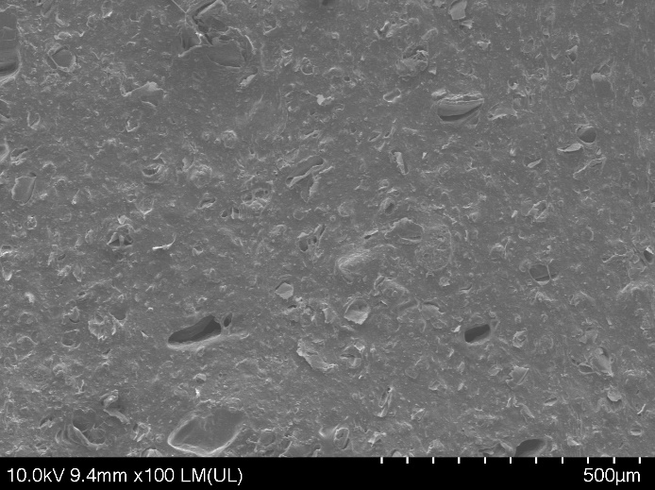
c
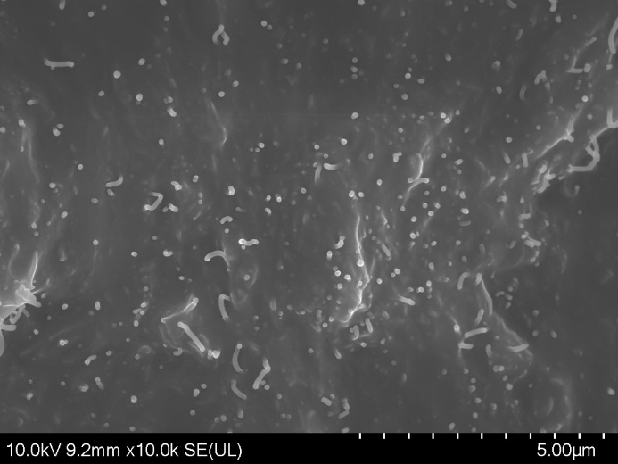
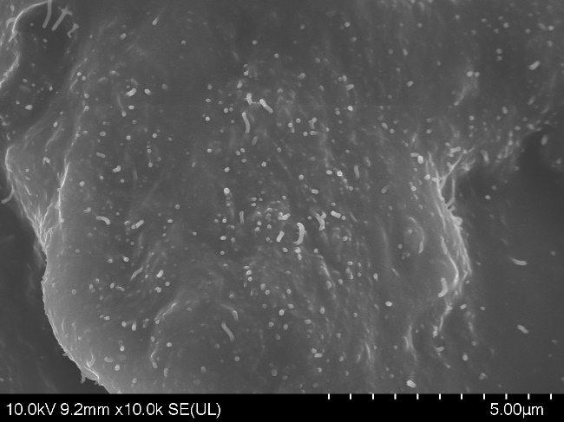
d

Supplementary Figure 7 | The images taken by scanning electron microscope (Hitachi regulus 8220, Japan) . the CNT and graphene palate are evenly distributed in the silicone matrix and no obvious aggregation of CNT was found. (a) The micrograph taken with 100 times magnification. (b) The micrograph taken with 5,000 times magnification (c). (d) The micrograph taken with 10,000 times magnification.

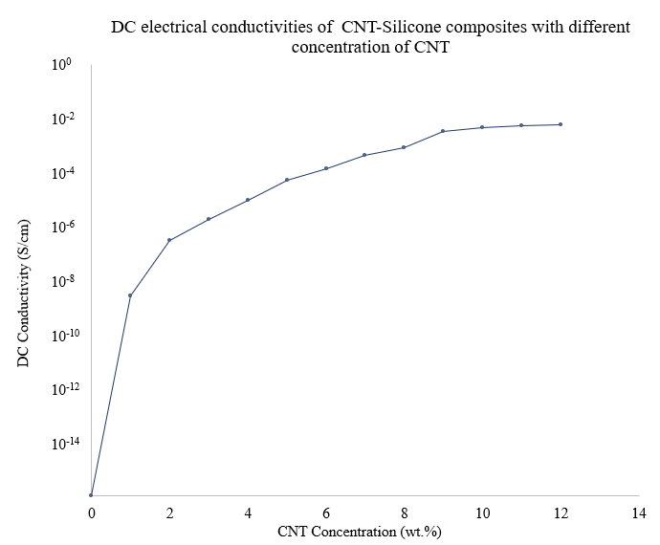
Supplementary Figure 8 | The electrical conductivities of CNT-Silicone composites under different concentration of CNT.

Table 1 The comparisons between the published and the sensor presented in this research with regards to the fabrication process, fabrication environment and lead time
Author | Fabrication process |  | Material | Lead time | High-demanded fabricating environment | Reference
Boutry et al. |  | Photolithography and etching | CNT/Silicone wafer | >1.5 hours |  | 2
Park et al. |  | Solution-based rod casting etc. | GO/PVDF | >24 hours |  | 15
Makihata et al. |  | Wafer bonding, photolithography and etching | Silicon diaphragm | >1 hour |  | 17
Oh et al. |  | Deposition and wet etching | ZnO thin-film transistors | >2 hours |  | 18
Pyo et al. |  | Photolithography and drop casting | NiCr | >0.5 hour |  | 19
Zhu et al. |  | Photolithography and silicon etching | rGO/PDMS | >5 hours |  | 20
Pang et al. |  | Photolithography, etching and molding | Pt/PDMS | >2 hours |  | 32
Wei et al. (This study) |  | 3D Printing | CNT/Graphene /Silicone | 1 hour

