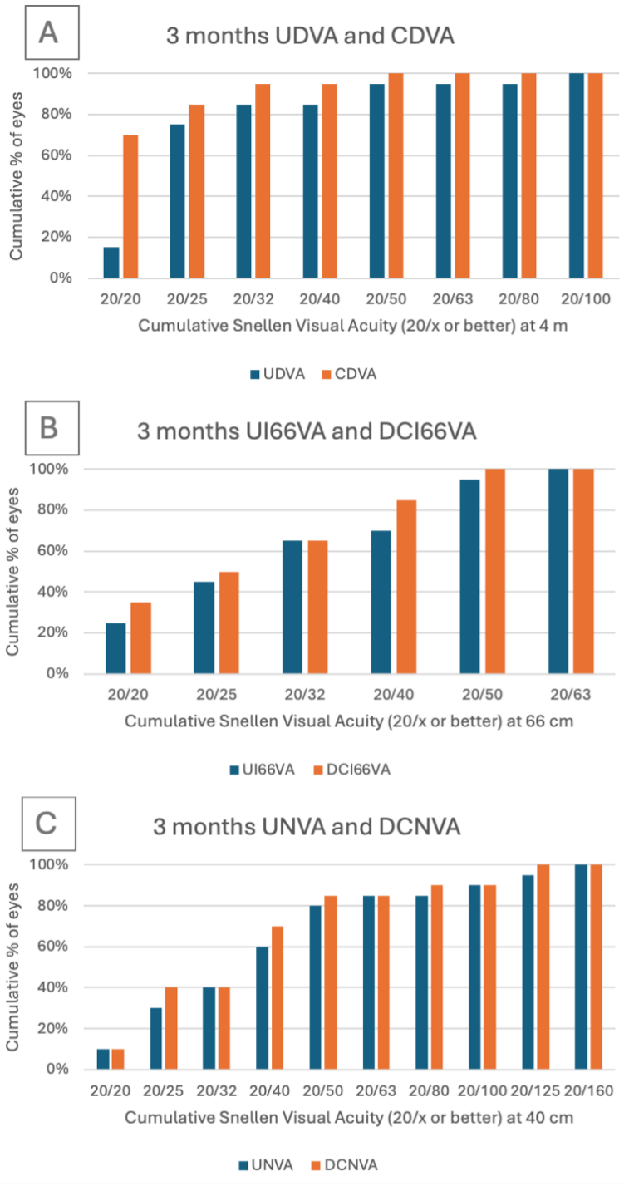
Supplemental Figure 1 A-D. Post operative differences between monocular corrected and uncorrected visual acuity at 4 m, 66 cm and 40 cm. UDVA = uncorrected distance visual acuity; UI66VA = uncorrected intermediate (66 cm) visual acuity; UNVA = uncorrected near visual acuity; CDVA = corrected distance visual acuity; DCI66VA = distance-corrected intermediate (66 cm) visual acuity; DCNVA = distance-corrected near visual acuity.
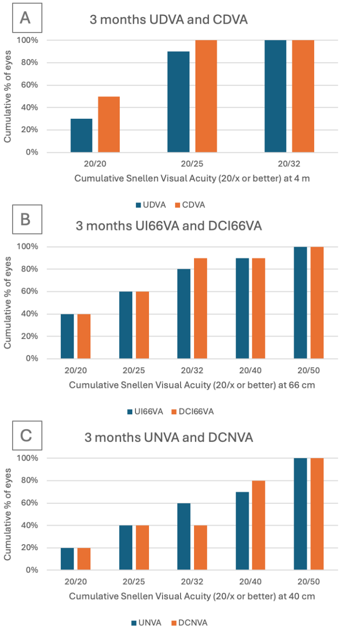
Supplemental Figure 2 A-D. Post operative differences between binocular corrected and uncorrected visual acuity at 4 m, 66 cm and 40 cm. UDVA = uncorrected distance visual acuity; UI66VA = uncorrected intermediate (66 cm) visual acuity; UNVA = uncorrected near visual acuity; CDVA = corrected distance visual acuity; DCI66VA = distance-corrected intermediate (66 cm) visual acuity; DCNVA = distance-corrected near visual acuity.

