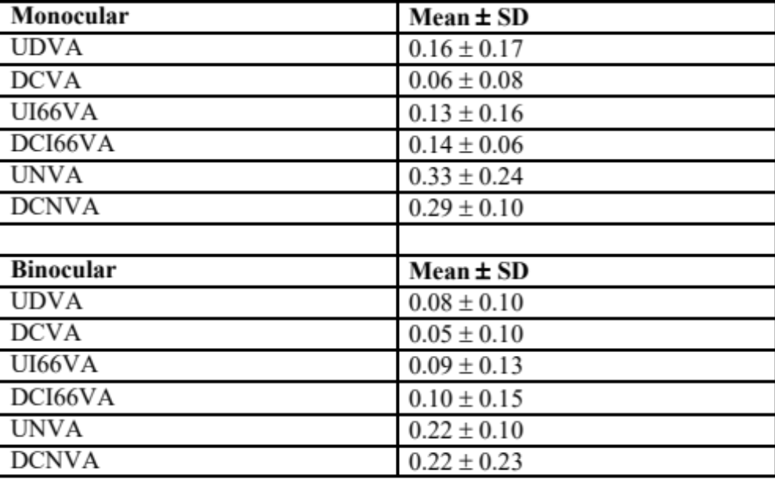
Table 1. Postoperative monocular and binocular visual acuity. SD = standard deviation; UDVA = uncorrected distance visual acuity; UI66VA = uncorrected intermediate (66 cm) visual acuity; UNVA = uncorrected near visual acuity; CDVA = corrected distance visual acuity; DCI66VA = distance-corrected intermediate (66 cm) visual acuity; DCNVA = distance-corrected near visual acuity.

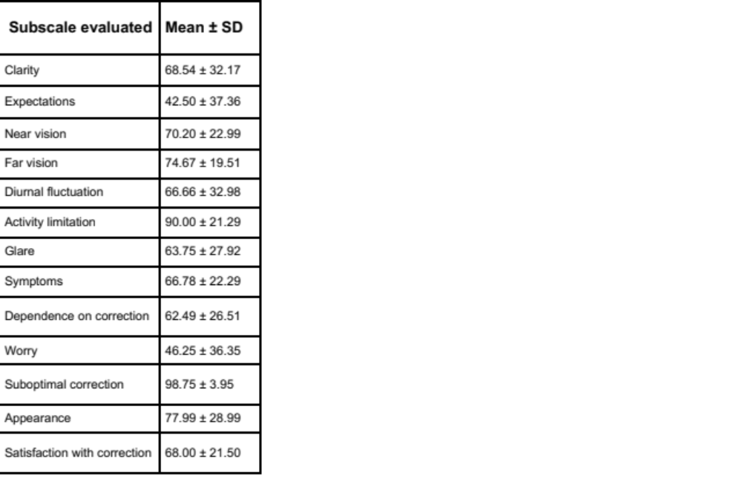
Table 2. Subjective quality of vision by means of NEI- RQL-42 scores.

