Supplementary Materials

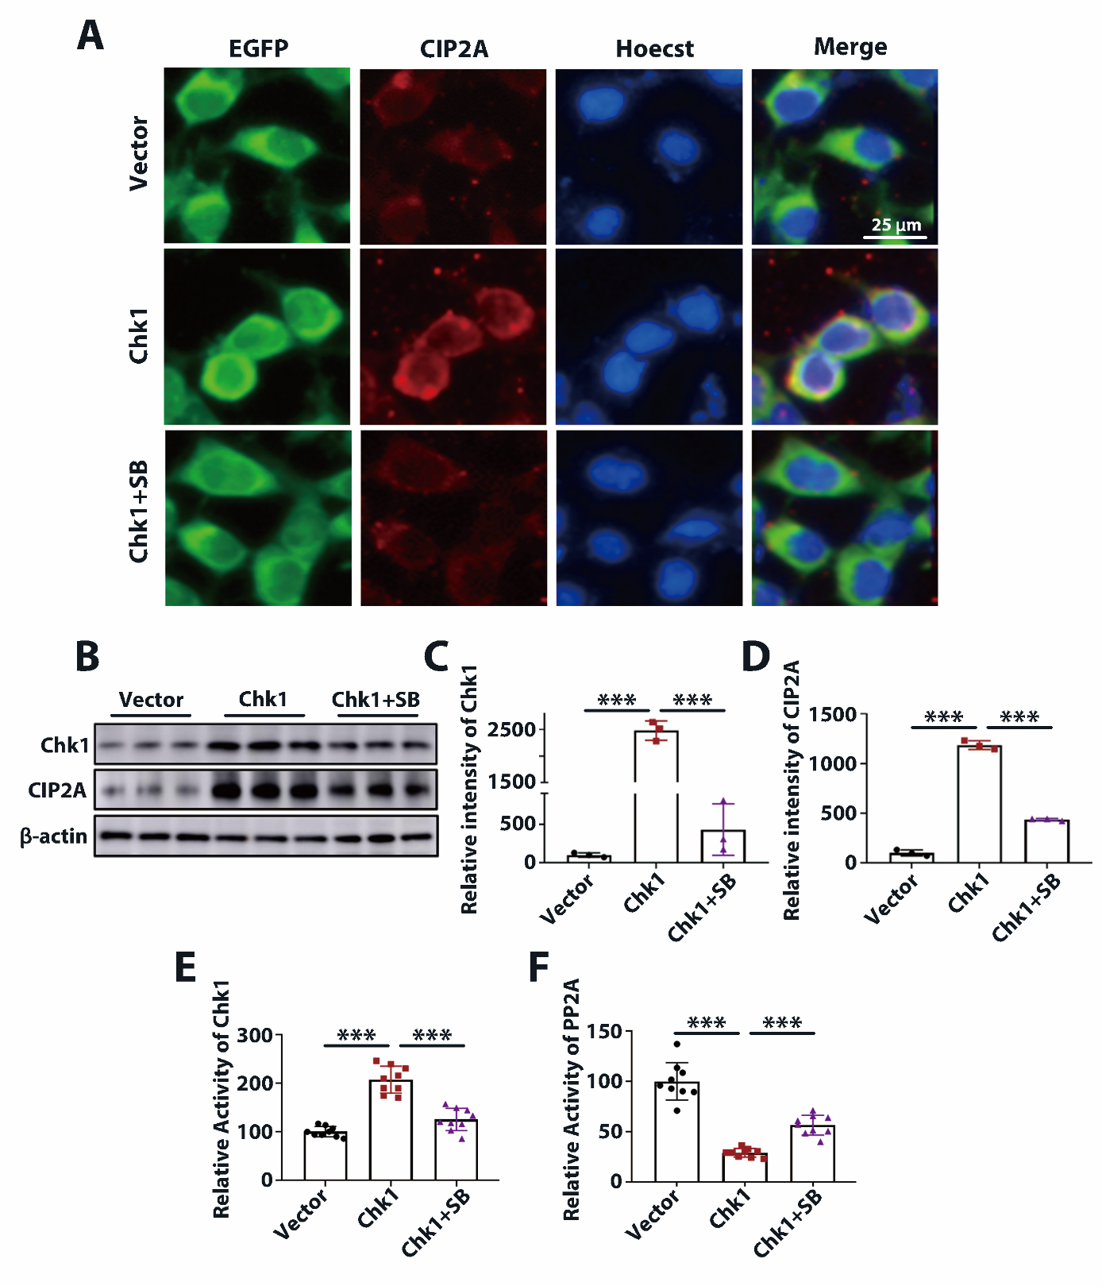

Supplemental figure 1 ChK1 overexpression induces CIP2A upregulation and PP2A inhibition in HEK293-T cells, which can be reversed by ChK1 inhibitor SB.
A HEK293-T cells were transfected with EGFP vector or EGFP-ChK1, with or without treatment of ChK1 inhibitor SB (SB281078) for 48 hours. Fluorescence of EGFP (green) and Hoechst (blue), immunofluorescence staining of CIP2A (red) in Vector expression, ChK1 overexpression, and ChK1 overexpression + SB treatment groups. Scale bar: 25 μm. B Representative immunoblots of total ChK1, CIP2A, and β-actin in Vector, ChK1, and ChK1+SB groups. n=3 per group, ***P < 0.001, Data are mean ± SEM. C and D Quantitative analysis of the proteins levels in B. E and F ChK1 and PP2A activities in these three groups. n=6 per group, ***P < 0.001, Data are mean ± SEM.

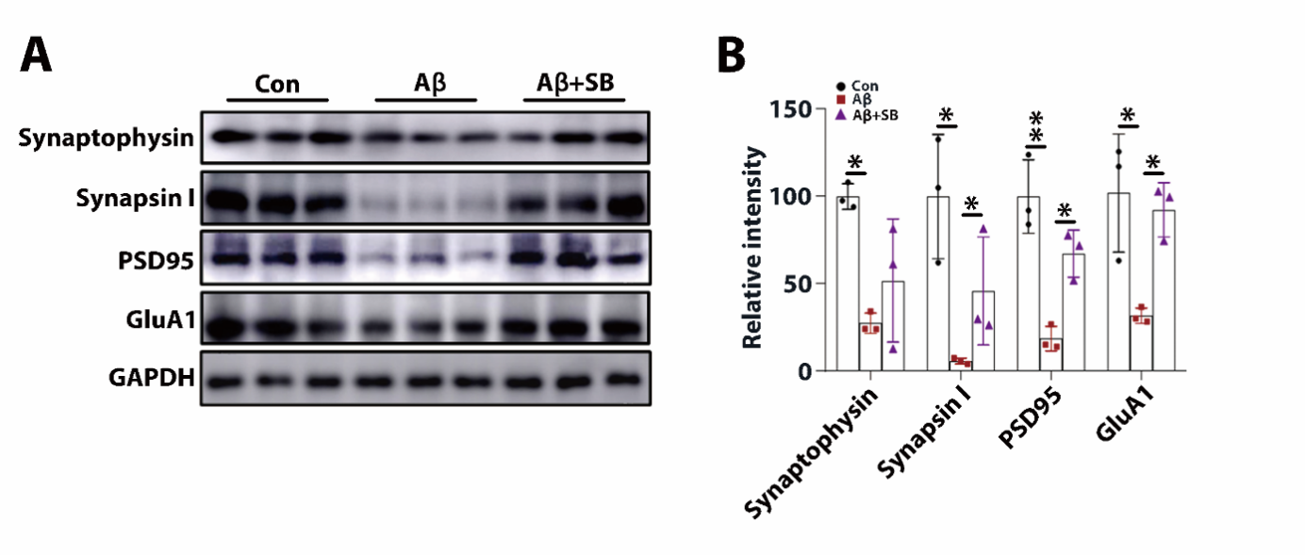

Supplemental figure 2. Aβ-ACM induces neurodegeneration in primary neurons and Aβ+SB-ACM rescues neurodegeneration. A The rat primary neurons (DIV 8) were cultured with conditioned medium from Aβ-treated astrocytes (Aβ-ACM) or Aβ+SB-treated astrocytes (Aβ+SB-ACM) for 4 days. Representative immunoblots of Synaptophysin (Synap), Synapsin I (Syn I), PSD95, GluA1 and GAPDH in the Con, Aβ and Aβ+SB groups. B Quantitative analysis of the proteins levels in (A). n=3 per group. *P < 0.05, **P < 0.01, Data are mean ± SEM.

