Supplementary materials
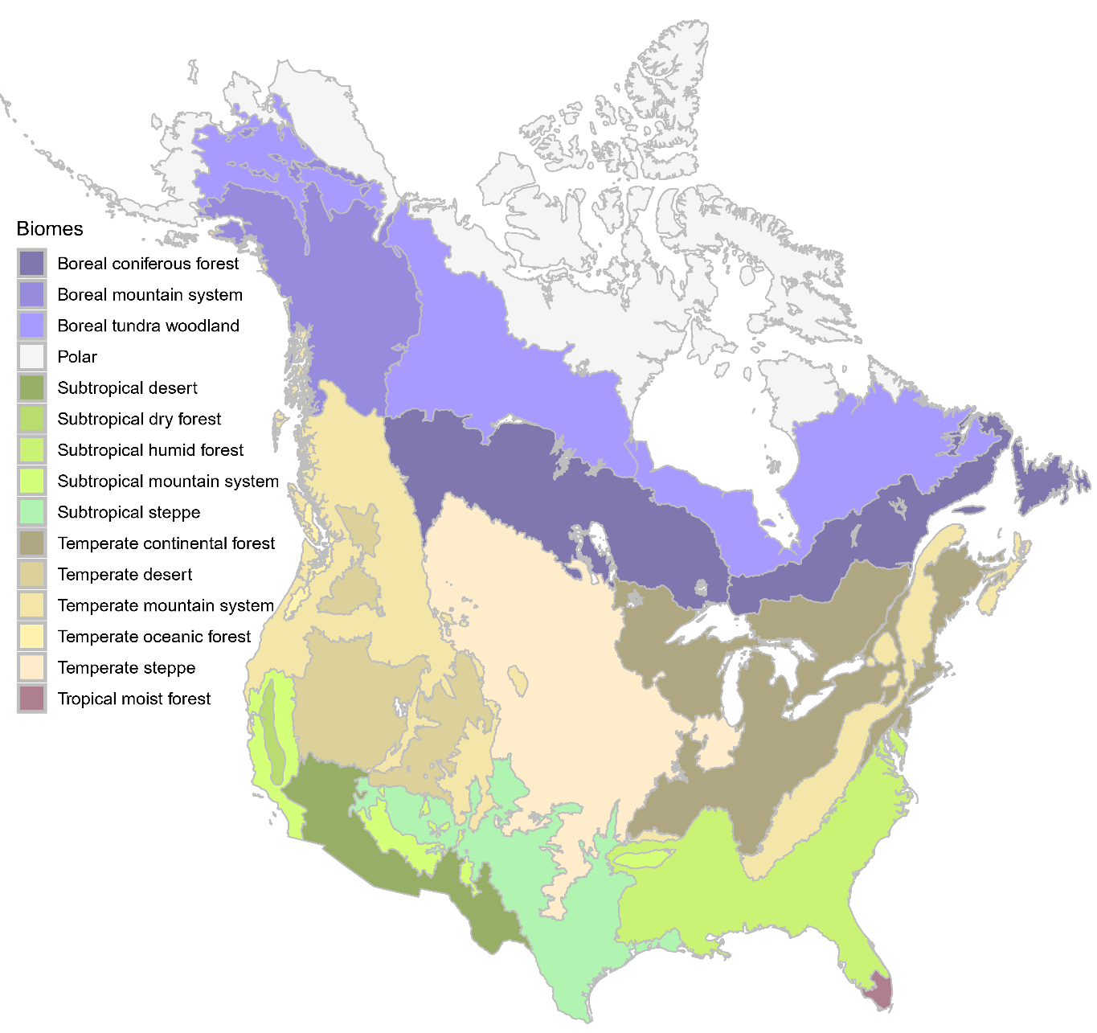
Fig. S1 Biome classification for North America. Based on ABD and OBE observed from 2017-2023, we identified 11 biomes as burnable and fire-prone areas: Subtropical steppe, Subtropical desert, Subtropical mountain system, Temperate steppe, Temperate desert, Temperate mountain system west, Boreal coniferous forest east, Boreal coniferous forest west, Boreal tundra woodland east, Boreal tundra woodland west, and Boreal mountain system. For biomes subdivided into western and eastern regions, gray lines mark the boundaries.
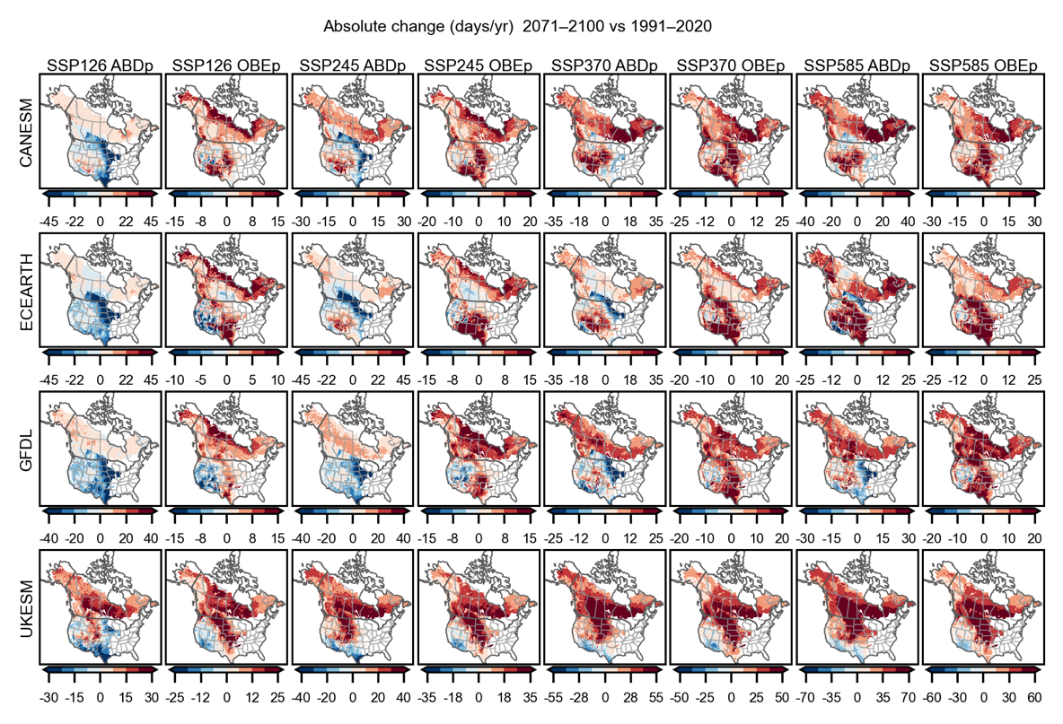
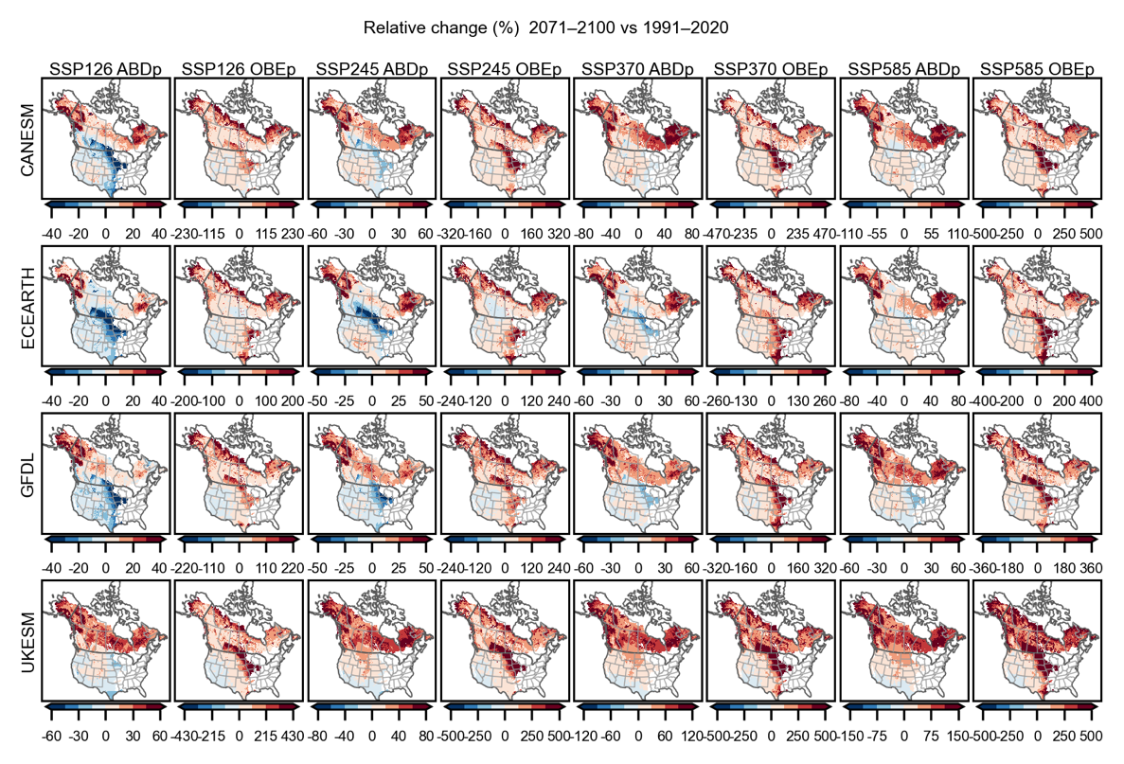
Fig. S2 Scenario- and model-dependent changes in ABDp and OBEp by late-century. This figure synthesizes projected late-century (2071-2100) absolute changes (upper panels, days yr⁻¹) and relative changes (lower panels, %) in annual potential active burning days (ABDp) and potential overnight burning events (OBEp) relative to the 1991–2020 baseline for each SSP (SSP1-2.6/2-4.5/3-7.0/5-8.5) and each climate model (CanESM, ECEarth, GFDL, UKESM).
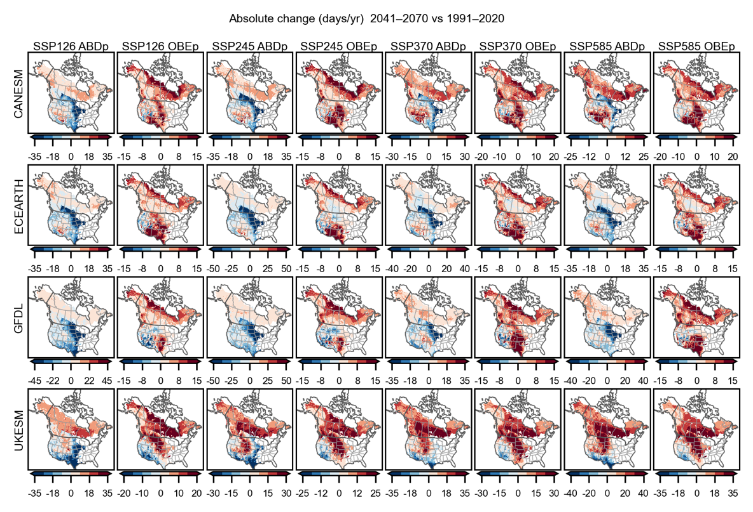
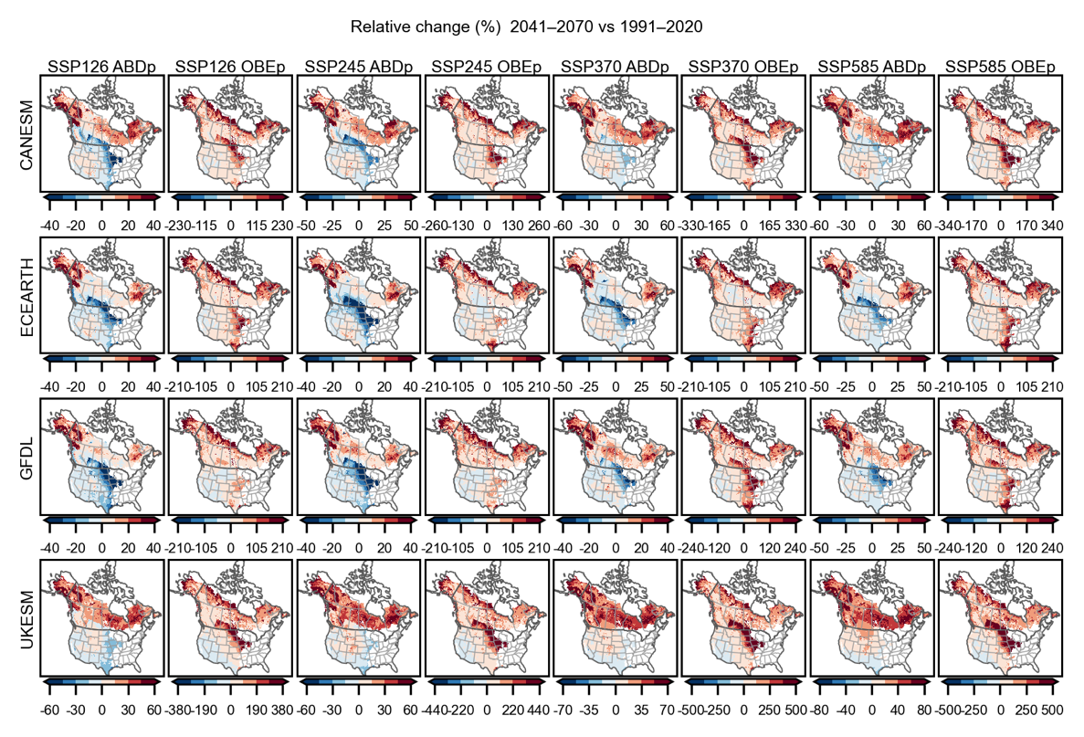
Fig. S3 Scenario- and model-dependent changes in ABDp and OBEp by mid-century. This figure synthesizes projected mid-century (2041-2100) absolute changes (upper panels, days yr⁻¹) and relative changes (lower panels, %) in annual potential active burning days (ABDp) and potential overnight burning events (OBEp) relative to the 1991–2020 baseline for each SSP (SSP1-2.6/2-4.5/3-7.0/5-8.5) and each climate model (CanESM, ECEarth, GFDL, UKESM).
Table S1: Continental-scale changes in annual Active-Burning-Day potential (ABDp) and Overnight-Burning-Event potential (OBEp) for mid-century (2041–2070) and late-century (2071–2100) relative to the historical baseline (1991–2020). Values are spatial averages across all fire-prone biomes and are reported as relative changes, with absolute changes shown in parentheses. “Mean” denotes the average of the four individual GCMs (CanESM, ECEarth, GFDL and UKESM). Negative values indicate decreases.
Period | Model | SSP126 |  | SSP245 |  | SSP370 |  | SSP585
 |  | ABDp | OBEp | ABDp | OBEp | ABDp | OBEp | ABDp | OBEp
late-century  (2071–2100) | CANESM | -1.5 (-1.4) | 19.6 (5.9) | 6.2 (5.9) | 30.1 (9.0) | 16.5 (15.8) | 43.8 (13.1) | 19.8 (18.9) | 49.3 (14.8)
late-century  (2071–2100) | ECEARTH | -6.6 (-6.3) | 13.1 (3.9) | 0.1 (0.1) | 21.0 (6.3) | 5.9 (5.7) | 29.9 (9.0) | 12.3 (11.7) | 38.6 (11.5)
late-century  (2071–2100) | GFDL | -4.0 (-3.9) | 14.5 (4.3) | 0.8 (0.8) | 22.4 (6.7) | 6.7 (6.4) | 32.9 (9.8) | 10.5 (10.0) | 37.3 (11.2)
late-century  (2071–2100) | UKESM | 9.2 (8.8) | 36.9 (11.1) | 19.2 (18.4) | 55.4 (16.6) | 31.5 (30.1) | 80.5 (24.1) | 42.2 (40.4) | 99.9 (29.9)
late-century  (2071–2100) | Mean | -0.7 (-0.7) | 21.0 (6.3) | 6.6 (6.3) | 32.2 (9.7) | 15.2 (14.5) | 46.8 (14.0) | 21.2 (20.3) | 56.3 (16.8)
mid-century  (2041–2070) | CANESM | -0.1 (-0.1) | 20.9 (6.3) | 1.6 (1.5) | 23.5 (7.0) | 6.5 (6.2) | 30.6 (9.2) | 8.0 (7.7) | 31.8 (9.5)
mid-century  (2041–2070) | ECEARTH | -2.9 (-2.8) | 18.5 (5.5) | -5.0 (-4.8) | 15.2 (4.5) | -2.6 (-2.5) | 18.9 (5.7) | -1.8 (-1.7) | 17.9 (5.4)
mid-century  (2041–2070) | GFDL | -5.2 (-5.0) | 13.9 (4.1) | -3.9 (-3.8) | 15.6 (4.7) | 0.8 (0.7) | 23.5 (7.0) | 0.6 (0.6) | 23.3 (7.0)
mid-century  (2041–2070) | UKESM | 5.2 (5.0) | 30.5 (9.1) | 10.3 (9.8) | 40.0 (12.0) | 15.3 (14.6) | 48.9 (14.7) | 18.9 (18.0) | 55.4 (16.6)
mid-century  (2041–2070) | Mean | -0.7 (-0.7) | 20.9 (6.3) | 0.7 (0.7) | 23.6 (7.1) | 5.0 (4.8) | 30.5 (9.1) | 6.4 (6.1) | 32.1 (9.6)

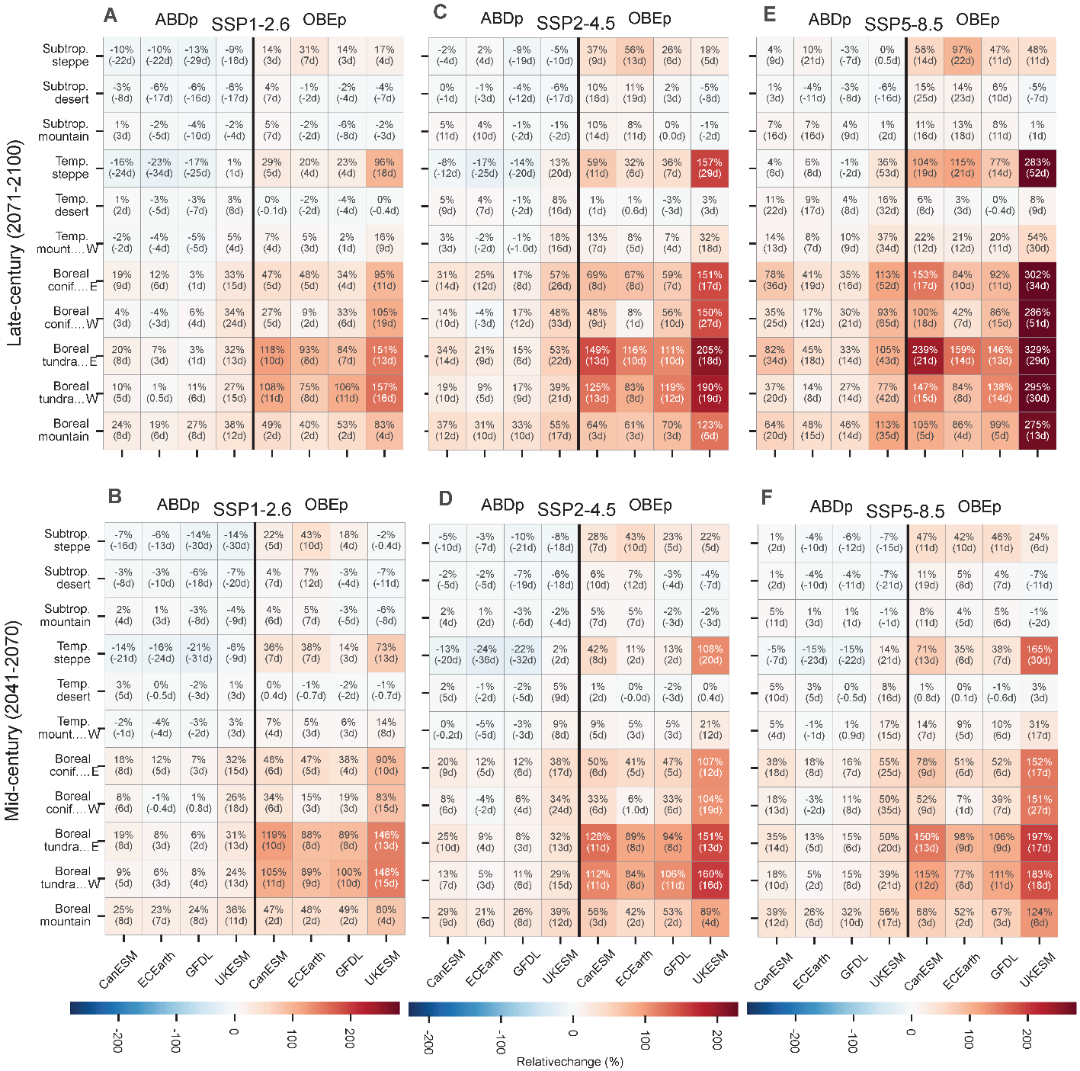
Fig. S4 Biome-scale projected changes in annual ABDp and OBEp across SSPs.
(A–F) Relative and absolute changes in annual Active-Burning-Day potential (ABDp) and Overnight-Burning-Event potential (OBEp) for late-century (2071–2100; top row, A, C, E) and mid-century (2041–2070; bottom row, B, D, F) relative to the historical baseline (1991–2020). Columns correspond to SSP1-2.6 (A, B), SSP2-4.5 (C, D) and SSP5-8.5 (E, F). Rows show fire-prone biomes, and within each panel the four GCMs (CanESM, EC-Earth, GFDL, UKESM) are shown separately for ABDp and OBEp. In each cell, the number denotes the relative change (%) and the value in parentheses denotes the absolute change (day year ⁻¹). Shading indicates the relative change, with a separate colour bar for each SSP column and identical scales for the late- and mid-century panels within that column.
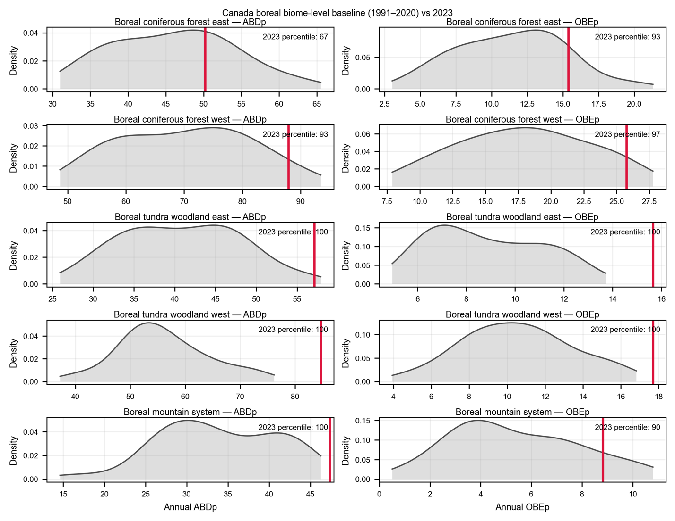
Fig. S5 Boreal biome-level context for Canada 2023 relative to the 1991–2020 baseline. Gray density curves show the 1991–2020 baseline distribution of annual potential active burning days (ABDp, left column) and potential overnight burning events (OBEp, right column) for each boreal biome. The red vertical line marks the 2023 value for that biome. Text in each panel reports the percentile rank of the 2023 value within the corresponding 1991–2020 baseline distribution (higher percentile = rarer under baseline; 100th indicates 2023 is at/above the sampled baseline maximum).

