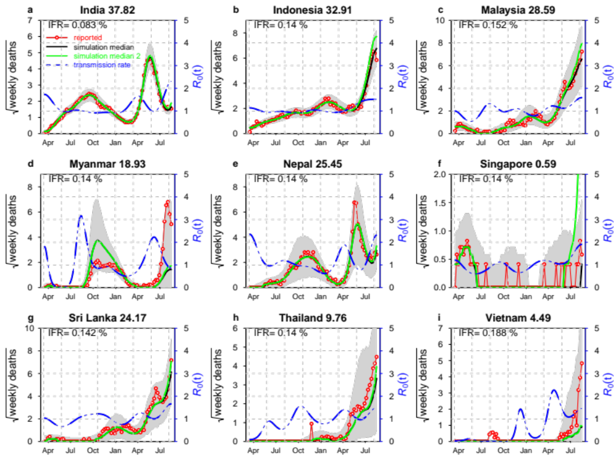
Figure S1. Reproduce Figure 2 as a sensitive test. $ϕ=0.01$ for India; $ϕ=0.02$ for other countries.

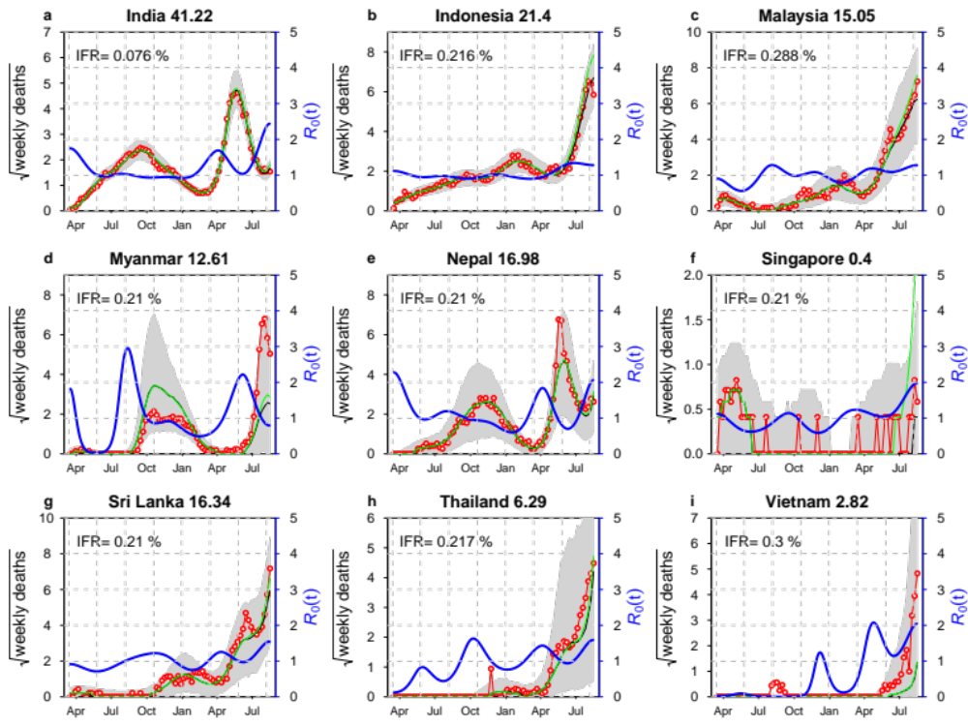
Figure S3 Reproduce Figure 2 with an explicit unsuccessful vaccinated class V and assume that 85% vaccinated directly moved to R class, and 15% vaccinated moved to V class and those in V class has a reduced susceptibility 75% relative to S.
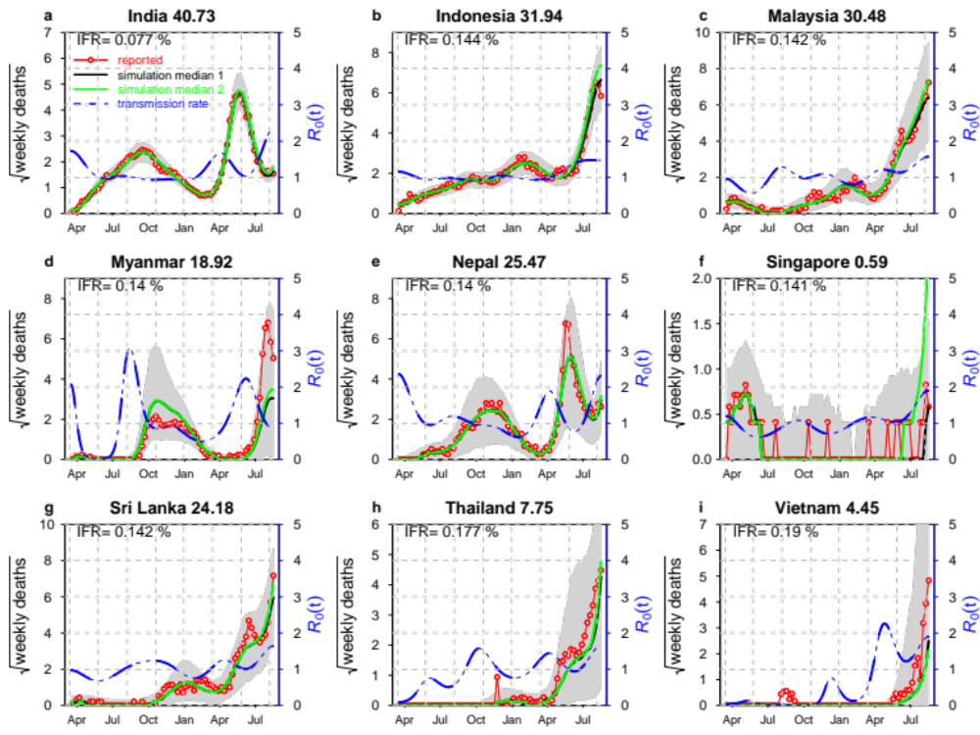
Figure S4. Reproduce Figure S1 with an unsuccessful vaccinated class V and assume that 75% vaccinated directly moved to R class, and 15% vaccinated moved to V class and those in V class has a reduced susceptibility 75% relative to those in S class.

