Dupuytren’s Contracture: What You Need to Know

Who is this leaflet for?
This leaflet is for individuals diagnosed with Dupuytren’s disease who are considering or preparing for surgery. It explains:
- What Dupuytren’s disease is
- How it progresses
- Symptoms and stages
- Treatment options
- What to expect from surgery
- The importance of postoperative therapy

Understanding Dupuytren’s Disease
Dupuytren’s disease affects the palm of the hand, making it difficult to straighten your fingers. It’s a progressive condition where the tissue beneath the skin thickens and tightens over time, pulling fingers toward the palm.

What Causes It?
While the exact cause is unknown, several contributing factors include:
- Genetics: Family history increases risk.
- Age & Gender: More common after age 50, especially in men.
- Ethnicity: Higher risk in people of Northern European descent.
- Health conditions: More frequent in those with diabetes or epilepsy.
- Lifestyle factors: Smoking and excessive alcohol use may contribute.
- Hand trauma: Repetitive hand injuries might play a role.

How It Affects the Hand
There are three layers to the palm of the hand:
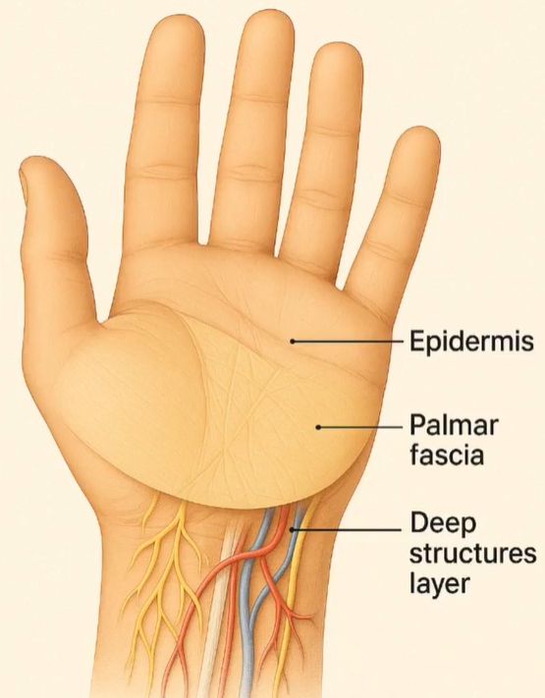

1. Epidermis – thicker than normal and lacking hair follicles
2. Palmar fascia - a fibrous layer that supports grip and protects deep structures beneath
3. Deep structures - nerves, tendons, and vessels
In Dupuytren’s disease, the palmar fascia thickens, forming:
- Pits: Small dents in the palm
- Nodules: Small lumps under the skin
- Cords: Rope-like tissue that may pull fingers downward
- Contractures: Permanent bending of fingers, impairing function
Tasks like shaking hands, using pockets, or wearing gloves may become difficult.

How It’s Diagnosed
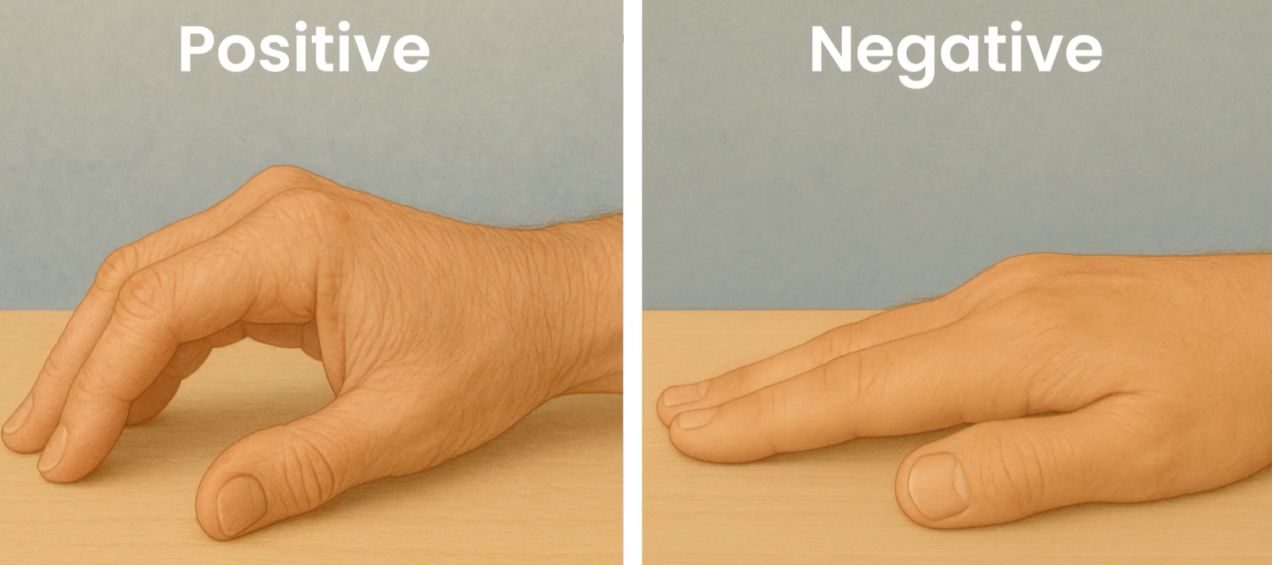
Diagnosis is typically through a physical examination. A common test is the Tabletop Test:
Lay your hand flat on a table:
- If it doesn’t lie flat, it’s a positive test.
- If it lies flat, the test is negative.

Stages of Dupuytren’s Disease
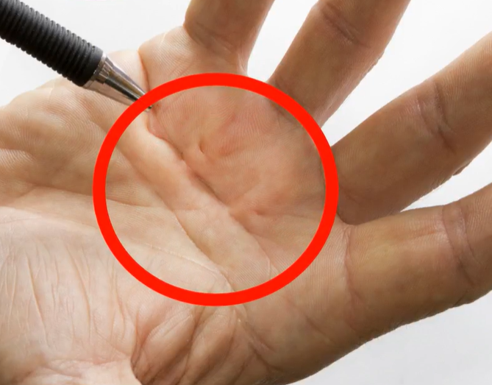
1. Mild: Pits or nodules, slight finger bend

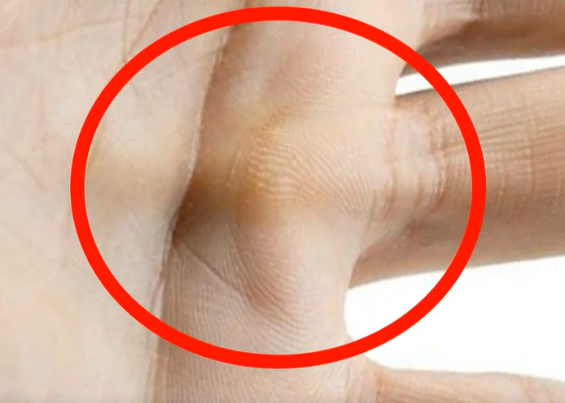
2. Moderate: Cord formation, moderate bend

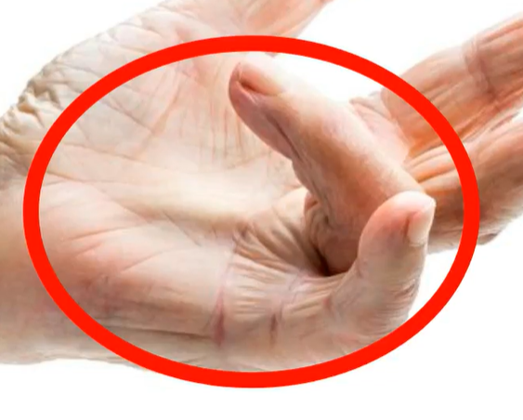
3. Severe: Finger severely bent, affecting daily activities

Non-Surgical Treatment Options
May include:
- Stretching & Massage
- Steroid Injections
- Radiotherapy

Evidence for effectiveness is unclear. Your doctor or therapist will discuss these options with you if you are in the early stages of the disease.

Surgical Treatment Options
If the disease gets worse, surgery might be needed to straighten your fingers. Surgery can't cure, but it can make your hand more usable. The surgical options include:
- Needle Fasciotomy: Cord is cut using a needle (local anaesthetic)
- Fasciectomy: Cord surgically removed (local/regional anaesthetic)
- Dermofasciectomy: Cord and skin removed, with a skin graft (general anaesthetic)
Your surgeon will advise on the best approach.

What to Expect After Surgery
- Recovery: 6–8 weeks minimum
- Dressing Clinic: Wound check (1–2 weeks)
- Hand Therapy: Regain movement and strength
- Expected milestones/Resuming Activities: Guided by your therapist

Therapy After Surgery
You'll work with a hand therapist to help you regain movement and strength in your fingers. They will guide you through specific exercises designed to strengthen your hand, prevent stiffness, and improve your range of movement. Your therapist might recommend several types of therapy which may include:
- Education: Pain management & recovery
- Splinting: Wearing a splint at night to keep fingers straight
- Scar Massage: Improves flexibility and reduces sensitivity
- Exercises: Strengthens hand and improve range of motion
- Swelling Management: Elevation, cold therapy, compression

Final Thoughts
Dupuytren’s disease may progress over time. While surgery isn’t a cure, therapy and early treatment can greatly improve outcomes.
Most people have a good outcome after surgery, especially when they follow their therapy plan closely.
Follow your treatment plan and speak to your healthcare provider if you have any concerns.

Further information and support is available via the British Dupuytren’s Society:

https://dupuytrens-society.org.uk

