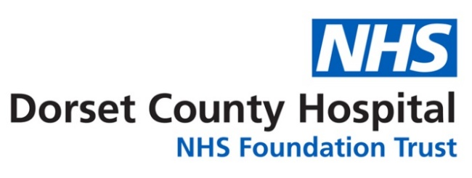


Dear
I hope this letter finds you well.
My name is Tahra Babiker-Moore, and I am a hand therapist at Dorset County Hospital, as well as a clinical PhD student working in collaboration with Mr. Tim Crook, Consultant Hand and Wrist Surgeon.
As a patient currently awaiting Dupuytren’s fasciectomy surgery, we would like to invite you to consider participating in a new preoperative therapy project we are undertaking. At present, no preoperative therapy is routinely offered to patients undergoing this surgery. However, emerging research suggests that a short period of splinting or casting before surgery may help optimise outcomes and support recovery.
We are exploring the feasibility and acceptability of introducing such an intervention. Your involvement would contribute to shaping how preoperative care could be improved for future patients. If you choose to take part, you may be asked to attend weekly hospital appointments during the four weeks leading up to your surgery. More details, including what to expect and the level of involvement, can be found in the enclosed Patient Information Leaflet.
Please be assured that:
- Participation is entirely voluntary.
- You can withdraw at any time without giving a reason.
- Taking part in this project will not affect your planned surgery or standard care in any way.
A member of the team will follow up with a phone call in the coming days to answer any questions and find out whether you may be interested. In the meantime, if you would like more information, please feel free to contact me by phone or email—my contact details are provided below.
Thank you for considering this opportunity to contribute to the development of improved care for Dupuytren’s patients.
Warm regards,
Tahra Babiker-Moore
Hand Therapist & Clinical PhD Researcher
Dorset County Hospital
Phone: 07074 709 699
Email: tbabikermoore@bournemouth.ac.uk

