PRESCET
PRE-operative Serial Casting Education and Therapy

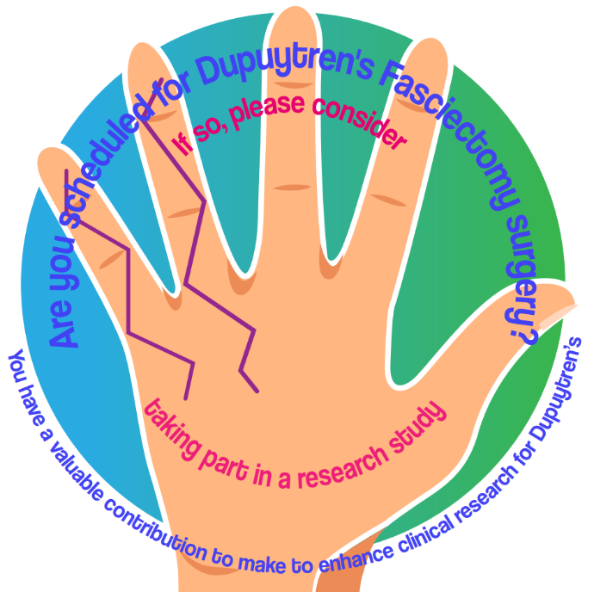
Patient information sheet



Version 2.0 Date 03/10/2025 IRAS Project ID: 349520

Preoperative Serial Casting, Stretching, and Massage Therapy Package for Dupuytren's Patients with Severe Proximal Interphalangeal Joint Contracture: A Feasibility Study Protocol for a Randomised Trial

PRESCET Study Invitation

We invite you to consider participating in the PRESCET Study, a collaborative research project by Dorset County Hospital Foundation Trust and Bournemouth University. The main aim of this feasibility study is to examine the use of casting before Dupuytren's fasciectomy surgery, to assess whether it is practical to conduct a larger trial evaluating its effectiveness.
You are being invited because you have Dupuytren’s disease and are scheduled for surgery. For this study, we are inviting people who have a significant bend (contracture) in the middle joint of the finger. We are focusing on this joint because more severe bends here can be harder to correct with surgery, and we want to see if casting beforehand could improve surgical results. The study is designed to focus on the group of patients for whom casting before surgery may be most useful.
This feasibility study will also look at whether researching preoperative treatments is practical. The results will help us improve how we design and deliver these treatments and prepare for a larger study to better understand their potential benefits.
Please take the time to read the following information carefully, and feel free to discuss it with family, friends, or a healthcare provider. If anything is unclear, or if you’d like more information, please don’t hesitate to contact our study team using the details provided.
Thank you for considering the PRESCET study and for helping us explore new ways to improve care for individuals affected by Dupuytren’s disease.

PRESCET Why is the study needed?

Dupuytren’s disease affects over two million people in the UK, causing fingers to bend and stiffen, making everyday tasks challenging. Surgery is often recommended to straighten the affected joints, especially when bending (or "contracture") becomes severe.
While post-surgery therapy is standard for recovery, we are exploring whether preoperative treatment could also be beneficial. The aim is to determine if holding the affected finger(s) in a stretched position in a custom-made cast for a few weeks before surgery can enhance results.
We are recruiting patients from Dorset County Hospital. If you fit the eligibility criteria, you will be asked if you would like to join the trial. If you choose to participate, you will be randomly assigned to one of two groups: one group receiving the preoperative casting treatment along with educational information about the condition, and the other group receiving only educational information. ‘Randomisation’ means you have an equal chance of being placed in either group. If you are unhappy with the group, you have been assigned to, you can choose to switch to the other group with no effect on your ongoing care. Both groups will attend their routine follow-up visits, where we will measure hand function and range of motion before and after surgery.
At the end of this study, we will compare how well participants can use their hands, how much they can move their fingers, and their overall satisfaction between those who had preoperative casting and those who did not. This will help us see if this therapy before surgery can improve surgical results for people with Dupuytren’s disease.

PRESCET What does taking part in the study involve?

Participants will be divided into two groups: the education and casting group or the education only group. Both groups will have similar measurements taken before and after surgery, with the study concluding approximately 12 weeks after surgery.
- First Therapy Appointment (About 4 Weeks Before Surgery)
Participants will attend an appointment to have measurements taken of their hand and complete a questionnaire. During this session, we will provide educational information about the condition, surgery, and postoperative treatment. Those assigned to the casting group will receive a temporary cast and will need to return three times for cast adjustments. The cast is not designed to be removable and will be taken off only by the study team. Each adjustment session will include application of heat, a gentle massage, and stretching before the cast is reapplied. They will also be asked to keep a short daily diary to record their experiences, pain levels, and any challenges they face. This diary can be completed either on paper or by email.
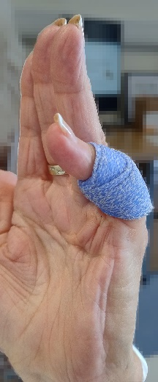
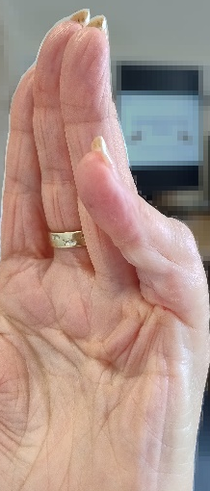

- Preoperative Therapy Visit (Up to 48 Hours Before Surgery)
Before surgery, all participants will have their finger range of motion measured and complete another questionnaire.
- Postoperative Therapy Visits
All participants will attend regular postoperative dressing clinics and therapy visits starting about one week after surgery. These visits will be tailored to each patient's needs to optimise surgical results.
- Postoperative Follow-Up (About 12 Weeks After Surgery)
At the end of the study, participants will have a final measurement taken of their hand and complete a questionnaire. Everyone will be encouraged to keep a diary to track their recovery and therapy adherence. All participants from each group will be invited for an interview at the final follow-up to discuss their experiences in the study and the treatment received. If you need any further treatment as part of your standard postoperative care, this will continue as normal and will not be affected by your participation in the study.

PRESCET How much time will the study take?

If you take part, you will need to attend several extra visits before your surgery, depending on which group you are in. We will reimburse reasonable travel costs for these additional hospital visits, and free parking on the hospital site can be arranged if you provide us with your car registration in advance. Each visit will last between 45 and 90 minutes.
Visit | When it happens | Control group | Intervention group
Visit 1 | About 4 weeks before surgery | 45–60 minutes | 60–90 minutes
Visit 2 | About 3 weeks before surgery | – | 45–60 minutes
Visit 3 | About 2 weeks before surgery | – | 45–60 minutes
Visit 4 | About 1 week before surgery | – | 45–60 minutes
Visit 5 | 1–2 days before surgery | 45–60 minutes | 45–60 minutes
Normal care | Routine postoperative hand therapy | As usual | As usual
Visit 6 | 12 weeks after surgery | 60–90 minutes | 60–90 minutes
PRESCET Do I have to take part?

Participation in this study is entirely voluntary. You have the right to decide whether or not to participate, and your decision will not affect the care you receive at Dorset County Hospital. If you choose not to participate, you will still receive the standard treatment for Dupuytren’s disease without any penalties or consequences.
PRESCET Can I withdraw after agreeing to participate?

You can withdraw from the study at any time. Participation is entirely voluntary, and you have the right to discontinue your involvement without any penalties or negative consequences for your future care. However, the study will be most valuable if fewer participants withdraw, so it's important to discuss any concerns you may have with a member of the study team before agreeing to participate. If you choose to withdraw, please inform the study team so they can document your decision and ensure you continue to receive the treatment you need without interruption. If you have any questions or concerns about the withdrawal process, don’t hesitate to reach out to a member of the study team. Withdrawal will require you to confirm your wishes in writing, via a withdrawal form we will provide for you. Please note that any data already collected by the study will be retained for analysis, in accordance with ethical guidelines.

PRESCET What are the possible benefits of taking part?

Participants in the study will have the opportunity to gain valuable knowledge about Dupuytren’s disease, including its treatment options and recovery expectations, through access to educational resources. Additionally, by participating in the study, you will contribute to important medical research that aims to enhance the understanding and treatment of Dupuytren’s disease. Your involvement may lead to advancements in care that benefit future patients and shape the future of treatments.
PRESCET What are the possible disadvantages of taking part?

While participating in the study, you may experience certain disadvantages. These could include the time commitment required for additional therapy appointments and follow-up sessions, which might be inconvenient or interfere with your daily activities. Although unlikely, there is also a possibility of discomfort or side effects from the treatments, such as temporary pain, skin irritation, or discomfort from the casting therapy. Additionally, you may feel uncertain about being assigned to a particular group. If you are unhappy with the group, you have been allocated to please discuss your concerns with a member of the study team.

PRESCET What if something goes wrong?
In the event that something does go wrong and you are harmed during the research, and this is due to someone's negligence then you may have grounds for a legal action for compensation against Bournemouth University, but you may have to pay your legal costs.

PRESCET How will we use information about you?
We will need to use information from you and from your medical records for this research project. We will only use information that we need for the research study. People will use this information to do the research or to check your records to make sure that the research is being done properly. This information will include your:
- Name
- Age
- Race
- Gender
- Comorbidities
- Dominant hand
- Education
- Contact phone number
- E-mail address
- NHS number
Everyone involved in this study will keep your data safe and secure. We will also follow all privacy rules. People who do not need to know who you are will not be able to see your name or contact details. Your data will be pseudonymised, meaning that your personal details (such as your name and address) will be removed and replaced with a unique study identification code. This code allows the study team to link the data back to you if needed (for example, to ensure your safety), but your identity will not be included in any reports, publications, or shared results. This means your responses cannot be identified by anyone outside the study team.
We will keep all information about you safe and secure. Data collected at Dorset County Hospital will comply with local NHS policy and procedures. Bournemouth University is the sponsor of this research and will hold the information we collect about you in hard copy in a secure location and on a Bournemouth University password protected secure network electronically. Your data will be kept for a minimum of 10 years according to the sponsor's Research data policy (2020).
When study results are published or presented, data will be aggregated, and individual identities will not be disclosed. This means that no personal information will be shared in any reports or publications. Pseudonymised information may also be used for future research and shared in with other researchers, ensuring you remain unidentifiable. Study results will also be offered to you at the end of the study via the contact details you provided.
You can stop being part of the study at any time, without giving a reason, but we will keep information about you that we already have.
You can find out more about how we use your information:
- by asking one of the research team
- by sending an email to tbabikermoore@bournemouth.ac.uk
- The Bournemouth University Research Participant Privacy Notice
PRESCET Who is funding this study?

The PRESCET study has been sponsored by Bournemouth University (BU) in collaboration with Dorset County Hospital Foundation Trust (DCHFT). Funding has been provided by both BU and DCHFT. This study is also being supported by the British Dupuytren’s Society.
PRESCET Who has approved this study?

All research in the NHS is reviewed by independent research ethics committee. The committee protects the rights and interests of the people who will be in the trial. This project has been reviewed and was given a favourable review by South West - Frenchay Health Research Authority.

PRESCET Who do I contact if I have questions or concerns?

If you experience urgent problems, or cannot reach your usual care team, please attend your nearest Accident & Emergency (A&E) department.
If you have any questions about the PRESCET study or your involvement in it, or if you need medical advice or support related to your condition between study visits, please contact:
Tahra Babiker-Moore (Lead Researcher)
Email: tbabikermoore@bournemouth.ac.uk
Tel: (+44) 07974 709 699
If you wish to raise a concern or complaint about the study and would prefer to speak to someone independent, please contact:
Andy Scott (Head of Research and Innovation Services, Bournemouth University)
Email: AScott@bournemouth.ac.uk
Tel: (+44) 01event 202 961216

PRESCET sub study Follow-up interview invitation

You will also be invited to take part in a short interview about your experience in the PRESCET study. This opportunity will be offered to all participants, but you do not have to take part in the interview even if you have taken part in the study.
Interviews will then take place during your final follow-up visit (around 12 weeks after surgery).
Please read the following information carefully. If anything is unclear or if you have any questions, feel free to contact us using the details at the end of this sheet.
PRESCET sub study What is the purpose of the interview?

You recently took part in the PRESCET research study, which investigated a preoperative therapy approach for people undergoing Dupuytren’s fasciectomy. We are now asking participants to take part in a follow-up interview to help us understand what it was like to take part in the study, whether the intervention was acceptable and easy to follow and how the study process could be improved. Your insights will help us shape future research and improve patient care.

PRESCET sub study Do I have to take part?

No. Taking part is entirely voluntary. If you decide not to take part, it won’t affect your medical care or your relationship with the research team. You can also stop the interview at any point or skip any questions you don’t want to answer.
PRESCET sub study What will the interview involve?

The interview will take about 15 to 20 minutes and will be conducted in your final therapy visit. With your permission, the conversation will be audio recorded so that we can accurately capture what you say.
PRESCET sub study Will the information be kept confidential?

Yes. Any personal information or quotes will be pseudonymised so that your name and other details are replaced with a study code. This means the research team can link the information back to you if needed, but you will not be identifiable in any reports or publications. All data will be stored securely in accordance with UK data protection laws and only accessed by members of the research team.

PRESCET sub study What will happen to the results?

The results will be used to improve future research studies and may be included in academic publications or presentations. You will not be personally identified in any published material.
PRESCET sub study Who is funding this study?

The PRESCET study has been sponsored by Bournemouth University (BU) in collaboration with Dorset County Hospital Foundation Trust (DCHFT). Funding has been provided by both BU and DCHFT. This study is also being supported by the British Dupuytren’s Society.

PRESCET sub study Who has approved this study?

All research in the NHS is reviewed by independent research ethics committee. The committee protects the rights and interests of the people who will be in the trial. This project has been reviewed and was given a favourable review by South West - Frenchay Health Research Authority.

PRESCET Who do I contact if I have questions or concerns?

If you experience urgent problems, or cannot reach your usual care team, please attend your nearest Accident & Emergency (A&E) department.
If you have any questions about the PRESCET study or your involvement in it, or if you need medical advice or support related to your condition between study visits, please contact:
Tahra Babiker-Moore (Lead Researcher)
Email: tbabikermoore@bournemouth.ac.uk
Tel: (+44) 07974 709 699
If you wish to raise a concern or complaint about the study and would prefer to speak to someone independent, please contact:
Andy Scott (Head of Research and Innovation Services, Bournemouth University)
Email: AScott@bournemouth.ac.uk
Tel: (+44) 01202 961216

