Supplementary Materials
Section 1. Analysis on images without partial volume correction
Without partial volume correction (PVC), the overall topography of statistically significant negative correlation between [¹⁸F]-FEOBV uptake and MDS-UPDRS PIGD sub-scores was largely recapitulated from the original analysis (presented in figure 1), with additional statistically significant clusters observed also within the pons, midbrain, and brainstem. Statistically significant correlation within those areas on the analysis without PVC may be explained with reference to greater proportion of white matter within those regions potentially influencing the gray matter included in the correlation analysis, an effect which is minimized upon application of PVC, which is why no significant correlation was observed in those regions after PVC.
Figure S1. Voxels where [¹⁸F]-FEOBV uptake (without partial volume correction) exhibited statistically significant negative correlation with MDS-UPDRS PIGD sub-scores in PSP subjects. Color indicates SPM voxel-based regression analysis strength of correlation between lower cholinergic binding and MDS-PIGD scores in PSP subjects with yellower color indicating more robust significant correlations (voxel-level uncorrected p<0.001, cluster-level FDR-corrected at P<0.01; adjusted for sex, disease duration and Levodopa Equivalent Dose).
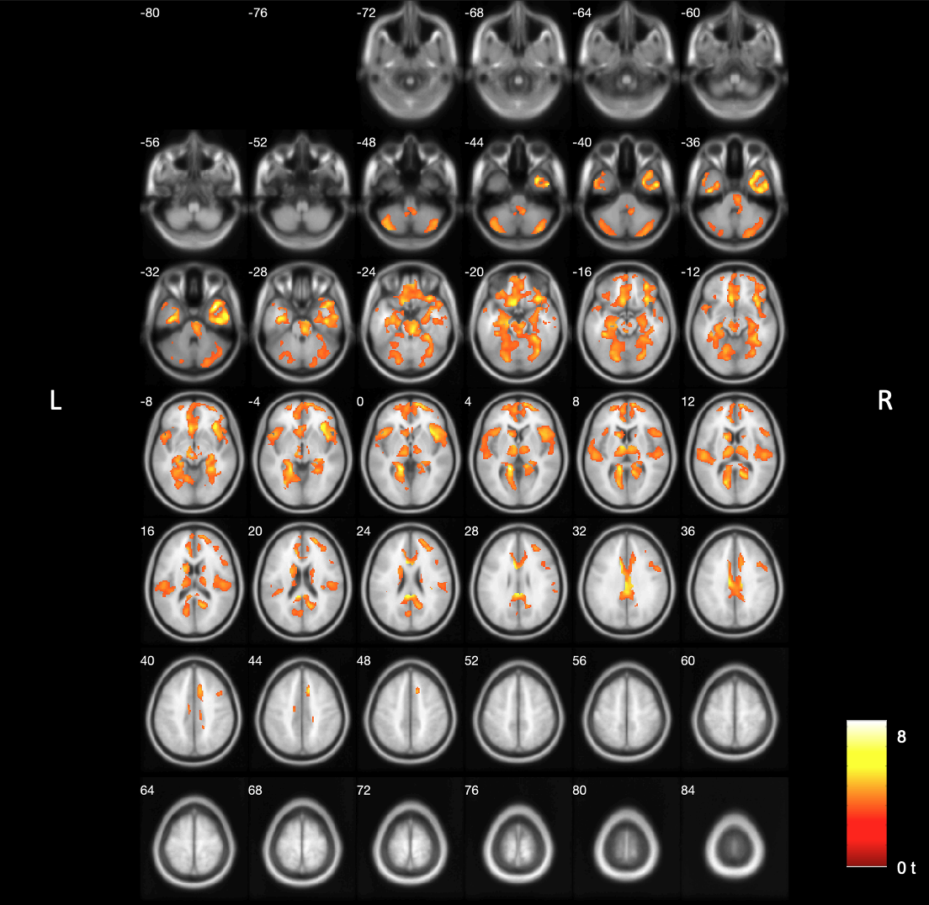

Section 2. Voxel-based regression analysis with MDS-Part III total as the independent variable
The overall topography of the statistically significant negative correlation between [18F]-FEOBV uptake and total scores on the MDS-UPDRS Part III was primarily observed in the cortical region. This largely overlapped with our primary analysis, here, we identified reduced statistically significant clusters in areas including the orbital frontal cortex, superior frontal cortex, fusiform gyrus, anterior cingulate, calcarine, precuneus, and the left inferior frontal cortex, as well as the left mid-temporal cortex, with a greater involvement on the left side than the right.
Figure S2. Voxels where [18F]-FEOBV uptake (partial volume correction) exhibited statistically significant negative correlation with MDS-UPDRS Part III totalscores in PSP subjects. Color indicates SPM voxel-based regression analysis strength of correlation between lower cholinergic binding and MDS-UPDRS Part III total scores in PSP subjects with yellower color indicating more robust significant correlations (voxel-level uncorrected p<0.01, cluster-level FDR-corrected at P<0.05, k=1023; adjusted for sex, disease duration and Levodopa Equivalent Dose).
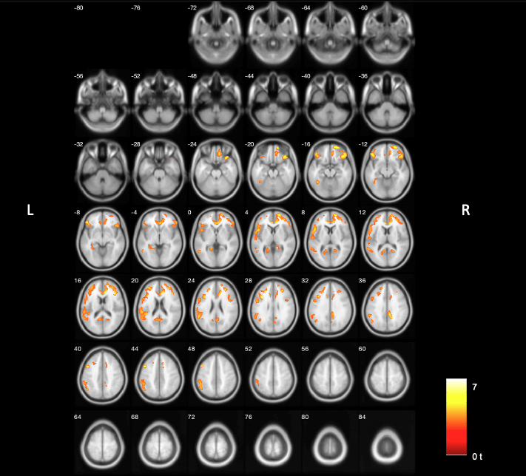
Section 3. Subregion sensitivity analysis
The cluster of statistically significant voxels obtained in the primary analysis was split into five separate regions based on the different sources of cholinergic innervations, as initially described in our [¹⁸F]-FEOBV study of age-related changes among normal controls (Kanel et al. 2022). Statistically significant voxels in the cerebral cortex and the amygdala were grouped together because they both predominantly receive innervation from the cholinergic nucleus Basalis of Meynert (nBM). Voxels in the cerebellum were grouped together due to being innervated by pedunculopontinue nucleus/laterodorsal tegmental complex (PPN/LDTC) and medial vestibular nucleus (MVN). Voxels in the hippocampus were grouped together due to shared innervation originating from medial septum (MS) and vertical limb of the diagonal band (VLDB). Voxels in the thalamus were categorized into a subregion predominantly innervated by PPN. Lastly, voxels in the caudate nucleus were categorized into a subregion predominantly innervated by the intrinsic striatal cholinergic interneurons (SChI). Mean distribution volume ratios (DVR) were extracted from standard space parametric images for voxels corresponding to each of the clusters defined above.
Table S1. Post-hoc analysis, examining correlation between PIGD score and subregions within the statistically significant cluster of associations, focusing on cholinergic innervation targets with differential sources. Sources of cholinergic innervation corresponding to each region and relevant regression model parameters including standardized regression coefficient (β), coefficient of determination (R²), F-value for the model comparison against an intercept-only model along with its respective P-value are provided. Abbreviations: nBM, nucleus Basalis of Meynert; PPN, pedunculopontine nucleus; LDTC, laterodorsal tegmental complex; MS, medial septum; VLDB, vertical limb of the diagonal band; SChI, striatal cholinergic interneurons.
Region | Source | β | R² | F | P(>|F|)
Cortex & Amygdala | nBM | -0.608 | 0.369 | 9.957 | 0.005774
Cerebellum | PPN, LDTC, MVN | -0.616 | 0.379 | 10.381 | 0.005005
Hippocampus | MS, VLDB | -0.678 | 0.459 | 14.435 | 0.001433
Thalamus | PPN | -0.672 | 0.451 | 13.964 | 0.001641
Caudate | SChI | -0.584 | 0.341 | 8.807 | 0.008629

Section 4. Reference region validation analysis
A supplementary analysis was performed, examining whether reference region standardized uptake value (SUV) associated significantly with any variables of interest, such as age, PIGD score, or site (University of Michigan vs. Groningen) to identify whether these variables might have introduced a quantification bias to our primary analyses. The procedure for calculating SUV values in a manner that makes them comparable across site is presented in our prior article involving a combined dataset from University of Michigan and Groningen (Bohnen et al. 2025). Regression coefficients of the resulting multivariate model are presented below:
 | SUV
Predictors | Estimates | CI | p
(Intercept) | 0.897 | -0.846 – 2.639 | 0.290
Age (years) | 0.418 | -0.291 – 1.128 | 0.228
PIGD Score | 0.412 | -0.242 – 1.065 | 0.199
Site | -1.065 | -3.060 – 0.930 | 0.273
Observations | 19
R² / R² adjusted | 0.256 / 0.108
None of the regression coefficients were statistically significant, which supports the conclusion that variance in reference region uptake across sites, age, and outcome measure (PIGD score) values did not bias the quantification of [¹⁸F]-FEOBV uptake, thus making it unlikely that our choice of reference region was a significant biasing factor in our findings.
References
Bohnen, Nicolaas I., Stiven Roytman, Sygrid van der Zee, Giulia Carli, Fotini Michalakis, Austin Luker, Sofie Slingerland, et al. 2025. “A Multicenter Longitudinal Study of Cholinergic Subgroups in Parkinson Disease.” Nature Communications. https://doi.org/10.1038/s41467-025-60815-0.
Kanel, Prabesh, Sygrid van der Zee, Carlos A. Sanchez-Catasus, Robert A. Koeppe, Peter J. H. Scott, Teus van Laar, Roger L. Albin, and Nicolaas I. Bohnen. 2022. “Cerebral Topography of Vesicular Cholinergic Transporter Changes in Neurologically Intact Adults: A [18F]FEOBV PET Study.” Aging Brain 2 (100039): 100039.

