Supplementary Information

Integrative dual ctDNA 5mC/5hmC methylomics and clonal reconstruction infer
tumor transcription and resistance phenotypes in metastatic prostate cancer

Chennan Li et al.

- Supplementary Tables
- Supplementary Figures

Supplementary Table 1

Case | Sample | Timepoint | WGS Purity | Mean genome coverage  (duet evoC) | % 5hmC | % 5mC
2044 | PLASMA | OFFSTUDY | 0.34 | 10.89 | 2.06 | 63.63
2114 | PLASMA | PROGRESSION | 0.25 | 19.35 | 1.31 | 72.88
2114 | PLASMA | RESTAGING | 0.23 | 22.10 | 1.59 | 75.63
2130 | PLASMA | PROGRESSION | 0.15 | 19.38 | 1.37 | 72.34
2131 | PLASMA | PROGRESSION | 0.45 | 19.40 | 2.44 | 78.04
2134 | PLASMA | BASELINE | 0.34 | 41.70 | 1.71 | 69.81
2134 | PLASMA | PROGRESSION | 0.58 | 7.00 | 1.22 | 69.05
2134 | PLASMA | RESTAGING | 0.47 | 7.53 | 1.37 | 68.93
2134 | PLASMA | RESTAGING | 0.46 | 9.84 | 1.21 | 69.49
2141 | PLASMA | BASELINE | 0.21 | 2.19 | 1.68 | 75.03
2142 | PLASMA | BASELINE | 0.21 | 21.29 | 2.46 | 76.04
2142 | PLASMA | PROGRESSION | 0.24 | 27.50 | 1.90 | 68.71
2142 | PLASMA | RESTAGING | 0.11 | 23.24 | 2.19 | 72.03
2145 | PLASMA | BASELINE | 0.60 | 30.04 | 2.00 | 67.06
2145 | PLASMA | PROGRESSION | 0.73 | 29.01 | 1.81 | 65.69
2147 | PLASMA | BASELINE | 0.21 | 16.93 | 1.57 | 77.10
2147 | PLASMA | PROGRESSION | 0.42 | 15.21 | 1.24 | 71.49
2147 | PLASMA | RESTAGING | 0.20 | 23.17 | 1.76 | 68.92
2149 | PLASMA | BASELINE | 0.21 | 22.50 | 2.76 | 74.95
2149 | PLASMA | PROGRESSION | 0.23 | 22.98 | 2.09 | 69.54
2152 | PLASMA | RESTAGING | 0.12 | 42.38 | 2.31 | 71.24
2156 | PLASMA | BASELINE | 0.20 | 30.97 | 2.51 | 76.30
2156 | PLASMA | PROGRESSION | 0.35 | 18.41 | 1.50 | 75.06
2158 | PLASMA | PROGRESSION | 0.28 | 27.48 | 2.40 | 68.77
2160 | PLASMA | BASELINE | 0.81 | 32.38 | 1.80 | 66.96
2160 | PLASMA | PROGRESSION | 0.79 | 32.57 | 1.87 | 66.20
2164 | PLASMA | BASELINE | 0.21 | 26.90 | 2.44 | 76.26
2164 | PLASMA | PROGRESSION | 0.21 | 29.65 | 2.29 | 71.06
2164 | PLASMA | RESTAGING | 0.21 | 23.29 | 2.08 | 71.47
2167 | PLASMA | BASELINE | 0.56 | 7.57 | 1.42 | 75.09
2170 | PLASMA | BASELINE | 0.38 | 14.24 | 2.18 | 62.00
2170 | PLASMA | PROGRESSION | 0.20 | 30.35 | 2.35 | 66.09
2170 | PLASMA | RESTAGING | 0.52 | 28.68 | 2.12 | 57.20
2172 | PLASMA | RESTAGING | 0.26 | 22.43 | 1.81 | 77.65
2174 | PLASMA | BASELINE | 0.24 | 26.27 | 3.02 | 76.57
2174 | PLASMA | PROGRESSION | 0.46 | 21.19 | 1.79 | 77.59
2176 | PLASMA | BASELINE | 0.61 | 7.38 | 1.80 | 72.56
2176 | PLASMA | PROGRESSION | 0.28 | 10.71 | 1.94 | 76.33
2181 | PLASMA | BASELINE | 0.32 | 8.16 | 1.75 | 68.84
2181 | PLASMA | OFFSTUDY | 0.16 | 11.56 | 1.58 | 72.85
2181 | PLASMA | RESTAGING | 0.19 | 10.37 | 1.54 | 69.67
2188 | PLASMA | BASELINE | 0.19 | 26.99 | 2.49 | 76.26
2189 | PLASMA | BASELINE | 0.69 | 27.14 | 1.90 | 75.29
2189 | PLASMA | PROGRESSION | 0.58 | 29.89 | 2.29 | 74.07
2189 | PLASMA | RESTAGING | 0.11 | 31.90 | 2.83 | 75.53
2193 | PLASMA | BASELINE | 0.30 | 26.73 | 2.54 | 77.22
2193 | PLASMA | PROGRESSION | 0.24 | 32.57 | 3.00 | 73.32
2201 | PLASMA | PROGRESSION | 0.31 | 12.15 | 1.67 | 78.65
2210 | PLASMA | BASELINE | 0.15 | 29.26 | 2.43 | 74.17
2044 | BUFFYCOAT | BASELINE | 0 | 16.42 | 1.11 | 72.26
2130 | BUFFYCOAT | PROGRESSION | 0 | 27.16 | 1.70 | 81.17
2142 | BUFFYCOAT | BASELINE | 0 | 28.85 | 1.59 | 80.97
2142 | BUFFYCOAT | PROGRESSION | 0 | 8.94 | 1.10 | 72.31
2167 | BUFFYCOAT | BASELINE | 0 | 9.46 | 1.13 | 74.01
2189 | BUFFYCOAT | BASELINE | 0 | 26.99 | 1.24 | 81.40
2189 | BUFFYCOAT | PROGRESSION | 0 | 4.48 | 1.25 | 74.88
2189 | BUFFYCOAT | RESTAGING | 0 | 30.06 | 1.21 | 80.27
2201 | BUFFYCOAT | PROGRESSION | 0 | 27.26 | 1.21 | 81.26

Supplementary Table 1. Summary metrics for 6-base evoC sequencing of plasma and buffy coat samples. For ctDNA samples (from plasma), the tumor purity for each sample is derived from the high-depth 4-base sequencing as depicted in Supplementary Figure 1.

Supplementary Table 2

Gene category | Genes
Globins | HBA1, HBA2, HBB, HBD, HBE1, HBG1, HBG2, HBM, HBQ1, HBZ
Erythroid  markers | ALAS2, AHSP, EPB42, SLC4A1, GYPA, GYPB, GYPC, KLF1, FECH, TFRC, RHAG
Platelet/  megakaryocyte markers | PPBP, PF4, PF4V1, SDPR, NRGN, RGS18, SPARC, GNG11, CLU, PTGS1, GP9, GP1BA, GP1BB, ITGA2B, ITGB3, NBEAL2

Supplementary Table 2. Anucleated-component marker genes excluded from RNA expression preprocessing.

Supplementary Figure 1

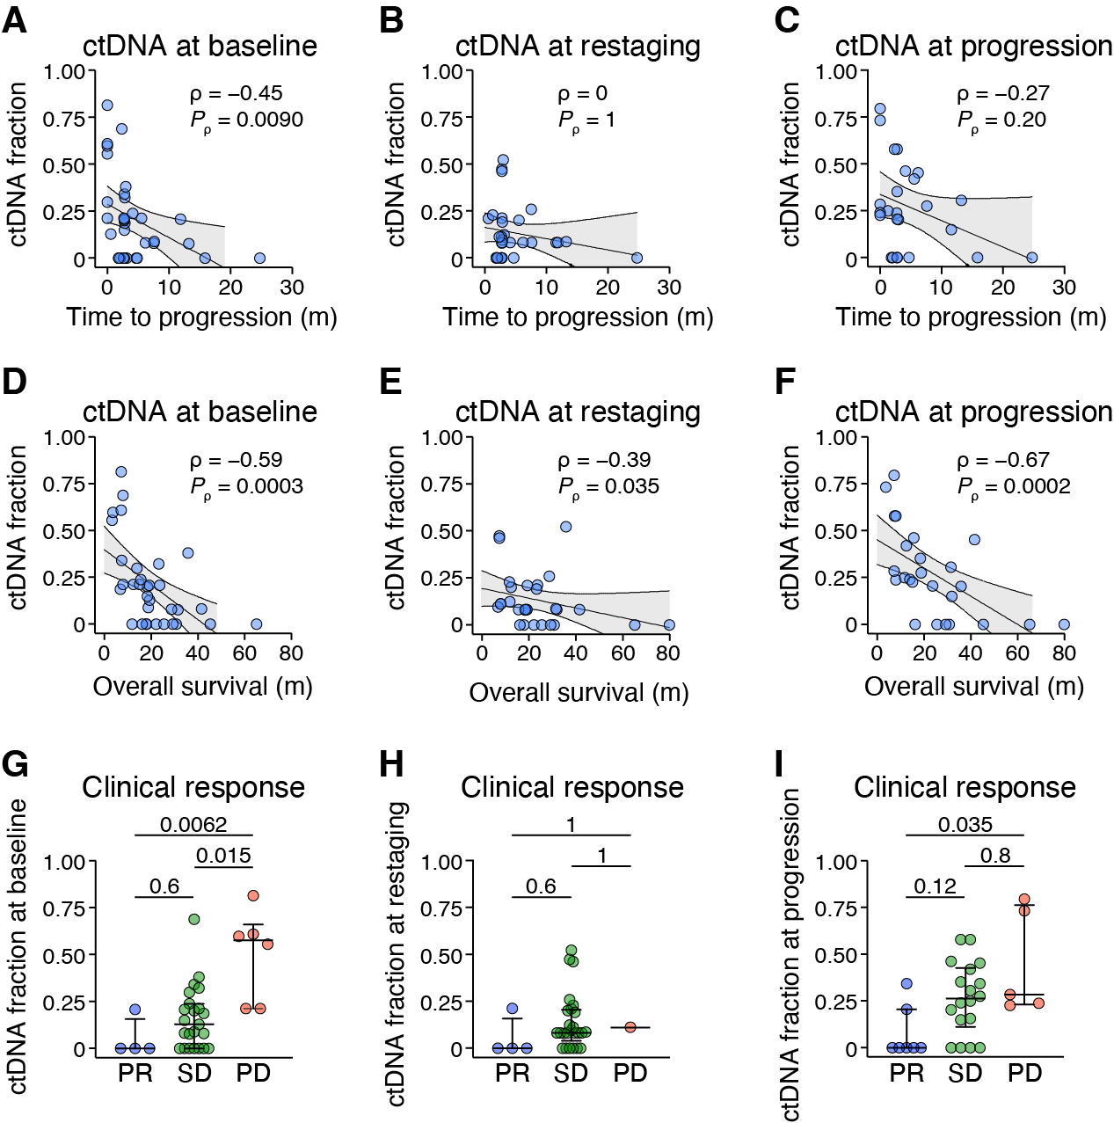

Supplementary Figure 1. Associations between ctDNA fraction and clinical variables. (A–F) Correlation of the ctDNA fraction for each patient at baseline (A,D), restaging (B,E), or progression (C,F) plotted against the time to radiographic progression (A–C) or overall survival (D–F). Nonparametric Spearman correlation analyses ρ values are shown with their respective P values. Lines and bands represent linear regression lines and 95% confidence intervals, respectively. (G–I) ctDNA fraction at baseline (G), restaging (H), or progression (I) was stratified by clinical response. P values shown were determined using Kruskal-Wallis test with Dunn’s multiple comparisons test. Bars depict median with whiskers showing the interquartile range.

Supplementary Figure 2

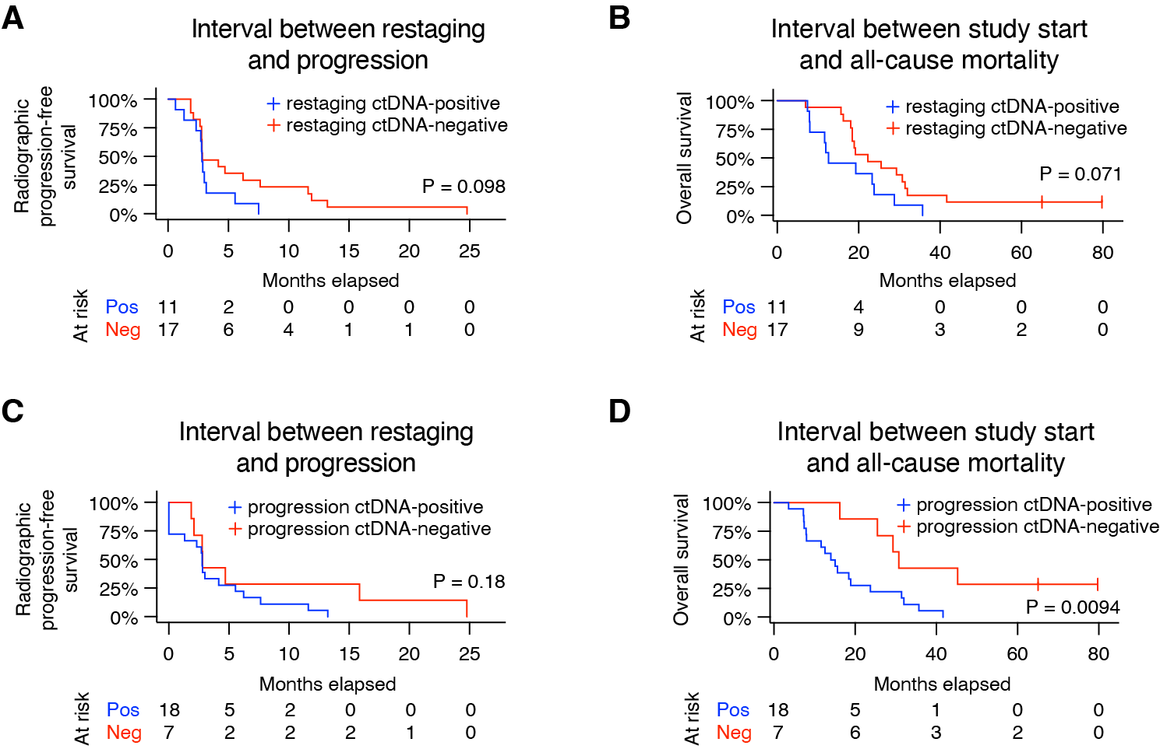

Supplementary Figure 2. Survival estimates stratified by ctDNA detection. Kaplan-Meier estimates of radiographic progression-free survival (A,C) and overall survival (B,D) stratified by the detection or absence of ctDNA at restaging (A–B) or progression (C–D). P values are determined using log-rank test.

Supplementary Figure 3

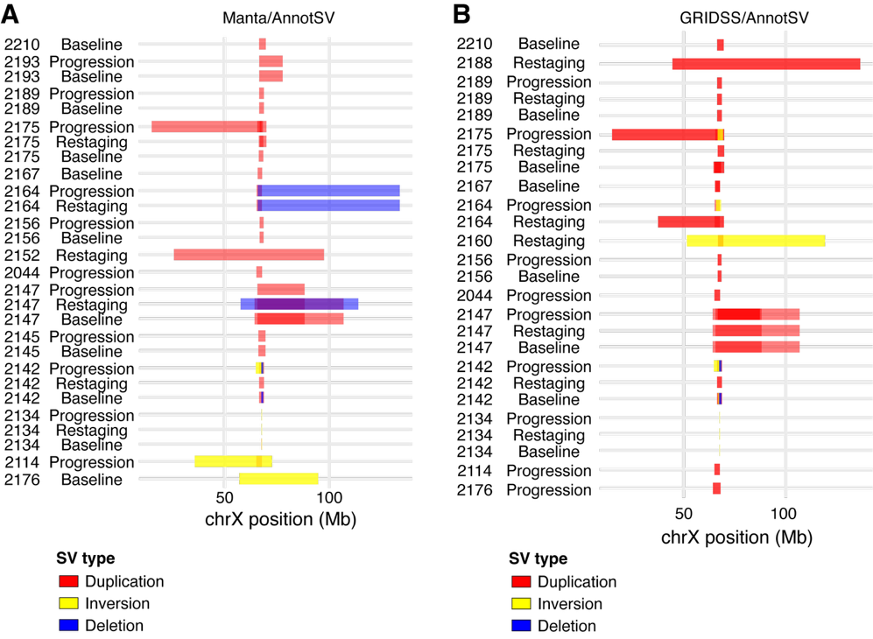

Supplementary Figure 3. Structural variants (SVs) involving the Androgen Receptor gene (AR). AnnotSV was used to merge and annotate SVs involving AR in each ctDNA-positive sample, following discovery using Manta (A) or GRIDSS/Purple (B).

Supplementary Figure 4

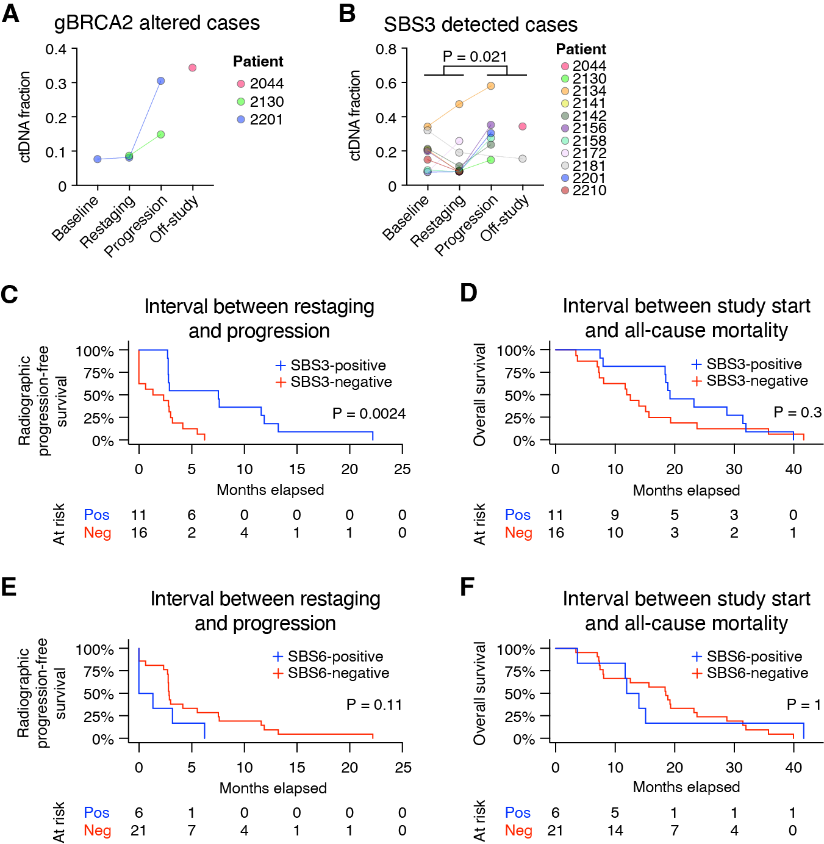

Supplementary Figure 4. Prevalence of DNA repair defect mutational signatures. (A) ctDNA fraction is plotted for each plasma timepoint from patients harboring germline deleterious alterations to BRCA2. (B–F) SigProfileExtractor was used identify and quantify single-base substitution (SBS) signatures from somatic mutations called in each cfDNA sample. (B) ctDNA fraction is plotted for each plasma timepoint from patients where at least one ctDNA samples was positive for SBS3. P value was determined using Mann-Whitney U test between the average ctDNA fraction values of sensitive (baseline/restaging) vs. resistant (progression/off-study) samples. (C–F) Kaplan-Meier estimates of radiographic progression-free survival (C,E) and overall survival (D,F) stratified by the detection of SBS3 (C–D) or SBS6 (E–F) in plasma at any timepoint. P values are determined using log-rank test.
Supplementary Figure 5

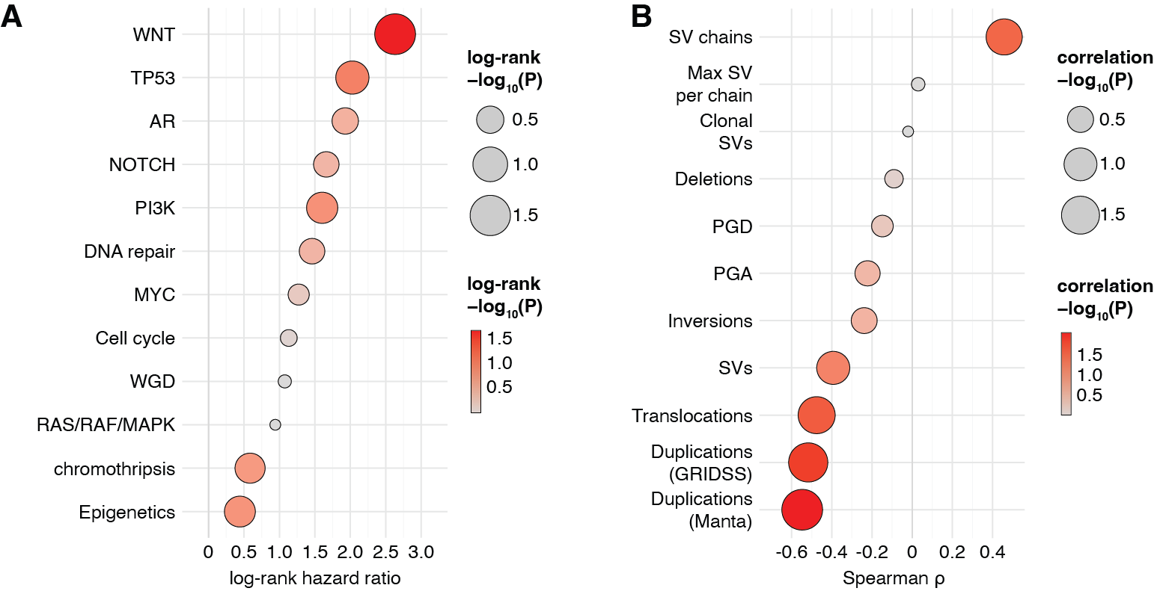

Supplementary Figure 5. Aggregation of gene-level somatic events into pathways and genome-wide observations and their association with overall survival. (A) Determined by log-rank test. (B) Determined by Spearman correlation.

Supplementary Figure 6

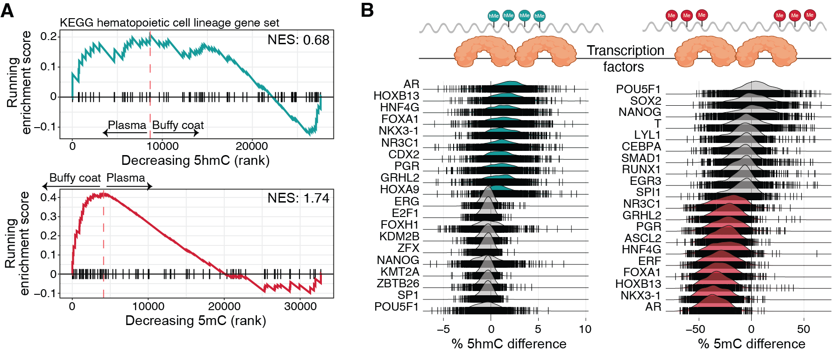

Supplementary Figure 6. Comparison of plasma cfDNA against buffy coat vs iPSC controls. (A) Gene set enrichment analysis of six high-purity plasma cfDNA vs. buffy coat gDNA, ranked on the modified cytosine difference for the KEGG hematopoietic cell lineage gene set. (B) Ridge plots illustrating the top and bottom 10 ranked candidate transcription factors (TFs) based on TF binding site differential hydroxymethylation (left) or methylation (right), comparing plasma cfDNA vs. iPSC gDNA.

Supplementary Figure 7

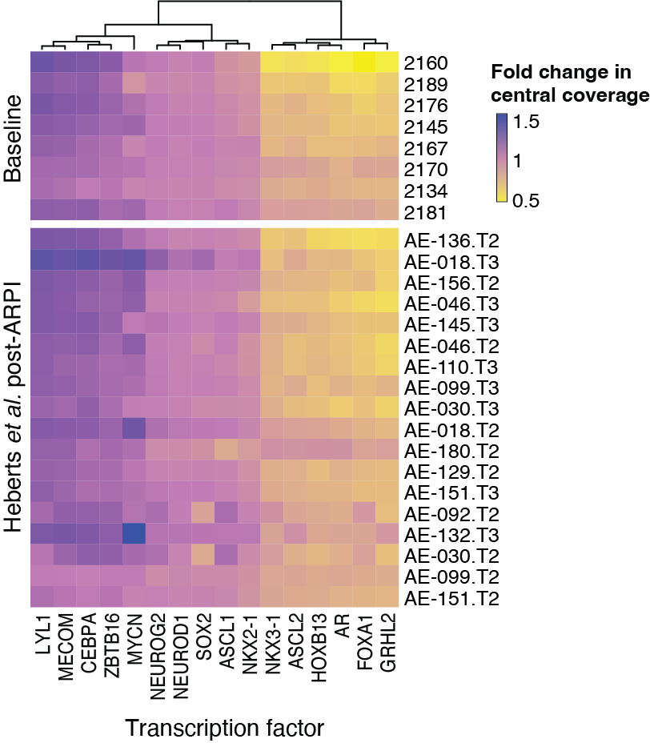

Supplementary Figure 7. Fragmentomic-based subtyping of prostate tumors. Heatmap depicting the unadjusted central coverage of 8 high-purity baseline ctDNA samples (top) and 18 ctDNA samples from patients after receiving AR pathway inhibitors (ARPI) against a panel of 16 lineage-defining transcription factors.

Supplementary Figure 8

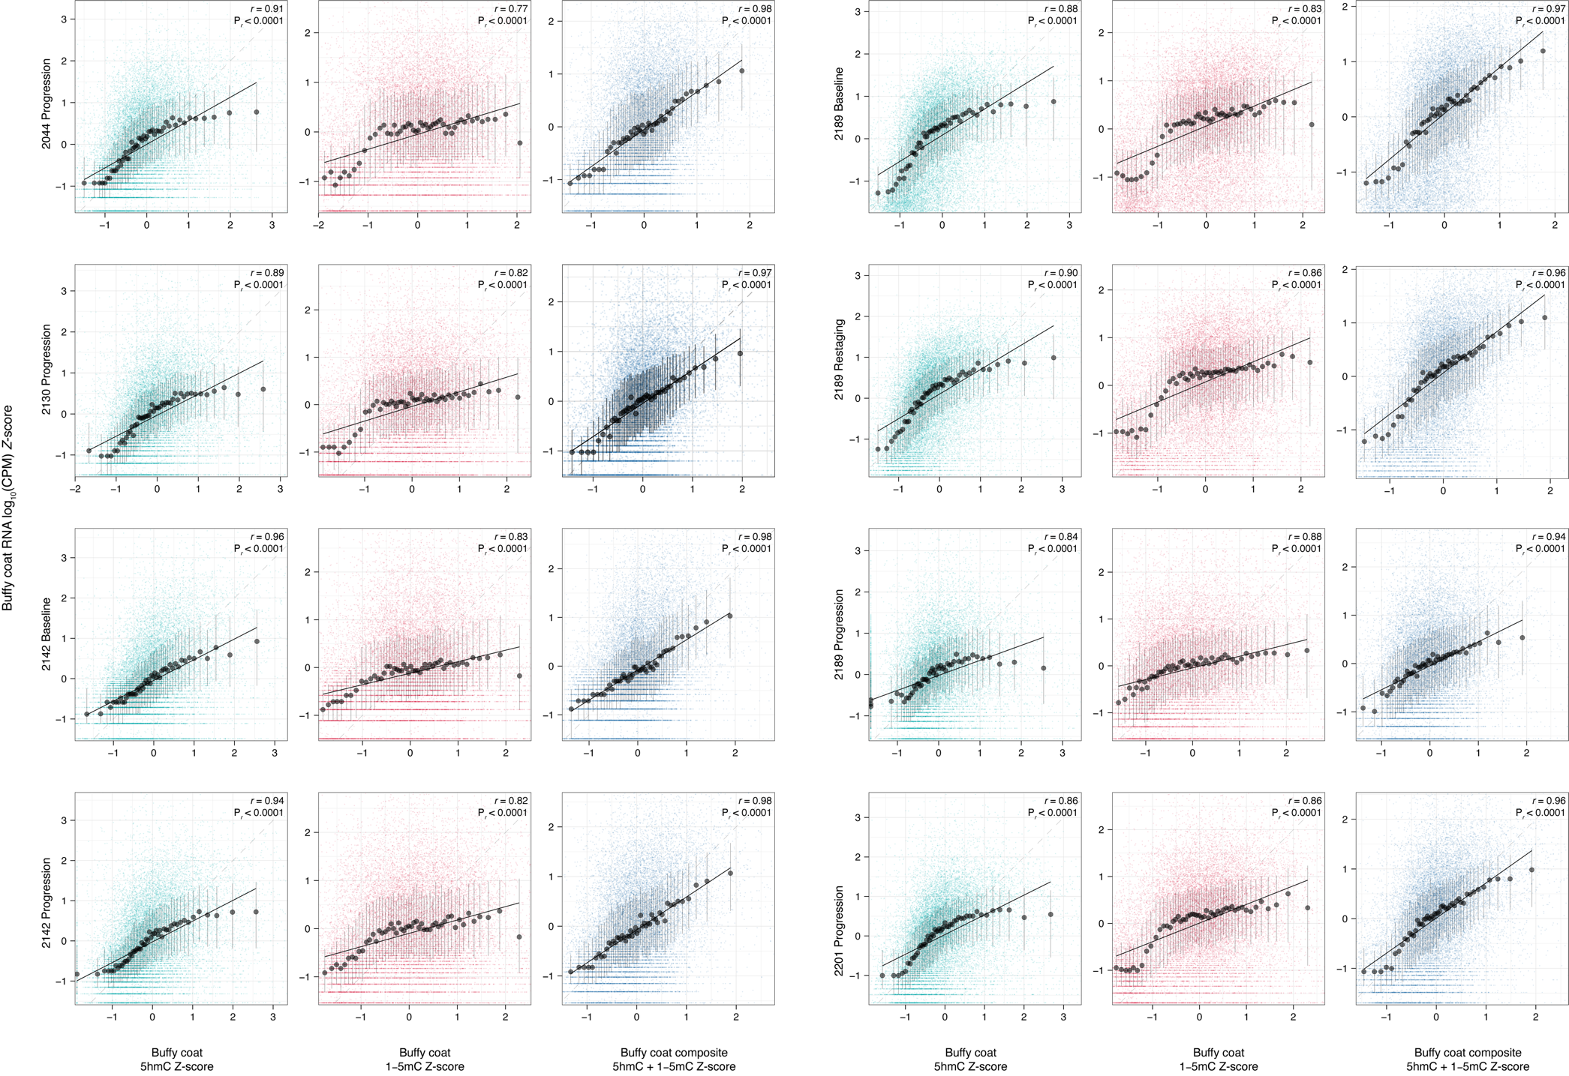

Supplementary Figure 8. Association of per-gene methylation and RNA-seq transcript abundance. Scatter plots depicting the positive correlation between normalized expression from RNA-seq and %5hmC gene body hypermethylation Z-score, inverse 5mC (1−%5mC) promoter hypomethylation Z-score, or a composite or %5hmC and 1−%5mC Z-score for 8 buffy coat samples. Pearson correlation analyses r values are shown with their respective P values. Points show the median x and y bin for all genes ranked by each Z-score metric and partitioned into 50 equal-sized quantile bins. Error bars depict the interquartile range. r its and associated two-sided P value were computed using the binned medians. Black lines represent linear regressions. Individual genes are also shown.

Supplementary Figure 9

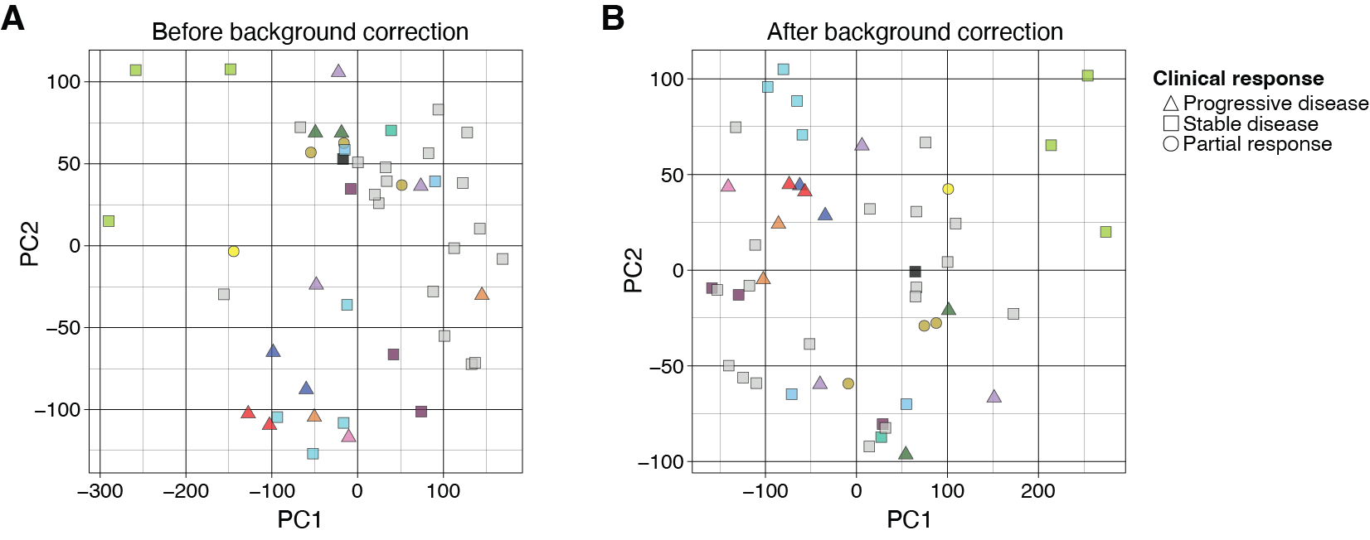

Supplementary Figure 9. Principal component analysis based 5mC promoter hypomethylation. Genome-wide promoter hypomethylation, calculated as (1−%5mC), was projected into two dimensional space by the first to principal components. Samples are colored by patient ID (for selected cases), either (A) before or (B) after background correction by subtraction of gene-level aggregates of (1−%5mC) from the 9 buffy coat samples.

Supplementary Figure 10

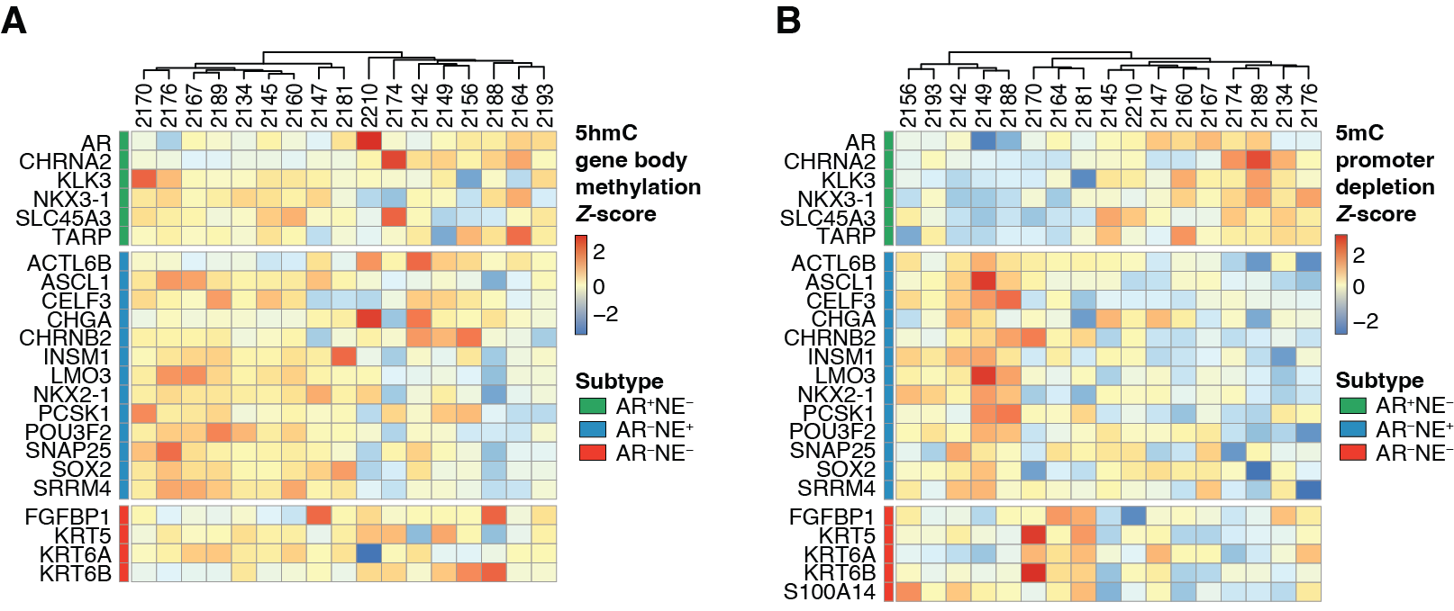

Supplementary Figure 10. Tumor subtyping based on gene methylation. Heatmap depicting gene-level expression estimates of prostate cancer subtype-defining genes based on the relative (Z-score) of (A) 5hmC gene body hypermethylation or (B) 5mC promoter hypomethylation (calculated as 1−%5mC), per gene. Positive Z-scores are predictive of greater gene expression. Variation in S100A14 was used for subtyping based on 5mC, but was not detected in 5hmC gene body quantification.

Supplementary Figure 11

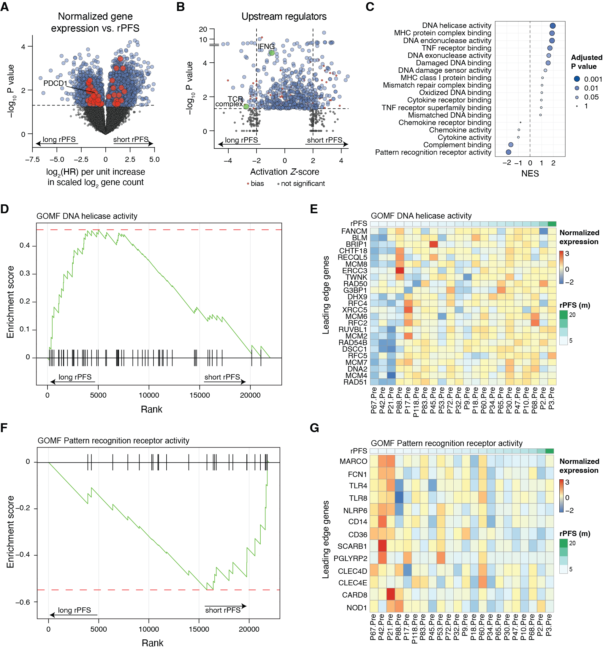

Supplementary Figure 11. Baseline tumor intrinsic patterns of gene expression associated with treatment response in ovarian cancer. (A) Volcano plot depicting the association of normalized gene expression with rPFS by Cox proportional hazards analysis. Red indicates genes whose inferred differential regulation is consistent with TCR Complex upregulation in patients with longer rPFS. (B) Statistically significant gene Z-scores (P < 0.05) from Cox PH analysis depicted in (A) were used to infer upstream pathway regulators using the upstream regulator module of Ingenuity Pathway Analysis. A positive Z-score is associated with the risk of pathway activation in patients with shorter rPFS. (C) Gene set enrichment analysis using rPFS as a continuous variable assessed against a curated panel of gene ontology molecular function (GOMF) terms. A positive NES is associated with longer rPFS. (D, F) Mountain climber plot of the top GOMF terms, DNA helicase activity (D) and Pattern recognition receptor activity (F), associated with longer rPFS. (E, G) Heatmaps of individual gene expression values for the leading edge genes of the analyses depicted in (D and F).

Supplementary Figure 12

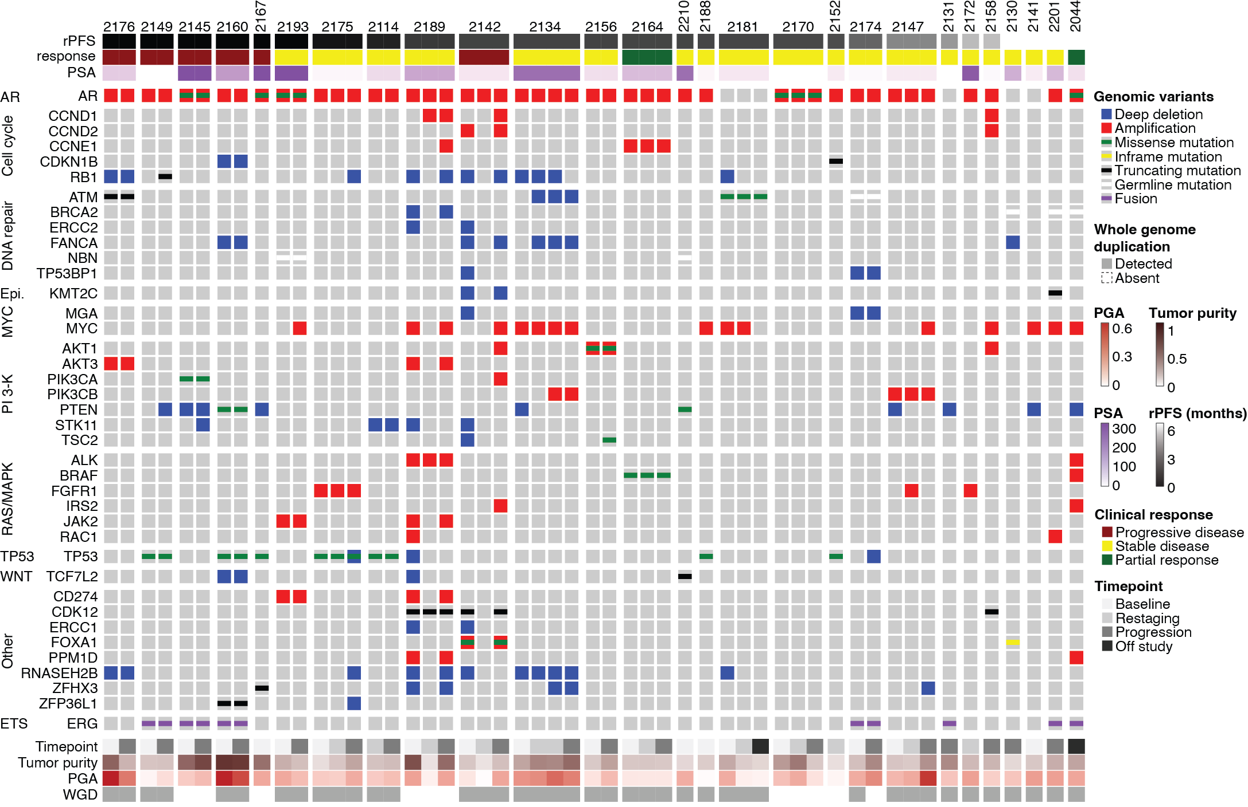

Supplementary Figure 12. Identification of genomic alterations in ctDNA-positive plasma at all timepoints. Genes mutated in at least two cases are shown; samples below 10% ctDNA fraction are not shown.

Supplementary Figure 13

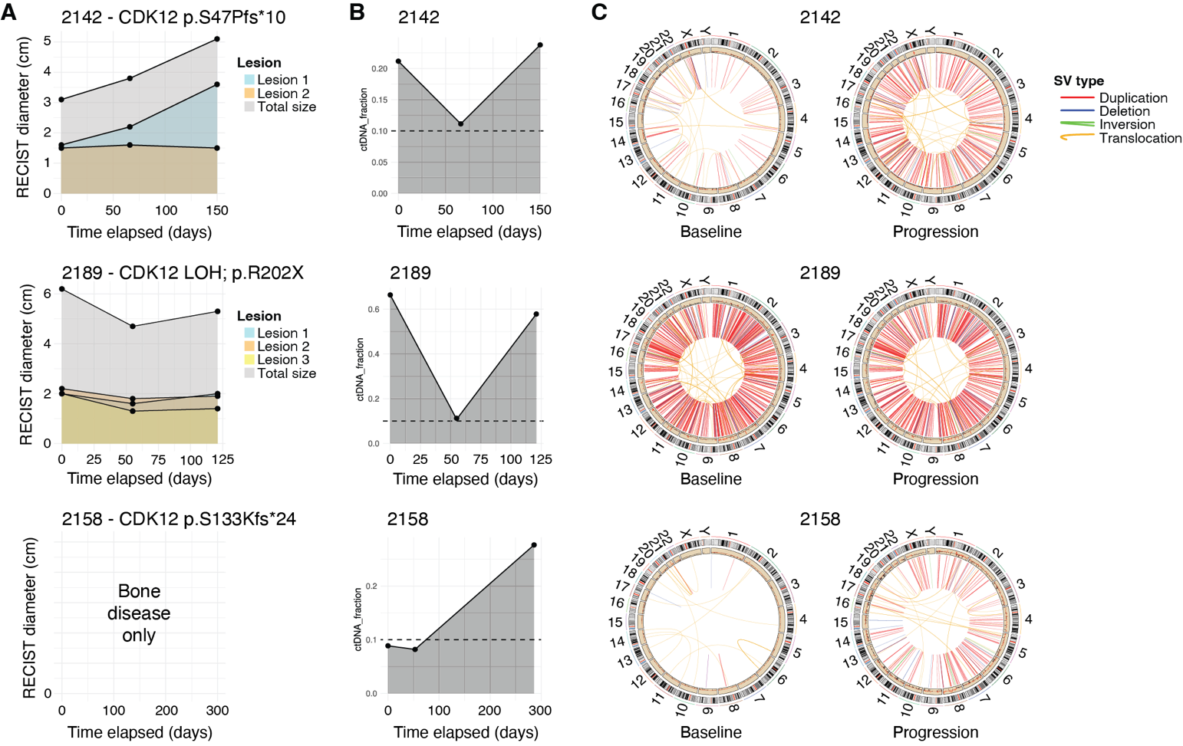

Supplementary Figure 13. Clinicogenomic profiling of cases harboring CDK12-mutated ctDNA. Case 2142 is shown at the top, case 2189 in the middle, and case 2158 at the bottom. (A) Imaging dynamics as a function of treatment response for cases 2142 and 2189. Case 2158 was predominantly bone disease and not measurable using RECIST criteria. (B) ctDNA fraction is shown for three CDK12-mutated cases. Dashed line represents ctDNA positivity cutoff at 10% ctDNA fraction. (C) CIRCOS plots showing genomic structural rearrangements in each sample at baseline (left) and upon progression (right).

Supplementary Figure 14

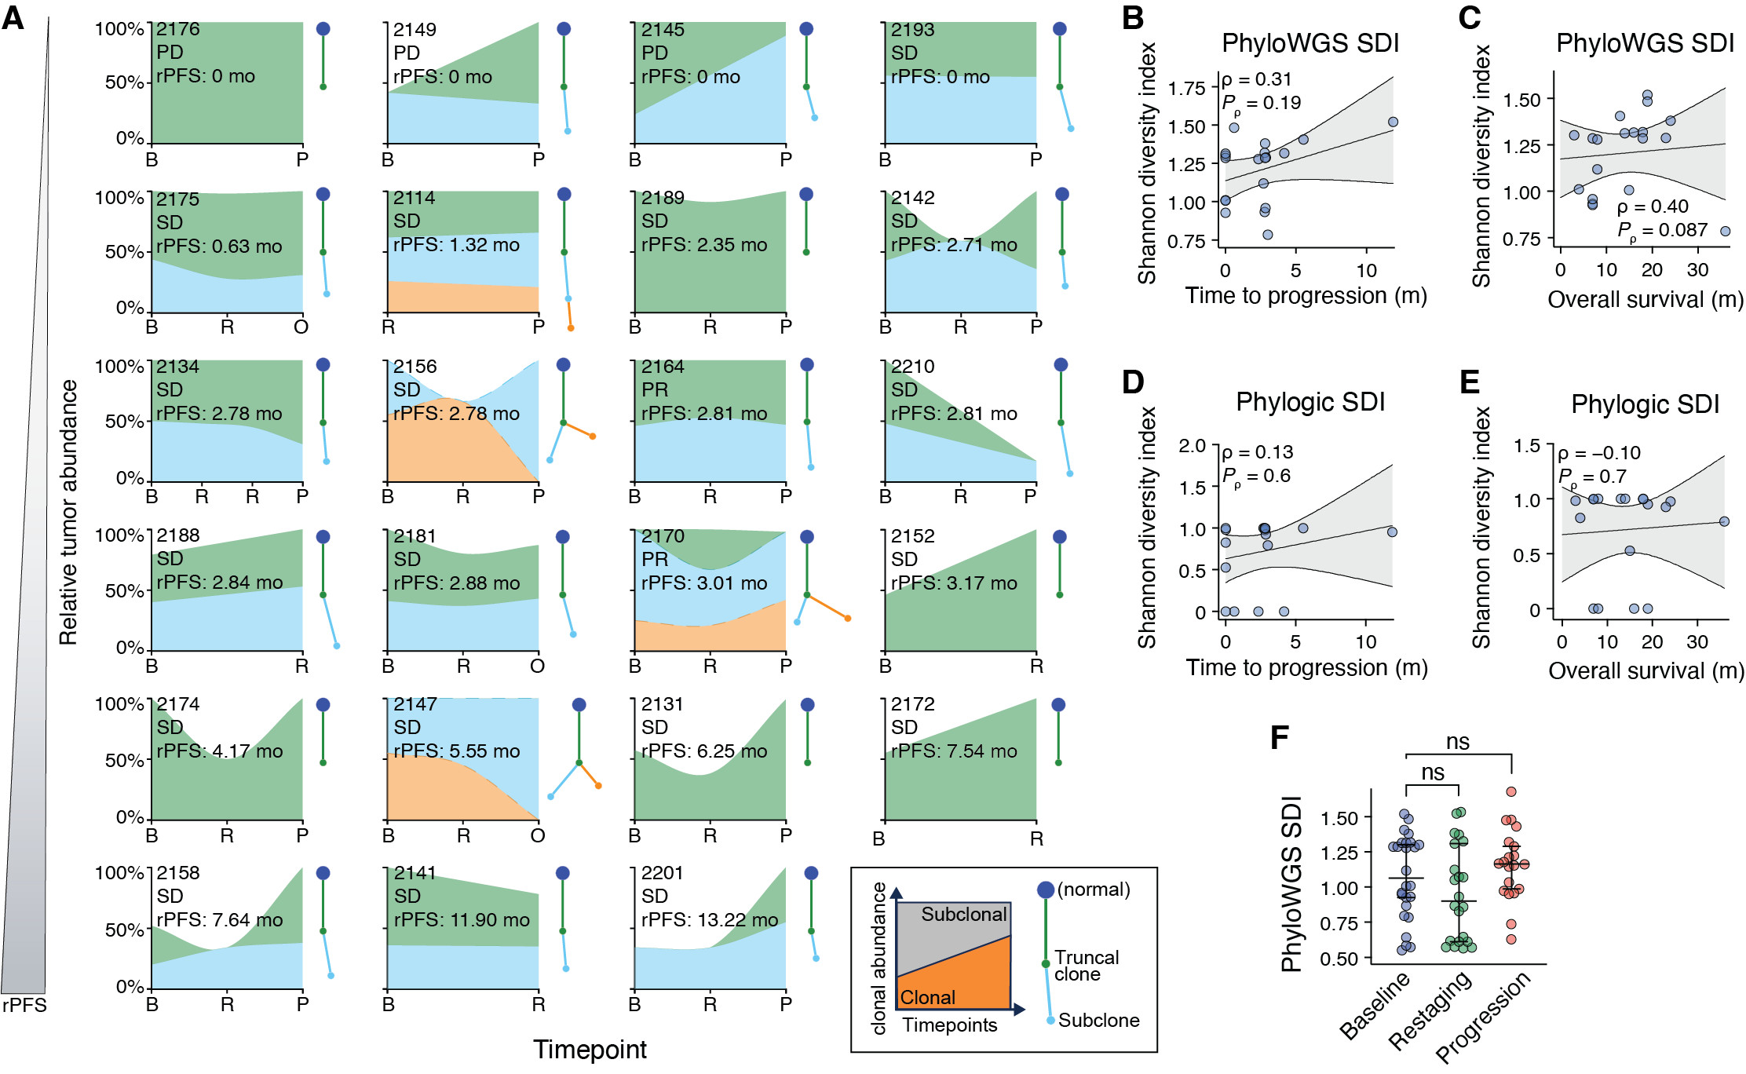

Supplementary Figure 14. Clonal composition of each tumor. (A) Phylogenetic reconstruction (Phylogic) and depiction of relative subclonal abundance for each case in which more than one cfDNA sample was collected and at least one timepoint was ctDNA-positive. x-axis depicts each timepoint; B: baseline; R: restaging; P: progression; O: off-study. Cases are arranged by rPFS. PD: Progressive disease; SD: stable disease; PR: partial response. (B–E) Correlation of the Shannon diversity index (SDI) for each ctDNA-positive patient at baseline calculated using PhyloWGS (B–C) or Phylogic (D–E) plotted against the time to radiographic progression (B, D) or overall survival (C, E). Nonparametric Spearman correlation analyses ρ values are shown with their respective P values. Lines and bands represent linear regression lines and 95% confidence intervals, respectively. (F) PhyloWGS-derived SDI of each ctDNA sample grouped by timepoint. P values shown were determined using Welch’s ANOVA test with Dunnett’s multiple comparisons test. Bars depict median with whiskers showing the 95% confidence interval.

Supplementary Figure 15

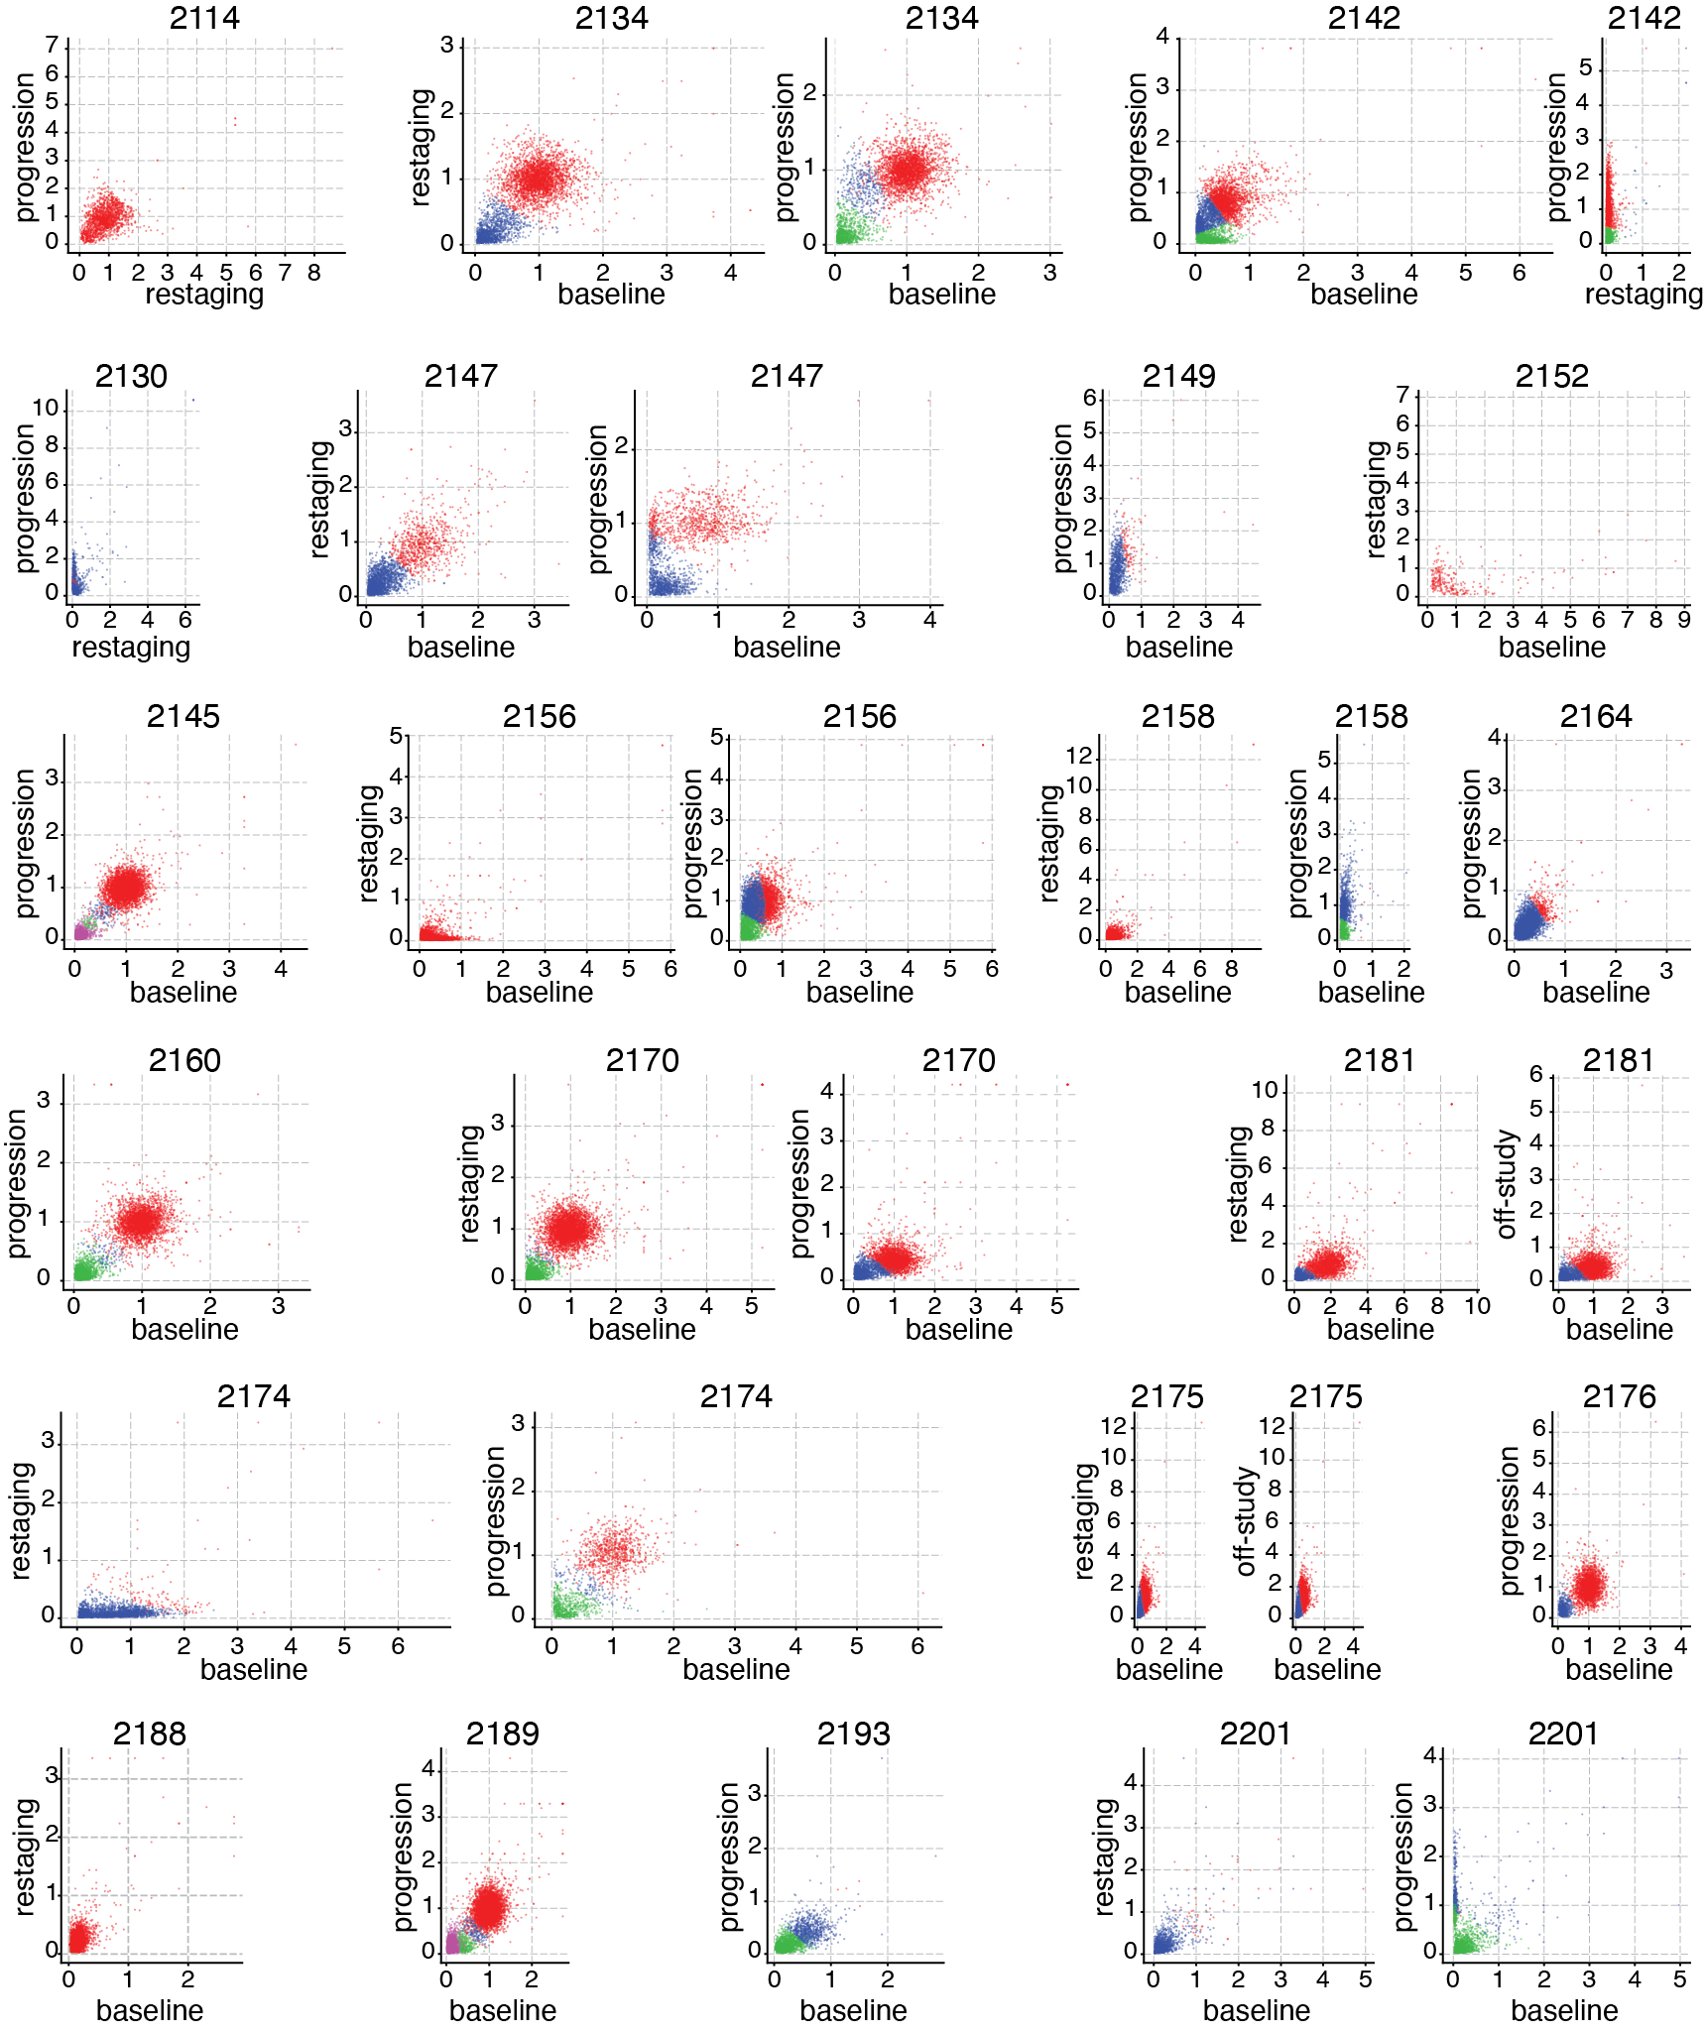

Supplementary Figure 15. Multidimensional clustering of mutation cancer cell fractions across temporally distinct plasma samples. The cancer cell fraction (CCF) for each mutation is shown for pairs of ctDNA samples, following subclonal reconstruction. Mutation clusters are colored as clone or subclone. Each comparison depicts Baseline (when available) vs. each other timepoint. Other timepoints are shown if baseline was not collected or if model fitting failed to compare baseline vs. one of the other timepoints. Patients with only one timepoint of plasma collection are omitted from this figure. Axis scales are generated automatically to encompass 99.9% of mutations.

