Supplementary Material

Disaster Type correction
For some reports, the IFRC does not provide a disaster type. In these cases, we identify the disaster type through a keyword search, first in the report title and, if no match is found, in the first 200 characters of the text extracted from the report. The classification is performed according to the following mapping:
Disaster Type | Keywords Used for Identification
Flood | flood, flash flood, pluvial
Earthquake | earthquake, quake, seismic
Cyclone | cyclone
Hurricane | hurricane
Typhoon | typhoon
Storm Surge | storm surge
Drought | drought
Epidemic | epidemic, outbreak
Cholera | cholera
Dengue | dengue
Ebola | ebola
Zika | zika
Meningitis | meningitis
Yellow Fever | yellow fever
Polio & Measles | polio, measles
Food Insecurity | food insecurity, famine
Population Movement | displaced, migration, refugee
Civil Unrest | unrest, violence, conflict
Complex Emergency | complex emergency, crisis
Fire | fire
Urban Fire | urban fire
Cold Wave | cold, winter
Heat Wave | heat
Extreme Winter Condition | snow, freeze
Landslide | landslide, mudslide
Volcanic Eruption | volcano, eruption
Tsunami | tsunami
Transport Accident | crash, accident
Industrial Explosion | explosion

Report sections selection
During manual review of some of the reports, we identified repeated patterns, allowing us to extract specific sections that contain impact-related information. The search begins at the start of each report and is done sentence by sentence. Once a keyword from headers_drop is detected, the search stops, and the section header is set to end at the conclusion of that sentence.
However, because report formats may vary, it is important to ensure that no impact information is overlooked. If a headers_keep keyword appears within a sentence that would otherwise be excluded, the header boundary is adjusted and extended to include the sentences that follow this header, until a stop header is found. If no stop header is found, the remainder of the report is kept.
headers_drop = [
"coordination and partnerships",
"operational strategy",
"red cross red crescent action",
"operational developments",
"summary of response",
"summary of the response",
"the response so far",
"previous operations",
"current national society actions",
"national society actions",
"summary of measures taken by the national society",
"detailed operation plan",
"summary of the current response",
"summary of current response",
"Overview of the host National Society and ongoing response",
"Overview of Operating National Society Response Action",
"financial status",
"appeal history",
"targeting",
"planned operations",
"IFRC Network Actions Related To The Current Event",
"ICRC Actions Related To The Current Event",
"Other Actors Actions Related To The Current Event",
"Overall objective of the operation",
"Operation strategy rationale",
"Targeting Strategy",
"Who was targeted by this operation?",
"Explain the selection criteria for the targeted population",
"Total Targeted Population",
"Risk and Security Considerations",
"Please indicate about potential operation risk for this operations and mitigation actions",
"Please indicate any security and safety concerns for this operation",
"Implementation",
"Narrative description of achievements",
"Lessons Learnt",
"National Society Strengthening",
"Financial Report",
"About Support Services",
"How many staff and volunteers will be involved in this operation. Briefly describe their role.",
"If there is procurement, will it be done by National Society or IFRC?",
"How will this operation be monitored?",
"Please briefly explain the National Societies communication strategy for this operation",
]

headers_keep = [
"operation summary",
"scope and scale",
"A. situation analysis",
"description of the crisis",
"what happened, where and when",
"what happened, where and when?",
"description of the emergency",
"description of the disaster",
"description of disaster",
"description of the event",
"the situation",
"summary",
"the disaster",
"situation overview",
"needs (gaps) identified",
]

Control impact subtype

Impact Maintype | Impact Subtype | Description
Human | Targeted People | The number of people targeted by recovery or response measures after the event.
Human | Assisted People | The number of people assisted by recovery or response measures after the event.
Economy & Culture | DREF Allocation & Funding requirements | The DREF allocation or funding requirements for the event in CHF or other currency.

Impact subtype - division
Impact Maintype | Impact Subtype | Impact Subtype divided | Description
Infrastructure | Transportation | Road Infrastructure | Roads and road infrastructure (e.g. bridges, highways..) impacted by a hazard.
Infrastructure | Transportation | Other Transportation Infrastructure | Transportation infrastructure, other than roads, impacted by a hazard. For example : Railways, airport, ferries, cars…
Infrastructure | Transportation | Mobility and Access to Transport | People losing the capacity to move safely and efficiently between locations.
Infrastructure | Water, Sanitation, and Hygiene Infrastructure | Water, Sanitation, and Hygiene Infrastructure | Number of water, sanitation, and hygiene infrastructure such as sewage networks, drainage systems, wastewater treatment plants, etc. impacted by a hazard.
Infrastructure | Water, Sanitation, and Hygiene Infrastructure | Access to Water, Sanitation, and Hygiene | People losing access to water, sanitation, and hygiene services.
Infrastructure | Water, Sanitation, and Hygiene Infrastructure | Water Quality and Availability | People losing safe, clean, and consistent supply of water for drinking, sanitation, and other essential uses.
Infrastructure | Healthcare | Healthcare Infrastructure | Number of healthcare infrastructure such as hospitals, healthcare centers, pharmacies, clinics, etc. impacted by a hazard.
Infrastructure | Healthcare | Access to Healthcare | People losing the ability to obtain needed medical services, including preventative care, emergency services …
Infrastructure | Education | Education Infrastructure | Number of education infrastructures such as schools, universities, etc. impacted by a hazard.
Infrastructure | Education | Access to Education | People losing the ability to attend educational institutions and receive instruction.
Infrastructure | Agriculture and Access to Food | Access to Food | People losing access to a secure food supply
Infrastructure | Agriculture and Access to Food | Crop Production and Forestry | Number of crops, agricultural production and forest impacted by a hazard
Infrastructure | Agriculture and Access to Food | Affected Livestock and Animals | Total number of animals, including terrestrial and aquatic species, impacted by the hazard. (e.g. loss, death, perished animals or fishes)
Infrastructure | Power and Energy Production | Power and Energy Production Infrastructure | Number of energy production infrastructures such as power plants, turbines, grids, pipelines, etc., impacted by a hazard.
Infrastructure | Power and Energy Production | Access to Power and Energy | Any identified impact on service access which cannot be associated with the previous impactSubtypes.
Infrastructure | Undefined Infrastructure and Service Access | Undefined Infrastructure | Any identified impact on infrastructure where the type of infrastructure impacted is not clearly defined, e.g. critical infrastructure, public infrastructure, etc.
Infrastructure | Undefined Infrastructure and Service Access | Undefined Service Access | Any identified impact on service access where the type of service impacted is not clearly defined, e.g. access to basic services
Infrastructure | Undefined Infrastructure and Service Access | Other Service Access | Any identified impact on service access where the type of service impacted is not clearly defined, e.g. access to basic services

Geocoding process
In order to convert textual location strings to polygons, we first compute the Levenshtein similarity³⁵ between the input location string and all OSM address keys, with and without administrative descriptors and across rotated word orders. If OSM does not return any location, the flag_nomin_no_result is raised. If a perfect match (similarity of 1.0) is found, the search stops; otherwise, we keep the address key with the highest similarity above a similarity threshold of 0.5. This step identifies the most likely location name and administrative level, and corrects spelling variations introduced by the LLM. If no location with a similarity above the threshold is found, the flag_nomin_sim_below_th is raised. The corrected name is then matched to the corresponding Natural Earth or GAUL polygon at the identified administrative level.
If matching with a polygon fails, we apply several fallback strategies. First, the location name may differ from the official GAUL designation, so we iterate over other OSM address keys at the same administrative level and attempt to match each to a polygon. If this fails, we translate the location name into the country’s official languages and widely spoken languages (French, Spanish, German) and retry the match. If this translation results in the identification of the final corrected location, we raise the flag flag_nomin_translate. If no textual match is found, we use the geographic object returned by OSM and search for a corresponding GAUL polygon by testing for intersections at the identified administrative level, which raises the flag_osm_polygon. If all attempts fail, we repeat the procedure at progressively coarser administrative levels until a match is found.

Guidelines manual labelling
Guidelines for manual labelling are available as an additional supplementary material file

Manually labelled reports
The following list of reports has been selected at random for manual labelling

appealCode | reportDate | reportLink
MDRBD022 | 18/07/2019 00:00 | https://adore.ifrc.org/Download.aspx?FileId=247507
MDR55001 | 31/03/2017 00:00 | https://adore.ifrc.org/Download.aspx?FileId=160398
MDRYE011 | 03/08/2022 00:00 | https://adore.ifrc.org/Download.aspx?FileId=558578
MDREC019 | 12/4/2022 00:00 | https://adore.ifrc.org/Download.aspx?FileId=517350
MDRIQ014 | 27/12/2021 00:00 | https://adore.ifrc.org/Download.aspx?FileId=480634
MDRID013 | 20/09/2021 00:00 | https://adore.ifrc.org/Download.aspx?FileId=448035
MDRPH036 | 31/05/2020 00:00 | https://adore.ifrc.org/Download.aspx?FileId=309056
MDRIR009 | 20/6/2025 00:00 | https://go-api.ifrc.org/api/DownloadFile/R67950/MDRIR009FR
MDRJO003 | 17/06/2025 00:00 | https://go-api.ifrc.org/api/DownloadFile/89672/MDRJO003fr
MDRPK026 | 28/03/2025 00:00 | https://go-api.ifrc.org/api/DownloadFile/88815/MDRPK026dfr
MDRSD034 | 17/03/2025 00:00 | https://go-api.ifrc.org/api/DownloadFile/90654/MDRSD034du1
MDRVU012 | 05/02/2025 00:00 | https://go-api.ifrc.org/api/DownloadFile/89890/MDRVU012OU1
MDRAF014 | 31/12/2024 00:00 | https://go-api.ifrc.org/api/DownloadFile/87310/MDRAF014dfr
MDRMZ024 | 02/10/2024 00:00 | https://go-api.ifrc.org/api/DownloadFile/88076/MDRMZ024eu2
MDRDZ011 | 22/09/2024 00:00 | https://go-api.ifrc.org/api/DownloadFile/88864/MDRDZ011do
MDRCM039 | 13/9/2024 00:00 | https://go-api.ifrc.org/api/DownloadFile/88788/MDRCM039do
MDRBJ019 | 07/09/2024 00:00 | https://go-api.ifrc.org/api/DownloadFile/88663/MDRBJ019do
MDRNG041 | 06/09/2024 00:00 | https://go-api.ifrc.org/api/DownloadFile/88650/MDRNG041do
MDRRW022 | 05/09/2024 00:00 | https://go-api.ifrc.org/api/DownloadFile/84424/MDRRW022dfr
MDRUG050 | 30/08/2024 00:00 | https://go-api.ifrc.org/api/DownloadFile/88608/MDRUG050du1
MDRS2001 | 05/08/2024 00:00 | https://go-api.ifrc.org/api/DownloadFile/88274/MDRS2001ou1
MDRRS015 | 10/05/2024 00:00 | https://go-api.ifrc.org/api/DownloadFile/84780/MDRRS015dfr
MDRKE058 | 26/04/2024 00:00 | https://go-api.ifrc.org/api/DownloadFile/87656/MDRKE058eu3
MDRZM022 | 28/03/2024 00:00 | https://go-api.ifrc.org/api/DownloadFile/87422/MDRZM022do
MDRCO023 | 13/03/2024 00:00 | https://go-api.ifrc.org/api/DownloadFile/84331/MDRCO023fr
MDRTJ035 | 28/12/2023 00:00 | https://go-api.ifrc.org/api/DownloadFile/84135/MDRTJ035dfr
MDRDZ008 | 10/11/2023 00:00 | https://go-api.ifrc.org/api/DownloadFile/R67948/MDRDZ008fr
MDRCM036 | 23/10/2023 00:00 | https://go-api.ifrc.org/api/DownloadFile/85568/MDRCM036do
MDRLB013 | 03/10/2023 00:00 | https://go-api.ifrc.org/api/DownloadFile/83724/MDRLB013fr
MDRUY004 | 21/07/2023 00:00 | https://go-api.ifrc.org/api/DownloadFile/84891/MDRUY004ou2
MDRMN017 | 08/03/2023 00:00 | https://go-api.ifrc.org/api/DownloadFile/83842/MDRMN017OU1
MDRSV012 | 25/06/2019 00:00 | https://adore.ifrc.org/Download.aspx?FileId=243784
MDRGW003 | 24/04/2019 00:00 | https://adore.ifrc.org/Download.aspx?FileId=237001
MDRCN006 | 15/02/2019 00:00 | https://adore.ifrc.org/Download.aspx?FileId=233003
MDRPG008 | 24/11/2018 00:00 | https://adore.ifrc.org/Download.aspx?FileId=219337
MDRMY003 | 02/11/2017 00:00 | https://adore.ifrc.org/Download.aspx?FileId=176204
MDRKZ010 | 01/04/2022 00:00 | https://adore.ifrc.org/Download.aspx?FileId=510557
MDRPK018 | 30/11/2020 00:00 | https://adore.ifrc.org/Download.aspx?FileId=363702
MDRHU005 | 29/11/2016 00:00 | https://adore.ifrc.org/Download.aspx?FileId=152707

The reports selected for manual labelling cover all types of hazards(figure S1) and such over all the continents (figure S2).
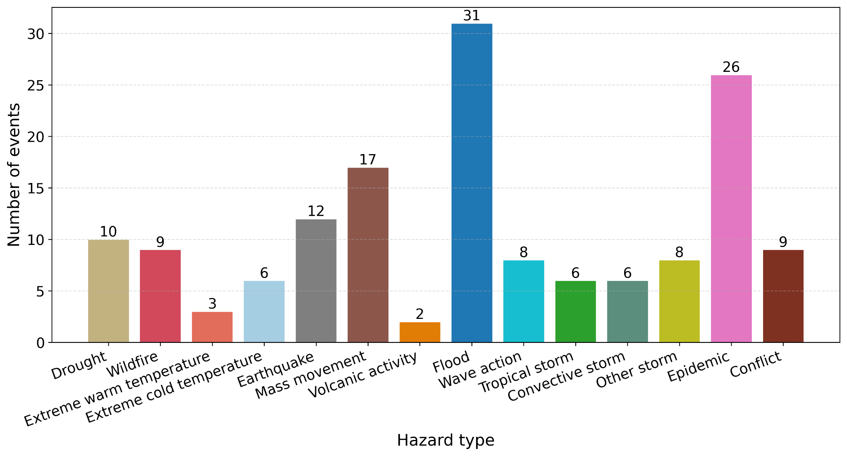
Figure S1: Counts of manually labelled events by hazard type. Colours are ordered according to the type of hazard. 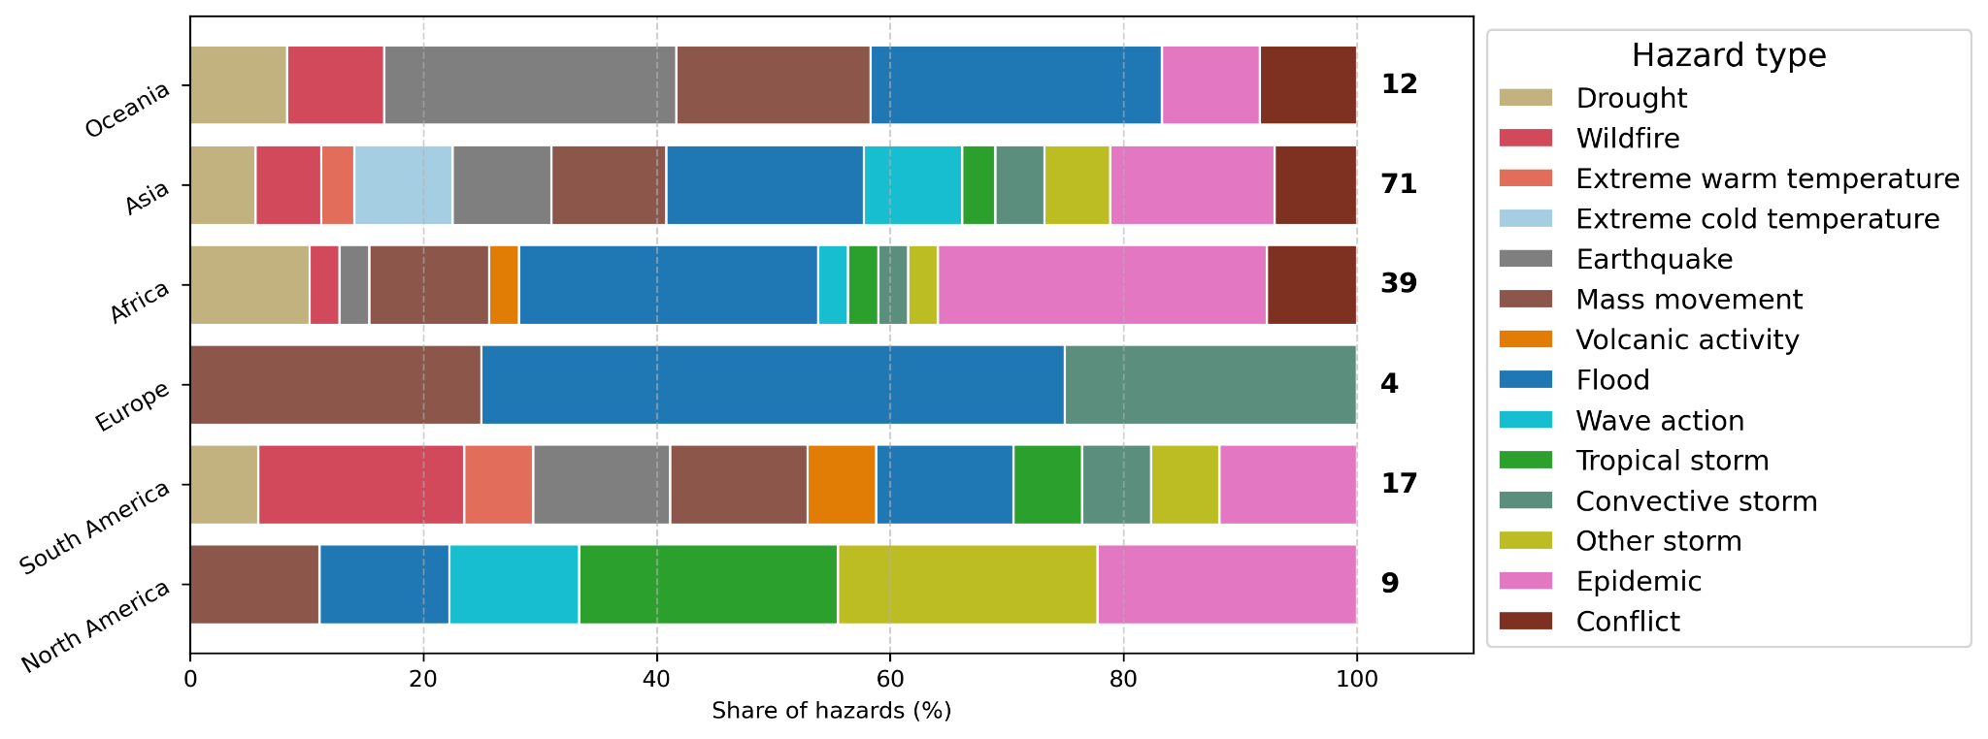
Figure S2 : Share of hazards (in %) to which impacts are associated, for each continent, for the manually labelled reports. Colours are ordered according to the type of hazard.

Prompts

Prompts are detailed in the code archive under the file /src/prompts_impacts.py

Matching algorithm for internal validation
We derive a matching algorithm that allows us to match each manually-labelled row to an equivalent row in the LLM-extracted data (Section Validation with manually labelled data). The algorithm follows the steps:
- Each labelled and extracted rows are grouped per event (appealCode) to avoid matching unrelated events. We further separate between rows describing quantitative (non-null impactValue) vs. qualitative (null impactValue) to ensure quantitative impacts are only matched with quantitative and inversely.
- Each extracted and labelled row is vectorised. Vectorisation corresponds to the process of turning each categorical variable of the row into a vector spanning over N-dimensions, N being the dimension of the categorical variable. The categorical variables considered for matching are iso3_code, impactSubtype, impactUnit, damageDegree, hazards, startYear, startMonth, startDay, endYear, endMonth, and endDay.
- For each possible pair of extracted-labelled rows, a cosine similarity between the corresponding categorical variables is computed. For the geometry column, the intersection-over-union is used: $IoT(x,y) = \frac{∩(x,y)}{∪(x,y)}(1)$ . For the impactValue column, we define our error metric as follows: $impactValueSim = 1-max(|\frac{{(v}_{1 }-v_{2})}{v_{1}}|,|\frac{{(v}_{2 }-v_{1})}{v_{2}}| ) if max(|\frac{{(v}_{1 }-v_{2})}{v_{1}}|,|\frac{{(v}_{2 }-v_{1})}{v_{2}}| ) ≤ 1 else 0 (2)$This error metric scores 1 in case of perfect value equality, and 0 when the relative difference between the two values in absolute terms is greater than 100%. The metric is symmetric with regard to which of the two assessed values is taken as the denominator.
- Possible pairs are made by maximising a weighted sum of the similarity of the matching variables for each extracted-labelled row pair. Note that we keep ties if the maximum weighted aggregated similarity value is shared by more than one possible pair.

Next, we use the pairing algorithm described above to match the extracted to the manually-labelled impacts. We define a correct match as a pair for which the weighted similarity exceeds 0.5. Weights are defined for each matching variable and are selected so that quantitative pairs that show a perfect match for at least two of the impactSubtype, impactUnit, or impactValue variables get a similarity score of at least 0.5. For qualitative impacts, the weights are selected so that pairs that match the impactSubtype and geometry variables perfectly receive a similarity score of at least 0.5. Below this value of 0.5, we consider the two paired impacts to be too dissimilar to likely represent the same impact. For quantitative impacts, we add a constraint on the error of the impactValue, so that only pairs for which the difference between the two impactValues is less than 5% are considered as correct matches.

Sensitivity analyses
We repeat identical queries, test multiple language models, and evaluate the stability of the outputs to assess the sensitivity, robustness and transferability of the approach.
We repeat three extractions with identical parameters and a fixed random seed to test the determinism of the selected meta-llama_llama-4-scout-17b-16e-instruct model. Figure S3 shows the precision and recall for these repeated extractions. Results show that the effects of the stochastic behaviour of the LLM lead to stable precision and recall across the simulations for both qualitative and quantitative data. The highest difference of 0.05 is observed for the precision of the qualitative data. This shows that the output of the LLM remains partly non-deterministic even when a random seed is fixed. Overall, however, the influence of this randomness on the precision and recall scores is limited, indicating that the extraction performance remains stable across repeated runs.

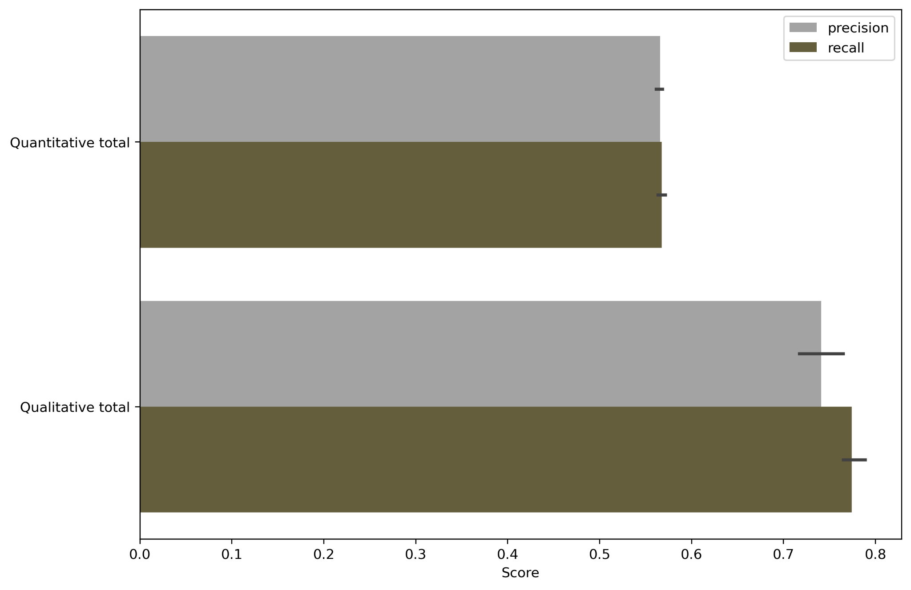
Figure S3: Precision and recall per quantitative vs. qualitative extraction for three repeated identical simulations. Colorbars represent the average value of the metrics across the different simulations. Black error bars represent the spread between the different simulations.

Next, we compare the performance of different large language models. We run the extraction with four different large language models: meta-llama_llama-4-scout-17b-16e-instruct¹, llama-3.1-8b-instant², llama-3.3-70b-versatile³, and openai_gpt-oss-20b⁴. Figure S4 shows the results of the quantitative vs qualitative extraction for each different model in terms of F1 score (i.e. the harmonic mean of precision and recall), while Table S1 shows the average extraction time and average price per report for the different models.
We select the meta-llama_llama-4-scout-17b-16e-instruct model due to its good performance in terms of accuracy and rapidity of extraction, its good quality-over-price ratio, and its being open-source.
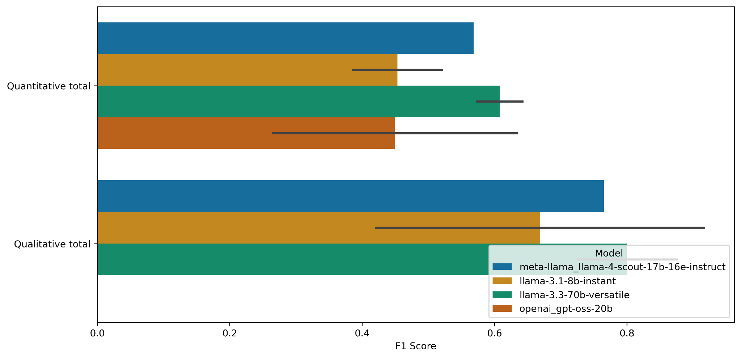
Figure S4: F1 score per quantitative vs. qualitative extraction conducted with four different LLMs.

Model name | Average extraction time per report (s) | Average extraction price per report (USD)
meta-llama_llama-4-scout-17b-16e-instruct | 67.82 | 0.020
llama-3.1-8b-instant | 70.20 | 0.016
llama-3.3-70b-versatile | 54.58 | 0.13
openai_gpt-oss-20b | 58.94 | 0.018

References
1. meta-llama/Llama-4-Scout-17B-16E-Instruct · Hugging Face. https://huggingface.co/meta-llama/Llama-4-Scout-17B-16E-Instruct (2025).
2. meta-llama/Llama-3.1-8B-Instruct · Hugging Face. https://huggingface.co/meta-llama/Llama-3.1-8B-Instruct (2024).
3. llama-models/models/llama3_3/MODEL_CARD.md at main · meta-llama/llama-models. GitHub https://github.com/meta-llama/llama-models/blob/main/models/llama3_3/MODEL_CARD.md.
4. OpenAI et al. gpt-oss-120b & gpt-oss-20b Model Card. Preprint at https://doi.org/10.48550/arXiv.2508.10925 (2025).

