Supplementary Material

Headers Key-word search
Although IFRC reports lack a consistent structure, repeated patterns can be identified, allowing us to extract specific sections that contain impact-related information. The search begins at the start of each report and is done sentence by sentence. Once a keyword from headers_drop is detected, the search stops, and the section header is set to end at the conclusion of that sentence.
However, because report formats may vary, it is important to ensure that no impact information is overlooked. If a headers_keep keyword appears within a sentence that would otherwise be excluded, the header boundary is adjusted and extended to include the sentences that follow this header, until a stop header is found.

headers_drop = [
"coordination and partnerships",
"operational strategy",
"red cross red crescent action",
"operational developments",
"summary of response",
"summary of the response",
"the response so far",
"previous operations",
"current national society actions",
"national society actions",
"summary of measures taken by the national society",
"detailed operation plan",
"summary of the current response",
"Overview of Operating National Society Response Action"
]

headers_keep = [
"operation summary",
"situation analysis",
"description of the crisis",
"what happened, where and when",
"description of the disaster",
"description of the event",
"needs (gaps) identified"
]

Geocoding process

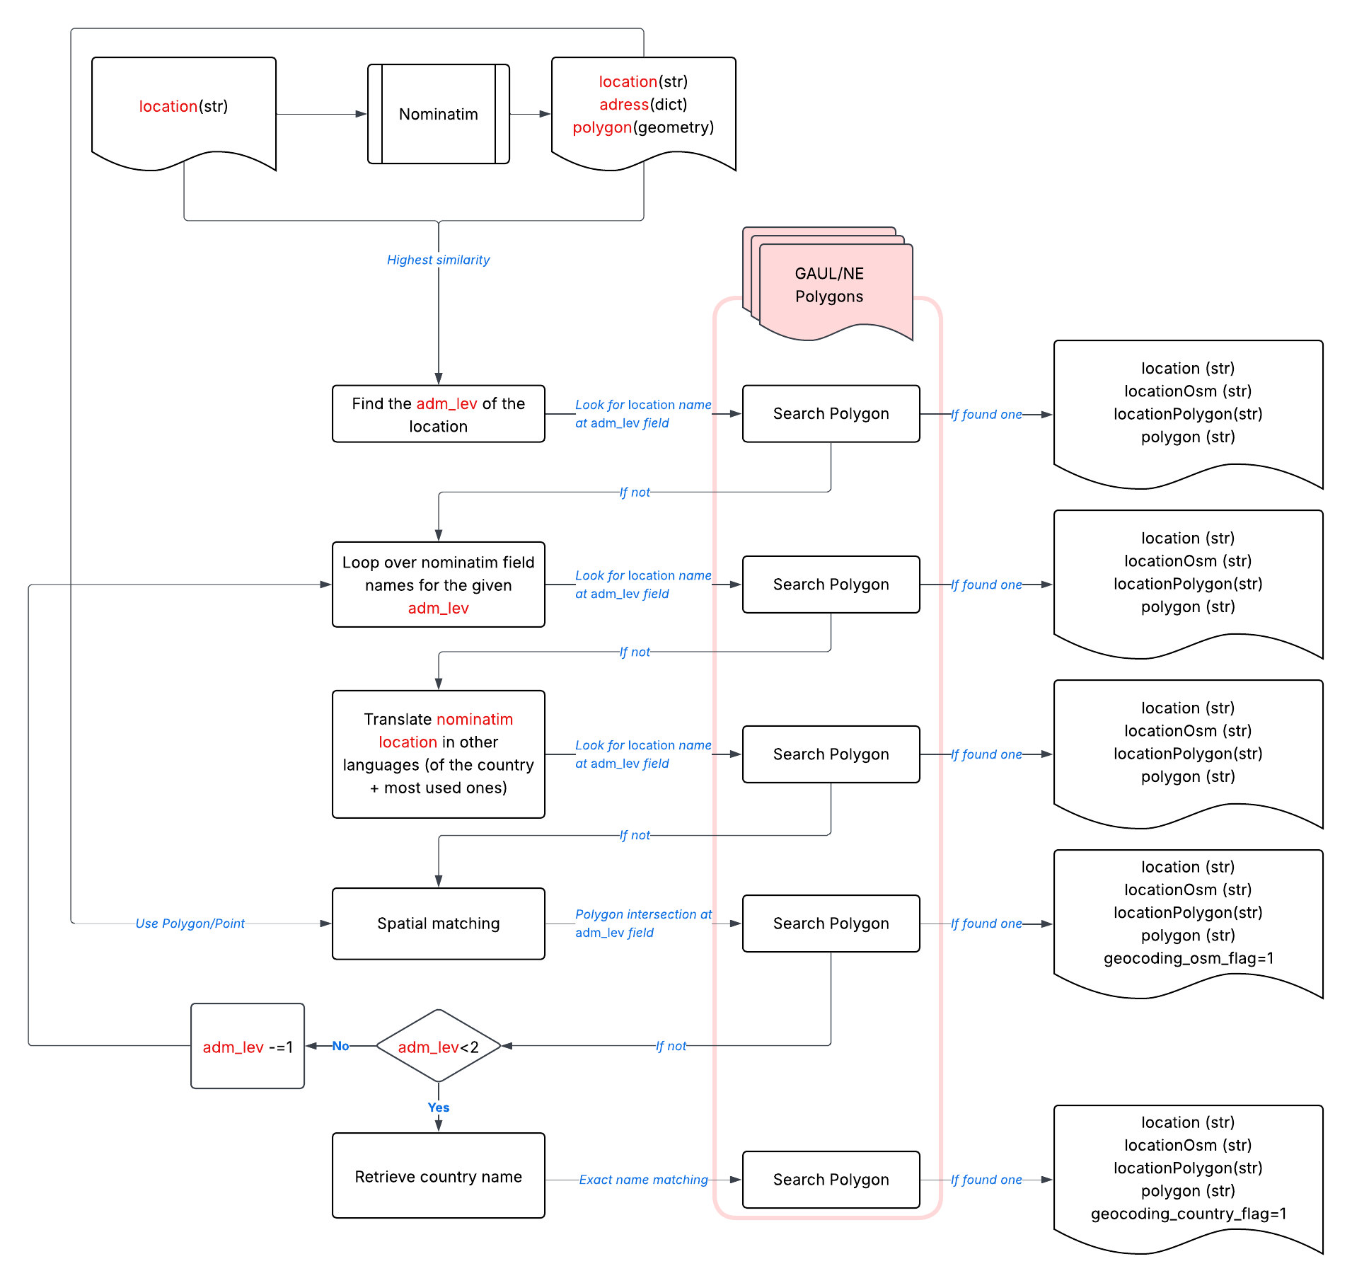
Figure S1: Flowchart of the geocoding pipeline. The procedure is applied for every unique combination of (location, country)

Guidelines manual labelling
Guidelines for manual labelling are available as an additional supplementary material file

Manually labelled reports
The following list of reports has been selected at random for manual labelling

appealCode | reportDate | reportLink
MDRS2001 | 06/08/2024 00:00 | https://adore.ifrc.org/Download.aspx?FileId=839625
MDRKE058 | 26/04/2024 00:00 | https://adore.ifrc.org/Download.aspx?FileId=828551
MDRYE011 | 03/08/2022 00:00 | https://adore.ifrc.org/Download.aspx?FileId=558578
MDRIQ014 | 27/12/2021 00:00 | https://adore.ifrc.org/Download.aspx?FileId=480634
MDRBD022 | 19/07/2019 00:00 | https://adore.ifrc.org/Download.aspx?FileId=247507
MDRSV012 | 26/06/2019 00:00 | https://adore.ifrc.org/Download.aspx?FileId=243784
MDRCN006 | 14/03/2019 00:00 | https://adore.ifrc.org/Download.aspx?FileId=233003
MDRMY003 | 21/11/2017 00:00 | https://adore.ifrc.org/Download.aspx?FileId=176204
MDRBJ019 | 07/09/2024 00:00 | https://adore.ifrc.org/Download.aspx?FileId=839791
MDRCM039 | 13/09/2024 00:00 | https://adore.ifrc.org/Download.aspx?FileId=839863
MDRCO023 | 07/03/2024 00:00 | https://adore.ifrc.org/Download.aspx?FileId=809127
MDRDZ011 | 22/09/2024 00:00 | https://adore.ifrc.org/Download.aspx?FileId=839903
MDRGE019 | 16/03/2025 00:00 | https://go-api.ifrc.org/api/downloadfile/90652/MDRGE019do.
MDRGT009 | 01/02/2017 00:00 | https://adore.ifrc.org/Download.aspx?FileId=155059
MDRGW003 | 24/04/2019 00:00 | https://adore.ifrc.org/Download.aspx?FileId=237001
MDRHU005 | 29/11/2016 00:00 | https://adore.ifrc.org/Download.aspx?FileId=152707
MDRMZ024 | 02/10/2024 00:00 | https://adore.ifrc.org/Download.aspx?FileId=839951
MDRNG041 | 06/09/2024 00:00 | https://adore.ifrc.org/Download.aspx?FileId=839787
MDRPK026 | 28/03/2025 00:00 | https://go-api.ifrc.org/api/downloadfile/88815/MDRPK026dfr.
MDRRW022 | 05/09/2024 00:00 | https://adore.ifrc.org/Download.aspx?FileId=839784
MDRSD034 | 17/03/2025 00:00 | https://go-api.ifrc.org/api/downloadfile/90654/MDRSD034du1.
MDRTN010 | 03/09/2024 00:00 | https://adore.ifrc.org/Download.aspx?FileId=839770
MDRUG050 | 30/08/2024 00:00 | https://adore.ifrc.org/Download.aspx?FileId=839753
MDRZM022 | 02/04/2024 00:00 | https://adore.ifrc.org/Download.aspx?FileId=818930

Prompts

Prompts are detailed in the code archive under the file /src/prompts_impacts.py

Matching algorithm for internal validation
We derive a matching algorithm that allows us to match each extracted row to an equivalent row in the manually-labelled data (Section Internal validation). The algorithm follows the steps:
- Each labelled and extracted rows are grouped per event (appealCode) to avoid matching unrelated events. We further separate between rows describing quantitative (non-null impactValue) vs. qualitative (null impactValue) to ensure quantitative impacts are only matched with quantitative and inversely.
- Each extracted and labelled row is vectorised. Vectorisation corresponds to the process of turning each categorical variable of the row into a vector spanning over N-dimensions, N being the dimension of the categorical variable. The categorical variables considered for matching are Country, impactSubtype, impactUnit, hazards, startYear, startMonth, startDay, endYear, endMonth, and endDay.
- For each possible pair of extracted-labelled rows, a cosine similarity between the corresponding categorical variables is computed. For the geometry column, the intersection-over-union is used: $IoT(x,y) = \frac{∩(x,y)}{∪(x,y)}(1)$ . For the impactValue column, we define our error metric as follows: $impactValueSim = 1-max(|\frac{{(v}_{1 }-v_{2})}{v_{1}}|,|\frac{{(v}_{2 }-v_{1})}{v_{2}}| ) if max(|\frac{{(v}_{1 }-v_{2})}{v_{1}}|,|\frac{{(v}_{2 }-v_{1})}{v_{2}}| ) ≤ 1 else 0 (2)$This error metric scores 1 in case of perfect value equality, and 0 when the relative difference between the two values in absolute terms is greater than 100%. The metric is symmetric with regard to which of the two assessed values is taken as the denominator.
- Possible pairs are made by maximising a weighted sum of the similarity of the matching variables for each extracted-labelled row pair. Note that we keep ties if the maximum weighted aggregated similarity value is shared by more than one possible pair.

Next, we use the pairing algorithm described above to match the extracted to the manually-labelled impacts. We define a correct match as a pair for which the weighted similarity exceeds 0.5. Weights are defined for each matching variable and are selected so that quantitative pairs that show a perfect match for at least two of the impactSubtype, impactUnit, or impactValue variables get a similarity score of at least 0.5. For qualitative impacts, the weights are selected so that pairs that match the impactSubtype and geometry variables perfectly receive a similarity score of at least 0.5. Below this value of 0.5, we consider the two paired impacts to be too dissimilar to likely represent the same impact. For quantitative impacts, we add a constraint on the error of the impactValue, so that only pairs for which the difference between the two impactValues is less than 10% are considered as correct matches.

Sensitivity analyses
We repeat identical queries, test multiple language models, and evaluate the stability of the outputs to assess the sensitivity, robustness and transferability of the approach.
We repeat three extractions with identical parameters and a fixed random seed to test the determinism of the selected meta-llama_llama-4-scout-17b-16e-instruct model. Figure S1 shows the precision and recall for these repeated extractions. Results show that the effects of the stochastic behaviour of the LLM lead to differences of up to 0.11 for the recall of the quantitative data, whereas the recall of the qualitative data and the precision remain stable across the simulations. This shows that the output of the LLM remains partly non-deterministic even when a random seed is fixed. These discrepancies in precision and recall result from differences in the number and the details of the extracted impacts across the repeated simulations. While these differences might affect the precision and recall at the report level when the reports are short and the number of impacts extracted little, the overall effects on the metrics calculated over all reports are limited.

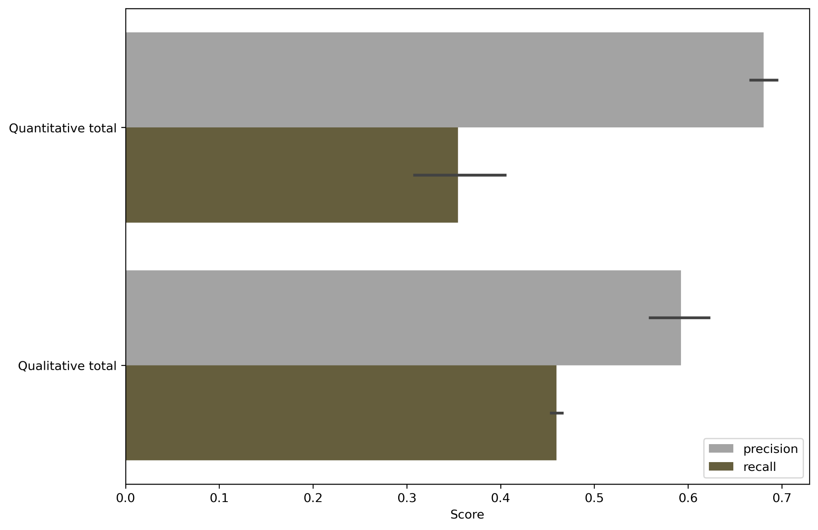
Figure S2: Precision and recall per quantitative vs. qualitative extraction for three repeated identical simulations. Colorbars represent the average value of the metrics across the different simulations. Black error bars represent the spread between the different simulations.

Next, we compare the performance of different large language models. We run the extraction with four different large language models: meta-llama_llama-4-scout-17b-16e-instruct¹, llama-3.1-8b-instant², llama-3.3-70b-versatile³, and openai_gpt-oss-20b⁴. Figure S2 shows the results of the quantitative vs qualitative extraction for each different model in terms of F1 score (i.e. the harmonic mean of precision and recall), while Table S1 shows the average extraction time and average price per report for the different models.
We select the meta-llama_llama-4-scout-17b-16e-instruct model due to its good performance in terms of accuracy and rapidity of extraction, its price, and as being open-source.
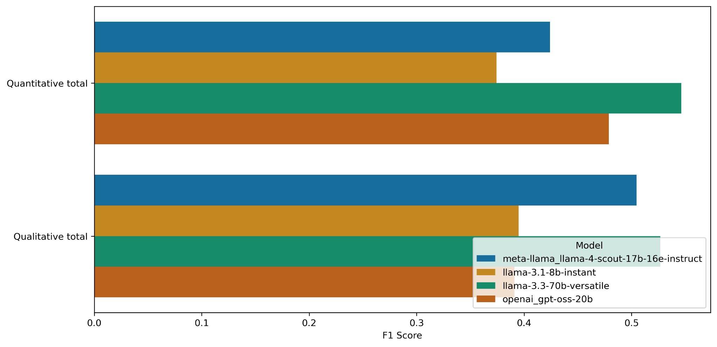
Figure S3: F1 score per quantitative vs. qualitative extraction conducted with four different LLMs.

Model name | Average extraction time per report (s) | Average extraction price per report (USD)
meta-llama_llama-4-scout-17b-16e-instruct | 67.82 | 0.042
llama-3.1-8b-instant | 52.63 | 0.027
llama-3.3-70b-versatile | 52.70 | 0.1615
openai_gpt-oss-20b | 103.60 | 0.040

References

1. meta-llama/Llama-4-Scout-17B-16E-Instruct · Hugging Face. https://huggingface.co/meta-llama/Llama-4-Scout-17B-16E-Instruct (2025).
2. meta-llama/Llama-3.1-8B-Instruct · Hugging Face. https://huggingface.co/meta-llama/Llama-3.1-8B-Instruct (2024).
3. llama-models/models/llama3_3/MODEL_CARD.md at main · meta-llama/llama-models. GitHub https://github.com/meta-llama/llama-models/blob/main/models/llama3_3/MODEL_CARD.md.
4. OpenAI et al. gpt-oss-120b & gpt-oss-20b Model Card. Preprint at https://doi.org/10.48550/arXiv.2508.10925 (2025).

