1.One Diet and Physical Activity Habits Questionnaire

Basic Information
Name: _____ Gender: _____ Date of Birth: _______
Contact Information: ________ Occupation: _____
Education Level: _____ Years of Education: _____
Height: _____ Weight: _____ BMI: ______
Preferred Hand: Right Hand / Left Hand

Present illness history________________________

Medication history
Drug Name | Dose | Starting Time of Administration | Duration of Administration | Is Administration Regular

2.Hamilton Scale
HAMD
1.Depression | Does not exist - 0  Only expressed when asked - 1  Expressed spontaneously in words - 2  Can express this emotion through facial expressions, body postures, voice or tears without using words - 3  The patient's spontaneous and non-spontaneous language (facial expressions, actions) almost completely manifest this emotion - 4
2.sense of guilt | Nonexistent - 0  Blaming oneself and feeling that one has caused harm to others - 1  Believing that one has committed a crime or repeatedly reflecting on past mistakes and errors - 2  Believing that the current illness is a punishment for one's own mistakes, or having sinful delusions - 3  Sinful delusions accompanied by accusing or threatening hallucinations - 4
3.suicide | Does not exist - 0  Feels that life has no meaning - 1  Wishes to be dead or often thinks about death-related matters - 2  Negative thoughts (suicidal thoughts) - 3  Has serious suicidal behavior - 4
4.difficulty falling asleep | No difficulty - 0  The main complaint is sometimes having difficulty falling asleep, that is, still unable to fall asleep half an hour after going to bed - 1  The main complaint is having difficulty falling asleep every night - 2
5.Poor sleep quality (intermediate-level insomnia) | No difficulties - 0  Sleep is light with many nightmares - 1  Woke up in the middle of the night (before 12 o'clock at night) (excluding going to the bathroom) - 2
6.Early awakening (with insomnia at the end) | No difficulty - 0  Has early awakening, waking up 1 hour earlier than usual, but can fall asleep again - 1  Unable to fall asleep again after early awakening - 2
7.Work and interests | No difficulties - 0  Expresses only after being asked - 1  Spontaneously and directly or indirectly expresses a loss of interest in activities, work or study, such as feeling listless, indecisive, unable to persist or needing to force oneself to work or engage in activities - 2
8.sluggish | Normal thinking and speech - 0  Mild retardation was found during the mental examination - 1  Significant retardation was found during the mental examination - 2  Difficulties in conducting the mental examination - 3  Unable to answer questions completely (catatonia) - 4
9.loud and strong | No - 0  Showing some nervousness during the examination - 1  Significant nervousness or excessive fidgeting - 2  Unable to sit still and stood up during the examination - 3  Rubbing hands, biting fingers, pulling hair, biting lips - 4
10.Psychological anxiety | No - 0  When asked, they would recount - 1  Spontaneously express - 2  Clear signs of worry shown through facial expressions and speech - 3  Clearly frightened - 4
11.somatic anxiety | No - 0  Mild - 1  Moderate (with definite above symptoms) - 2  Severe (the above symptoms are severe and affect daily life or require additional treatment) - 3  Disabling (seriously affecting daily life and activities) - 4
12.gastrointestinal symptom | No - 0  Loss of appetite, but able to eat on one's own without needing encouragement from others - 1  Requires urging, asking for help, or the use of laxatives or digestive aids to eat - 2
13.Generalized physical symptoms | No - 0  Feeling of heaviness in limbs, back or neck, back pain, headache, muscle pain, general weakness or fatigue - 1  The above symptoms are obvious - 2
14.Sexual symptoms (such as loss of sexual desire, menstrual disorders) | Asymptomatic - 0  Mild - 1  Severe - 2  Uncertain, or this item is not suitable for the evaluated person (not included in the total score) - 0.
15.hypochondria | Absence - 0  Excessive concern about the body - 1  Repeated consideration of health issues - 2  Hypochondriac delusion - 3  Delusion of hypochondria with hallucinations - 4
16.lose weight | Weight not reduced - 0  Perhaps there is weight loss related to the current condition - 1  Actually, there is weight loss - 2
17.insight | Admitting to depression and being ill, or not being depressed now - 0  Admitting to having a disease, but attributing it to poor diet, environmental issues, overwork, viral infection or the need for rest, etc. - 1  Completely denying having a disease - 2
18.Diurnal variation type | No —— 0  Mild —— 1  Severe —— 2
19.Dissociation of reality and dissociation of personality | Nonexistent - 0  Expressed only upon questioning - -1  Spontaneously expressed - -2  Having nihilistic delusion - 3  Nihilistic delusion accompanied by hallucinations - 4
20.Paranoid-like symptoms | No - 0  With suspicion - 1  With relationship concepts - 2  With relationship delusions or paranoid delusions - 3  With hallucinations in relationship delusions or paranoid delusions - 4
21.obsessive-compulsive disorder (ocd) | Does not exist - 0  Tells when asked - 1  Spontaneously tells - 2
22.Loss of ability | No —— 0  Only when asked will subjective experiences be elicited — 1  The patient actively expresses a sense of reduced ability — 2  It is necessary to encourage, guide and comfort in order to complete daily affairs in the ward or personal hygiene — 3  Putting on clothes, washing, eating, making the bed or personal hygiene all require assistance from others — 4
23.feeling of despair | None - 0  Sometimes doubt "whether the situation will improve", but can accept after explanation - 1  Persistently feel "there is no hope", but can accept after explanation - 2  Feel discouraged, pessimistic and desperate about the future, and cannot be excluded after explanation - 3  Automatically and repeatedly state "my illness will not get better" or similar situations - 4
24.inferiority feeling | No - 0  Only when asked did the patient express feeling of inferiority (I am inferior to others) - 1  The patient spontaneously expressed feeling of inferiority (I am inferior to others) - 2  The patient voluntarily stated: "I am nothing" or "I am inferior", which is only a degree difference from those rated as 2 - 3  The feeling of inferiority reaches the level of delusion, such as "I am a loser" - 4

Project | Total Score of Titles | Points
A.Anxiety/Somatic Symptoms | 10+11+12+15+17
B.Weight | 16
C.Cognitive Impairment | 2+3+9+19+20+21
D.Day-Night Rhythm Changes | 18
E.Delay | 1+7+8+14
F.Sleep Disorders | 4+5+6
G.Despair | 22+23+24
H.Total Score | 1-24

HAMA
Please mark the boxes corresponding to the physical and mental symptoms you experienced in the past one week:：
number | project |  | No | Light | Medium | Heavy | Extremely Heavy
1 | anxious mood | Worrying, being anxious, feeling that the worst is about to happen, and being easily irritated. | 0 | 1 | 2 | 3 | 4
2 | tension | Tension, fatigue easily, inability to relax, emotional reactions, crying easily, trembling, feeling uneasy. | 0 | 1 | 2 | 3 | 4
3 | fear | Afraid of darkness, strangers, being alone, animals, taking a vehicle or traveling, and crowded places. | 0 | 1 | 2 | 3 | 4
4 | insomnia | Difficulty in falling asleep, easy awakening, poor sleep quality, frequent dreams, night terrors, and feeling tired after waking up. | 0 | 1 | 2 | 3 | 4
5 | cognitive function | Or it can be called memory or attention disorder, with difficulty in concentrating and poor memory. | 0 | 1 | 2 | 3 | 4
6 | depressive mood | Loss of interest, lack of pleasure in past hobbies, depression, early awakening, more daytime sleepiness and less nighttime sleep. | 0 | 1 | 2 | 3 | 4
7 | Physiological anxiety (muscle system) | Muscle soreness, limited mobility, muscle twitching, limb twitching, teeth trembling, voice trembling. | 0 | 1 | 2 | 3 | 4
8 | Somatic anxiety (sensory system) | Blurred vision, chills and fever, weakness and fatigue, and a tingling sensation all over the body. | 0 | 1 | 2 | 3 | 4
9 | Cardiovascular system symptoms | Tachycardia, palpitations, chest pain, vascular throbbing sensation, fainting sensation, atrial fibrillation. | 0 | 1 | 2 | 3 | 4
10 | Respiratory system symptoms | Chest tightness, suffocation sensation, sighing, difficulty in breathing. | 0 | 1 | 2 | 3 | 4
11 | gastrointestinal symptom | Difficulty in swallowing, belching, indigestion (abdominal pain, bloating, nausea, feeling of fullness in the stomach after eating), intestinal motility, intestinal rumbling, diarrhea, weight loss, constipation. | 0 | 1 | 2 | 3 | 4
12 | Reproductive and urinary system symptoms | Frequent urge to urinate, urgency in urination, amenorrhea, sexual apathy, premature ejaculation, impotence. | 0 | 1 | 2 | 3 | 4
13 | Symptoms of the autonomic nervous system | Dry mouth, flushed face, pale complexion, excessive sweating, goosebumps, tension headache, hair standing on end. | 0 | 1 | 2 | 3 | 4
14 | Behavior during the meeting | General manifestations: Nervousness, inability to relax, unease, biting fingers, clenching fists, touching handkerchiefs, facial muscle twitching, foot restlessness, hand tremors, frowning, stiff expression, high muscle tension, sigh-like breathing, pale complexion.  Physiological manifestations: Swallowing, belching, fast heart rate at rest, rapid breathing (more than 20 breaths per minute), hyperactive tendon reflexes, tremors, dilated pupils, eyelid twitching, excessive sweating, protruding eyes. | 0 | 1 | 2 | 3 | 4

Project | Total Score of Titles | Points
A.Overall Score | 1-14
B.Physical Anxiety | 7+8+9+10+11+12+13
C.Psychogenic Anxiety | 1+2+3+4+5+6+14

3.STOP BANG
口No 口Yes 1.Snoring: Do you snore loudly (so loudly that it can be heard even when there's a closed door between you and the person listening)?
口No 口Yes 2.Fatigue: Do you feel tired, exhausted or want to sleep during the day?
口No 口Yes 3.Observation: Has anyone observed any instance of breathing cessation when you were sleeping?
口No 口Yes 4.Blood pressure: Have you ever been or currently be a patient with hypertension?
口No 口Yes 5.BMI: > 35 kilograms per square meter?
口No 口Yes6.Age: ≥ 50 years old?
口No 口Yes7.Neck Circumference: ≥ 40 centimeters?
口No 口Yes 8.Gender: Male?

Criteria for assessment: Those who answered "yes" to 3 or more items are classified as high-risk individuals for OSAS, while those who answered "yes" to less than 3 items are considered to be at low risk.
Is it more than 3 items? 口No 口Yes
Part A | 1 | 2 | 3 | 4 | 5
Drum |  |  |  |  |  | Drum
Curtain |  |  |  |  |  | Curtain
Bell |  |  |  |  |  | Bell
Tea |  |  |  |  |  | Tea
School |  |  |  |  |  | School
Parent |  |  |  |  |  | Parent
Moon |  |  |  |  |  | Moon
Garden |  |  |  |  |  | Garden
Hat |  |  |  |  |  | Hat
Farmer |  |  |  |  |  | Farmer
Ear |  |  |  |  |  | Ear
Swan |  |  |  |  |  | Swan
Color |  |  |  |  |  | Color
House |  |  |  |  |  | House
River |  |  |  |  |  | River
4.1.California Verbal Learning Test（CAVLT）

result | 1 | 2 | 3 | 4 | 5
Correct
replication
Insertion

Part B | 6
Table
Cavalry
Bird
Shoe
Stove
Mountain
Glasses
Towel
White cloud
Ship
Sheep
Pistol
Pencil
Church
Fish
Part A | 7
Drum
Curtain
Bell
Tea
School
Parent
Moon
Garden
Hat
Farmer
Ear
Swan
Color
House
River

result | 6 | 7
Correct
replication
Insertion

30 minutes later.....

Part B | 8 Delayed recall of words |  | 9 Delayed (30-minute) oral recognition test
Drum |  |  | Buffer
Curtain |  |  | A Bell | PA Stomach | SA  Teacher | A Parent
Bell |  |  | SA Sun | PA Bridal Attire | B Cavalry | B Towel
Tea |  |  | A Tea | B Fireplace | A Garden | SB Socks
School |  |  | SA Nose | B Cloud | PB Bed | B Pistol
Parent |  |  | B Church | A Drum | B Glasses | SA Window
Moon |  |  | A Hat | PA Leader | PA Cat | B Table
Garden |  |  | SB Pen | A Swan | A House | PB Wine Jar
Hat |  |  | A School | B Mountain | SA Apartment | SA Sea
Farmer |  |  | PA Court | A Moon | A Farmer | A Color
Ear |  |  | B Shoes | SA Rainbow | PA Mussels | PA Dragon Gate
Swan |  |  | SA Coffee | A Ear | B Boat | B Fish
Color |  |  | B Bird | B Sheep | A River
House |  |  | A Curtain | B Pencil | PB Skirt
River
result | 8
Correct
replication
Insertion

result | 9
List A Number of errors（A is not）
List A Number of voice intrusions（PA stands for）
List A Semantic intrusion count（SA stands for）
List B Intrusion count（B stands for）
List B Number of voice intrusions（PB stands for）
List B Semantic intrusion count（SB stands for）

4.2.Stroop Color Word Test（SCWT）
Card A Correct Answer:
Green Blue Yellow Red
Yellow Red Green Blue
Blue Green Yellow Red
Blue Yellow Red Green
Red Green Blue Yellow
Yellow Green Blue Red

Card B Correct Answer:
Green Blue Yellow Red
Yellow Red Green Blue
Blue Green Yellow Red
Blue Yellow Red Green
Red Green Blue Yellow
Yellow Green Blue Red

Card C Correct Answer:
Green Blue Yellow Red
Yellow Red Green Blue
Blue Green Yellow Red
Blue Yellow Red Green
Red Green Blue Yellow
Yellow Green Blue Red

Project | 1 | 2 | 3
Completion time (seconds)
Number of errors
Total score

4.3.Digit Span Test
forward backward
3 □5-8-2 | 2 □2-4
□6-9-4 | □5-8
4 □6-4-3-9 | 3 □6-2-9
□7-2-8-6 | □4-1-5
5 □4-2-7-3-1 | 4 □3-2-7-9
□7-5-8-3-6 | □4-9-6-8
6 □6-1-9-4-7-3 | 5 □1-5-2-8-6
□3-9-2-4-8-7 | □6-1-8-4-3
7 □5-9-7-1-4-2-8 | 6 □5-3-9-4-1-8
□4-1-7-9-3-8-6 | □7-2-4-8-5-6
8 □5-8-1-9-2-6-4-7- | 7 □8-1-2-9-3-6-5
□3-8-2-9-5-1-7-4 | □4-7-3-9-1-2-8
9 □2-7-5-8-6-2-5-8-4 | 8 □9-4-3-7-6-2-5-8
□7-1-3-9-4-2-5-6-8 | □7-2-8-1-9-6-5-3
10 □5-2-7-4-9-1-3-7-4-6 | 9 □6-3-1-9-4-3-6-5-8
□4-7-2-5-9-1-6-2-5-3 | □9-4-1-5-3-8-5-7-2
11 □4-1-6-3-8-2-4-6-3-5-9 | 10 □6-4-5-2-6-7-9-3-8-6
□3-6-1-4-9-7-5-1-4-2-7 | □5-1-6-2-7-4-3-8-5-9
12 □7-4-9-6-1-3-5-9-6-8-2-5
□6-9-4-7-1-9-7-4-2-5-9-2
Scored from the forward
Scored from the backward
Total

4.4.Colored Trails Test（CTT）
Trail 1
Total completion time of all numbers__________ （0-150）second（If the process is not completed within 150 seconds, record 150.）
Number of errors__________ （0-25） | Number of correct__________ （0-25）

Trail 2
Total completion time of all numbers__________ （0-300）second（If the process is not completed within 150 seconds, record 150.）
Error in numerical sequence__________ （0-25）
The correct number of lines__________ （0-24）

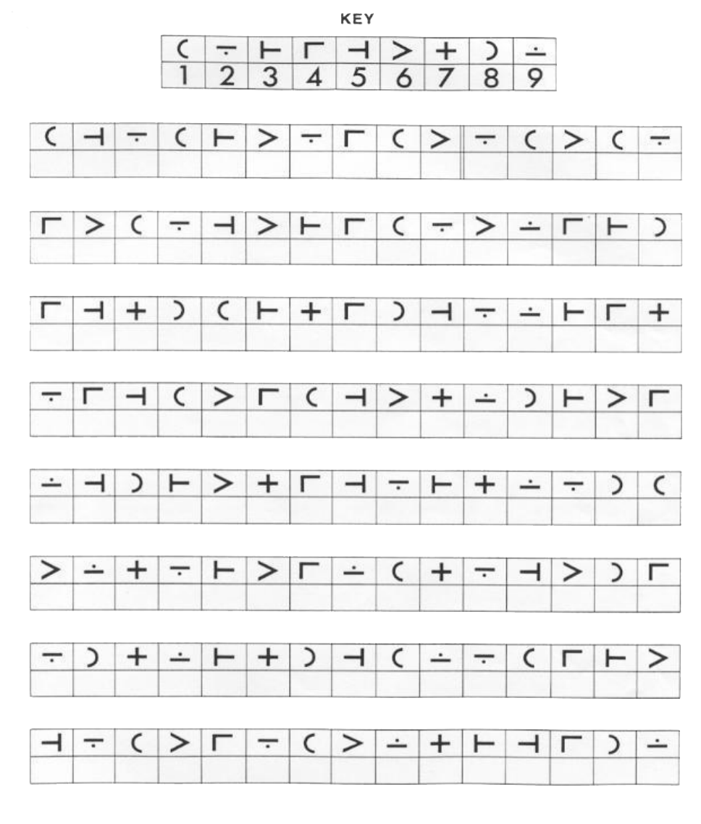
4.5.Symbol Digit Modalities Test（SDMT）
Record the correct number of filled-in digits within 90 seconds＿＿＿＿Number of errors＿＿＿＿Number of continue＿＿

