Appendix Tables
Table A1 Fuel model classes (Scott and Burgan 2005) assigned to the main habitat groups of the Habitat Catalogue of the Czech Republic (Chytrý et al. 2010) – Result of the first classification step
Code of habitat group (Chytrý et al. 2010) | Groups of habitat  (Chytrý et al. 2010) | Fuel model classes  (Scott and Burgan, 2005)
V | Streams and water bodies | NB
M | Wetlands and riverine vegetation | NB, GR1, GR2, GR4, GR7
R | Springs and mires | GR1, GR2, GR4, GS2
S | Cliffs and boulder areas | NB, GR1, GR2, SH1
A | Alpine treeless habitat | GR1, GR2, GR4, GS1, SH5, SH2, SH7
T | Secondary grassland and heathland | GR1, GR2, GR4, GS1, GS2
K | Shrubs | SH2, SH5, SH7
L | Forests | TL2, TL6, TL8, TL3
X | Habitat strongly influenced or created by man | NB, GR, GS, SH, TU, TL, SB

Table A2 Assignment of fuel models to different ecosystem classification levels provided by the consolidated layer of ecosystems
Consolidated layer of ecosystems |  | Fuel model  (Scott and Burgan, 2005)
Ecosystem types | Basic ecosystems categories
Urban systems | Continuously built-up areas | NB1 | Nonburnable
Urban systems | Discontinuously built-up areas | NB1 | Nonburnable
Urban systems | Industrial and commercial built-up area | NB1 | Nonburnable
Urban systems | Transport infrastructure and network | NB9 | Nonburnable
Urban systems | Landfills and construction sites | GS2 | Grass
Urban systems | Urban green areas, ornamental gardens, parks, and cemeteries | TU1 | Timber-understory
Urban systems | Scattered greenery | TU1 | Timber-understory
Urban systems | Sports and recreational areas | GR1 | Grass
Agricultural ecosystems | Arable land | GR2/GR4 | Grass
Agricultural ecosystems | Orchards, productive gardens | SH5 | Shrub
Agricultural ecosystems | Hops | SH5 | Shrub
Agricultural ecosystems | Vineyards | SH5 | Shrub
Agricultural ecosystems | Degraded grasslands | GR2 | Grass
Agricultural ecosystems | Alluvial and wet meadows | GR4 | Grass
Agricultural ecosystems | Dry grasslands | GR2 | Grass
Grassland ecosystems | Mesophilous meadows | GR4 | Grass
Grassland ecosystems | Alpine meadows | GR2 | Grass
Grassland ecosystems | Heathlands | GS2 | Grass-shrub
Forest Ecosystems | Coniferous commercial forests | TL3 | Timber–litter
Forest Ecosystems | Deciduous commercial forests | TL6 | Timber–litter
Forest Ecosystems | Mixed commercial forests | TL6 | Timber–litter
Forest Ecosystems | Flood and wetland forests | TL2 | Timber–litter
Forest Ecosystems | Oak and oak-hornbeam forests | TL6 | Timber–litter
Forest Ecosystems | Rusty forests | TL6 | Timber–litter
Forest Ecosystems | Beech forests | TL6 | Timber–litter
Forest Ecosystems | Dry pine forests | TL8 | Timber–litter
Forest Ecosystems | Spruce forests | TL3 | Timber–litter
Forest Ecosystems | Peat forests | TL3 | Timber–litter
Forest Ecosystems | Natural dwarf forests | SH5 | Shrub
Forest Ecosystems | Natural shrubs | SH5 | Shrub
Forest Ecosystems | Nonnatural dwarf forests | SH5 | Shrub
Forest Ecosystems | Nonnatural shrubs | SH5 | Shrub
Wetland ecosystems | Wetlands and coastal vegetation | GR4 | Grass
Wetland ecosystems | Mires and springs | GR4 | Grass
Wetland ecosystems | Marshes | NB8 | Nonburnable
Water ecosystems | Macrophytic vegetation of standing waters | NB8 | Nonburnable
Water ecosystems | Ponds and reservoirs | NB8 | Nonburnable
Water ecosystems | Watercourses | NB8 | Nonburnable
Area without vegetation | Rocks, quarries (artificial) | NB9 | Nonburnable
Area without vegetation | Rocks, rubble | GR2 | Grass

Table A3 Assignment of forest ecosystem fuel models identifiable based on remote sensing data and other available data
Fuel model  (Scott and Burgan, 2005) |  | Forest ecosystems characteristics
Grass–shrub | GS1 | Clearcuts and young sparse stands up to 10 years old at extreme and arid sites; low-productivity stands; the fire spread rate is medium; the flame length is short.
Grass–shrub | GS2 | Clearcuts and young sparse stands up to 10 years old at fertile and wetter sites; medium-productivity stands. The fire spread rate is high, and the flame length is medium.
Shrub | SH2 | Partly open to connected stands up to 10 years at old on extreme and arid sites. Low- and medium-productivity stands. The fire spread rate is low, and the flame length is short.
Shrub | SH5 | Partly open to connected stands up to 10 years old at fertile and wetter sites. Highly productive stands. The fire spread rate is very high, and the flame length is very high.
Timber–understory | TU1 | Open stands with undergrowth, with a small amount of fuel in the form of grass or litter; low spread rate; short flame length.
Timber–understory | TU4 | Lower stands of conifers aged 11–30 years, with undergrowth of grasses and shrubs. Moderate spread rate; medium flame length.
Timber–understory | TU5 | Highly productive stands of woody plants with undergrowth; a thick layer of litter and shrubs or undergrowth are typical. Moderate spread rate; medium flame length.
Timber–litter | TL1 | Coniferous forest, with a compact litter layer and a low to medium depth of litter. May be a postfire forest. Very low spread rate; very small flame length.
Timber–litter | TL2 | Deciduous forest with a compact and low litter layer. The fire spread rate is very low, and the flame length is very low.
Timber–litter | TL3 | Coniferous stands with a medium litter layer and a thin layer of coarse fuel. The fire spread rate is very low, and the flame length is low.
Timber–litter | TL4 | Stands with a medium amount of litter and dead wood including thinner trunks. The fire spread rate is low, and the flame length is low.
Timber–litter | TL5 | Coniferous stands with a large amount of fuel after splits or due to mortality. The fire spread rate is low, and the flame length is low.
Timber–litter | TL6 | Deciduous stands with a medium layer of less compact litter. The fire spread rate is medium, and the flame length is low.
Timber–litter | TL7 | Stands with large amounts of litter, including larger pieces of lying dead wood. The fire spread rate is low, and the flame length is low.
Timber–litter | TL8 | Pine stands with a medium layer of litter with a small amount of undergrowth. The fire spread rate is medium, and the flame length is low.
Timber–litter | TL9 | Deciduous stands with a large amount of unburned litter (the litter can be blown away by wind). PM can also be used for coniferous trees with a dense long crown. The fire spread rate is medium, and the flame length is medium.
Landslides and stands after logging | SB1 | The fire carrier is fuel with a diameter of 3–7 cm in an amount of approximately 3–5 kg/m² in a layer of approximately 30 cm. The amount of dead or broken trees does not exceed 50% of the trees (or stand stock). The fire spread rate is medium, and the flame length is short.
Landslides and stands after logging | SB2 | The fire carrier is dead tree biomass lying on the ground after disturbance. The fuel is of various dimensions, and some trees are standing. There is approximately 2–4 kg/m² of fine fuel in a layer of approximately 30 cm. The amount of dead or broken trees does not exceed 70% of the trees (or stand stock). The fire spread rate is medium, and the flame length is medium.
Landslides and stands after logging | SB3 | Forests after fellings or other disturbances with a large amount of wood of various dimensions on the ground. There is 2–4 kg/m² of fine fuel on the ground, and the layer of fine fuel is thicker than 30 cm. The amount of dead or broken trees reaches up to 100% of the trees (or stand stock). The fire spread rate is high, and the flame length is high.
Landslides and stands after logging | SB4 | Forests after very heavy fellings or dumps of wood and biomass; the fuel bed is not compact. Fine fuel (branches, needles, and leaves) is still visible. The amount of dead or broken trees reaches up to 100% of the trees (or stand stock). The trunks of trees lie atop each other. The fire spread rate is very high, and the flame length is very high.

Table A4 Site potential for stands dominated by deciduous tree species
Forest vegetation zones (FVZ) |  | 0 across the FVZ | 1 to 2 low elevations | 3 to 4 moderate elevations | 5 to 6 high elevations | 7 to 9 alpine elevations
Edaphic category
X | Basiphilous dwarf | A | A | B
C | Drying/xeric | A | A | B | B
W | Calcareous |  | B | B | B
Z | Extreme | A | A | B | B | A
Y | Skeletal | A | A | B | B | B
J | Enriched skeletal |  | B | C | C
A | Enriched rocky |  | B | C | C
F | Fresh rocky |  | C | C | C | B
N | Acidic rocky | A | B | B | B | B
M | Poor | A | B | B | B | B
K | Acidic | A | B | B | B | B
I | Acidic loamy |  | B | B | B
S | Fresh | A | B | B | B | B
B | Nutrient rich |  | C | C | C
H | Loamy |  | C | C | C
D | Enriched |  | C | C | C
V |  |  | C | C | C | B
  Moist/wet
O | Gleyic fresh | B | C | C | C | B
P | Gleyic acidic | B | B | B | B | B
Q | Gleyic poor | B | B | B | B | B
T | Gleyic poor | B | B | B | B | B
G | Gleyic | B | B | B | B | B
R |  | B | B | B | B | B
  Peaty/peat
L |  |  | A | A | A | A
  Floodplain
U | Valley-bottom |  | A | A | A

Table A5 Site potential for stands dominated by coniferous tree species
Forest vegetation zones (FVZ) |  | 0 across the FVZ | 1 to 2 low elevations | 3 to 4 moderate elevations | 5 to 6 high elevations | 7 to 9 alpine elevations
Edaphic category
X | Basiphilous dwarf | A | A | A
C | Drying/xeric | A, | A | A | A
W | Calcareous |  | A | A | A
Z | Dwarf | A | A | A | A | A
Y | Skeletal | A | A | A | A | A
J | Enriched skeletal |  | B | B | B
A | Enriched rocky |  | B | B | B | B
F | Fresh rocky |  | B | B | B | B
N | Acidic rocky | B | B | B | B | B
M | Poor | B | B | B | B | B
K | Acidic | B | B | B | B | B
I | Acidic loamy |  | B | B | B
S | Fresh | A | A | A | A | A
B | Rich |  | B | B | B
H | Loamy |  | B | B | B
D | Enriched |  | B | B | B
V |  |  | B | B | B | B
  Moist/wet
O | Gleyic fresh | B | B | B | B | B
P | Gleyic acidic | B | B | B | B | B
Q | Gleyic poor | B | B | B | B | B
T | Gleyic poor | C | C | C | C | C
G | Gleyic | C | C | C | C | C
R | Peaty/peat | C | C | C | C | C
L | Foodplain |  | A | A | A | A
U | Valley-bottom |  | A | A | A

Appendix Figures
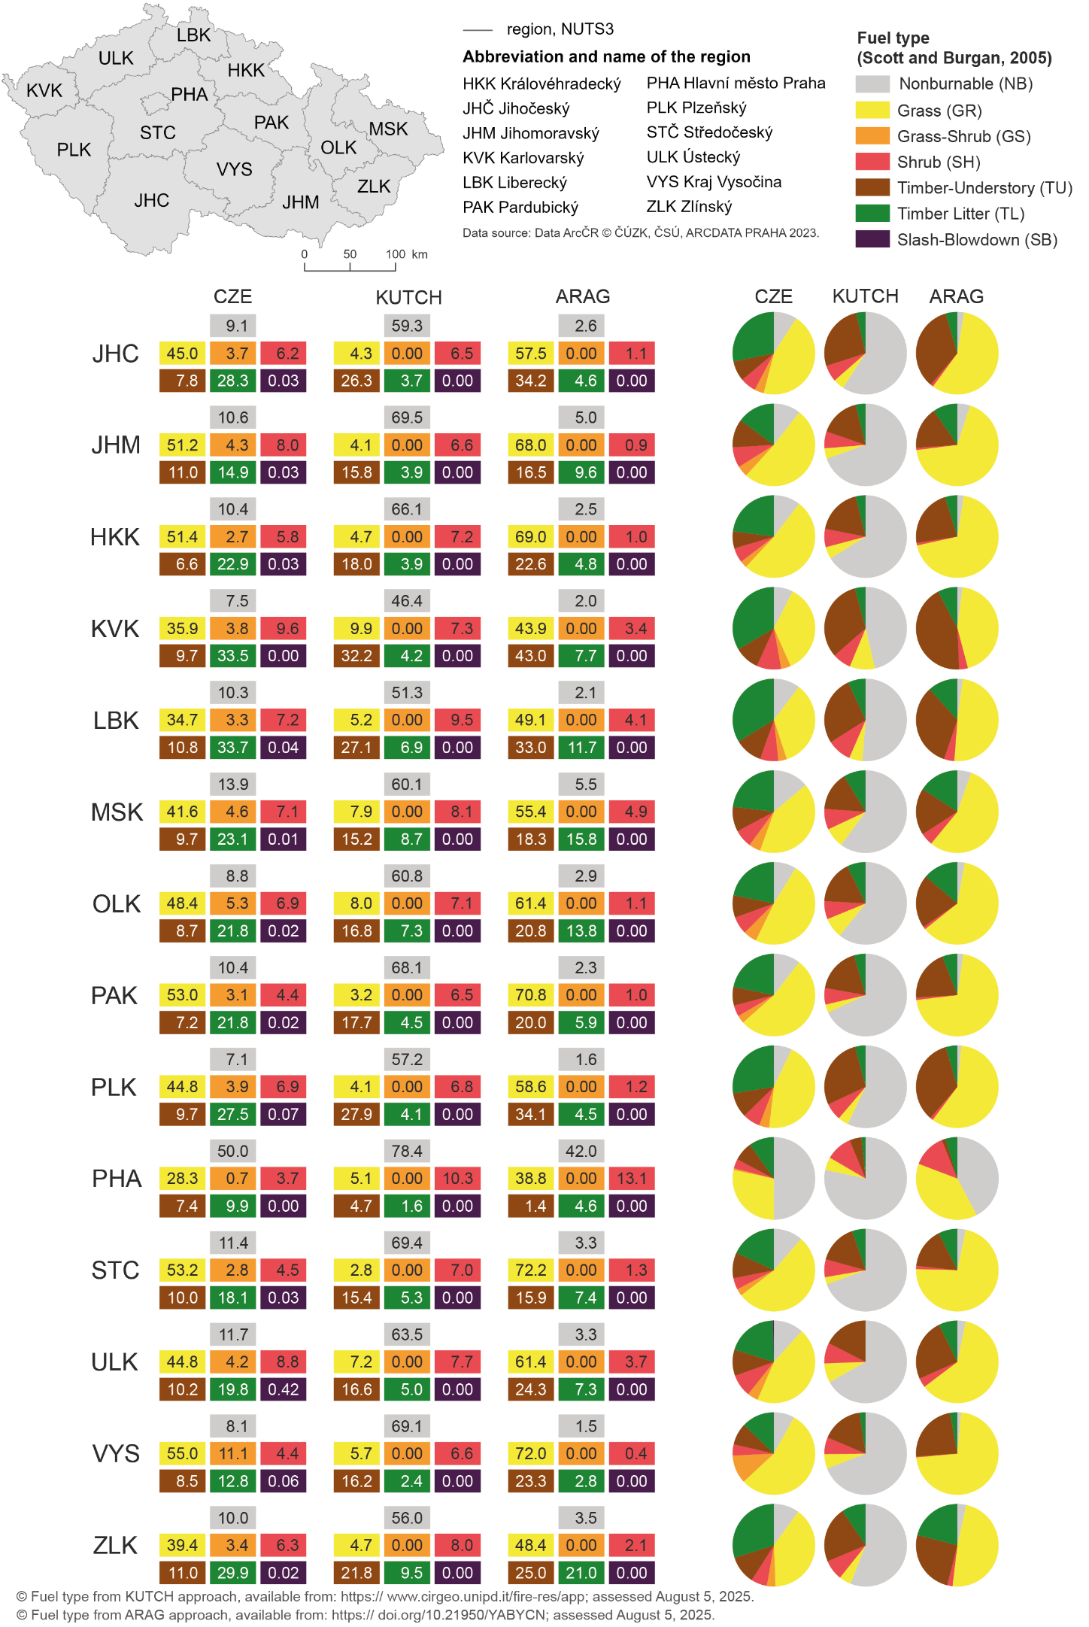
Fig. A1 Spatial distribution and proportional representation of fuel model groups across NUTS3 regions of the Czech Republic, comparing three fuel classification approaches, namely, the methodology proposed in this study (CZE, 30 m), the Kutchartt et al. (2024) approach (KUTCH, 100 m), and the Aragoneses et al. (2023) approach (ARAG, 1 km). The map (upper left) shows the delineation of NUTS3 regions. For each region, the stacked bar charts show the relative area (%) of major fuel groups, namely, nonburnable (NB), grass (GR), grass–shrub (GS), shrub (SH), timber–understory (TU), timber–litter (TL), and slash–blowdown (SB), as derived from each classification. The corresponding pie charts (right) show a visual comparison of the proportions of the various fuel groups among the three approaches. Differences among classifications reflect differences in the spatial resolution and methodological assumptions, particularly in the representation of transitional fuels (GS), shrub fuels (SH), and disturbance-related fuel types (SB). The fuel models follow the classification system of Scott and Burgan (2025).

