SUPPLEMENTS
- Preliminary parameter study
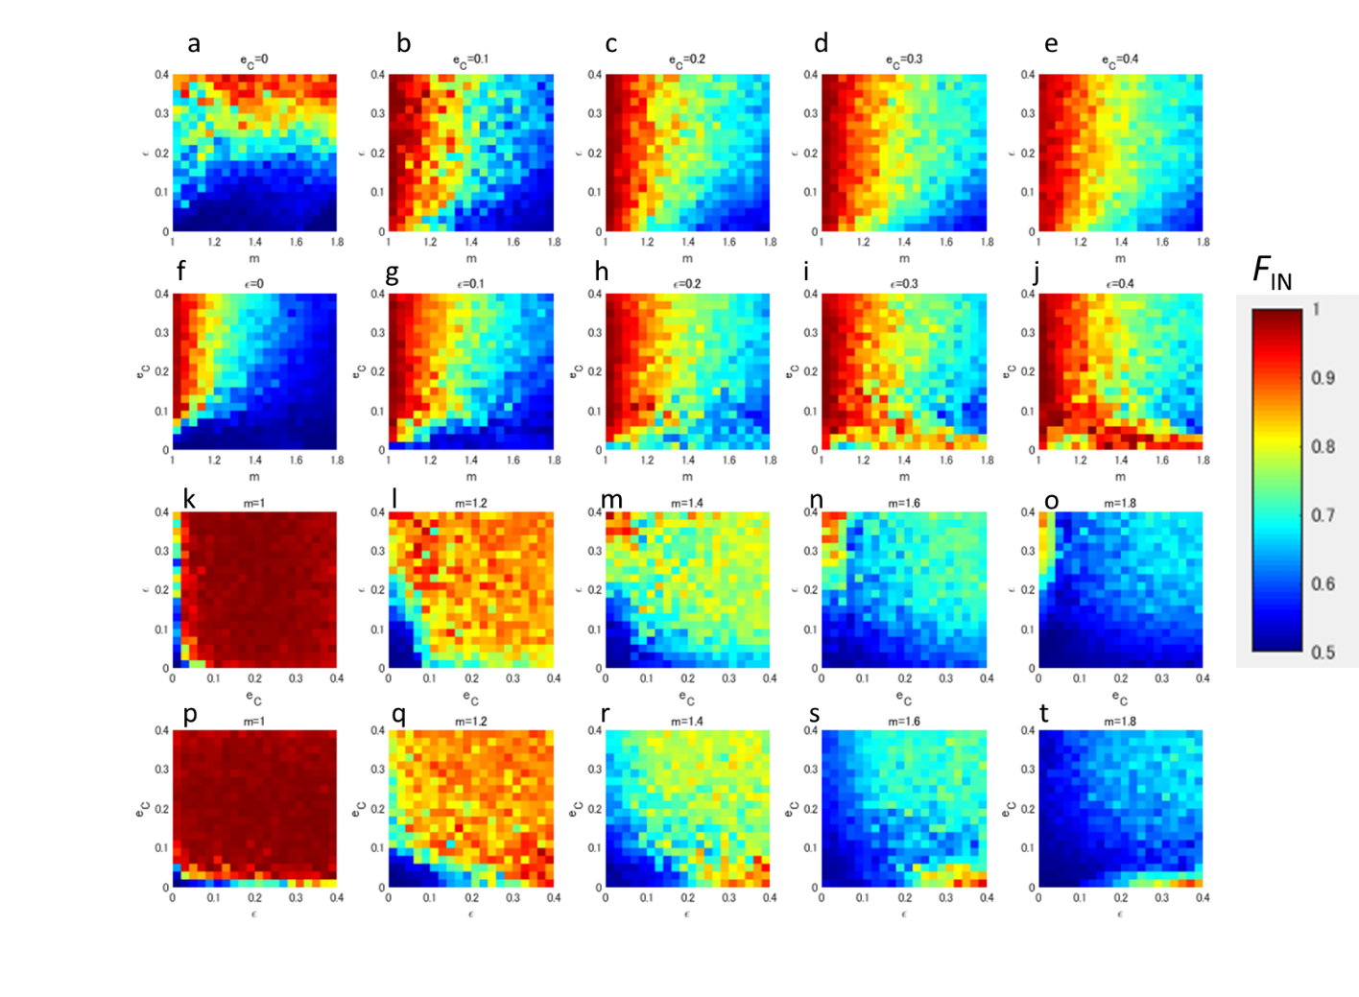
Figure S-1. Dependence of the strength of in-phase synchronisation on m, $ε$ and $e_{C}.$ First row (a), (b), (c), (d), and (e):m vs ε diagram for e_{C} =0, 01, 0.2, 0.3,and 0.4; second row (f), (g), (h),(j) , and (k):m vs e_{C} diagram for ε =0, 01, 0.2, 0.3, and 0.4; third row (k) ,(l), (m), (n) , and (o): $e_{C} vs. ε$diagram for m = 1.0, 1.2, 1.4, 1.6, and 1.8.; fourth row (p),(q), (r),(s) , and (t): $e_{C} vs. ε$diagram for m = 1.0, 1.2, 1.4, 1.6, and 1.8.

Fig. S-1 shows the preliminary parameter study for the essential factors.
In the orchard, F_{IN} ranges from 0.92 to 0.7 in the west-east direction. As shown in the panels of the third and last rows, both $e_{C}$ and $ε$ do not affect the F_{IN} range of the orchard (i.e. F_{IN} =[0.92, 0.7]). Since m is the only parameter changing F_{IN} in that range (i.e. 0.92 to 0.7), we assume that m changes spatially from west to east. The cropping coefficient m is the control parameter of the RBM, which depends on plant species. Common noise $e_{C}$ and the local direct coupling ε vary depending on meteorological environments and the state of the root network developments of the orchards, respectively. Therefore, F_{IN} is considered as a function of m accompanied with endogenous and exogenous parameters;ε and $e_{C}$ respectively. For all panels of Fig. S-1, the phase synchronisations are enhanced by local coupling ε. As exhibited in Figs. S-1(f) and (g) later, ε larger than 0.2 cannot satisfy the feature observed in the spatial correlation of the orchard. Common noise $e_{C}$ enhances phase synchronisation, however, an $e_{C}$ higher than 0.2 does not increase $F_{IN}$ significantly.
Summarising the results and considerations above, we estimate the ranges of the three essential parameters i.e. common noise ($e_{C}$ = 0.2~0.3), local coupling (ε = 0.1) and cropping coefficient (m = 1~1.6, west to east) as general approximation values.

