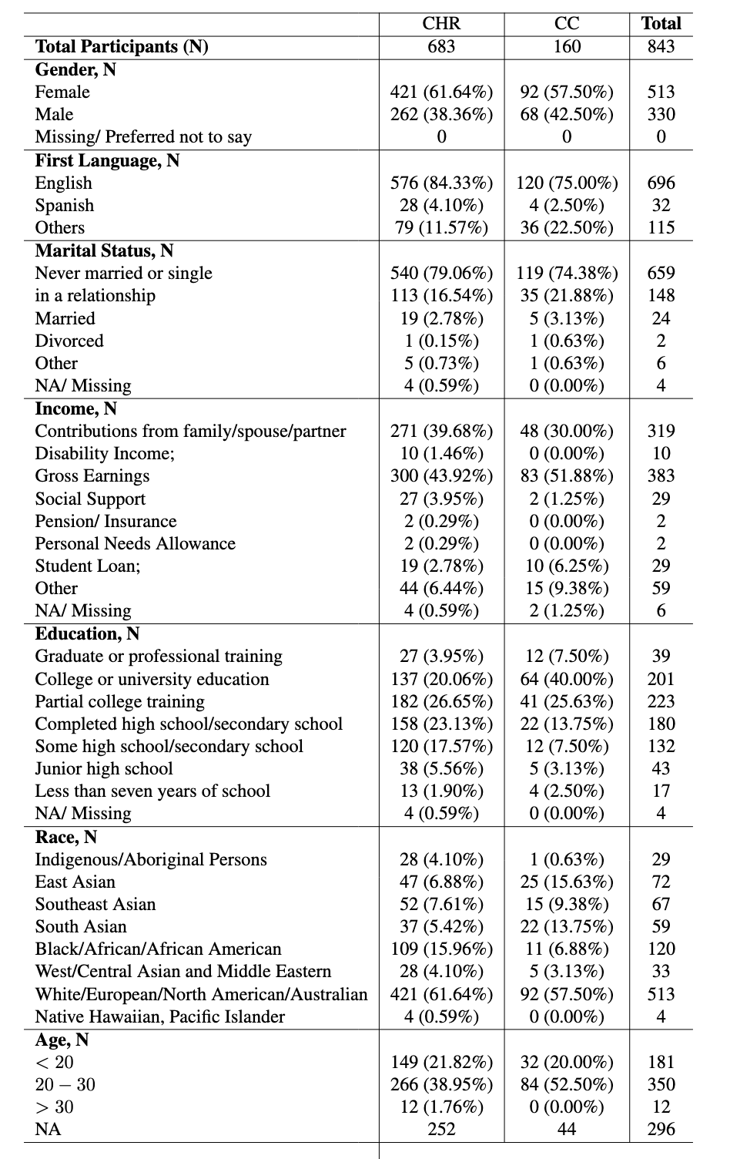
Table 1. Demographic characteristics of community controls and individuals who identified as at clinical high risk for psychosis. Abbreviations: CHR: clinical high risk. CC: community control. NA: not available. The parentheses in each column reflects the percent relative to the sample size of each population category (i.e. CHR or CC).

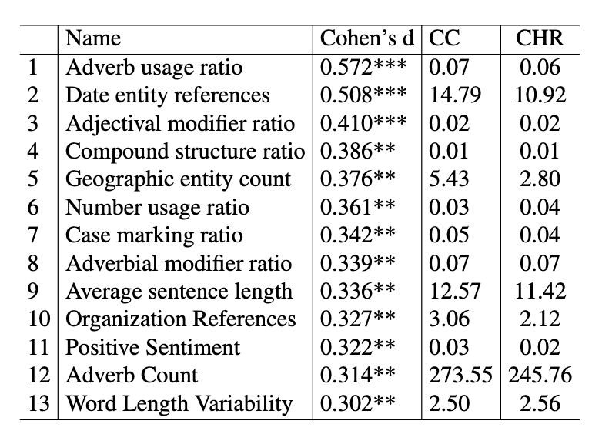

Table 2. OPEN Interview Transcripts: Top 13 features used in our experiments which survived Bonferroni corrections. *** p<0.001, ** p<0.01, * p<0.05. CC: Community control. CHR: Clinical high risk.

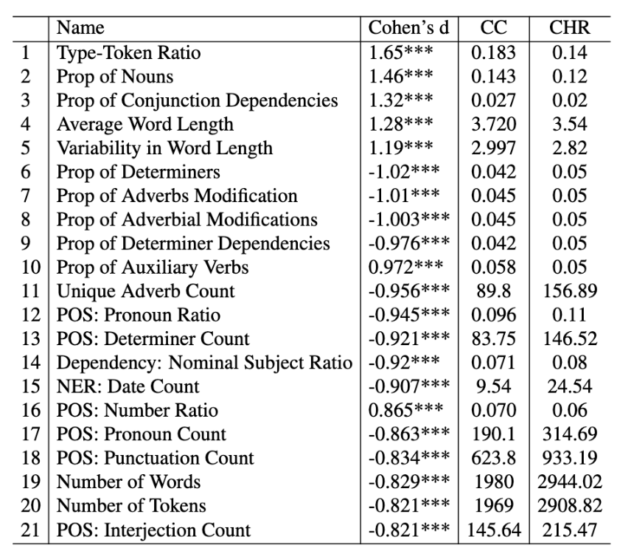
Table 3. PSYCHS Interview Transcripts: Top 21 features used in our experiments which survived Bonferroni corrections. *** p<0.001, ** p<0.01, * p<0.05. Abbreviations: POS: CC: Community control. CHR: Clinical high risk. Part-of-Speech. NER: Named Entity Recognition.
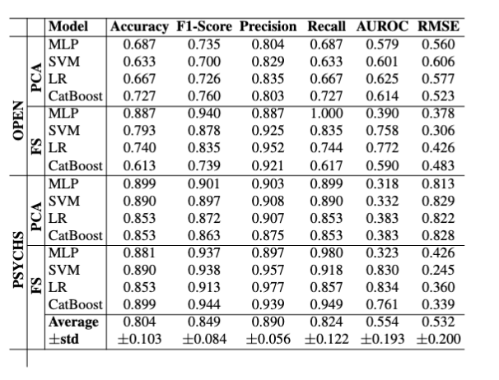
Table 4. NLP-based Results: Results across two different interview formats: an open and a semi-structured PSYCHS interview across two different feature extraction methods. Abbreviation: FS: feature selection. GM: Gaussian mixture. LR: logistic regression. PCA: principal component analysis. std: standard deviation.
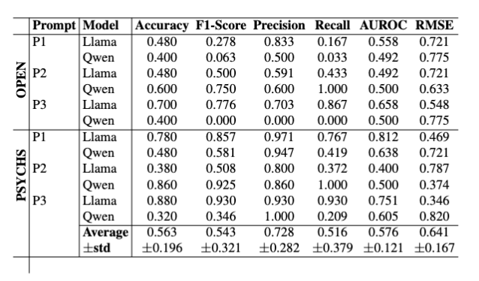
Table 5. LLM-based Results: Results across the 2 different scripts, 2 different LLMs and 3 different prompts. Abbreviations: P1: Prompt 1 (Neutral). P2: Prompt 2 (NLP-based). P3: Prompt 3 (PSYCHS-based). std: standard deviation.

