Supplementary Information
Tower-shaped Super-adhesive Microneedles Loaded with Vitamin A-Containing Bletilla striata Vesicles: Temporally Regulated Inflammation Resolution and ECM Remodeling for Scarless Wound Healing
Shixing Edi^{a,1}, Guopeng Tao^{a,1}, Quluo Mupoª, Jiahong Huª, Huan Guª, Kaijun Gou ^{a,b,c}, Ping Zhou^{d}, Jijun Zhou^{d}, Xiao Wangª*, Rui Zeng ^{a,b,c}*
ª College of Pharmacy and Food, Southwest Minzu University, Chengdu, 610225, China.
^{b} Key Laboratory of Research and Application of Ethnic Medicine Processing and Preparation on the Qinghai Tibet Plateau, Southwest Minzu University.
^{c} Sichuan Zoige Alpine Wetland Ecosystem National Observation and Research Station, Southwest Minzu University, Chengdu 610041, China.
^{d} Leshan City Central District Traditional Chinese Medicine Hospital, 614000 , China.
*Corresponding authors: Xiao Wang, Tel.: +8618408210821; Rui Zeng, Tel.:
+8618081975370. E-mail: Xiao Wangª* ,wangxiao12643@126.com; Rui Zeng ^{a,b,c}* , rzeng@swun.edu.cn.
Present address: Shixing Edi, Guopeng Tao, Quluo Mupo, Jiahong Hu, (residing in the Student Dormitory of Southwest Minzu University), Huan Gu, Kaijun Gou, Xiao Wang, Rui Zeng (residing in the Faculty Apartment of Southwest Minzu University), Ping Zhou, Jijun Zhou (residing in Leshan City).

Supporting Figures
Figure S1 Encapsulation efficiency of BSEVs.
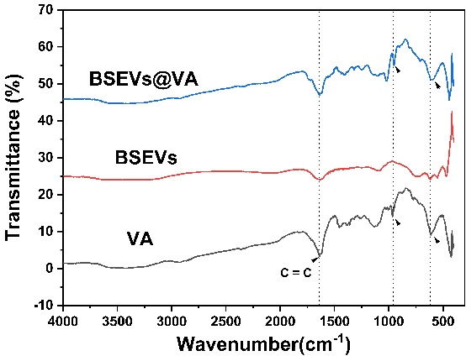
Figure S2 FTIR spectra of BSEVs@VA.
B
A
Figure S3 Release profiles of BSEVs@VA in Different Media. (A)Cumulative release of VA in PBS. (B)Cumulative release of VA in triton-X 100.
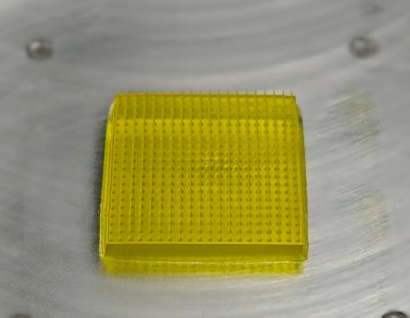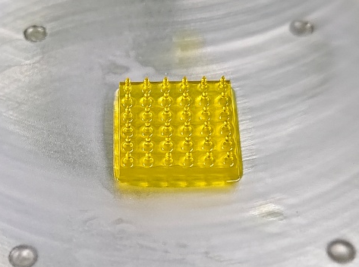
C
A
B
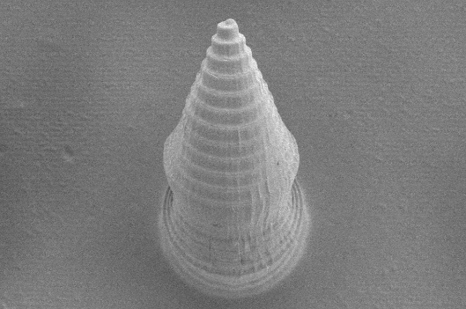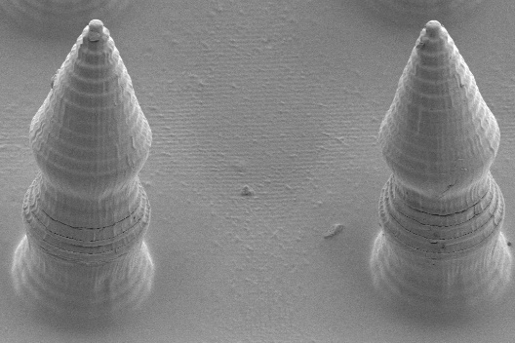

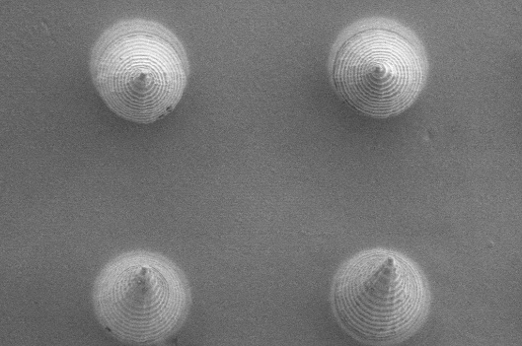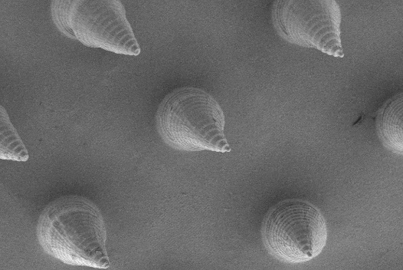
Figure S4 Representative Images of MNs.(A)3D-Printed 20×20 Microneedle Array.(B) 3D-Printed 6×6 Microneedle Array.(C) Supplementary SEM Images of MNs.
Figure S5 Cumulative release profiles of BSEVs@VA-HP MNs.
Figure S6 The degradation behavior of MNs in PBS with Hyaluronidase.
B
A
C
Figure S7 Cytotoxicity Assays on (A)L929 Cells, (B)HUVECs, and (C)RAW264.7 Cells.
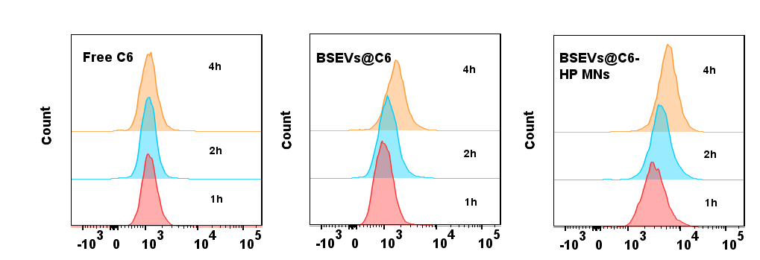
D
C
B
A
Figure S8 The uptake efficiency of Free C6 group.(A) BSEVs@VA group (B)and BSEVs@VA-HP MNs group (C) in L929 cells were tested using flow cytometry.(D) Quantitative analysis of flow cytometry data.
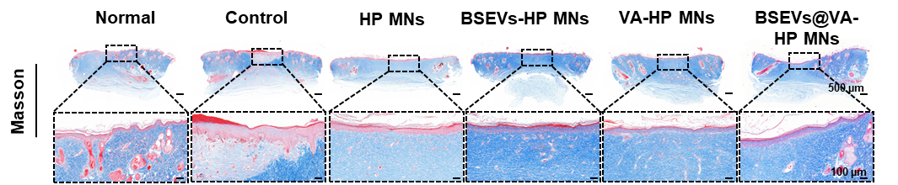
Figure S9 Masson staining images of rat wound.
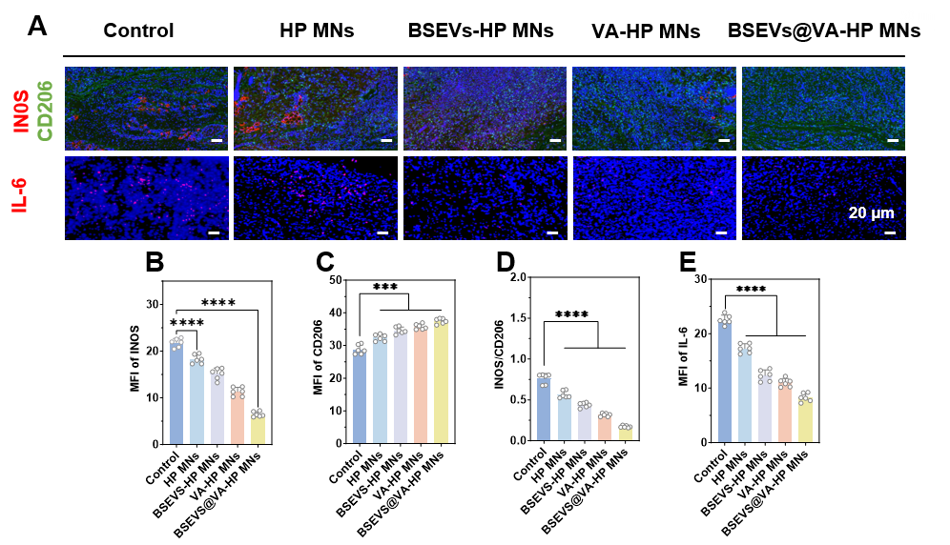Figure S10 (A)Immunofluorescence staining images about INOS,CD206 and IL-10 of rat wounds on day 7. Scale bar, 20μm.(B-E) Quantitative analysis of INOS,CD206,IL-6 via immunofluorescence staining.
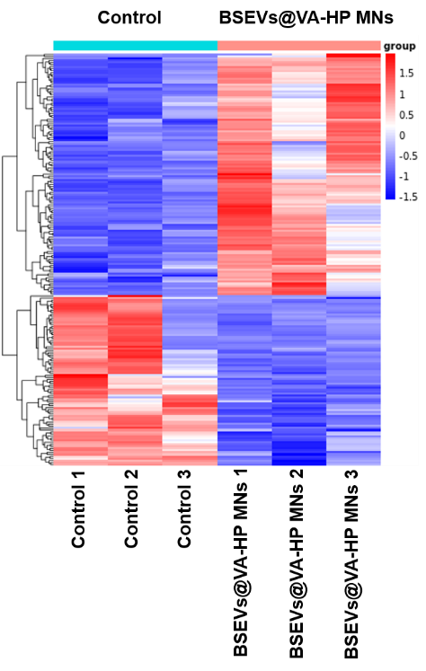
Figure S11 Heatmap analysis of differentially expressed genes(red = upregulation; blue = downregulation).
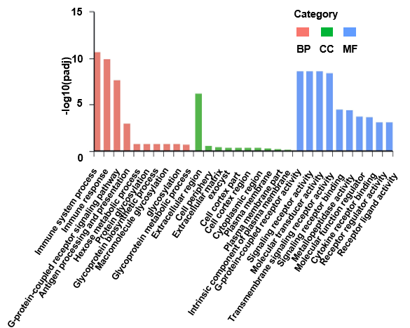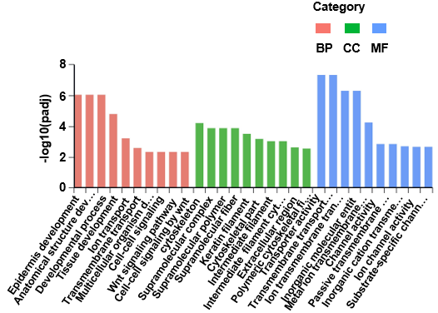
B
A
Figure S12 (A) Down-regulation of GO analysis of differentially expressed genes. (B) Up-regulation of GO analysis of differentially expressed genes.

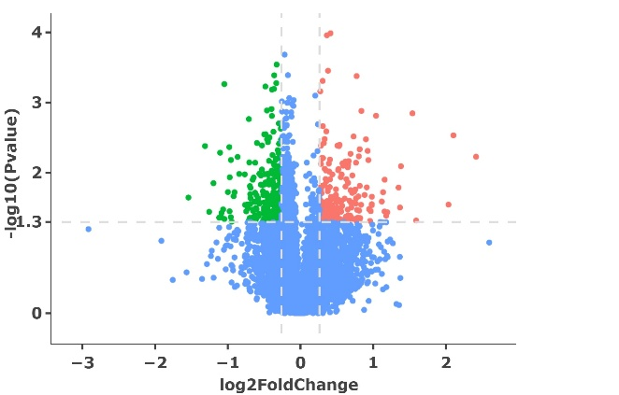
NO 10270
UP 197
DOWN 239
Figure S13 Proteomic analysis of differentially expressed proteins in volcano map.
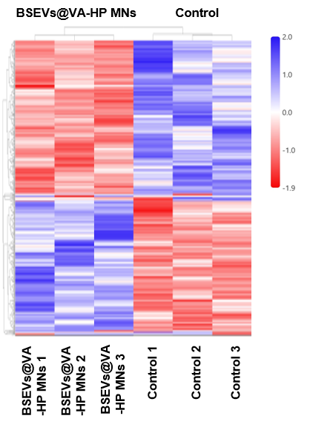
Figure S14 Heatmap analysis of differentially expressed proteins.
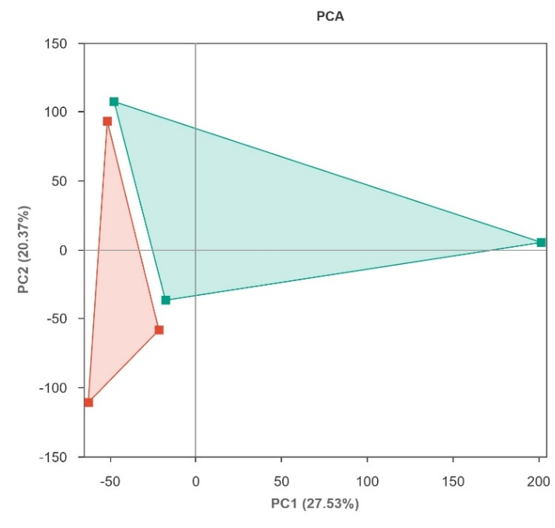
Figure S15 PCA score plot showing the separation of BSEVs@VA-HP MNs and Control Groups(Green: control group; red: BSEVs@VAP-HP MNs group).
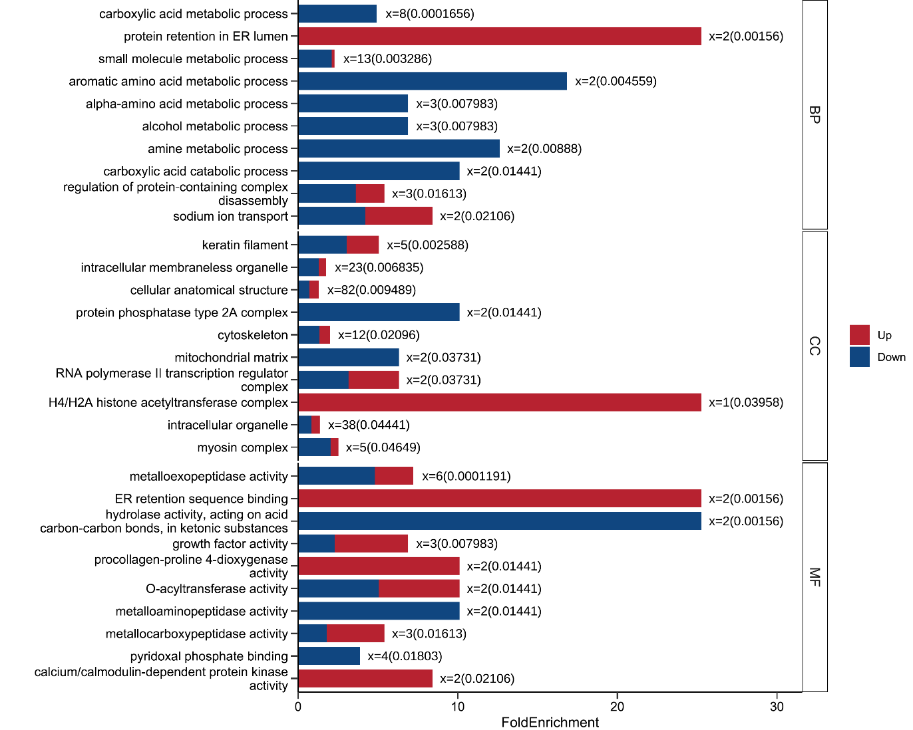
Figure S16 GO analysis of upregulated and downregulated differentially expressed proteins.
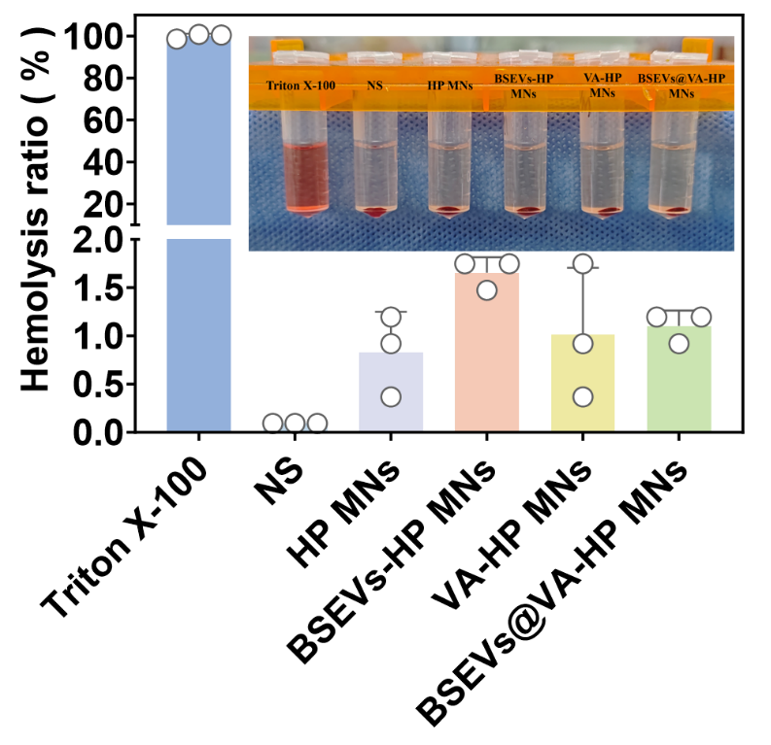
Figure S17 Hemolysis assays of different microneedle groups.
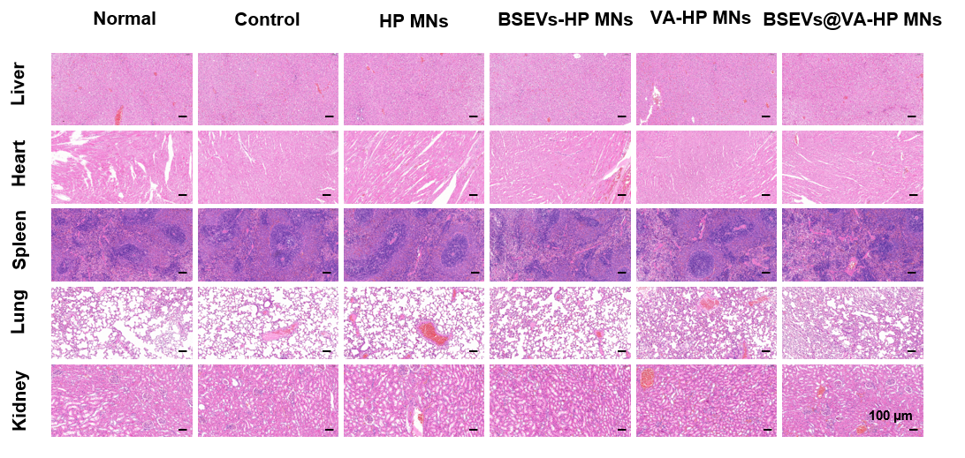
Figure S18 Biocompatibility of MNs. H&E staining images of major organs (heart, liver, spleen, lung, kidney) of rats following 14 days of various treatments. Scale bar, 100 µm.

