Urban Ecosystems
Impact of urbanisation on the diversity and abundance of butterflies along an urban gradient in Guwahati, Assam, India

Nayanjyoti Moran¹, Renu Gogoi², Narayan Sharma¹

¹Department of Environmental Biology and Wildlife Sciences, Cotton University, Panbazar, Guwahati 781001, Assam, India
²Department of Zoology, Cotton University, Panbazar, Guwahati 781001, Assam, India

Email: narayan.sharma@cottonuniversity.ac.in (*corresponding author)

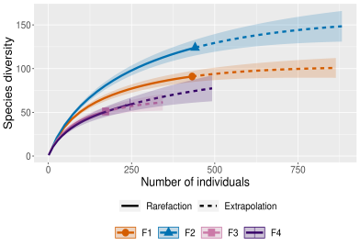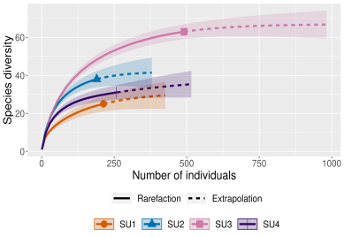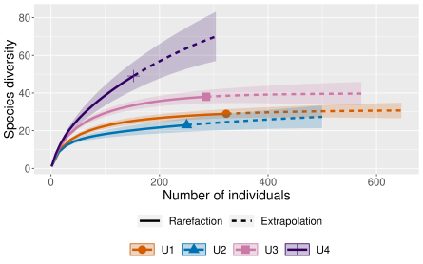
Forest Semi-urban Urban
Fig. S1 Species accumulation curves for butterfly communities across three habitat types

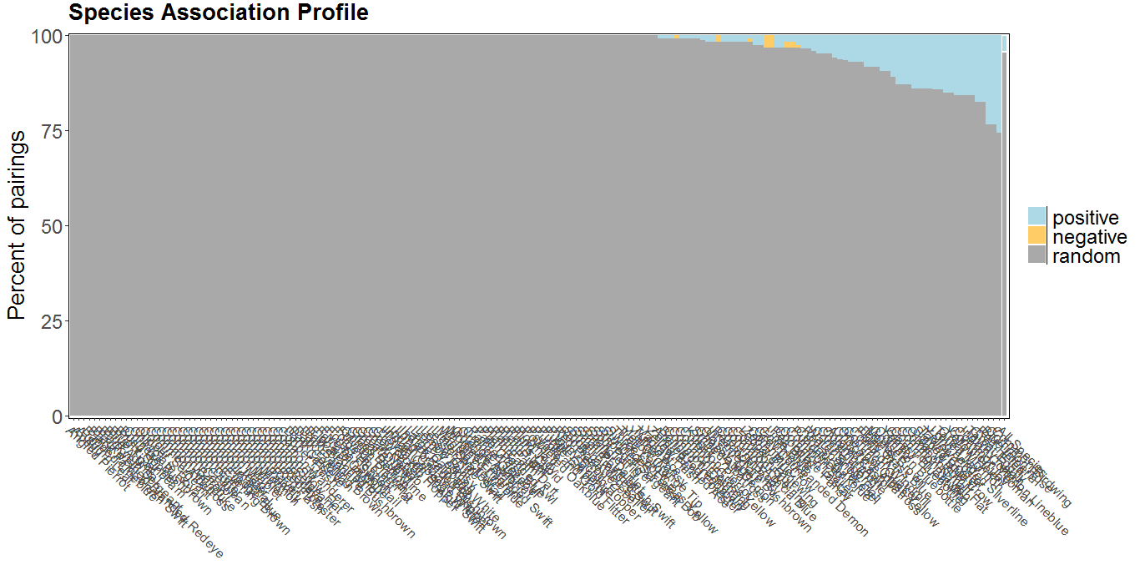
Fig. S2 Plot showing the percent of total pairings for each species that are positive, negative, or random
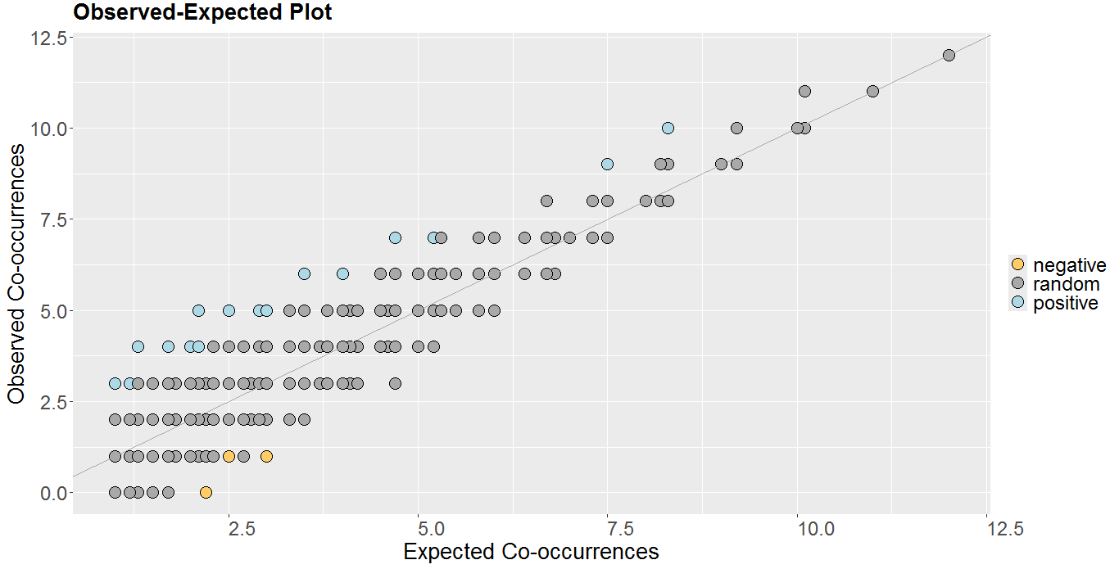
Fig. S3 Observed versus expected co-occurence scatter plot

