Variables (变量) | β | S.E | Z | P | OR (95%CI)
SPAP-rest | 0.12 | 0.04 | 2.87 | 0.004 | 1.13 (1.04 ~ 1.23)
TV s′-rest | 50.58 | 19.04 | 2.66 | 0.008 | 9.25e21 (5.79e5 ~ 1.48e38)
TAPSE/SPAP-rest | -7.37 | 3.27 | -2.25 | 0.024 | 0.00 (0.00 ~ 0.38)
IVC-peak | 0.24 | 0.11 | 2.22 | 0.026 | 1.27 (1.03 ~ 1.56)
mPAP-peak | 0.21 | 0.07 | 2.87 | 0.004 | 1.23 (1.07 ~ 1.42)
PVR-peak | 5.27 | 1.94 | 2.71 | 0.007 | 194.78 (4.32 ~ 8776.40)
SPAP-peak | 0.1 | 0.04 | 2.34 | 0.019 | 1.10 (1.02 ~ 1.20)
TR -peak | 3.44 | 1.21 | 2.85 | 0.004 | 31.24 (2.93 ~ 332.70)
mPAP/CO slope | 0.56 | 0.25 | 2.28 | 0.023 | 1.76 (1.08 ~ 2.86)
ΔPVR | 0.06 | 0.02 | 2.85 | 0.004 | 1.06 (1.02 ~ 1.11)
ΔTV s′ | -0.23 | 0.1 | -2.4 | 0.016 | 0.79 (0.65 ~ 0.96)

Supplemental Table 1. Significant univariable predictors (P < 0.05) entered into the multivariable model.

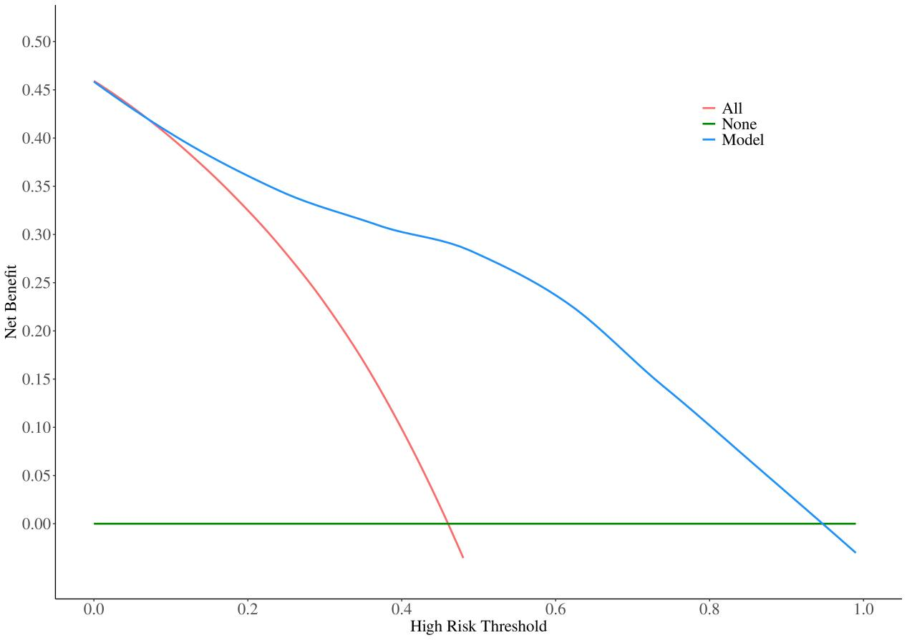
Supplemental Figure 1 Decision curve analysis (DCA) curves.
Supplemental Figure 2A, Clinical Impact Curve of ΔPVR.

Supplemental Figure 2B, Clinical Impact Curve of IVC-peak.
Supplemental Figure 2C, Clinical Impact Curve of ΔTV s′.

