Supplemental Table 1. Primers used for cloning, real-time PCR and dsRNA synthesis.

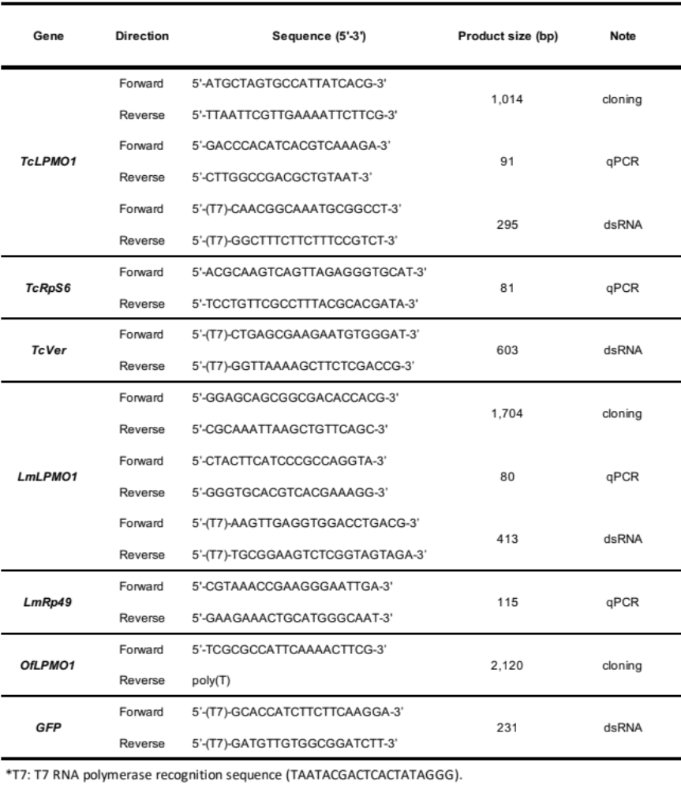

Supplemental Table 2. Accession numbers of insect LMPO1s used for the amino acid sequence alignment and phylogenetic analysis.

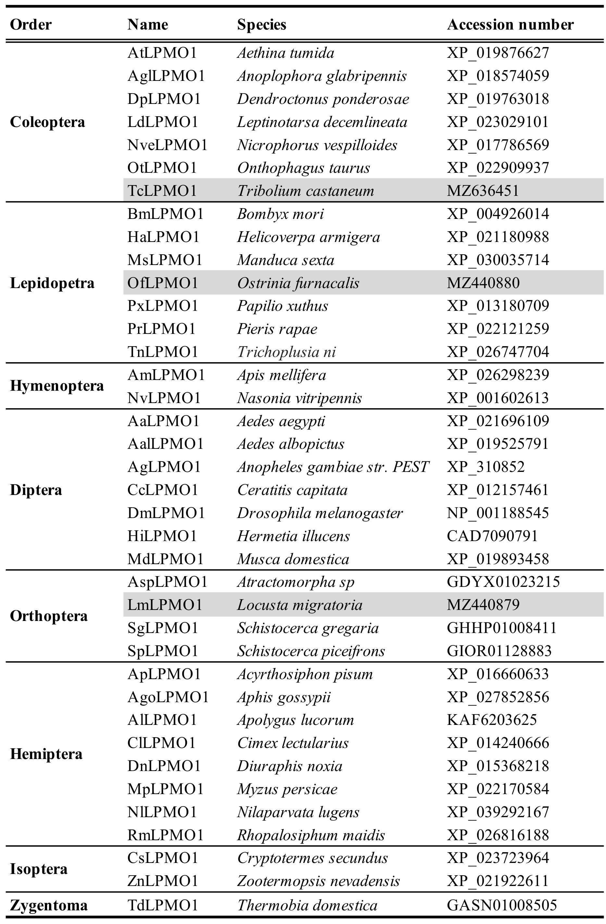
Supplementary Fig. 1

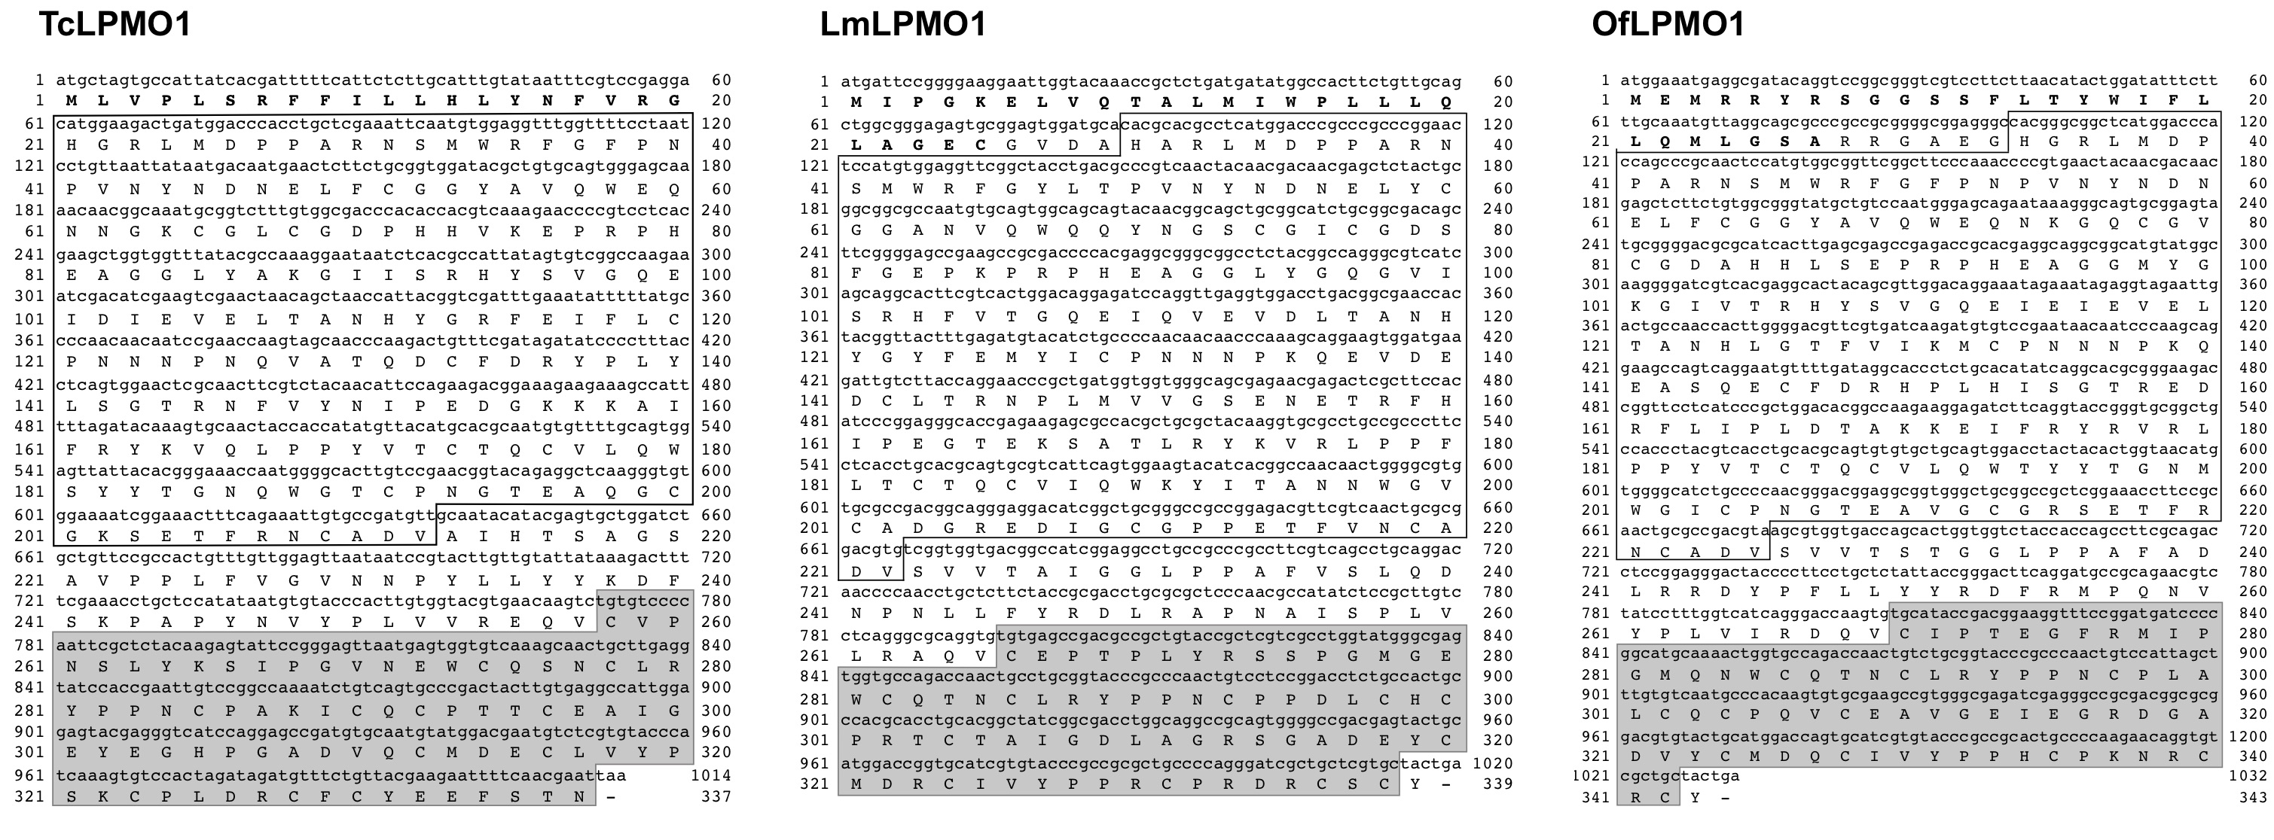
Supplementary Fig. 2
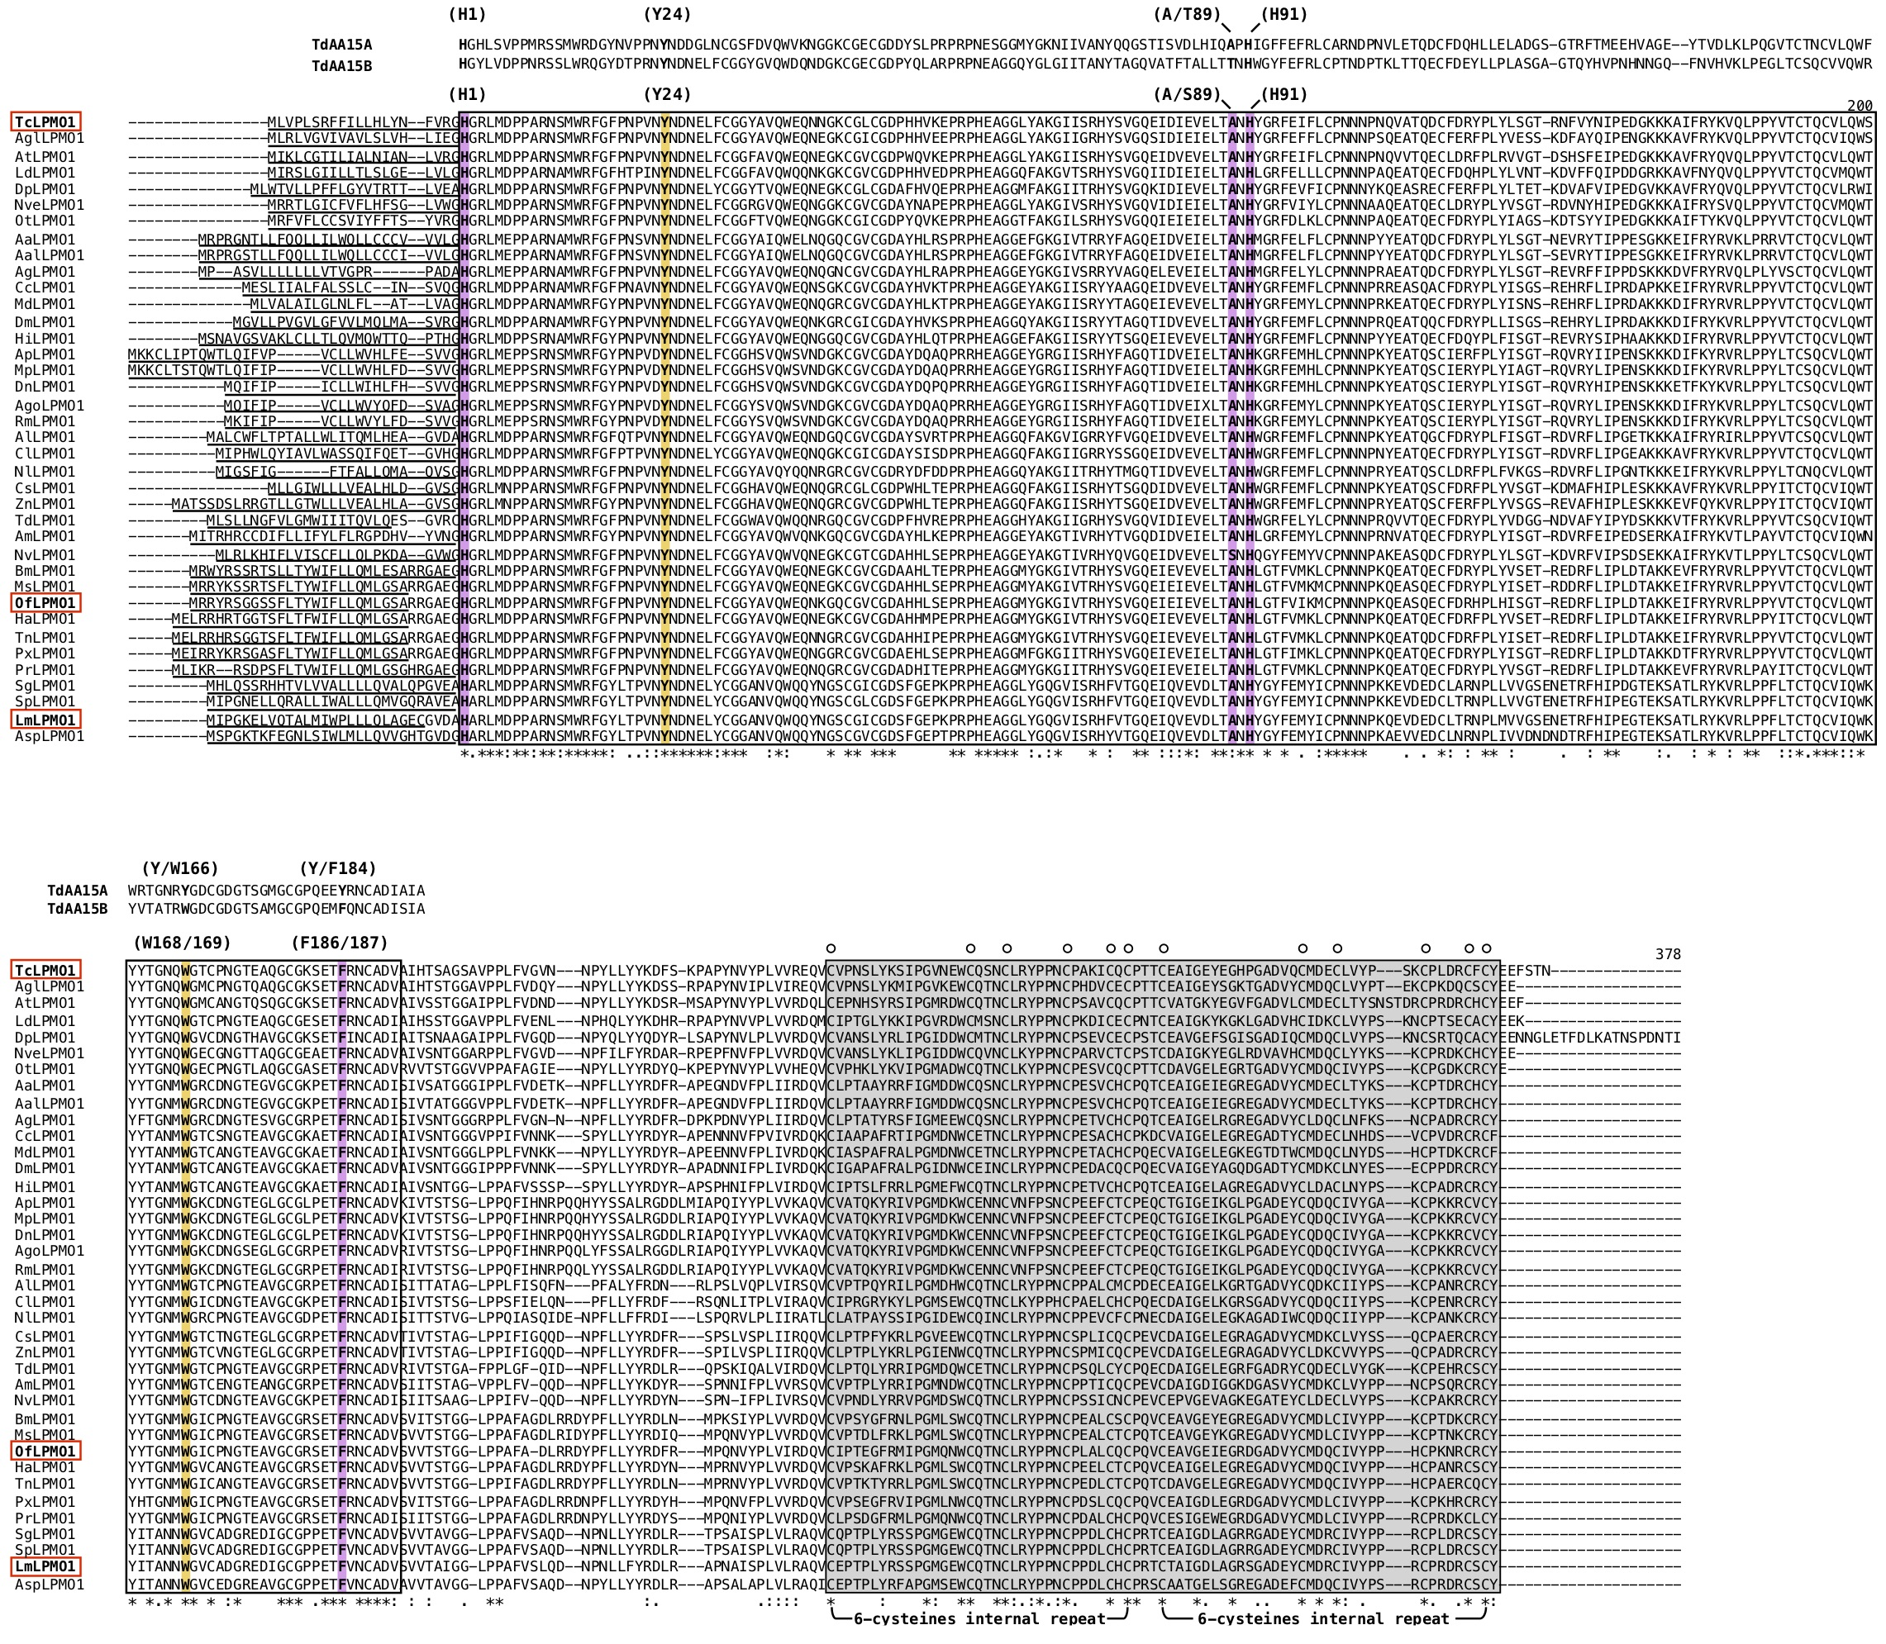

Supplementary Fig. 3

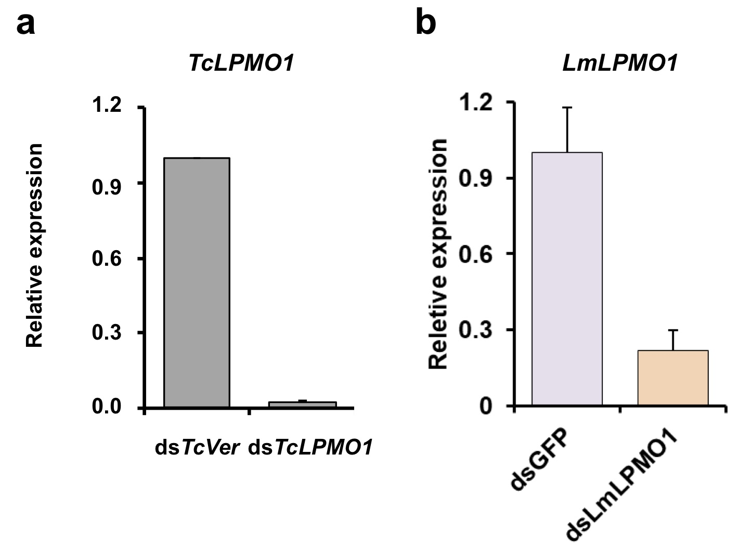
Supplementary Fig. 4

