Supplementary Materials for

CCR1 Signaling as a Common Injury Pathway in Retinal Degeneration
Sarah Elbaz-Hayoun et al.

*Corresponding author. Email: chowers@hadassah.org.il

This PDF file includes:

Figs. S1

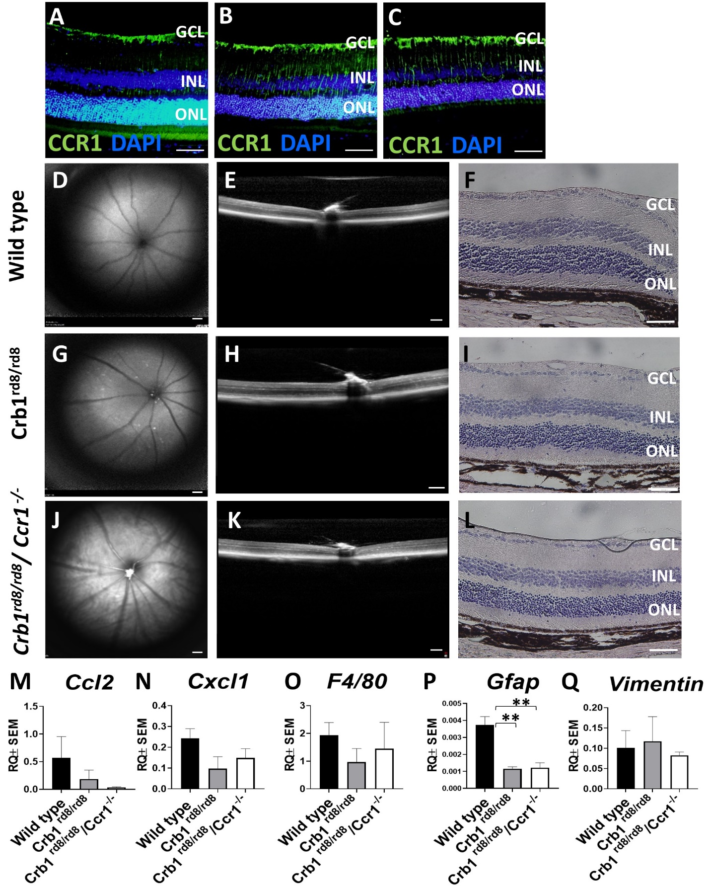
Fig. S1. Retinal imaging, histology and inflammation in Crb1^{rd8}/ ^{rd8}/Ccr1^{-/-}mice. (A-C) Enhanced CCR1 signal is detected in retina of Crb1^{rd8}/^{rd8} mice at the age of 10 and 15 months (B and C, respectively) compared with wild-type mice at the age of 15 months (A). (D-L) At 10 months, fundus auto-fluorescence (FAF) showed no abnormal retinal lesions in any of the groups (D, G, J), and OCT imaging (E, H, K), and histological analysis (F, I, L) showed no retinal structural alterations. (M-Q) qPCR analysis of Ccl2, Cxcl1, F4/80 and Vimentin demonstrated similar expression levels across the three groups (n=4 per group; M, N, O, Q). Gfap mRNA levels were upregulated in wild-type mice compared to Crb1^{rd8}/ ^{rd8} and Crb1^{rd8}/ ^{rd8}/Ccr1^{-/-} mice (n=4 per group; P). GCL, ganglion cell layer; INL, inner nuclear layer; ONL, outer nuclear layer. Data shown as mean ± SEM. p-values indicated by **p<0.01, one-way ANOVA with correction for multiple comparisons. Scale bars: 200 µm (A-L).

