Supporting Information File (SIF)

Unveiling a ternary MOF-derived LDH nanoarchitecture utilized for photocatalytic degradation of Meropenem pharmaceutical contaminant from wastewater: Developing thorough chemical mechanism
Seyed Ali Hosseiniª, Mohammad Kazemeini^{a,}*, Alireza Mohammadiª
ª Department of Chemical and Petroleum Engineering, Sharif University of Technology, Tehran, Iran
*:Corresponding Author, E-mail: kazemini@sharif.edu

This file contains:
Four sections
Four figures
Two Tables
And
7 References.
S-1. Materials and Instrumentation
S-1.1. Materials
To carry out this research, the following chemicals were used: Chromium (III) nitrate nonahydrate (Cr(NO₃)₃·9H₂O), Iron (III) chloride hexahydrate (FeCl₃·6H₂O), Terephthalic acid (C₈H₆O₄), Fumaric acid (C₄H₄O₄), Nickel (II) nitrate hexahydrate (Ni(NO₃)₂·6H₂O), Urea (NH₂CONH₂), N,N-dimethylformamide (DMF), Ethanol (C₂H₆O) and Hydrofluoric acid (HF). All chemicals were obtained from Sigma-Aldrich and were used without any additional purification or processing. Meropenem (MER), the pharmaceutical pollutant investigated in this study, was supplied by the Jaber-Ibn-Hayyan Pharmaceutical Company. Deionized water (with TDS ≈ 0) was used in all experimental procedures throughout the research.
S-1.2. Instrumentation
X-ray diffraction (XRD) patterns were obtained using a PANalytical X'Pert PRO MPD diffractometer with Cu Kα radiation over a 2θ range of 0.4°–78°. The surface morphology and elemental composition of gold-coated samples were analyzed using a Field Emission Scanning Electron Microscope (FESEM) coupled with Energy-Dispersive X-ray Spectroscopy (EDS) on a TESCAN MIRA 3 LMU instrument operating at 15 kV. Fourier Transform Infrared (FTIR) spectra were obtained using a PerkinElmer Spectrum RX I spectrometer with KBr pellets. X-ray Photoelectron Spectroscopy (XPS) analysis was carried out on a Specs EA10 Plus system (Bestec) using Al Kα radiation, with binding energies calibrated against the C 1s peak at 284.8 eV [1]. Diffuse Reflectance Spectroscopy (DRS) measurements were performed on a SHIMADZU UV-2700 spectrophotometer, employing BaSO₄ as the reflectance standard. Thermogravimetric analysis (TGA) was conducted under a nitrogen atmosphere at a heating rate of 10 °C min-1 using a METTLER TOLEDO instrument. Nitrogen adsorption–desorption isotherms were recorded at 77 K using a BELSORP-mini II system (BEL, Japan) to evaluate surface area and pore characteristics, with total pore volume determined at P/P₀ = 0.981. Electrochemical impedance spectroscopy (EIS) was performed using a Corrtest CS350 system. Zeta potential measurements were conducted using a Malvern ZN Series instrument. Inductively Coupled Plasma (ICP) analysis was carried out using a Vista-Pro ICP spectrometer. High-Performance Liquid Chromatography–Mass/Mass Spectrometry (HPLC-MS/MS) was performed with a Shimadzu UFLC LC-AD20 system coupled to a 3200 QTRAP mass spectrometer (AB Sciex, MA, USA). Lastly, UV–Vis spectrophotometric analysis of drug photodegradation was conducted using a Mecasys spectrophotometer
S-2. Preparation of Catalyst

S-2.1. Synthesis of MIL-101(Cr)
MIL-101(Cr) was synthesized according to a previously reported method [2]. In this procedure, 1.1067 g of terephthalic acid and 2.67 g of Cr(NO₃)₃·9H₂O were dissolved in 30 mL of deionized water in a plastic beaker under ultrasonic agitation. Subsequently, 0.45 mL of HF was added to the solution, followed by an additional hour of sonication. The resulting mixture was transferred to a 50 mL Teflon-lined autoclave and heated at 220 °C for 8.5 hours. After cooling, the green solid product was dispersed in a 1:1 (v/v) mixture of DMF and water (total volume: 100 mL) and stirred magnetically for 1 hour to enhance purification. The suspension was then centrifuged, and the resulting precipitate was washed three times with deionized water. Finally, the purified MIL-101(Cr) was obtained by drying the solid at 65 °C overnight.

S-2.2. Synthesis of MIL-88A(Fe)
MIL-88A(Fe) was synthesized according to a previously reported method [3]. Specifically, 1.893 g of FeCl₃·6H₂O and 0.812 g of fumaric acid were completely dissolved in 35 mL of deionized under continuous magnetic stirring to yield a clear solution. This solution was subsequently transferred into a 50 mL Teflon-lined autoclave and subjected to thermal treatment at 65 °C for 12 hours. Upon cooling to ambient temperature, the resulting solid was recovered by centrifugation and washed thoroughly three times with deionized water. The final product was dried at 65 °C overnight to obtain purified MIL-88A(Fe).

S-2.3. Synthesis of MCr/MFe
MCr/MFe was carried out following a previously reported procedure with slight adjustments [4]. Solution A was prepared by dispersing 0.3 g of MIL-101(Cr) in 30 mL of deionized water under magnetic stirring, using a capped Erlenmeyer flask. Simultaneously, Solution B was obtained by dispersing 0.3 g of MIL-88A(Fe) in 30 mL of deionized water under the same conditions. Solution B was then added dropwise into Solution A while stirring was maintained at room temperature. The resulting mixture was continuously stirred for 48 hours. Afterward, the supernatant was removed by filtration, and the collected solid was washed three times with deionized water. Finally, the MCr/MFe composite was obtained by drying the product at 65 °C overnight.

S-2.4. Synthesis of Ni-MCr LDH
Ni-MCr LDH was synthesized according to a previously described method. In this procedure, 46.5 mg of the synthesized MIL-101(Cr) powder was suspended in 12 mL of deionized water to prepare Solution A. Separately, Solution B was prepared by dissolving 418.8 mg of Ni(NO₃)₂·6H₂O and 288.5 mg of urea in 24 mL of deionized water, followed by stirring until a clear solution was obtained. Solution B was then added dropwise to Solution A under continuous magnetic stirring to form Solution C. The resulting mixture was transferred into a Teflon-lined autoclave and heated at 120 °C for 12 hours. After cooling naturally to room temperature, the solid product was washed three times with deionized water and dried at 65 °C overnight to obtain the final Ni-MCr LDH composite.

S-2.5. Synthesis of Ni-MCr LDH
Ni-MFe LDH was synthesized using a previously reported approach [5]. In this procedure, 50 mg of the synthesized MIL-88A(Fe) powder was dispersed in 10 mL of absolute ethanol under magnetic stirring to prepare Solution A. Separately, Solution B was prepared by dissolving 450 mg of Ni(NO₃)₂·6H₂O and 300 mg of urea in 15 mL of deionized water and stirring until a homogeneous solution was obtained. Solution B was then added to Solution A under continuous magnetic stirring at room temperature to form Solution C. The resulting mixture was transferred into a Teflon-lined autoclave and heated at 90 °C for 6 hours. After cooling to room temperature, the obtained solid was washed three times with absolute deionized water and dried at 65 °C overnight to yield the final Ni-MFe LDH product.

S-2.6. Synthesis of Ni-MCr LDH/Ni-MFe LDH
The Ni-MCr LDH/Ni-MFe LDH composite was synthesized according to a previously reported [4]. In this process, Solution A was prepared by dispersing 0.3 g of Ni-MCr LDH in 30 mL of deionized water under magnetic stirring in a capped Erlenmeyer flask. Concurrently, Solution B was prepared by dispersing 0.3 g of Ni-MFe LDH in 30 mL of deionized water under identical conditions. Solution B was then added dropwise to Solution A under continuous magnetic stirring at room temperature. The resulting mixture was stirred for 48 hours. Subsequently, the supernatant was removed by filtration, and the solid residue was washed three times with deionized water. The final Ni-MCr LDH/Ni-MFe LDH composite was obtained by drying the collected solid at 65 °C overnight.

S-2.7. Synthesis of Ni-[MCr/MFe] LDH
Ni-[MCr/MFe] LDH DH was synthesized following a previously established procedure [5–7]. In this process, 46.5 mg of the synthesized MCr/MFe powder was dispersed in 12 mL of deionized water under magnetic stirring to prepare Solution A. Simultaneously, Solution B was obtained by dissolving 418.8 mg of Ni(NO₃)₂·6H₂O and 288.5 mg of urea in 24 mL of deionized water, followed by stirring until a clear solution was formed. Solution B was then added dropwise to Solution A under continuous magnetic stirring at room temperature. The resulting mixture was transferred into a Teflon-lined autoclave and heated at 120 °C for 12 hours. After cooling to room temperature, the resulting solid was washed three times with deionized water and dried at 65 °C overnight to obtain the final Ni-[MCr/MFe] LDH composite.
S-3. Results and discussion
S-3.1. Materials characterization
For detailed morphology analysis of other synthesized materials, field-emission scanning electron microscopy (FESEM) was employed. In Figures S1. (a, b), MIL-101(Cr) exhibits a distinct octahedral morphology, consistent with previous studies [2]. Figures S1. (c, d) show MIL-88A(Fe), where well-crystallized, needle-shaped microrods with pyramidal tips at both ends are observed, in agreement with earlier research [3]. Figures S1. (e, f) represent the MCr/MFe composite. In this structure, particles of both MILs are partially fragmented and deposited on each other, with MIL-101(Cr) particles predominantly located on the surface of MIL-88A(Fe). This composite formation resembles previously reported MIL/MIL combinations [4]. Figure S1. (g) shows the Energy Dispersive X-ray (EDX) and elemental mapping results of the MCr/MFe composite. It confirms the presence of Cr uniformly distributed on the MIL-88A(Fe) surface.
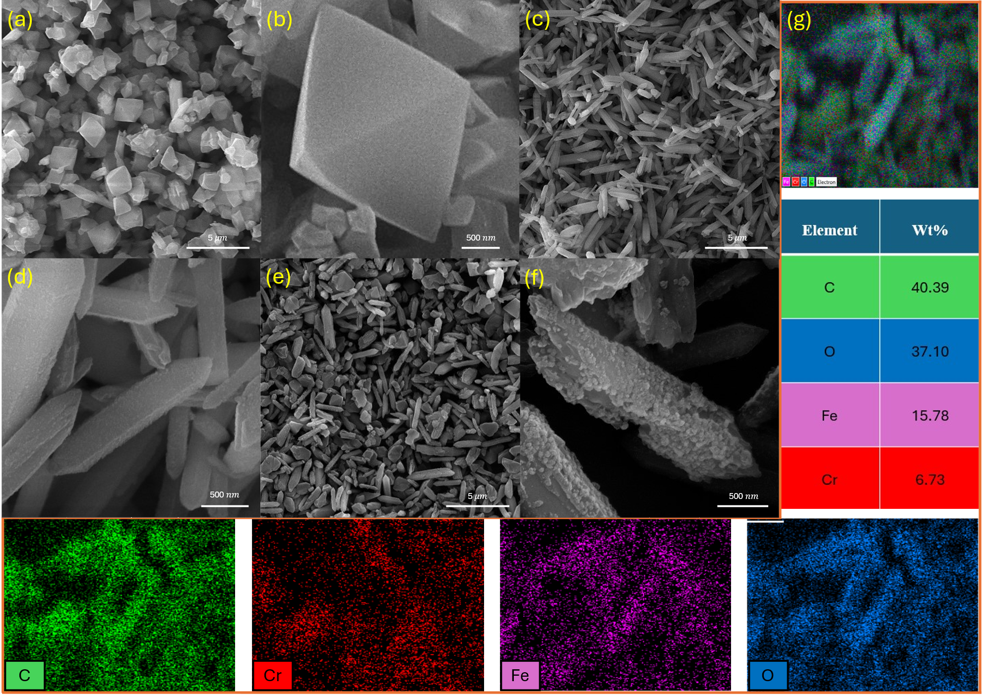
Figure S1. FESEM images of (a–b) MIL-101(Cr), (c–d) MIL-88A(Fe), and (e–f) MCr/MFe composites, and (g) EDX and elemental mapping of MCr/MFe.
S-3.2. Ni-[MCr/MFe] LDH and other synthesized catalysts: assessment of their adsorption and photocatalytic behavior for MER removal
The photocatalytic removal of MER was systematically investigated using a series of Cr- and Fe-based catalysts (Fig. 5e). The parent framework MIL-101(Cr) achieved only 37.72% removal under UV irradiation, whereas its layered derivative Ni-MCr LDH exhibited a markedly higher efficiency, achieving 96.50% removal. Despite its strong adsorption capacity, Ni-MCr LDH suffered from a wide band gap and high charge-transfer resistance. To overcome these limitations, MIL-88A(Fe) was employed as a precursor to synthesize Ni-MFe LDH, which exhibited a narrower band gap, lower resistance, and lower cost. While MIL-88A(Fe) alone removed 55.73%, the layered Ni-MFe LDH improved performance to 75.76%, confirming the advantage of LDH formation.
To further integrate the merits of both systems, composite strategies were investigated. The Ni-MCr LDH/Ni-MFe LDH, achieved only 66.89% removal, indicating that simple hybridization could not retain the favorable properties of each material. In parallel, a mixed-metal precursor, denoted as MCr/MFe, was prepared by combining MIL-101(Cr) and MIL-88A(Fe), which initially removed 55.27%. After transformation into the layered structure, the resulting Ni-[MCr/MFe] LDH successfully combined the strong adsorption of Ni-MCr LDH with the superior electronic properties (narrow band gap and low resistance) of Ni-MFe LDH. This optimized catalyst exhibited outstanding performance under visible light, achieving 98.1% removal of MER. For MIL-101(Cr) and Ni-MCr LDH, adsorption–desorption equilibrium was reached within 30 min, whereas for Ni-MFe LDH, Ni-MCr LDH/Ni-MFe LDH, MCr/MFe, and the final Ni-[MCr/MFe] LDH, equilibrium occurred after approximately 45 min.
Compared to other photocatalysts listed in Table S1, Ni-[MCr/MFe] LDH demonstrates multiple significant benefits. The catalyst dosage relative to the concentration of the drug in this study has been carefully optimized, leading to improved catalytic performance. For example, although NiCo₂O₄@MOF-801@MIL-88A was applied at a moderately low concentration, MER removal was limited to 60%. Similarly, D3-g-C₃N₄ and TiO₂@Fe₂O₃/Chitosan showed similar performance; despite this, the first sample required nearly twice as much catalyst per reaction volume and was assessed at only 10 mg L⁻¹ MER; in contrast, the latter involved a more complicated synthesis and the employment of chemical reducing agents. In contrast to Ni-MCr LDH, which operates effectively only under UV irradiation, Ni-[MCr/MFe] LDH demonstrates outstanding photocatalytic performance under visible-light illumination. Moreover, the catalyst maintained excellent structural stability and retained over 95% of its removal efficiency after five successive cycles, confirming its robust reusability. These findings highlight the remarkably enhanced efficiency, operational simplicity, and practical applicability of Ni-[MCr/MFe] LDH for the treatment of pharmaceutical wastewater in comparison with other catalysts.
Table S1. Comparison of Photocatalytic MER Removal by Various Photocatalysts
Photocatalysts | Photocatalyst dosage (mg/mL of solution) | Concentration of MER (mg/L) | Removal efficiency (%) | Reduction in removal performance (cycles / %) | Time (min): dark + light | Light Source | Ref.
TiO₂/Fiberglass | 101.7/25 | 100 | 83.79 | 5/11 | 35 + 60 | UV | [8]
TiO₂ | 500/1000 | 25 | >90 | - | 30+300 | SUN | [9]
TiO₂@Fe₂O₃/Chitosan* | 500/1000 | 25 | 95.64 | 5/15.64 | 60 + 30 | Visible | [10]
D3-g-C₃N₄ | 50/50 | 10 | 99 | - | 30 + 10 | Visible | [11]
NiCo₂O₄@MOF-801@MIL88A | 5/50 | 100 | 60 | - | 30 + 75 | Visible | [12]
MCN | 100/100 | 2 | 93 | - | 60 | Visible | [13]
Ni-MCr LDH | 50/100 | 25 | 96.05 | 5/5.46 | 30 + 150 | UV | [5]
Ni-[MCr/MFe] LDH | 50/100 | 25 | 98.1 | 5/4.73 | 45 + 180 | Visible | This work
*: Use Peroxymonosulfate (2mM)
S-3.3. Kinetic Studies
The kinetics of MER removal over Ni-[MCr/MFe] LDH were evaluated under two distinct regimes: dark adsorption and light-driven photocatalysis. Kinetic parameters were obtained by linear regression, and the goodness of fit was assessed using the coefficient of determination (R²).
The pseudo-first-order (PFO) kinetic model, which is commonly applied to physisorption processes and the early stages of photocatalytic degradation, was employed according to its linearized concentration-based form (Eq. S1)[14,15]:
Eq. (S1)
where C₀ and C (mg L⁻¹) represent the initial and time-dependent MER concentrations, respectively, k₁ (min⁻¹) is the apparent rate constant, and t (min) is the reaction time.
The pseudo-second-order (PSO) kinetic model, typically associated with chemisorption involving electron sharing or exchange, was also applied using its integrated concentration-based linear form (Eq. S2) [14,15]:
(S2)
where k₂ (L mg⁻¹ min⁻¹) is the rate constant of the PSO model.
During the dark adsorption stage, the PSO model provided a better description of the experimental data, yielding a higher R² value (0.99125) than the PFO model (0.94062). The corresponding rate constants were k₁ = 0.02361 min⁻¹ and k₂ = 0.00172 L mg⁻¹ min⁻¹ (Fig. 6a, b).
Under light irradiation, the PFO model showed superior agreement with the experimental data, exhibiting an R² value of 0.96942 compared to 0.78611 for the PSO model. The corresponding rate constants were k₁ = 0.01497 min⁻¹ and k₂ = 0.03346 L mg⁻¹ min⁻¹ (Fig. 6c, d). These results indicate a transition from chemisorption-dominated adsorption to photocatalytic degradation governed by apparent first-order kinetics.
S-3.4. Adsorption Study
Adsorption isotherms of MER on Ni-[MCr/MFe] LDH were recorded in darkness to evaluate equilibrium uptake. The experimental data were analyzed using three commonly used isotherm models. The Langmuir isotherm, which assumes a uniform surface and monolayer adsorption, is expressed in its linear form using the equilibrium concentration C_{e} (mg L⁻¹), the equilibrium adsorption capacity q_{e} (mg g⁻¹), the monolayer capacity q_{m} (mg g⁻¹), and the affinity constant b (L mg⁻¹) (Eq. S3) [16]:
(S3)
The Freundlich isotherm, suitable for multilayer adsorption on heterogeneous surfaces, is expressed in terms of the equilibrium concentration Ce and adsorption capacity q_{e}, with k_{f} (mg^{1-1/n} L^{1/n} g⁻¹) and n (dimensionless) as Freundlich constants (Eq. S4) [17]:
(S4)
The Temkin isotherm accounts for adsorbate–adsorbate interactions and assumes a linear decrease in adsorption energy with increasing surface coverage. It is described using the Temkin equilibrium binding constant kt (L mg⁻¹) and β, related to adsorption energy, which is calculated according to β = RT/b_{t}, where R is the universal gas constant (8.314 J mol⁻¹ K⁻¹), T is the absolute temperature (K), and b_{t} is the Temkin heat-of-adsorption constant (J mol⁻¹) (Eq. S5–S6) [18,19]:
(S5)
(S6)
The Temkin model provided the best fit to the experimental data, indicating that adsorption energies decrease gradually with increasing surface occupancy due to lateral interactions, and that the apparent monolayer capacity is mainly determined by the density of active sites rather than energy heterogeneity.
S-4. HPLC-MS/MS analysis conditions
Liquid Chromatography conditions:
• Mobile phase contained:
A: CH₃CN+0.1% HCOOH
And
B: H₂O +0.1% HCOOH
Time (Min.)* | B (%)
0 | 70
2 | 70
6 | 5
11 | 5
*: The gradient program was set as follows: 0–11 min corresponding to 70 to 5% of component B.

• Column: Kromasil 100-5 C18 column (150 mm×4.6 mm)
• Column temperature: 30 $℃$
• Flow rate: 0.25 ml/min

Mass spectroscopy conditions:
• Mode: ESI+
• Cone Volt: 4.5 V
• Gas nebulizer: N₂ (grade 5)
• Desolvation temperature: 450 ̊C
• Injection volume: 3 µl
• DP= 20 V
• GS1=40
• GS2=40

Device information:
Shimadzu UFLC LC-AD20 system (Shimadzu , Japan) -3200 QTRAP mass spectrometer instrument (AB Sciex, MA,USA)

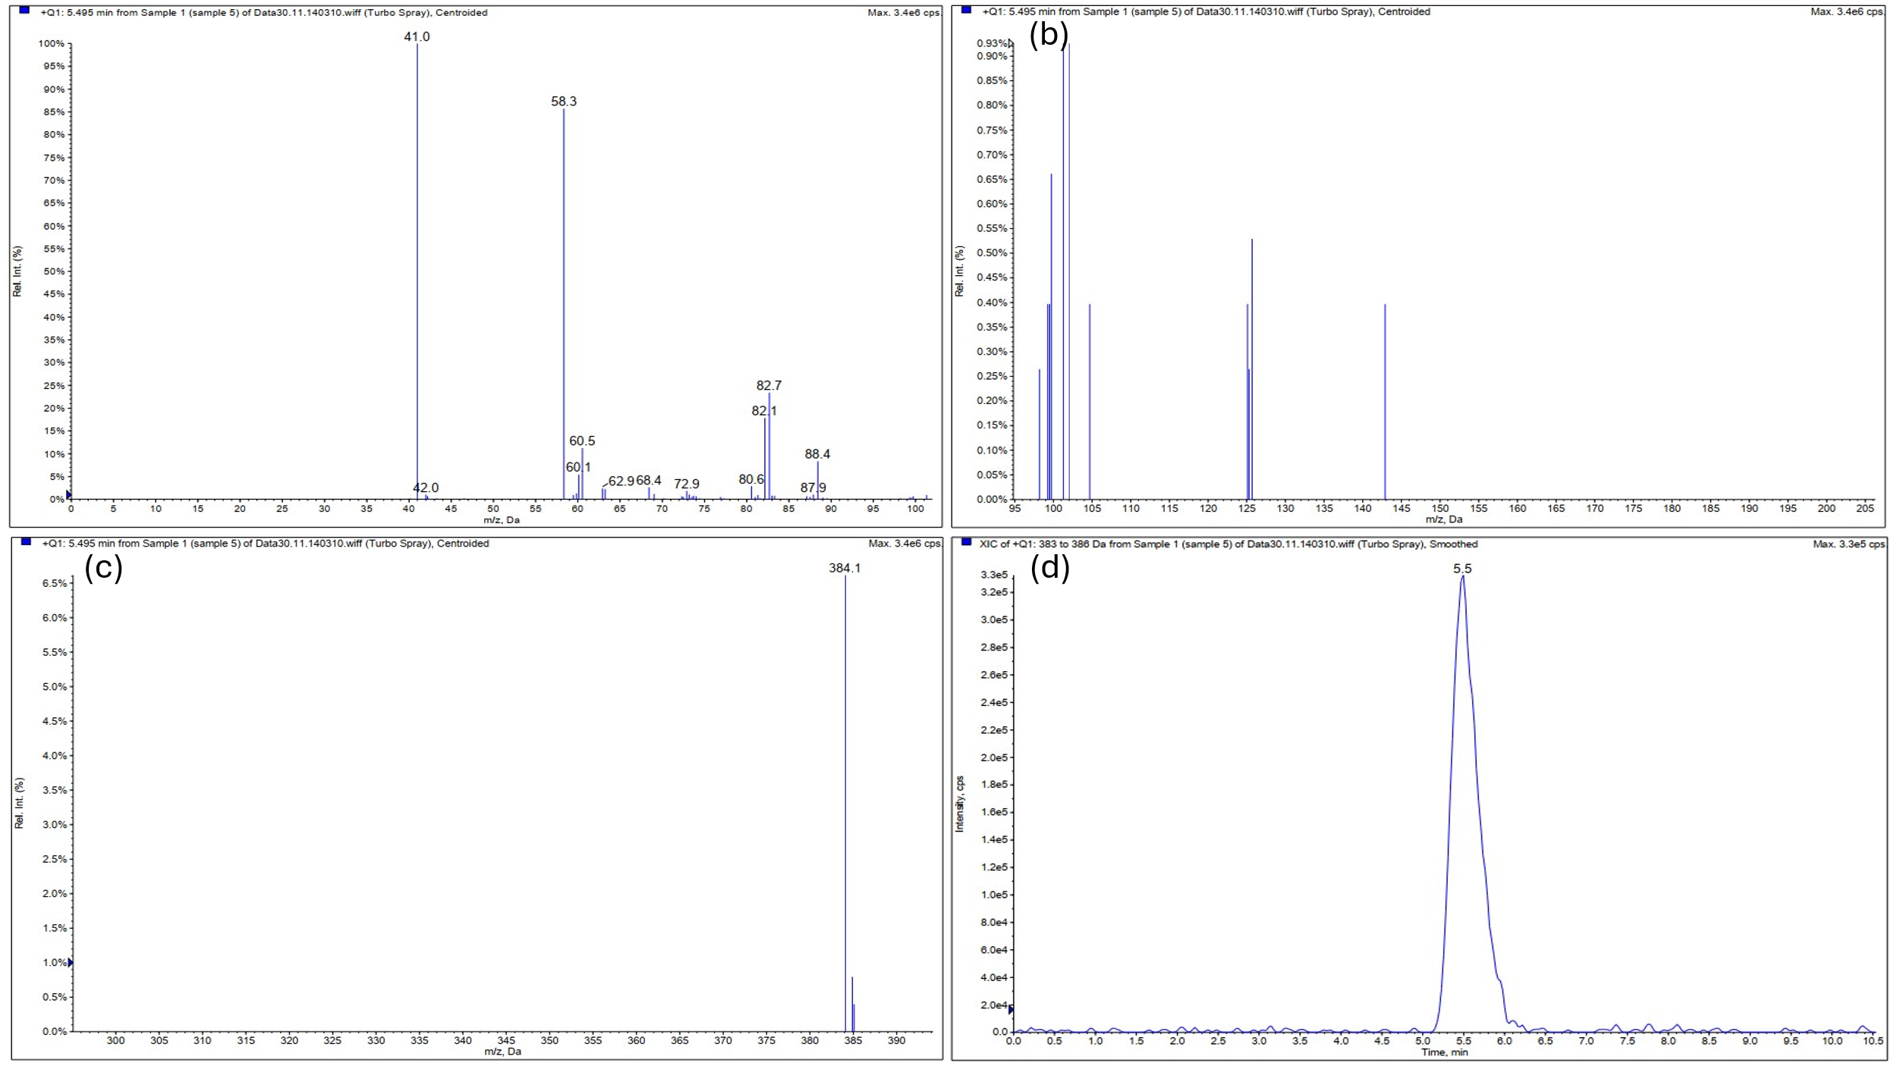 (a1) 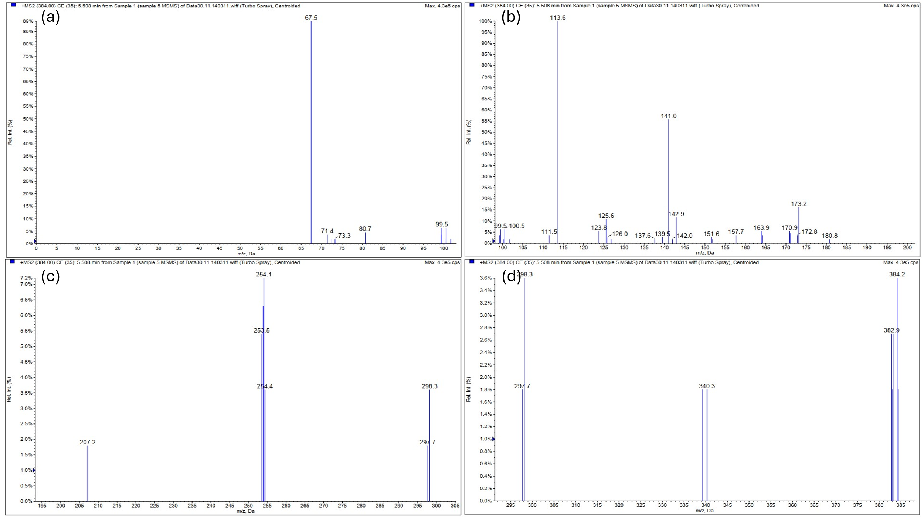
(b1)
Figure S2. Mass‑spectrometric results for the first sample of Meropenem degradation catalyzed by Ni-[MCr/MFe] LDH. (a1) MS spectra over m/z ranges 0–100 (a), 95–205 (b), and 300–390 (c), with the corresponding chromatogram (d). (b1) MS/MS spectra acquired for the precursor ion at m/z 384 over ranges 0–100 (a), 100–200 (b), 195–305 (c), and 295–385 (d).

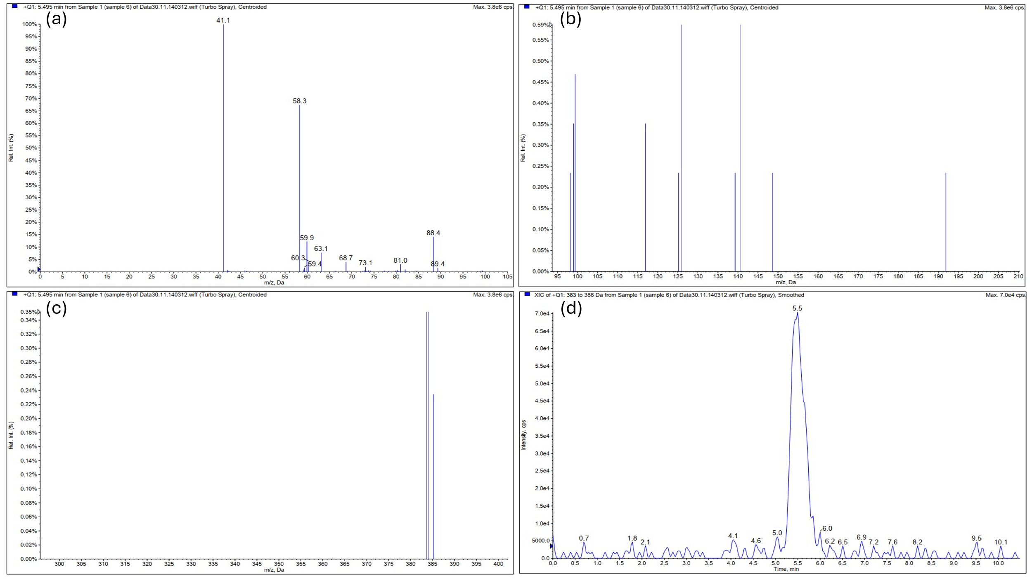
(a2)
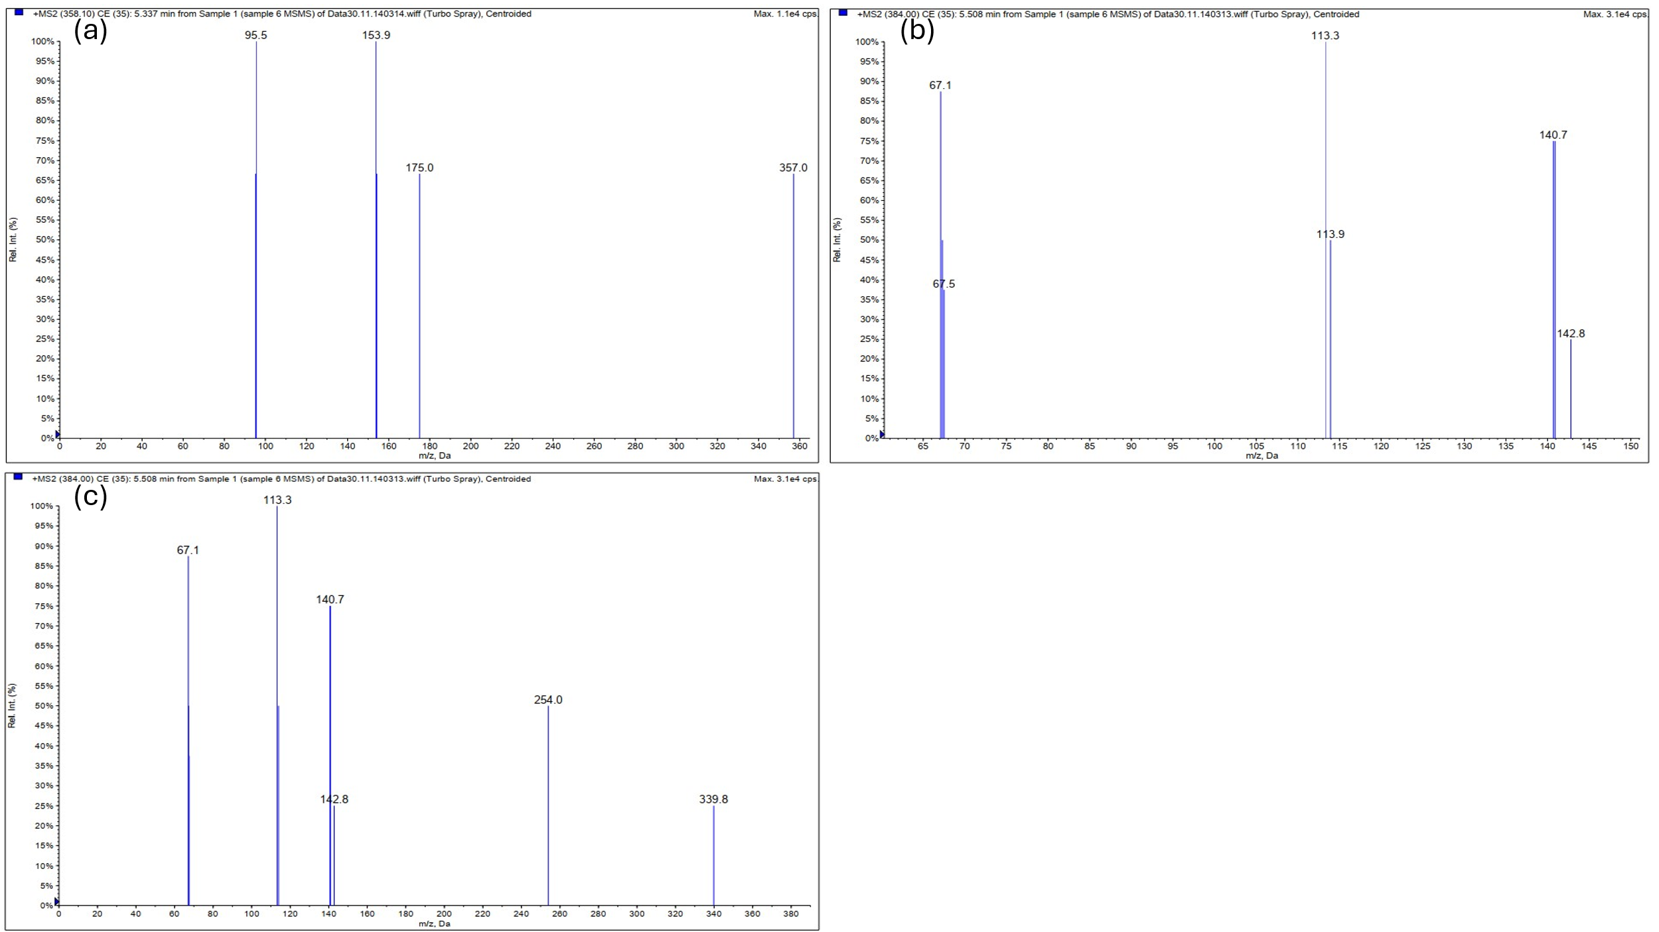
(b2)
Figure S3. Mass‑spectrometric analysis of the second sample from Meropenem degradation using Ni-[MCr/MFe] LDH. (a2) MS spectra over m/z 0–105 (a), 95–210 (b), and 300–400 (c), with the corresponding chromatogram (d). (b2) MS/MS spectra for precursor ions at m/z 358.1 (a; 0–360) and m/z 384 (b; 65–150), (c; 0–380).
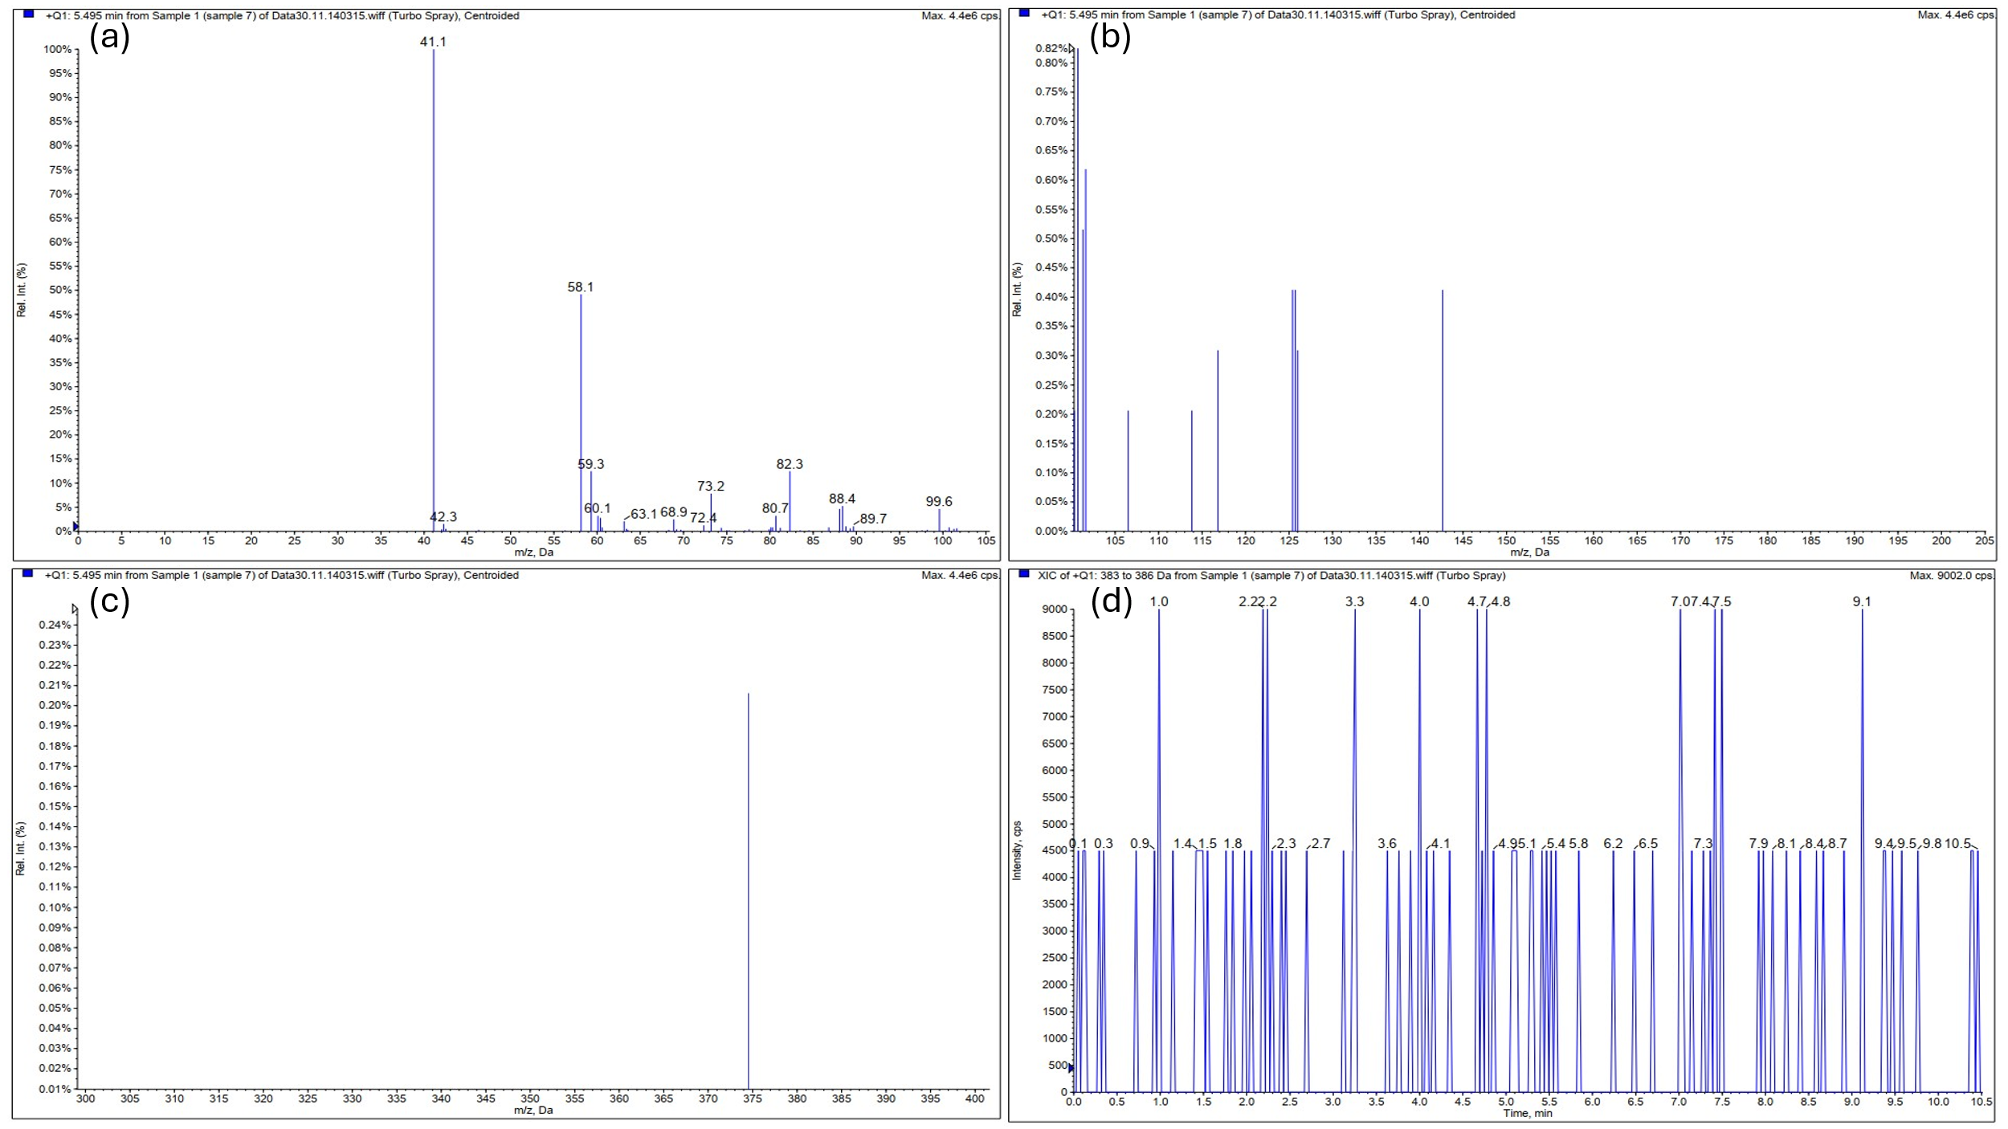 (a3)
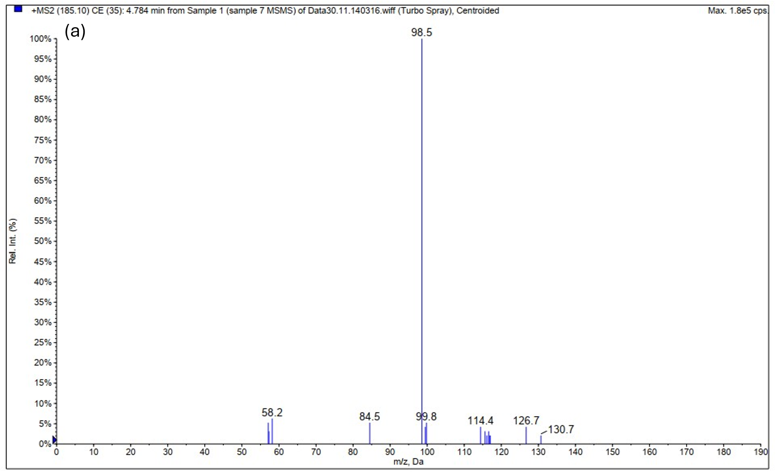
(b3)
Figure S4. Mass‑spectrometric data for the third sample from Meropenem degradation using Ni-[MCr/MFe] LDH. (a3) MS spectra over m/z 0–105 (a) and 105–205 (b), and 300–400 (c), with the corresponding chromatogram (d). (b3) MS/MS spectrum for the precursor ion at m/z 185 over the range 0–190.
Table S2. Products and identified intermediates of MER degradation by Ni-[MCr/MFe] LDH using HPLC–MS/MS technique (Please note: m is the Molecular weight and z is the ionic charge).
Structure | Molecular formula | Chemical name* | m/z
 | C₁₇H₂₅N₃O₅S₁ | (4R,5S,6S)-3-[(3S,5S)-5-(dimethylcarbamoyl)pyrrolidin-3-yl]sulfanyl-6-[(1R)-1-hydroxyethyl]-4-methyl-7-oxo-1-azabicyclo[3.2.0]hept-2-ene-2-carboxylic acid (Meropenem) | 384.1
 | C₁₆H₂₇N₃O₅S₁ | Decarboxylated Meropenem open β-lactam ring by Hydroxyl radical | 374.5
 | C₁₆H₂₅N₃O₄S₁ | Decarboxylated Meropenem by Hydroxyl radical | 357
 | C₁₆H₂₅N₃O₃S₁ | Decarboxylated Meropenem | 340.3
 | C₁₂H₁₉N₃O₁S₁ | (2S)-N,N-Dimethyl-3-[(3-methyl-1H-pyrrol-1-yl)sulfanyl]pyrrolidine-2-carboxamide | 254.1
 | C₇H₁₄N₂O₃S₁ | 2-(N,N-Dimethylcarbamoyl)-N-hydroxypyrrolidin-4-yl sulfenic acid | 207.2
 | C₇H₁₄N₂O₁S₁ | 2-(N,N-Dimethylcarbamoyl)-4-sulfanylpyrrolidine | 175
 | C₇H₁₃N₁O₂S₁ | N-hydroxy-2-(2-hydroxyethyl)-3-methyl-4-sulfanyl-1-pyrroline | 175
 | C₈H₁₄NO₁S₁ | 2-(Propan-2-ol)-3-methyl-4- sulfanyl -2- Pyrroline | 173.2
 | C₇H₁₃N₁O₁S₁ | 2-(2-hydroxyethyl)-3-methyl-4-sulfanyl-1-pyrroline | 159.2
 | C₇H₁₂N₂O₂ | 2-(N,N-Dimethylcarbamoyl)-2,5-dihydro-1H-pyrrole N-oxide | 157.6
 | C₇H₁₄N₂O₁ | 2-(N,N-Dimethylcarbamoyl)pyrrolidine | 142.8
 | C₇H₁₂N₂O₁ | 2-(N,N-dimethylcarbamoyl)-2,5-dihydro-1H-pyrrole | 140.9
 | C₈H₁₄NO₁ | 2-(Propan-2-ol)-3-methyl-2- Pyrroline | 140.1
 | C₅H₈N₁O₃ | trans-4-Hydroxy-L-proline | 130.7
 | C₇H₁₂N₁O₁ | 2-( Propan-2-ol)-2-Pyrroline | 126.7
 | C₄H₅N₁O₁S₁ | Pyrrole-3-sulfenic | 116.1
 | C₄H₅N₁S₁ | Pyrrole-3-thiol | 100.3
 | C₅H₁₂N₂ | (S)-(+)-2-(Aminomethyl)pyrrolidine | 101.3
 | C₅H₁₀N₂ | (S)-(+)-2-(Aminomethyl)-3-Pyrrolin | 99.5
 | C₃H₄O₃ | Pyruvic acid | 89.3
 | C₄H₉N₁O₁ | 2-Pyrrolidinol | 88.1
 | C₄H₇N₁O₁ | 2-hydroxypyrroline | 86.8
 | C₄H₅N₁O₁ | 2-hydroxypyrrole | 84.5
 | C₅H₉N₁ | 3-methyl-3-pyrroline | 84.5
 | C₅H₇N₁ | 3-Methylpyrrole | 82.3
 | C₂H₇N₁S ₁ | Cysteamine | 78.2
 | C₂H₂O₃ | 2-oxoacetic acid | 75
 | C₃H₇N₁O₁ | N-Methylacetamide | 74.3
 | C₄H₉N₁ | Pyrrolidine | 72.3
 | C₄H₇N₁ | 3-Pyrrolin | 69.7
 | C₄H₅N₁ | Pyrrole | 68.3
 | C₂H₄O₂ | Ethanoic acid | 60.6
 | C₂H₅N₁O₁ | Ethanamide | 60.1
*: Used IUPAC nomenclature

S-5. References
[1] A. Iqbal, N.H. Ibrahim, N.R.A. Rahman, K.A. Saharudin, F. Adam, S. Sreekantan, R.M. Yusop, N.F. Jaafar, L.D. Wilson, ZnO Surface Doping to Enhance the Photocatalytic Activity of Lithium Titanate/TiO2 for Methylene Blue Photodegradation under Visible Light Irradiation, Surfaces 3 (2020) 301–318. https://doi.org/10.3390/surfaces3030022.
[2] Q. Huo, X. Qi, J. Li, G. Liu, Y. Ning, X. Zhang, B. Zhang, Y. Fu, S. Liu, Preparation of a direct Z-scheme Α-Fe2O3/MIL-101(Cr) hybrid for degradation of carbamazepine under visible light irradiation, Appl. Catal. B 255 (2019). https://doi.org/10.1016/j.apcatb.2019.117751.
[3] N. Liu, W. Huang, X. Zhang, L. Tang, L. Wang, Y. Wang, M. Wu, Ultrathin graphene oxide encapsulated in uniform MIL-88A (Fe) for enhanced visible light-driven photodegradation of RhB, Appl. Catal. B 221 (2018) 119–128.
[4] H. Tian, T. Araya, R. Li, Y. Fang, Y. Huang, Removal of MC-LR using the stable and efficient MIL-100/MIL-53 (Fe) photocatalyst: the effect of coordinate immobilized layers, Appl. Catal. B 254 (2019) 371–379.
[5] S.A. Hosseini, M. Kazemeini, A. Mohammadi, A Dual-Functional Ni-MCr LDH nanostructure utilized for degradation of Meropenem antibiotic pollutant: Synthesis and physiochemical Characterizations toward development of a novel chemical mechanism, Advanced Powder Technology 36 (2025) 105084. https://doi.org/10.1016/j.apt.2025.105084.
[6] W. Ye, X. Fang, X. Chen, D. Yan, A three-dimensional nickel–chromium layered double hydroxide micro/nanosheet array as an efficient and stable bifunctional electrocatalyst for overall water splitting, Nanoscale 10 (2018) 19484–19491.
[7] X. Qian, W. Chen, J. Yang, S. Chen, G. Guan, MOFs-derived bifunctional Ni-Fe-Mo sulfide electrode catalysts with hollow bipyramidal structures for efficient photovoltaics and hydrogen generation, Electrochim. Acta 437 (2023) 141524.
[8] A. Altamirano Briones, I. Cóndor Guevara, D. Mena, I. Espinoza, C. Sandoval-Pauker, L. Ramos Guerrero, P. Vargas Jentzsch, F. Muñoz Bisesti, Degradation of meropenem by heterogeneous photocatalysis using TiO2/fiberglass substrates, Catalysts 10 (2020) 344.
[9] A. Cabrera-Reina, A.B. Martínez-Piernas, Y. Bertakis, N.P. Xekoukoulotakis, A. Agüera, J.A. Sánchez Pérez, TiO2 photocatalysis under natural solar radiation for the degradation of the carbapenem antibiotics imipenem and meropenem in aqueous solutions at pilot plant scale, Water Res. 166 (2019) 115037. https://doi.org/10.1016/j.watres.2019.115037.
[10] M. Ahmadmoazzam, H. Akbari, A. Adibzadeh, S. Pourfadakari, H. Akbari, Visible-light-driven TiO2@ Fe2O3/Chitosan nanocomposite with promoted photodegradation of meropenem and imipenem antibiotics by peroxymonosulfate, Environ. Technol. 45 (2024) 3456–3467.
[11] J. Wang, B. Gao, M. Dou, X. Huang, Z. Ma, A porous g-C3N4 nanosheets containing nitrogen defects for enhanced photocatalytic removal meropenem: Mechanism, degradation pathway and DFT calculation, Environ. Res. 184 (2020) 109339. https://doi.org/10.1016/j.envres.2020.109339.
[12] M. Bakhtian, N. Khosroshahi, V. Safarifard, Efficient Removal of Inorganic and Organic Pollutants over a NiCo2O4@MOF-801@MIL88A Photocatalyst: The Significance of Ternary Heterojunction Engineering, ACS Omega 7 (2022) 42901–42915. https://doi.org/10.1021/acsomega.2c05000.
[13] M. Dou, J. Wang, B. Gao, Z. Ma, X. Huang, A novel in-situ chemical oxidation channel – Selective pH-dependence of refractory β-lactam antibiotics in the synergistic mechanism of persulfate and g-C3N4 under visible light, Chemical Engineering Journal 394 (2020) 124899. https://doi.org/10.1016/j.cej.2020.124899.
[14] R. Wang, C. Yao, C. Peng, J. Qiu, Q. Wang, X. Liu, J. Meng, W. Wang, Ultra-strong adsorption of organic dyes and antibiotic onto the alk-MXene/ZIF adsorbents with a specific intercalation structure, Chemical Engineering Journal 485 (2024) 149916. https://doi.org/10.1016/j.cej.2024.149916.
[15] A. Mohammadi, M. Kazemeini, S. Sadjadi, A developed novel Hal′@ MIL-PMA triple composite utilized as a robust photocatalyst for activated removal of antibiotic contaminants: A new chemical mechanism for Tetracycline degradation, J. Environ. Chem. Eng. 12 (2024) 112941.
[16] P.S. Ghosal, A.K. Gupta, Determination of thermodynamic parameters from Langmuir isotherm constant-revisited, J. Mol. Liq. 225 (2017) 137–146. https://doi.org/10.1016/j.molliq.2016.11.058.
[17] B. Van der Bruggen, Freundlich Isotherm, in: E. Drioli, L. Giorno (Eds.), Encyclopedia of Membranes, Springer Berlin Heidelberg, Berlin, Heidelberg, 2015: pp. 1–2. https://doi.org/10.1007/978-3-642-40872-4_254-3.
[18] K.H. Chu, Revisiting the Temkin isotherm: dimensional inconsistency and approximate forms, Ind. Eng. Chem. Res. 60 (2021) 13140–13147.
[19] L. Suručić, D. Andrić, I. Jevtić, M. Momčilović, R. Suručić, J. Penjišević, Unmodified Hemp Biowaste as a Sustainable Biosorbent for Congo Red and Remazol Brilliant Blue R, Coatings 15 (2025) 519.

