SUPPLEMENTARY INFORMATION

Table S1 Snapshot of JEV detections in mosquitoes and pigs in Australia during the summer of 2024/2025
Species | Date | Region | Reference
Mosquito | Dec 2024 | Griffith (Murrumbidgee region) NSW | https://www.health.nsw.gov.au/environment/pests/vector/Publications/arbovirus-surveillance-weekly-report-2024-dec-07.pdf
Mosquito | Jan 2025 | Moree, NSW | https://thephn.com.au/news/japanese-encephalitis-virus-detected-in-mosquito-samples-from-moree-advice-for-providers
Mosquito | Late 2024/early 2025 | Moira Shire northern Vic | https://agriculture.vic.gov.au/biosecurity/animal-diseases/mosquitoes-controlling-and-reporting-mosquito-borne-illnesses/Japanese-encephalitis/Japanese-encephalitis-current-situation
Mosquito | Feb 2025 | Monto, North Burnett, Qld | https://northburnett.qld.gov.au/japanese-encephalitis-virus-detected-in-mosquitos-in-monto/
Mosquito | March 2025 | Hemmant, Brisbane, Qld | https://www.health.qld.gov.au/newsroom/doh-media-releases/be-alert-against-mosquitoes-as-jev-detected-in-brisbane?
Pig (feral) | Dec 2024 | Yomingley (near Dubbo), Western NSW | https://www.dpi.nsw.gov.au/__data/assets/pdf_file/0010/1596214/CVO-Bulletin-JEV-detection-Feral-Pigs-Dec-2024.pdf
Pig (farmed) | Feb 2025 | Goulburn Valley | https://agriculture.vic.gov.au/biosecurity/animal-diseases/mosquitoes-controlling-and-reporting-mosquito-borne-illnesses/japanese-encephalitis/japanese-encephalitis-current-situation
Pig (farmed) | Feb 2025 | Southern Qld | https://www.abc.net.au/news/2025-02-18/japanese-encephalitis-virus-queensland-piggeries/104949206
Pig | Apr 2025 | Banana Shire (Central Qld) | https://www.health.qld.gov.au/newsroom/doh-media-releases/be-alert-against-mosquitoes-as-jev-detected-in-central-queensland

Table S2 JEV Human Cases and Fatalities in Australia (Dec 2024 – 2025)
Date (published) | State |  | Case/Fatality* | Age/Sex | Probable Exposure location | Source | Website
17 Jan 2025 |  | QLD | Case | Not disclosed | Yelarbon / Goondiwindi | ABC News | https://www.abc.net.au/news/2025-01-17/mosquito-dengue-fever-japanese-encephalitis-cases-queensland/104828632
15 Feb 2025 |  | NSW | Case | Male | Murrumbidgee region | NSW Health | https://www.health.nsw.gov.au/news/Pages/20250215_00.aspx
25 Feb 2025 |  | NSW | Fatality | Male, Age: 70s | Murrumbidgee region | NSW Health/ABC | https://www.abc.net.au/news/2025-02-25/sydney-man-dies-japanese-encephalitis-mosquito/104979634
25 Feb 2025 |  | NSW | Case | Female, Age: 60s | Northern NSW | NSW Health/ABC | https://www.abc.net.au/news/2025-02-25/sydney-man-dies-japanese-encephalitis-mosquito/104979634
3 Mar 2025 |  | VIC | Case | Not disclosed | NSW Riverina / Murray River | Victoria Health | https://www.health.vic.gov.au/health-alerts/japanese-encephalitis-in-victoria
1 Apr 2025 |  | QLD | Fatality | Male | Under investigation (Bowen/Mackay) | Queensland Health | https://www.abc.net.au/news/2025-04-01/queenslander-likely-died-from-japanese-encephalitis-virus/105123982
5 Apr 2025 |  | QLD | Fatality | Not disclosed | Queensland (not specified) | ABC News | https://www.abc.net.au/news/2025-04-05/mosquito-japenese-encephalitis-dengue-fever-rain-flood/105133696
20 Dec 2024 |  | VIC | Case | Not disclosed | Northern Victoria (likely Murray River) | Victoria Health
*case numbers for the 2024/2025 as of August 2025, as reported by the Australian notifiable conditions reports for each state, Qld Health (https://www.health.qld.gov.au/clinical-practice/guidelines-procedures/diseases-infection/surveillance/reports/notifiable); NSW Health (https://www.health.nsw.gov.au/Infectious/Pages/data.aspx) and Department of Health, Victoria (https://www.health.vic.gov.au/infectious-diseases/notifiable-infectious-diseases-conditions-and-micro-organisms).
Table S3 Inactivation kinetics of BinJ/JEV_{NSW22} as clarified cell culture supernatant
Passage | Day 7* | Day 14* | Day 21* | Day 28*
BinJ/JEV_{NSW22} + 0.05% formalin at 4°C
1 (T75) | ++ | + | + | -
2 (T25) | +++ | +++ | +++ | -
3 (T25) | not imaged | not imaged | +++ | -
BinJ/JEV_{NSW22} + 0.08% formalin at 4°C
1 (T75) | ++ | + | + | -
2 (T25) | +++ | ++ | not imaged | -
3 (T25) | not imaged | not imaged | not imaged | -
BinJ/JEV_{NSW22} + 0.10% formalin at 4°C
1 (T75) | ++ | - | - | -
2 (T25) | +++ | + | - | -
3 (T25) | not imaged | not imaged | - | -
BinJ/JEV_{NSW22} + 0% formalin at 4°C (positive control; 4.40 x 10⁷ IU/mL)
1 (T75) | +++ | +++ | +++ | +++
2 (T25) | +++ | +++ | +++ | +++
3 (T25) | not imaged | not imaged | +++ | +++
Mock-infected C6/36 culture supernatant + 0.10% formalin at 4°C (negative control)
1 (T75) | - | - | - | -
2 (T25) | - | - | - | -
3 (T25) | not imaged | not imaged | - | -

*Day post formalin addition
T25, T75 denotes the flask size for culture supernatant passaging
Table S4. Serological response of weaner pigs to BinJ/JEV_{NSW22} vaccination and later JEV infection challenge determined using a JEV blocking ELISA. Pigs were vaccinated on with a priming dose on Day 0 (5 weeks of age) and a booster of the same vaccine preparations were administered to 9 pigs per treatment group on Day 28 (9 weeks of age). Positive results were distinguished by a percentage inhibition (PI) in the assay >60 at the screening dilution of 1/10.
Treatment group | JEV antibody positive % (n=9)
Treatment group | Priming dose |  |  |  |  | Booster dose |  |  | JEV infection challenge
Treatment group | Day 0 | Day 7 | Day 14 | Day 21 | Day 28 |  | Day 35 | Day 42 | Day 49 | Day 56 | Day 63
1. No vaccine | 0 | 11* | 0 | 11* | 0 |  | 0 | 0 | 100 | 100 | 100
2. BinJ/JEV_{NSW22} (pure, not inactivated) | 0 | 100 | 67 | 11 | 67 |  | 100 | 100 | 100 | not tested
3. Inactivated BinJ/JEV_{NSW22}, higher dose, clarified supernatant | 0 | 100 | 89 | 78 | 89 |  | 100 | 100 | 100 | 100 | 100
4. Inactivated BinJ/JEV_{NSW22}, lower dose, clarified supernatant | 0 | 100 | 89 | 67 | 56 |  | 100 | 100 | 100 | 100 | 100
5. Inactivated BinJ/JEV_{NSW22}, higher dose, clarified supernatant, no emulsigen | 0 | 78 | 33 | 56 | 56 |  | 100 | 78 | not tested
* One sample was just above the positive PI value, but in each case the subsequent blood sample from each individual pig gave a negative result.

Table S5. Serological response of pigs after second dose of BinJ/JEV_{NSW22} vaccine (D28) and challenge at D42. Titres determined by testing serial dilutions of serum in JEV bELISA. The endpoint was determined to be the last dilution before a negative result was obtained (PI>40%)
Treatment Group | Animal ID | Days from first vaccination (challenge D42)
Treatment Group | Animal ID | D35 | D42 | D49 | D56 | D63
1. No vaccine | 90003 | 0 | 0 | 320 | 160 | 320
1. No vaccine | 90016 | 0 | 0 | 160 | 320 | 640
1. No vaccine | 90017 | 0 | 0 | 640 | 640 | 1280
1. No vaccine | 90019 | 0 | 0 | 320 | 640 | 1280
1. No vaccine | 90025 | 0 | 0 | 320 | 320 | 640
1. No vaccine | 90027 | 0 | 0 | 320 | 320 | 640
1. No vaccine | 90063 | 0 | 0 | 320 | 320 | 1280
1. No vaccine | 90064 | 0 | 0 | 320 | 320 | 640
1. No vaccine | 90066 | 0 | 0 | 160 | 640 | 320
3. Inactivated BinJ/JEV_{NSW22}, higher dose, clarified supernatant | 90000 | >5120 | 2560 | 1280 | 2560 | 1280
 | 90001 | 1280 | 640 | 640 | 640 | 640
 | 90004 | 2560 | 2560 | 2560 | 2560 | 2560
 | 90014 | 5120 | 2560 | 1280 | 1280 | 1280
 | 90030 | 1280 | 640 | 640 | 1280 | 1280
 | 90042 | 80 | 320 | 320 | 1280 | 5120
 | 90051 | >5120 | 2560 | 1280 | 10240 | 10240
 | 90062 | 5120 | 10240 | 2560 | 2560 | 2560
 | 90071 | >5120 | 1280 | 1280 | 1280 | 1280
4. Inactivated BinJ/JEV_{NSW22}, lower dose, clarified supernatant | 90018 | 2560 | 1280 | 640 | 1280 | 2560
 | 90023 | 640 | 640 | 1280 | 5120 | 10240
 | 90024 | 2560 | 640 | 1280 | 1280 | 2560
 | 90039 | 1280 | 640 | 1280 | 2560 | 2560
 | 90046 | 5120 | 640 | 2560 | 10240 | >10240
 | 90049 | >5120 | 1280 | 640 | 2560 | 2560
 | 90052 | 2560 | 640 | 640 | 1280 | 1280
 | 90058 | >5120 | 1280 | 640 | 1280 | 5120
 | 90068 | 1280 | 640 | 640 | 1280 | 1280

Table S6: Neutralising antibody response of pigs on the day of JEV challenge (2 weeks post-booster vaccine dose). Titres were determined by testing serial dilutions of serum in JEV PRNT₅₀ or microneutralisation₅₀ assay. The titres were defined as the highest dilution that results in a 50% reduction of plaques or staining, respectively.
Treatment Group | Animal ID | PRNT₅₀ Titre |  | Microneut₅₀
Treatment Group | Animal ID | D0 | D42 | D42
1. No Vaccine | 90019 | <10 | <10 | <10
1. No Vaccine | 90063 | <10 | <10 | <10
1. No Vaccine | 90025 | <10 | <10 | <10
1. No Vaccine | 90003 | <10 | <10 | <10
1. No Vaccine | 90064 | <10 | <10 | <10
1. No Vaccine | 90066 | <10 | <10 | <10
1. No Vaccine | 90017 | <10 | <10 | <10
1. No Vaccine | 90027 | <10 | <10 | <10
1. No Vaccine | 90016 | <10 | <10 | <10
2. BinJ/JEV_{NSW22} (pure, non-inactivated) | 90013 | <10 | 160 | 80
2. BinJ/JEV_{NSW22} (pure, non-inactivated) | 90022 | <10 | 320 | 80
2. BinJ/JEV_{NSW22} (pure, non-inactivated) | 90048 | <10 | 160 | 80
2. BinJ/JEV_{NSW22} (pure, non-inactivated) | 90029 | <10 | >1280 | 160
2. BinJ/JEV_{NSW22} (pure, non-inactivated) | 90026 | <10 | >1280 | 80
2. BinJ/JEV_{NSW22} (pure, non-inactivated) | 90072 | <10 | 160 | 40
2. BinJ/JEV_{NSW22} (pure, non-inactivated) | 90040 | <10 | 40 | 20
2. BinJ/JEV_{NSW22} (pure, non-inactivated) | 90005 | <10 | 160 | 40
2. BinJ/JEV_{NSW22} (pure, non-inactivated) | 90055 | <10 | 160 | 80
3. Inactivated BinJ/JEV_{NSW22}, higher dose, clarified supernatant | 90042# | <10 | <10* | <10
 | 90051 | <10 | 160 | 80
 | 90001 | <10 | 40 | 40
 | 90004 | <10 | 160 | 80
 | 90062 | <10 | 320 | 80
 | 90014 | <10 | 40 | 80
 | 90071 | <10 | 40 | 20
 | 90000 | <10 | 40 | 40
 | 90030 | <10 | 80 | 20
4. Inactivated BinJ/JEV_{NSW22}, lower dose, clarified supernatant | 90018 | <10 | 160 | 40
 | 90039 | <10 | 10 | 10
 | 90058 | <10 | 40 | 40
 | 90024 | <10 | <10* | 10
 | 90052 | <10 | <10* | 10
 | 90023 | <10 | <10* | 10
 | 90049 | <10 | 40 | 40
 | 90068 | <10 | 10 | 10
 | 90046 | <10 | 40 | 20
5. Inactivated BinJ/JEV_{NSW22}, higher dose, no emulsigen, clarified supernatant | 90044 | <10 | 10 | ND
 | 90056 | <10 | 80 | ND
 | 90088 | <10 | <10* | ND
 | 90089 | <10 | 40 | ND
 | 90002 | <10 | 80 | ND
 | 90031 | <10 | 10 | ND
 | 90028 | <10 | <10* | ND
 | 90061 | <10 | 80 | ND
 | 90047 | <10 | 160 | ND
* Partial neutralisation seen but did not reach cut-off threshold.
# vaccinated animal with breakthrough JEV infection post challenge

Table S7 Assessment of multiparous sows pre-vaccination with pan-orthoflavivirus (mAb 6B6C-1) blocking ELISA.
Pig ID | Pen ID | PI Values* | Interpretation
35393 | 1 | 7.71 | Negative
1333 | 2 | 3.91 | Negative
978 | 3 | -25.20 | Negative
1611 | 4 | 14.28 | Negative
582 | 5 | 5.68 | Negative
34915 | 6 | 13.98 | Negative
2031 | 7 | 12.36 | Negative
1311 | 8 | 12.39 | Negative
6848 | 9 | 18.61 | Negative
35396 | 10 | 19.41 | Negative
Positive control# | N/A | 94.91 | Positive
*Percent inhibition of >30% is positive
#positive control pig – naturally infected with JEV
Table S8. Serological response of sows to BinJ/JEV_{NSW22} vaccination as assessed in the JEV bELISA. Pigs were vaccinated with a priming dose on Day 0, with booster vaccinations occurring on days 28 and 70.
 |  | PI values*
Pig ID | Pen ID | Day 0 | Day 14 | Day 28 | Day 42 | Day 56 | Day 70
35393 | 1 | 31.90 | 88.98 | 76.88 | 94.66 | NS# | NS#
1333 | 2 | 30.26 | 87.88 | 84.75 | 94.28 | 95.82 | 95.35
978 | 3 | 48.58 | 94.14 | 88.18 | 94.99 | 95.27 | 94.36
1611 | 4 | 45.54 | 89.58 | 77.16 | 94.74 | 89.18 | 94.74
582 | 5 | 65.13 | 91.40 | 88.64 | 94.82 | 92.91 | 95.58
34915 | 6 | 38.75 | 87.96 | 82.09 | 94.99 | 95.73 | 96.70
2031 | 7 | 21.59 | 78.99 | 72.63 | 95.04 | 92.80 | 95.72
1311 | 8 | 23.54 | 90.22 | 91.90 | 96.36 | 94.44 | 95.10
6848 | 9 | 20.43 | 76.89 | 59.79 | 95.13 | 95.33 | 94.33
35396 | 10 | 27.42 | 92.38 | 92.50 | 94.54 | 95.40 | 93.91
*PI (percent inhibition) values of >60% are positive, <40% are negative and 40 – 60% equivocal.
#NS – not sampled

Table S9. Titres of anti-JEV antibodies in sows at different times post-vaccination with BinJ/JEV_{NSW22} estimated from limiting dilution when tested using the JEV blocking ELISA
 |  | Titres*
Pig ID | Pen ID | Day 0 | Day 14 | Day 28 | Day 42 | Day 56 | Day 70
35393 | 1 | <10 | 80 | 20 | 1280 | NS | NS
1333 | 2 | <10 | 40 | 20 | 640 | 320 | 320
978 | 3 | 10 | 160 | 40 | 640 | 160 | 80
1611 | 4 | 10 | 80 | 40 | 640 | 160 | 80
582 | 5 | 10 | 160 | 80 | 640 | 320 | 160
34915 | 6 | <10 | 80 | 40 | 640 | 320 | 160
2031 | 7 | <10 | 40 | 20 | 640 | 320 | 320
1311 | 8 | <10 | 160 | 80 | 2560 | 1280 | 1280
6848 | 9 | <10 | 20 | 10 | 1280 | 320 | 320
35396 | 10 | <10 | 160 | 80 | 2560 | 640 | 640
*End-point titres were defined as the highest dilution that gave a PI>40%

Table S10. Neutralising antibody titres of anti-JEV antibodies in sows as PRNT₅₀ at different times post-vaccination with BinJ/JEV_{NSW22}.
 |  | PRNT₅₀ Titre*
Pig ID | Pen ID | Day 0 | Day 14 | Day 28
35393 | 1 | <10 | 20 | 20
1333 | 2 | <10 | 20 | 20
978 | 3 | <10 | 40 | 40
1611 | 4 | <10 | 20 | 20
582 | 5 | <10 | 80 | 10
34915 | 6 | <10 | 40 | 20
2031 | 7 | <10 | 40 | 40
1311 | 8 | <10 | 80 | 40
6848 | 9 | <10 | 80 | 40
35396 | 10 | <10 | 80 | 40
* The PRNT₅₀ titre was defined as the highest dilution that results in a 50% reduction of plaques.

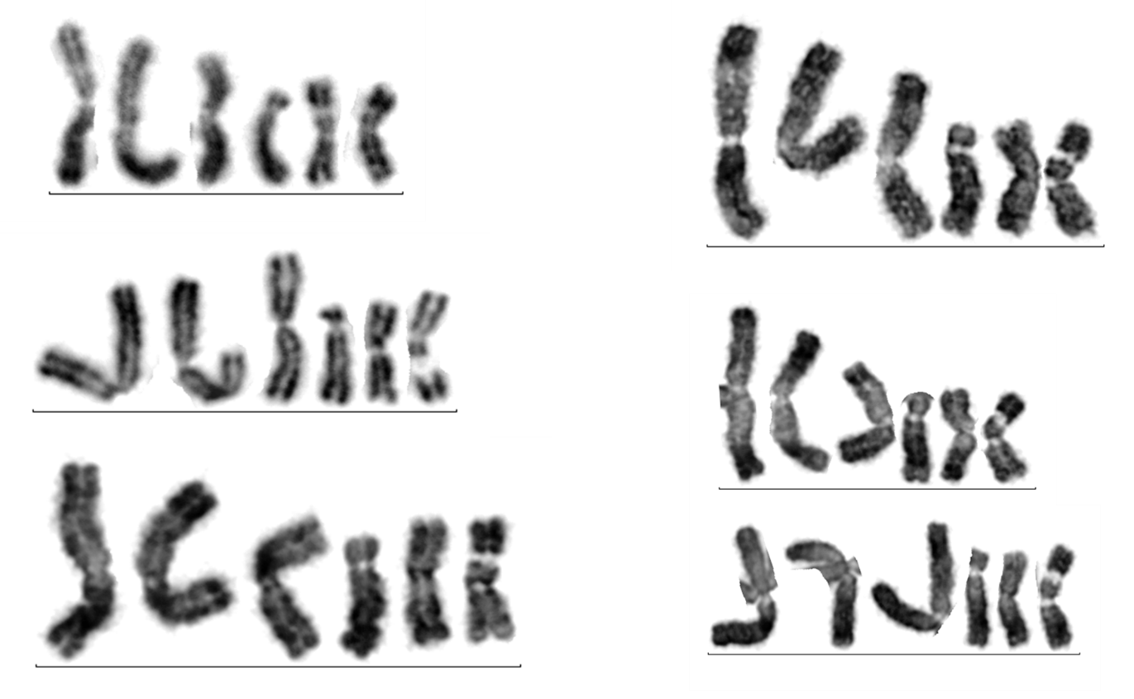

Figure S1. Chromosome analysis of the mosquito cell line C6/36 Aedes albopictus. Chromosome enumeration of 20 C6/36 cells revealed the presence of six chromosomes. G-banding was of low resolution but showed that the karyotype appears to be abnormal with only one set of homologues identified.

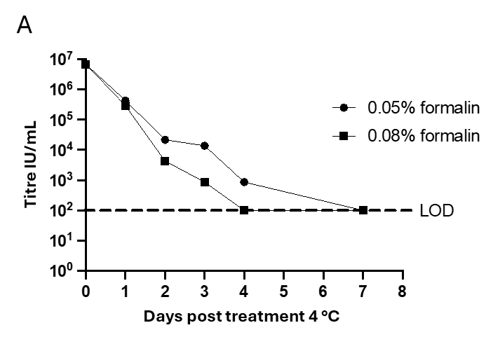

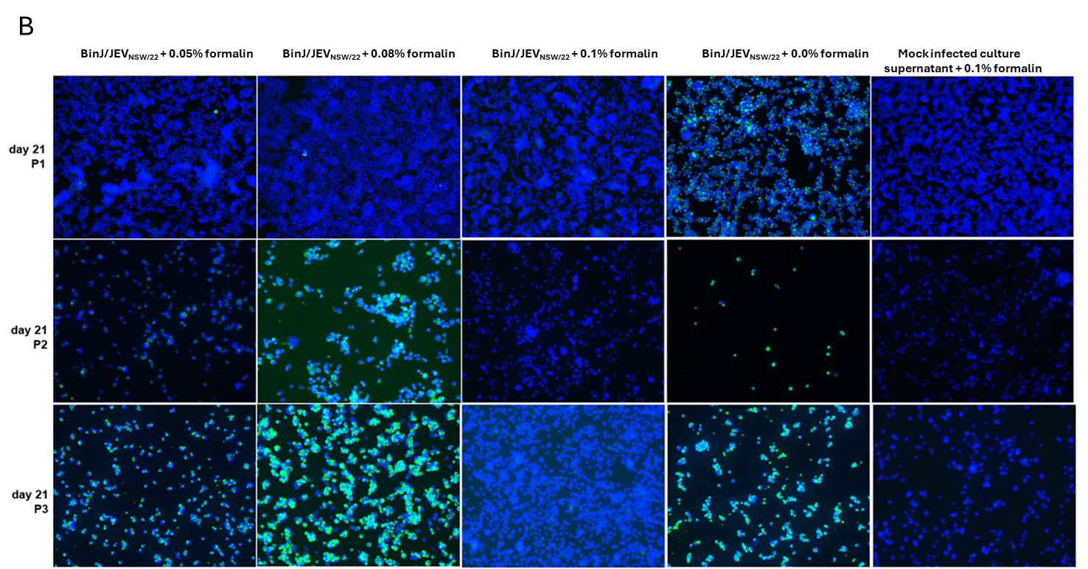
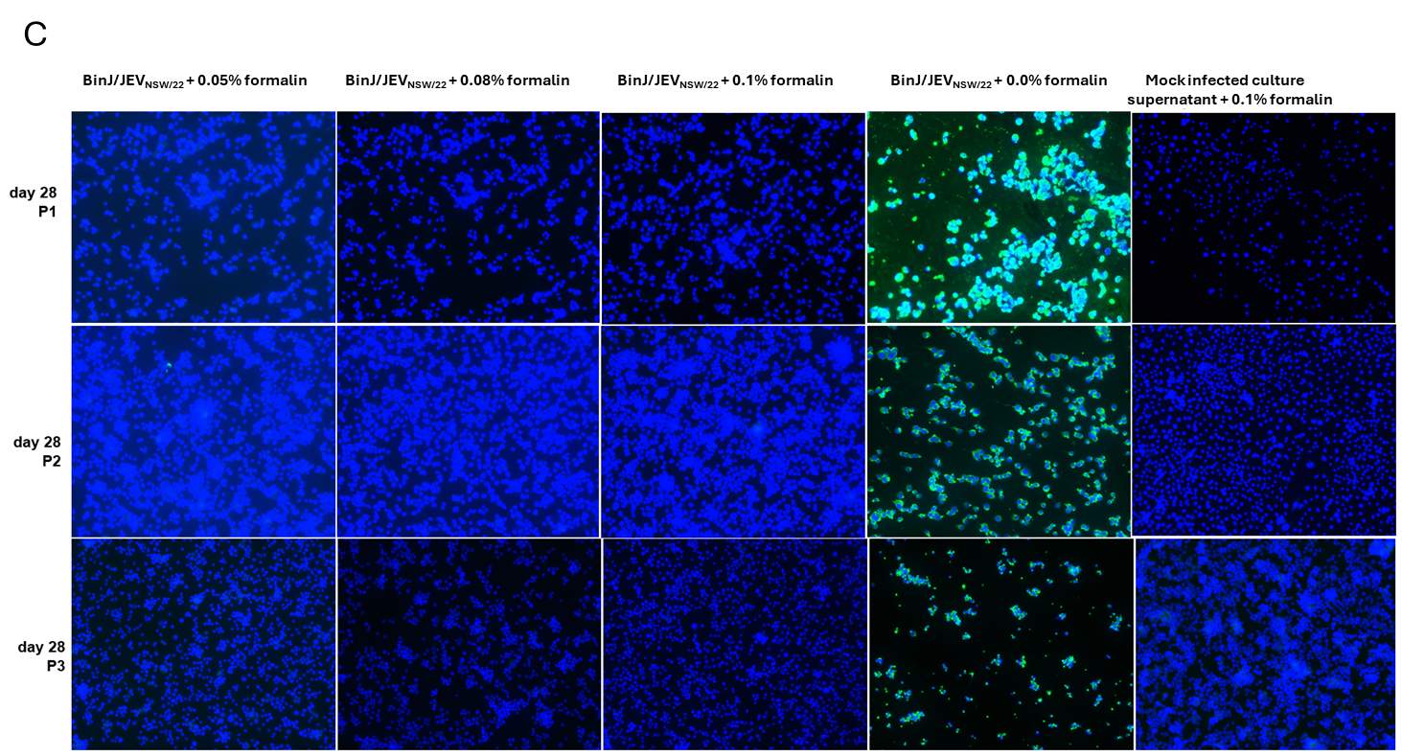
Figure S2. Inactivation kinetics of BinJ/JEV_{NSW/22} with various concentrations of formalin (data from Table S3). A) Inactivation of BinJ/JEV_{NSW/22} as clarified cell culture supernatant (RPMI/2% FBS) following addition of 0.05% (circles) or 0.08% (squares) formalin and infectious titre determined by TCID₅₀ of daily samples post formalin addition. B, C) Representative IFA images of C6/36 cell monolayers infected with the treated BinJ/JEV_{NSW/22} solutions. Panel B displays the results following harvesting of the culture supernatant 21 days after formalin addition and passaged 3 times, while panel C shows the results following culture supernatant harvesting 28 days post-formalin addition. Blue staining is the cell nuclei. Green staining is detection of replicating BinJ/JEV_{NSW/22.}

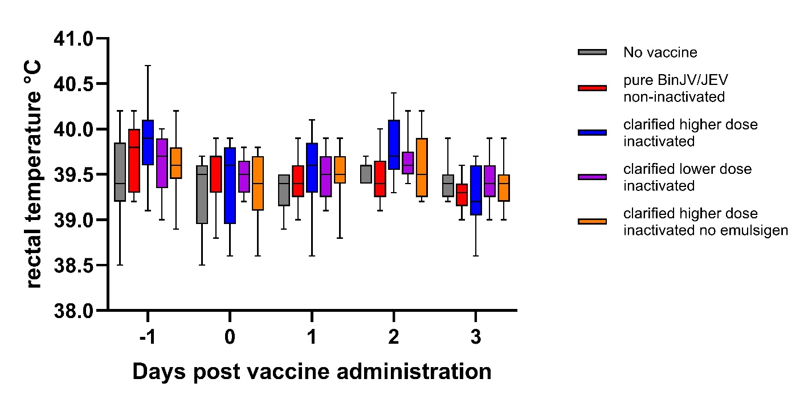
Figure S3. Rectal temperature of pigs measured each day before and after administration of the priming dose of each BinJ/JEV_{NSW/22} vaccine preparation, for a total of 5 days. Data are plotted as a box and whisker plot, the line marks the median and the whiskers extend to the minimum and maximum values. Each vaccine group comprised 9 animals. BinJ/JEV_{NSW/22} vaccine formulations: 1) no vaccine (sham-vaccine (cell culture medium)) grey; 2) purified virions, non-inactivated with Advax adjuvant, red; 3) Formalin-inactivated BinJ/JEV_{NSW/22} as clarified cell culture supernatant, higher concentration with Emulsigen/aluminium hydroxide gel adjuvant, blue; 4) Formalin-inactivated BinJ/JEV_{NSW/22} as clarified cell culture supernatant, lower concentration with Emulsigen/aluminium hydroxide gel adjuvant, purple; 5) Formalin-inactivated BinJ/JEV_{NSW/22} as clarified cell culture supernatant, higher concentration with aluminium hydroxide gel adjuvant only, orange. A linear mixed-effects model fitted using restricted maximum likelihood (REML) in R (Version 4.5.1 with the lme4 package version 1.1-33) to evaluate the effects of vaccine group, day post-vaccination, and their interaction on body temperature with Pig ID included as a random effect. No statistically significant effects were observed for Group (p=0.40), Day (p=0.23), or their interaction (p=0.95), indicating that body temperature remained consistent across groups and time points, including the sham vaccination

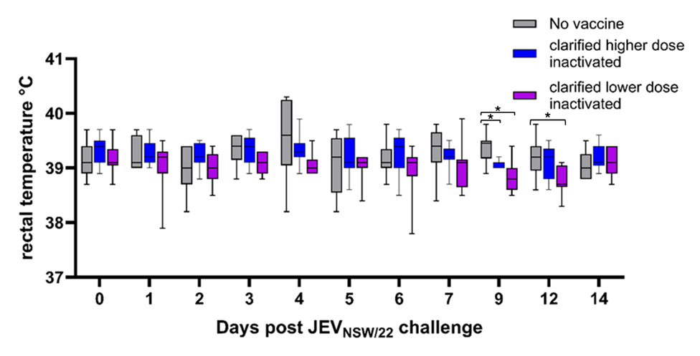
Figure S4. Rectal temperature of pigs measured each day after challenge with JEV_{NSW/22}. Data are plotted as a box and whisker plot, the line marks the median and the whiskers extend to the minimum and maximum values. Each vaccine group comprised 9 animals. BinJ/JEV_{NSW/22} vaccine formulations: Grp 1) no vaccine (sham-vaccine (cell culture medium)) grey; Grp 3) Formalin-inactivated BinJ/JEV_{NSW/22} as clarified cell culture supernatant, higher concentration with Emulsigen/aluminium hydroxide gel adjuvant, blue; Grp 4) Formalin-inactivated BinJ/JEV_{NSW/22} as clarified cell culture supernatant, lower concentration with Emulsigen/aluminium hydroxide gel adjuvant, purple. A linear mixed-effects model was fitted using restricted maximum likelihood (REML) in R (Version 4.5.1 with the lme4 version 1.1-33). The model indicated that both Group (vaccine type or no vaccine) and Day influenced temperature (p<0.05) with Pig ID included as a random effect. Post-hoc pairwise comparisons of estimated marginal means (EMMs) were conducted using Tukey’s honestly significant difference (HSD) test (emmeans package v1.11.2-8). Statistically significant differences (adjusted p<0.05) between groups within each day are indicated (*).

Fig S5. Body weights of multiparous sows over the vaccine study trial. Each curve represents an individual animal.

