Supplementary Material for
“Classical Ideal Curves of Fluid Mixtures and their Role for the Development of Equations of State”

International Journal of Thermophysics

Jessica Buchenfeld¹ ∙ Monika Thol¹ ∙ Roland Span¹

¹Chair of Thermodynamics, Faculty of Mechanical Engineering, Ruhr University Bochum, Bochum, 44801, Germany

E-Mail: Jessica.Buchenfeld@thermo.ruhr-uni-bochum.de

Classical Ideal Curves: reduced p,T-diagrams
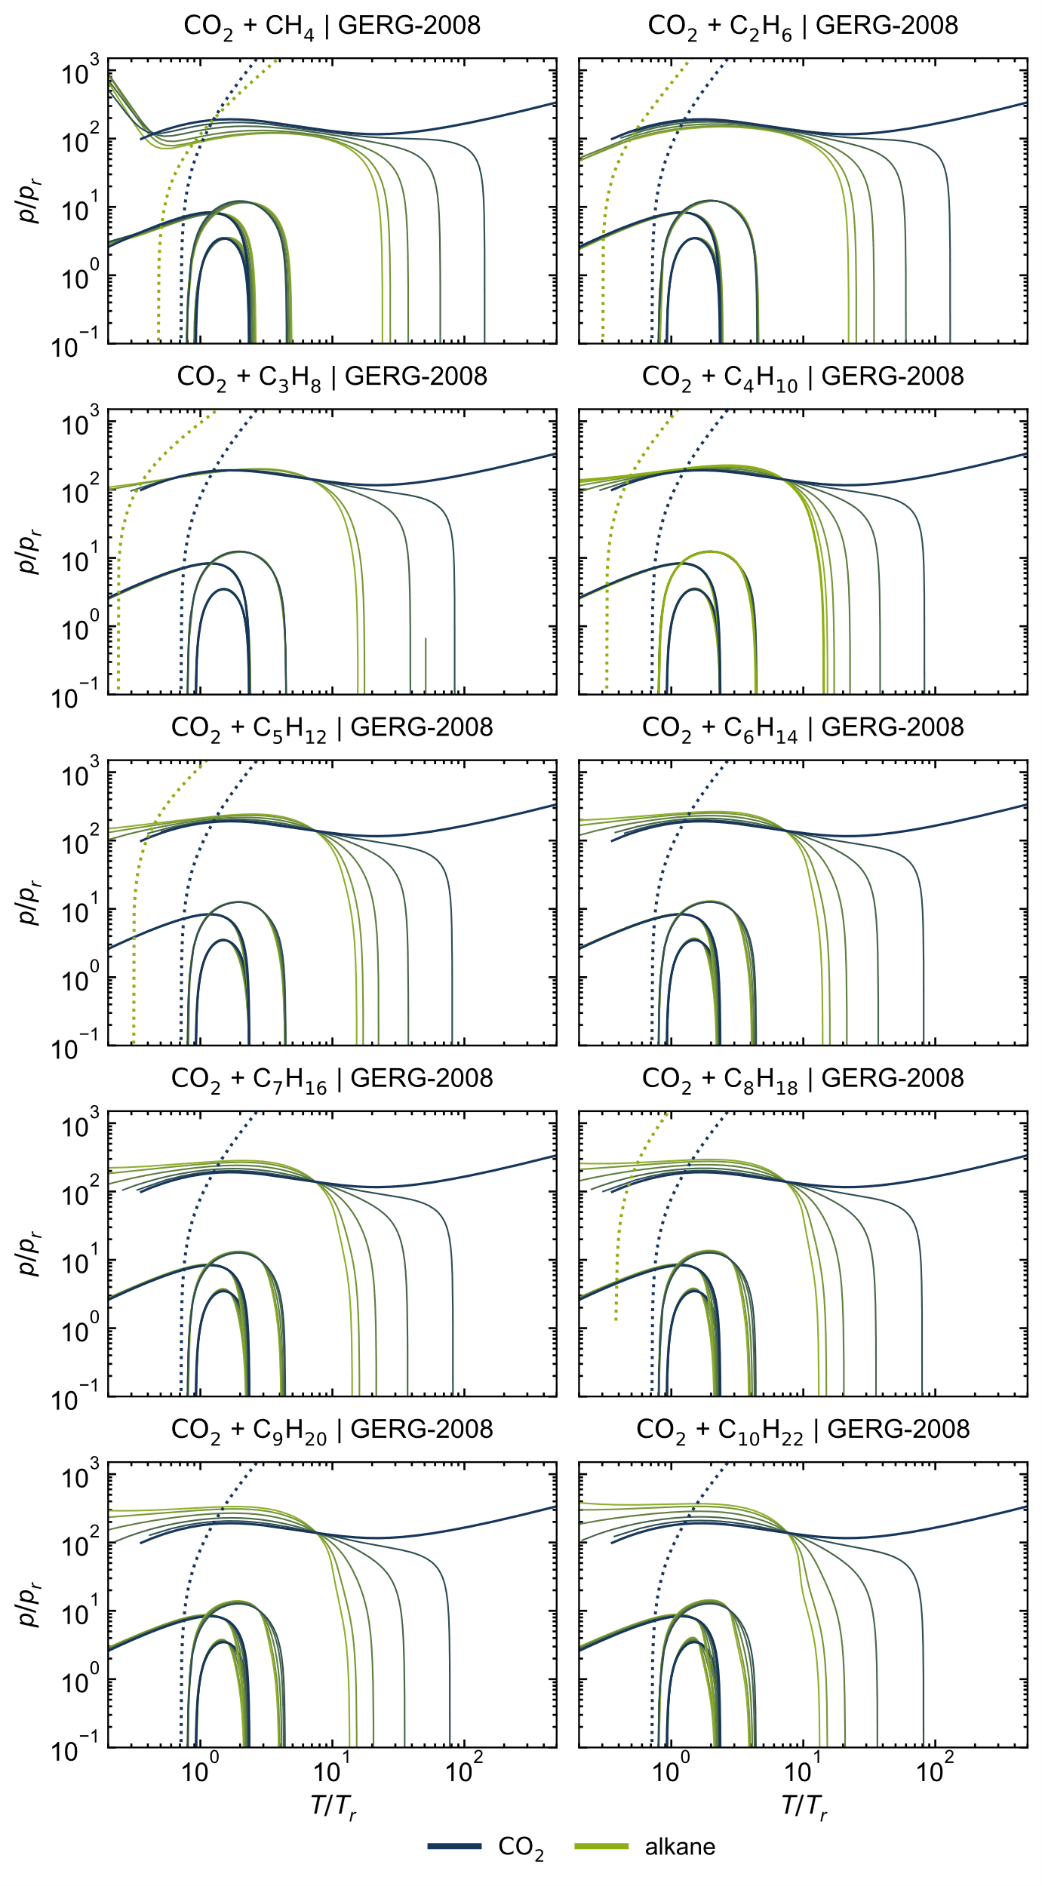
Figure S 1: Ideal curves of all considered CO₂ + alkane mixtures, calculated with the GERG-2008 model [1].
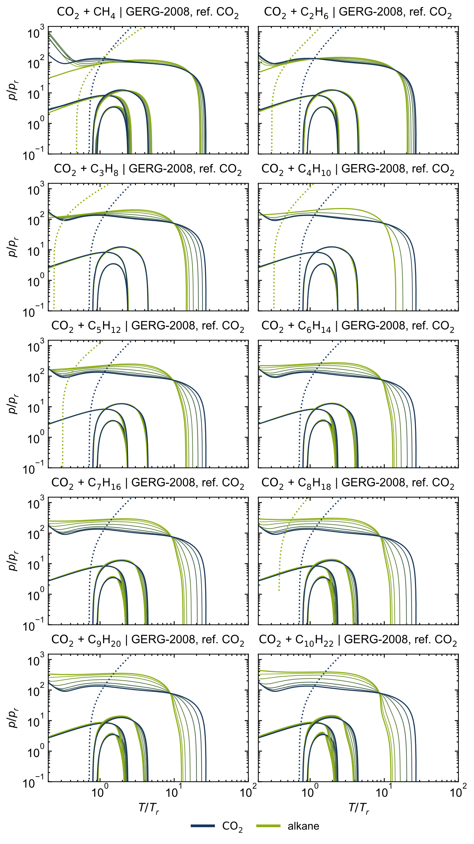
Figure S 2: Ideal curves of all considered CO₂ + alkane mixtures, calculated with the GERG-2008 model [1] and the reference EOS for CO₂ [2].

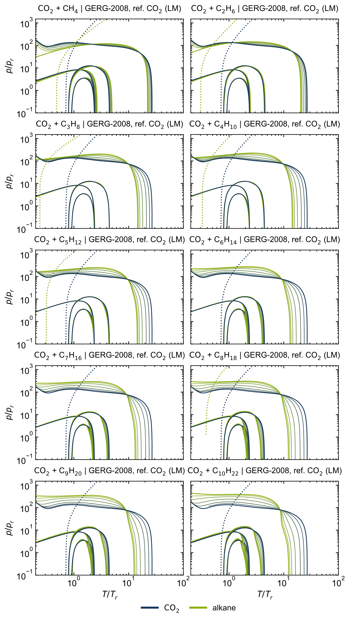
Figure S 3: Ideal curves of all considered CO₂ + alkane mixtures, calculated with the GERG-2008 model [1] and the reference EOS for CO₂ [2] using the linear mixing rule (LM).

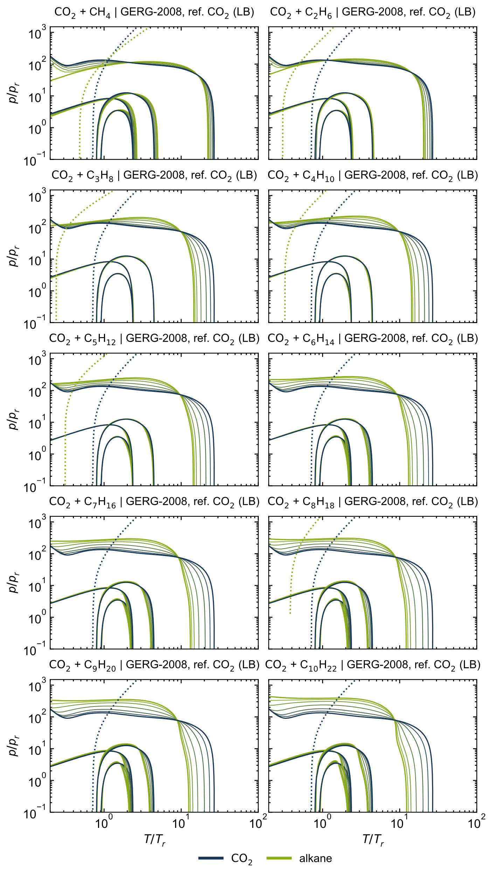
Figure S 4: Ideal curves of all considered CO₂ + alkane mixtures, calculated with the GERG-2008 model [1] and the reference EOS for CO₂ [2] using the Lorentz-Berthelot mixing rule (LB).

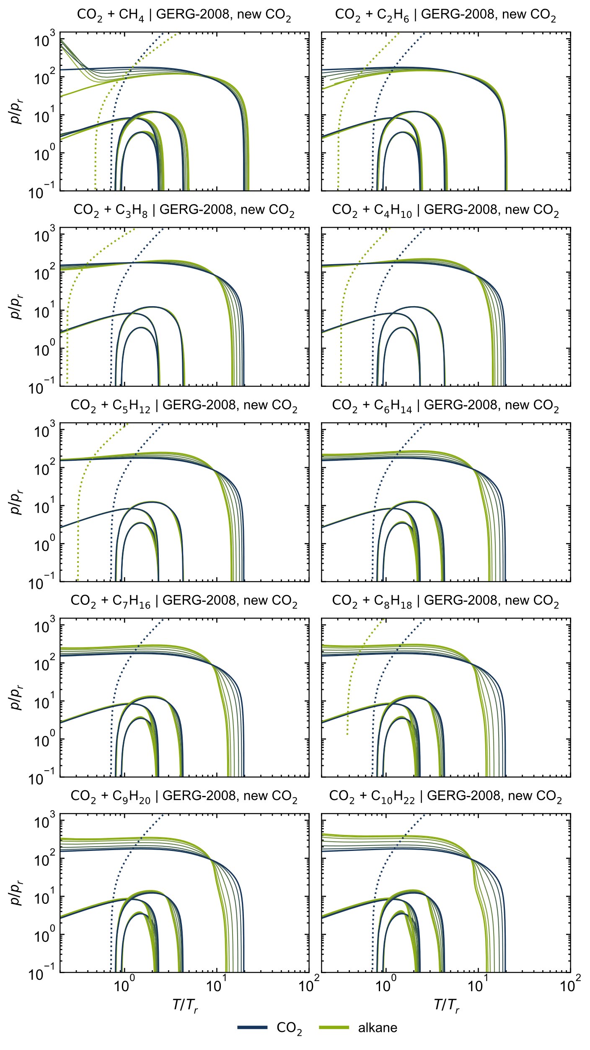
Figure S 5: Ideal curves of all considered CO₂ + alkane mixtures, calculated with the GERG-2008 model [1] and the new preliminary EOS for CO₂ [3].
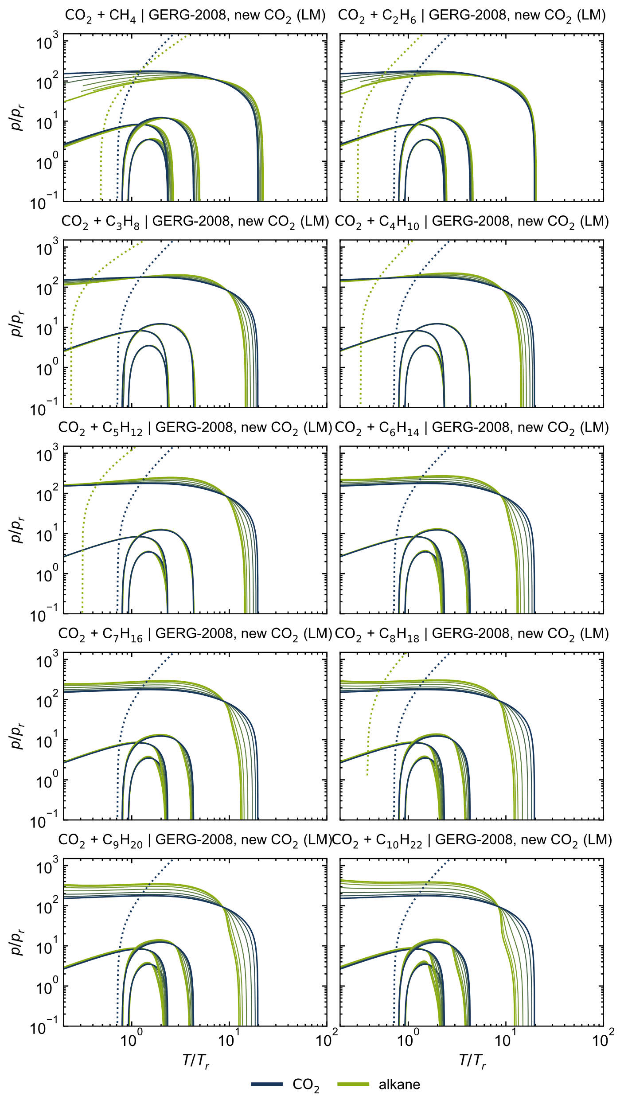
Figure S 6: Ideal curves of all considered CO₂ + alkane mixtures, calculated with the GERG-2008 model [1] and the new preliminary EOS for CO₂ [3] using the linear mixing rule (LM).
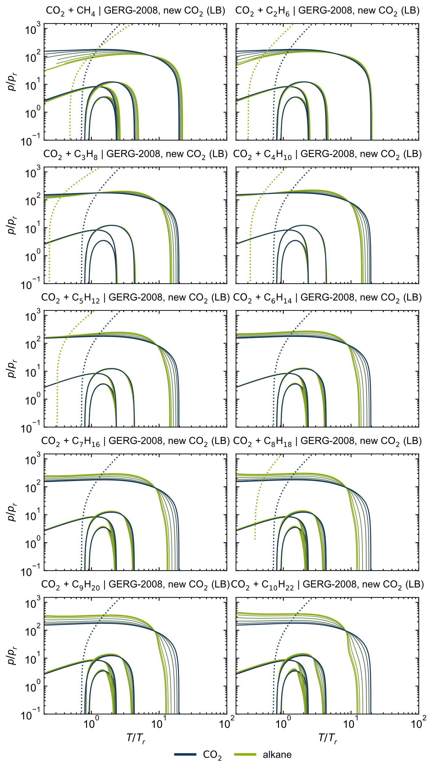
Figure S 7: Ideal curves of all considered CO₂ + alkane mixtures, calculated with the GERG-2008 model [1] and the new preliminary EOS for CO₂ [3] using the Lorentz-Berthelot mixing rule (LB).

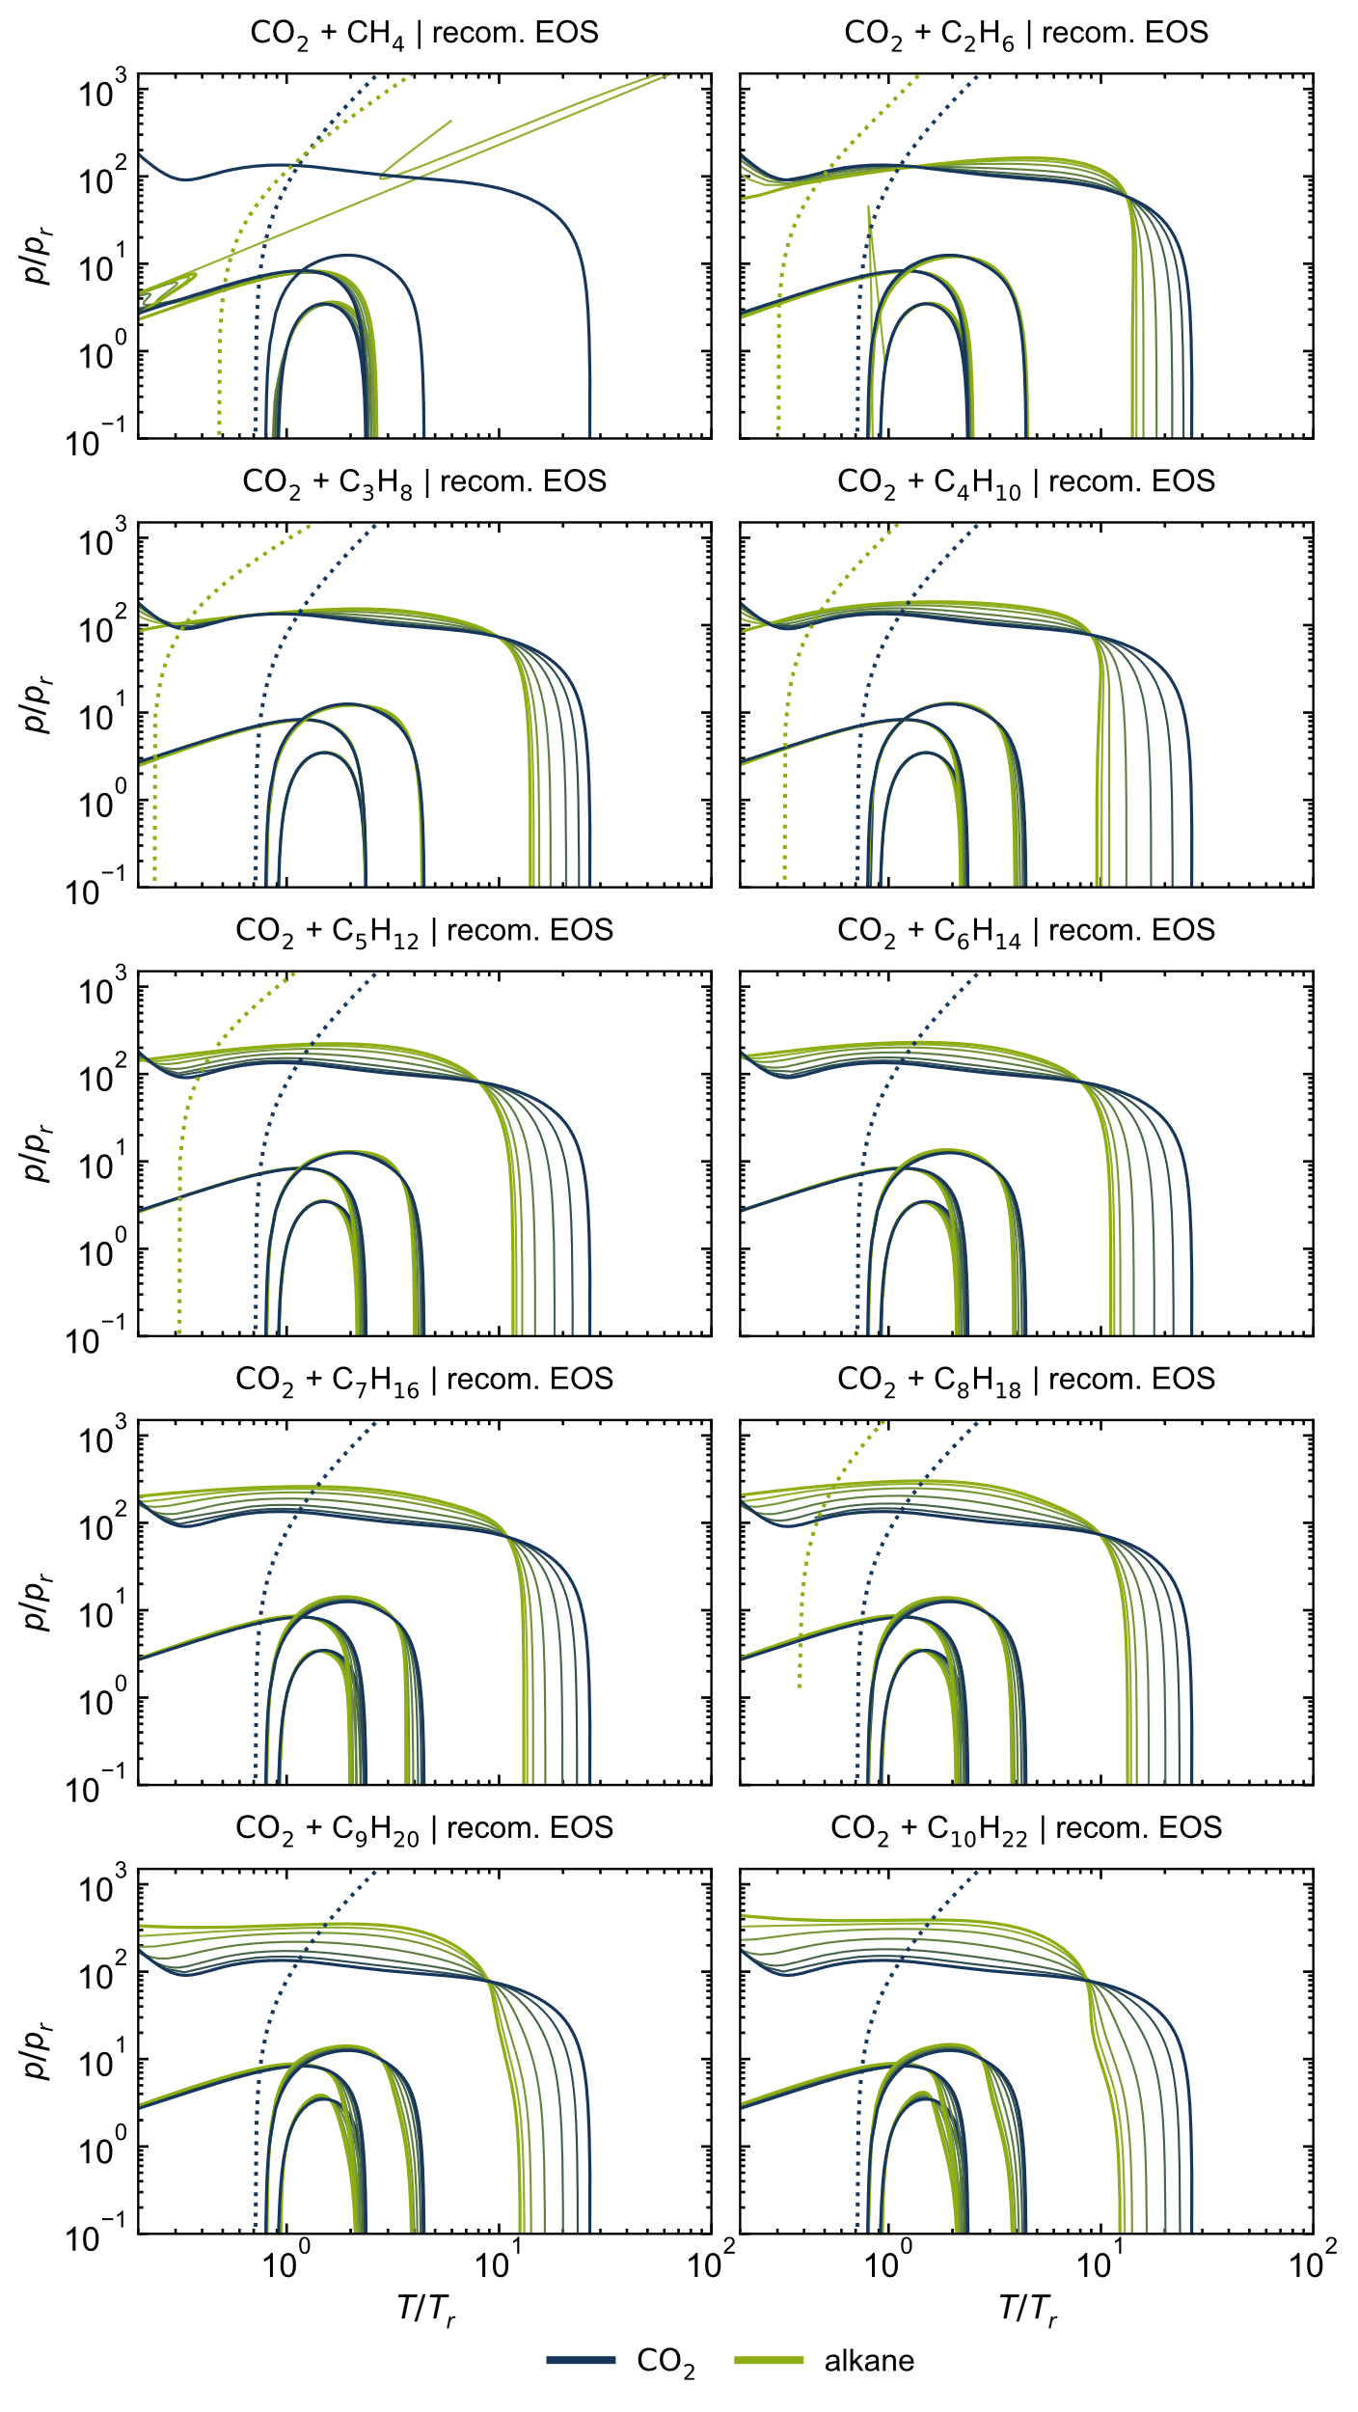
Figure S 8: Ideal curves of all considered CO₂ + alkane mixtures, calculated with the recommended EOS [2, 4–12].
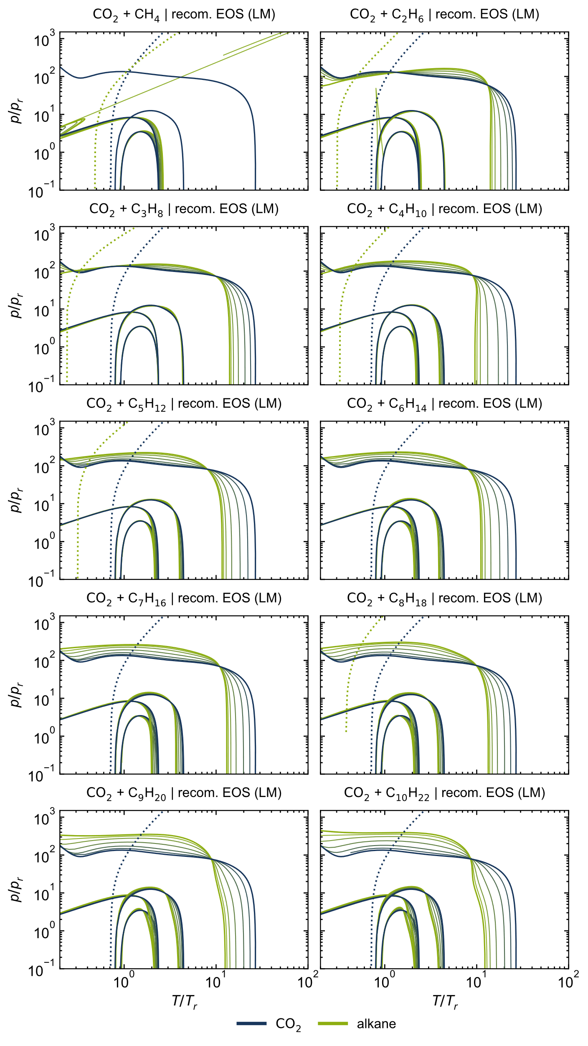
Figure S 9: Ideal curves of all considered CO₂ + alkane mixtures, calculated with the recommended EOS [2, 4–12] using the linear mixing rule (LM).
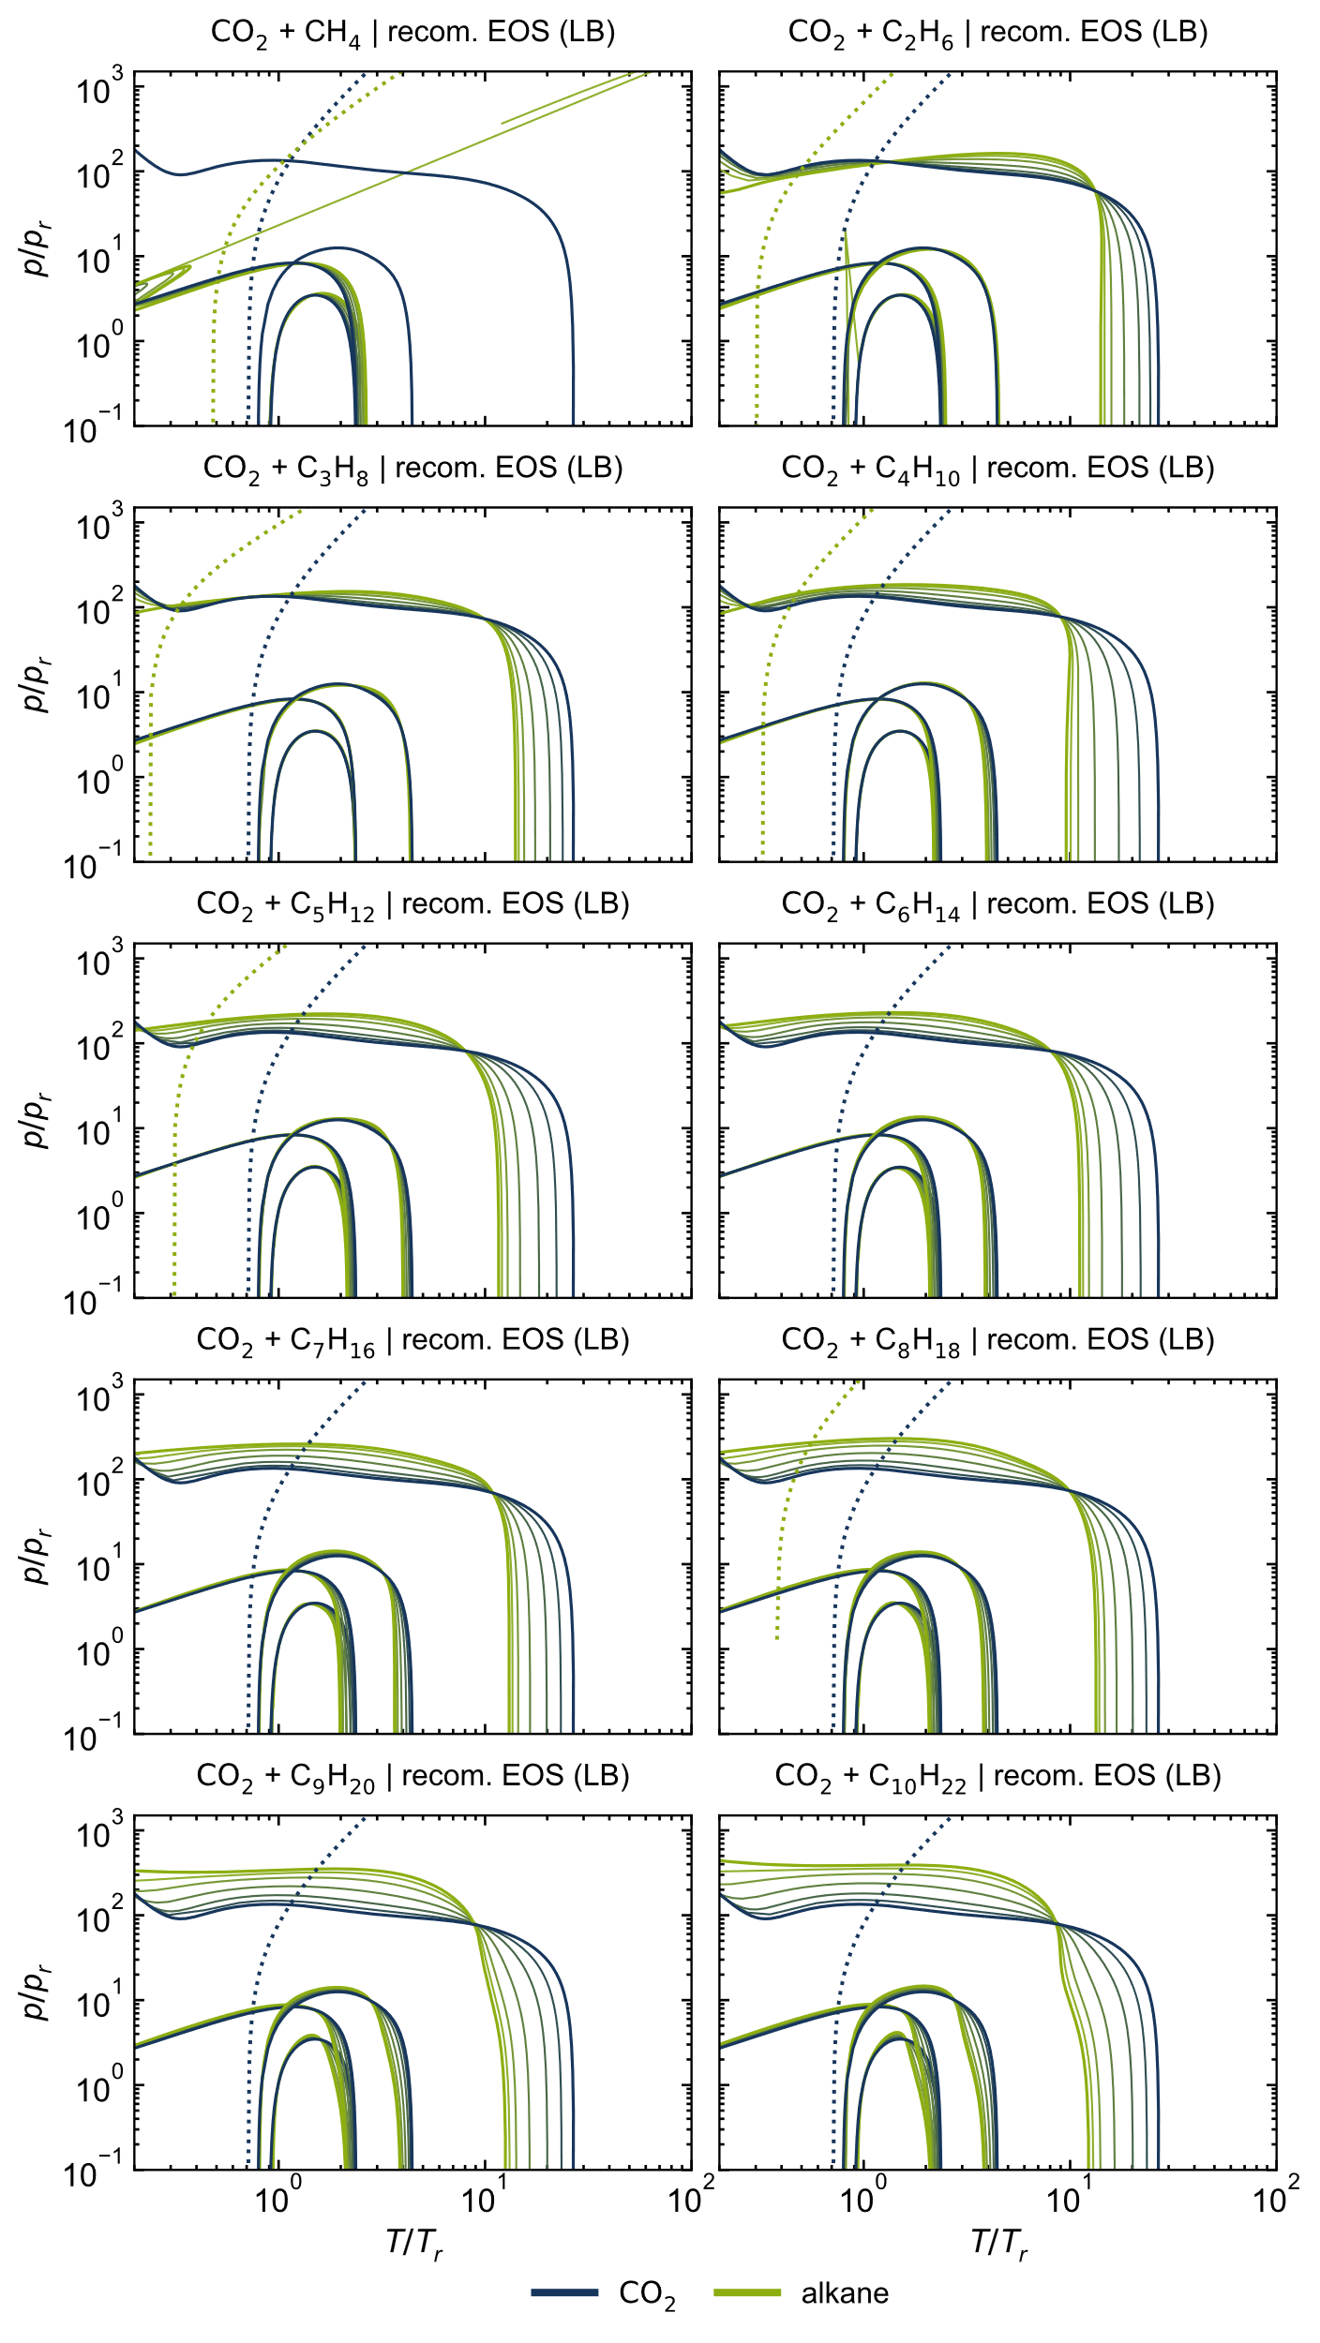
Figure S 10: Ideal curves of all considered CO₂ + alkane mixtures, calculated with the recommended EOS [2, 4–12] using the Lorentz-Berthelot mixing rule (LB).

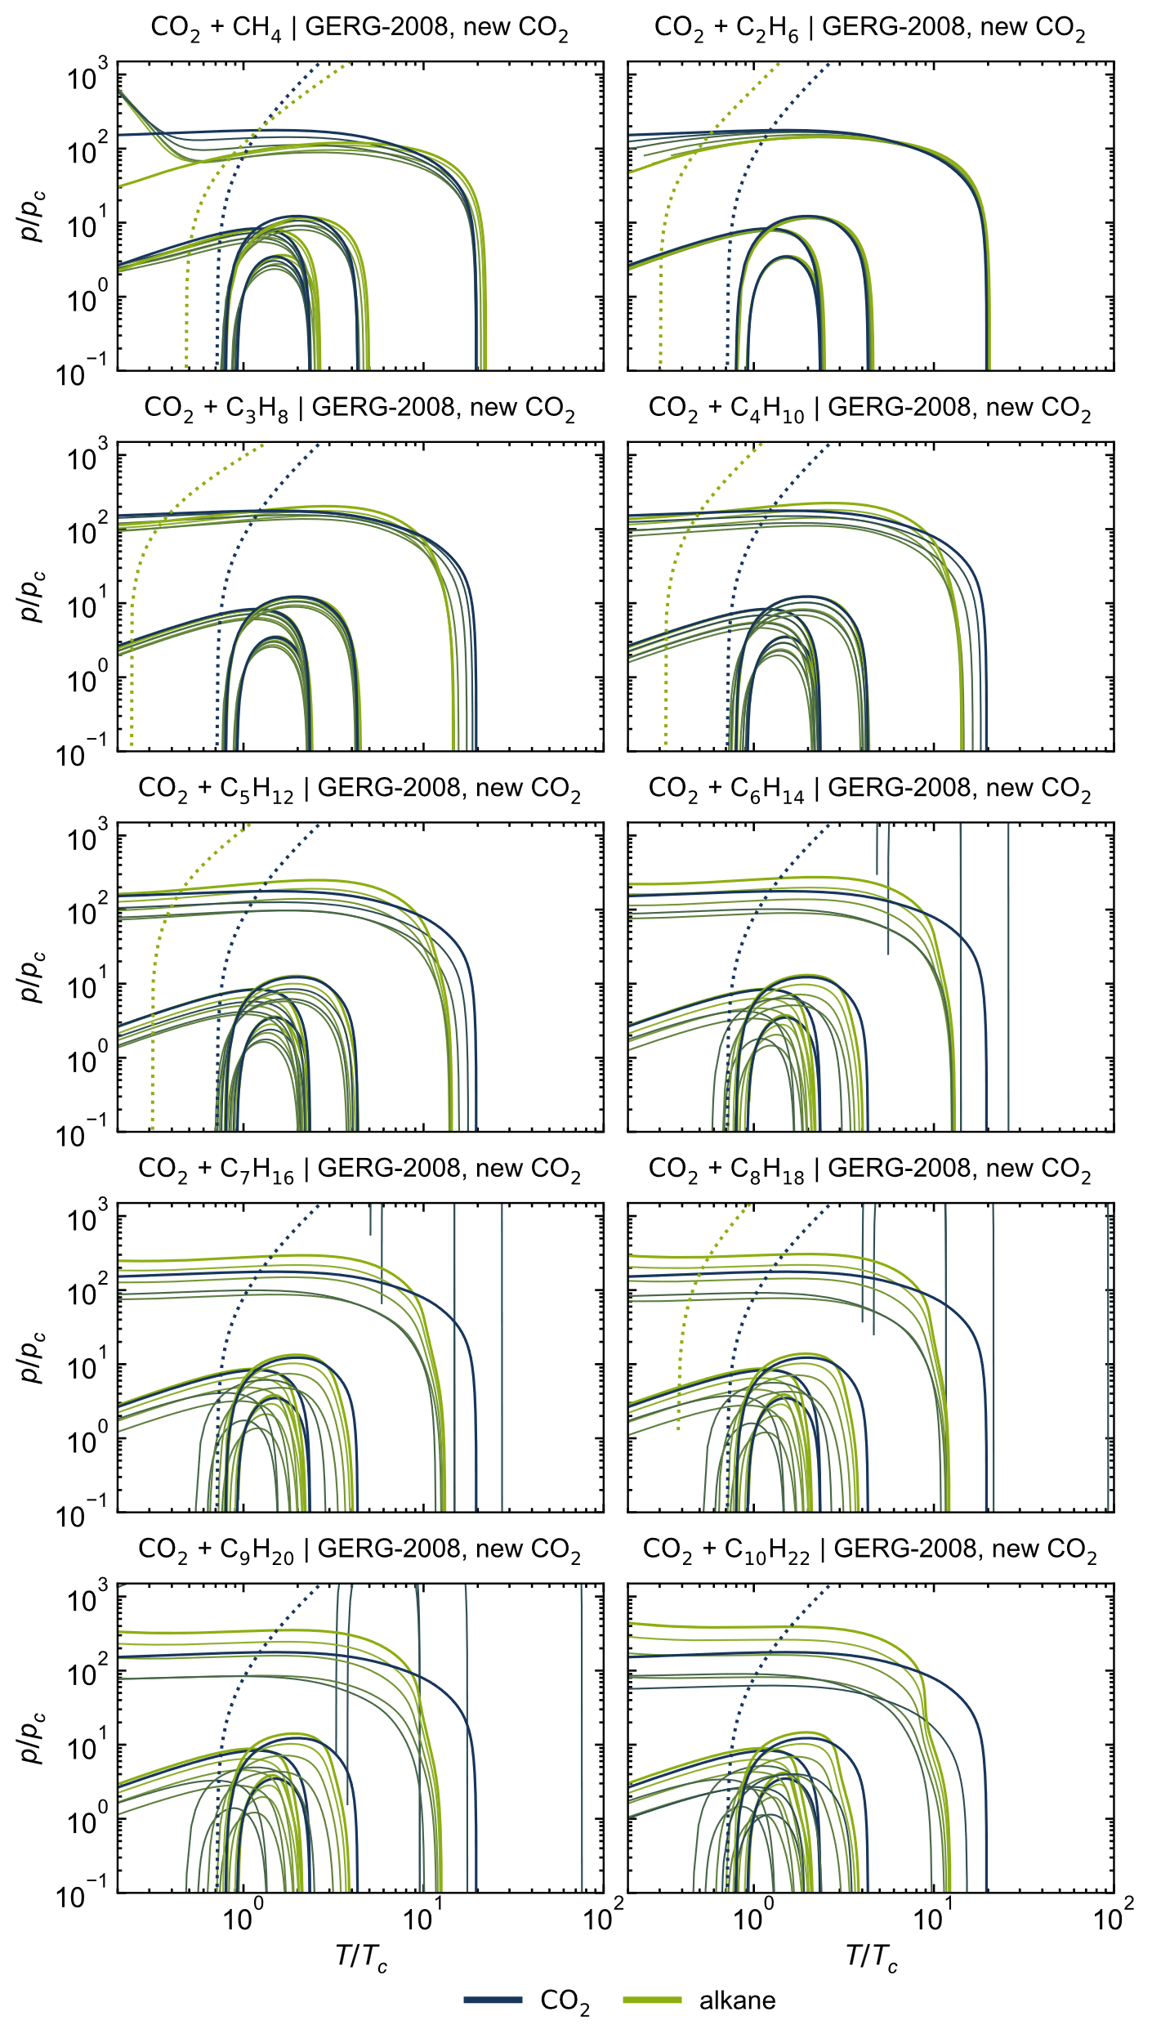
Figure S 11: Ideal curves of all considered CO₂ + alkane mixtures, calculated with the GERG-2008 model [1] and the new preliminary EOS for CO₂ [3], normalized with the calculated critical values.

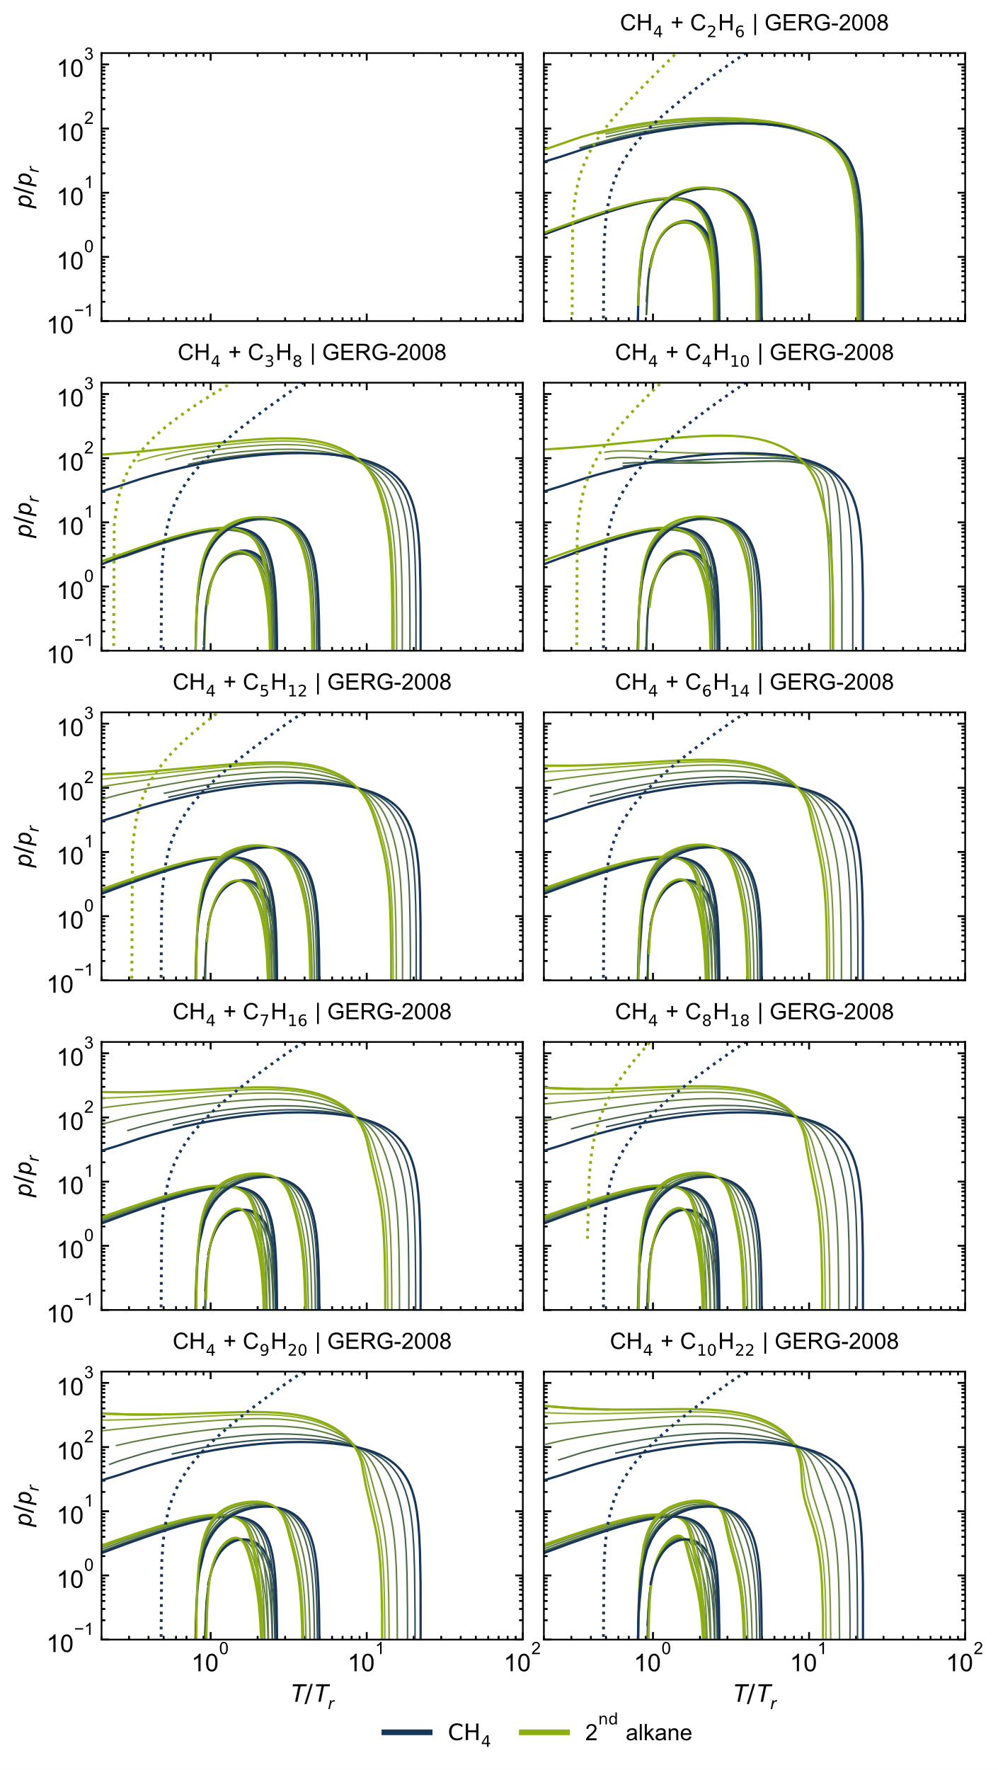
Figure S 12: Ideal curves of all considered CH₄ + alkane mixtures, calculated with the GERG-2008 model [1].
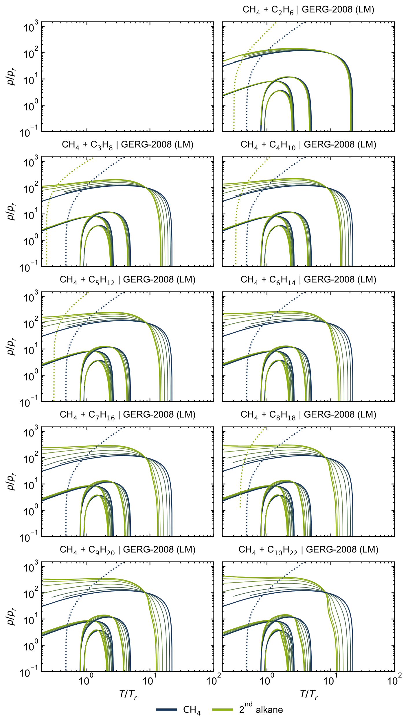
Figure S 13: Ideal curves of all considered CH₄ + alkane mixtures, calculated with the GERG-2008 model [1] using the linear mixing rule (LM).
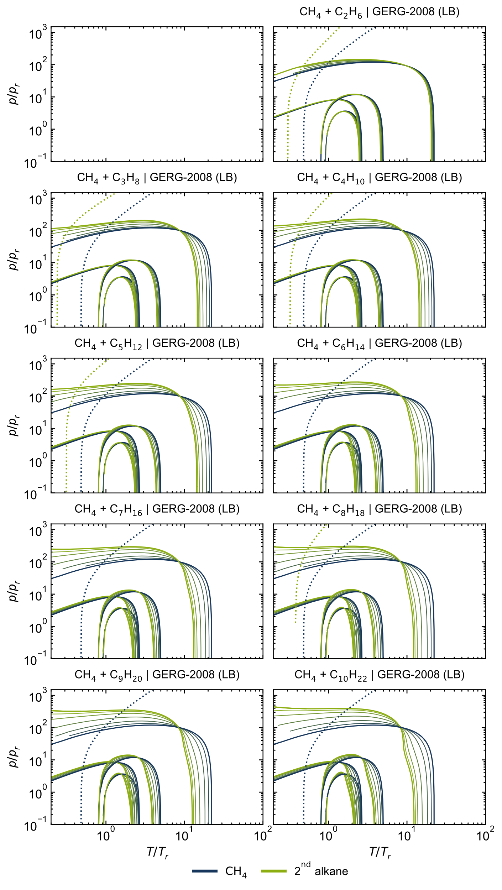
Figure S 14: Ideal curves of all considered CH₄ + alkane mixtures, calculated with the GERG-2008 model [1] using the Lorentz-Berthelot mixing rule (LB).

Classical Ideal Curves: reduced T, ρ diagrams
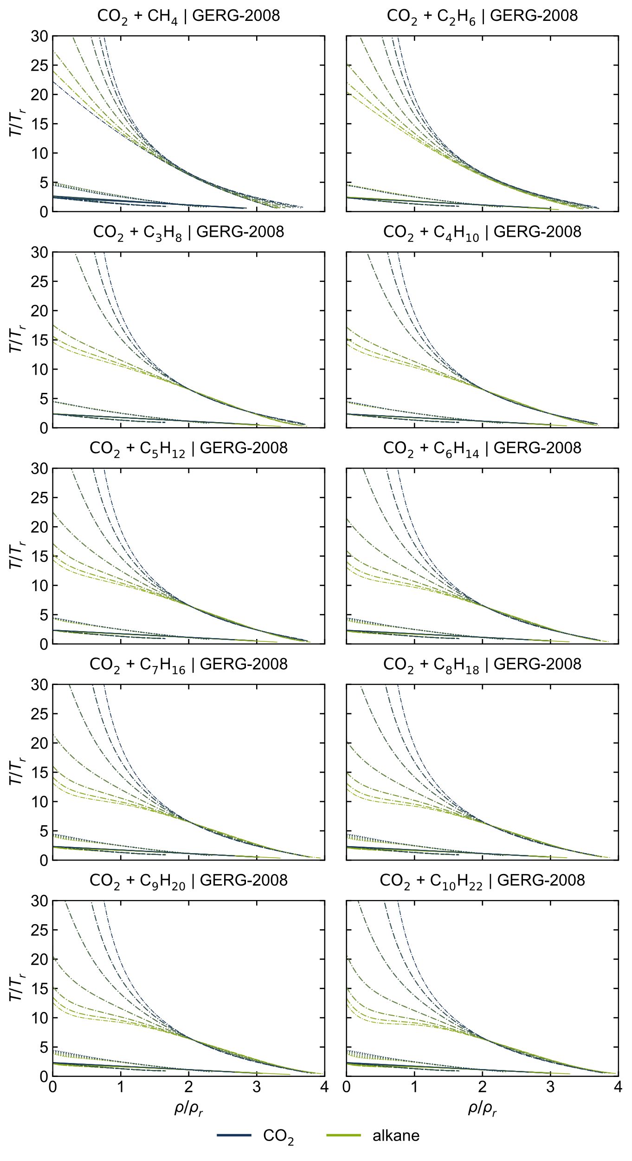
Figure S 15: T,ρ-curves of all considered CO₂ + alkane mixtures, calculated with the GERG-2008 model [1].
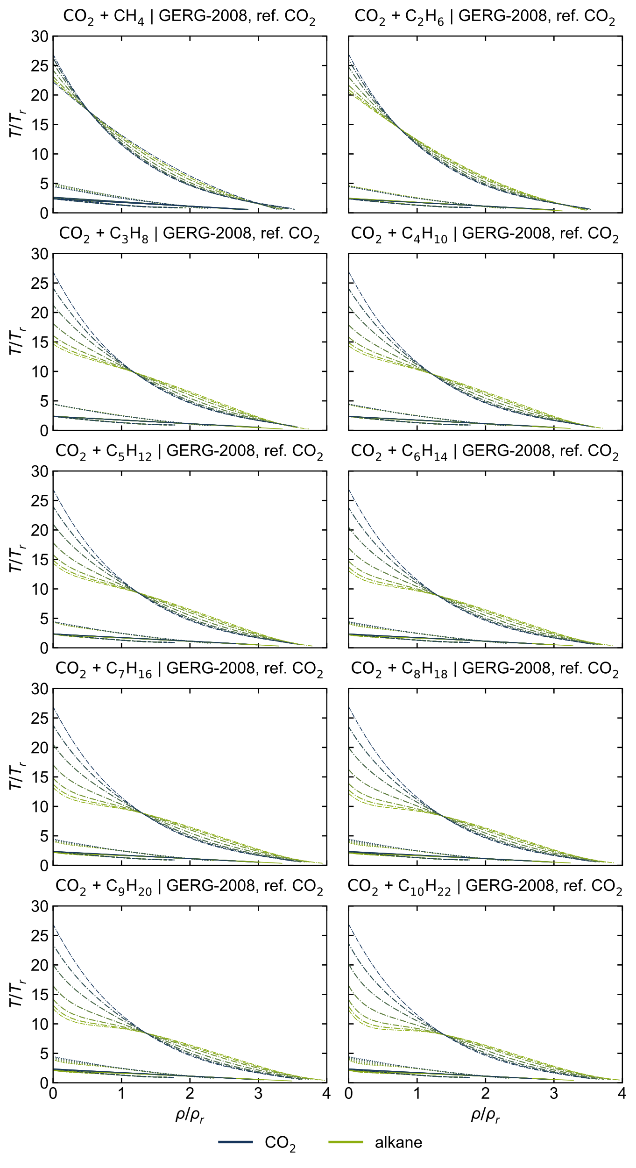
Figure S 16: T,ρ-curves of all considered CO₂ + alkane mixtures, calculated with the GERG-2008 model [1] with the reference CO₂-EOS [2].
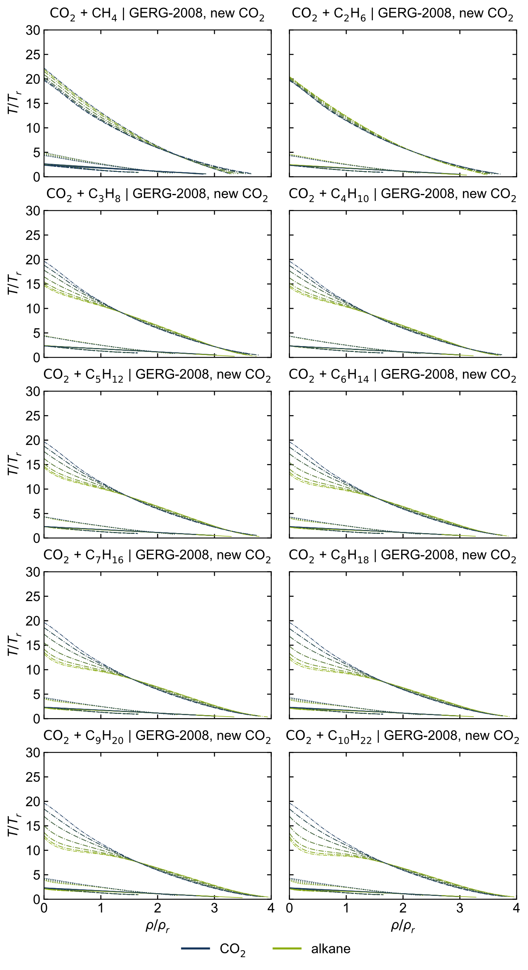
Figure S 17: T,ρ-curves of all considered CO₂ + alkane mixtures, calculated with the GERG-2008 model [1] with the new preliminary CO₂-EOS [3].
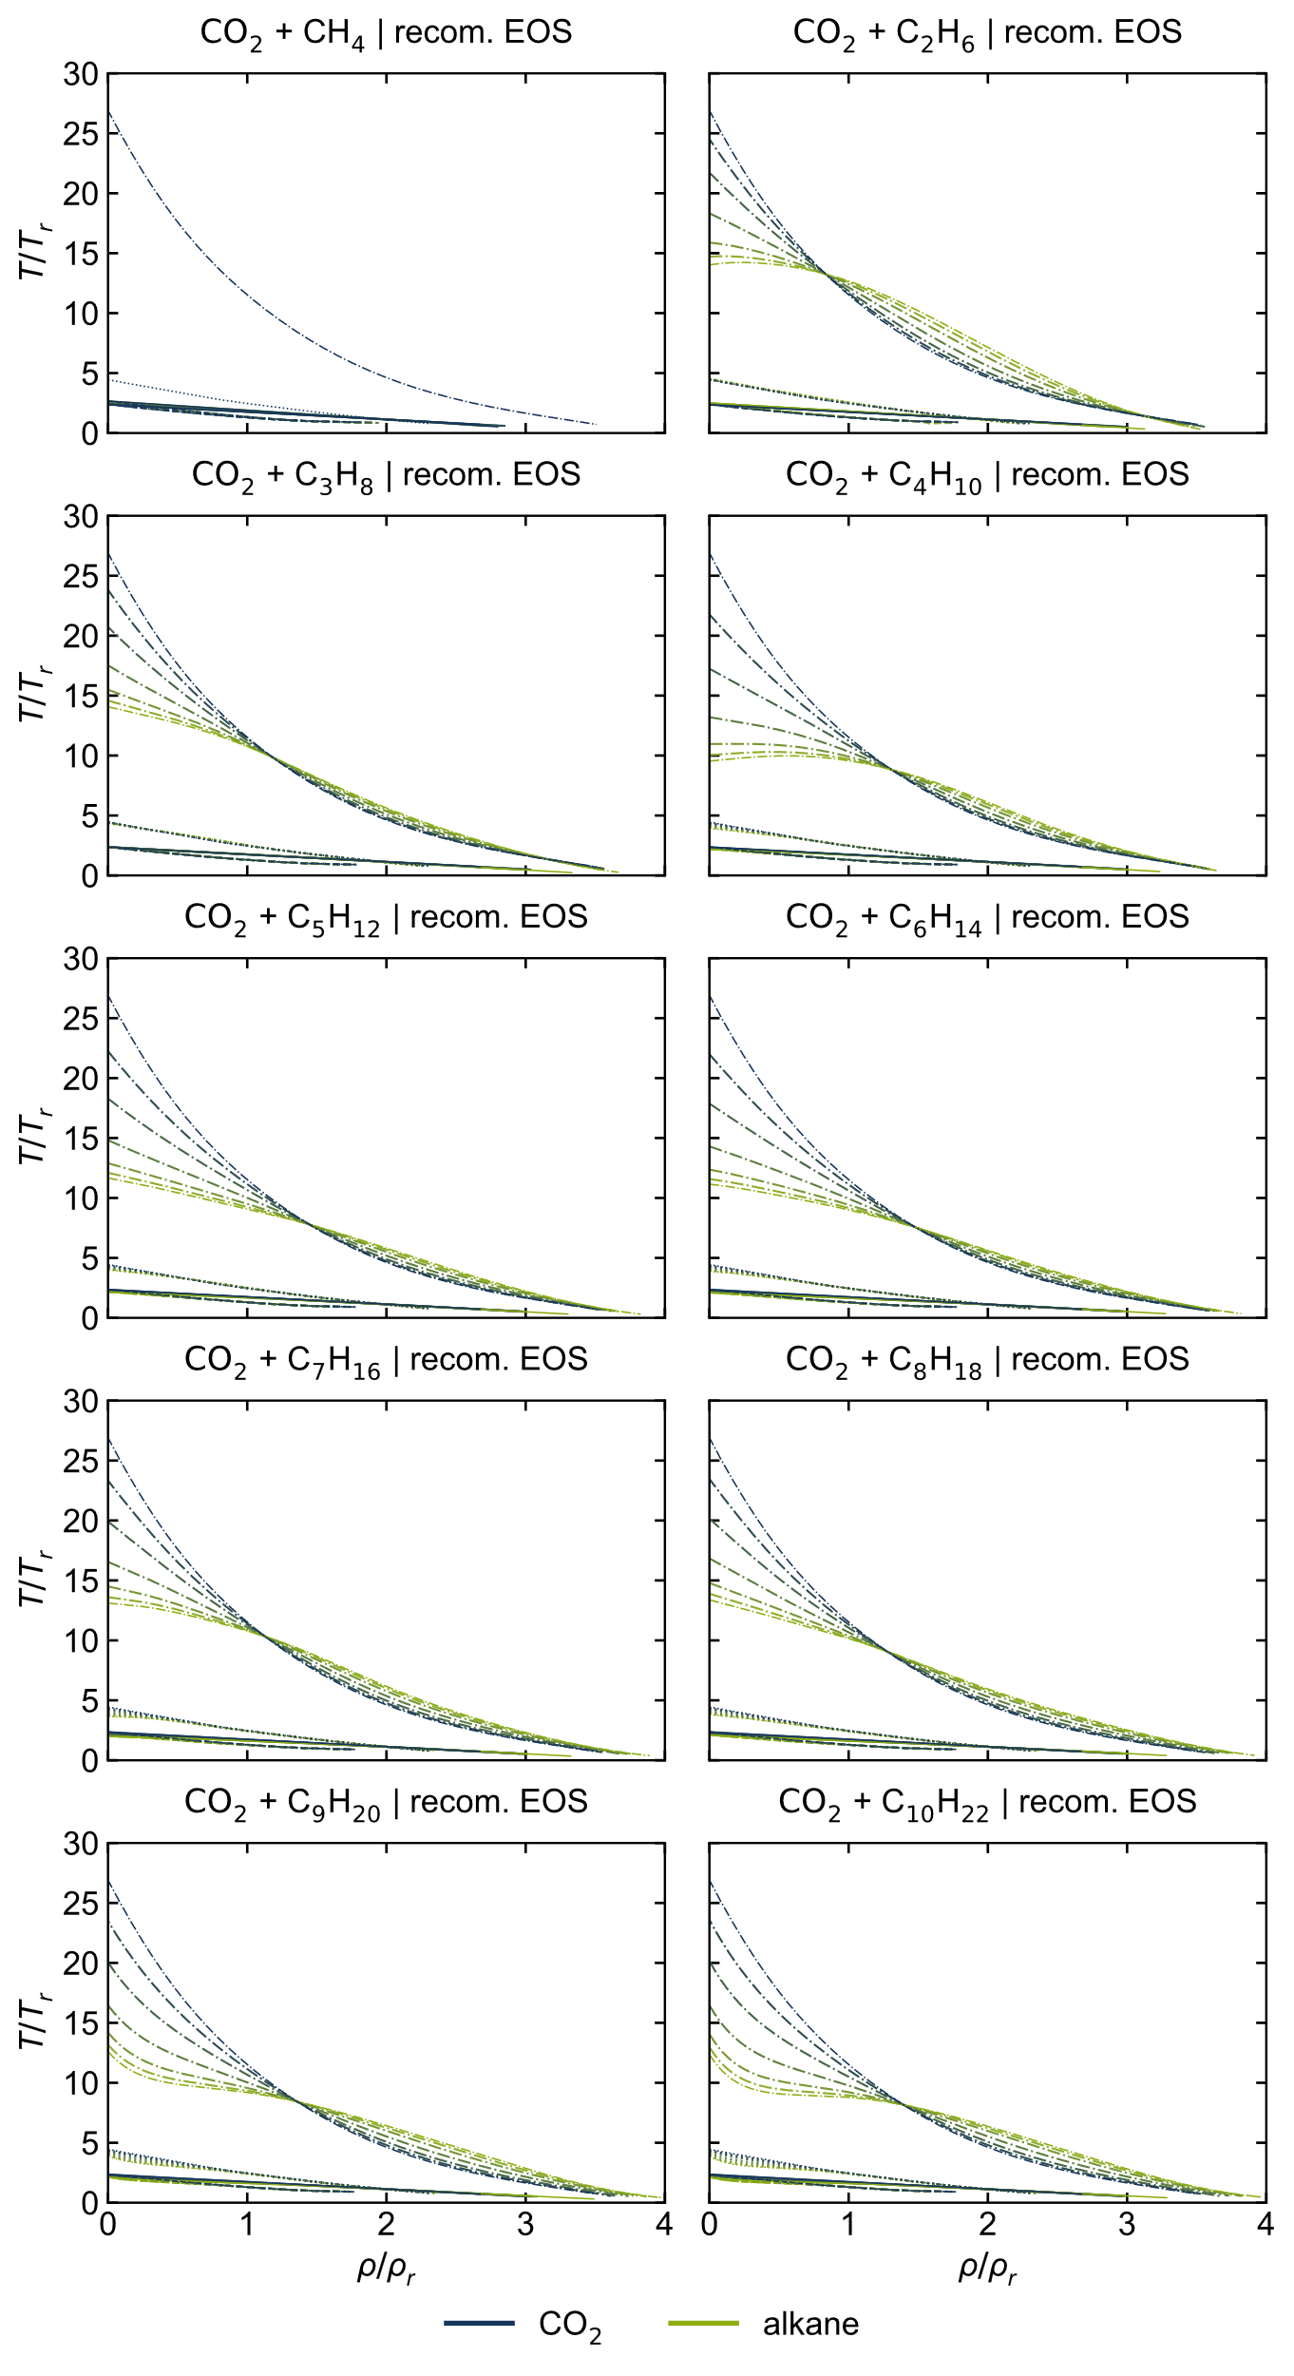
Figure S 18: T,ρ-curves of all considered CO₂ + alkane mixtures, calculated with the recommended EOS [2, 4–12].

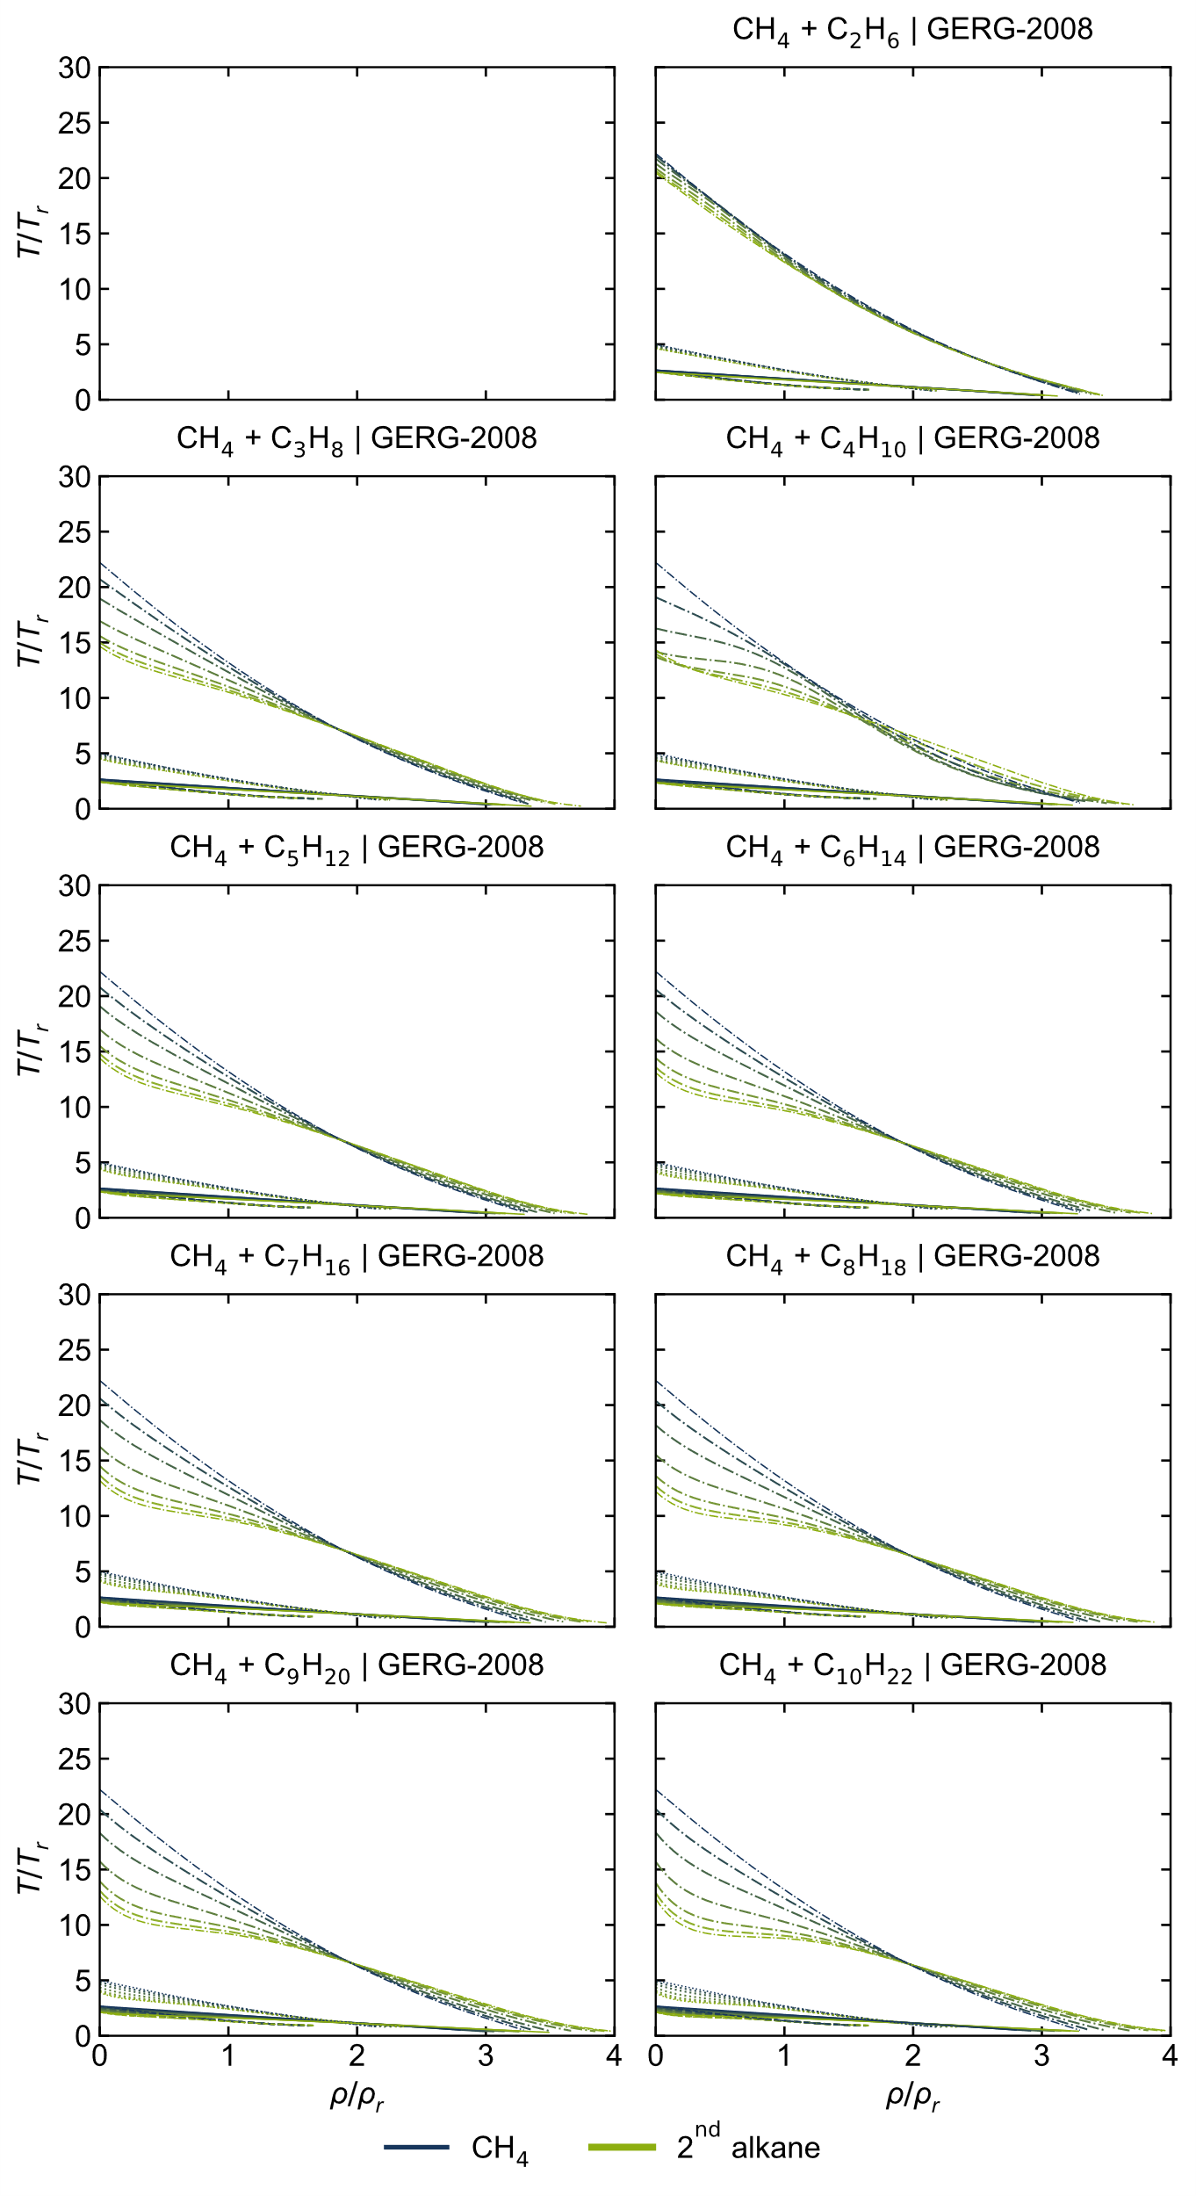
Figure S 19: T,ρ-curves of all considered CH₄ + alkane mixtures, calculated with the GERG-2008 model [1].

VLE data: p,x diagrams
Using the linear mixing rule and the Lorentz-Berthelot mixing rule instead of adjusted reducing and departure functions yields in lower accuracies in other properties, here shown for vapor-liquid-equilibria (VLE) in p,x diagrams. As illustrated in Figure S 20, the phase equilibria using the GERG-2008 model with the linear and the Lorentz-Berthelot mixing rule instead of the adjusted functions are described poorly. While observing some differences between both combining rules in the p,x-diagrams, no significant differences can be seen in the ideal curves (see Figure S 3 and Figure S 4).
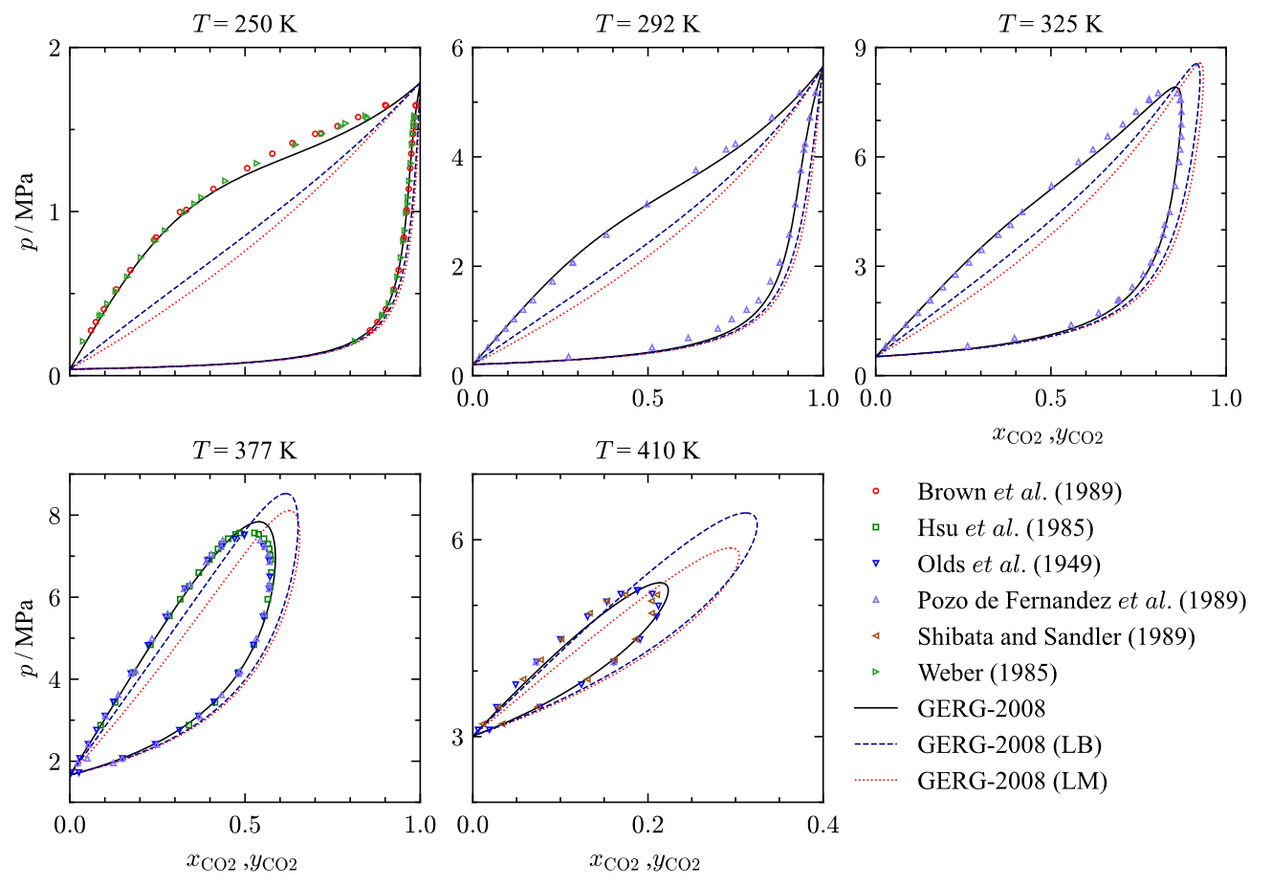
Figure S 20: p,x-diagrams representing selected experimental data [13–18] of vapor-liquid-equilibria (VLE) for the binary system CO₂ + C₄H₁₀ at 250 K, 292 K, 325 K, 377 K and 410 K in comparison to VLEs calculated with the original GERG-2008 model [1] and modified model versions using the linear mixing rule (LM) and the Lorent-Berthelot mixing rule (LB).

The impact of the interaction parameter on the calculated vapor-liquid-equilibria is apparent (see Figure S 21). The overall best representation of the experimental VLE data is obtained using the average interaction parameter, while the results simultaneously indicate a clear temperature dependence of the interaction parameter.
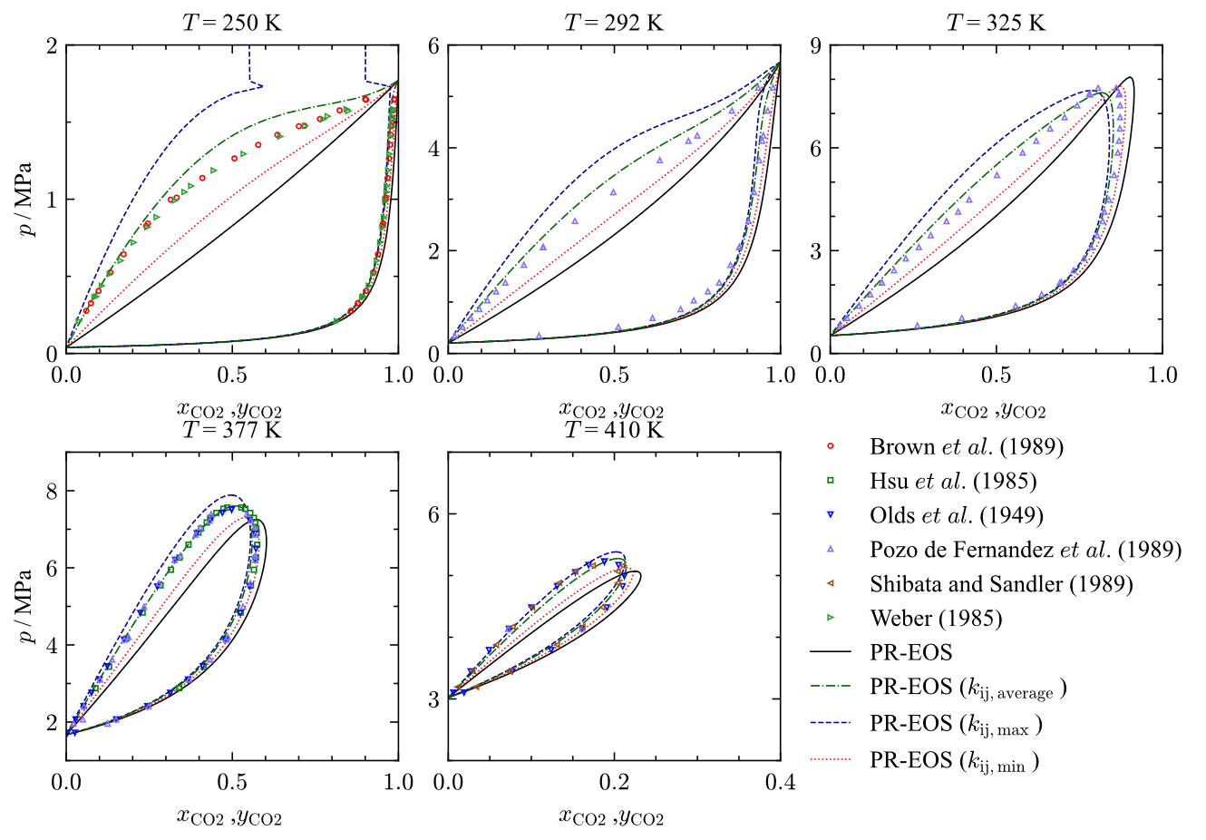
Figure S 21: p,x-diagrams representing selected experimental data [13–18] of vapor-liquid-equilibria (VLE) for the binary system CO₂ + C₄H₁₀ at 250 K, 292 K, 325 K, 377 K and 410 K in comparison to VLEs calculated using the PR-EOS [19] with different interaction parameters k_{ij} from Table 6.

Characteristic values
Table S 1: Overview of the characteristic values from Span and Wagner [20] of all components, CO₂ mixtures and mixture models considered.
 | θ_{B},θ_{I} | θ_{JT} | θ_{J} | δ_{B | T=Tc} | δ_{I | T=Tc} | π_{max,JT} | θ_{max,JT}
Predicted for pure fluids [20]: | 2.66 | 5 | 19.5 | 1.435 | 2.2235 | 11.8 | 2.25
system | GERG-2008 [1]
CO₂ | 2.3511 | 4.4533 | 89.7040 | 1.4410 | 2.2309 | 12.5290 | 1.9377
C₁ | 2.6720 | 4.9894 | 22.2147 | 1.4277 | 2.2032 | 11.8196 | 2.2643
C₂ | 2.4830 | 4.6213 | 20.4638 | 1.4303 | 2.1940 | 12.1023 | 2.1125
C₃ | 2.4215 | 4.4967 | 14.6510 | 1.4336 | 2.1947 | 12.0989 | 2.0563
C₄ | 2.3658 | 4.3884 | 14.3410 | 1.4448 | 2.2013 | 12.3293 | 1.9995
C₅ | 2.3564 | 4.3732 | 14.3829 | 1.4435 | 2.1991 | 12.7175 | 1.9606
C₆ | 2.2067 | 4.0490 | 13.0851 | 1.4643 | 2.2114 | 13.0722 | 1.9699
C₇ | 2.2191 | 4.0683 | 13.1894 | 1.4549 | 2.2373 | 13.4027 | 1.9559
C₈ | 2.1093 | 3.8314 | 12.1951 | 1.4340 | 2.2170 | 13.8698 | 1.9281
C₉ | 2.1368 | 3.8993 | 12.6051 | 1.4681 | 2.2297 | 14.1518 | 1.9077
C₁₀ | 2.1351 | 3.8643 | 12.3639 | 1.4442 | 2.2136 | 14.6909 | 1.9706
 | recommended EOS (TREND 6 [21]), used in This work [2, 4–12]
CO₂ | 2.3744 | 4.4513 | 26.5436 | 1.4415 | 2.2318 | 12.5362 | 1.9369
C₁ | 2.6697 | + | + | 1.4278 | 2.2028 | 5.3000 | +
C₂ | 2.5057 | 4.5365 | 14.0155 | 1.4341 | 2.1999 | 12.0777 | 2.1100
C₃ | 2.3588 | 4.3494 | 14.0677 | 1.4354 | 2.1953 | 12.1050 | 2.0598
C₄ | 2.1953 | 3.9444 | 9.5370 | 1.4472 | 2.2021 | 12.8618 | 1.9704
C₅ | 2.1570 | 4.0052 | 11.6686 | 1.4474 | 2.2063 | 12.9816 | 2.0125
C₆ | 2.0984 | 3.8794 | 11.1520 | 1.4441 | 2.2091 | 13.6075 | 1.9001
C₇ | 1.9881 | 3.6499 | 13.1122 | 1.4525 | 2.2193 | 14.3209 | 1.8565
C₈ | 2.0886 | 3.8131 | 13.3792 | 1.4574 | 2.2283 | 13.9759 | 1.8530
C₉ | 2.1368 | 3.8993 | 12.6051 | 1.4681 | 2.2297 | 14.1518 | 1.9077
C₁₀ | 2.1351 | 3.8643 | 12.3639 | 1.4442 | 2.2136 | 14.6909 | 1.9706
 | new CO₂-EOS [3]
CO₂ | 2.344 | 4.3083 | 19.6385 | 1.4409 | 2.2307 | 12.2759 | 1.9833

Table 7 continued
 | Peng-Robinson EOS [19]
CO₂ | 2.3256 | 3.8396 | 5.8336 | 1.5602 | 2.7981 | 13.6491 | 1.8711
C₁ | 2.9952 | 5.3550 | 12.6295 | 1.5602 | 2.7982 | 13.0850 | 2.3188
C₂ | 2.6435 | 4.5613 | 8.4131 | 1.5601 | 2.7982 | 13.2742 | 2.0701
C₃ | 2.4921 | 4.2180 | 7.0695 | 1.5601 | 2.7982 | 13.4194 | 1.9647
C₄ | 2.3743 | 3.9503 | 6.1716 | 1.5601 | 2.7982 | 13.5732 | 1.8983
C₅ | 2.2731 | 3.7201 | 5.4885 | 1.5601 | 2.7982 | 13.7394 | 1.8506
C₆ | 2.1902 | 3.5314 | 4.9821 | 1.5601 | 2.7982 | 13.9080 | 1.7951
C₇ | - | - | - | - | - | - | -
C₈ | - | - | - | - | - | - | -
C₉ | - | - | - | - | - | - | -
C₁₀ | - | - | - | - | - | - | -
 | GERG-2008 [1]
CO₂+C₁ | 2.6369 - 2.3809 | 4.9323 - 4.5045 | 24.0468 - 145.7370 | 1.4161 - (1.3966) - 1.4270 | 2.1981 - (2.1937) - 2.2203 | 11.7006 - (11.5956) - 12.2363 | 2.2610 - 1.9924
CO₂+C₂ | 2.4691 - 2.3633 | 4.6038 - 4.4696 | 22.9289 - 134.9980 | 1.4312 - 1.4399 | 2.1975 - 2.2269 | 12.1365 - 12.4770 | 2.0969 - 1.9466
CO₂+C₃ | 2.4144 - 2.3580 | 4.4926 - 4.4580 | 15.6304 - 90.7700 | 1.4343 - 1.4408 | 2.1981 - 2.2270 | 12.1362 - 12.4806 | 2.0333 - (1.9412) - 1.9646
CO₂+C₄ | 2.3643 - 2.3525 | 4.3945 - 4.4464 | 15.3037 - 89.4285 | 1.4444 - 1.4416 | 2.2040 - 2.2277 | 12.3445 - 12.5021 | 1.9981 - 1.9332
CO₂+C₅ | 2.3559 - 2.3516 | 4.3805 - 4.4445 | 15.3217 - 87.5162 | 1.4433 - 1.4416 | 2.2020 - 2.2273 | 12.6922 - 12.5392 | 1.9754 - 1.9307
CO₂+C₆ | 2.2204 - 2.3359 | 4.0856 - 4.4088 | 14.0505 - 85.2604 | 1.4618 - 1.4438 | 2.2132 - 2.2287 | 13.0113 - 12.5736 | 1.9991 - (1.9635) - 1.9806
CO₂+C₇ | 2.2316 - 2.3372 | 4.1033 - 4.4111 | 14.1596 - 84.7979 | 1.4532 - 1.4422 | 2.2367 - 2.2316 | 13.3085 - 12.6097 | 1.9619 - (1.9629) - 1.9508
CO₂+C₈ | 2.1309 - 2.3242 | 3.8851 - 4.3819 | 13.1375 - 83.8218 | 1.4349 - 1.4410 | 2.2182 - 2.2293 | 13.7221 - 12.6471 | 1.9357 - 1.9707
CO₂+C₉ | 2.1557 - 2.3270 | 3.9465 - 4.3888 | 13.5235 - 81.9127 | 1.4650 - 1.4441 | 2.2298 - 2.2308 | 13.9693 - 12.6685 | 1.8958 - 1.9760
CO₂+C₁₀ | 2.1546 - 2.3274 | 3.9163 - 4.3873 | 13.3387 - 81.7846 | 1.4440 - (1.4417) - 1.4422 | 2.2151 - 2.2289 | 14.4477 - 12.7110 | 1.9587 - (1.9490) - 1.9868
 | GERG-2008, ref.CO₂ [1, 2]
CO₂+C₁ | 2.6405 - 2.4029 | 4.9321 - 4.5026 | 22.5798 - 27.8621 | 1.4162 - (1.3970) - 1.4274 | 2.1982 - (2.1939) - 2.2211 | 11.696 - (11.588) - 12.236 | 2.2603 - 1.9911
CO₂+C₂ | 2.4719 - 2.3847 | 4.6036 - 4.4677 | 20.9158 - 25.0363 | 1.4314 - 1.4404 | 2.1975 - 2.2277 | 12.1350 - 12.4825 | 2.0966 - 1.9458
CO₂+C₃ | 2.4169 - 2.3791 | 4.4924 - 4.4561 | 15.1770 - 23.8276 | 1.4343 - 1.4412 | 2.1981 - 2.2278 | 12.1355 - 12.4836 | 2.0331 - (1.9405) - 1.9636
CO₂+C₄ | 2.3666 - 2.3735 | 4.3943 - 4.4445 | 14.8714 - 23.7222 | 1.4444 - 1.4419 | 2.2041 - 2.2284 | 12.3442 - 12.5090 | 1.9979 - 1.9325
CO₂+C₅ | 2.3581 - 2.3725 | 4.3803 - 4.4427 | 14.8989 - 23.6198 | 1.4433 - 1.4418 | 2.2020 - 2.2281 | 12.6922 - 12.5462 | 1.9752 - 1.9301
CO₂+C₆ | 2.2222 - 2.3564 | 4.0854 - 4.4069 | 13.6692 - 23.2482 | 1.4618 - 1.4440 | 2.2132 - 2.2295 | 13.0111 - 12.5781 | 1.9989 - 1.9161
CO₂+C₇ | 2.2335 - 2.3577 | 4.1031 - 4.4092 | 13.7720 - 23.3692 | 1.4532 - 1.4427 | 2.2368 - 2.2324 | 13.3088 - 12.6144 | 1.9618 - (1.9624) - 1.9499
CO₂+C₈ | 2.1325 - 2.3444 | 3.8849 - 4.3800 | 12.8015 - 23.1776 | 1.4349 - 1.4415 | 2.2183 - 2.2301 | 13.7227 - 12.6493 | 1.9356 - (1.9319) - 1.9696
CO₂+C₉ | 2.1573 - 2.3471 | 3.9463 - 4.3869 | 13.1807 - 24.3708 | 1.4650 - 1.4445 | 2.2299 - 2.2316 | 13.9704 - 12.6747 | 1.8958 - (1.9294) - 1.9070
CO₂+C₁₀ | 2.1563 - 2.3476 | 3.9161 - 4.3854 | 12.9835 - 24.2708 | 1.4440 - (1.4420) - 1.4426 | 2.2152 - 2.2297 | 14.4481 - 12.7187 | 1.9586 - 1.9133

Table 7 continued
 | GERG-2008, new CO₂ [1, 3]
CO₂+C₁ | 2.6368 - 2.3748 | 4.9154 - 4.3715 | 21.9412 - 20.1436 | 1.4161 - (1.3966) - 1.4270 | 2.1981 - (2.1937) - 2.2202 | 11.6843 - (11.5194) - 12.0192 | 2.2606 - 2.0424
CO₂+C₂ | 2.4686 - 2.3571 | 4.5885 - 4.3381 | 20.3885 - (19.8555) - 19.9215 | 1.4313 - 1.4398 | 2.1975 - 2.2268 | 12.1155 - 12.2541 | 2.0959 - 1.9962
CO₂+C₃ | 2.4138 - 2.3517 | 4.4787 - 4.3279 | 14.9500 - 18.8447 | 1.4342 - 1.4408 | 2.1981 - 2.2269 | 12.1150 - 12.2542 | 2.0323-(2.0004)-(2.0467)-2.0166
CO₂+C₄ | 2.3636 - 2.3462 | 4.3809 - 4.3168 | 14.6527 - 18.7804 | 1.4444 - 1.4415 | 2.2040 - 2.2275 | 12.3224 - 12.2796 | 1.9970-(1.9664)-(2.0081)-1.9859
CO₂+C₅ | 2.3552 - 2.3453 | 4.3672 - 4.3153 | 14.6849 - 18.7684 | 1.4433 - 1.4415 | 2.2020 - 2.2272 | 12.6698 - 12.3162 | 1.9743-(1.9681)-(2.0040)-1.9845
CO₂+C₆ | 2.2196 - 2.3294 | 4.0728 - 4.2800 | 13.4670 - 18.5699 | 1.4618 - 1.4437 | 2.2132 - 2.2286 | 12.9891 - 12.3501 | 1.9981 - 1.9692
CO₂+C₇ | 2.2308 - 2.3307 | 4.0905 - 4.2822 | 13.5674 - 18.5916 | 1.4532 - 1.4421 | 2.2367 - 2.2315 | 13.2842 - 12.3806 | 1.9608 - (1.9505) - 2.0073
CO₂+C₈ | 2.1301 - 2.3177 | 3.8734 - 4.2541 | 12.6153 - 18.3934 | 1.4349 - 1.4410 | 2.2182 - 2.2292 | 13.6974 - 12.4202 | 1.9346 - (1.9713) - 1.9592
CO₂+C₉ | 2.1550 - 2.3204 | 3.9347 - 4.2611 | 12.9942 - 18.4369 | 1.4650 - 1.4441 | 2.2298 - 2.2306 | 13.9437 - 12.4444 | 1.8947 -1.9648
CO₂+C₁₀ | 2.1539 - 2.3208 | 3.9042 - 4.2590 | 12.7888 - 18.4560 | 1.4440 - (1.4416) - 1.4422 | 2.2151 - 2.2288 | 14.4240 - 12.4910 | 1.9578-(1.9465)-(1.9792)-1.9759
 | GERG-2008, new CO₂ [1, 3], linear mixing rule
CO₂+C₁ | 2.6335 - 2.3717 | 4.9110 - 4.3669 | 21.9378 - 20.1266 | 1.4292 - 1.4397 | 2.2059 - 2.2280 | 11.8403 - 12.2037 | 2.2591- (2.0424) - 2.0429
CO₂+C₂ | 2.4686 - 2.3571 | 4.5885 - 4.3381 | 20.3885 - 19.7322 | 1.4313 - 1.4401 | 2.1975 - 2.2268 | 12.1154 - 12.2541 | 2.1020 - 2.0026
CO₂+C₃ | 2.4138 - 2.3517 | 4.4787 - 4.3279 | 14.9500 - 18.8447 | 1.4342 - 1.4408 | 2.1981 - 2.2269 | 12.1150 - 12.2539 | 2.0318-(2.0025)-(2.0474)-2.0182
CO₂+C₄ | 2.3636 - 2.3462 | 4.3809 - 4.3168 | 14.6527 - 18.7804 | 1.4444 - 1.4417 | 2.2040 - 2.2275 | 12.3223 - 12.2794 | 2.0075 - 1.9799
CO₂+C₅ | 2.3552 - 2.3453 | 4.3672 - 4.3153 | 14.6849 - 18.7684 | 1.4432 - 1.4417 | 2.2020 - 2.2272 | 12.6699 - 12.3131 | 1.9683 - (1.9481) - 2.0132
CO₂+C₆ | 2.2196 - 2.3294 | 4.0728 - 4.2800 | 13.4670 - 18.5699 | 1.4617 - 1.4436 | 2.2132 - 2.2286 | 12.9884 - 12.3513 | 1.9714 - (2.0028) - 1.9856
CO₂+C₇ | 2.2308 - 2.3307 | 4.0905 - 4.2822 | 13.5674 - 18.5916 | 1.4532 - 1.4427 | 2.2367 - 2.2315 | 13.2833 - 12.3798 | 1.9508 - (1.9858) - 1.9569
CO₂+C₈ | 2.1301 - 2.3177 | 3.8734 - 4.2541 | 12.6153 - 18.3934 | 1.4347 - 1.4402 | 2.2182 - 2.2292 | 13.6971 - 12.4173 | 1.9613 - (1.9495) - 2.0162
CO₂+C₉ | 2.1550 - 2.3204 | 3.9347 - 4.2611 | 12.9942 - 18.4369 | 1.4650 - 1.4441 | 2.2298 - 2.2306 | 13.9440 - 12.4438 | 1.9362 - (1.9148) - 1.9932
CO₂+C₁₀ | 2.1539 - 2.3208 | 3.9042 - 4.2590 | 12.7888 - 18.4560 | 1.4442 - (1.4417) - 1.4423 | 2.2151 - 2.2288 | 14.4229 - 12.4909 | 1.9421 - 1.9898
 | GERG-2008, new CO₂ [1, 3], Lorentz-Berthelot mixing rule
CO₂+C₁ | 2.6373 - 2.3998 | 4.9278 - 4.4982 | 22.5764 - 27.8441 | 1.4293 - 1.4401 | 2.2060 - 2.2289 | 11.8524 - 12.4284 | 2.2589 - (1.9888) - 1.9921
CO₂+C₂ | 2.4719 - 2.3847 | 4.6036 - 4.4677 | 20.9158 - 27.3899 | 1.4315 - 1.4407 | 2.1976 - 2.2277 | 12.1338 - 12.4825 | 2.1076 - 1.9587
CO₂+C₃ | 2.4169 - 2.3791 | 4.4924 - 4.4561 | 15.1770 - 23.6551 | 1.4343 - 1.4408 | 2.1981 - 2.2278 | 12.1349 - 12.4830 | 2.0189 - (2.0190) - 1.9261
CO₂+C₄ | 2.3666 - 2.3735 | 4.3943 - 4.4445 | 14.8714 - 23.5696 | 1.4445 - 1.4424 | 2.2041 - 2.2284 | 12.3442 - 12.5061 | 1.9980 - (1.9377) - 1.9687
CO₂+C₅ | 2.3581 - 2.3725 | 4.3803 - 4.4427 | 14.8989 - 23.5537 | 1.4433 - 1.4422 | 2.2020 - 2.2281 | 12.6927 - 12.5453 | 1.9617 - (1.9162) - 1.9570
CO₂+C₆ | 2.2222 - 2.3564 | 4.0854 - 4.4069 | 13.6692 - 23.3533 | 1.4618 - 1.4440 | 2.2133 - 2.2295 | 13.0112 - 12.5811 | 1.9669-(1.9183)-(1.9871)-1.9519
CO₂+C₇ | 2.2335 - 2.3577 | 4.1031 - 4.4092 | 13.7720 - 23.4073 | 1.4532 - 1.4425 | 2.2368 - 2.2324 | 13.3080 - 12.6146 | 1.9484-(1.9311)-(1.9664)-1.9481
CO₂+C₈ | 2.1325 - 2.3444 | 3.8849 - 4.3800 | 12.8015 - 23.1783 | 1.4347 - 1.4411 | 2.2183 - 2.2301 | 13.7215 - 12.6530 | 1.9596 - (1.9272) - 1.9554
CO₂+C₉ | 2.1573 - 2.3471 | 3.9463 - 4.3869 | 13.1807 - 23.2460 | 1.4650 - 1.4442 | 2.2299 - 2.2316 | 13.9694 - 12.6760 | 1.8910 - 1.9563
CO₂+C₁₀ | 2.1563 - 2.3476 | 3.9161 - 4.3854 | 12.9835 - 23.3343 | 1.4442 - (1.4420) - 1.4425 | 2.2152 - 2.2297 | 14.4477 - 12.7169 | 1.9420 - (1.9338) - 1.9716

Table 7 continued
 | This work
CO₂+C₁ | 2.6375 - 2.4012 | + | + | 1.4339 - (1.4494) - 1.4458 | 2.2193 - (2.2566) - 2.2430 | 5.4777 - (5.5196) - 0.5396 | +
CO₂+C₂ | 2.4925 - 2.3874 | 4.5305 - 4.4621 | 14.7281 - 24.0613 | 1.4386 - (1.4487) - 1.4446 | 2.2132 - (2.2464) - 2.2395 | 12.2523 - (12.7015) - 12.6222 | 2.1136 - 1.9438
CO₂+C₃ | 2.3645-(2.3795)-2.3772 | 4.3687 - 4.4514 | 14.6438 - 23.7451 | 1.4539 - (1.5120) - 1.4606 | 2.2407 - (2.3432) - 2.2748 | 12.7151 - (14.1219) - 13.0979 | 2.0764 - (2.0980) - 1.9715
CO₂+C₄ | 2.2177 - 2.3622 | 4.0016 - 4.4109 | 10.0979 - 21.9239 | 1.4868 - (1.7016) - 1.4811 | 2.2798 - (2.4507) - 2.3115 | 13.9265 - (16.4390) - 13.6704 | 2.0313 - (2.0961) - 2.0151
CO₂+C₅ | 2.1800 - 2.3553 | 4.0524 - 4.4124 | 12.1770 - 22.5610 | 1.4982 - (1.8305) - 1.4902 | 2.2956 - (2.4917) - 2.3271 | 14.1985 - (17.2411) - 13.8915 | 2.0675 - (2.1169) - 1.9764
 | This work (2)
CO₂+C₁ | 2.5976 - 2.3714 | + | + | 1.4216 - (1.4130) - 1.4325 | 2.2117 - (2.2405) - 2.2363 | 5.2360 - 0.5095 | +
CO₂+C₂ | 2.4857 - 2.3816 | 4.5157 - 4.4484 | 14.6811 - 23.9716 | 1.4336 - (1.4327) - 1.4395 | 2.2038 - 2.2296 | 12.0557 - (12.0498) - 12.4126 | 2.1035 - 1.9512
CO₂+C₃ | 2.3580-(2.3576)-2.3702 | 4.3534 - 4.4341 | 14.5743 - 23.5706 | 1.4353 - 1.4408 | 2.1991 - 2.2284 | 12.1048 - 12.4466 | 2.0548 - (1.9432) - 1.9684
CO₂+C₄ | 2.2046 - 2.3460 | 3.9718 - 4.3714 | 10.0158 - 21.5408 | 1.4441 - (1.4374) - 1.4396 | 2.2066 - 2.2309 | 12.6920 - (12.3356) - 12.4328 | 1.9981 - (2.0042) - 1.9552
CO₂+C₅ | 2.1454-(2.1397)-2.3049 | 3.9708-(3.9457)-4.2923 | 11.9641 - 21.7580 | 1.4339 - (1.4049) - 1.4298 | 2.2181 - (2.2547) - 2.2415 | 12.2745 - (11.3486) - 11.9555 | 2.0949 - (2.2157) - 2.0156
 | recommended EOS (TREND 6 [21]) [2, 4–12]
CO₂+C₁ | 2.6388 - 2.4029 | + | + | 1.4163 - (1.3972) - 1.4274 | 2.1979 - (2.1936) - 2.2210 | 5.3949 - 0.5160 | +
CO₂+C₂ | 2.4912 - 2.3863 | 4.5275 - 4.4593 | 14.7095 - 24.0187 | 1.4347 - 1.4407 | 2.2029 - 2.2284 | 12.1136 - 12.4812 | 2.0944 - 1.9456
CO₂+C₃ | 2.3603 - 2.3727 | 4.3586 - 4.4400 | 14.5859 - 23.5975 | 1.4360 - 1.4414 | 2.1986 - 2.2278 | 12.1401 - 12.4848 | 2.0361 - (1.9416) - 1.9640
CO₂+C₄ | 2.2116 - 2.3547 | 3.9871 - 4.3917 | 10.0418 - 21.6343 | 1.4466 - 1.4421 | 2.2048 - 2.2286 | 12.8281 - 12.5675 | 1.9672 - (1.9840) - 1.9364
CO₂+C₅ | 2.1740 - 2.3467 | 4.0375 - 4.3903 | 12.1034 - 22.2389 | 1.4468 - 1.4422 | 2.2086 - 2.2290 | 12.9316 - 12.5749 | 1.9899 - 1.9316
CO₂+C₆ | 2.1184 - 2.3364 | 3.9173 - 4.3664 | 11.5802 - 21.9348 | 1.4439 - 1.4422 | 2.2111 - 2.2293 | 13.4965 - 12.6374 | 1.8973 - (1.9237) - 1.9174
CO₂+C₇ | 2.0137 - 2.3171 | 3.7005 - 4.3278 | 13.6106 - 23.0648 | 1.4513 - 1.4428 | 2.2205 - 2.2304 | 14.1327 - 12.7025 | 1.8651 - 1.9541
CO₂+C₈ | 2.1091 - 2.3351 | 3.8575 - 4.3613 | 13.8874 - 23.2348 | 1.4557 - 1.4435 | 2.2286 - 2.2314 | 13.8182 - 12.6611 | 1.8642 - 1.9622
CO₂+C₉ | 2.1573 - 2.3471 | 3.9463 - 4.3869 | 13.1807 - 24.3710 | 1.4650 - 1.4445 | 2.2299 - 2.2316 | 13.9704 - 12.6747 | 1.8958 - (1.9294) - 1.9070
CO₂+C₁₀ | 2.1563 - 2.3476 | 3.9161 - 4.3854 | 12.9835 - 24.2710 | 1.4440 - (1.4420) - 1.4426 | 2.2152 - 2.2297 | 14.4481 - 12.7187 | 1.9586 - 1.9133
 | recommended EOS (TREND 6 [21]) [2, 4–12], linear mixing rule
CO₂+C₁ | 2.6356 - 2.3998 | + | + | 1.4294 - 1.4401 | 2.2057 - 2.2288 | 5.4199 - 0.5205 | +
CO₂+C₂ | 2.4912 - 2.3863 | 4.5275 - 4.4593 | 14.7095 - 23.8487 | 1.4349 - 1.4410 | 2.2029 - 2.2284 | 12.1128 - 12.4814 | 2.1003 - 1.9518
CO₂+C₃ | 2.3603 - 2.3727 | 4.3586 - 4.4400 | 14.5859 - 23.4405 | 1.4360 - 1.4414 | 2.1986 - 2.2278 | 12.1401 - 12.4845 | 2.0356 - (1.9436) - 1.9656
CO₂+C₄ | 2.2116 - 2.3547 | 3.9871 - 4.3917 | 10.0418 - 21.6220 | 1.4465 - 1.4422 | 2.2049 - 2.2286 | 12.8287 - 12.5669 | 1.9789 - 1.9306
CO₂+C₅ | 2.1740 - 2.3467 | 4.0375 - 4.3903 | 12.1034 - 22.1941 | 1.4468 - 1.4426 | 2.2086 - 2.2290 | 12.9313 - 12.5740 | 1.9838-(1.9548) -(1.9956)-1.9583
CO₂+C₆ | 2.1184 - 2.3364 | 3.9173 - 4.3664 | 11.5802 - 21.9608 | 1.4440 - 1.4422 | 2.2111 - 2.2293 | 13.4953 - 12.6386 | 1.9055-(1.8848)-(1.9334)-1.9296
CO₂+C₇ | 2.0137 - 2.3171 | 3.7005 - 4.3278 | 13.6106 - 23.1324 | 1.4513 - 1.4432 | 2.2205 - 2.2304 | 14.1321 - 12.7016 | 1.8949 - (1.9269) - 1.9049
CO₂+C₈ | 2.1091 - 2.3351 | 3.8575 - 4.3613 | 13.8874 - 23.2984 | 1.4556 - 1.4430 | 2.2286 - 2.2314 | 13.8163 - 12.6652 | 1.8888 - (1.8846) - 1.9449
CO₂+C₉ | 2.1573 - 2.3471 | 3.9463 - 4.3869 | 13.1807 - 23.3446 | 1.4650 - 1.4443 | 2.2299 - 2.2315 | 13.9695 - 12.6786 | 1.8918 - 1.9307
CO₂+C₁₀ | 2.1563 - 2.3476 | 3.9161 - 4.3854 | 12.9835 - 23.4730 | 1.4442 - (1.4420) - 1.4425 | 2.2152 - 2.2297 | 14.4478 - 12.7213 | 1.9429 - (1.9579) - 1.9255

Table 7 continued
 | recommended EOS (TREND 6 [21]) [2, 4–12], Lorentz Berthelot mixing rule
CO₂+C₁ | 2.6356 - 2.3998 | + | + |  |  | 1.4294 - 1.4401 |  |  | 2.2057 - 2.2288 |  |  | 5.4176 - 0.5226 |  |  | +
CO₂+C₂ | 2.4912 - 2.3863 | 4.5275 - 4.4593 | 14.7095 - 23.8449 |  |  | 1.4349 - 1.4411 |  |  | 2.2030 - 2.2284 |  |  | 12.1120 - 12.4812 |  |  | 2.1053 - (1.9420) - 1.9584
CO₂+C₃ | 2.3603 - 2.3727 | 4.3586 - 4.4400 | 14.5859 - 23.4366 |  |  | 1.4360 - 1.4410 |  |  | 2.1986 - 2.2278 |  |  | 12.1399 - 12.4848 |  |  | 2.0484 - 1.9265
CO₂+C₄ | 2.2116 - 2.3547 | 3.9871 - 4.3917 | 10.0418 - 21.5775 |  |  | 1.4466 - 1.4426 |  |  | 2.2049 - 2.2286 |  |  | 12.8283 - 12.5629 |  |  | 1.9691-(1.9471)-(1.9811)-1.9725
CO₂+C₅ | 2.1740 - 2.3467 | 4.0375 - 4.3903 | 12.1034 - 22.2044 |  |  | 1.4468 - 1.4426 |  |  | 2.2086 - 2.2290 |  |  | 12.9307 - 12.5740 |  |  | 2.0101 - (1.9202) - 1.9586
CO₂+C₆ | 2.1184 - 2.3364 | 3.9173 - 4.3664 | 11.5802 - 21.9718 |  |  | 1.4439 - 1.4421 |  |  | 2.2111 - 2.2293 |  |  | 13.4960 - 12.6364 |  |  | 1.9012 - (1.8945) - 1.9528
CO₂+C₇ | 2.0137 - 2.3171 | 3.7005 - 4.3278 | 13.6106 - 23.0970 |  |  | 1.4513 - 1.4427 |  |  | 2.2205 - 2.2304 |  |  | 14.1326 - 12.7030 |  |  | 1.8924 - (1.8806) - 1.9523
CO₂+C₈ | 2.1091 - 2.3351 | 3.8575 - 4.3613 | 13.8874 - 23.2346 |  |  | 1.4556 - 1.4430 |  |  | 2.2286 - 2.2314 |  |  | 13.8166 - 12.6646 |  |  | 1.8872 - (1.8694) - 1.9482
CO₂+C₉ | 2.1573 - 2.3471 | 3.9463 - 4.3869 | 13.1807 - 23.2460 |  |  | 1.4650 - 1.4442 |  |  | 2.2299 - 2.2316 |  |  | 13.9694 - 12.6760 |  |  | 1.8910 - 1.9563
CO₂+C₁₀ | 2.1563 - 2.3476 | 3.9161 - 4.3854 | 12.9835 - 23.3344 |  |  | 1.4442 - (1.4420) - 1.4425 |  |  | 2.2152 - 2.2297 |  |  | 14.4477 - 12.7169 |  |  | 1.9420 - (1.9338) - 1.9716
 | Peng-Robinson EOS (k_{ij} = 0) [19], absolute values
CO₂+C₁ | 588.176-696.670 | 1042.70-1158.77 |  |  | 12153.5-1774.19 |  |  | - |  |  | - |  |  | 199.475-(198.899)-(199.638)-199.167 |  |  | 473.4172 - 649.4324
CO₂+C₂ | 796.009-716.021 | 1368.57-1188.63 |  |  | 2568.71-1774.19 |  |  | - |  |  | - |  |  | 199.244 - (198.998) - 199.589 |  |  | 614.7742-(588.5118)-644.5654
CO₂+C₃ | 900.732-728.530 | 1522.81-1208.51 |  |  | 2614.93-1774.19 |  |  | - |  |  | - |  |  | 199.412-(199.013)-(199.456)-199.356 |  |  | 699.3236-(601.2510)-627.5553
CO₂+C₄ | 982.519-740.353 | 1635.85-1227.05 |  |  | 2623.71-1774.19 |  |  | - |  |  | - |  |  | 198.337 - (199.862) - 198.788 |  |  | 758.6986 - 608.6796
CO₂+C₅ | 1038.25-750.134 | 1702.94-1241.95 |  |  | 2577.93-1774.19 |  |  | - |  |  | - |  |  | 198.430 - (199.667) - 198.780 |  |  | 796.0194-594.1974
CO₂+C₆ | 1081.48-758.991 | 1749.67-1255.12 |  |  | 2530.02-1774.19 |  |  | - |  |  | - |  |  | 199.043-(198.823)-(199.841)-199.700 |  |  | 810.0676 - 599.1440
CO₂+C₇ | - | - |  |  | - |  |  | - |  |  | - |  |  | - |  |  | -
CO₂+C₈ | - | - |  |  | - |  |  | - |  |  | - |  |  | - |  |  | -
CO₂+C₉ | - | - |  |  | - |  |  | - |  |  | - |  |  | - |  |  | -
CO₂+C₁₀ | - | - |  |  | - |  |  | - |  |  | - |  |  | - |  |  | -
 | Peng-Robinson EOS (k_{ij} = 0) [19], normalized with critical values
CO₂+C₁ | 2.8350 - 2.3459 | 5.0257 - 3.9019 |  | 11.6003 - 5.9741 |  |  | 1.2759 - (1.1514) - 1.4147 |  |  | 2.3047 - (2.0892) - 2.5479 |  |  | 11.2223 - (9.6983) - 12.0918 |  |  | 2.2818 - (2.1766) - 2.1868
CO₂+C₂ | 2.6119 - 2.3589 | 4.4907 - 3.9159 |  | 8.4287 - 5.8450 |  |  | 1.4938 - (1.4992) - 1.4962 |  |  | 2.6799 - (2.6904) - 2.6839 |  |  | 13.2430-(13.2273)-(13.3942)-13.2540 |  |  | 2.0563 - (1.9729) - 2.1235
CO₂+C₃ | 2.4647 - 2.3289 | 4.1668 - 3.8632 |  | 7.1552 - 5.6715 |  |  | 1.4738 - (1.4256) - 1.4632 |  |  | 2.6506 - (2.5810) - 2.6352 |  |  | 12.7843 - (11.4533) - 12.5364 |  |  | 1.9598 - (1.8636) - 2.0061
CO₂+C₄ | 2.3431 - 2.2753 | 3.9012 - 3.7710 |  | 6.2571 - 5.4524 |  |  | 1.4526 - (1.2989) - 1.3619 |  |  | 2.6198 - (2.3780) - 2.4717 |  |  | 12.3087 - (9.4380) - 11.0015 |  |  | 1.8870 - (1.7928) - 1.8706
CO₂+C₅ | 2.2396 - 2.2151 | 3.6733 - 3.6674 |  | 5.5607 - 5.2309 |  |  | 1.4387 - (1.1764) - 1.2455 |  |  | 2.6005 - (2.1822) - 2.2803 |  |  | 11.9901 - (0.0000) - 9.3442 |  |  | 1.8021 - 1.7819
CO₂+C₆ | 2.1552 - 2.1564 | 3.4868 - 3.5660 |  | 5.0419 - 5.0408 |  |  | 1.4293 - (1.0772) - 1.1375 |  |  | 2.5881 - (2.0234) - 2.1007 |  |  | 11.7860 - (6.3067) - 7.8950 |  |  | 1.7669 - (1.6440) - 1.7302
CO₂+C₇ | - | - |  | - |  |  | - |  |  | - |  |  | - |  |  | -
CO₂+C₈ | - | - |  | - |  |  | - |  |  | - |  |  | - |  |  | -
CO₂+C₉ | - | - |  | - |  |  | - |  |  | - |  |  | - |  |  | -
CO₂+C₁₀ | - | - |  | - |  |  | - |  |  | - |  |  | - |  |  | -
+: calculations converged towards infinity
-: calculations failed

References
1. O. Kunz, W. Wagner, J. Chem. Eng. Data (2012) doi:10.1021/je300655b
2. R. Span, W. Wagner, Journal of Physical and Chemical Reference Data (1996) doi:10.1063/1.555991
3. E.W. Lemmon
4. U. Setzmann, W. Wagner, Journal of Physical and Chemical Reference Data (1991) doi:10.1063/1.555898
5. D. Bücker, W. Wagner, Journal of Physical and Chemical Reference Data (2006) doi:10.1063/1.1859286
6. E.W. Lemmon, M.O. McLinden, W. Wagner, J. Chem. Eng. Data (2009) doi:10.1021/je900217v
7. D. Bücker, W. Wagner, Journal of Physical and Chemical Reference Data (2006) doi:10.1063/1.1901687
8. Thol, M., Uhde, T., Lemmon, E.W., and Span, R. (2026)
9. Thol, M., Wang, Y., Lemmon, E. W., Span, R. (to be published, 2026)
10. Tenji, D., Thol, M., Lemmon, E. W., Span, R. (to be submitted 2026)
11. R. Beckmüller, R. Span, E.W. Lemmon, M. Thol, Journal of Physical and Chemical Reference Data (2022) doi:10.1063/5.0104661
12. E.W. Lemmon, R. Span, J. Chem. Eng. Data (2006) doi:10.1021/je050186n
13. T.S. Brown, V.G. Niesen, E.D. Sloan, A.J. Kidnay, Fluid Phase Equilibria (1989) doi:10.1016/0378-3812(89)80067-6
14. J.J.C. Hsu, N. Nagarajan, R.L. Robinson, J. Chem. Eng. Data (1985) doi:10.1021/je00042a036
15. R.H. Olds, H.H. Reamer, B.H. Sage, W.N. Lacey, Ind. Eng. Chem. (1949) doi:10.1021/ie50471a011
16. M.E. Pozo de Fernandez, J.A. Zollweg, W.B. Streett, J. Chem. Eng. Data (1989) doi:10.1021/JE00057A019
17. S.K. Shibata, S.I. Sandler, J. Chem. Eng. Data (1989) doi:10.1021/je00057a011
18. L.A. Weber, Cryogenics (1985) doi:10.1016/0011-2275(85)90019-0
19. D.-Y. Peng, D.B. Robinson, Ind. Eng. Chem. Fund. (1976) doi:10.1021/i160057a011
20. R. Span, W. Wagner, Int J Thermophys (1997) doi:10.1007/BF02575343
21. R. Span, R. Beckmueller, J. Buchenfeld, F. Fiedler, A. Jaeger, E. Mickoleit, T. Neumann, T.-T.-G. Nguyen, S.M. Pohl, S. Rath, F. Sabozin, B. Semrau, M. Thol, TREND. Thermodynamic Reference and Engineering Data 6.0 (Lehrstuhl für Thermodynamik, Ruhr-Universität Bochum, Bochum, Germany, 2025)

