Supplementary Materials
Figure S1. Subgroup Analysis Showing Cardiovascular Risk Stratification by Dr. Noon CVD (Alternative Risk Categories) Within the SCORE2 High Risk Group. 2
Figure S2. Flowchart of Participant Selection from The UK Biobank. 3
Figure S3. Age-specific Distribution of Dr. Noon CVD Scores Among (A) Female and (B) Male Participants. 4
Figure S4. Overview of the AI-derived Retinal Imaging (Dr. Noon CVD) Deep Learning Framework. 5
Table S1. Impact of Sequential Covariate Adjustment on 5-Year Cardiovascular Event Risk Across Dr. Noon CVD Groups Stratified by Original and Alternative Risk Categories. 6
Table S2. Concordance and Discordance of Risk Classification Between Dr. Noon CVD (Alternative Risk Categories) and SCORE2 Algorithms. 7
Table S3. Impact of Sequential Covariate Adjustment on 5-Year Cardiovascular Event Risk Across Dr. Noon CVD Groups Stratified by Original and Alternative Risk Categories. 8
Table S4. Association Between Dr. Noon CVD Risk Groups and 10-Year Cardiovascular Events in Participants With Dyslipidemia Without Cholesterol-Lowering Medication. 9
Table S5. Impact of Sequential Covariate Adjustment on 10-Year Cardiovascular Event Risk Across Dr. Noon CVD Groups Stratified by Original and Alternative Risk Categories. 10
Table S6. Incidence Rates and Unadjusted Hazard Ratios for 10-Year Cardiovascular Events Stratified by Age and Sex Subgroups Using Within-Group Risk Quartiles. 11
Table S7. Hazard Ratios for 10-Year Cardiovascular Events Stratified by Dr. Noon CVD Alternative Risk Classification Within the SCORE2 High Risk Subgroup. 12
Table S8. Disease Definitions and Code Lists. 13
Table S9. Distribution of Dr. Noon CVD Score Percentiles Stratified by Age and Sex 15Table S3. Baseline Characteristics of Participants With Dyslipidemia Without Cholesterol-Lowering Medication (Dr. Noon CVD Alternative Risk Classification). 15

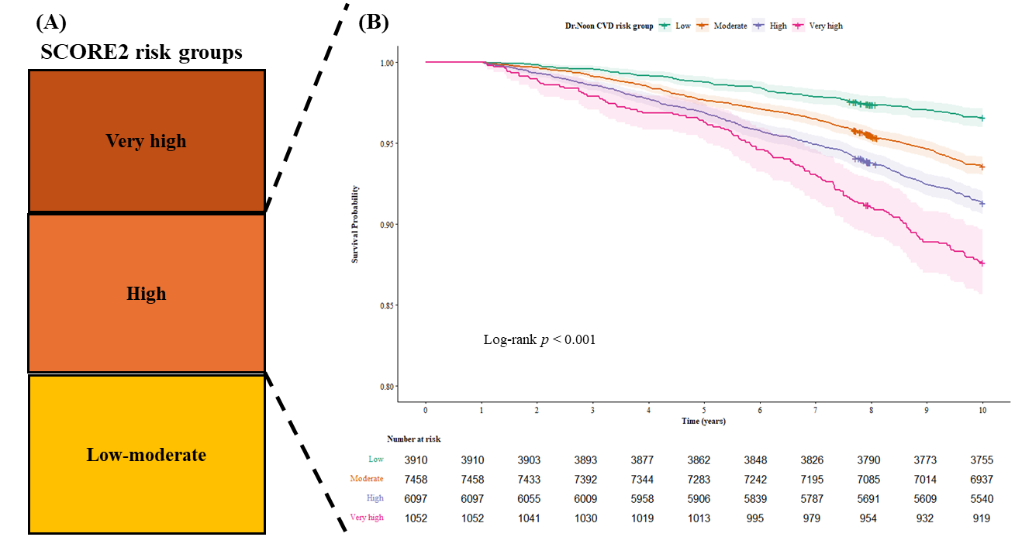
Figure S1. Subgroup Analysis Showing Cardiovascular Risk Stratification by Dr. Noon CVD (Alternative Risk Categories) Within the SCORE2 High Risk Group.
(A) Schematic representation of SCORE2 risk categories (low-moderate, high, very-high), highlighting the ‘High’ risk subgroup selected for this analysis. (B) Kaplan-Meier estimates of 10-year cardiovascular event-free survival for participants within this SCORE2 high-risk subgroup, stratified by Dr. Noon CVD alternative risk classification (low, moderate, high, very-high). The number at risk is provided below the graph. SCORE2, Systematic Coronary Risk Evaluation 2.
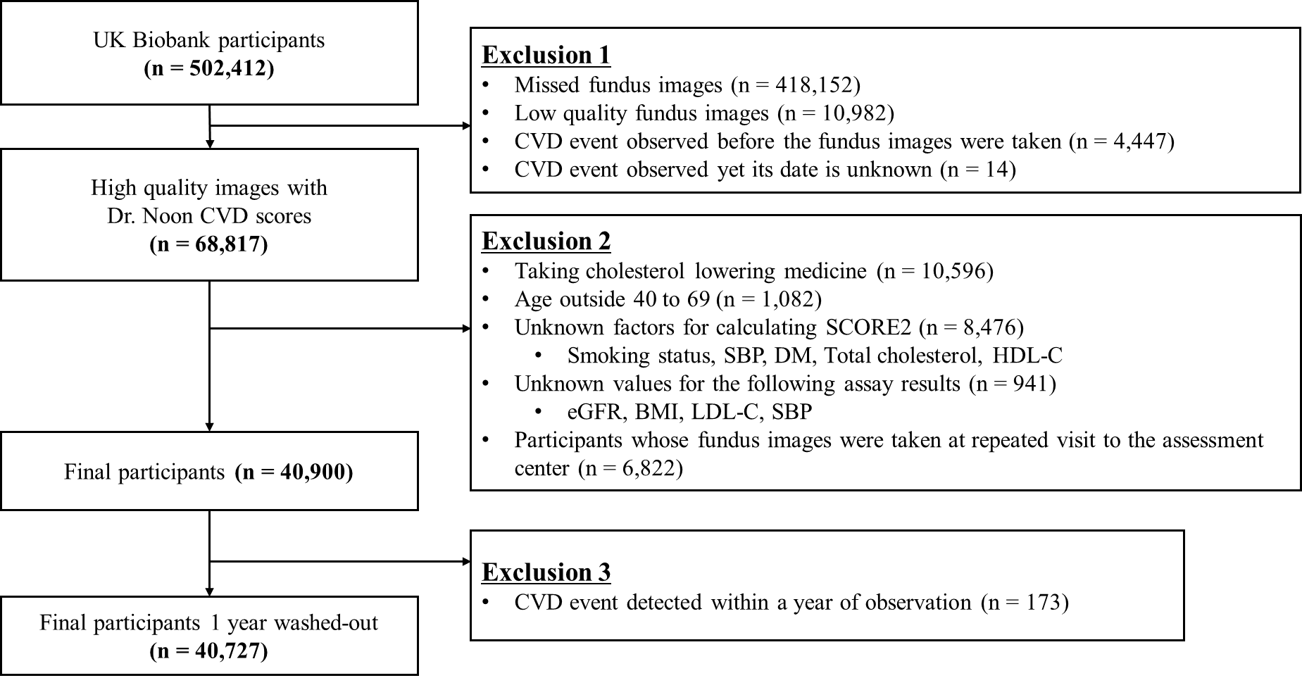
Figure S2. Flowchart of Participant Selection from The UK Biobank.
Among 502,412 participants, 68,817 with valid Dr. Noon CVD scores were identified after excluding invalid images and baseline CVD. Following exclusions for cholesterol-lowering medication, age appropriateness, missing clinical variables, and repeated visits, 40,900 individuals remained. The final analytic cohort comprised 40,727 participants after excluding cardiovascular events occurring within the first year. BMI, body mass index; CVD, cardiovascular disease; DM, diabetes mellitus; eGFR, estimated glomerular filtration rate; HDL-C, high-density lipoprotein cholesterol; LDL-C, low-density lipoprotein cholesterol; SBP, systolic blood pressure; SCORE2, Systematic COronary Risk Evaluation 2.

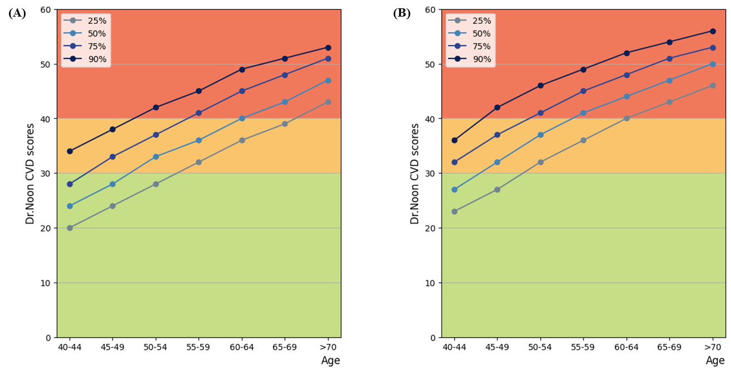
Figure S3. Age-specific Distribution of Dr. Noon CVD Scores Among (A) Female and (B) Male Participants.
Percentile trajectories (25th, 50th, 75th, and 90th) of Dr. Noon CVD scores are shown across 5-year age intervals. Background shading represents predefined cardiovascular risk zones based on Dr. Noon CVD thresholds: low (green), moderate (yellow), and high (red). Dr. Noon CVD scores demonstrated an age-dependent increase in all percentiles. P25, 25th percentile; P75, 75th percentile; P90, 90th percentile.

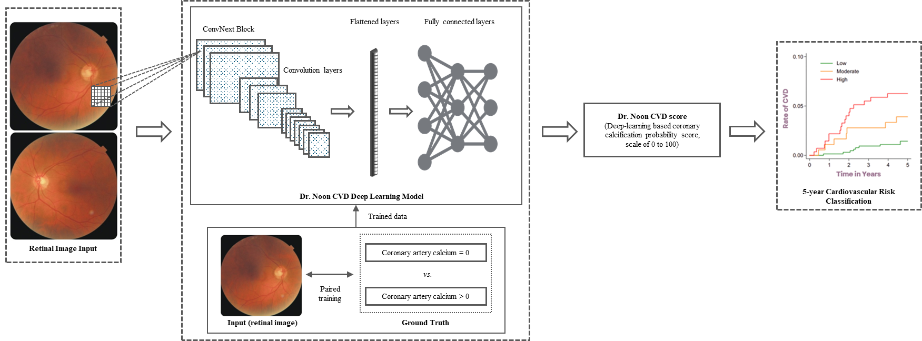
Figure S4. Overview of the AI-derived Retinal Imaging (Dr. Noon CVD) Deep Learning Framework.
This diagram depicts the analytic workflow in which a retinal fundus image is processed through a convolutional neural network comprising sequential convolutional, pooling, and fully connected layers to yield the Dr. Noon CVD score (range, 0-100). The model quantifies retinal vascular and structural features to estimate a 5-year cardiovascular risk and stratifies individuals into low (<1%), moderate (1–5%), or high (>5%) risk categories.

 | Dyslipidemia without medication | Dr. Noon CVD risk groups
 | Dyslipidemia without medication | Low (<31) | Moderate (31-40) | High (≥41-50) | Very high (≥51) | p-value
Variable, n (%) | 40,727 (100) | 11,560 (28.4) | 15,678 (38.5) | 11,300 (27.7) | 2,189 (5.4)
Age, mean±SD, years | 56.00±14.00 | 47.00±18.00 | 56.00±11.00 | 62.00±8.00 | 64.00±6.00 | < 0.001
40-49, n (%) | 11,790 (28.9) | 7,680 (66.4) | 3,522 (22.5) | 565 (5.0) | 23 (1.1) | < 0.001
50-59, n (%) | 13,910 (34.2) | 3,245 (28.1) | 7,038 (44.9) | 3,299 (29.2) | 328 (15.0) | < 0.001
60-69, n (%) | 15,027 (36.9) | 635 (5.5) | 5,118 (32.6) | 7,436 (65.8) | 1,838 (84.0) | < 0.001
Male, n (%) | 17,128 (42.1) | 3,702 (32.0) | 6,307 (40.2) | 5,704 (50.5) | 1,415 (64.6) | < 0.001
Smokers, n (%) | 23,853 (58.6) | 6,232 (53.9) | 9,045 (57.7) | 7,099 (62.8) | 1,477 (67.5) | < 0.001
Diabetes, n (%) | 541 (1.3) | 103 (0.9) | 180 (1.1) | 197 (1.7) | 61 (2.8) | < 0.001
Hypertension, n (%) | 21,597 (53.03) | 3,937 (34.1) | 8,393 (53.5) | 7,619 (67.4) | 1,648 (75.3) | < 0.001
SBP, mean±SD, mmHg | 134.00±24.50 | 126.00±20.50 | 134.00±23.00 | 140.50±24.50 | 144.00±25.00 | < 0.001
DBP, mean±SD, mmHg | 81.00±13.50 | 78.50±13.00 | 81.50±13.50 | 83.00±13.50 | 83.50±13.50 | < 0.001
Triglyceride, mean±SD, mg/dL | 322.75±94.06 | 304.50±92.67 | 326.29±92.64 | 334.66±91.14 | 329.21±87.06 | < 0.001
TC, mean±SD, mg/dL | 225.68±53.36 | 215.35±52.44 | 228.40±52.77 | 232.37±52.98 | 229.82±49.88 | < 0.001
LDL-C, mean±SD, mg/dl | 140.91±41.07 | 132.95±40.46 | 142.46±40.45 | 146.11±39.79 | 143.74±38.01 | < 0.001
HDL-C, mean±SD, mg/dl | 56.77±19.84 | 56.88±19.03 | 57.35±20.38 | 56.34±20.07 | 54.99±18.83 | < 0.001
eGFR, mean±SD, ml/min/1.73m² | 92.90±17.00 | 98.70±17.20 | 93.00±16.40 | 90.10±15.80 | 88.60±14.90 | < 0.001
BMI, mean±SD, kg/m² | 26.22±5.51 | 25.60±5.48 | 26.17±5.44 | 26.78±5.36 | 26.85±5.46 | < 0.001
SCORE2, mean±SD, % | 4.80±4.80 | 2.50±2.40 | 4.70±3.90 | 7.10±4.70 | 9.00±5.00 | < 0.001
CVD events, n (%)
10-year CVD events, n (%) | 2,531 (6.21) | 279 (2.4) | 875 (5.6) | 1,064 (9.4) | 313 (14.3) | < 0.001
5-year CVD events, n (%) | 944 (2.3) | 103 (0.9) | 319 (2.0) | 403 (3.6) | 119 (5.4) | < 0.001
Table S1. Baseline Characteristics of Participants With Dyslipidemia Without Cholesterol-Lowering Medication (Dr. Noon CVD Alternative Risk Classification).
Values are expressed as mean±SD or n (%). Comparisons performed with Kruskal–Wallis tests or χ² tests. BMI, body mass index; CVD, cardiovascular disease; DBP, diastolic blood pressure; eGFR, estimated glomerular filtration rate; HDL-C, high-density lipoprotein cholesterol; IQR, interquartile range; LDL-C, low-density lipoprotein cholesterol; SBP, systolic blood pressure; SD, standard deviation; TC, total cholesterol; SCORE2, Systematic COronary Risk Evaluation 2.
Dr. Noon CVD Risk Groups | Total (n) | SCORE2 Risk Groups (n, %)
Dr. Noon CVD Risk Groups | Total (n) | Low-moderate | High | Very high
Low (<31) | 11,560 | 7,459 (64.5) | 3,910 (33.8) | 191 (1.7)
Moderate (31-40) | 15,678 | 6,892 (44.0) | 7,458 (47.6) | 1,328 (8.5)
High (41-50) | 11,300 | 2,519 (22.3) | 6,097 (54.0) | 2,684 (23.8)
Very High (≥51) | 2,189 | 239 (10.9) | 1,052 (48.1) | 898 (41.0)
Pearson’s chi-square p-value: <0.001
Table S2. Concordance and Discordance of Risk Classification Between Dr. Noon CVD (Alternative Risk Categories) and SCORE2 Algorithms.
Data are presented as number (%). The p-value was calculated using Pearson's chi-square test to evaluate the association between Dr. Noon CVD risk tiers and SCORE2 risk categories. SCORE2, Systematic COronary Risk Evaluation 2.
Variable | Unadjusted model  HR (95% CI), p-value | Demographic-adjusted model  HR (95% CI), p-value | Traditional risk-adjusted model  HR (95% CI), p-value | Fully adjusted model  HR (95% CI), p-value
Dr. Noon CVD groups stratified by original risk categories
Dr. Noon CVD
Low | 1 (Reference) | 1 (Reference) | 1 (Reference) | 1 (Reference)
Moderate | 2.30 (1.84, 2.87), <0.001 | 1.36 (1.07, 1.74), 0.013 | 1.28 (1.00, 1.63), 0.051 | 1.26 (0.99, 1.61), 0.064
High | 4.41 (3.57, 5.45), <0.001 | 1.74 (1.34, 2.25), <0.001 | 1.55 (1.20, 2.01), 0.002 | 1.51 (1.16, 1.95), 0.002
Age group
50-59 years | - | 1.71 (1.33, 2.20), <0.001 | 1.63 (1.27, 2.10), <0.001 | 1.64 (1.27, 2.11), <0.001
60-69 years | - | 3.50 (2.72, 4.51), <0.001 | 3.14 (2.43, 4.05), <0.001 | 3.203 (2.48, 4.14), <0.001
Gender (Male) | - | 1.95 (1.70, 2.22), <0.001 | 1.84 (1.61, 2.11), <0.001 | 1.87 (1.63, 2.14), <0.001
Hypertension (yes) | - | - | 1.72 (1.48, 2.00), <0.001 | 1.64 (1.40, 1.90), <0.001
Diabetes (yes) | - | - | 1.95 (1.38, 2.77), <0.001 | 1.78 (1.25, 2.52), 0.001
Smoking (current) | - | - | 1.08 (0.95, 1.24), 0.246 | 1.08 (0.95, 1.23), 0.257
eGFR ≥60mL/min/1.73m² | - | - | - | 0.49 (0.35, 0.69), <0.001
BMI ≥30kg/m² | - | - | - | 1.38 (1.19, 1.60), <0.001
Dr. Noon CVD groups stratified by alternative risk categories
Dr. Noon CVD
Low | 1 (Reference) | 1 (Reference) | 1 (Reference) | 1 (Reference)
Moderate | 2.30 (1.84, 2.87), <0.001 | 1.37 (1.07, 1.76), 0.011 | 1.29 (1.01, 1.64), 0.045 | 1.27 (0.99, 1.62), 0.058
High | 4.06 (3.27, 5.04), <0.001 | 1.68 (1.30, 2.18), <0.001 | 1.51 (1.16, 1.96), 0.002 | 1.47 (1.13, 1.91), 0.004
Very high | 6.26 (4.81, 8.15), <0.001 | 2.11 (1.55, 2.88), <0.001 | 1.84 (1.34, 2.51), <0.001 | 1.75 (1.28, 2.40), <0.001
Age group
50-59 years | - | 1.71 (1.32, 2.20), <0.001 | 1.63 (1.27, 2.10), <0.001 | 1.64 (1.27, 2.11), <0.001
60-69 years | - | 3.45 (2.68, 4.45), <0.001 | 3.10 (2.40, 4.00), <0.001 | 3.17 (2.45, 4.09), <0.001
Gender (Male) | - | 1.92 (1.68, 2.20), <0.001 | 1.82 (1.59, 2.09), <0.001 | 1.85 (1.62, 2.12), <0.001
Hypertension (yes) | - | - | 1.72 (1.48, 2.00), <0.001 | 1.63 (1.40, 1.90), <0.001
Diabetes (yes) | - | - | 1.94 (1.37, 2.75), <0.001 | 1.77 (1.24, 2.51), 0.001
Smoking (current) | - | - | 1.08 (0.94, 1.23), 0.264 | 1.08 (0.94, 1.23), 0.276
eGFR ≥60mL/min/1.73m² | - | - | - | 0.50 (0.36, 0.70), <0.001
BMI ≥30kg/m² | - | - | - | 1.38 (1.19, 1.59), <0.001
Table S3. Impact of Sequential Covariate Adjustment on 5-Year Cardiovascular Event Risk Across Dr. Noon CVD Groups Stratified by Original and Alternative Risk Categories.
Hazard ratios and p-values are presented across incrementally adjusted models to illustrate the influence of covariate inclusion: demographic (age and sex), traditional risk (plus systolic blood pressure, smoking, diabetes, total cholesterol, and high-density lipoprotein cholesterol), and fully adjusted (further including estimated glomerular filtration rate and body mass index). Original classification comprised low, moderate, and high-risk groups. The alternative classification further divided the original high-risk group to define an additional very-high risk category representing the upper extreme of risk. BMI, body mass index; CI, confidence interval; CVD, cardiovascular disease; eGFR, estimated glomerular filtration rate; HDL-C, high-density lipoprotein cholesterol; HR, hazard ratio; SBP, systolic blood pressure.

Dr. Noon CVD risk groups | N | Cases | Person-years (PY) | Incidence rate  (per 1,000 PY) | Unadjusted HR  (95% CI) | Demographic-adjusted HR  (95% CI) | Traditional risk-adjusted HR  (95% CI) | Fully-adjusted HR (95% CI)
Dr. Noon CVD groups stratified by original risk categories
Low | 11,560 | 279 | 114,321 | 2.44 | 1 (Reference) | 1 (Reference) | 1 (Reference) | 1 (Reference)
Moderate | 15,678 | 875 | 153,179 | 5.71 | 2.35 (2.05, 2.69) | 1.41 (1.22, 1.63) | 1.34 (1.15, 1.55) | 1.32 (1.14, 1.53)
High | 13,489 | 1,377 | 129,119 | 10.66 | 4.41 (3.88, 5.01) | 1.81 (1.55, 2.12) | 1.64 (1.40, 1.92) | 1.60 (1.37, 1.87)
HR trend (per group increase) |  |  |  |  | 2.03 (1.92, 2.15) | 1.33 (1.23, 1.42) | 1.27 (1.18, 1.35) | 1.25 (1.16, 1.33)
p for trend |  |  |  |  | <0.001 | <0.001 | <0.001 | <0.001
Dr. Noon CVD groups stratified by alternative risk categories
Low | 11,560 | 279 | 114,321 | 2.44 | 1 (Reference) | 1 (Reference) | 1 (Reference) | 1 (Reference)
Moderate | 15,678 | 875 | 153,179 | 5.71 | 2.35 (2.05, 2.69) | 1.42 (1.23, 1.65) | 1.35 (1.16, 1.56) | 1.33 (1.15, 1.54)
High | 11,300 | 1,064 | 108,551 | 9.80 | 4.05 (3.55, 4.62) | 1.74 (1.49, 2.04) | 1.59 (1.35, 1.86) | 1.55 (1.32, 1.81)
Very high | 2,189 | 313 | 20,568 | 15.22 | 6.32 (5.38, 7.42) | 2.26 (1.87, 2.72) | 2.00 (1.66, 2.42) | 1.92 (1.59, 2.33)
HR trend (per group increase) |  |  |  |  | 1.82 (1.74, 1.90) | 1.28 (1.21, 1.36) | 1.24 (1.17, 1.31) | 1.22 (1.15, 1.29)
p for trend |  |  |  |  | <0.001 | <0.001 | <0.001 | <0.001
Table S4. Association Between Dr. Noon CVD Risk Groups and 10-Year Cardiovascular Events in Participants With Dyslipidemia Without Cholesterol-Lowering Medication.
Demographic-adjusted model included age and sex. Traditional risk-adjusted model additionally adjusted for systolic blood pressure, smoking status, diabetes, total cholesterol, and high-density lipoprotein cholesterol. Fully adjusted model further included estimated glomerular filtration rate and body mass index. Original classification comprised low, moderate, and high-risk groups. The alternative classification further divided the original high-risk group to define an additional very-high risk category representing the upper extreme of risk. Incidence rates were calculated per 1,000 person-years. p for trend was estimated by modeling Dr. Noon CVD risk group as an ordinal variable. CI, confidence interval; PY, person-years; HR, hazard ratio.
Variable | Unadjusted model  HR (95% CI), p-value | Demographic-adjusted model  HR (95% CI), p-value | Traditional risk-adjusted model  HR (95% CI), p-value | Fully adjusted model  HR (95% CI), p-value
Dr. Noon CVD groups stratified by original risk categories
Dr. Noon CVD
Low | 1 (Reference) | 1 (Reference) | 1 (Reference) | 1 (Reference)
Moderate | 2.35 (2.05, 2.69), <0.001 | 1.41 (1.22, 1.64), <0.001 | 1.34 (1.15, 1.55), <0.001 | 1.32 (1.14, 1.53), <0.001
High | 4.41 (3.88, 5.01), <0.001 | 1.81 (1.55, 2.12), <0.001 | 1.64 (1.40, 1.92), <0.001 | 1.60 (1.37, 1.87), <0.001
Age group
50-59 years | - | 1.81 (1.55, 2.11), <0.001 | 1.73 (1.49, 2.02), <0.001 | 1.74 (1.50, 2.03), <0.001
60-69 years | - | 3.46 (2.97, 4.04), <0.001 | 3.14 (2.69, 3.67), <0.001 | 3.22 (2.75, 3.76), <0.001
Gender (Male) | - | 1.79 (1.65, 1.94), <0.001 | 1.70 (1.57, 1.85), <0.001 | 1.72 (1.59, 1.87), <0.001
Hypertension (yes) | - | - | 1.59 (1.45, 1.74), <0.001 | 1.52 (1.38, 1.66), <0.001
Diabetes (yes) | - | - | 2.19 (1.78, 2.70), <0.001 | 2.02 (1.64, 2.49), <0.001
Smoking (current) | - | - | 1.05 (0.97, 1.14), 0.218 | 1.05 (0.97, 1.14), 0.229
eGFR ≥60mL/min/1.73m² | - | - | - | 0.57 (0.46, 0.71), <0.001
BMI ≥30kg/m² | - | - | - | 1.36 (1.25, 1.49), <0.001
Dr. Noon CVD groups stratified by alternative risk categories
Dr. Noon CVD
Low | 1 (Reference) | 1 (Reference) | 1 (Reference) | 1 (Reference)
Moderate | 2.35 (2.05, 2.69), <0.001 | 1.42 (1.23, 1.65), <0.001 | 1.35 (1.16, 1.56), <0.001 | 1.33 (1.15, 1.54), <0.001
High | 4.05 (3.55, 4.62), <0.001 | 1.74 (1.49, 2.04), <0.001 | 1.59 (1.35, 1.86), <0.001 | 1.55 (1.32, 1.82), <0.001
Very high | 6.32 (5.38, 7.43), <0.001 | 2.26 (1.87, 2.72), <0.001 | 2.00 (1.66, 2.42), <0.001 | 1.92 (1.59, 2.33), <0.001
Age group
50-59 years | - | 1.81 (1.55, 2.11), <0.001 | 1.73 (1.49, 2.02), <0.001 | 1.75 (1.50, 2.03), <0.001
60-69 years | - | 3.40 (2.92, 3.98), <0.001 | 3.10 (2.65, 3.62), <0.001 | 3.17 (2.71, 3.71), <0.001
Gender (Male) | - | 1.76 (1.62, 1.91), <0.001 | 1.68 (1.55, 1.82), <0.001 | 1.70 (1.57, 1.85), <0.001
Hypertension (yes) | - | - | 1.58 (1.45, 1.73), <0.001 | 1.51 (1.38, 1.65), <0.001
Diabetes (yes) | - | - | 2.18 (1.77, 2.68), <0.001 | 2.00 (1.62, 2.47), <0.001
Smoking (current) | - | - | 1.05 (0.97, 1.14), 0.218 | 1.05 (0.97, 1.14), 0.229
eGFR ≥60mL/min/1.73m² | - | - | - | 0.58 (0.46, 0.72), <0.001
BMI ≥30kg/m² | - | - | - | 1.36 (1.24, 1.49), <0.001
Table S5. Impact of Sequential Covariate Adjustment on 10-Year Cardiovascular Event Risk Across Dr. Noon CVD Groups Stratified by Original and Alternative Risk Categories.
Hazard ratios and p-values are presented across incrementally adjusted models to illustrate the influence of covariate inclusion: demographic (age and sex), traditional risk (plus systolic blood pressure, smoking, diabetes, total cholesterol, and high-density lipoprotein cholesterol), and fully adjusted (further including estimated glomerular filtration rate and body mass index). Original classification comprised low, moderate, and high-risk groups. The alternative classification further divided the original high-risk group to define an additional very-high risk category representing the upper extreme of risk. BMI, body mass index; CI, confidence interval; CVD, cardiovascular disease; eGFR, estimated glomerular filtration rate; HDL-C, high-density lipoprotein cholesterol; HR, hazard ratio; SBP, systolic blood pressure.

Subgroup | Age-Sex Specific  Dr. Noon CVD Score Quartile | N of Events  / Total N | Person-Years  (PY) | Incidence Rate  (per 1,000 PY) | Unadjusted HR  (95% CI) | p-value
Female, 40-49 years | Q1-Q2 (<50%) | 36 / 3,522 | 35,028 | 1.03 | 1 (Reference)
Female, 40-49 years | Q3 (50-75%) | 22 / 1,562 | 15,500 | 1.42 | 1.38 (0.81-2.35) | 0.232
Female, 40-49 years | Q4 (≥75%) | 37 / 1,549 | 15,313 | 2.42 | 2.35 (1.49-3.72) | <0.001
Female, 40-49 years | p for trend |  |  |  |  | <0.001
Female, 50-59 years | Q1-Q2 (<50%) | 138 / 4,386 | 43,282 | 3.19 | 1 (Reference)
Female, 50-59 years | Q3 (50-75%) | 73 / 2,058 | 20,271 | 3.60 | 1.13 (0.85-1.50) | 0.398
Female, 50-59 years | Q4 (≥75%) | 79 / 1,876 | 18,396 | 4.29 | 1.35 (1.02-1.78) | 0.034
Female, 50-59 years | p for trend |  |  |  |  | 0.035
Female, 60-69 years | Q1-Q2 (<50%) | 325 / 4,578 | 44,502 | 7.30 | 1 (Reference)
Female, 60-69 years | Q3 (50-75%) | 202 / 2,283 | 22,032 | 9.17 | 1.26 (1.06-1.50) | 0.010
Female, 60-69 years | Q4 (≥75%) | 165 / 1,785 | 17,179 | 9.60 | 1.32 (1.09-1.59) | 0.004
Female, 60-69 years | p for trend |  |  |  |  | 0.001
Male, 40-49 years | Q1-Q2 (<50%) | 71 / 2,866 | 28,341 | 2.51 | 1 (Reference)
Male, 40-49 years | Q3 (50-75%) | 41 / 1,005 | 9,876 | 4.15 | 1.66 (1.13-2.44) | 0.010
Male, 40-49 years | Q4 (≥75%) | 62 / 1,286 | 12,551 | 4.94 | 1.98 (1.41-2.78) | <0.001
Male, 40-49 years | p for trend |  |  |  |  | <0.001
Male, 50-59 years | Q1-Q2 (<50%) | 190 / 2,900 | 28,221 | 6.73 | 1 (Reference)
Male, 50-59 years | Q3 (50-75%) | 98 / 1,423 | 13,814 | 7.09 | 1.05 (0.83-1.35) | 0.670
Male, 50-59 years | Q4 (≥75%) | 102 / 1,267 | 12,279 | 8.31 | 1.24 (0.97-1.57) | 0.085
Male, 50-59 years | p for trend |  |  |  |  | 0.097
Male, 60-69 years | Q1-Q2 (<50%) | 388 / 3,454 | 32,892 | 11.80 | 1 (Reference)
Male, 60-69 years | Q3 (50-75%) | 241 / 1,472 | 13,697 | 17.60 | 1.50 (1.28-1.76) | <0.001
Male, 60-69 years | Q4 (≥75%) | 261 / 1,455 | 13,442 | 19.42 | 1.66 (1.42-1.94) | <0.001
Male, 60-69 years | p for trend |  |  |  |  | <0.001
Table S6. Incidence Rates and Unadjusted Hazard Ratios for 10-Year Cardiovascular Events Stratified by Age and Sex Subgroups Using Within-Group Risk Quartiles.
To assess risk discrimination independent of demographic variances, participants were categorized based on the within-group percentile distribution of Dr. Noon CVD scores specific to each age and sex subgroup. Categories were defined as: Q1-2 (<50th percentile), Q3 (50th-75th percentile), and Q4 (≥75th percentile). Incidence rates are calculated per 1,000 person-years. p for trend was estimated by modeling the risk group as an ordinal variable. The analysis was performed in participants with dyslipidemia not receiving cholesterol-lowering medication. CI, confidence interval; HR, hazard ratio; PY, person-years; Q, quartile.

Dr. Noon CVD  risk groups | Prediction of 10-year CVD events
Dr. Noon CVD  risk groups | Unadjusted HR  (95% CI) | p-value | Demographic-  adjusted HR  (95% CI) | p-value | Traditional risk-  adjusted HR  (95% CI) | p-value | Fully-adjusted  HR  (95% CI) | p-value
Low | 1 (Reference) | - | 1 (Reference) | - | 1 (Reference) | - | 1 (Reference) | -
Moderate | 1.90 (1.57, 2.30) | <0.001 | 1.34 (1.09, 1.66) | 0.007 | 1.32 (1.07, 1.63) | 0.011 | 1.31 (1.06, 1.62) | 0.012
High | 2.61 (2.16, 3.15) | <0.001 | 1.56 (1.25, 1.94) | <0.001 | 1.51 (1.21, 1.88) | <0.001 | 1.48 (1.19, 1.85) | < 0.001
Very-high | 3.77 (2.97, 4.80) | <0.001 | 2.09 (1.59, 2.75) | <0.001 | 1.99 (1.52, 2.62) | <0.001 | 1.94 (1.48, 2.55) | < 0.001
HR trend | 1.51 (1.41, 1.61) | <0.001 | 1.24 (1.15, 1.34) | <0.001 | 1.22 (1.13, 1.32) | <0.001 | 1.21 (1.12, 1.31) | <0.001
Table S7. Hazard Ratios for 10-Year Cardiovascular Events Stratified by Dr. Noon CVD Alternative Risk Classification Within the SCORE2 High Risk Subgroup.
Data are hazard ratios (95% CIs) unless otherwise stated. Models were sequentially adjusted to evaluate the stability of the association. The demographic-adjusted model controlled for age and sex. The traditional risk-adjusted model additionally controlled for systolic blood pressure, smoking status, diabetes, total cholesterol, and high-density lipoprotein cholesterol. The fully-adjusted model further included estimated glomerular filtration rate and body mass index. CI, confidence interval; CVD, cardiovascular disease; HR, hazard ratio; SCORE2, Systematic Coronary Risk Evaluation 2.

Cardiovascular event
Domain | Component | Codes
ICD-10 | Coronary heart disease | I20–I25.*
ICD-10 | Cerebrovascular disease | I60–I69.*
ICD-10 | Transient ischaemic attack | G45.*
ICD-10 | Heart failure | I50.*, I11.0, I13.0, I13.2, I110, I130, I132
ICD-9 | Coronary heart disease | 410–412
ICD-9 | Cerebrovascular disease | 430–438
ICD-9 | Heart failure | 428.* 402.01, 402.11, 402.91, 404.01, 404.03, 404.11, 404.13, 404.91, 404.93
OPCS-4 | CABG | K40–K46 (all subcodes)
OPCS-4 | PCI | K49.* (all subcodes)
Self-report (Field 20002) | Myocardial infarction | 1075
Self-report (Field 20002) | Heart failure | 1076
Self-report (Field 20002) | Stroke | 1081
Self-report (Field 20002) | Transient ischaemic attack | 1082
Self-report (Field 20002) | Subarachnoid haemorrhage | 1086
Self-report (Field 20002) | Brain haemorrhage | 1491
Self-report (Field 20002) | Ischaemic stroke | 1583
Dyslipidemia
Domain | Component | Codes
ICD-10 (Field 41270) | Disorders of lipoprotein metabolism and other lipidaemias | E78
ICD-10 (Field 41270) | Pure hypercholesterolaemia | E78.0
ICD-10 (Field 41270) | Pure hyperglyceridaemia | E78.1
ICD-10 (Field 41270) | Mixed hyperlipidaemia | E78.2
ICD-10 (Field 41270) | Hyperchylomicronaemia | E78.3
ICD-10 (Field 41270) | Other hyperlipidaemia | E78.4
ICD-10 (Field 41270) | Hyperlipidaemia, unspecified | E78.5
ICD-10 (Field 41270) | Other disorders of lipoprotein metabolism | E78.8
ICD-10 (Field 41270) | Disorder of lipoprotein metabolism, unspecified | E78.9
ICD-9 (Field 41271) | Disorders of lipoid metabolism | 272
ICD-9 (Field 41271) | Pure hypercholesterolaemia | 2720
ICD-9 (Field 41271) | Familial hypercholesterolaemia | 27200
ICD-9 (Field 41271) | Hyper-beta-lipoproteinaemia | 27201
ICD-9 (Field 41271) | Pure hypercholesterolaemia (hyperlipidaemia, group a) | 27202
ICD-9 (Field 41271) | Low-density-lipoid-type (ldl) hyperlipoproteinaemia | 27203
ICD-9 (Field 41271) | Pure hypercholesterolaemia (other) | 27209
ICD-9 (Field 41271) | Pure hyperglyceridaemia | 2721
ICD-9 (Field 41271) | Mixed hyperlipidaemia | 2722
ICD-9 (Field 41271) | Hyperchylomicronaemia | 2723
ICD-9 (Field 41271) | Other and unspecified hyperlipidaemia | 2724
ICD-9 (Field 41271) | Hyperlipidaemia of nephrotic syndrome | 27240
ICD-9 (Field 41271) | Hyperlipidaemia due to other specified causes | 27248
ICD-9 (Field 41271) | Hyperlipidaemia not otherwise specified | 27249
Medication (Field 6177, 6153) | Cholesterol lowering medication | 1
Self-report (Field 20002) | high cholesterol | 1473
Total cholesterol (Field 30690), LDL-C (Field 30780), HDL-C (Field 30760), Triglyceride (Field 30780) | Total cholesterol≥240, LDL-C≥160, HDL-C<40, or triglycerides≥200
Hypertension
Domain | Component | Codes
Systolic blood pressure (Field 4080), Diastolic blood pressure (Field 4079) | Systolic blood pressure≥140 or diastolic blood pressure≥90
ICD-10 (Field 41270) | Essential (primary) hypertension | I10* (all subcodes)
ICD-10 (Field 41270) | Hypertensive heart disease | I11* (all subcodes)
ICD-10 (Field 41270) | Hypertensive renal disease | I12* (all subcodes)
ICD-10 (Field 41270) | Hypertensive heart and renal disease | I13* (all subcodes)
ICD-10 (Field 41270) | Secondary hypertension | I15* (all subcodes)
ICD-9 (Field 41271) | Essential hypertension | 401* (all subcodes)
ICD-9 (Field 41271) | Hypertensive heart disease | 402* (all subcodes)
ICD-9 (Field 41271) | Hypertensive renal disease | 403* (all subcodes)
ICD-9 (Field 41271) | Hypertensive heart and renal disease | 404* (all subcodes)
ICD-9 (Field 41271) | Secondary hypertension | 405* (all subcodes)
Self-report (Field 20002) | hypertension | 1065
Self-report (Field 20002) | essential hypertension | 1072
Self-report (Field 20002) | gestational hypertension/pre-eclampsia | 1073
Diabetes
Domain | Component | Codes
ICD-10 (Field 41270) | Insulin-dependent diabetes mellitus | E10* (all subcodes)
ICD-10 (Field 41270) | Non-insulin-dependent diabetes mellitus | E11* (all subcodes)
ICD-10 (Field 41270) | Malnutrition-related diabetes mellitus | E12* (all subcodes)
ICD-10 (Field 41270) | Other specified diabetes mellitus | E13* (all subcodes)
ICD-10 (Field 41270) | Unspecified diabetes mellitus | E14* (all subcodes)
ICD-9 (Field 41271) | Diabetes mellitus | 250* (all subcodes)
Self-report (Field 20002) | diabetes | 1220
Self-report (Field 20002) | type 1 diabetes | 1222
Self-report (Field 20002) | type 2 diabetes | 1223
Self-report (Field 20002) | diabetic eye disease | 1276
Self-report (Field 20002) | diabetic neuropathy/ulcers | 1468
Self-report (Field 20002) | diabetic nephropathy | 1607
Table S8. Disease Definitions and Code Lists.
Cardiovascular events, dyslipidemia, hypertension, and diabetes were identified using hospital admission and procedural records (ICD-9, ICD-10, and OPCS-4 codes), self-reported diagnoses, medication records, and relevant clinical measurements, as summarized above. BMI, body mass index; CABG, coronary artery bypass grafting; CVD, cardiovascular disease; DBP, diastolic blood pressure; HDL-C, high-density lipoprotein cholesterol; ICD, International Classification of Diseases; LDL-C, low-density lipoprotein cholesterol; OPCS-4, Office of Population Censuses and Surveys Classification of Surgical Operations and Procedures, 4th Revision; PCI, percutaneous coronary intervention; SBP, systolic blood pressure.

Age groups  (years) | Female |  |  |  |  | Male
Age groups  (years) | N | Dr. Noon CVD score |  |  |  | N | Dr. Noon CVD score
Age groups  (years) | N | P25 | Median | P75 | P90 | N | P25 | Median | P75 | P90
40-44 | 3513 | 20 | 42 | 24 | 34 | 2947 | 23 | 42 | 32 | 36
45-49 | 5131 | 24 | 47 | 28 | 38 | 3965 | 27 | 47 | 37 | 42
50-54 | 5981 | 28 | 52 | 33 | 42 | 4364 | 32 | 52 | 41 | 46
55-59 | 6875 | 32 | 57 | 36 | 45 | 4924 | 36 | 57 | 45 | 49
60-64 | 9264 | 36 | 62 | 40 | 49 | 7217 | 40 | 62 | 48 | 52
65-69 | 6876 | 39 | 67 | 43 | 51 | 6101 | 43 | 67 | 51 | 54
70-76 | 778 | 43 | 71 | 47 | 53 | 880 | 46 | 71 | 53 | 56
Table S9. Distribution of Dr. Noon CVD Score Percentiles Stratified by Age and Sex.
Data are presented as Dr. Noon CVD scores corresponding to specific percentiles within each age group. N, number of participants; P25, 25th percentile; P75, 75th percentile; P90, 90th percentile.

