Supplementary data
Table S1: Simple linear regression of total number of participants

 | Total
 | Practice score |  | Knowledge score |  | Attitude score
Variable | Standardized Beta | p-value | Standardized Beta | p-value | Standardized Beta | p-value
Age | -0.136 | 0.263 | 0.201 | <0.001 | 0.090 | 0.042
Gender  - *Female  - male | 0.075 | 0.538 | 0.003 | 0.946 | 0.002 | 0.963
Living area  - *Urban  - Rural | -0.016 | 0.894 | -0.003 | 0.942 | 0.041 | 0.755
number of family members | 0.007 | 0.953 | 0.041 | 0.760 | -0.036 | 0.417
Educational level  - *Non university  - University | 0.163 | 0.177 | 0.069 | 0.122 | 0.042 | 0.340
Are you studying or have you studied something related to health?  - *Yes  - No | 0.120 | 0.324 | 0.013 | 0.765 | 0.095 | 0.033
Chronic disease presence  - *Yes  - No | 0.169 | 0.161 | -0.019 | 0.662 | 0.007 | 0.874
Income level  - *Others  - More than 1000$/month | -0.061 | 0.616 | 0.097 | 0.029 | 0.065 | 0.140
What type of olive oil do you use?  - *Others  - Extra virgin olive oil&Virgin olive oil | 0.216 | 0.072 | 0.332 | <0.001 | 0.087 | 0.050
Do you or your family/relatives produce olive oil?  - *Yes  - No | -0.009 | 0.940 | -0.207 | <0.001 | -0.137 | 0.002
Have you heard of olive pomace oil?  - *Yes  - No | 0.033 | 0.785 | -0.302 | <0.001 | -0.195 | <0.001

Table S2: Simple linear regression of each country separately
 | Jordan
 | Practice score |  |  |  | Knowledge score |  |  |  | Attitude score
Variable | Standardized Beta |  | p-value |  | Standardized Beta |  | p-value |  | Standardized Beta |  | p-value
Age | -0.006 |  | 0.910 |  | 0.343 |  | <0.001 |  | 0.113 |  | 0.018
Gender  - *Female  - male | -0.087 |  | 0.122 |  | -0.031 |  | 0.589 |  | -0.017 |  | 0.760
Living area  - *Urban  - Rural | 0.086 |  | 0.129 |  | 0.071 |  | 0.206 |  | -0.024 |  | 0.672
number of family members | 0.083 |  | 0.139 |  | -0.036 |  | 0.521 |  | -0.060 |  | 0.289
Educational level  - *Non university  - University | -0.019 |  | 0.731 |  | 0.071 |  | 0.765 |  | 0.020 |  | 0.725
Are you studying or have you studied something related to health?  - *Yes  - No | -0.082 |  | 0.146 |  | 0.093 |  | 0.098 |  | 0.157 |  | 0.005
Chronic disease presence  - *Yes  - No | 0.013 |  | 0.814 |  | -0.074 |  | 0.193 |  | -0.046 |  | 0.412
Income level  - *Others  - More than 1000$/month | -0.023 |  | 0.679 |  | -0.073 |  | 0.197 |  | 0.087 |  | 0.123
What type of olive oil do you use?  - *Others  - Extra virgin olive oil&Virgin olive oil | 0.054 |  | 0.342 |  | 0.317 |  | <0.001 |  | 0.072 |  | 0.204
Do you or your family/relatives produce olive oil?  - *Yes  - No | -0.023 |  | 0.690 |  | -0.203 |  | <0.001 |  | -0.148 |  | 0.008
Have you heard of olive pomace oil?  - *Yes  - No | -0.137 |  | 0.015 |  | -0.323 |  | <0.001 |  | -0.278 |  | <0.001
 |  | Morocco
 |  | Practice score |  |  |  | Knowledge score |  |  |  | Attitude score
Variable |  | Standardized Beta |  | p-value |  | Standardized Beta |  | p-value |  | Standardized Beta |  | p-value
Age |  | -0.131 |  | 0.143 |  | 0.077 |  | 0.393 |  | 0.080 |  | 0.374
Gender  - *Female  - male |  | -0.190 |  | 0.033 |  | 0.224 |  | 0.012 |  | 0.163 |  | 0.069
Living area  - *Urban  - Rural |  | 0.010 |  | 0.908 |  | -0.040 |  | 0.659 |  | 0.118 |  | 0.188
number of family members |  | 0.105 |  | 0.242 |  | 0.020 |  | 0.826 |  | -0.041 |  | 0.652
Educational level  - *Non university  - University |  | 0.033 |  | 0.711 |  | 0.246 |  | 0.005 |  | 0.096 |  | 0.285
Are you studying or have you studied something related to health?  - *Yes  - No |  | -0.023 |  | 0.799 |  | -0.128 |  | 0.152 |  | -0.042 |  | 0.638
Chronic disease presence  - *Yes  - No |  | -0.112 |  | 0.213 |  | -0.016 |  | 0.862 |  | 0.143 |  | 0.111
Income level  - *Others  - More than 1000$/month |  | 0.012 |  | 0.894 |  | 0.090 |  | 0.314 |  | -0.006 |  | 0.950
What type of olive oil do you use?  - *Others  - Extra virgin olive oil & Virgin olive oil |  | 0.227 |  | 0.010 |  | 0.283 |  | 0.001 |  | 0.041 |  | 0.650
Do you or your family/relatives produce olive oil?  - *Yes  - No |  | 0.093 |  | 0.298 |  | -0.048 |  | 0.594 |  | -0.070 |  | 0.437
Have you heard of olive pomace oil?  - *Yes  - No |  | -0.026 |  | 0.777 |  | -0.009 |  | 0.923 |  | 0.084 |  | 0.351
 |  | Egypt
 |  | Practice score |  |  |  | Knowledge score |  |  |  | Attitude score
Variable |  | Standardized Beta |  | p-value |  | Standardized Beta |  | p-value |  | Standardized Beta |  | p-value
Age |  | -0.136 |  | 0.263 |  | -0.071 |  | 0.562 |  | -0.086 |  | 0.477
Gender  - *Female  - male |  | 0.075 |  | 0.538 |  | -0.088 |  | 0.469 |  | -0.137 |  | 0.258
Living area  - *Urban  - Rural |  | -0.016 |  | 0.894 |  | -0.185 |  | 0.126 |  | 0.060 |  | 0.620
number of family members |  | 0.007 |  | 0.953 |  | -0.044 |  | 0.719 |  | 0.026 |  | 0.832
Educational level  - *Non university  - University |  | 0.163 |  | 0.177 |  | 0.019 |  | 0.876 |  | 0.094 |  | 0.437
Are you studying or have you studied something related to health?  - *Yes  - No |  | 0.120 |  | 0.324 |  | 0.092 |  | 0.450 |  | 0.081 |  | 0.507
Chronic disease presence  - *Yes  - No |  | 0.169 |  | 0.161 |  | 0.020 |  | 0.870 |  | -0.073 |  | 0.549
Income level  - *Others  - More than 1000$/month |  | -0.061 |  | 0.616 |  | 0.028 |  | 0.816 |  | -0.029 |  | 0.814
What type of olive oil do you use?  - *Others  - Extra virgin olive oil&Virgin olive oil |  | 0.216 |  | 0.072 |  | 0.314 |  | 0.008 |  | 0.153 |  | 0.206
Do you or your family/relatives produce olive oil?  - *Yes  - No |  | -0.009 |  | 0.940 |  | 0.106 |  | 0.381 |  | 0.022 |  | 0.855
Have you heard of olive pomace oil?  - *Yes  - No |  | 0.033 |  | 0.785 |  | -0.117 |  | 0.333 |  | -0.073 |  | 0.546

Table S3: Multiple linear regression of each country separately
 |  | Jordan
 |  | Practice score |  |  |  | Knowledge score |  |  |  | Attitude score
Variable |  | Standardized Beta |  | p-value |  | Standardized Beta |  | p-value |  | Standardized Beta |  | p-value
Age |  |  |  |  |  | 0.304 |  | <0.001 |  | 0.016 |  | 0.797
Gender  - *Female  - male |  | -0.109 |  | 0.058
Living area  - *Urban  - Rural |  | 0.102 |  | 0.076 |  | 0.019 |  | 0.705
number of family members |  | 0.061 |  | 0.285
Are you studying or have you studied something related to health?  - *Yes  - No |  | -0.088 |  | 0.125 |  | -0.109 |  | 0.055 |  | 0.126 |  | 0.041
Chronic disease presence  - *Yes  - No |  |  |  |  |  | 0.049 |  | 0.349
Income level  - *Others  - More than 1000$/month |  |  |  |  |  | 0.015 |  | 0.775 |  | 0.111 |  | 0.044
What type of olive oil do you use?  - *Others  - Extra virgin olive oil/ Virgin olive oil |  |  |  |  |  | 0.191 |  | <0.001 |  | -0.040 |  | 0.483
Do you or your family/relatives produce olive oil?  - *Yes  - No |  |  |  |  |  | -0.146 |  | 0.004 |  | -0.112 |  | 0.041
Have you heard of olive pomace oil?  - *Yes  - No |  | -0.152 |  | 0.007 |  | -0.224 |  | <0.001 |  | -0.254 |  | <0.001
 |  | Morocco
 |  | Practice score |  |  |  | Knowledge score |  |  |  | Attitude score
Variable |  | Standardized Beta |  | p-value |  | Standardized Beta |  | p-value |  | Standardized Beta |  | p-value
Age |  | -0.113 |  | 0.230
Gender  - *Female  - male |  | -0.185 |  | 0.047 |  | 0.177 |  | 0.039 |  | 0.162 |  | 0.069
Living area  - *Urban  - Rural |  |  |  |  |  |  |  |  |  | 0.096 |  | 0.281
number of family members |  | 0.096 |  | 0.276
Educational level  - *Non university  University |  |  |  |  |  | 0.152 |  | 0.090
If you are a university graduate, is your degree related to a health specialty, health sciences, or nutrition?  - *Yes  - No |  |  |  |  |  | -0.078 |  | 0.370
Chronic disease presence  - *Yes  - No |  | -0.181 |  | 0.040 |  |  |  |  |  | 0.145 |  | 0.102
What type of olive oil do you use?  - *Others  - Extra virgin olive oil/ Virgin olive oil |  | 0.251 |  | 0.005 |  | 0.233 |  | 0.007
 | Egypt
 | Practice score |  |  |  | Knowledge score |  |  |  | Attitude score
Variable | Standardized Beta |  | p-value |  | Standardized Beta |  | p-value |  | Standardized Beta |  | p-value
Living area  - *Urban  - Rural |  |  |  |  | -0.143 |  | 0.222
Educational level  - *Non university  - University | 0.159 |  | 0.192
Chronic disease presence  - *Yes  - No | 0.204 |  | 0.090
What type of olive oil do you use?  - *Others  - Extra virgin olive oil /Virgin olive oil | 0.191 |  | 0.115 |  | 0.294 |  | 0.014 |  | 0.153 |  | 0.206

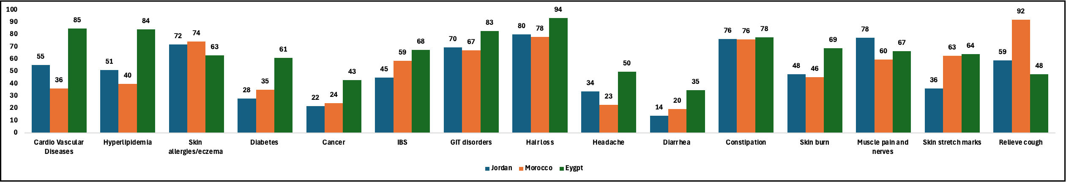
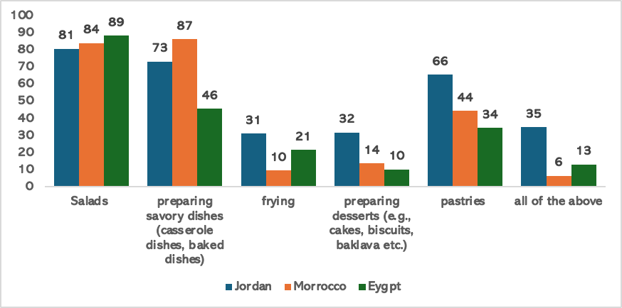
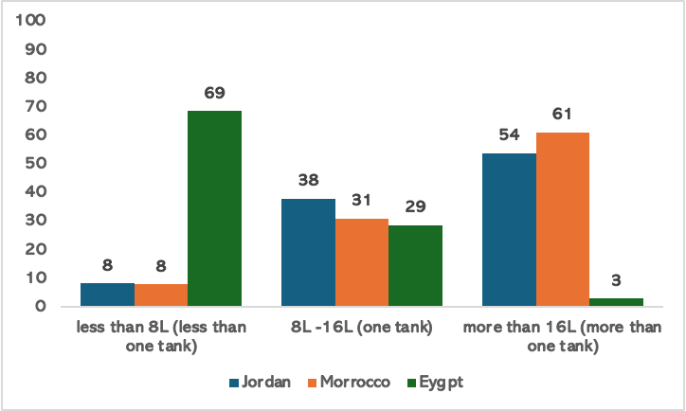
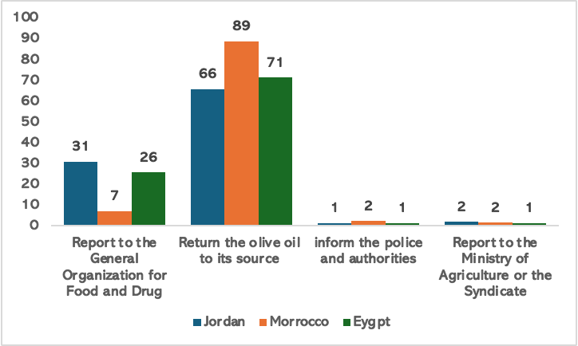
Illustration S1. Shows the percentage of participants from each country where A) shows the percentage of participants that use olive oil in different medical purposes. B) shows the percentage of participants that use olive oil in various purposes in cooking, C) shows the percentage of participants use of olive oil amounts per year, and D) shows what would the participants do in case of suspected adultery actions reported as percentage of participants.

