Supplementary fig. 1: Spectra information on effect of formalin on protein structure of liver tissues fixed at varying temperatures of 25 ͦС, 37 ͦС and 60 ͦС respectively.

Supplementary fig. 2: Spectra information on the effect of formalin on the protein structure of lung tissues fixed at varying temperatures of 25 ͦС, 37 ͦС, and 60 ͦС, respectively.

Supplementary fig. 3: Spectra information on the effect of formalin on protein structure of kidney tissues fixed at varying temperatures of 25 ͦС, 37 ͦС, and 60 ͦС, respectively.

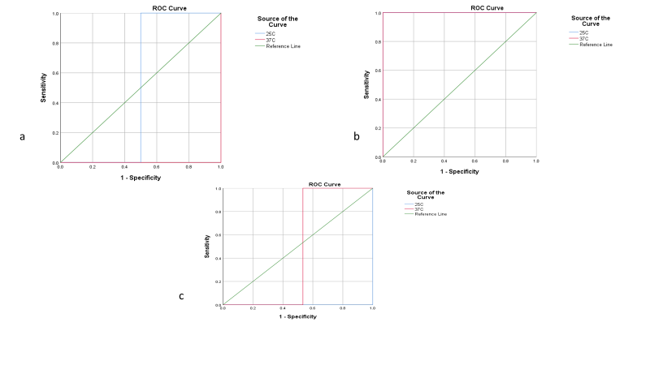
Supplementary Fig 4: Performance test on α – helix /β -sheet ratio of (a) liver tissues, (b) lung tissues and (c) kidney tissues formalin-fixed between 25 ͦC and 37 ͦC

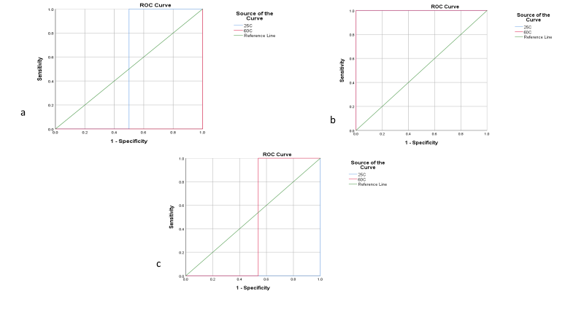
Supplementary Fig 5: Performance test on α – helix /β -sheet ratio of (a) liver tissues, (b) lung tissues and (c) kidney tissues formalin-fixed between 25 ͦC and 60 ͦC

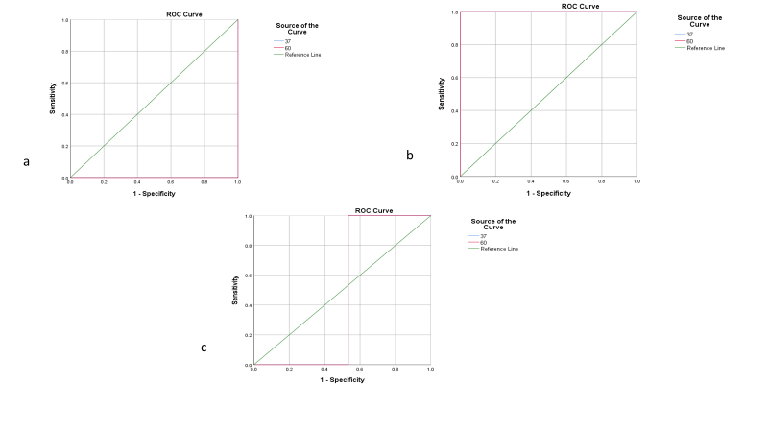
Supplementary Fig 6: Performance test on α – helix /β -sheet ratio of (a) liver tissues, (b) lung tissues and (c) kidney tissues formalin-fixed between 37 ͦC and 60 ͦC

