Supplementary Information

Manuscript Title: Classifying urban areas into residential, non-residential and mixed-use proportions using building footprints and geospatial models.

Contents:
Appendix A: Additional results (Figures and Tables)
- Table A.1: Metadata information for Lagos Building Sample Point (LBSP), a dataset collected in 2018 by the Lagos State Government covering over 180,000 building points with the original intent to survey all buildings within the state and create a property record database. NB not all attributes are populated across the whole datasets.

- Table A.2: List of 68 ancillary datasets (covariates) used in the models (both Random Forest and Bayesian Hierarchical) to classify settlements into functional uses. Those highlighted in light brown indicate covariates selected for fitting the residential and non-residential models.

- Figure A.1: Uncertainty estimate of the Bayesian model predictions at 1 x 1 km. The uncertainty was calculated using the formula (upper credible interval – lower credible interval) / mean population. A) shows the uncertainty residential class predictions; B) shows the uncertainty for non-residential predictions.

- Figure A.2: Scatterplot of the residential class proportion of Observed vs Predicted for Random Forest (Red) and Bayesian Hierarchical (Blue) model output, showing the correlation coefficient per Local Government Area (LGA). Note, Badagry LGA has no observation dataset, so it is excluded from this analysis.

- Figure A.3: Scatterplot of the non-residential class proportion of Observed vs Predicted for Random Forest (Red) and Bayesian Hierarchical (Blue) model output showing the correlation coefficient per Local Government Area (LGA). Note, Badagry LGA has no observation dataset, so it is excluded from this analysis.

Appendix A: Additional results (Figures and Tables)

Attribute label | Description | Percentage of Completeness
X | X coordinate (latitude) | 100%
Y | Y coordinate (longitude) | 100%
date | Date of capture | 100%
time | Time of capture | 100%
lagos_east_senatorial_district | Local government area within Lagos east senatorial district | 33.2%
lagos_central_senetorial_district | Local government area within Lagos central senatorial district | 24.4%
lagos_west_senetorial_district | Local government area within Lagos west senatorial district | 42.4%
property_number | Property number | 71.8%
street | Street name where property is located | 100%
survey_plan | Does property document include a survey plan | 100%
building_approval | Does property have a valid building approval | 100%
year_built | Year property was built | 34.5%
type_of_property | Description of property (e.g. High rise, block of flats, government buildings) | 100%
other_property_types | Other property types not described | 27.3%
property_classification | Classification of property (e.g. residential, commercial, mixed) | 26.8%
property_use | Detailed use of within property (e.g. office space, shops, school) | 26.8%
occupant | Occupant of property (e.g. owner, tenant, multitenant) | 100%
property_possession | Is property occupied or unoccupied | 100%
number_of_floors | Number of floors within property | 67.1%
number_of_building_unit | Number of building unit within property | 47.3%
land_area_in_sqm | land area of property in square metres | 25.6%
gross_floor_area_in_sqm | floor area of property in square metres | 27.8%

Table A.1: Metadata information for Lagos Building Sample Point (LBSP), a dataset collected in 2018 by the Lagos State Government covering over 180,000 building points with the original intent to survey all buildings within the state and create a property record database.

Category | Source dataset name | Temporal coverage of covariate(s) | Covariate(s) | Download source
Inland Water Mask | ESA WorldCover 10m v200 | 2021 | Inland water coverage [%] | https://hub.worldpop.org/project/categories?id=14
Inland Water Mask | ESA WorldCover 10m v200 | 2021 | Presence of inland water based on different thresholds of water coverage (25%, 50%, 60%, 75%, 80%, 85% and 90%) [binary] | https://hub.worldpop.org/project/categories?id=14
Inland Water Mask | ESA WorldCover 10m v200 | 2021 | Distance to inland water [km] | https://hub.worldpop.org/project/categories?id=14
Inland Water Mask | ESA WorldCover 10m v200 | 2021 | Distance to open-water coastline [km] | https://hub.worldpop.org/project/categories?id=14
Topography | MERIT DEM | ~2007 | MERIT-based Elevation [m] | https://hub.worldpop.org/project/categories?id=14
Topography | MERIT DEM | ~2007 | MERIT-based Slope [°] | https://hub.worldpop.org/project/categories?id=14
Climate | Terra MODIS LST | 2020 | Annual Mean Surface Temperature [Kelvin] | https://hub.worldpop.org/project/categories?id=14
Climate | TerraClimate | 2020 | Annual Mean Precipitation (scaling factor 10] [mm] | https://hub.worldpop.org/project/categories?id=14
Nighttime Lights | VIIRS NTL 2.1 | 2020 | Night time lights, flares/volcanoes filtered [nW/cm2/sr] | https://hub.worldpop.org/project/categories?id=14
Land Cover | ESA CCI Land Cover v2.1.1 | 2020 | Distance to cultivated area edges (reclassified class 11) [km] | https://hub.worldpop.org/project/categories?id=14
Land Cover | ESA CCI Land Cover v2.1.1 | 2020 | Distance to woody-tree area edges (reclassified class 40) [km] | https://hub.worldpop.org/project/categories?id=14
Land Cover | ESA CCI Land Cover v2.1.1 | 2020 | Distance to shrub area edges (reclassified class 130) [km] | https://hub.worldpop.org/project/categories?id=14
Land Cover | ESA CCI Land Cover v2.1.1 | 2020 | Distance to herbaceous area edges (reclassified class 140) [km] | https://hub.worldpop.org/project/categories?id=14
Land Cover | ESA CCI Land Cover v2.1.1 | 2020 | Distance to sparse vegetation area edge (reclassified class 150) [km] | https://hub.worldpop.org/project/categories?id=14
Land Cover | ESA CCI Land Cover v2.1.1 | 2020 | Distance to aquatic vegetation area edges (reclassified class 160) [km] | https://hub.worldpop.org/project/categories?id=14
Land Cover | ESA CCI Land Cover v2.1.1 | 2020 | Distance to artificial surface area edges (reclassified class 190) [km] | https://hub.worldpop.org/project/categories?id=14
Land Cover | ESA CCI Land Cover v2.1.1 | 2020 | Distance to bare area edges (reclassified class 200) [km] | https://hub.worldpop.org/project/categories?id=14
Land Cover |  |  | Distance to Water, Snow and Ice (reclassified class 210) [km] | https://hub.worldpop.org/project/categories?id=14
Protected Areas | World Database of Protected Areas (WDPA) | 2020 | Distance to IUCN strict nature reserve and wilderness area edges [km] | https://hub.worldpop.org/project/categories?id=14
 |  |  | Distances to IUCN national park, national monument, habitat species management, protected landscape/seascape and managed resource protected area edges [km] | https://hub.worldpop.org/project/categories?id=14
Infrastructure | OpenStreetMap (OSM) | 2023 | Distance to OSM major roads [km] | https://hub.worldpop.org/project/categories?id=14
Infrastructure | OpenStreetMap (OSM) | 2023 | Distance to OSM major road intersections [km] | https://hub.worldpop.org/project/categories?id=14
Infrastructure | OpenStreetMap (OSM) | 2023 | Distance to OSM waterbodies [km] | https://hub.worldpop.org/project/categories?id=14
Infrastructure | Microsoft Roads Detection | ~2021 | Count of Microsoft Roads | https://hub.worldpop.org/project/categories?id=14
Infrastructure | Microsoft Roads Detection | ~2021 | Presence of Microsoft Roads [binary] | https://hub.worldpop.org/project/categories?id=14
Infrastructure | Microsoft Roads Detection | ~2021 | Microsoft Roads Density | https://hub.worldpop.org/project/categories?id=14
Infrastructure | Microsoft Roads Detection | ~2021 | Distance to Microsoft Roads [km] | https://hub.worldpop.org/project/categories?id=14
Infrastructure | Microsoft Roads Detection | ~2021 | Total length of Microsoft Roads [m] | https://hub.worldpop.org/project/categories?id=14
Infrastructure | GRID3 point of interest | ~2018 | Count of churches | https://data.grid3.org/search?tags=NGA
Infrastructure | GRID3 point of interest | ~2018 | Distance to churches | https://data.grid3.org/search?tags=NGA
Infrastructure | GRID3 point of interest | ~2018 | Count of farms | https://data.grid3.org/search?tags=NGA
Infrastructure | GRID3 point of interest | ~2018 | Distance to farms | https://data.grid3.org/search?tags=NGA
Infrastructure | GRID3 point of interest | ~2018 | Count of filling stations | https://data.grid3.org/search?tags=NGA
Infrastructure | GRID3 point of interest | ~2018 | Distance to filling stations | https://data.grid3.org/search?tags=NGA
Infrastructure | GRID3 point of interest | ~2018 | Count of health facilities | https://data.grid3.org/search?tags=NGA
Infrastructure | GRID3 point of interest | ~2018 | Distance to health facilities | https://data.grid3.org/search?tags=NGA
Infrastructure | GRID3 point of interest | ~2018 | Count of industries | https://data.grid3.org/search?tags=NGA
Infrastructure | GRID3 point of interest | ~2018 | Distance to industries | https://data.grid3.org/search?tags=NGA
Infrastructure | GRID3 point of interest | ~2018 | Count of markets | https://data.grid3.org/search?tags=NGA
Infrastructure | GRID3 point of interest | ~2018 | Distance to markets | https://data.grid3.org/search?tags=NGA
Infrastructure | GRID3 point of interest | ~2018 | Count of mosques | https://data.grid3.org/search?tags=NGA
Infrastructure | GRID3 point of interest | ~2018 | Distance to mosques | https://data.grid3.org/search?tags=NGA
Infrastructure | GRID3 point of interest | ~2018 | Count of police stations | https://data.grid3.org/search?tags=NGA
Infrastructure | GRID3 point of interest | ~2018 | Distance to police stations | https://data.grid3.org/search?tags=NGA
Infrastructure | GRID3 point of interest | ~2018 | Count of schools | https://data.grid3.org/search?tags=NGA
Infrastructure | GRID3 point of interest | ~2018 | Distance to schools | https://data.grid3.org/search?tags=NGA
Infrastructure | GRID3 point of interest | ~2018 | Count of water points | https://data.grid3.org/search?tags=NGA
Infrastructure | GRID3 point of interest | ~2018 | Distance to water points | https://data.grid3.org/search?tags=NGA
Built-up Area | Microsoft Building Footprints | 2014 and 2024 | Count of MS Buildings | `https://github.com/microsoft/GlobalMLBuildingFootprints
Built-up Area | Microsoft Building Footprints | 2014 and 2024 | Variation coefficient of MS Buildings’ area | `https://github.com/microsoft/GlobalMLBuildingFootprints
Built-up Area | Microsoft Building Footprints | 2014 and 2024 | MS Building density | `https://github.com/microsoft/GlobalMLBuildingFootprints
Built-up Area | Microsoft Building Footprints | 2014 and 2024 | Total area of MS Buildings | `https://github.com/microsoft/GlobalMLBuildingFootprints
Built-up Area | Microsoft Building Footprints | 2014 and 2024 | Mean area of MS Buildings | `https://github.com/microsoft/GlobalMLBuildingFootprints
Built-up Area | Microsoft Building Footprints | 2014 and 2024 | Total length of perimeter of MS Buildings | `https://github.com/microsoft/GlobalMLBuildingFootprints
Built-up Area | Microsoft Building Footprints | 2014 and 2024 | Mean length of perimeter of MS Buildings | `https://github.com/microsoft/GlobalMLBuildingFootprints
Built-up Area | Microsoft Building Footprints | 2014 and 2024 | Variation coefficient of MS Buildings’ perimeter length | `https://github.com/microsoft/GlobalMLBuildingFootprints
Built-up Area | Google Open Buildings Footprints | (not specified) | Count of Google Buildings | https://sites.research.google/gr/open-buildings/
Built-up Area | Google Open Buildings Footprints | (not specified) | Google Building density | https://sites.research.google/gr/open-buildings/
Built-up Area | Google Open Buildings Footprints | (not specified) | Total area of Google Buildings | https://sites.research.google/gr/open-buildings/
Built-up Area | Google Open Buildings Footprints | (not specified) | Mean area of Google MS Buildings | https://sites.research.google/gr/open-buildings/
Built-up Area | Google Open Buildings Footprints | (not specified) | Total length of perimeter of Google Buildings | https://sites.research.google/gr/open-buildings/
Built-up Area | Google Open Buildings Footprints | (not specified) | Mean length of perimeter of Google Buildings | https://sites.research.google/gr/open-buildings/
Built-up Area | Google Open Buildings Footprints | (not specified) | Variation coefficient of Google Buildings’ area | https://sites.research.google/gr/open-buildings/
Built-up Area | Google Open Buildings Footprints | (not specified) | Variation coefficient of Google Buildings’ perimeter length | https://sites.research.google/gr/open-buildings/
Built-up Area | Global Human Settlement Layer (GHSL) BUILT-S | 2020 | Built-up Surface [m2] | https://human-settlement.emergency.copernicus.eu/download.php?ds=bu
Built-up Area | Global Human Settlement Layer (GHSL) BUILT-S | 2020 | Distance to Built-up Surface [km]
Built-up Area | Global Human Settlement Layer (GHSL) BUILT-S | 2020 | Presence of Built-up Surface [binary]
Table A.2: List of 68 ancillary datasets (covariates) used in the models (both Random Forest and Bayesian Hierarchical) to classify settlements into functional uses. Those highlighted in light brown indicate covariates selected for fitting the residential and non-residential models.

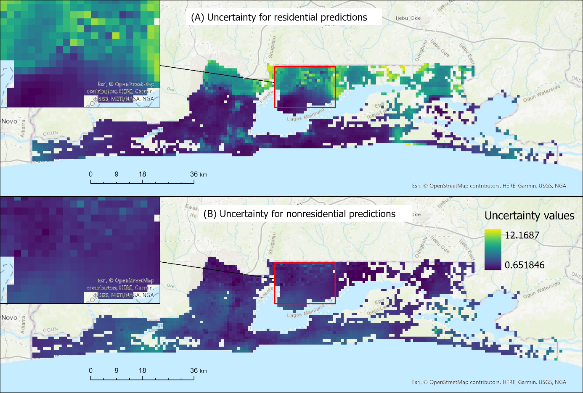
Figure A.1: Uncertainty estimate of the Bayesian model predictions at 1 x 1 km. The uncertainty was calculated using the formula (upper credible interval – lower credible interval) / mean population. A) shows the uncertainty residential class predictions; B) shows the uncertainty for non-residential predictions.

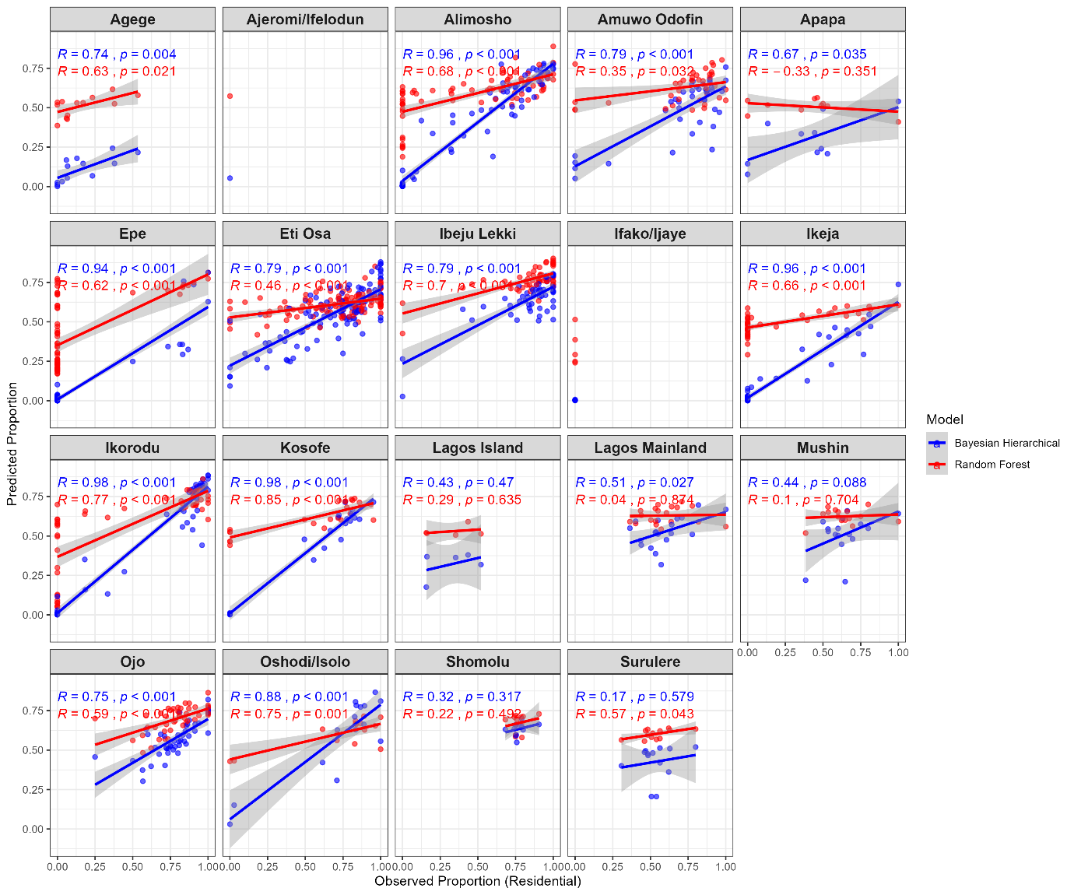
Figure A.2: Scatterplot of the residential class proportion of Observed vs Predicted for Random Forest (Red) and Bayesian Hierarchical (Blue) model output, showing the correlation coefficient per Local Government Area (LGA). Note, Badagry LGA has no observation dataset, so it is excluded from this analysis.

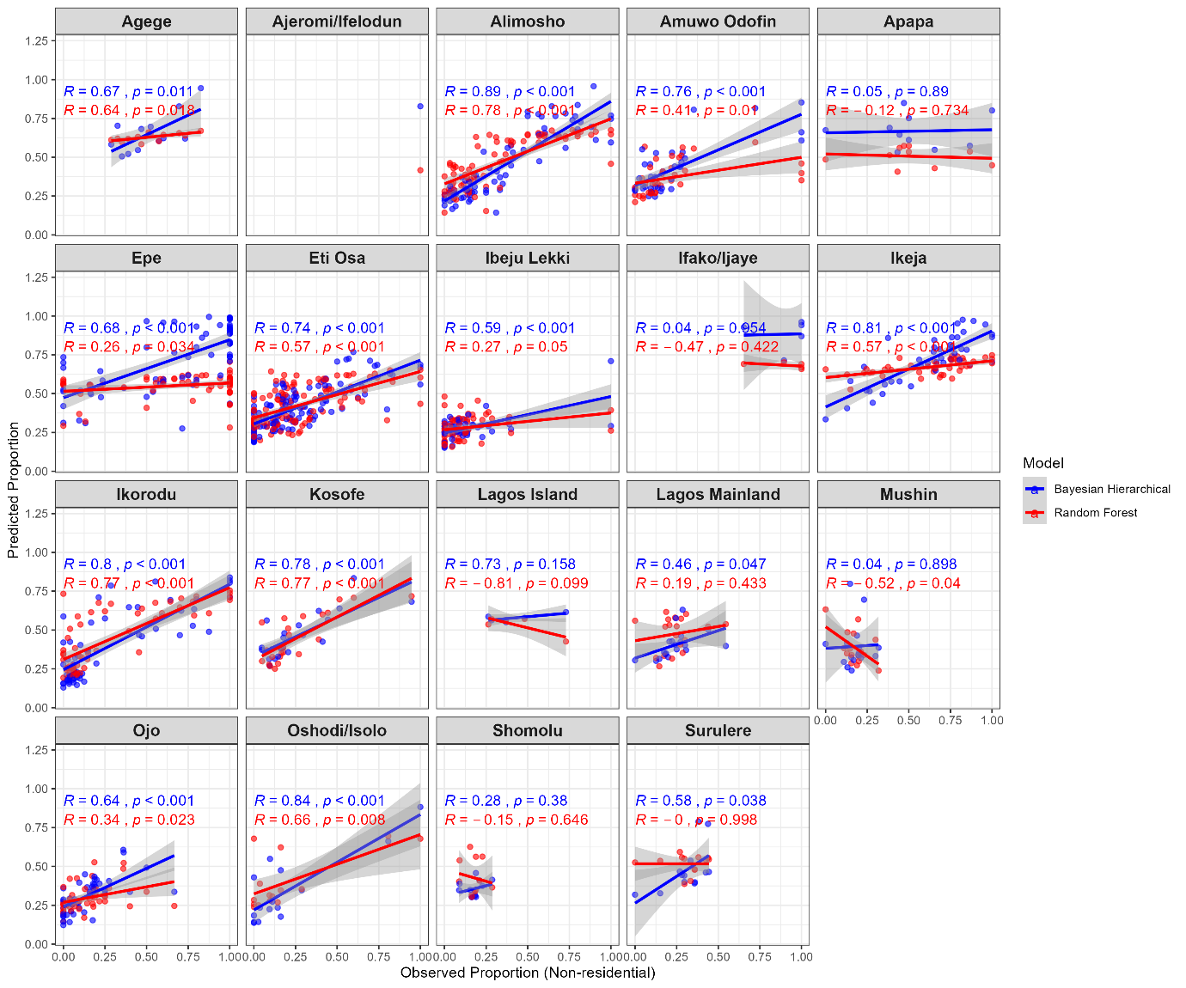
Figure A.3: Scatterplot of the non-residential class proportion of Observed vs Predicted for Random Forest (Red) and Bayesian Hierarchical (Blue) model output showing the correlation coefficient per Local Government Area (LGA). Note, Badagry LGA has no observation dataset, so it is excluded from this analysis.

