Supporting Information
Misplaced-dipole engineered repairable fluoropolymer elastomer for flexible perovskite solar cell with excellent thermal-mechanical cycling resistance
Feihu Liu,^{1,4,5} Jie Dou,^{1,4,5*} Ying Li,^{1,4,5} Wei Zhang,^{1,4,5} Jiale Li,^{1,4,5} Yuchen Li,^{1,4,5} Qiyao Guo,^{1,4,5} Yuanyuan Zhao,^{4,5} Benlin He,³ Jialong Duan,^{1,4,5*} Qi Chen^{2,*}and Qunwei Tang^{1,4,5*}

Figure S1. Images of HFBA-TFEMA blend (molar ratio of 1:1) under natural conditions, as well as those after heating at 60 °C for 3 minutes.

Figure S2. Water contact angle images for the perovskite films without (control) and with (target) copolymer modification.

Figure S3. Time evolution of (a) electrostatic interactions and (b) van der Waals interactions in the molecular dynamics simulation system.

Figure S4. Images of (a) TFEMA monomer, (b) HFBA monomer, and (c) HFBA-TFEMA blend (molar ratio of 1:1) under natural conditions, as well as those after heating at 60 °C for 3 minutes.

Figure S5. Electrostatic potential of a class of polymer repeating units.

Figure S6. Electrostatic potential isosurface map with charge polarity around the molecule.

Figure S7. XPS spectra for Pb 4f in the control and target perovksite samples.

Figure S8. ¹H-NMR spectra of HFBA and HFBA/PbI₂ mixture.

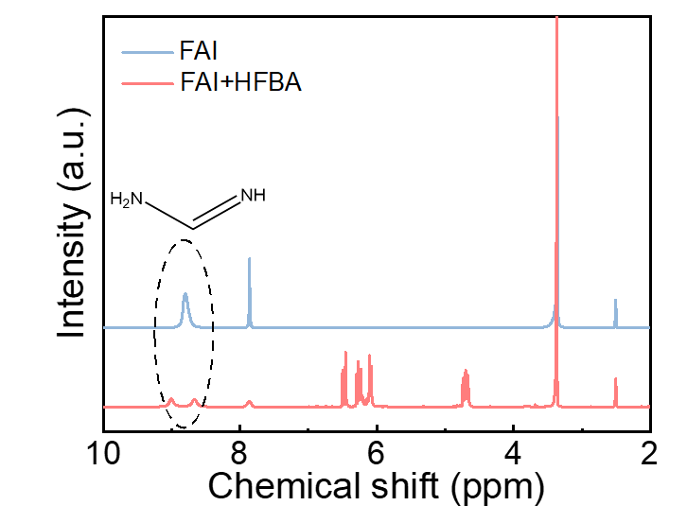
Figure S9. ¹H-NMR spectra of FAI and HFBA/FAI mixture.

Figure S10. FTIR spectra of pure polymers and polymers mixed with a) PbI₂ and b) perovskite.

Figure S11. Top-view SEM images of a) control and b) target perovskite films, and the related particle size analysis. Cross-sectional SEM image. SEM images of c) control and d) target perovskite films.

Figure S12. XRD patterns of control and target perovskite films.

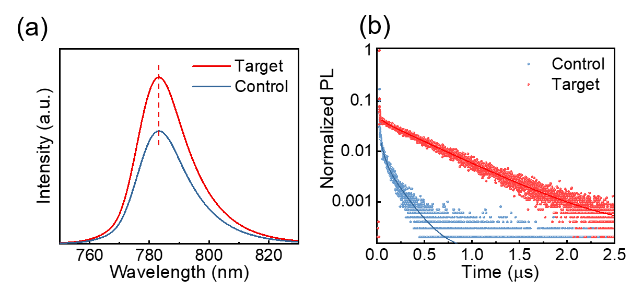
Figure S13. PL spectra of control and target perovskite films on glass.

Figure S14 a) Space-charge-limited current (SCLC) measurements of the electron-only device (ITO/SnO₂/perovskite/PCBM/Cu); b) SCLC measurements of the hole-only device (ITO/MeO-2PAcz/perovskite/Spiro-OMeTAD/Cu).

Figure S15. a) Atomic force microscopy (AFM) and b) Nano-IR images of the control perovskite films.

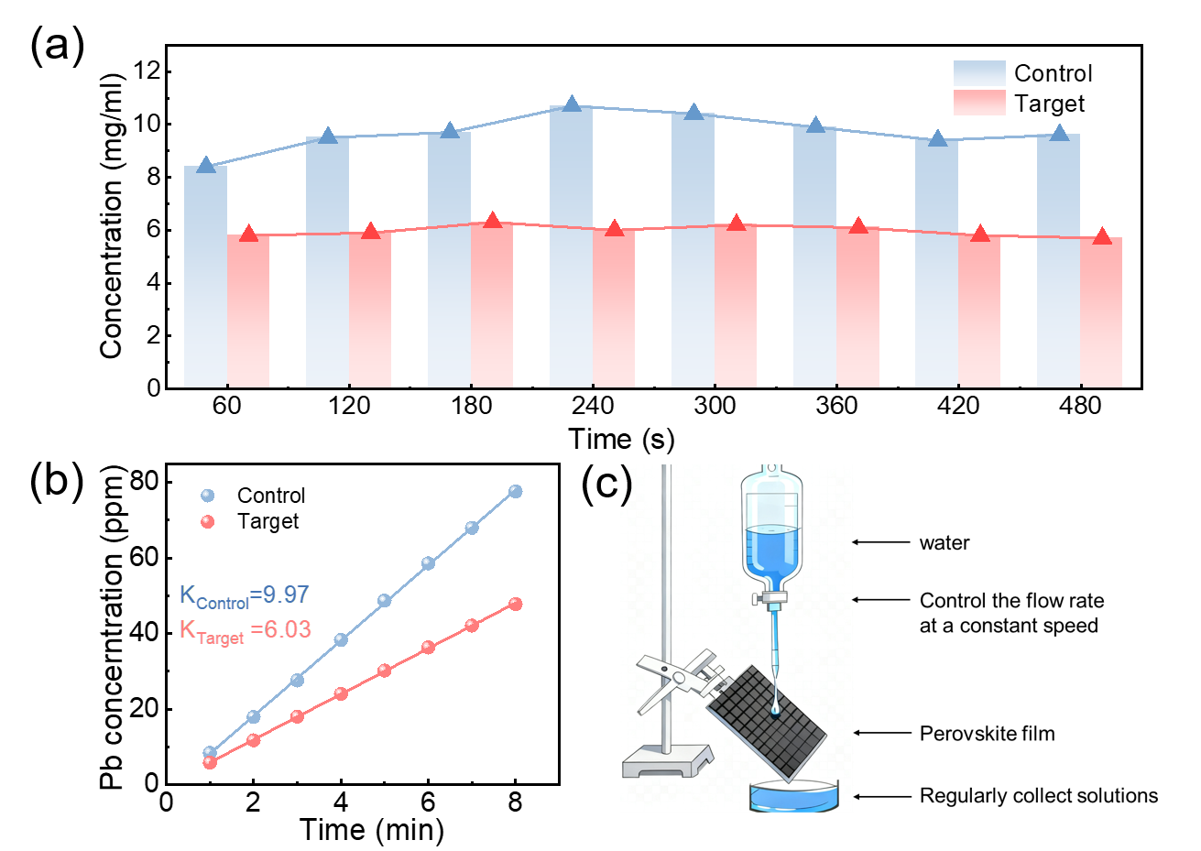
Figure S16. a) The concentration of lead ions in the aqueous solution after different time periods in the perovskite thin film drip experiment. b) Fitting of lead ion concentration in water. c) Schematic diagram of lead leakage test for perovskite thin film dripping water.

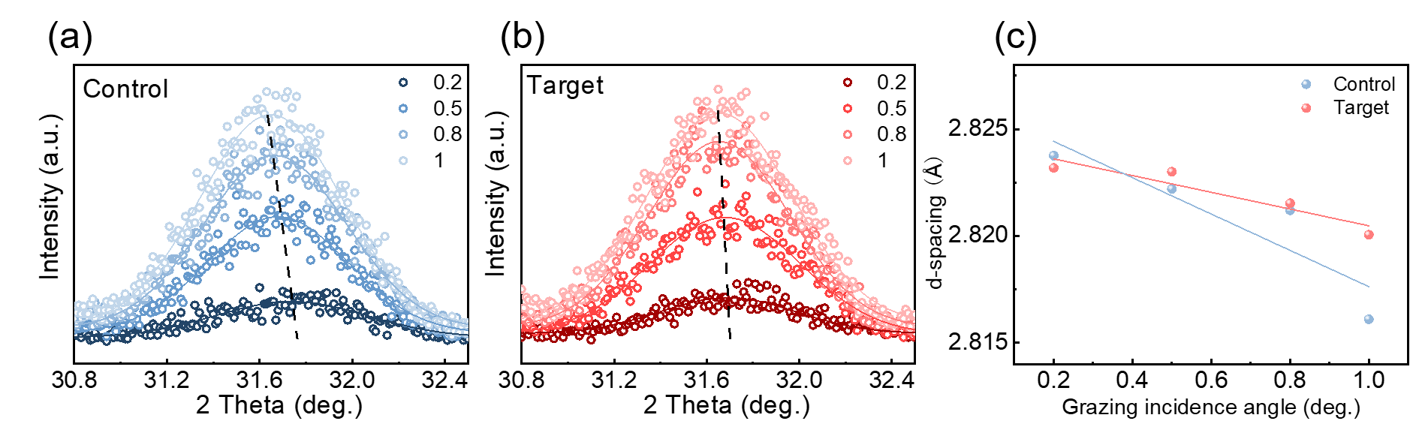
Figure S17. GIXRD spectra of a) control and b) target perovskite films. c) In-of-plane residual strain distribution for the of 600 nm depthperovskite film (measured (points) and Gauss fitted (line) diffraction strain data as a function of sin2ϕ.

Figure S18. Top-view SEM images of a,c) control and b,d) tagret perovskite films after repeated bending.

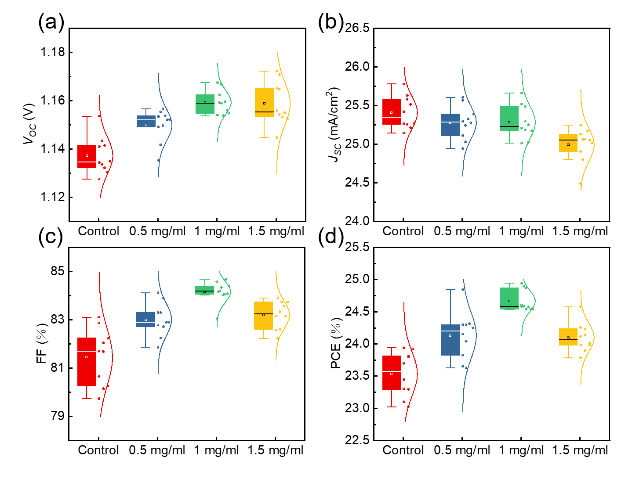
Figure S19. Photovoltaic data: a) V_{oc}, b) J_{sc},c) FF, d) PCE of PSCs as a function of concentration of cross-linked polymer.

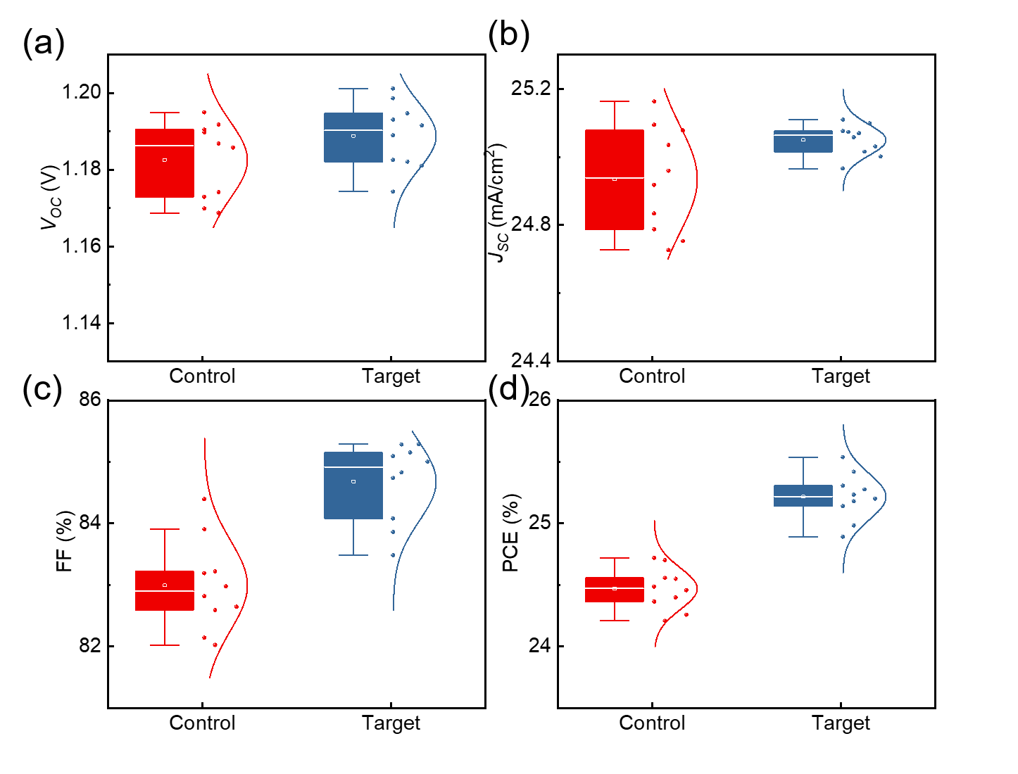
Figure S20. Photovoltaic data: a) Voc, b) Jsc,c) FF, d) PCE of F-PSCs.

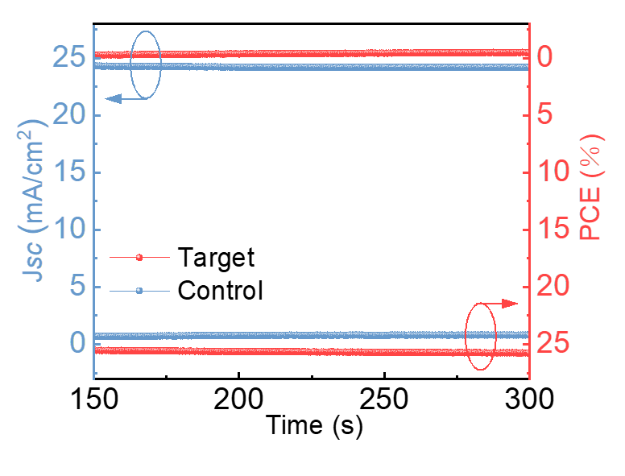
Figure S21. Steady-state power output measurements for control and target perovskite devices.

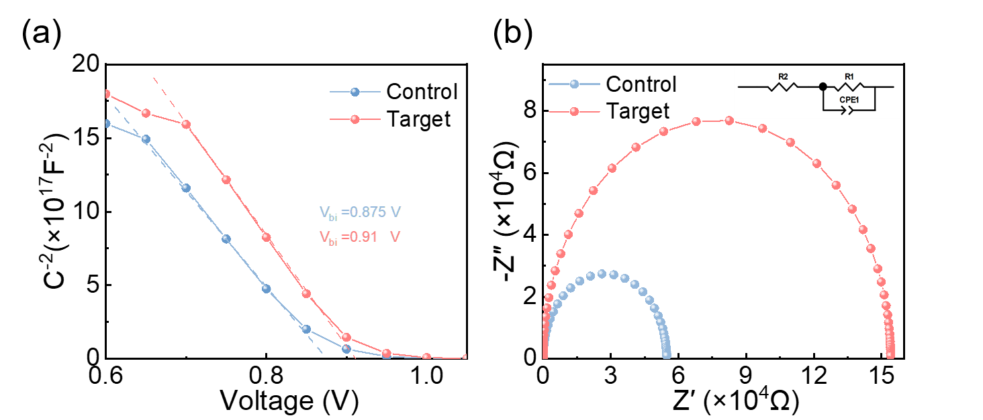
Figure S22. a) The M-S plots of the control and the target PSCs. b) The EIS spectra of the control and the target PSCs.

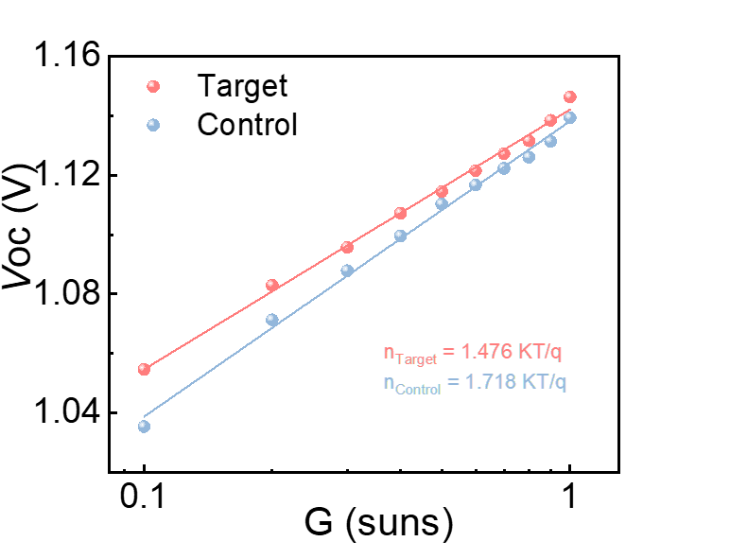
Figure S23. V_{OC} as a function of incident light intensity of the control and the target PSCs.

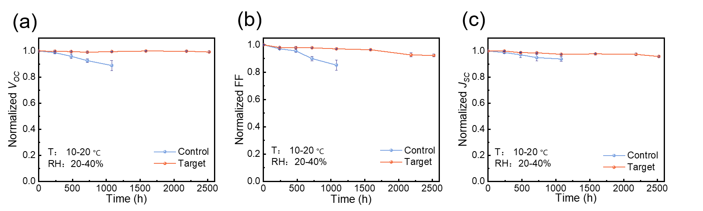
Figure S24. The evolution of (a) Voc, (b) FF, and (c) Jsc of perovskite solar cells ambient air (20%–40% RH at room temperature) without encapsulation.

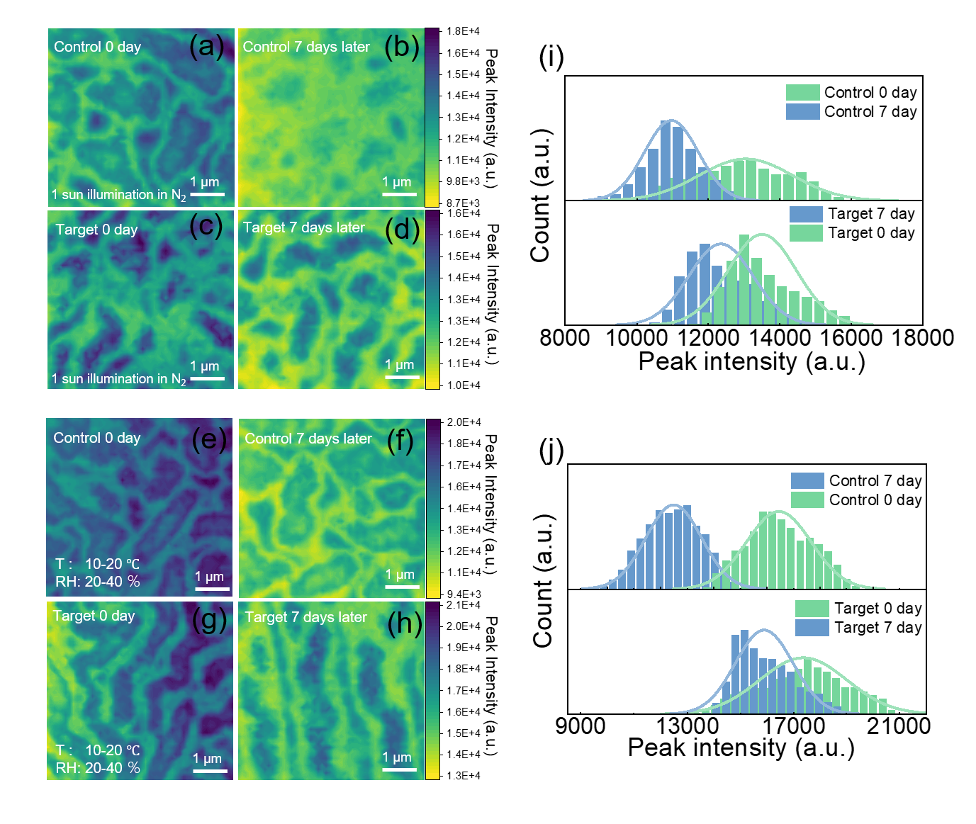
Figure S25. The PL peak intensity mapping images of control a) and target b) before aging, as well as control c) and target d) after aging, and the corresponding distribution statistics of PL peak intensity for i) of perovskite thin films under equivalent 1-sun illumination .The PL peak intensity mapping images of control e) and target f) before aging and control g) and target h) after aging of perovskite thin films in ambient air (20% -40% RH at room temperature), as well as j)the corresponding distribution statistics of PL peak intensity.

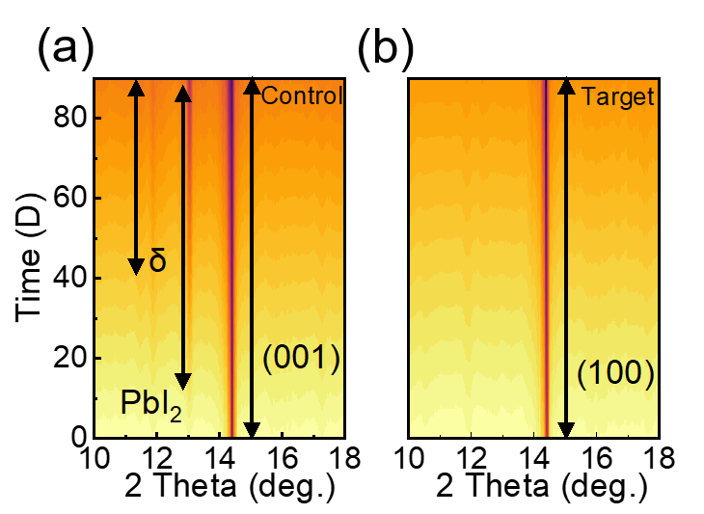
Figure S26. XRD patterns under a,b) ambient conditions (20-40% relative humidity at room temperature).

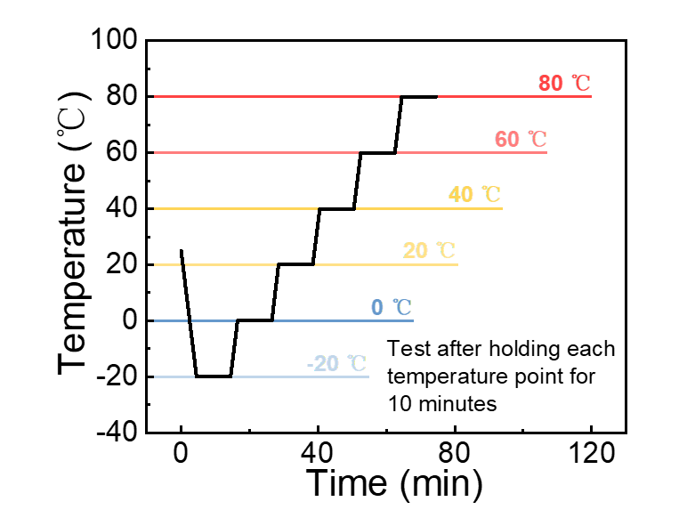
Figure S27. In-situ XRD Test Conditions.

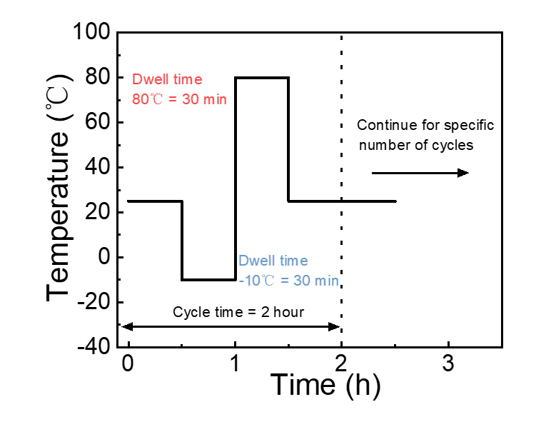
Figure S28. Thermal Cycling XRD Test Conditions.

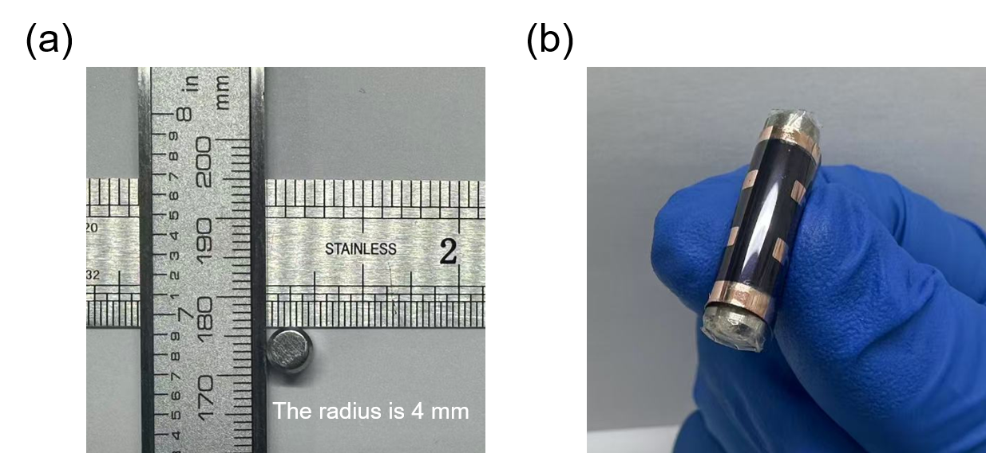
Figure S29. The radius of the cyclic bending tool for flexible perovskite devices.

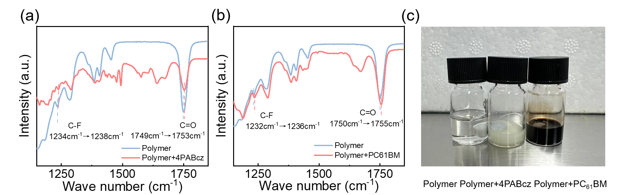
Figure S30. Fourier transform infrared spectroscopy of fluoropolymer blends with a) 4PABcz and b) PC₆₁BM.

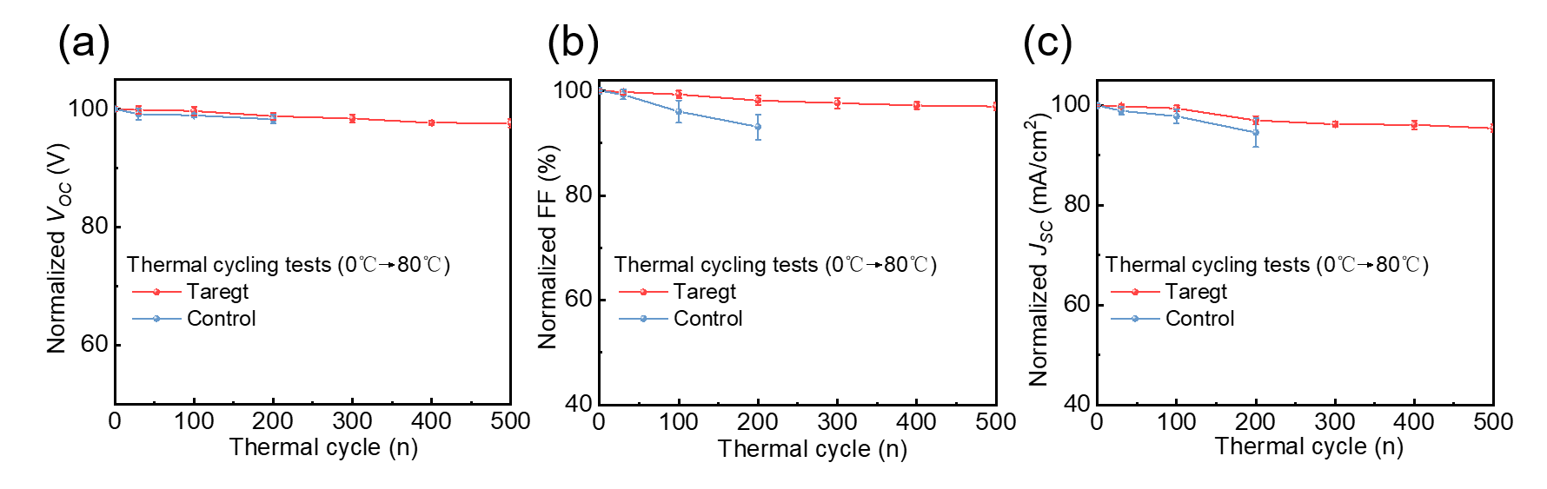
Figure S31. The evolution of a Voc, (b) FF, and (c) Jsc of perovskite solar cells in cold and hot cycling tests without encapsulation.

Table S1. Values of Coulombic Forces and van der Waals Forces in the Molecular Dynamics Simulation of Self-Healing Materials.
 | LJ-SR Energy (kJ/mol) | Coulomb-SR Energy (kJ/mol) | Average LJ-SR Energy (kJ/mol) | Average Coulomb-SR  Energy (kJ/mol)
TFEMA | -59291.98 | -474059.53 | -57897.36 | -473596.14
HFBA | -83051.32 | 25924.18 | 81693.55 | 27031.11
TFEMA-HFBA | -73671.93 | -212963.25 | -72801.12 | -212184.96

Table S2. Ratio of positive and negative charges on the surface of a molecule.
HFBA | Positively charged region (％) | negatively charged region (％)
1 | 0.55012 | 0.44988
2 | 0.43769 | 0.56231
3 | 0.53231 | 0.46769
4 | 0.53505 | 0.46495

TFEMA | Positively charged region (％) | negatively charged region (％)
1 | 0.52805 | 0.47195
2 | 0.51128 | 0.48872
3 | 0.50928 | 0.49072
4 | 0.48578 | 0.51422

HFBA-TFEMA 1:1 Blend | Positively charged region (％) | negatively charged region (％)
2 | 0.50016 | 0.49984
4 | 0.49814 | 0.50186

Table S3. Finite Element Simulation Parameters.

 |  | Young‘s modulus (Gpa) | Poisson's ratio
Cu |  | 119 | 0.326
PCBM |  | 0.384 | 0.36
PVSK | Control | 26.69 | 0.31
PVSK | Target | 19.42 | 0.31
PTAA |  | 2 | 0.3
ITO |  | 210 | 0.3

Table S4. Champion Rigid Device Performance Parameters
Devices | V_{oc} (V) | PCE (%) | FF (%) | J_{sc} (mA/cm²)
Control | 1.188 | 25.700 | 83.098 | 26.032
Target | 1.195 | 26.834 | 86.292 | 26.037

Table S5. Champion flexible device performance parameters of the control and target devices.
Devices | V_{oc} (V) | PCE (%) | FF (%) | J_{sc} (mA/cm²)
Control | 1.170 | 24.720 | 84.398 | 25.036
Target | 1.193 | 25.539 | 85.290 | 25.099

Table S6. Flexible inverted device performance parameters of mechanical stability in 2025.
Bending cycle (n) | Normalized PCE | R (mm) | Champion PCE | Ref
10000 | 82.40% | 0.5 | 20.45% | Adv. Funct. Mater. 2025, 09960
5000 | 92.60% | 3 | 25.11% | Adv. Mater. 2025, 19365
11000 | 90.2% | 4 | 25.54% | This work
10000 | 91.5% | 4 | 25.54% | This work
8000 | 87.2% | 4 | 25.47% | Angew. Chem. Int. Ed. 2025, 1131
30000 | 90% | 4 | 25.76% | Adv. Funct. Mater. 2025, 25744
4000 | 97% | 4 | 24.75% | Energy Environ. Sci., 2025, 18, 8803
20000 | 97.3% | 5 | 25.45% | Adv. Energy Mater., 2025, DOI:10.1002/aenm.202505869
10000 | 91% | 5 | 24.64% | Sci. Adv.,2025, 11, 2290
3000 | 89.30% | 5 | 22.54% | Sci. Adv.,2025, 11, 1116
20000 | 86.7% | 6 | 24.17% | Adv. Funct. Mater. 2025, 24919
10000 | 92.5% | 6 | 24.52% | Nat. Energy, 2025, DOI:10.1038/s41560-025-01932-4
3600 | 90% | 8 | 25.01% | Angew. Chem. Int. Ed., 2025, 64, 202512376
5000 | 95.30% | 10 | 25.30% | Angew. Chem. 2025, 137, 202501267

Table S7. Flexible device performance parameters of thermal cycling stability in recent year.
Thermal cycle (n) | NormalizedPCE | Minimum temperature | Maximum temperature | Champion PCE | Ref
500 | 90% | 0 | 80 | 26.83% | This work
500 | 80 | -40 | 85 | 27.05% | Nat. Photonics, 2025, 19,1255
300 | 93.53% | -40 | 85 | 22.07% | Sci. Adv.,2025, 11, 1437
200 | 90.20% | -40 | 85 | 25.78% | Angew. Chem. Int. Ed. 2025, 64, 202421063
250 | 94.40% | 25 | 85 | 26.26% | Angew. Chem. Int. Ed. 2025, 21774
5 | 90% | 25 | 85 | 18.1% | Adv. Energy Mater. 2018, 8, 1703421

