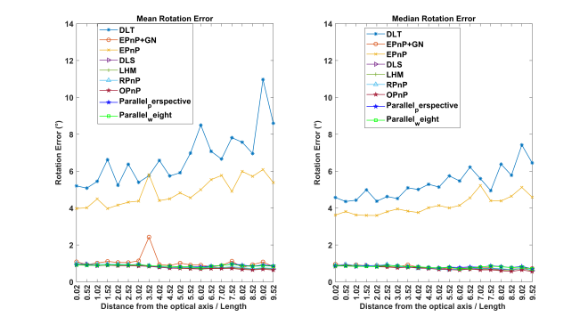
(a) | (b)
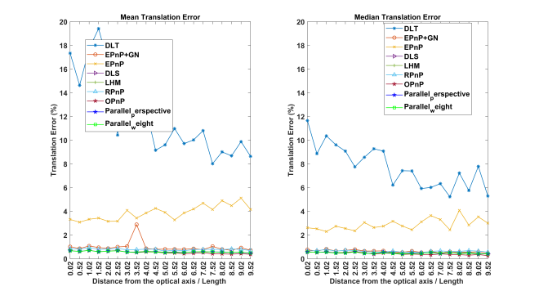
(c) | (d)
Fig. S1. Effect of the distance from the origin of the coordinate system containing the 6 feature points to the optical axis of the camera on the algorithms (the origin of the coordinate system of the feature points is 200 mm away from the focal point).

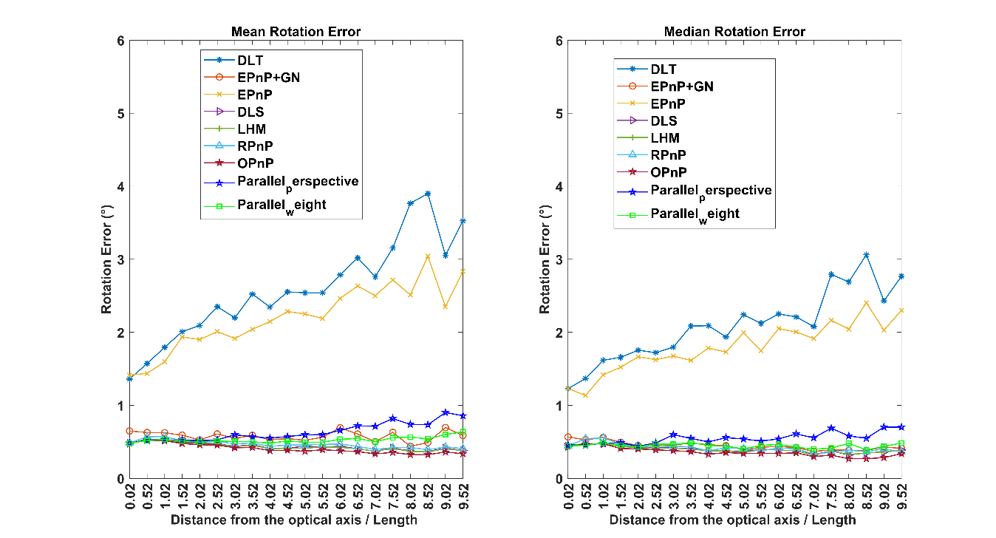
(a) | (b)
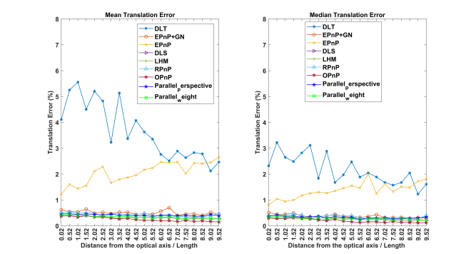
(c) | (d)
Fig. S2. Influence of the distance from the origin of the coordinate system containing the 6 feature points (close to the focus) to the optical axis of the camera (the origin of the coordinate system of the feature points is 100 mm away from the focus) on the algorithms.

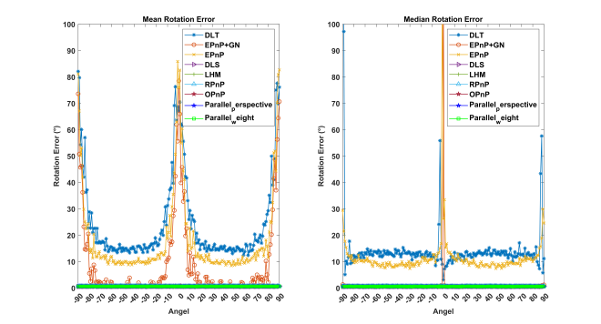
(a) | (b)
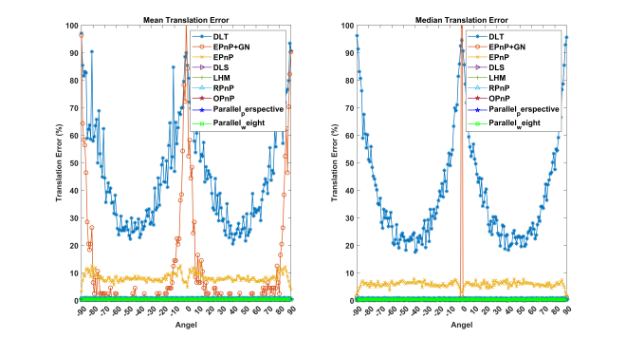
(c) | (d)

Fig. S3. Effects of the angle between the optical axis of the camera and the Z-axis of the coordinate system of the six feature points on the algorithms.

