Supporting Materials

Synthesis and Gas Separation of HOF-21/Triphenylamine Polyimide Mixed Matrix Membranes
Junjie Qu^{a, 1}, Junhao Mo^{a, 1}, Shanshan Wuª, Chao Shanª, Chanjuan Liu^{a, *}, Xiaohua Huang^{a, *}
ª MOE Key Laboratory of New Processing Technology for Nonferrous Metal and Materials, Guangxi Key Laboratory of Optical and Electronic Materials and Devices, Guangxi Colleges and Universities Key Laboratory of Natural and Biomedical Polymer Materials, College of Material Science and Engineering, Guilin University of Technology, Guilin, 541004, PR China
¹ These authors contribute equally
* Corresponding: Chanjuan Liu (liuchanjuan@glut.edu.cn) , Xiaohua Huang (huangxiaohua@glut.edu.cn)

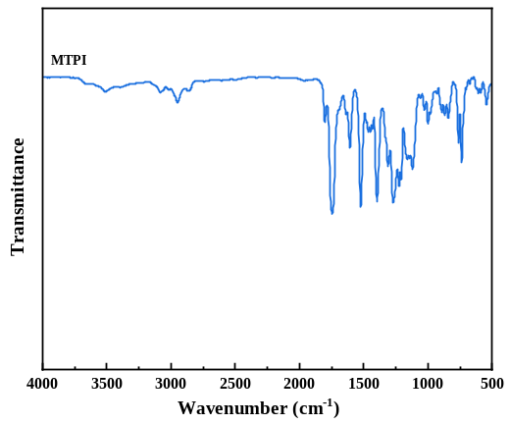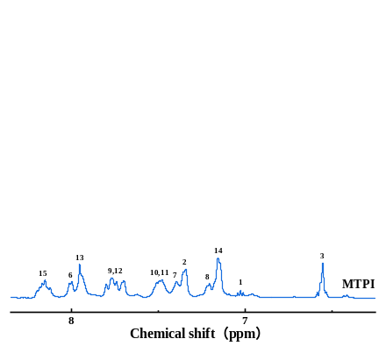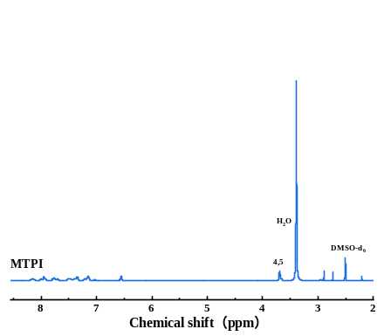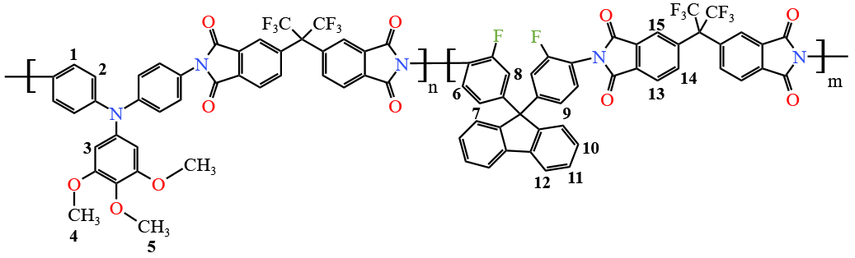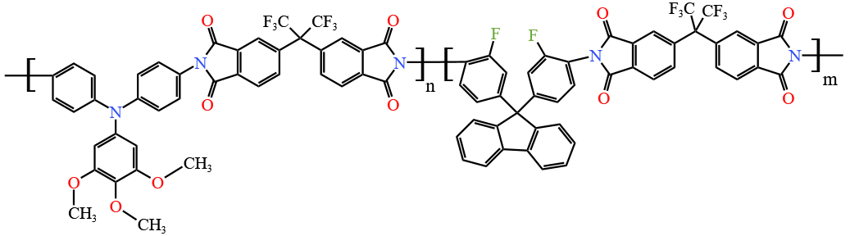
(a)
(b)
FIGURE S1 FT-IR spectra (a) and ¹H NMR spectra (b) of MTPI

