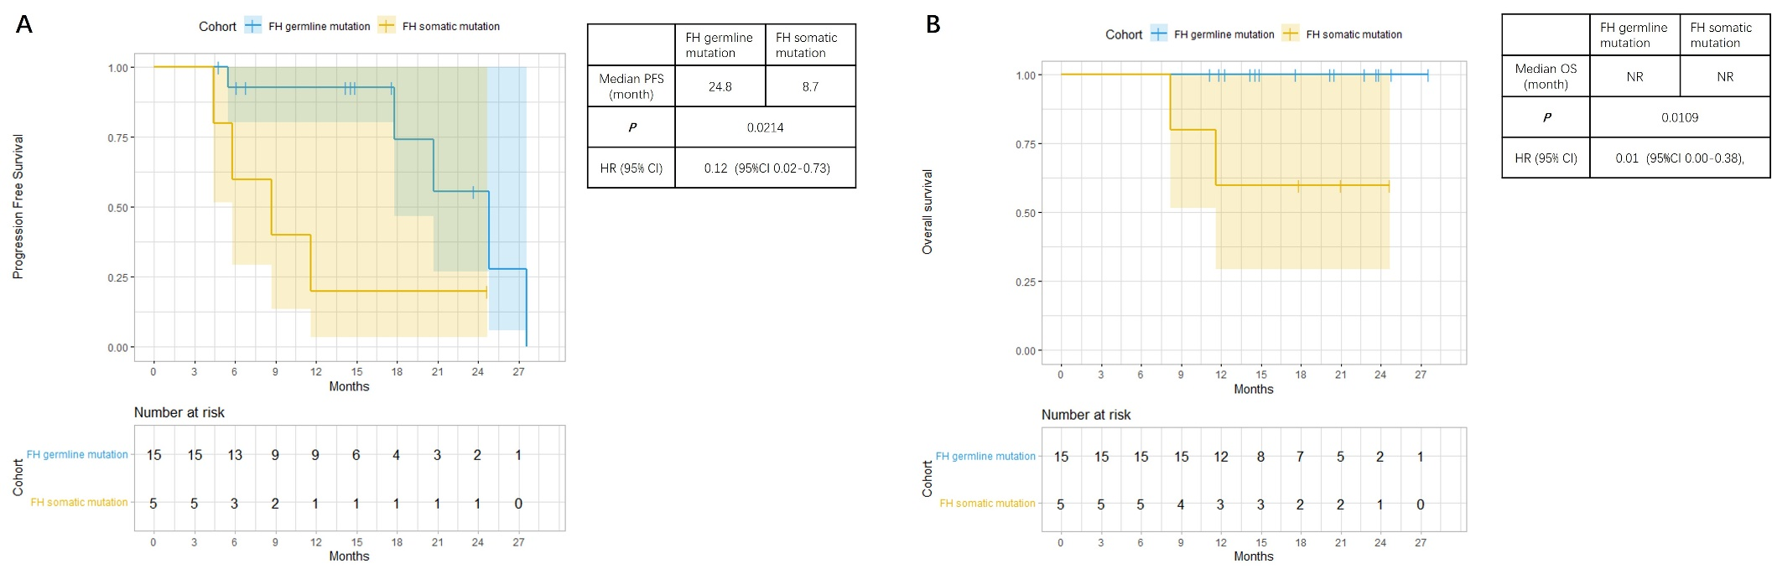
Figure S1: Comparison of progression-free survival and overall survival between subgroups with different FH status.
(A) Comparison of PFS between subgroups of patients with FH germline mutation and somatic mutation.
(B) Comparison of OS between subgroups of patients with FH germline mutation and somatic mutation.

