Supplementary
Supplementary Table 1 Annotations of the ORF 32 in genome of cyanophage PP-DH22 and its orthologs in the genomes of cyanophage PP, LPP and Pf-WMP3 by different annotation tools
cyanophage | amino acid length | eggNOG-mapper |  | blastx |  | Hmmer |  | VIPTree
cyanophage | amino acid length | Description | E-value | Description | E-value | Description | E-value | Description | E-value
PP-DH22 | 121 | hypothetical protein | - | endonuclease VII | 2e-14 | Recombination endonuclease VII | 1.9e-77 | endonuclease VII | 3.6e-65
PP | 121 | hypothetical protein | - | endonuclease VII | 7e-15 | Recombination endonuclease VII | 3.4e-78 | endonuclease VII | 5.5e-66
LPP | 118 | hypothetical protein | - | restriction endonuclease | 1e-78 | Recombination endonuclease VII | 6.0e-26 | recombination endonuclease | 2.8e-62
Pf-WMP3 | 126 | hypothetical protein | - | endonuclease VIl | 9e-88 | Recombination endonuclease VII | 3.9e-47 | endonuclease VII | 3.3e-71

- Not available

Supplementary Fig. 1 Infection of liquid culture of IU594 in 24 h (experimental treatment with lysate on the left, control treatment without lysate on the right) (a) and cyanophage plaques in the solid culture of IU594 (b)
Supplementary Fig. 2 Comparative genomic alignment of cyanophage PP-DH22 and its closest relatives generated by ViPTree. The analysis includes the query genome (PP-DH22) and four related phage genomes identified by the ViPTree server: Cyanophage PP (NC_022751), Phormidium phage Pf-WMP3 (NC_009551), Anabaena phage A-4L (NC_024358), and Phormidium phage Pf-WMP4 (NC_008367). (Left) Dot plots show the pairwise synteny between PP-DH22 (y-axis) and each subject genome (x-axis). Diagonal lines indicate collinear regions. (Right) Linear genome alignment based on tBLASTx similarity scores. Homologous regions are connected by colored blocks, with the color gradient representing the percentage of identity (purple: high identity; blue: low identity, see scale bar). Blue arrows indicate predicted ORFs and transcriptional direction.
Supplementary Fig. 3 Circular proteomic tree of cyanophage PP-DH22 and related cyanophages generated by ViPTree. The phylogenetic relationship was inferred based on genome-wide sequence similarities computed by tBLASTx. The tree includes the query genome PP-DH22 (marked with a red star), all available cyanophage genomes from the ViPTree database, and Enterobacteria phage T7 as an outgroup.
Supplementary Fig. 4 Sequence Similarity Network of the Endonuclease VII protein. The network was generated using the EFI-EST web server and visualized in Cytoscape. The dataset comprises the query sequence from cyanophage PP-DH22 and approximately 200 homologous sequences identified from the database.

a | 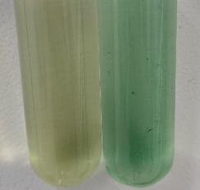
b | 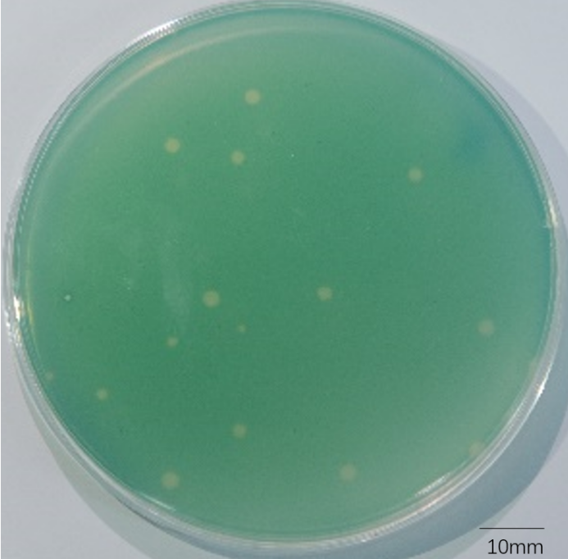
Supplementary Fig. 1

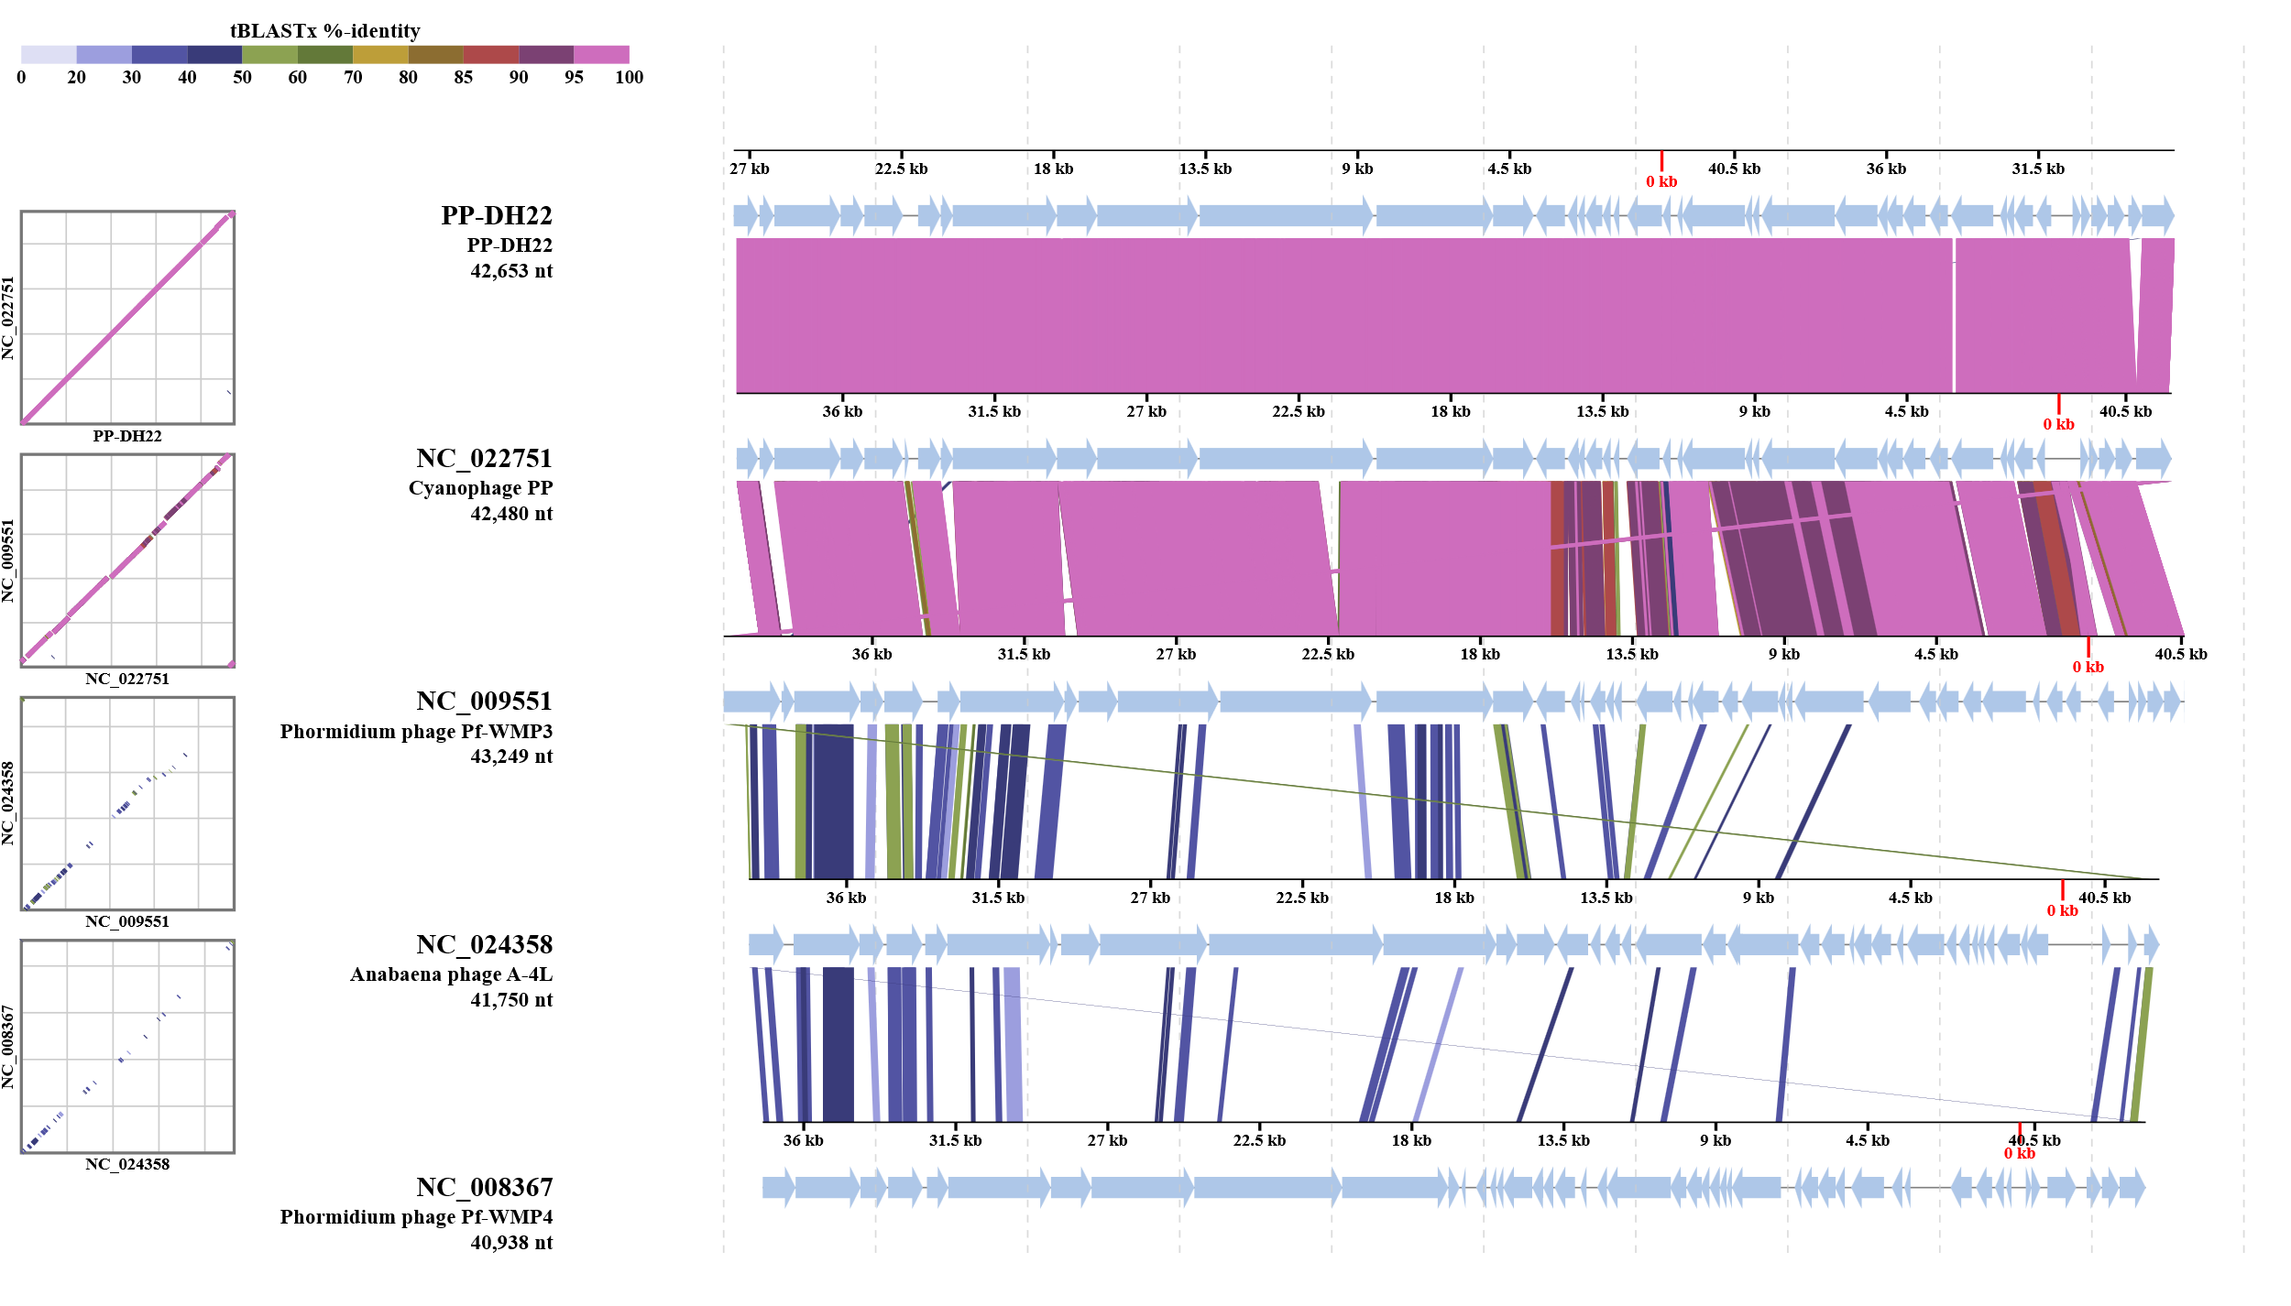
Supplementary Fig. 2

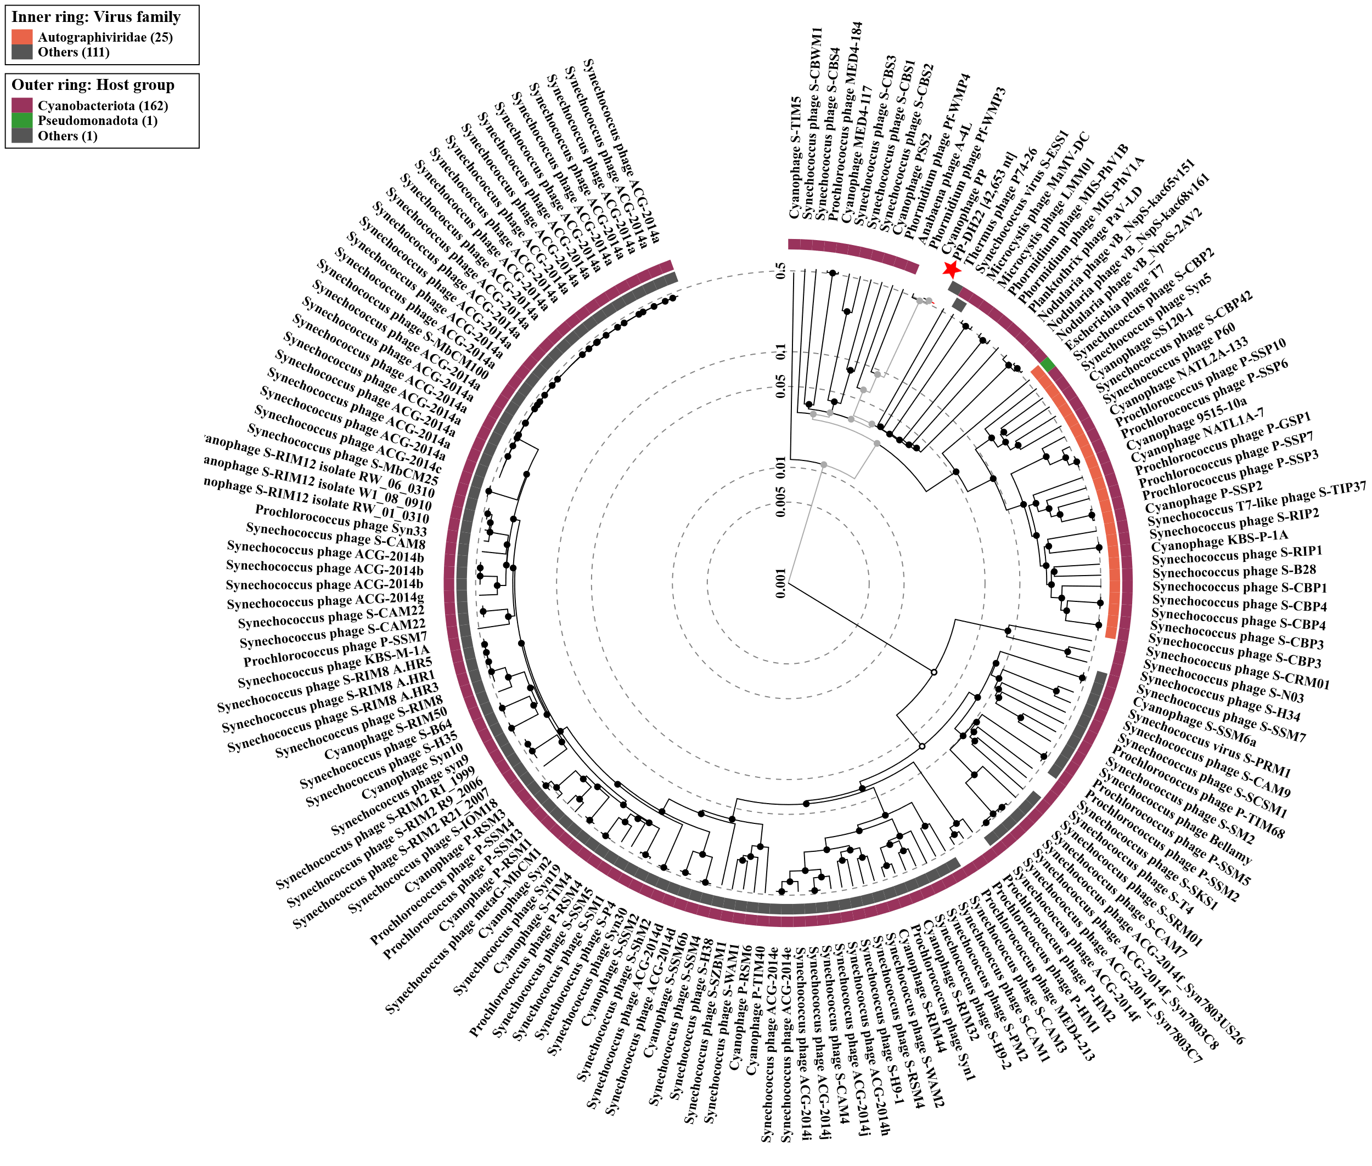
Supplementary Fig. 3

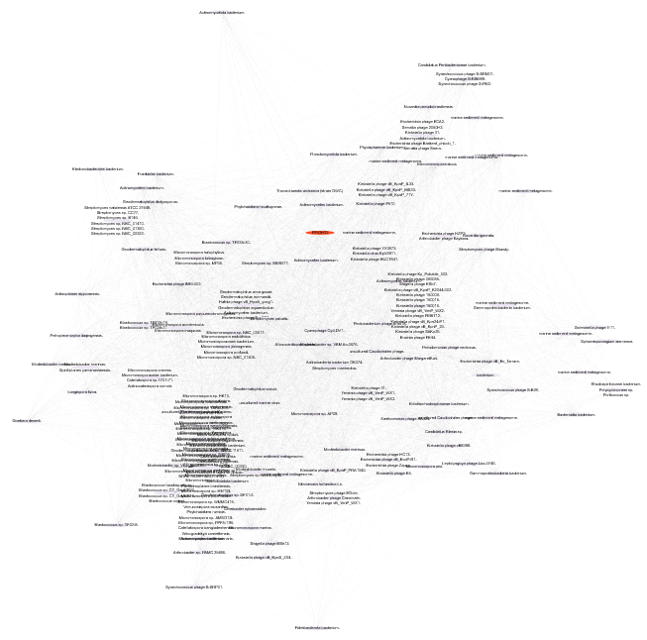
Supplementary Fig. 4

