Deficient de-S-acylation in aging and CLN1 contributes to lyso-mitochondrial dysfunction, lipid dyshomeostasis, and resultant lipofuscin biogenesis
Sofia Massaro Tieze^{1,2}, Alexander Esqueda,^{1,2} Rachel McAllister,³ Matija Lagator^{4,5}, Betül Yücel¹, Eric Sun⁶, TuKiet T. Lam^{7,8}, Nicholas Lockyer⁴, Kallol Gupta³, Sreeganga S. Chandra^{1,9,10,*}
¹Departments of Neurology & Neuroscience, Yale University, New Haven, CT, USA
²Interdepartmental Neuroscience Program, Yale University, New Haven, CT, USA
³Department of Cell Biology, Yale University, New Haven, CT, USA
⁴Photon Science Institute, Department of Chemistry, University of Manchester, Manchester, UK
⁵Rosalind Franklin Institute, Rutherford Appleton Laboratory, Didcot, Oxfordshire, UK
⁶Yale College, Yale University, New Haven, CT, USA
⁷Departments of Molecular Biophysics and Biochemistry, Yale University, New Haven, CT, USA
⁸Keck Mass Spectrometry & Proteomics Resource, W.M. Keck Biotechnology Resource Laboratory, New Haven, CT, USA
⁹Senior author
¹⁰Lead contact
*Correspondence: sreeganga.chandra@yale.edu

SUPPLEMENTAL FIGURES
Fig. S1.
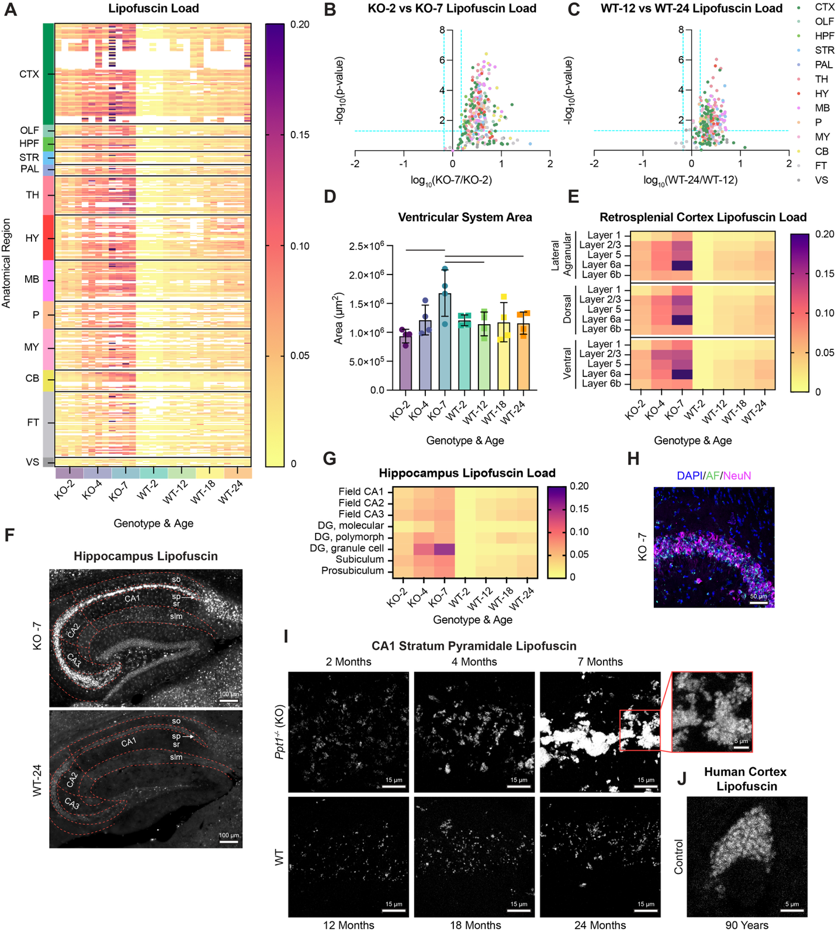
Figure S1. Lipofuscin load increases across fine neuroanatomical regions with age and CLN1 progression.
(A) Heat map of lipofuscin load across fine anatomical regions (n = 4 sex-matched biological replicates/genotype/timepoint; n = 4 alternate sections/replicate). White cells indicate that region was not found in measured sections. Rows corresponding to regions with fewer than 2 measurements across all samples were not included. Color blocks on left correspond to location of region within Allen Mouse Brain Atlas as in Fig. 1Biv (CTX: isocortex; OLF: olfactory areas; HPF: hippocampal formation; STR: striatum; PAL: pallidum; TH: thalamus; HY: hypothalamus; MB: midbrain; P: pons; MY: medulla; CB: cerebellum; FT: fiber tracts; VS: ventricular systems). Color blocks on bottom correspond to age and genotype of animals as in Fig. 1A.
(B and C) Log fold-change comparisons of lipofuscin load by fine (points) and gross (color groups) anatomical regions with (B) CLN1 progression in 2- vs 7-month-old KO mice and with (C) natural aging in 12- vs. 24-month-old WT mice (blue dashed line significance threshold at fold change > 1.5 and p < 0.05).
(D) Quantification of ventricular system area (µm²) with age and CLN1 progression (n = 4 sex-matched biological replicates/genotype/timepoint; n = 4 alternate sections/biological replicate). Lines indicate statistical comparisons where p < 0.05 by Tukey’s multiple comparison test.
(E) Heat map of lipofuscin load in lateral agranular (top) and dorsal (middle) and ventral (bottom) retrosplenial areas by cortical layer (average of n = 4 sex-matched biological replicates/genotype/timepoint; n = 4 alternate sections/replicate).
(F) Representative images of hippocampus autofluorescence in KO 7-month (top) and WT 24-month (bottom) animals (scale bar, 100 µm). Red dashed lines indicate fine anatomical regions of fields CA1, CA2 and CA3 (so: stratum oriens; sp: stratum pyramidale; sr: stratum radiatum; slm: stratum lacunosum-moleculare).
(G) Heat map of lipofuscin load in hippocampal formation regions. Fields CA1, CA2, CA3 are averaged across fine regions shown in panel F (DG: dentate gyrus; average of n = 4 sex-matched biological replicates/genotype/timepoint; n = 4 alternate sections/replicate).
(H) KO 7-month hippocampus stratum pyramidale with lipofuscin autofluorescence (AF; green), counterstained with nuclear marker DAPI (blue), and neuronal marker NeuN (magenta) (scale bar, 50 µm).
(I) Representative 63X images illustrating accumulation of autofluorescent lipofuscin granules in cells of stratum pyramidale layer of CA1 of hippocampus in KO and WT mice with CLN1 progression and age (scale bar, 15 µm). Inset shows region in red box at lower brightness to illustrate individual granules in saturated areas (scale bar, 5 µm).
(J) Representative lipofuscin-positive cell of dorsolateral prefrontal cortex of elderly human control (age = 90 years).
KO = Ppt1^{-/-} and WT = Ppt1^{+/+}, throughout.
Fig. S2.
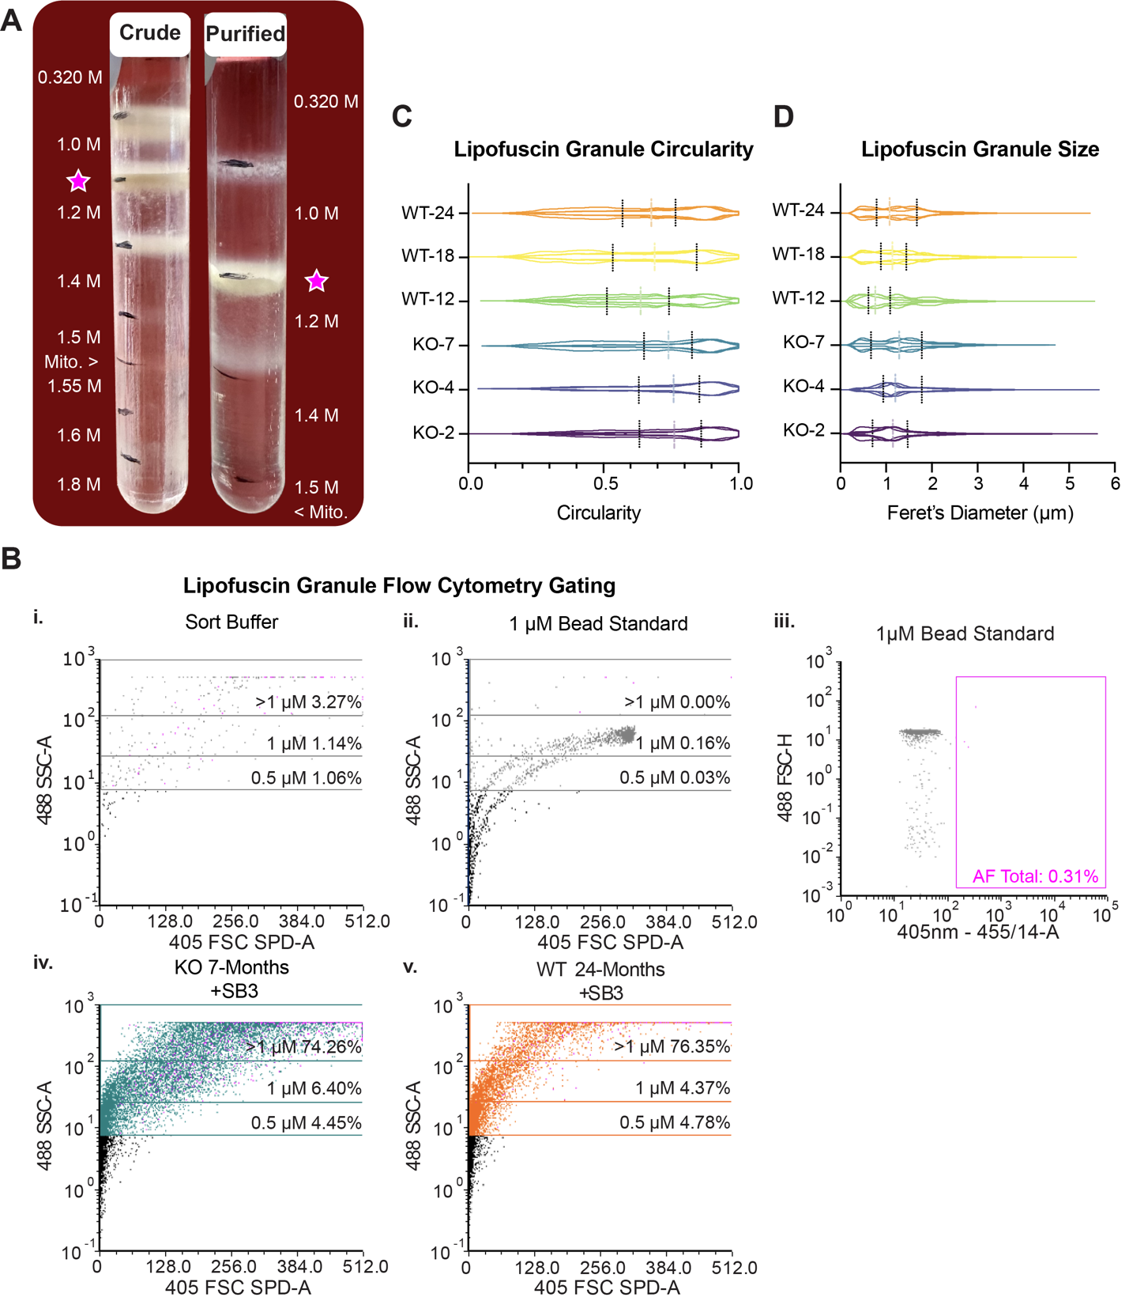
Figure S2. Lipofuscin purification and flow-cytometry strategies.
(A) Representative images of crude (left) and pure (right) sucrose gradients following ultracentrifugation. Yellow-brown autofluorescent fraction at 1.0-1.2 M sucrose interface is denoted by purple star. “Mito.” indicates density at which healthy mitochondria sediment.
(B) Flow cytometry gating plots of (i) sort buffer control, (ii) 1 µm plastic size-standard beads for small-particle gating, (iii) 1 µm plastic size-standard beads approximating lipofuscin granule size excluded by autofluorescence gate, and SB3-stained lipofuscin from (iv) KO 7-month and (v) WT 24-month animals illustrating majority of particles falling above 1 µm in diameter.
(C-D) Quantification of bright field SB3-stained granule images for (C) particle circularity and (D) particle size (Feret’s Diameter) (n = 3 biological replicates/genotype/age; n = 5 images/replicate). Solid lines = 25th and 75th percentile and dashed lines = median for summed replicate data.
KO = Ppt1^{-/-} and WT = Ppt1^{+/+}, throughout.
Fig. S3.
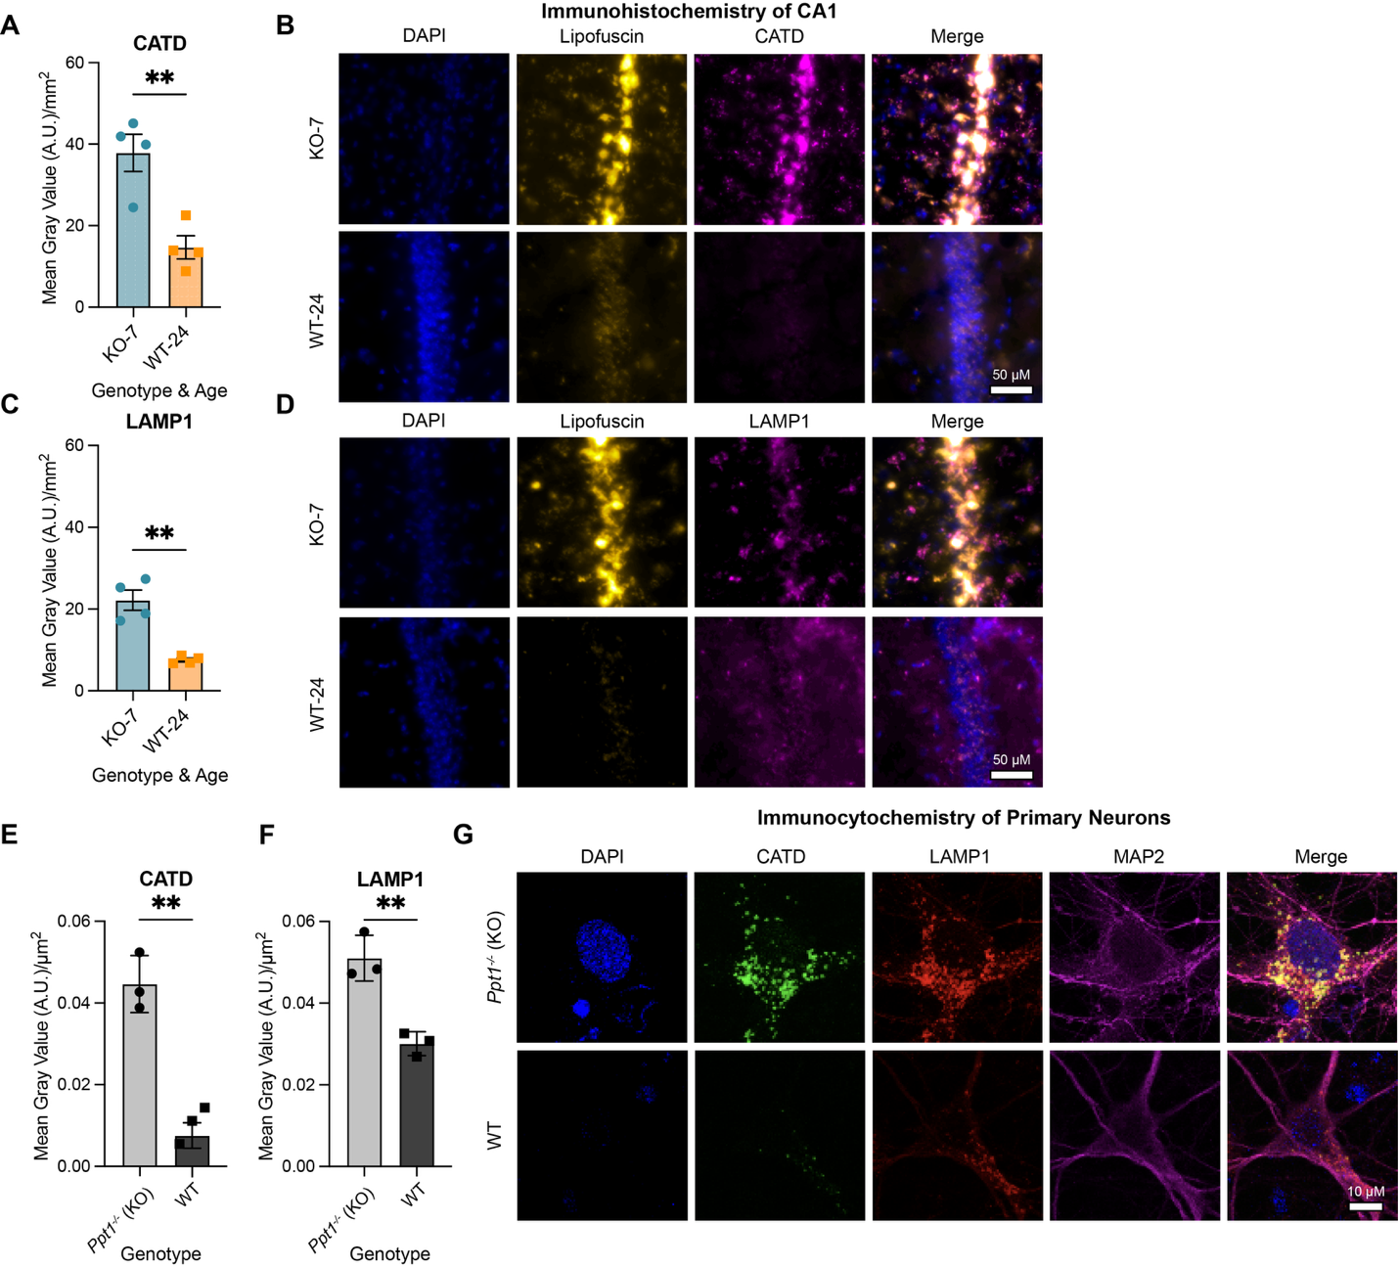
Figure S3. Ppt1 deficiency results in lysosome accumulation.
(A) Quantification of cathepsin D (CATD) expression (mean gray value/mm²) in hippocampal formation of 7-month KO and 24-month WT mice. Data are mean ± SD of n = 4 sex-matched biological replicates; n = 4 sections/replicate.
(B) Representative images of lipofuscin autofluorescence (yellow) and CATD expression (magenta) in CA1 stratum pyramidale layer of hippocampus in 7-month KO and 24-month WT mice with DAPI counterstain (blue) (scale bars, 50 µm).
(C) Quantification of LAMP1 lysosomal marker expression (mean gray value/mm²) in the hippocampal formation of 7-month KO and 24-month WT mice. Data are mean ± SD of n = 4 sex-matched biological replicates; n = 4 sections/replicate.
(D) Representative images of lipofuscin autofluorescence (yellow) and LAMP1 expression (magenta) in CA1 stratum pyramidale layer of hippocampus in 7-month KO and 24-month WT mice with DAPI counterstain (blue) (scale bars, 50 µm).
(E-F) Quantification of (E) CATD and (F) LAMP1 expression (mean gray value/mm²) in MAP2 positive neurons (magenta) in KO and WT primary cortical cultures at DIV14. Data are mean ± SD of n = 3 independent cultures; n = 5 neurons/culture.
(G) Representative images of CATD (green) and LAMP1 expression (red) in MAP2 positive neurons (magenta) with DAPI counterstain (blue) in KO and WT primary cortical cultures at DIV14 (scale bars, 10 µm).
KO = Ppt1^{-/-} and WT = Ppt1^{+/+}, throughout.
Fig. S4.
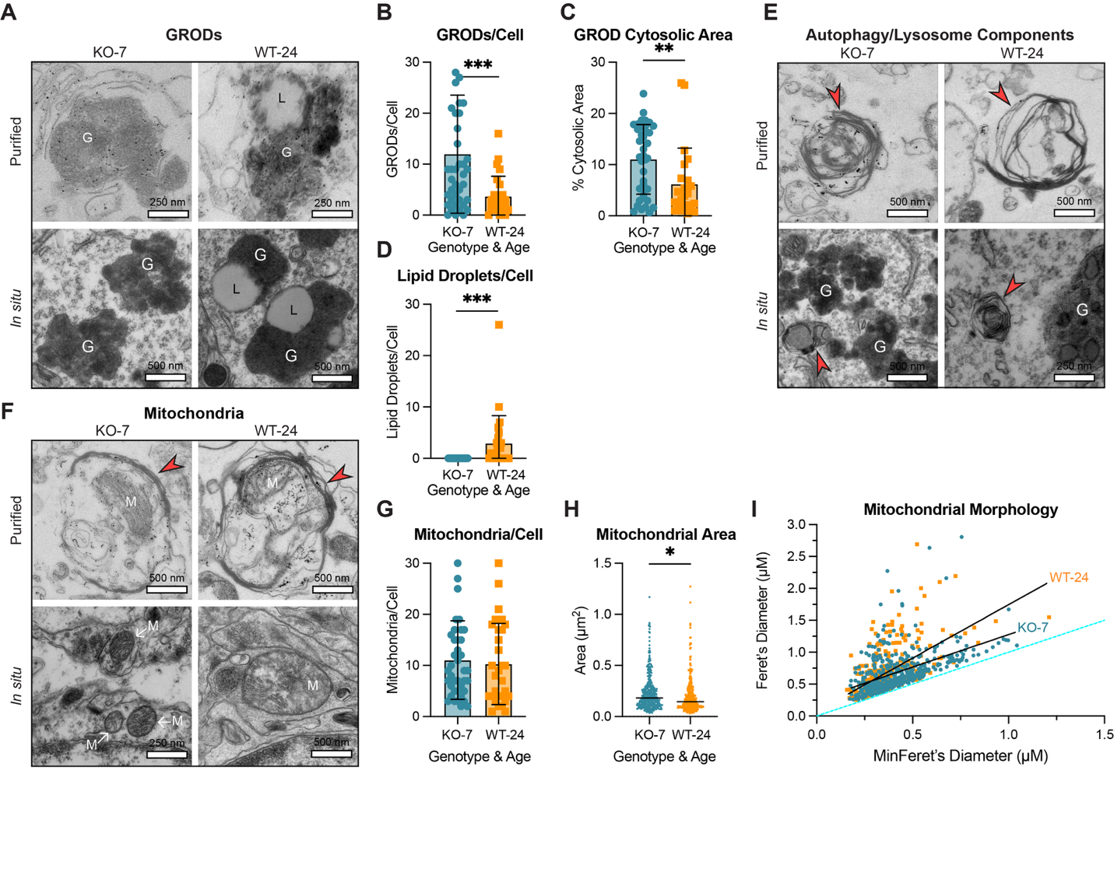
Figure S4. Ultrastructure of in situ and purified lipofuscin.
(A) Additional representative electron micrographs of granular osmiophilic deposit (GROD) structures (G) with associated lipid droplets (L) in purified lipofuscin (top) and in situ in KO 7-month and WT 24-month brain (bottom) (scale bars, 250 or 500 nm).
(B) Quantification of electron micrographs of cytosolic GROD structures/cell in KO 7-month and WT 24-month motor cortex and CA3 of hippocampus (*** indicates p < 0.001 by two-tailed t-test; WT: n = 26 cells; KO: n = 41 cells).
(C) Quantification of percentage (%) of cytosolic area taken up by GROD structures in KO 7-month and WT 24-month motor cortex and CA3 of hippocampus (** indicates p < 0.01 by two-tailed t-test; WT: n = 26 cells; KO: n = 41 cells).
(D) Quantification of number of lipid droplets per cell in KO 7-month and WT 24-month motor cortex and CA3 of hippocampus (*** p < 0.001 by two-tailed t-test; WT: n = 26 cells; KO: n = 41 cells).
(E) Additional representative electron micrographs of putative multilamellar lysosomes (red arrowheads) in purified autofluorescent fractions (top) and KO 7-month and WT 24-month brain (bottom) (scale bars, 250 nm or 500 nm; G, GROD).
(F) Representative electron micrographs of mitochondria (M) with disordered, sparse, or degraded cristae in putative multilamellar lysosome structures (red arrows) in purified autofluorescent fraction (top) or near synaptic densities in KO 7-month and WT 24-month brain (bottom) (scale bars, 250 or 500 nm).
(G) Quantification of mitochondrial number per cell soma in KO 7-month and WT 24-month motor cortex and CA3 of hippocampus (not significant by two-tailed t-test; WT: n = 30 cells; KO: n = 40 cells).
(H) Quantification of mitochondrial area in the soma of cells in KO 7-month and WT 24-month motor cortex and CA3 of hippocampus (* p < 0.05 by unpaired two-tailed t-test; WT: n = 309 mitochondria; KO: n = 447 mitochondria).
(I) Simple linear regression of Feret’s diameter (maximum caliper) versus minFeret’s diameter (minimum caliper) of mitochondria in KO 7-month and WT 24-month motor cortex and CA3 of hippocampus (KO-7: y = 1.018*X + 0.2587; R² = 0.2582; WT-24: Y = 1.675*X + 0.07064; R² = 0.3524; p < 0.0001 by F-test; WT: n = 309 mitochondria; KO: n = 447 mitochondria). Blue dashed line represents perfect circularity (Y = 1*X).
KO = Ppt1^{-/-} and WT = Ppt1^{+/+}, throughout.
Fig. S5.
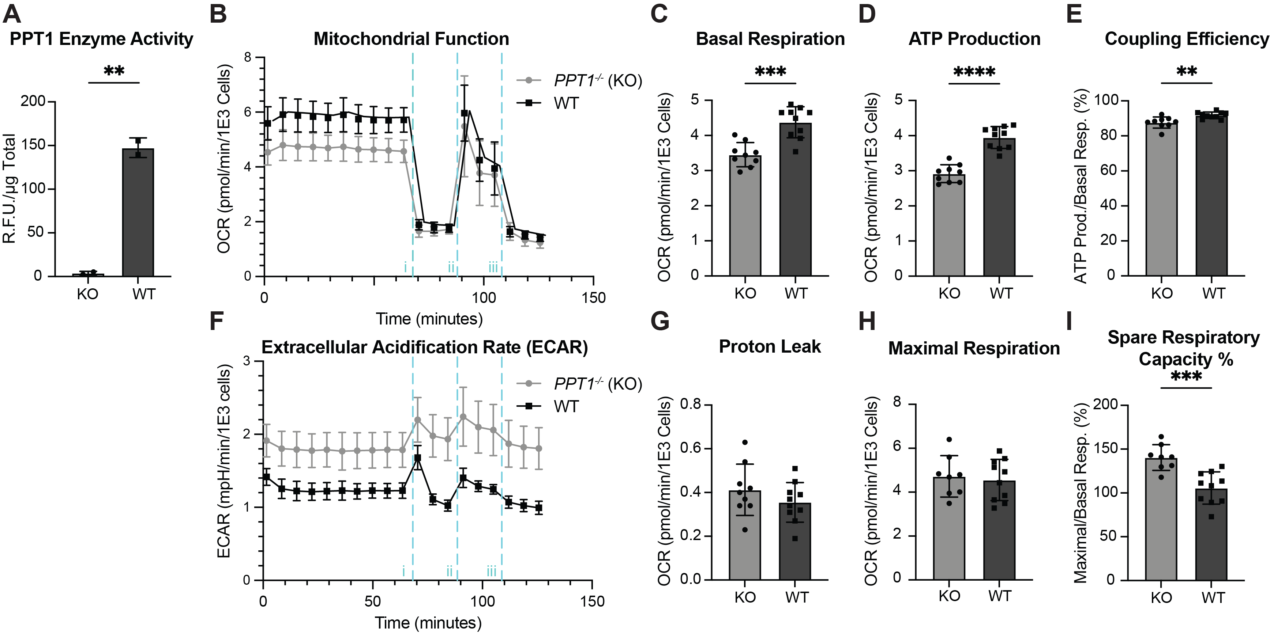
Figure S5. PPT1 deficiency causes aberrant mitochondrial flux.
(A) PPT1 enzyme activity in CRISPR-engineered HEK293T PPT1^{-/-} (KO) cells and WT controls normalized to protein concentration (µg) determined by BCA (n = 2 independent cultures).
(B) Mitochondrial stress test with nutrient-deprivation performed on control (WT) and CRISPR-engineered PPT1 KO HEK293T cells, with sequential injections of mitochondrial inhibitors, (i) oligomycin A, (ii) FCCP, and (iii) rotenone/antimycin A (represented by vertical blue dashed lines), to determine effects on oxygen consumption rate (OCR). OCR measurements are normalized to cell number (per thousand cells) in each well. Parameters calculated from this metabolic flux signature are shown in the following panels.
(C) Basal respiration.
(D) ATP production.
(E) Coupling efficiency percent (%) (ATP production/basal respiration).
(F) Extracellular acidification rate (ECAR) with mitochondrial inhibitor injections as in panel A.
(G) Proton leak.
(H) Maximal respiration.
(I) Percentage of spare respiratory capacity (%) (maximal respiration/basal respiration). Data are mean ± SD. * p < 0.05, ** p < 0.01, *** p < 0.001, **** p < 0.0001 by unpaired two-tailed t-test. Data shown are representative results from one of two independent experiments (n = 9-10 replicate wells/genotype).
KO = PPT1^{-/-} and WT = PPT1^{+/+}, throughout.
Fig. S6.
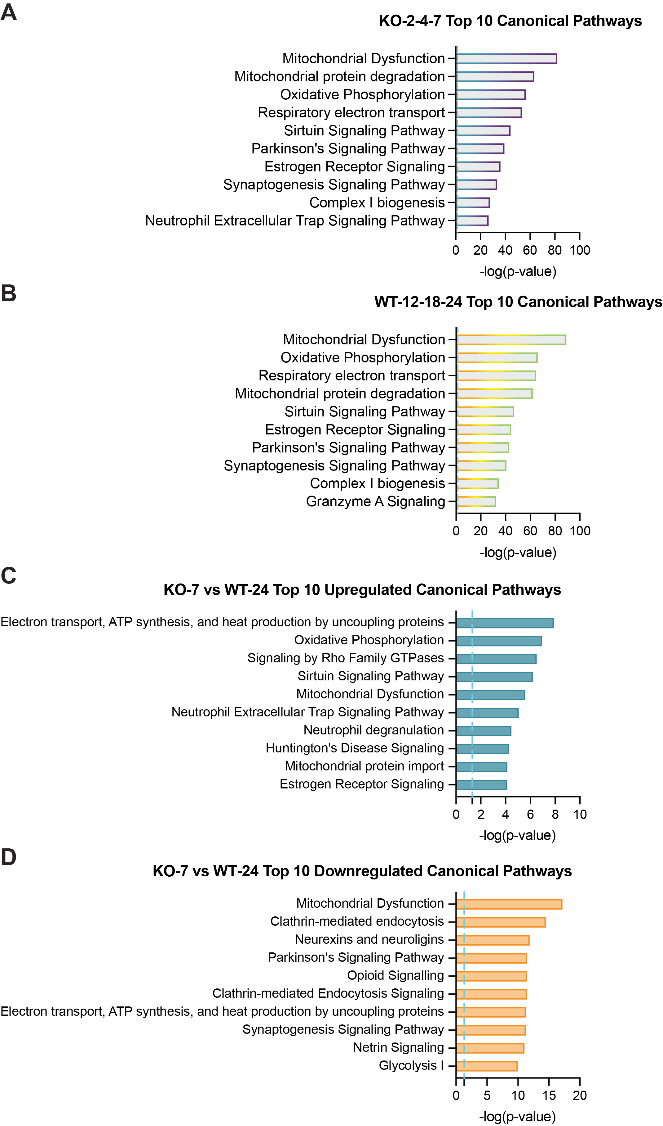
Figure S6. Ingenuity Pathway Analysis (IPA) of lipofuscin proteins.
Top 10 canonical pathways by Ingenuity Pathway Analysis of:
(A) Consensus KO lipofuscin proteins across timepoints (n = 745) (Fig. 3A).
(B) Consensus WT lipofuscin proteins across timepoints (n = 957) (Fig. 3A).
(C) Significantly upregulated lipofuscin proteins in KO 7-month/WT 24-month samples (n = 83) (Fig. 3N).
(D) Significantly downregulated lipofuscin proteins in KO 7-month/WT 24-month samples (n = 348) (Fig. 3N).
Blue dashed line indicates significance threshold at p = 0.05, throughout. KO = Ppt1^{-/-} and WT = Ppt1^{+/+}, throughout.
Fig. S7.
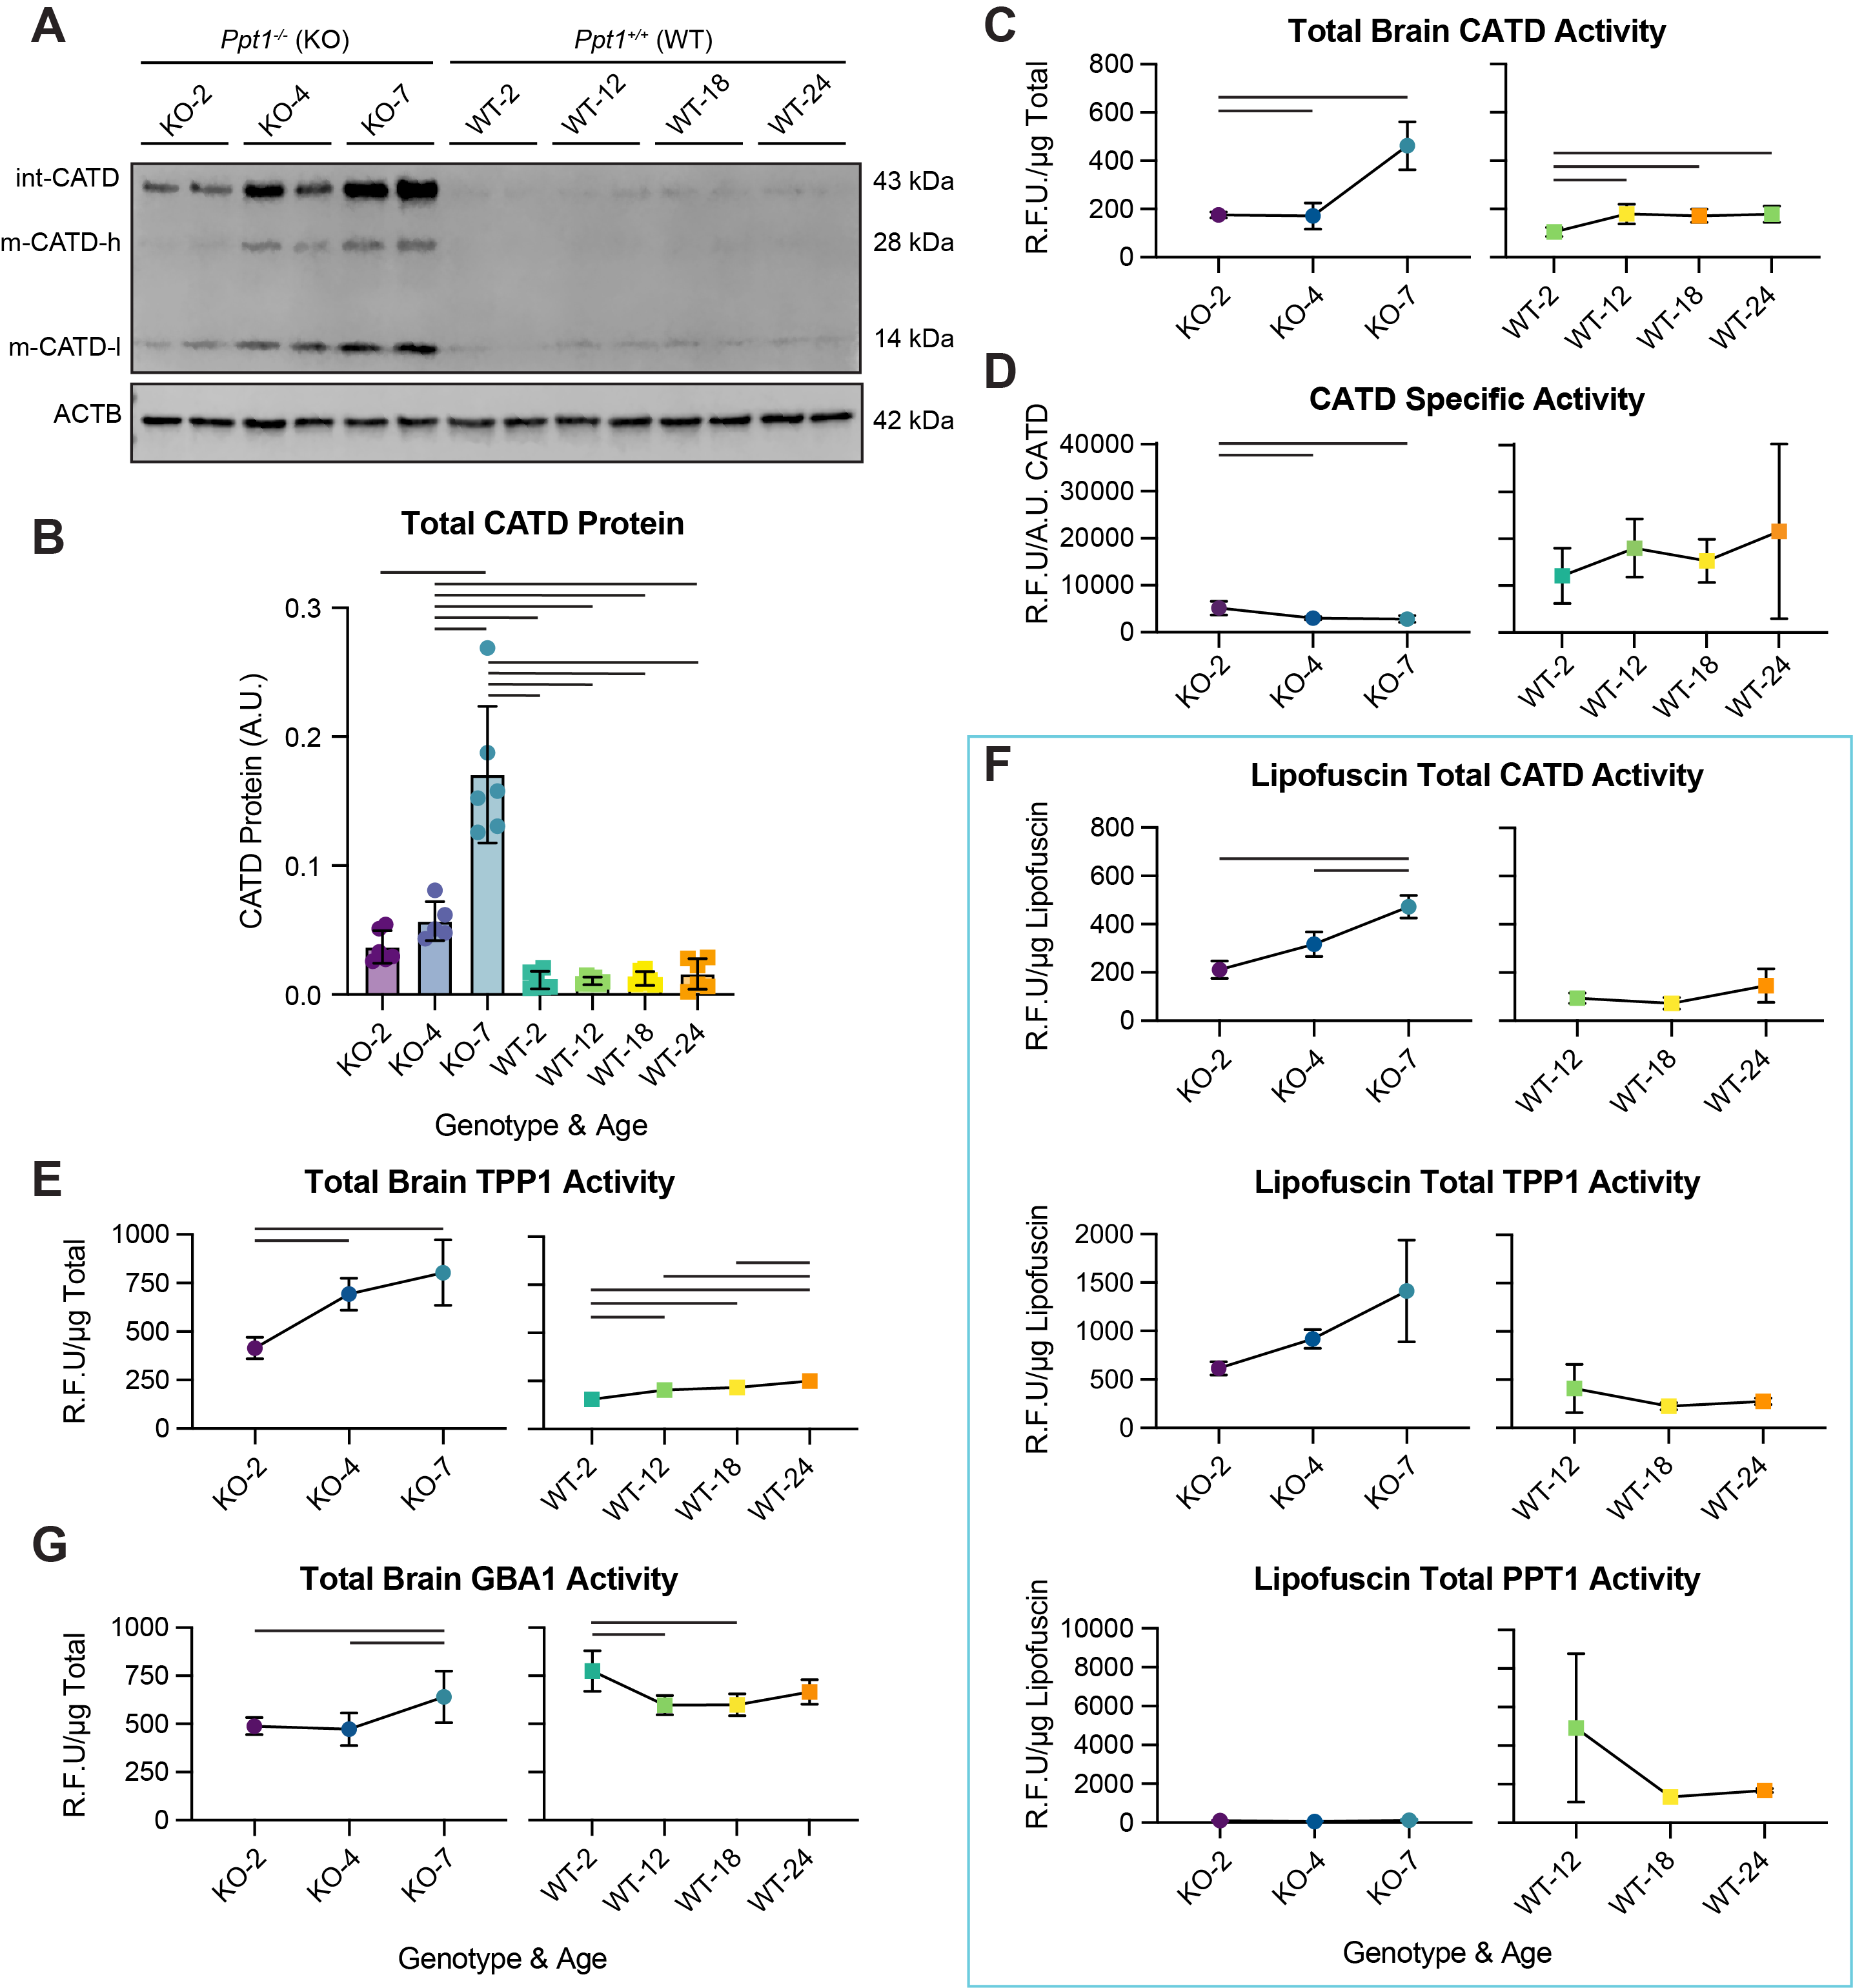
Figure S7. Levels and activity of enzymes implicated in lipofuscin biogenesis.
(A) Representative quantitative immunoblots of cathepsin D (CATD) across CLN1 and aging conditions with actin (ACTB) loading control in total brain homogenates (n = 5-6 biological replicates/genotype/timepoint; int = intermediate; m = mature; h = heavy chain; l = light chain).
(B) Quantification of immunoblots of CATD protein in total brain homogenates (A.U.), normalized to actin loading control (n = 5-6 biological replicates/genotype/timepoint).
(C) Bulk CATD enzyme activity (R.F.U.) in total brain fractions normalized to total protein (µg) determined by BCA (n = 4-5 biological replicates/genotype/age).
(D) Specific enzyme activity of CATD (R.F.U./A.U. total CATD protein) in total brain homogenates (n = 4-5 biological replicates/genotype/age).
(E) Bulk TPP1 enzyme activity (R.F.U.) in total brain fractions normalized to total protein (µg) determined by BCA (n = 4-5 biological replicates/genotype/age).
(F) Bulk CATD, TPP1, and Ppt1 enzyme activity (R.F.U.) in lipofuscin fractions (n = 3-5 biological replicates/genotype/age; n = 2 biological replicates for KO-4).
(G) Bulk GBA1 enzyme activity (R.F.U.) in total brain fractions normalized to total protein (µg) determined by BCA (n = 5-6 biological replicates/genotype/age).
Data are mean ± SD. Horizontal bars represent significant comparisons (p < 0.05) by 2-way ANOVA with Tukey’s multiple comparisons test for immunoblot quantification and by one-way ANOVA with Tukey’s multiple comparisons test for enzyme activity, throughout. KO = Ppt1^{-/-} and WT = Ppt1^{+/+}, throughout
Fig. S8.
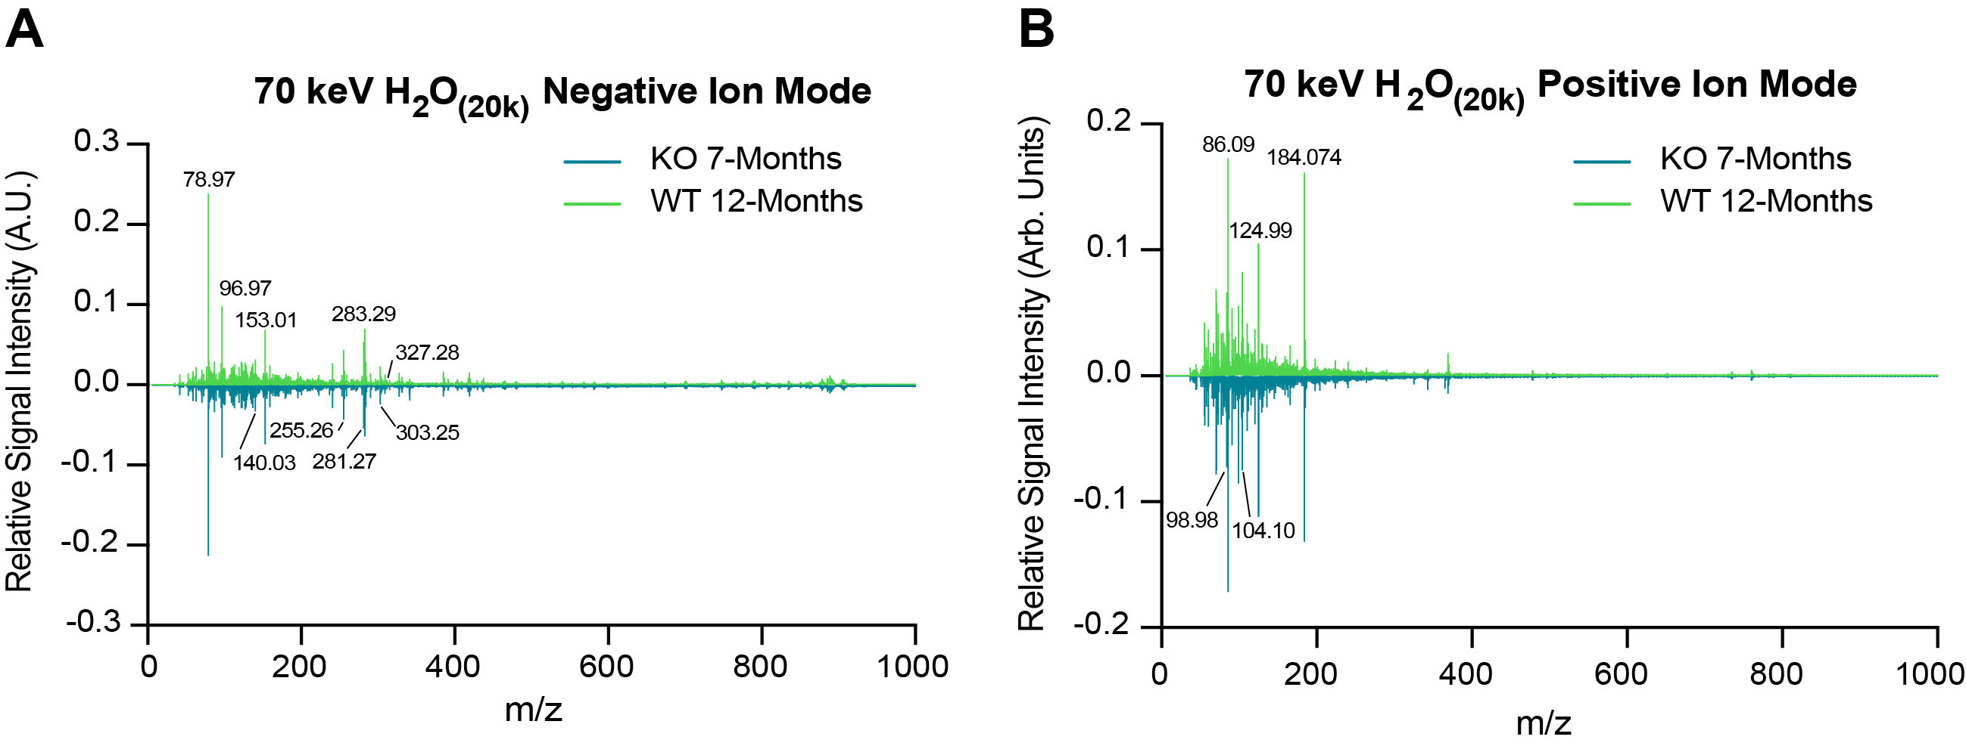
Figure S8. ToF-SIMS spectra of purified lipofuscin.
(A-B) ToF-SIMS spectra of purified lipofuscin from KO 7-month and WT 12-month mice (average of n = 3 biological replicates) run using a 70 keV Gas Cluster Ion Beam (GCIB) in (A) negative ion mode and (B) positive ion mode with (H₂O)₂₀₀₀₀ clusters with major peak mass-to-charge values (m/z) highlighted. KO = Ppt1^{-/-} and WT = Ppt1^{+/+}, throughout.
Fig. S9.
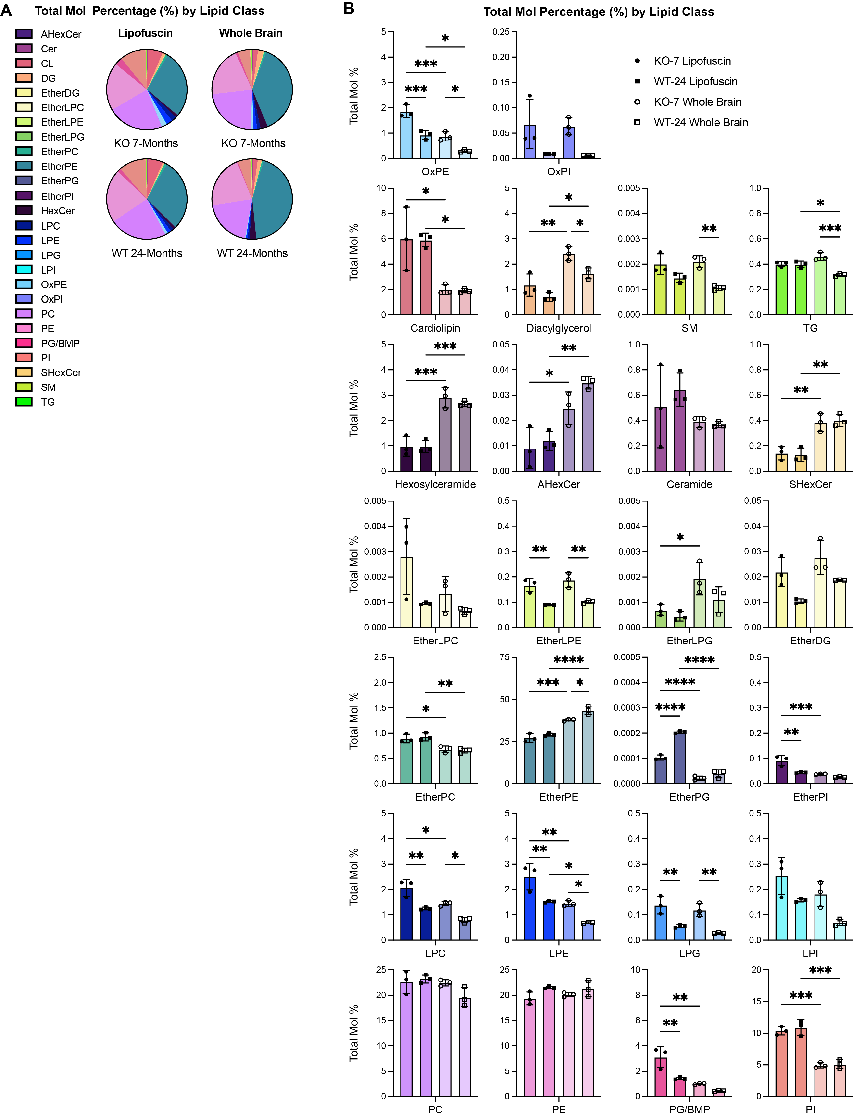
Figure S9. Composition of lipofuscin and total brain by lipid class.
(A) Pie-charts of total mol % by lipid class for lipofuscin (left) and whole brain (right) for KO 7-month samples (top) and WT 24-month samples (bottom). Statistical comparisons for each class are shown in adjacent bar graphs.
(B) Percent (%) contribution of lipid classes to total lipid content of lipofuscin and total brain from KO 7-month and WT 24-month mice. A-CAHexCer: acyl-hexosylceramide; Cer: ceramide; CL: cardiolipin; DG: diglyceride (diacylglycerol); EtherDG: ether-linked diglyceride; EtherLPC: ether-linked lysophosphatidylcholine; EtherLPE: ether-linked lysophosphatidylethanolamine; EtherLPG: ether-linked lysophosphatidylglycerol; EtherPC: ether-linked phosphatidylcholine; EtherPE: ether-linked phosphatidylethanolamine; EtherPG: ether-linked phosphatidylglycerol; EtherPI: ether-linked phosphatidylinositol; HexCer: hexosylceramide; LPC: lysophosphatidylcholine; LPE: lysophosphatidylethanolamine; LPG: lysophosphatidylglycerol; LPI: lysophosphatidylinositol; OxPE: oxidized phosphatidylethanolamine; OxPI: oxidized phosphatidylinositol; PC: phosphatidylcholine; PE: phosphatidylethanolamine; PG/BMP: phosphatidylglycerol/bis(monoacylglycero)phosphate; PI: phosphatidylinositol; SHexCer: sulfatide; SM: sphingomyelin; TG: triglyceride (triacylglycerol).
Data are mean ± SD. * p < 0.05, ** p < 0.01, *** p < 0.001 by one-way ANOVA with Tukey’s multiple comparisons test. KO = Ppt1^{-/-} and WT = Ppt1^{+/+}, throughout.
Fig. S10.
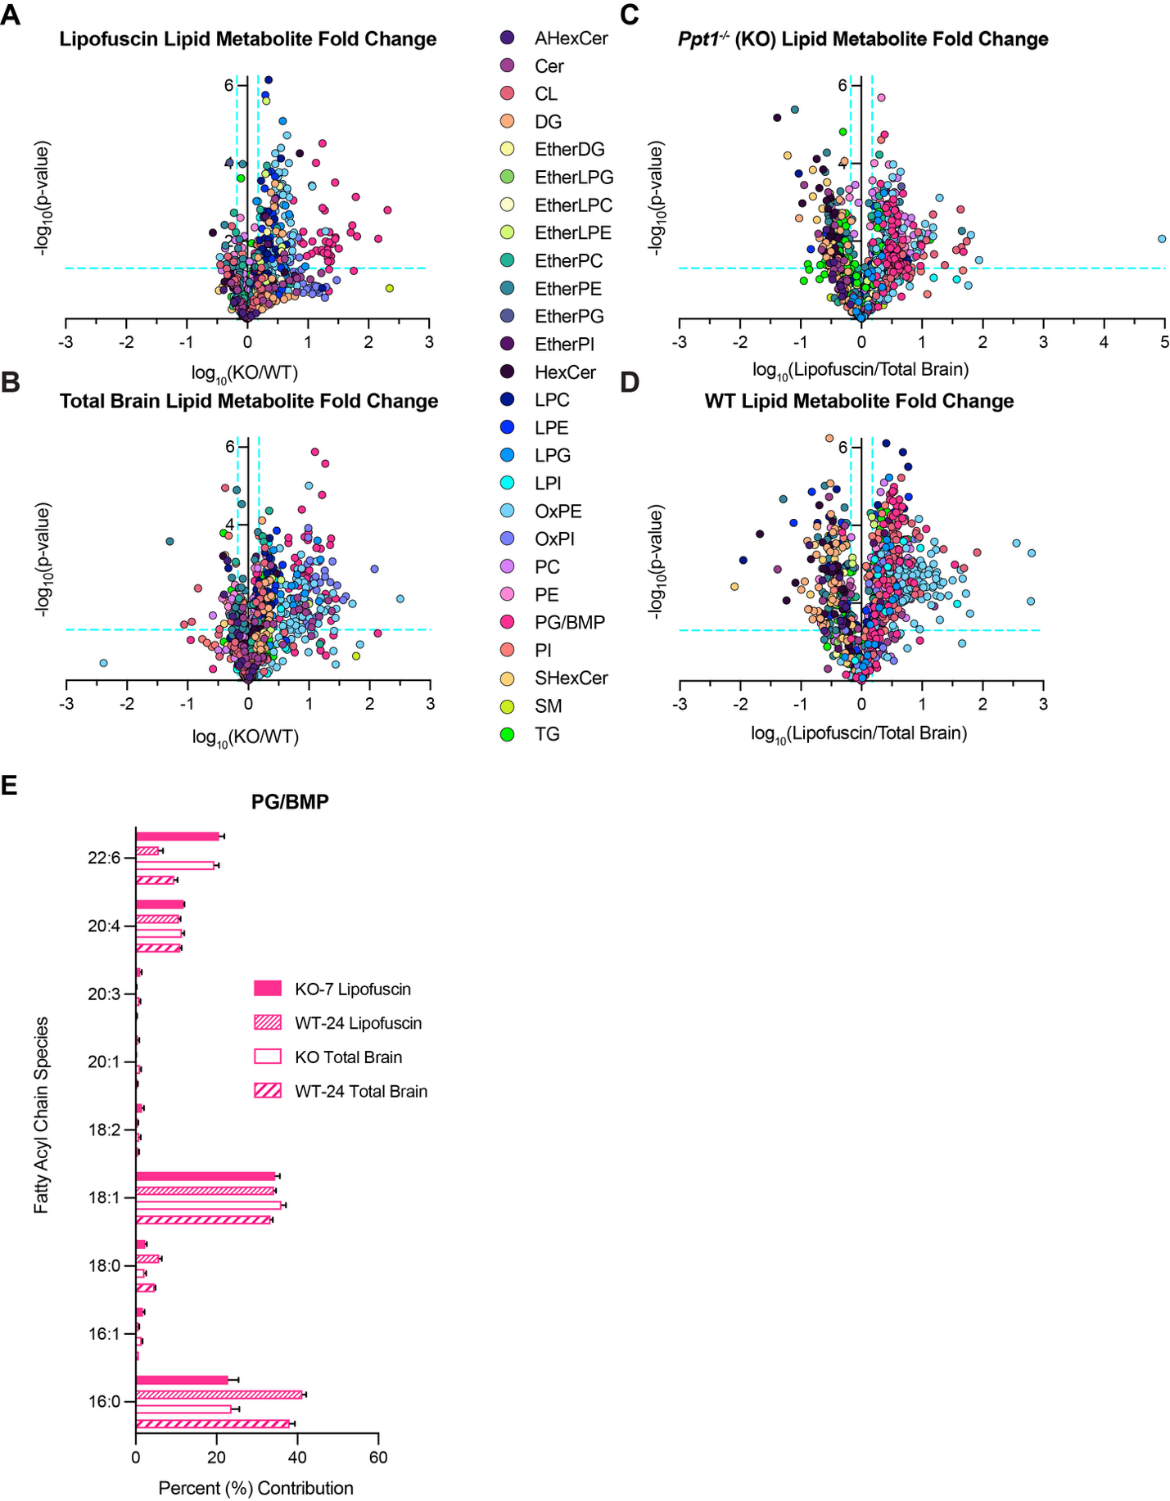
Figure S10. Lipofuscin-enriched lipids and PG/BMP fatty acyl composition.
(A-D) Lipid metabolite fold-change comparisons between (A) WT 24-month and KO 7-month lipofuscin, (B) WT 24-month and KO 7-month total brain, (C) KO 7-month lipofuscin and total brain, (D) WT 24-month lipofuscin and total brain. Colors represent lipid classes. Blue dashed lines indicate significant thresholds at 1.5-fold-change and p = 0.05 (n = 3 biological replicates/genotype). AHexCer: acyl-hexosylceramide; Cer: ceramide; CL: cardiolipin; DG: diglyceride (diacylglycerol); EtherDG: ether-linked diglyceride; EtherLPC: ether-linked lysophosphatidylcholine; EtherLPE: ether-linked lysophosphatidylethanolamine; EtherLPG: ether-linked lysophosphatidylglycerol; EtherPC: ether-linked phosphatidylcholine; EtherPE: ether-linked phosphatidylethanolamine; EtherPG: ether-linked phosphatidylglycerol; EtherPI: ether-linked phosphatidylinositol; HexCer: hexosylceramide; LPC: lysophosphatidylcholine; LPE: lysophosphatidylethanolamine; LPG: lysophosphatidylglycerol; LPI: lysophosphatidylinositol; OxPE: oxidized phosphatidylethanolamine; OxPI: oxidized phosphatidylinositol; PC: phosphatidylcholine; PE: phosphatidylethanolamine; PG/BMP: phosphatidylglycerol/bis(monoacylglycero)phosphate; PI: phosphatidylinositol; SHexCer: sulfatide; SM: sphingomyelin; TG: triglyceride (triacylglycerol).
(E) Percent (%) contribution (>1%) of fatty acyl chain species to PG/BMP isomer composition in KO 7-month and WT 24-month lipofuscin and total brain (n = 3 biological replicates).
KO = Ppt1^{-/-} and WT = Ppt1^{+/+}, throughout.

