Predicting gene expression from whole slide images in prostate cancer using deep learning
Supplementary Information
Supplementary Figures
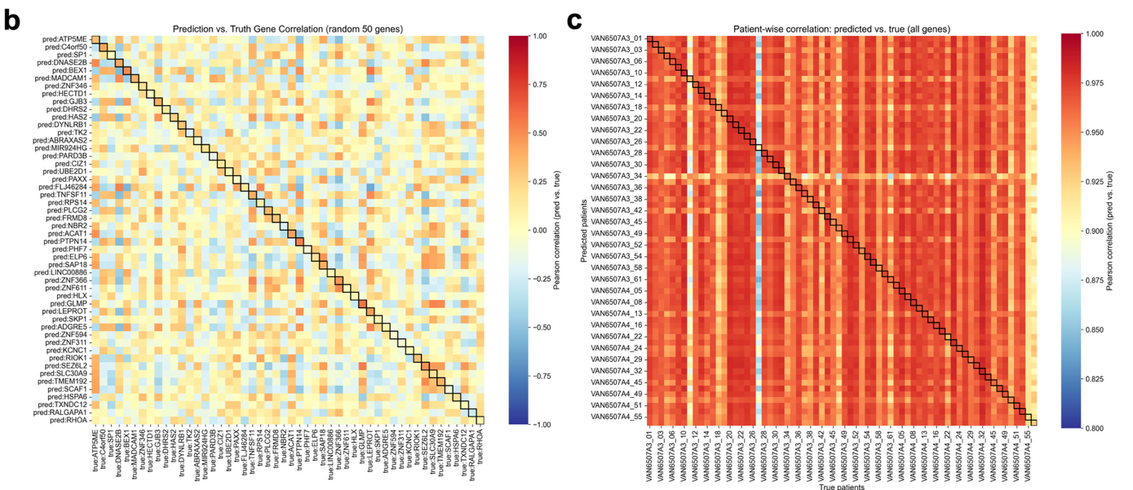
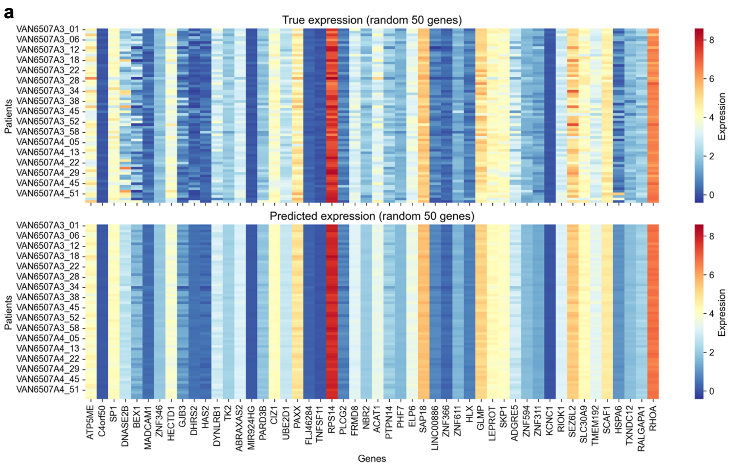

Supplementary Fig 1. Evaluation of gene expression prediction performance on the SAH cohort.
a Heatmaps showing the true (top) and predicted (bottom) expression levels of 50 randomly selected genes across SAH patients. b Gene-wise Pearson correlation heatmap comparing predicted and true expression profiles for 50 randomly selected genes. c P Patient-wise Pearson correlation heatmap comparing predicted and true expression profiles across all genes.

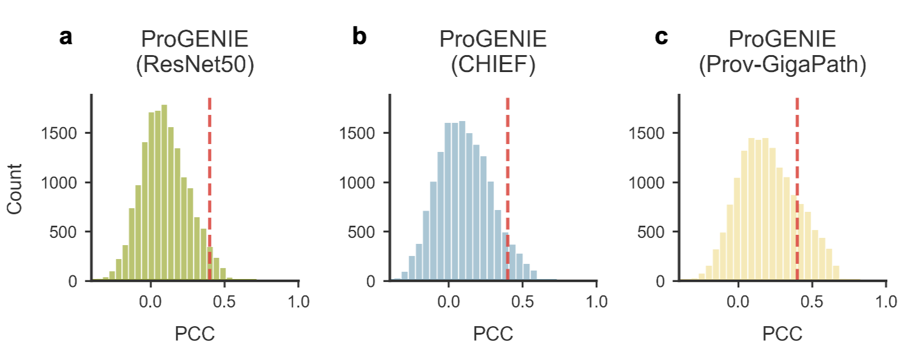
Supplementary Fig 2. Frequency distribution histogram from ProGENIE.
a,b,c Frequency distribution histogram showing the relationship between PCCs and gene count for ProGENIE(ResNet50), ProGENIE(CHIEF),ProGENIE(Prov-Gigapath).

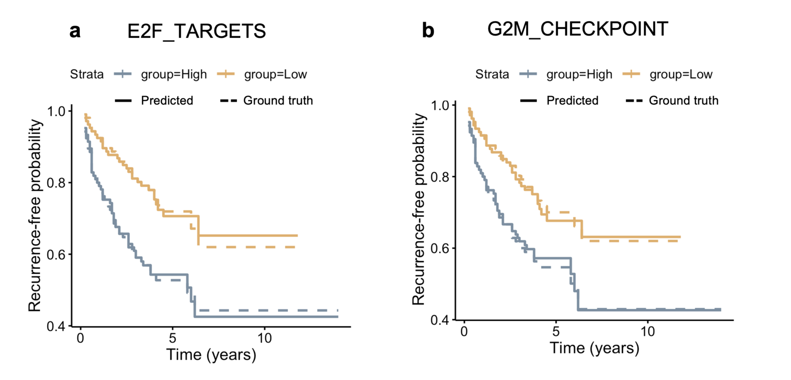

Supplementary Fig. 3 Comparison of recurrence-free survival (RFS) curves based on predicted and ground-truth pathway activities.
a, b Kaplan–Meier plots of recurrence-free survival probability for patients grouped by the median pathway activity scores of E2F_TARGETS and G2M_CHECKPOINT. Solid lines represent curves derived from predicted scores, while dashed lines represent those derived from ground-truth scores.

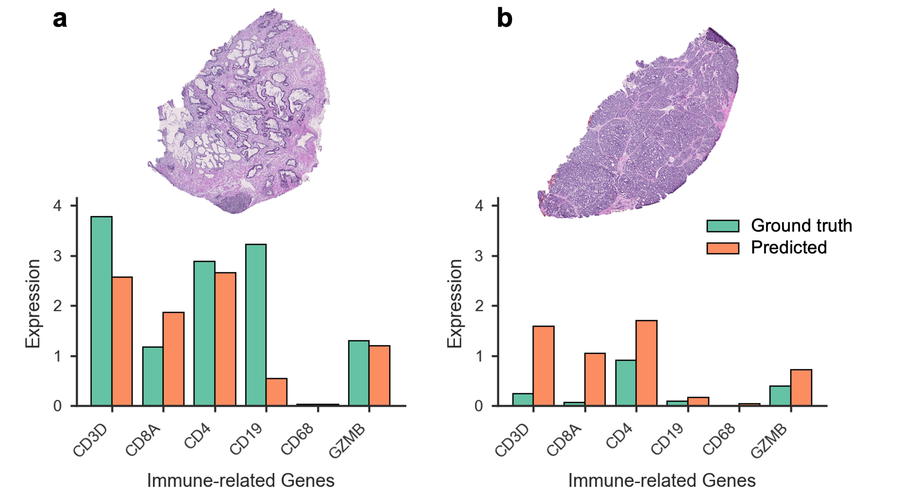
Supplementary Fig 4. Example visualization of predicted and ground truth gene expression for immune-related genes.
a, b WSIs and expression barplots for samples VAN6507A4_48 (a, high immune infiltration) and VAN6507A3_11 (b, low immune infiltration). For each sample, predicted and ground truth expression levels of immune-related genes (CD3D, CD8A, CD4, CD19, CD68, GZMB) are shown. Expression values are log-transformed.

Supplementary Data List
Supplementary Data 1. Gene-level prediction performance on the SAH independent dataset across four different encoders in ProGENIE and SEQUOIA.
Per-gene prediction performance on the SAH independent dataset, reported as Pearson correlation coefficient (PCC) and root mean squared error (RMSE) across samples. Results are shown for ProGENIE using four pretrained encoders (ResNet50, UNI, CHIEF, and Prov-GigaPath) and for SEQUOIA.
Supplementary Filename: Supplementary_Data_1.xlsx

Supplementary Data 2. Gene-level prediction performance for ablation experiments in ProGENIE.
Gene-level prediction performance from ablation experiments assessing the contribution of individual architectural components in ProGENIE. Separate sheets are provided for the full model and for variants with specific modules removed or modified (“no position”, “no nonlinearity”, “single head”, “two heads”, “six heads”, and “no attention”). For each gene, PCC and RMSE are reported across samples.
Supplementary Filename: Supplementary_Data_2.xlsx

Supplementary Data 3. Pathway-level correlation between predicted and ground truth gene expression.
Results from GO and KEGG enrichment analyses based on predicted gene expression across all samples, with comparisons to ground truth. PCCs were calculated at the Biological Process (BP), Molecular Function (MF), Cellular Component (CC), and KEGG pathway levels. Separate sheets are provided for the top 100 terms in each category. For each term, the table reports the pathway and the PCC between enrichment scores derived from predicted and ground truth expression.
Supplementary Filename: Supplementary_Data_3.xlsx

Supplementary Data 4. Immune cell-type infiltration correlation between predicted and ground truth transcriptomic profiles.
Immune cell infiltration scores for 28 immune cell types were estimated from predicted and ground truth expression profiles using single-sample gene set enrichment analysis (ssGSEA) with gene sets from the TISIDB database. PCCs between predicted and ground truth scores are reported to evaluate concordance.
Supplementary Filename: Supplementary_Data_4.csv

Supplementary Data 5. Correlation of predicted and ground truth drug response scores.
Half-maximal inhibitory concentration (IC50) values for 198 anti-cancer compounds were estimated using the OncoPredict package, applied separately to predicted and ground truth gene expression profiles. PCCs between predicted and actual IC50 values are reported for each compound.
Supplementary Filename: Supplementary_Data_5.csv

