Microstructure Mapping withTime-dependent Diffusion MRI Differentiates Primary Central Nervous System Lymphoma from Glioblastoma
ELECTRONIC SUPPLEMENTARY MATERIAL
Supplementary Text
Routine structural MRI
Routine structural MRI included T1-weighted images before and after Gd-enhancement, and T2-FLAIR images, with a total acquisition time of 17 min. The protocol parameters were as follows: CE-T1w (TE = 3.5 ms; TR = 7.9 ms; FOV = 250 × 199 × 170 mm³; slice thickness = 1 mm) and FLAIR (TE = 313 ms; TR = 4800 ms; FOV = 250 × 250 × 150 mm³; slice thickness = 2 mm).
T_{d}-MRI Acquisition and Processing
OGSE data were acquired at oscillating frequencies of 25 Hz (effective t_{d} = 12 ms, 1 cycle, b = 0/250/500/800/1200 s/mm²) and 50 Hz (effective t_{d} = 6 ms, 2 cycles, b = 0/100/200/300 s/mm²). PGSE was acquired with diffusion duration/separation = 15.9/77.3 ms at b-value of 0/250/500/1000/1500 s/mm². The other acquisition parameters were kept the same between the two sequences: echo time/repetition time = 106/3000 ms, field of view = 220 × 220 mm, matrix size = 80 × 80, slice thickness = 5 mm, 11 slices, 1 non-diffusion-weighted image (b0), and sense acceleration factor = 2.
Data Analysis and Principle of IMPULSED
t_{d}-MRI signals ($S$) were fitted using the IMPULSED model [1], a 2-compartment model comprising intra- ($S_{in}$) and extracellular ($S_{ex}$) components:
$S=V_{\text{in}}*S_{in}+(1-V_{in})*S_{ex}$
where $S$ is the measured t_{d}-MRI signal, $S_{in}$and $S_{ex}$are the intracellular and extracellular signals, respectively, and $V_{in}$represents the volume fraction of the intracellular space. $S_{in}$uses sphere geometry and adapts for trapezoid OGSE waveforms [2]. $S_{ex}$ assumes a t_{d}-independent exponential decay with extracellular diffusivity (D_{ex}).
Microstructural parameters including diameter ($d$), $V_{in}$, and $D_{ex}$ were estimated from Eq. 1 using a nonlinear least squares algorithm in Matlab R2024b (Mathworks, Natick, MA) with a fixed intracellular diffusion coefficient at 1.0 µm²/ms. The fitting was repeated 100 times with randomized initializations to avoid local minimums, under the following physiological constraints: 1< $d$ <50 µm, 0.01< $V_{in}$ <1, 0.5< $d$ <3.5 µm²/ms. Cellularity was defined as $V_{in} / d * 100$ [3]. ADC maps were calculated at each td according to the log-linear fitting $S/S0=e^{-bD }$to obtain ADC_{0Hz} (PGSE), ADC_{25Hz} and ADC_{50Hz}. The change in ADC (rADC₁, rADC₂) were calculated using the combination of the ADC:
$rADC_{1}=\frac{(ADC_{25Hz}-ADC_{0Hz})}{ADC_{25Hz}}$*100
$rADC_{2}=\frac{\left(ADC_{50Hz}-ADC_{0Hz}\right)}{ADC_{50Hz}}$*100

References
1. Jiang X, Li H, Xie J, et al. In vivo imaging of cancer cell size and cellularity using temporal diffusion spectroscopy. Ma{Jiang, 2017 #754}{Xu, 2020 #181}gn Reson Med 2017;78:156-164. https://doi.org/10.1002/mrm.26356.
2. Xu J, Jiang X, Li H, et al. Magnetic resonance imaging of mean cell size in human breast tumors. Magn Reson Med 2020;83:2002-2014. https://doi.org/10.1002/mrm.28056.
3. Wu D, Jiang K, Li H, et al. Time-Dependent Diffusion MRI for Quantitative Microstructural Mapping of Prostate Cancer. Radiology 2022;303:578-587. https://doi.org/10.1148/radiol.211180.
Supplementary Figures
Supplementary Figure S1. (a-b) ADC values measured at 0 Hz, 25 Hz, 50 Hz in tumor region or (c-d) peritumoral edema in GBM and PCNSL. * P< 0.05, ** P < 0.01, *** P < 0.001，ns show no significance.
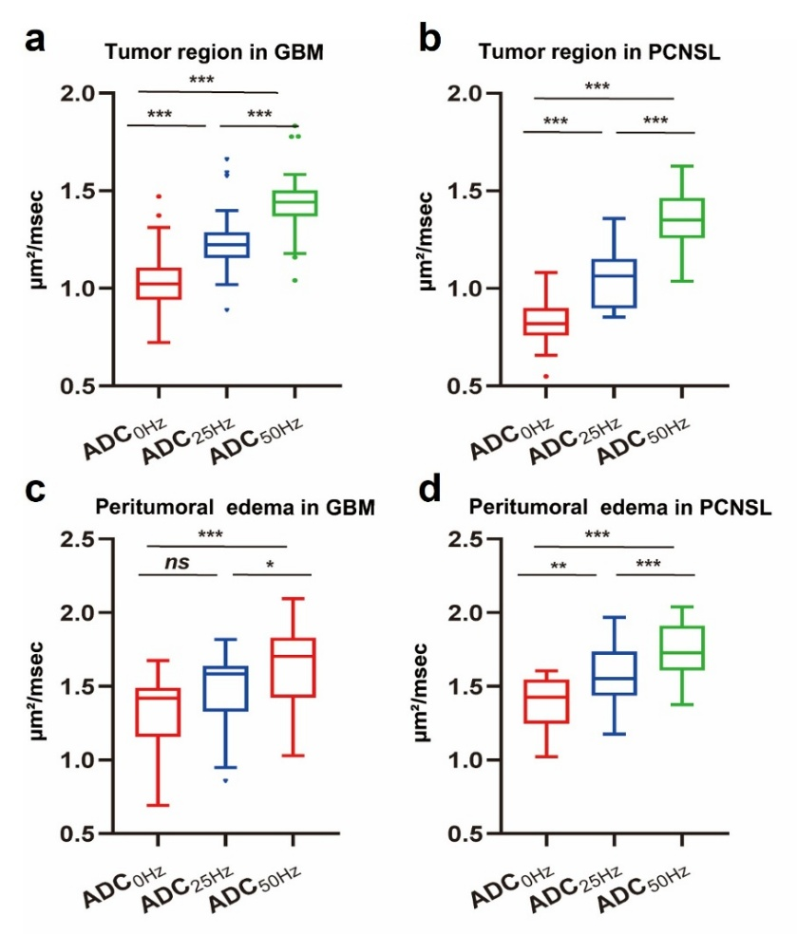
Supplementary Figure S2. Correlations between the ADC at 0 Hz and cellularity(a) or diameter(b) estimated from t_{d}-dMRI.
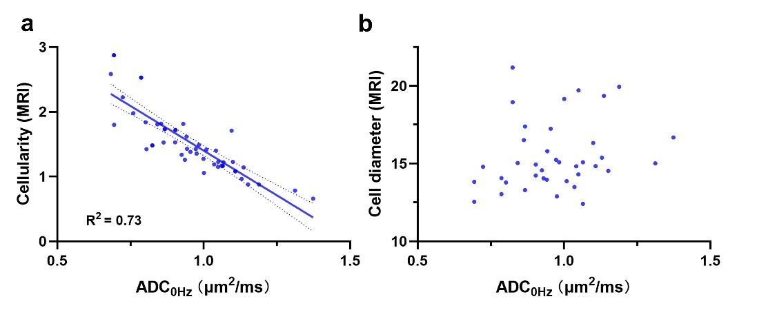
Supplementary Tables
Supplementary Table S1. Comparison of patient information between PCNSL and GBM.
 | PCNSL (n = 19) | GBM (n = 32) | P value
Gender  Male  Female | 10 (52.6%)  9 (47.4%) | 20 (62.5%)  12 (37.5%) | 0.489
Age | 59.95 ± 2.03 | 58.28 ± 2.20 | 0.785
Number of lesions (%)  Single  Multiple | 12 (63.2%)  7 (36.8%) | 21 (65.6%)  11 (34.4%) |  | 0.859
Location (%)  Only supratentorial  Only infratentorial  Supra-and infratentorial | 15 (78.9%)  0 (0%)  4 (21.1%) | 31 (96.9%)  1 (3.1%)  0 (0%) |  | 0.016
Note: Continuous variables are expressed as mean ± standard deviation, while categorical variables are presented as number (percentage).

Supplementary Table S3. Comparison of t_{d}-dMRI–derived microstructural parameters for distinguishing the peritumoral edema region of PCNSL and GBM.
Parameter | PCNSL（n = 19） | GBM（n = 27） | P value
V_{in}# | 0.10 ± 0.04 | 0.11 ± 0.06 | 0.647
Diameter# (μm) | 15.62 ± 0.53 | 15.11 ± 1.05 | 0.097
Cellularity# (μm⁻¹) | 0.63 ± 0.25 | 0.81 ± 0.55 | 0.415
D_{ex}# (μm²/msec) | 1.68 ± 0.13 | 1.60 ± 0.22 | 0.321
ADC_{0Hz}# (μm²/msec) | 1.40 ± 0.17 | 1.31 ± 0.27 | 0.343
ADC_{25Hz}# (μm²/msec) | 1.57 ± 0.18 | 1.47 ± 0.26 | 0.428
ADC_{50Hz}§ (μm²/msec) | 1.76 ± 0.18 | 1.64 ± 0.27 | 0.121
rADC₁# (%) | 10.90 ± 3.15 | 11.23 ± 3.88 | 0.780
rADC₂# (%) | 19.98 ± 4.56 | 20.21 ± 5.90 | 0.251
Note: Continuous variables are expressed as mean ± standard deviation. V_{in} = intracellular fraction, D_{ex} = extracellular diffusivity, ADC = apparent diffusion coefficient, ADC_{0Hz}= ADC measurement at 0 Hz, ADC_{25Hz} = ADC measurement at 25 Hz, ADC_{50Hz} = ADC measurement at 50 Hz, rADC₁ = (ADC_{25Hz} -ADC_{0Hz})/ADC_{0Hz,} rADC₂ = (ADC_{50Hz} -ADC_{0Hz})/ADC_{0Hz.}
§ Independent sample t-test

