APPENDICES

APPENDIX 1: QUESTIONAIRE IN ENGLISH VERSION
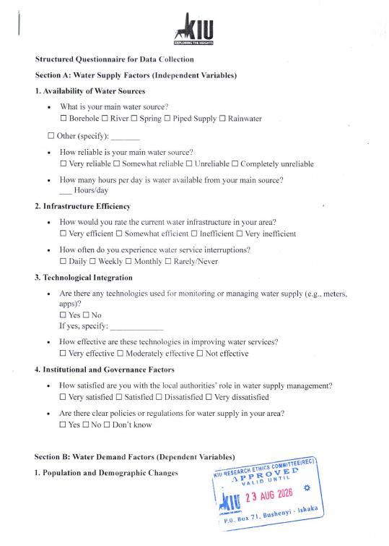

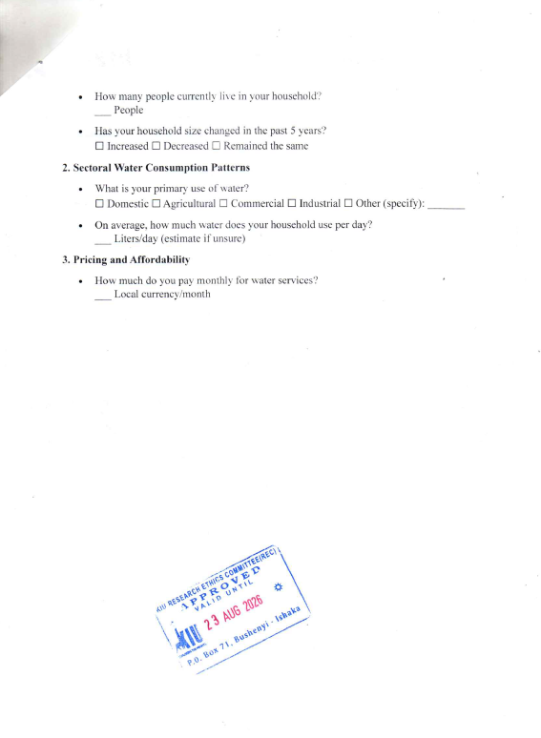

APPENDIX 1: QUESTIONAIRE IN LOCAL LANGUAGE (RUNYANKORE) VERSION
