Tunable High-Frequency Thin-Film Inductor through Stress-Induced Magnetic Anisotropy
Jian Zhang, Tianlong Fu, Hongjin Ji, Ningning Wang, Hongxia Li, Zhe Kong, Xiaoyu Zhao, Feng Zhou, Xuefeng Zhang

Calculation method for bending strain and radius of curvature
Assuming the thickness of the film is t and the thickness of the substrate is d, and the radius of curvature of the substrate after deformation due to stress is R, as shown in Fig. S1, when R>>d and R>>t, the strain ε in the film can be approximately calculated as follows:

$$ε=\frac{2π(R-t)-2π(R-t-d/2)}{2π(R-t-d/2)}=\frac{d}{2R-2t-d}≈\frac{d}{2R}$$
The radius of curvature R can be calculated using the following formula:
$$sin(L_{0}/2R)=L/2R$$
Where L₀ represents the length of the substrate before deformation (in this article, L₀=10mm), and L represents the length of the substrate after deformation.

In this experiment, the strain value of inductance bending is shown in the following table:
L0 | L | $$ε$$
10mm | 9mm | 0.010081
10mm | 8mm | 0.014077
10mm | 7mm | 0.017641

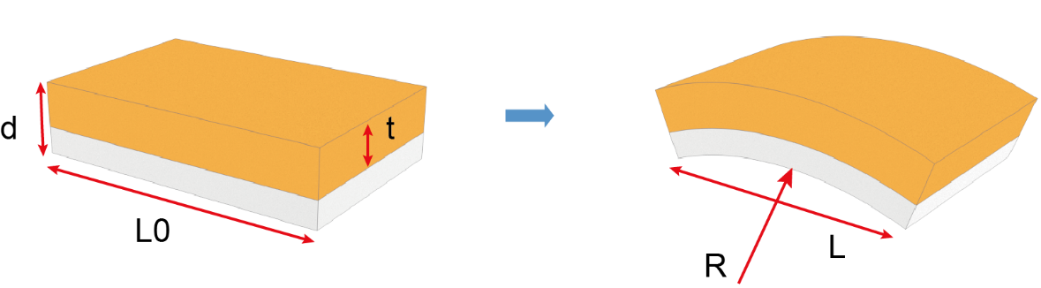
Fig.S1 Schematic diagram of strain calculation.

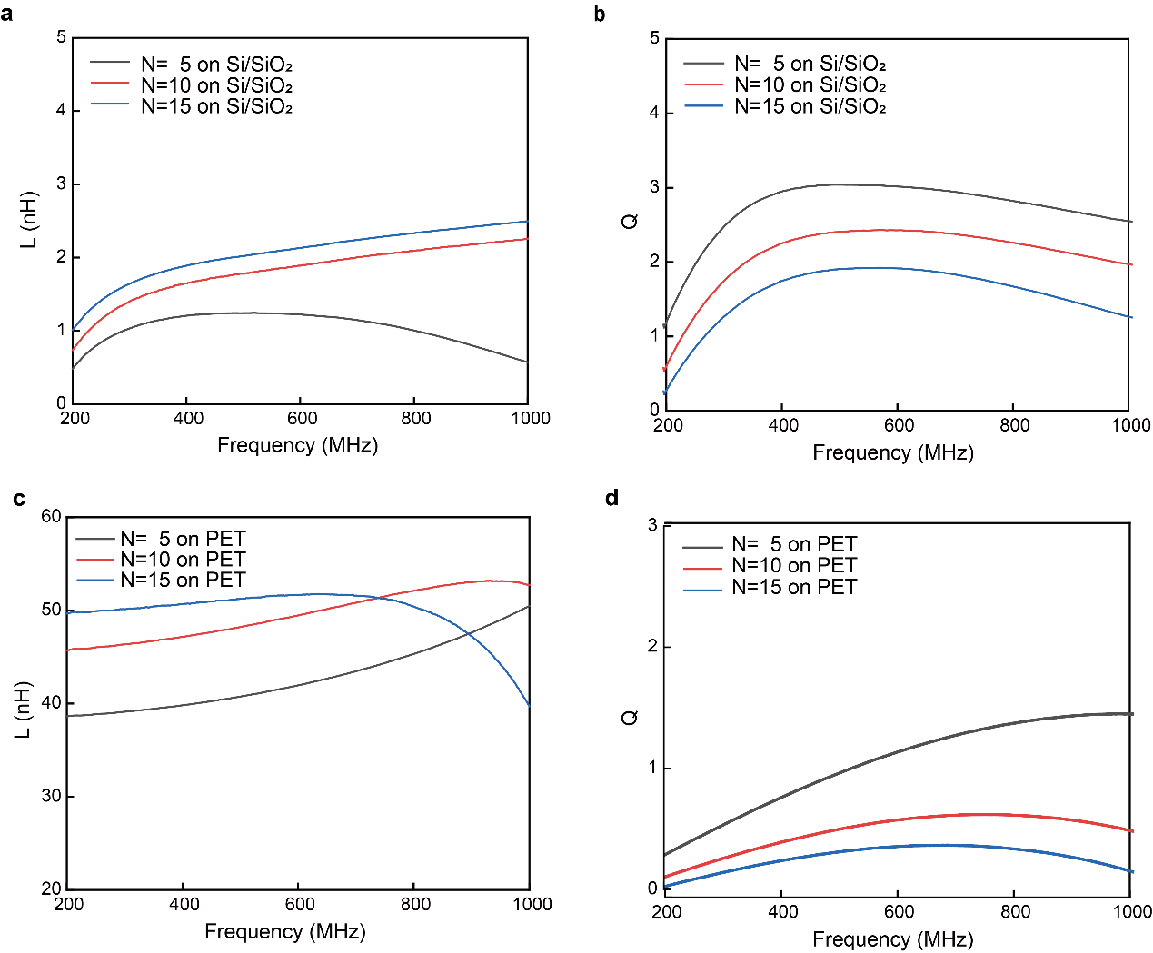

Fig.S2 The L and Q values of air core inductors with different turns on different substrates, (a) inductance value on rigid substrates, (b) Q value on rigid substrates, (c) inductance value on flexible substrates, and (d) Q value on flexible substrates.

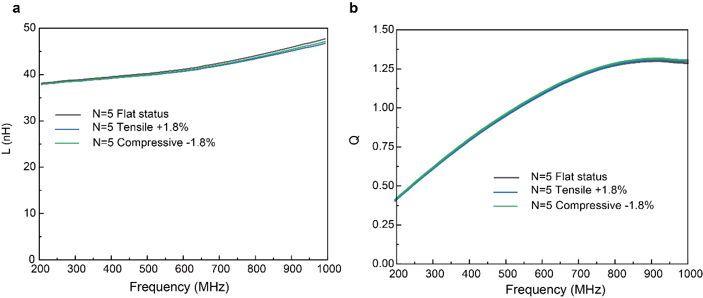 Fig.S3 Inductance value (a) and Q value (b) of 5-turn air core inductor under bending tensile stress and bending compressive stress
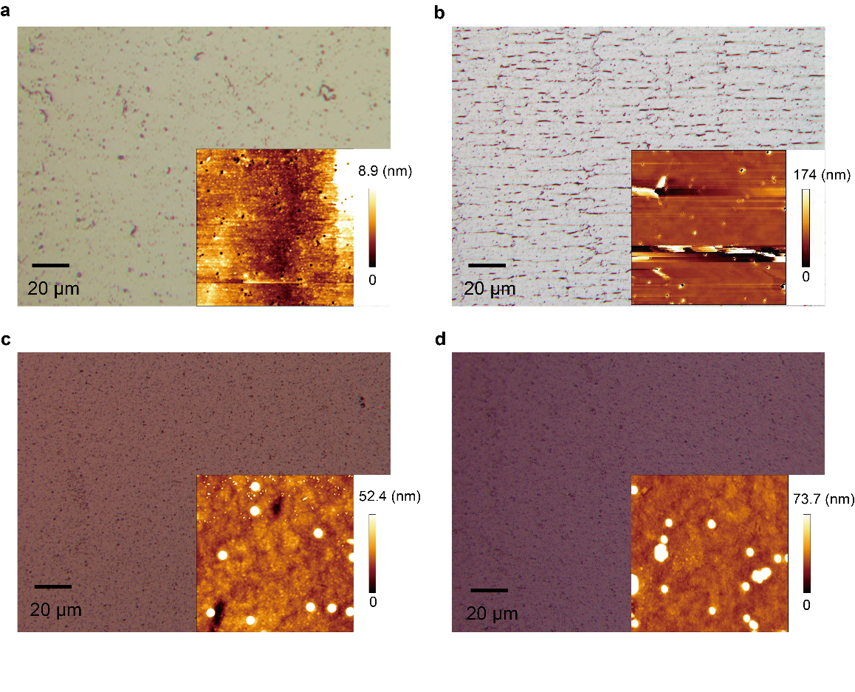
Fig.S4 Surface morphology and optical images of magnetic cores with and without silicon dioxide protection before and after bending cycle testing. (a) Without silica protection, before bending. (b) Without silica protection, after bending. (c) Protected with silica, before bending. (d) Protected by silicon dioxide, after bending.

