Supplementary Material
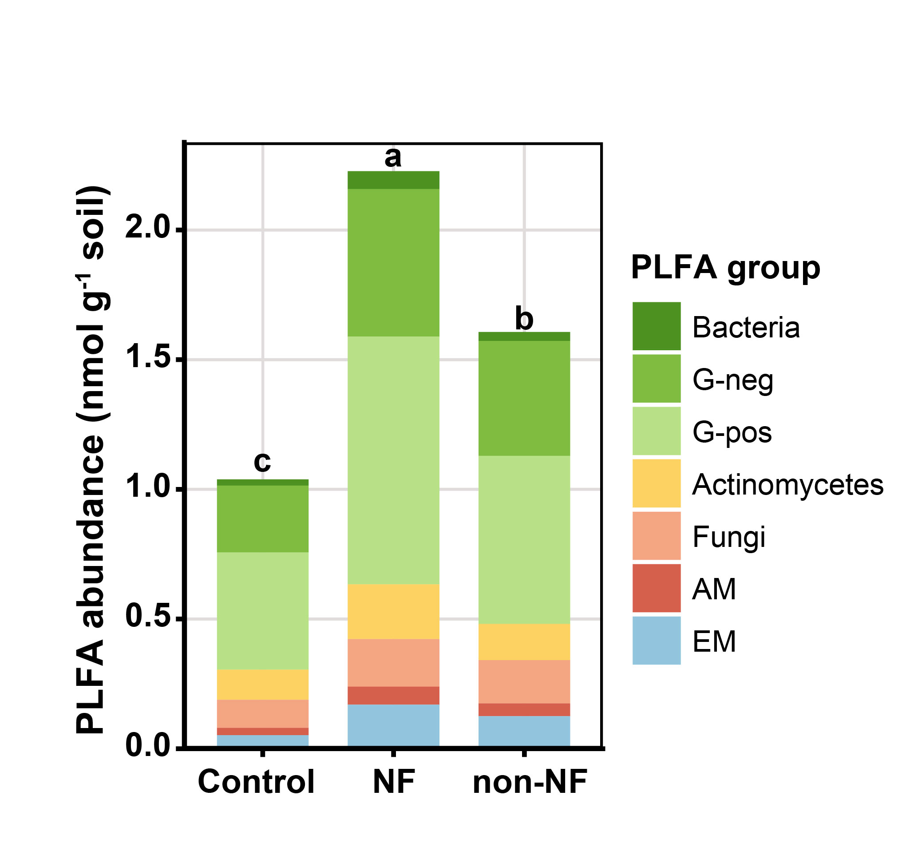
Fig. S1 Soil microbial abundance and structure in different treatments. Stacked bars show mean phospholipid fatty acid (PLFA) abundance (nmol g⁻¹ soil) for major microbial groups in unplanted controls, NF, and non-NF treatments. Segments represent total bacteria, Gram-negative bacteria (G-neg), Gram-positive bacteria (G-pos), actinomycetes, fungi, arbuscular mycorrhizal fungi (AM), and ectomycorrhizal fungi (EM). Letters within each microbial group denote significant differences among treatments for that group (p < 0.05; post hoc pairwise comparisons)
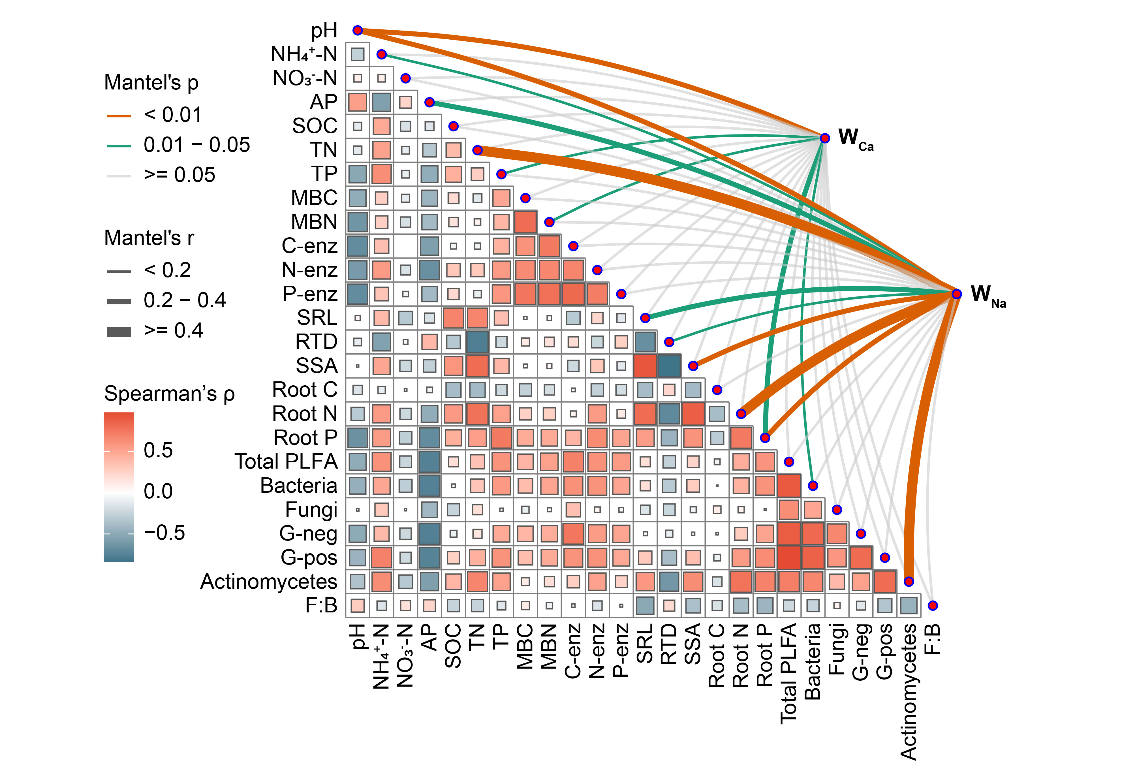
Fig. S2 Mantel-based network of associations linking weathering indices to root–soil–microbial variables. AP, available phosphorus; SOC, soil organic carbon; TN, total nitrogen; TP, total phosphorus; MBC, microbial biomass carbon; MBN, microbial biomass nitrogen; MBC:MBN, microbial biomass C:N ratio; C-enz, C-acquiring enzyme activity; N-enz, N-acquiring enzyme activity; P-enz, P-acquiring enzyme activity; SRL, specific root length; SSA, specific surface area; RTD, root tissue density; Root N, fine root N concentration; Root P, fine root P concentration; Total PLFA, total PLFA abundance; F:B, fungal:bacterial PLFA ratio; PLFA, phospholipid fatty acids; Actinomycetes, actinomycete PLFA abundance; W_{Ca} and W_{Na}, Al-normalised depletion indices for Ca and Na
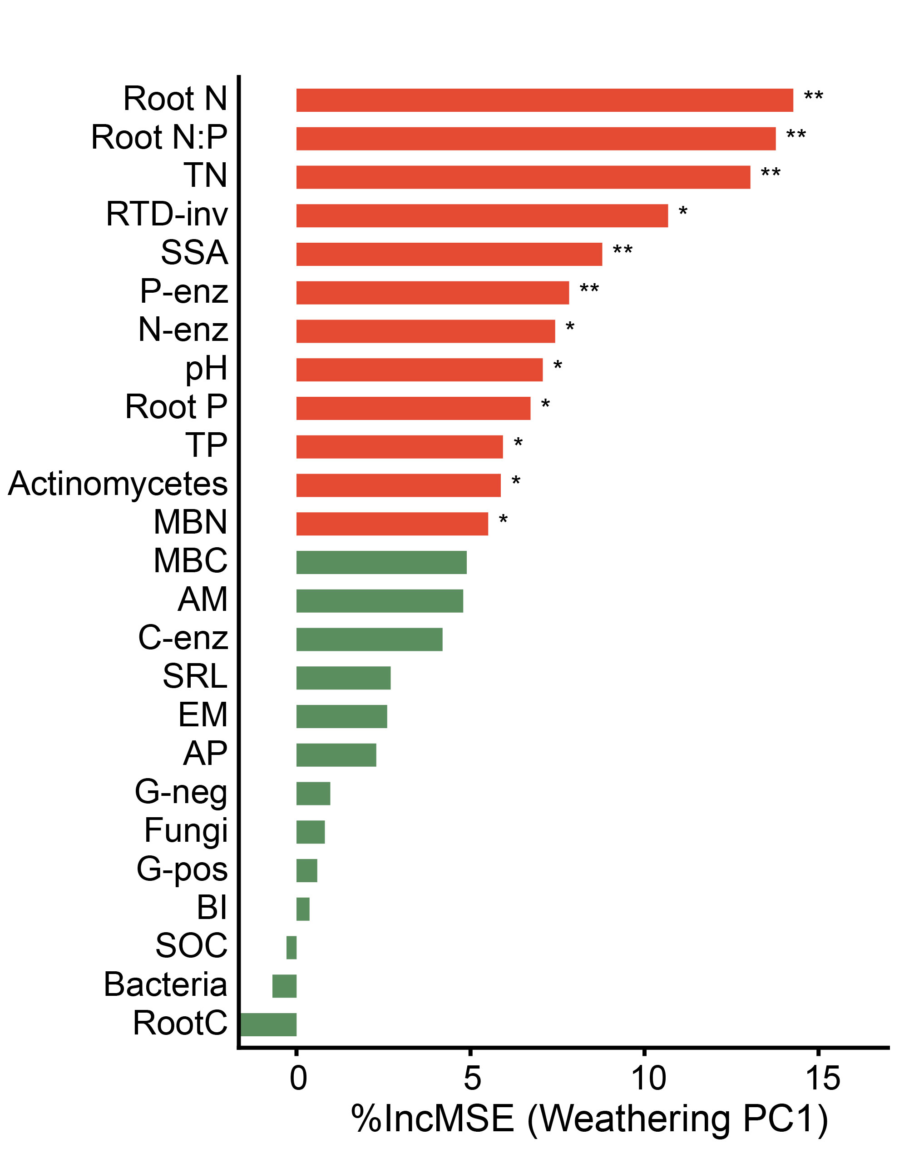
Fig. S3 Random forest ranking of predictors for the composite weathering axis. Variable importance for predicting Weathering PC1 (the first principal component derived from W_{Ca} and W_{Na}) using random forest models. Importance is expressed as the percent increase in mean squared error (%IncMSE) when each predictor is permuted; larger values indicate stronger predictive contribution. RTD-inv denotes inverse root tissue density (1/RTD). Asterisks indicate predictors with significant importance based on permutation tests (*p < 0.05, **p < 0.01)
Table S1 PCA results for the composite weathering index derived from W_{Ca} and W_{Na}
 |  | PC1 | PC2
All samples | Eigenvalue | 1.568 | 0.432
n=24 | Variance | 0.784 | 0.216
 | W_{Ca} | 0.707 | 0.707
 | W_{Na} | 0.707 | -0.707

