Article title: Uncertainties in the effectiveness of biological control of stem borers under different climate change scenarios in Eastern Africa
Journal name: Climatic Change
Author names: Ines Jendritzki, Henri E. Z. Tonnang, Paul-André Calatayud, Christian Borgemeister, Tino Johansson, Lisa Biber-Freudenberger
Affiliation and e-mail address of the corresponding author: Center for Development Research, Department of Ecology and Natural Resources Management, University of Bonn, ijendrit@uni-bonn.de

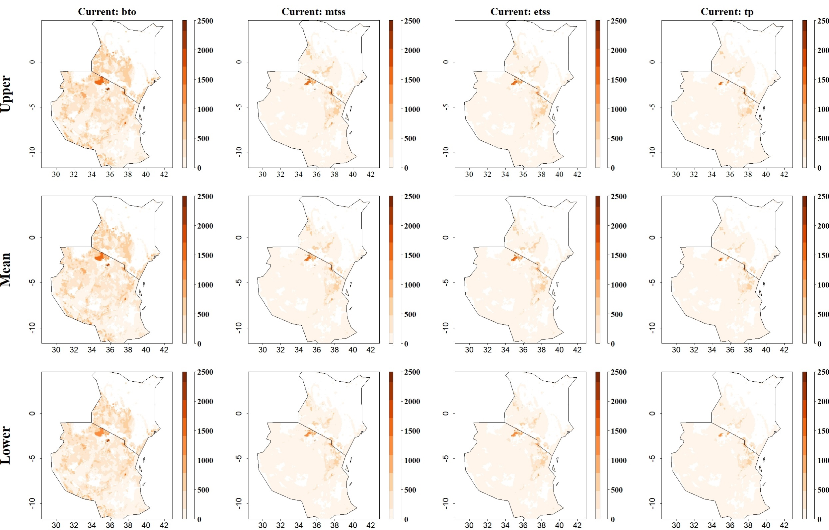
Fig: Predicted maize yield losses (in kg/ha) by the stem borer B. fusca under current climatic conditions for thresholds Balance training omission, predicted area and threshold values Cloglog (bto), Maximum training sensitivity plus specificity Cloglog threshold (mtss), Equal training sensitivity and specificity Cloglog threshold (etss) and 10th percentile training presence Cloglog threshold (tp). Grid cells with high predicted yield losses are colored in darker orange to brown, whereas cells where maize yield losses by the species are low are colored in lighter orange and white
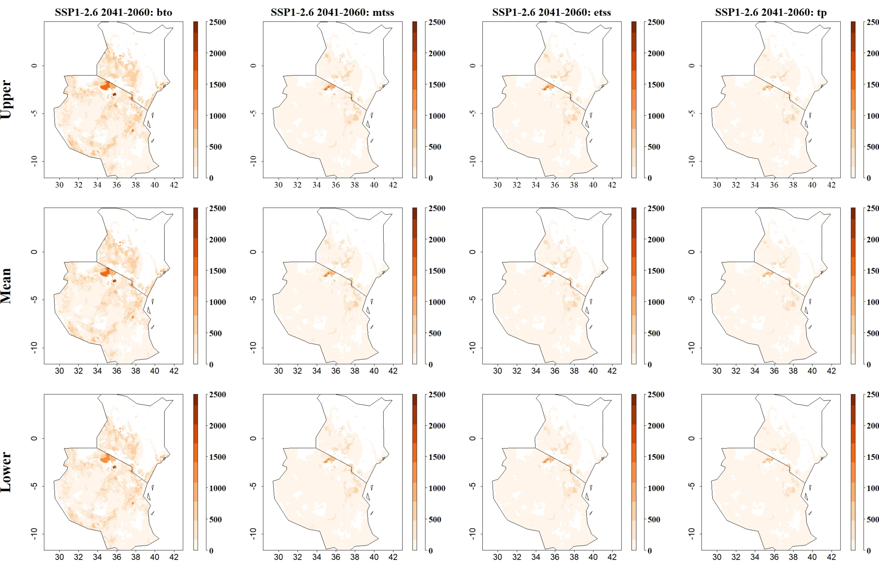
Fig: Predicted maize yield losses (in kg/ha) by the stem borer B. fusca for SSP1-2.6 in 2041–2060 and thresholds Balance training omission, predicted area and threshold values Cloglog (bto), Maximum training sensitivity plus specificity Cloglog threshold (mtss), Equal training sensitivity and specificity Cloglog threshold (etss) and 10th percentile training presence Cloglog threshold (tp). Grid cells with high predicted yield losses are colored in darker orange to brown, whereas cells where maize yield losses by the species are low are colored in lighter orange and white
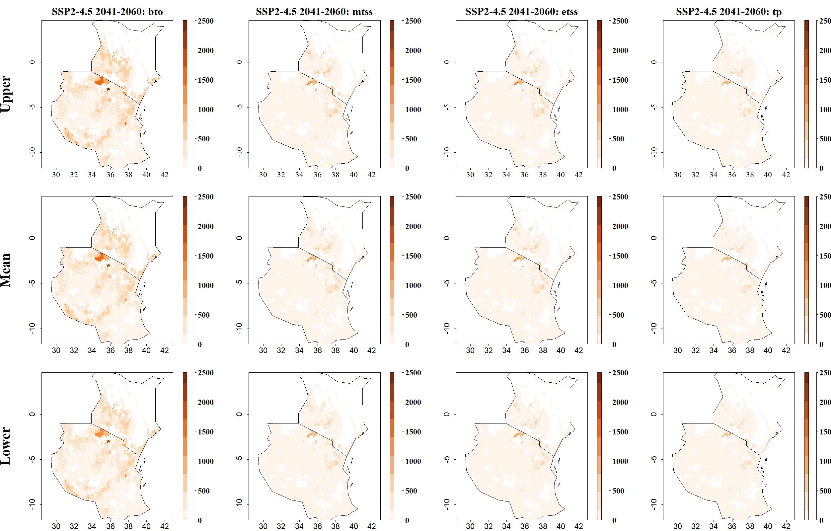
Fig: Predicted maize yield losses (in kg/ha) by the stem borer B. fusca for SSP2-4.5 in 2041–2060 and thresholds Balance training omission, predicted area and threshold values Cloglog (bto), Maximum training sensitivity plus specificity Cloglog threshold (mtss), Equal training sensitivity and specificity Cloglog threshold (etss) and 10th percentile training presence Cloglog threshold (tp). Grid cells with high predicted yield losses are colored in darker orange to brown, whereas cells where maize yield losses by the species are low are colored in lighter orange and white
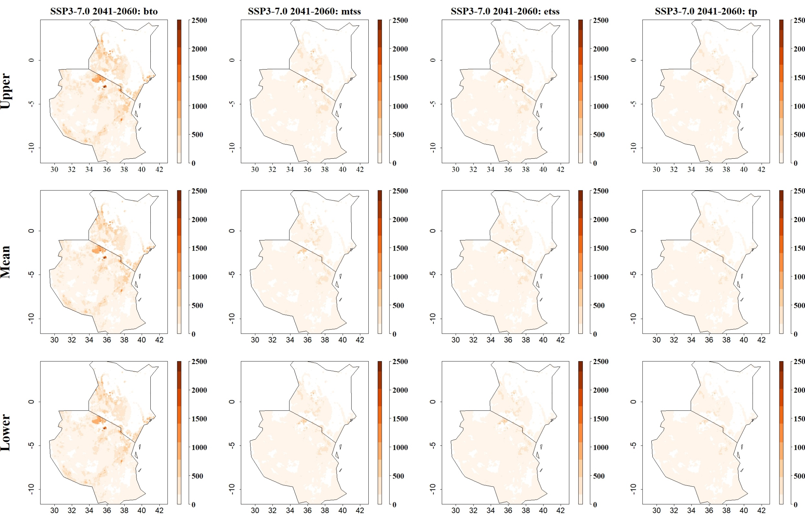
Fig: Predicted maize yield losses (in kg/ha) by the stem borer B. fusca for SSP3-7.0 in 2041–2060 and thresholds Balance training omission, predicted area and threshold values Cloglog (bto), Maximum training sensitivity plus specificity Cloglog threshold (mtss), Equal training sensitivity and specificity Cloglog threshold (etss) and 10th percentile training presence Cloglog threshold (tp). Grid cells with high predicted yield losses are colored in darker orange to brown, whereas cells where maize yield losses by the species are low are colored in lighter orange and white
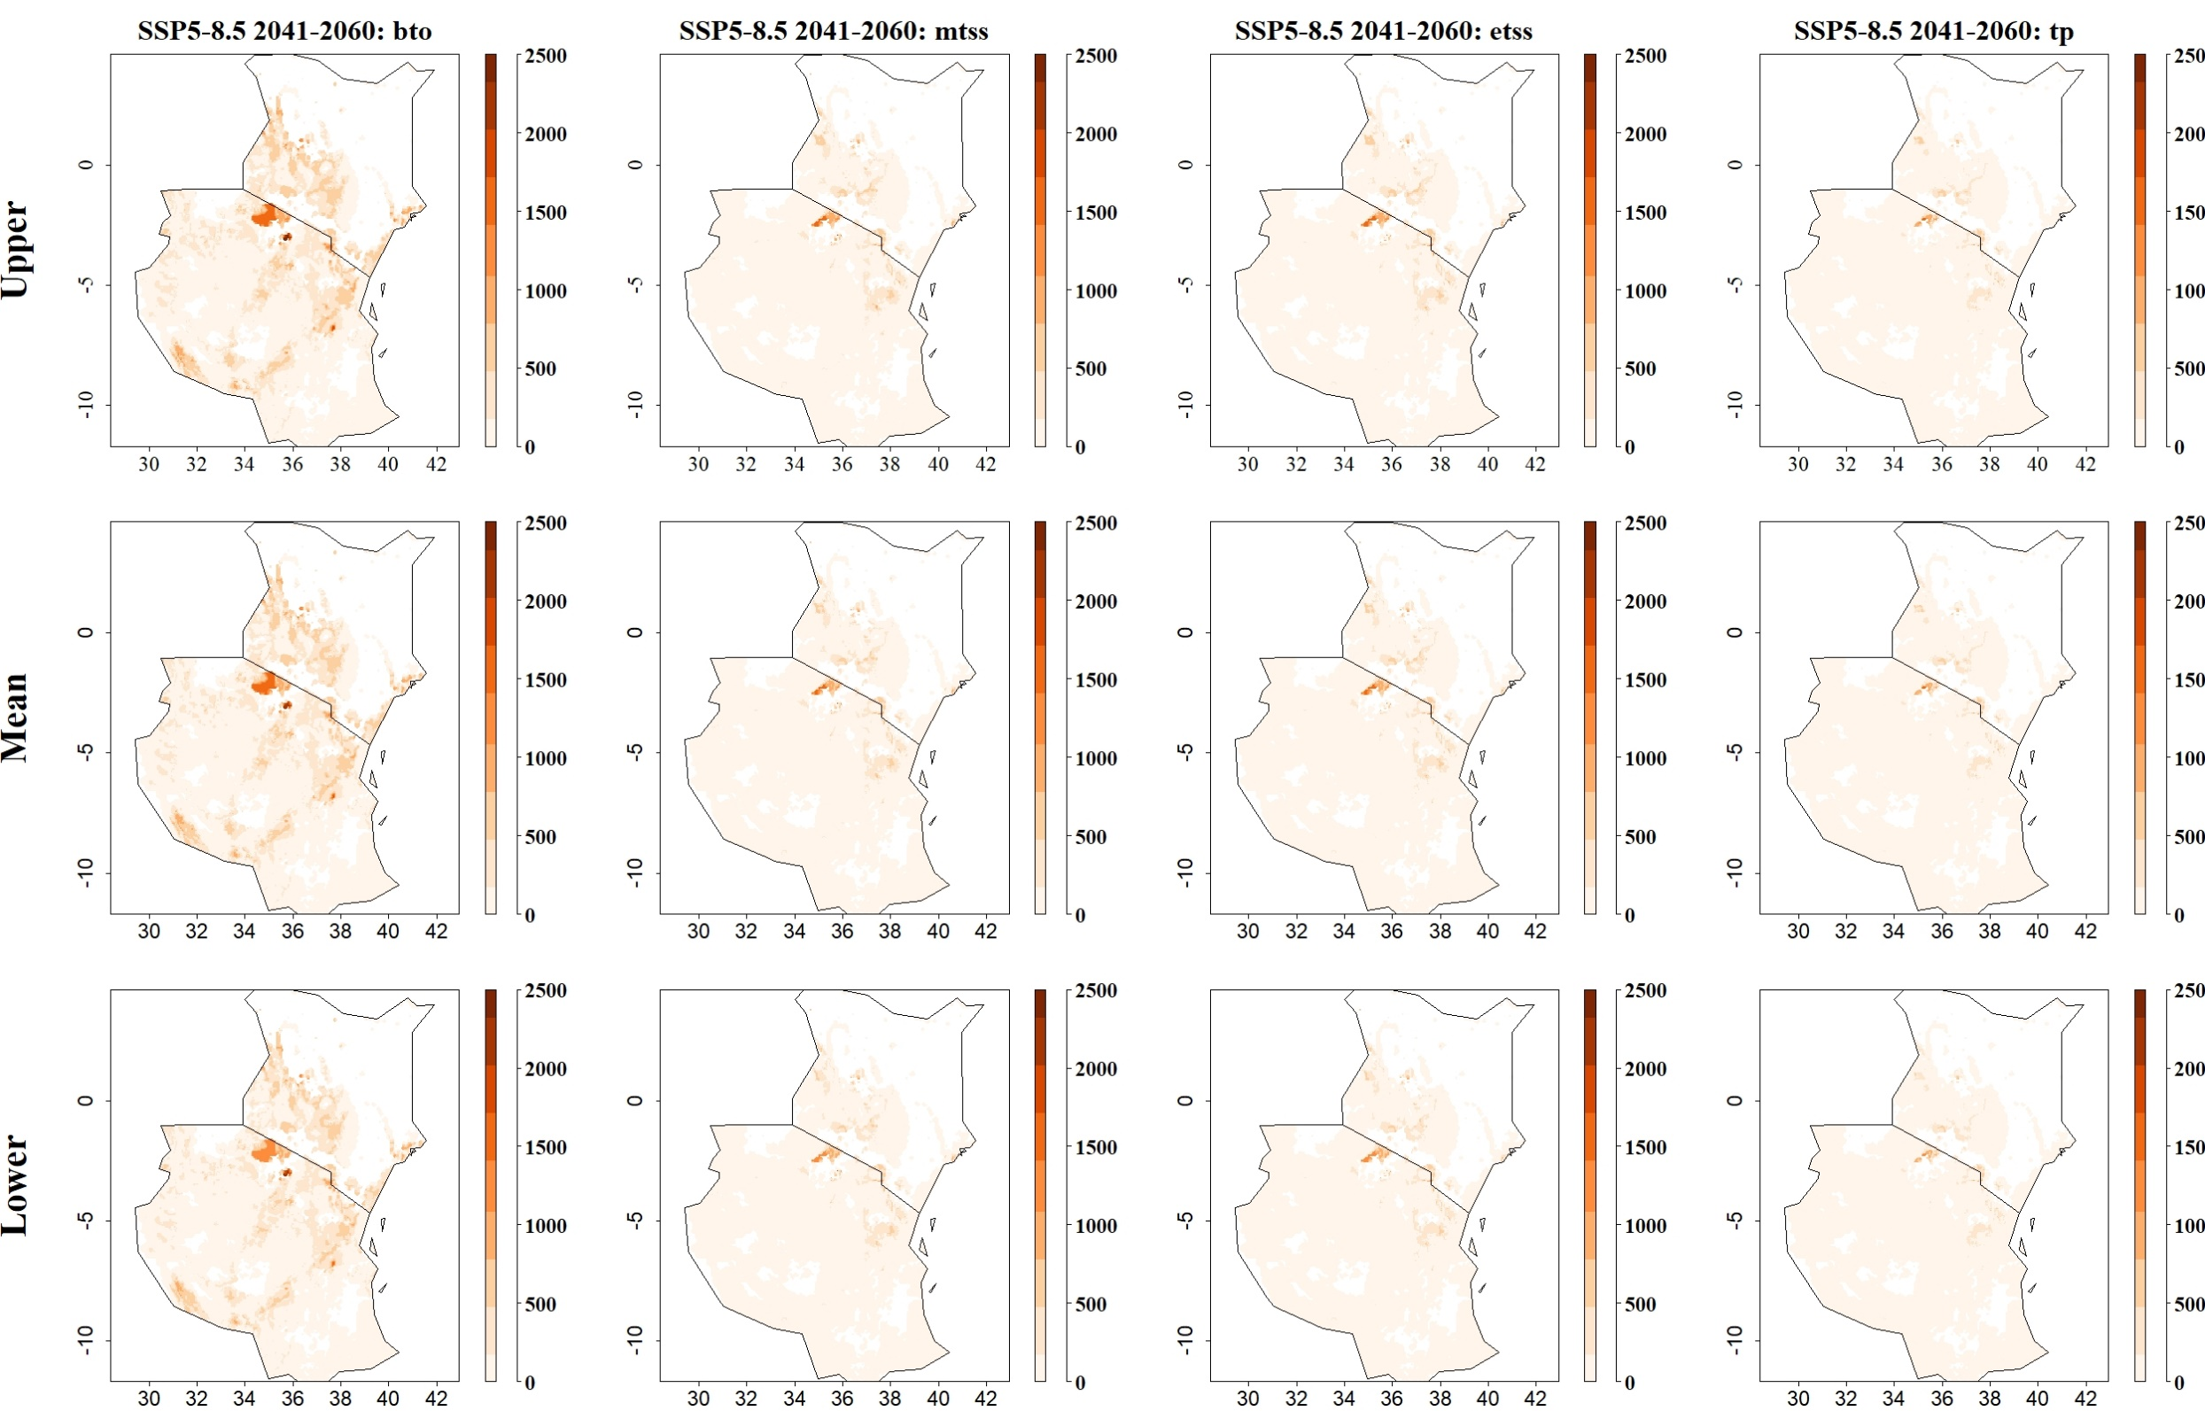
Fig: Predicted maize yield losses (in kg/ha) by the stem borer B. fusca for SSP5-8.5 in 2041–2060 and thresholds Balance training omission, predicted area and threshold values Cloglog (bto), Maximum training sensitivity plus specificity Cloglog threshold (mtss), Equal training sensitivity and specificity Cloglog threshold (etss) and 10th percentile training presence Cloglog threshold (tp). Grid cells with high predicted yield losses are colored in darker orange to brown, whereas cells where maize yield losses by the species are low are colored in lighter orange and white
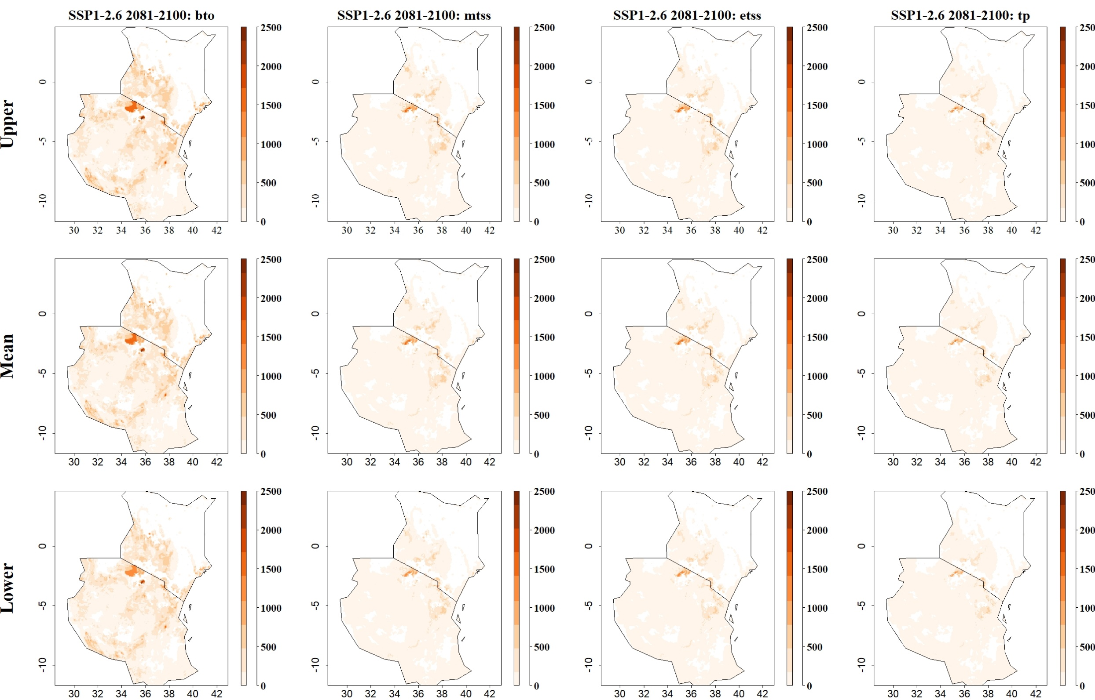

Fig: Predicted maize yield losses (in kg/ha) by the stem borer B. fusca for SSP1-2.6 in 2081–2100 and thresholds Balance training omission, predicted area and threshold values Cloglog (bto), Maximum training sensitivity plus specificity Cloglog threshold (mtss), Equal training sensitivity and specificity Cloglog threshold (etss) and 10th percentile training presence Cloglog threshold (tp). Grid cells with high predicted yield losses are colored in darker orange to brown, whereas cells where maize yield losses by the species are low are colored in lighter orange and white
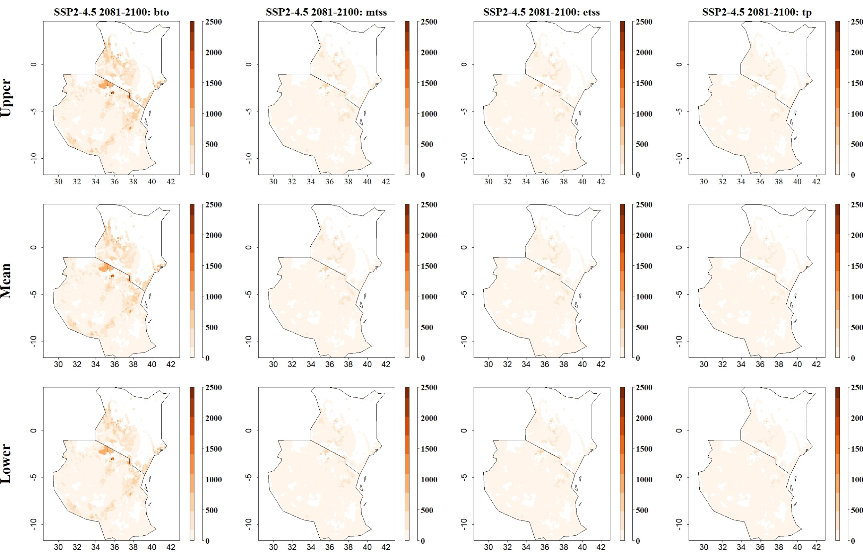
Fig: Predicted maize yield losses (in kg/ha) by the stem borer B. fusca for SSP2-4.5 in 2081–2100 and thresholds Balance training omission, predicted area and threshold values Cloglog (bto), Maximum training sensitivity plus specificity Cloglog threshold (mtss), Equal training sensitivity and specificity Cloglog threshold (etss) and 10th percentile training presence Cloglog threshold (tp). Grid cells with high predicted yield losses are colored in darker orange to brown, whereas cells where maize yield losses by the species are low are colored in lighter orange and white
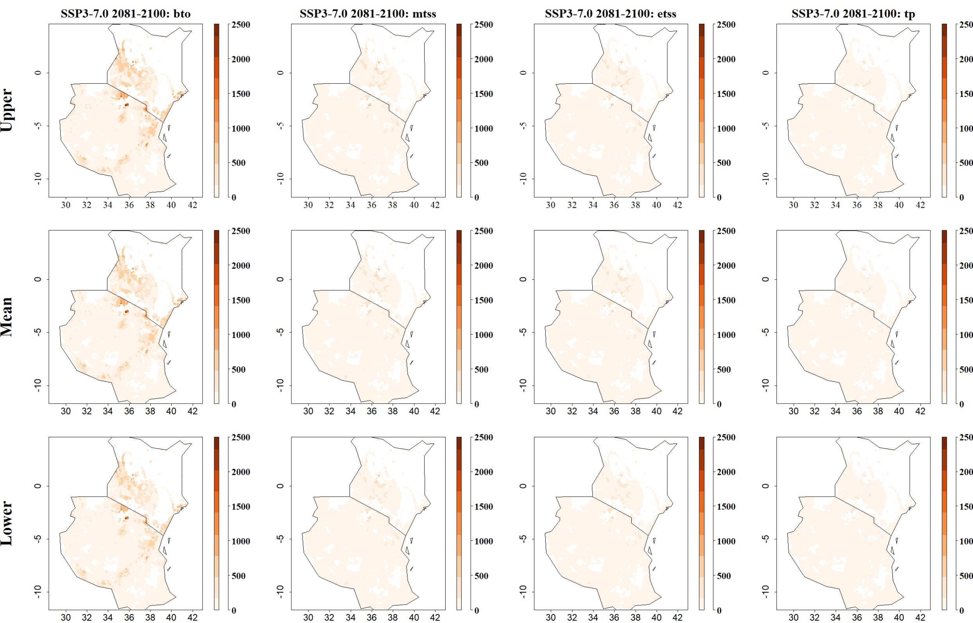
Fig: Predicted maize yield losses (in kg/ha) by the stem borer B. fusca for SSP3-7.0 in 2081–2100 and thresholds Balance training omission, predicted area and threshold values Cloglog (bto), Maximum training sensitivity plus specificity Cloglog threshold (mtss), Equal training sensitivity and specificity Cloglog threshold (etss) and 10th percentile training presence Cloglog threshold (tp). Grid cells with high predicted yield losses are colored in darker orange to brown, whereas cells where maize yield losses by the species are low are colored in lighter orange and white
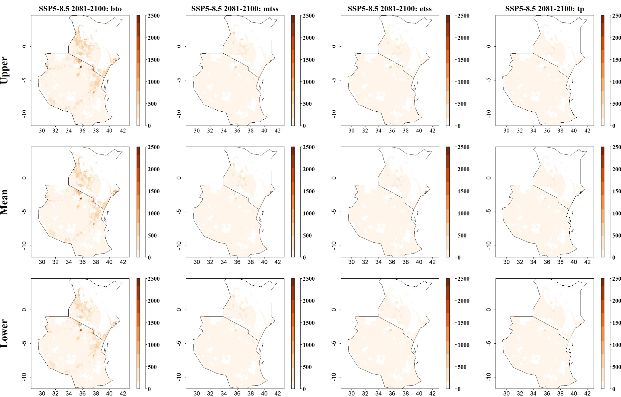
Fig: Predicted maize yield losses (in kg/ha) by the stem borer B. fusca for SSP5-8.5 in 2081–2100 and thresholds Balance training omission, predicted area and threshold values Cloglog (bto), Maximum training sensitivity plus specificity Cloglog threshold (mtss), Equal training sensitivity and specificity Cloglog threshold (etss) and 10th percentile training presence Cloglog threshold (tp). Grid cells with high predicted yield losses are colored in darker orange to brown, whereas cells where maize yield losses by the species are low are colored in lighter orange and white

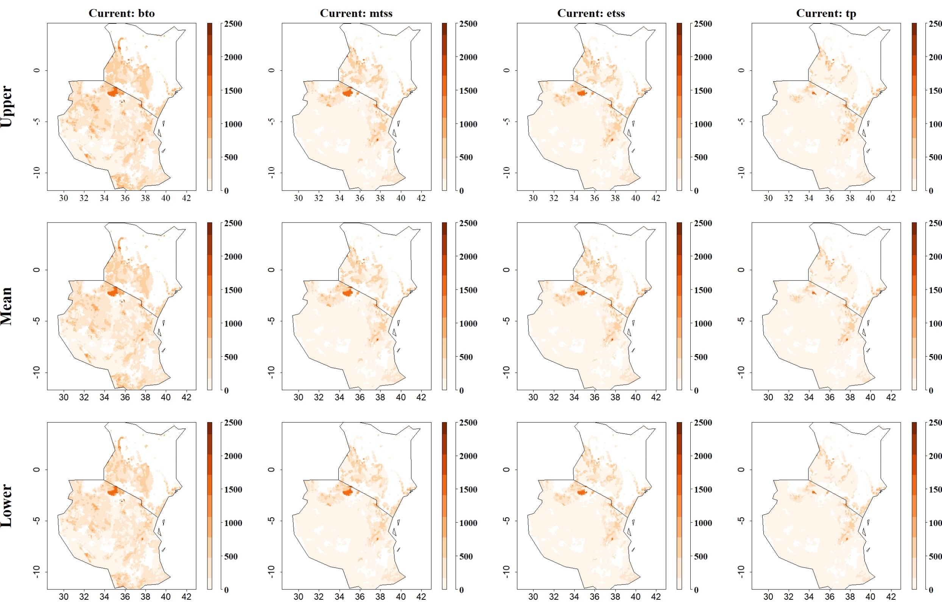
Fig: Predicted maize yield losses (in kg/ha) by the stem borer C. partellus under current climatic conditions for thresholds Balance training omission, predicted area and threshold values Cloglog (bto), Maximum training sensitivity plus specificity Cloglog threshold (mtss), Equal training sensitivity and specificity Cloglog threshold (etss) and 10th percentile training presence Cloglog threshold (tp). Grid cells with high predicted yield losses are colored in darker orange to brown, whereas cells where maize yield losses by the species are low are colored in lighter orange and white
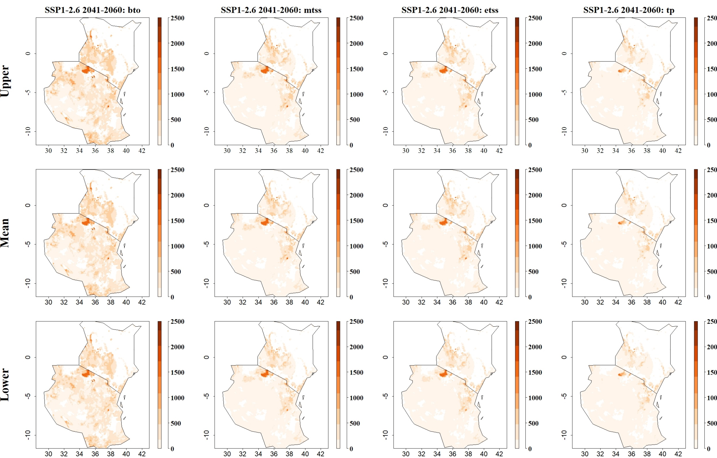
Fig: Predicted maize yield losses (in kg/ha) by the stem borer C. partellus for SSP1-2.6 in 2041–2060 and thresholds Balance training omission, predicted area and threshold values Cloglog (bto), Maximum training sensitivity plus specificity Cloglog threshold (mtss), Equal training sensitivity and specificity Cloglog threshold (etss) and 10th percentile training presence Cloglog threshold (tp). Grid cells with high predicted yield losses are colored in darker orange to brown, whereas cells where maize yield losses by the species are low are colored in lighter orange and white
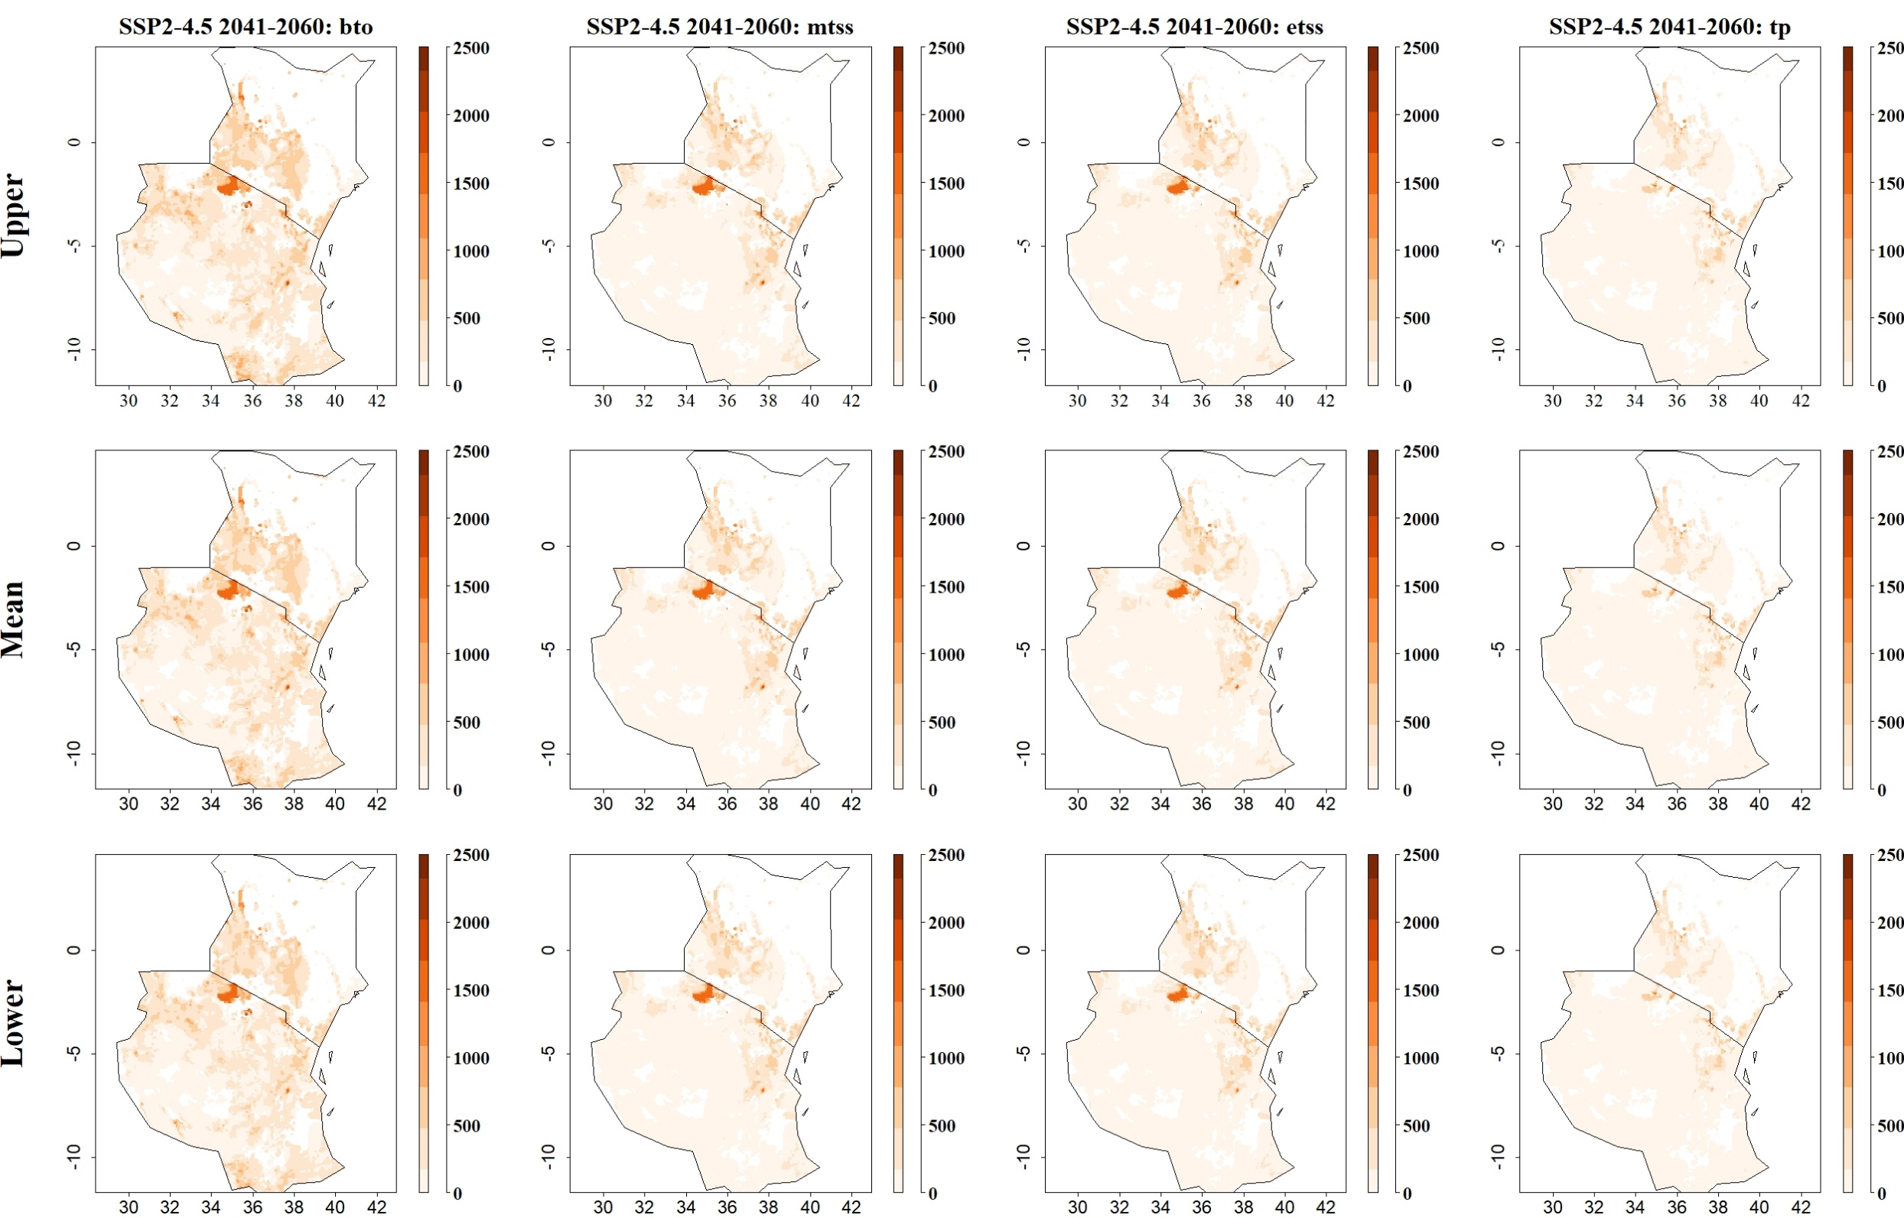
Fig: Predicted maize yield losses (in kg/ha) by the stem borer C. partellus for SSP2-4.5 in 2041–2060 and thresholds Balance training omission, predicted area and threshold values Cloglog (bto), Maximum training sensitivity plus specificity Cloglog threshold (mtss), Equal training sensitivity and specificity Cloglog threshold (etss) and 10th percentile training presence Cloglog threshold (tp). Grid cells with high predicted yield losses are colored in darker orange to brown, whereas cells where maize yield losses by the species are low are colored in lighter orange and white
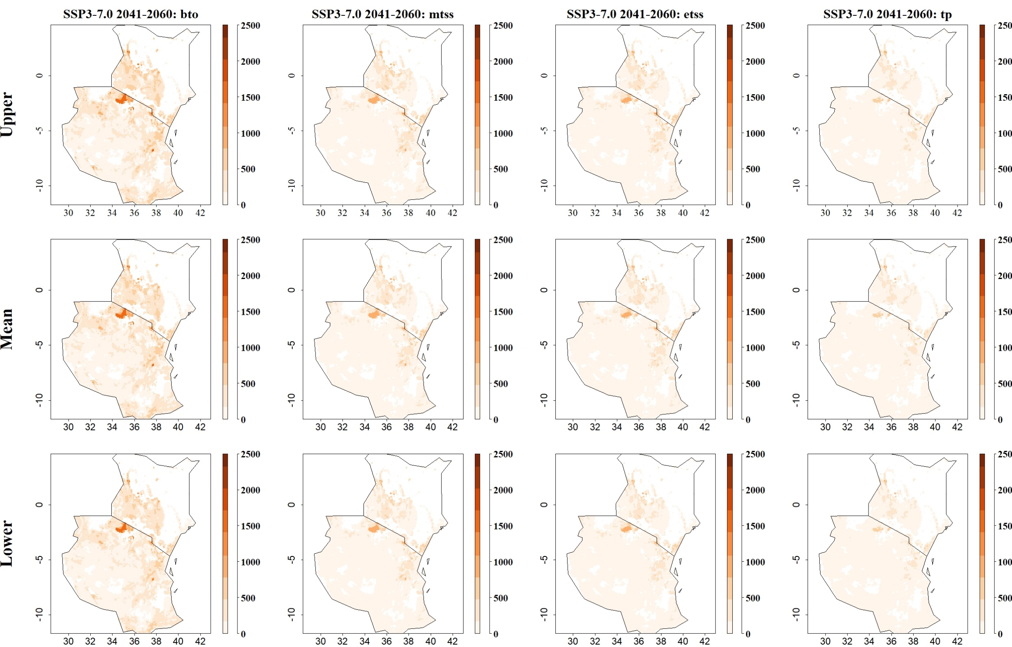
Fig: Predicted maize yield losses (in kg/ha) by the stem borer C. partellus for SSP3-7.0 in 2041–2060 and thresholds Balance training omission, predicted area and threshold values Cloglog (bto), Maximum training sensitivity plus specificity Cloglog threshold (mtss), Equal training sensitivity and specificity Cloglog threshold (etss) and 10th percentile training presence Cloglog threshold (tp). Grid cells with high predicted yield losses are colored in darker orange to brown, whereas cells where maize yield losses by the species are low are colored in lighter orange and white
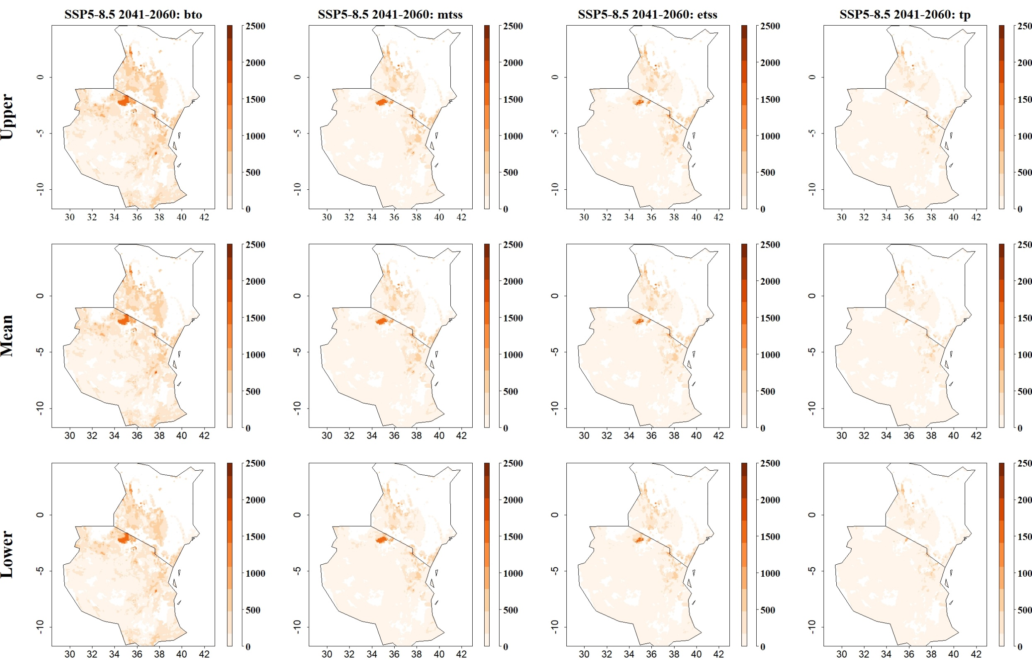
Fig: Predicted maize yield losses (in kg/ha) by the stem borer C. partellus for SSP5-8.5 in 2041–2060 and thresholds Balance training omission, predicted area and threshold values Cloglog (bto), Maximum training sensitivity plus specificity Cloglog threshold (mtss), Equal training sensitivity and specificity Cloglog threshold (etss) and 10th percentile training presence Cloglog threshold (tp). Grid cells with high predicted yield losses are colored in darker orange to brown, whereas cells where maize yield losses by the species are low are colored in lighter orange and white
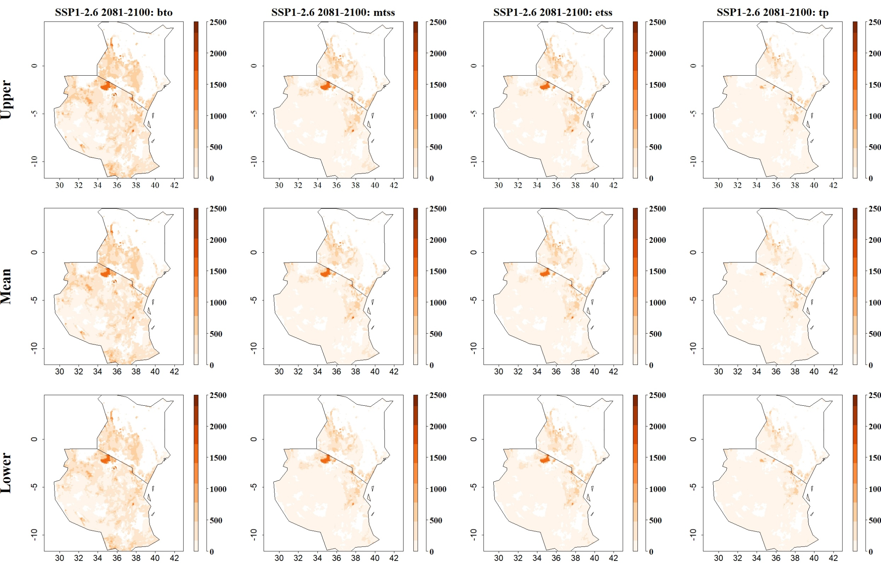

Fig: Predicted maize yield losses (in kg/ha) by the stem borer C. partellus for SSP1-2.6 in 2081–2100 and thresholds Balance training omission, predicted area and threshold values Cloglog (bto), Maximum training sensitivity plus specificity Cloglog threshold (mtss), Equal training sensitivity and specificity Cloglog threshold (etss) and 10th percentile training presence Cloglog threshold (tp). Grid cells with high predicted yield losses are colored in darker orange to brown, whereas cells where maize yield losses by the species are low are colored in lighter orange and white
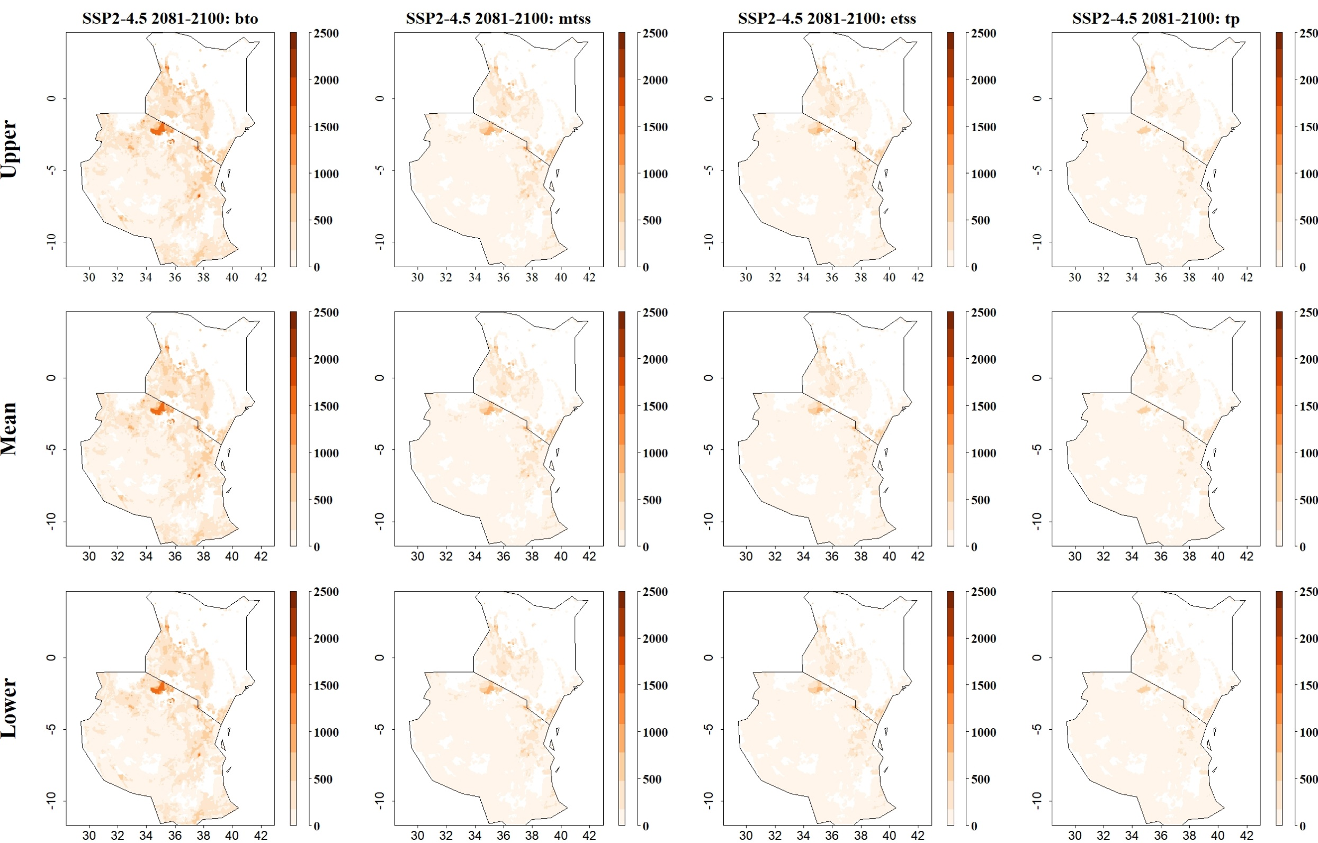
Fig: Predicted maize yield losses (in kg/ha) by the stem borer C. partellus for SSP2-4.5 in 2081–2100 and thresholds Balance training omission, predicted area and threshold values Cloglog (bto), Maximum training sensitivity plus specificity Cloglog threshold (mtss), Equal training sensitivity and specificity Cloglog threshold (etss) and 10th percentile training presence Cloglog threshold (tp). Grid cells with high predicted yield losses are colored in darker orange to brown, whereas cells where maize yield losses by the species are low are colored in lighter orange and white
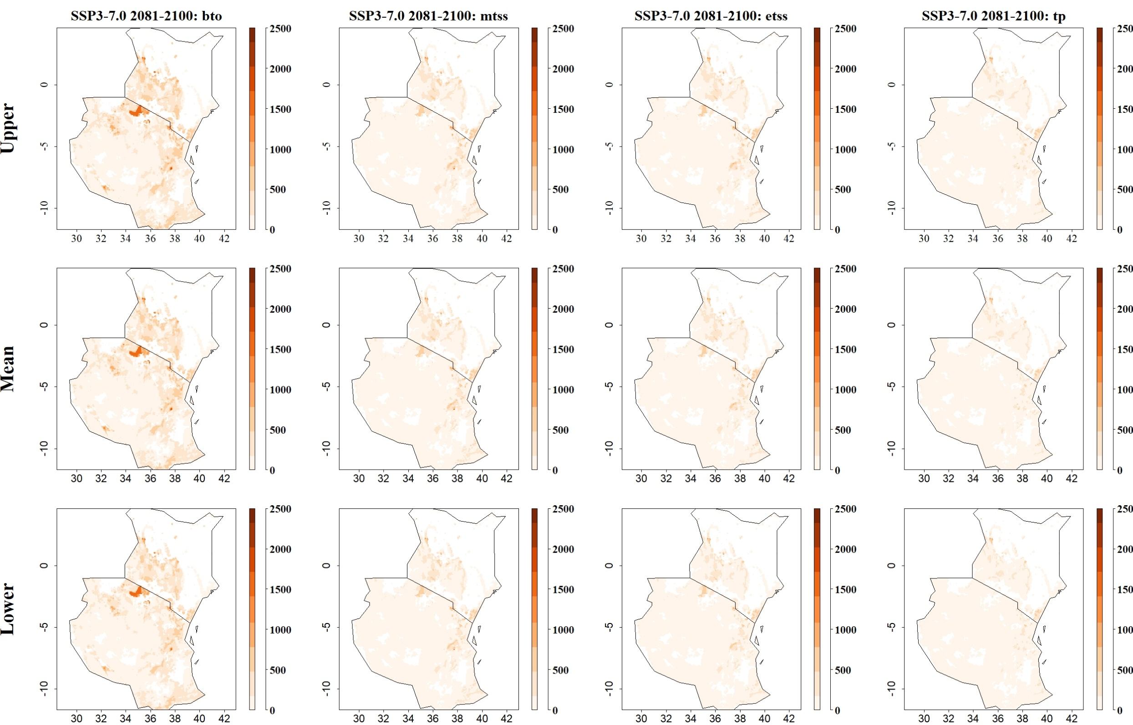
Fig: Predicted maize yield losses (in kg/ha) by the stem borer C. partellus for SSP3-7.0 in 2081–2100 and thresholds Balance training omission, predicted area and threshold values Cloglog (bto), Maximum training sensitivity plus specificity Cloglog threshold (mtss), Equal training sensitivity and specificity Cloglog threshold (etss) and 10th percentile training presence Cloglog threshold (tp). Grid cells with high predicted yield losses are colored in darker orange to brown, whereas cells where maize yield losses by the species are low are colored in lighter orange and white
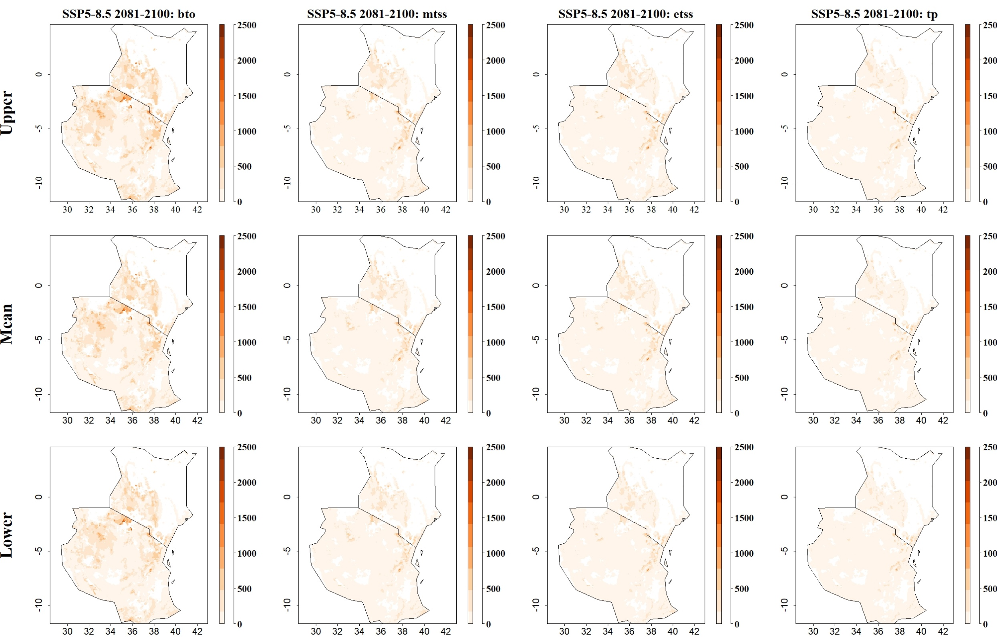
Fig: Predicted maize yield losses (in kg/ha) by the stem borer C. partellus for SSP5-8.5 in 2081–2100 and thresholds Balance training omission, predicted area and threshold values Cloglog (bto), Maximum training sensitivity plus specificity Cloglog threshold (mtss), Equal training sensitivity and specificity Cloglog threshold (etss) and 10th percentile training presence Cloglog threshold (tp). Grid cells with high predicted yield losses are colored in darker orange to brown, whereas cells where maize yield losses by the species are low are colored in lighter orange and white
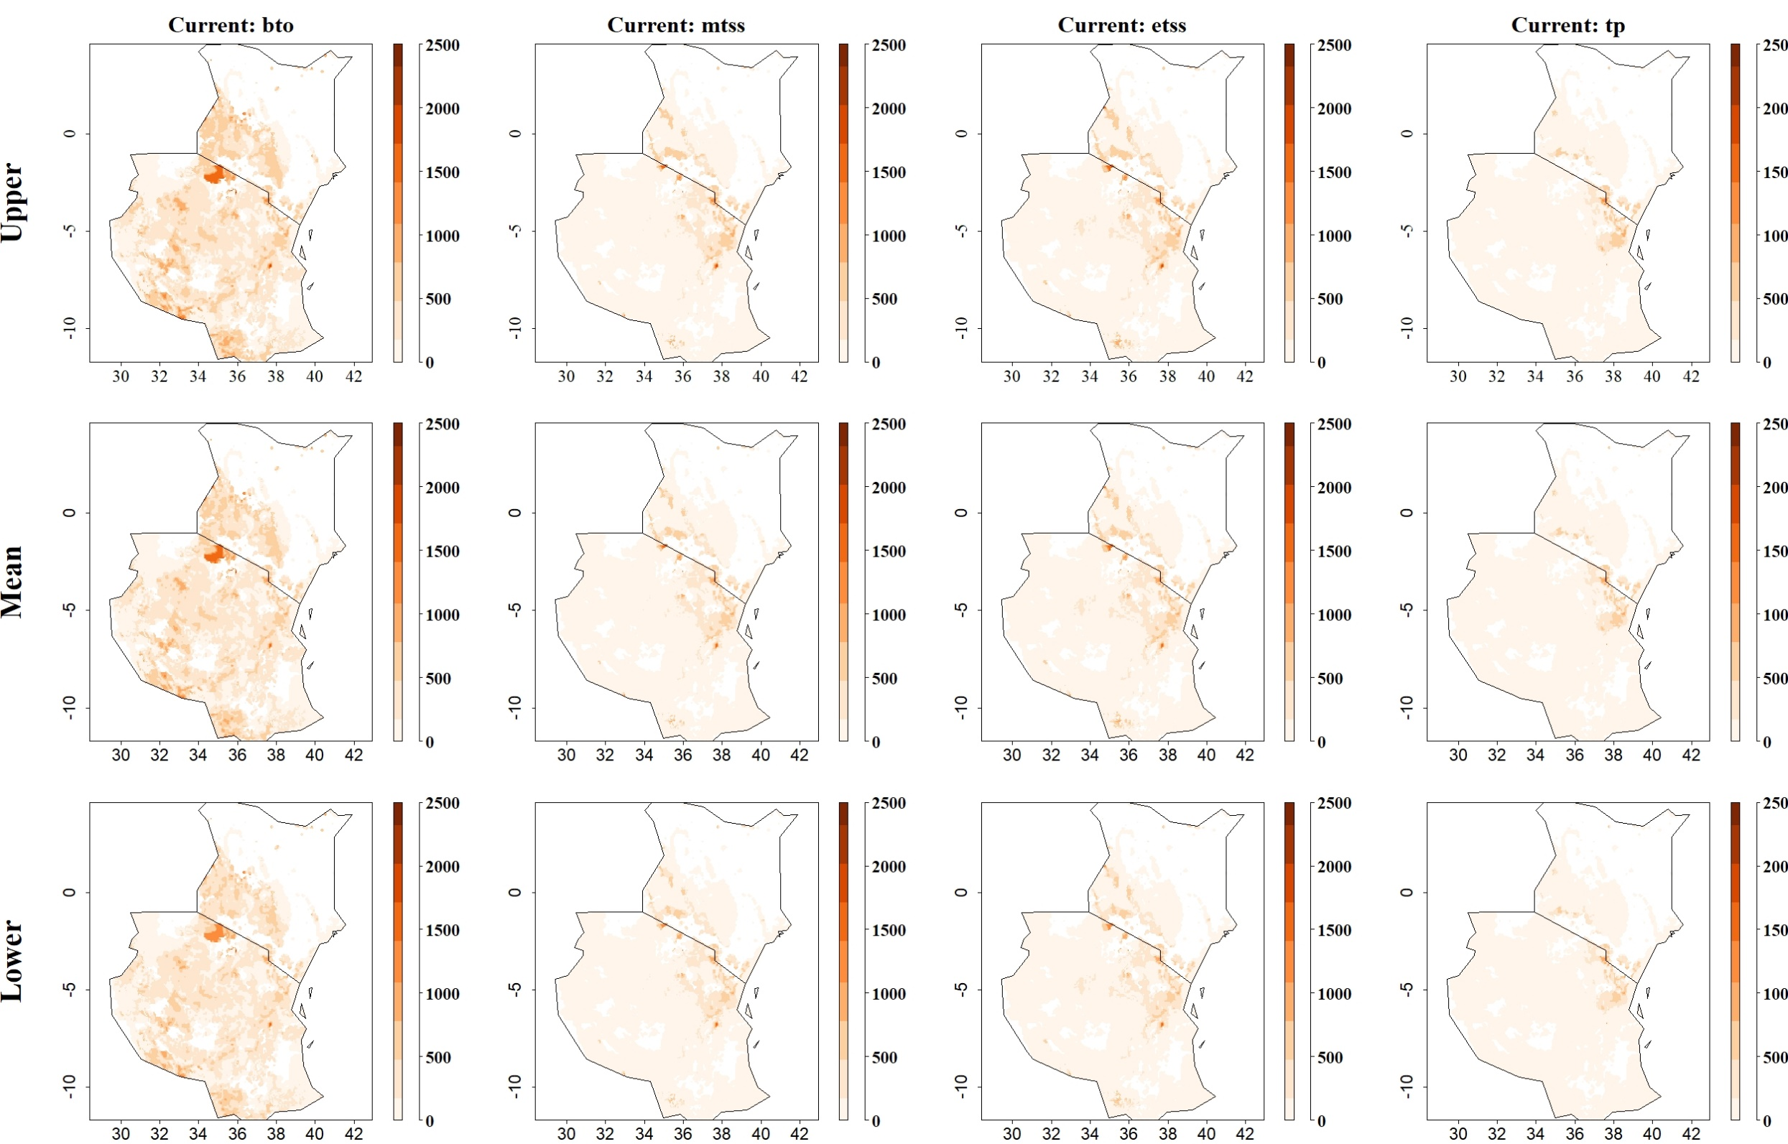
Fig: Predicted maize yield losses (in kg/ha) by the stem borer S. calamistis under current climatic conditions for thresholds Balance training omission, predicted area and threshold values Cloglog (bto), Maximum training sensitivity plus specificity Cloglog threshold (mtss), Equal training sensitivity and specificity Cloglog threshold (etss) and 10th percentile training presence Cloglog threshold (tp). Grid cells with high predicted yield losses are colored in darker orange to brown, whereas cells where maize yield losses by the species are low are colored in lighter orange and white
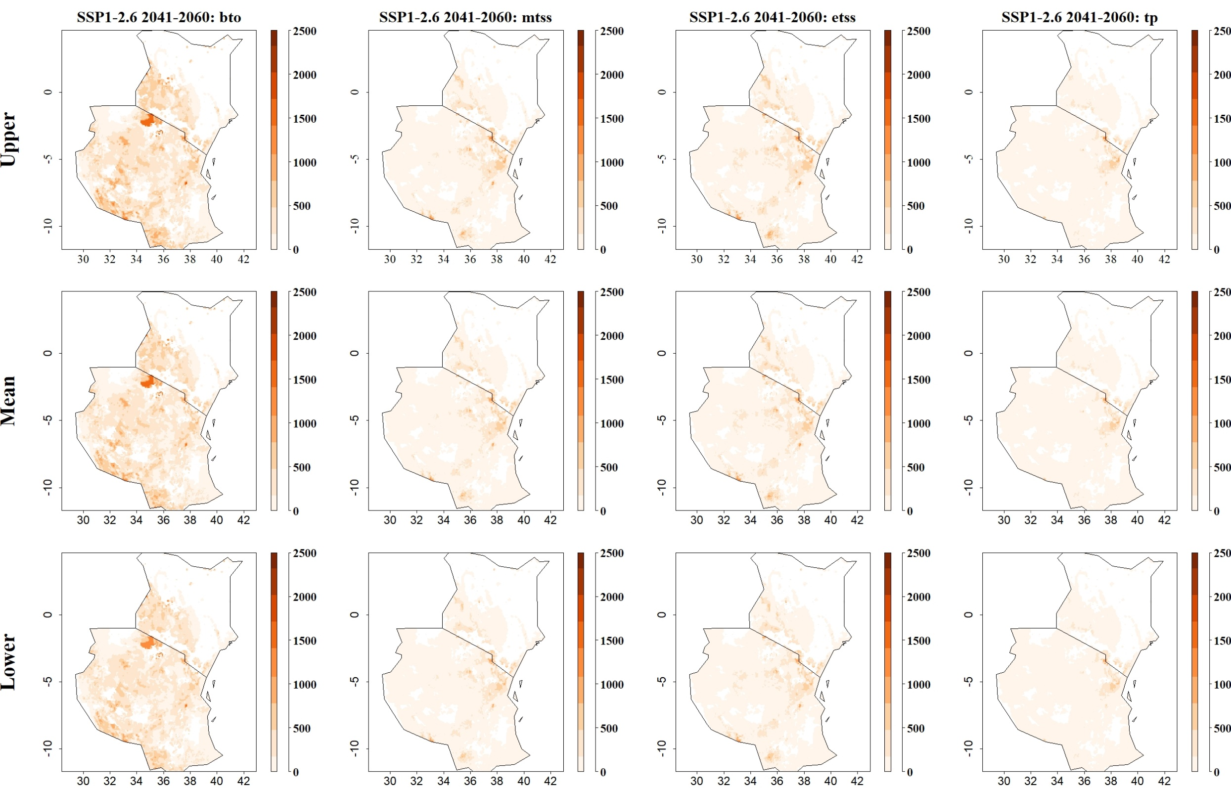
Fig: Predicted maize yield losses (in kg/ha) by the stem borer S. calamistis for SSP1-2.6 in 2041–2060 and thresholds Balance training omission, predicted area and threshold values Cloglog (bto), Maximum training sensitivity plus specificity Cloglog threshold (mtss), Equal training sensitivity and specificity Cloglog threshold (etss) and 10th percentile training presence Cloglog threshold (tp). Grid cells with high predicted yield losses are colored in darker orange to brown, whereas cells where maize yield losses by the species are low are colored in lighter orange and white
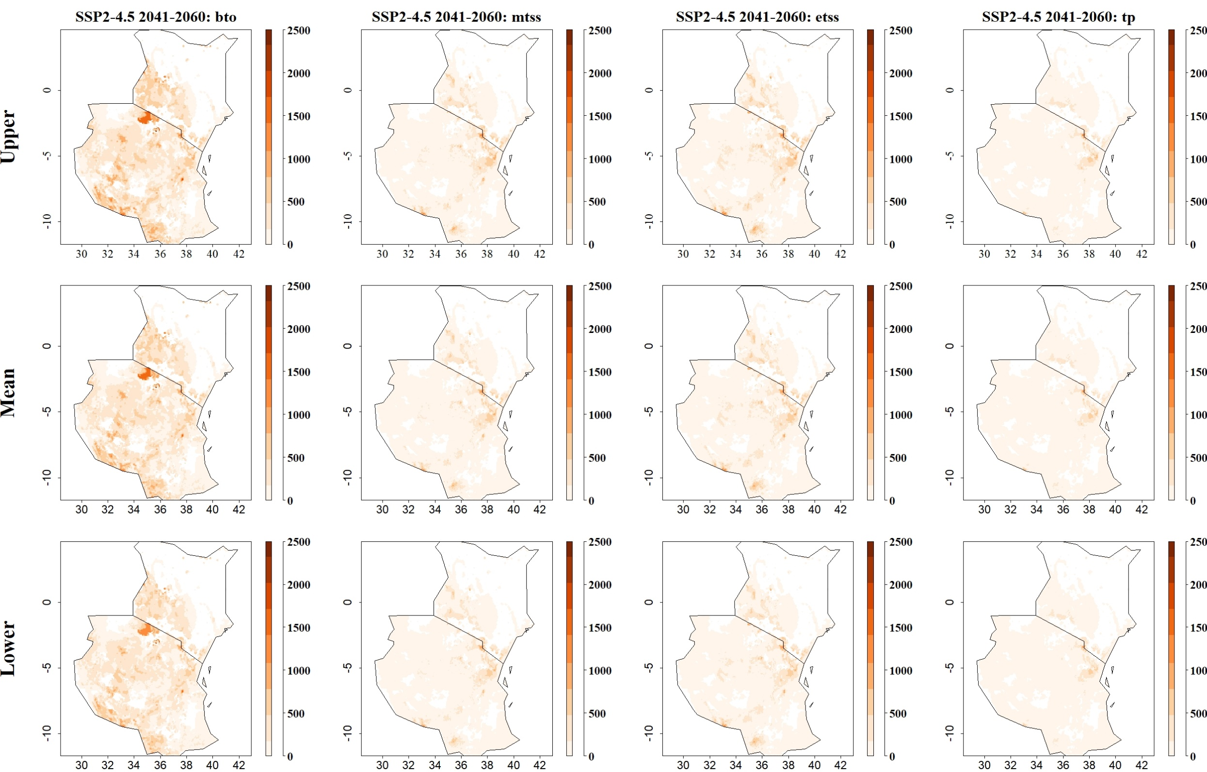
Fig: Predicted maize yield losses (in kg/ha) by the stem borer S. calamistis for SSP2-4.5 in 2041–2060 and thresholds Balance training omission, predicted area and threshold values Cloglog (bto), Maximum training sensitivity plus specificity Cloglog threshold (mtss), Equal training sensitivity and specificity Cloglog threshold (etss) and 10th percentile training presence Cloglog threshold (tp). Grid cells with high predicted yield losses are colored in darker orange to brown, whereas cells where maize yield losses by the species are low are colored in lighter orange and white
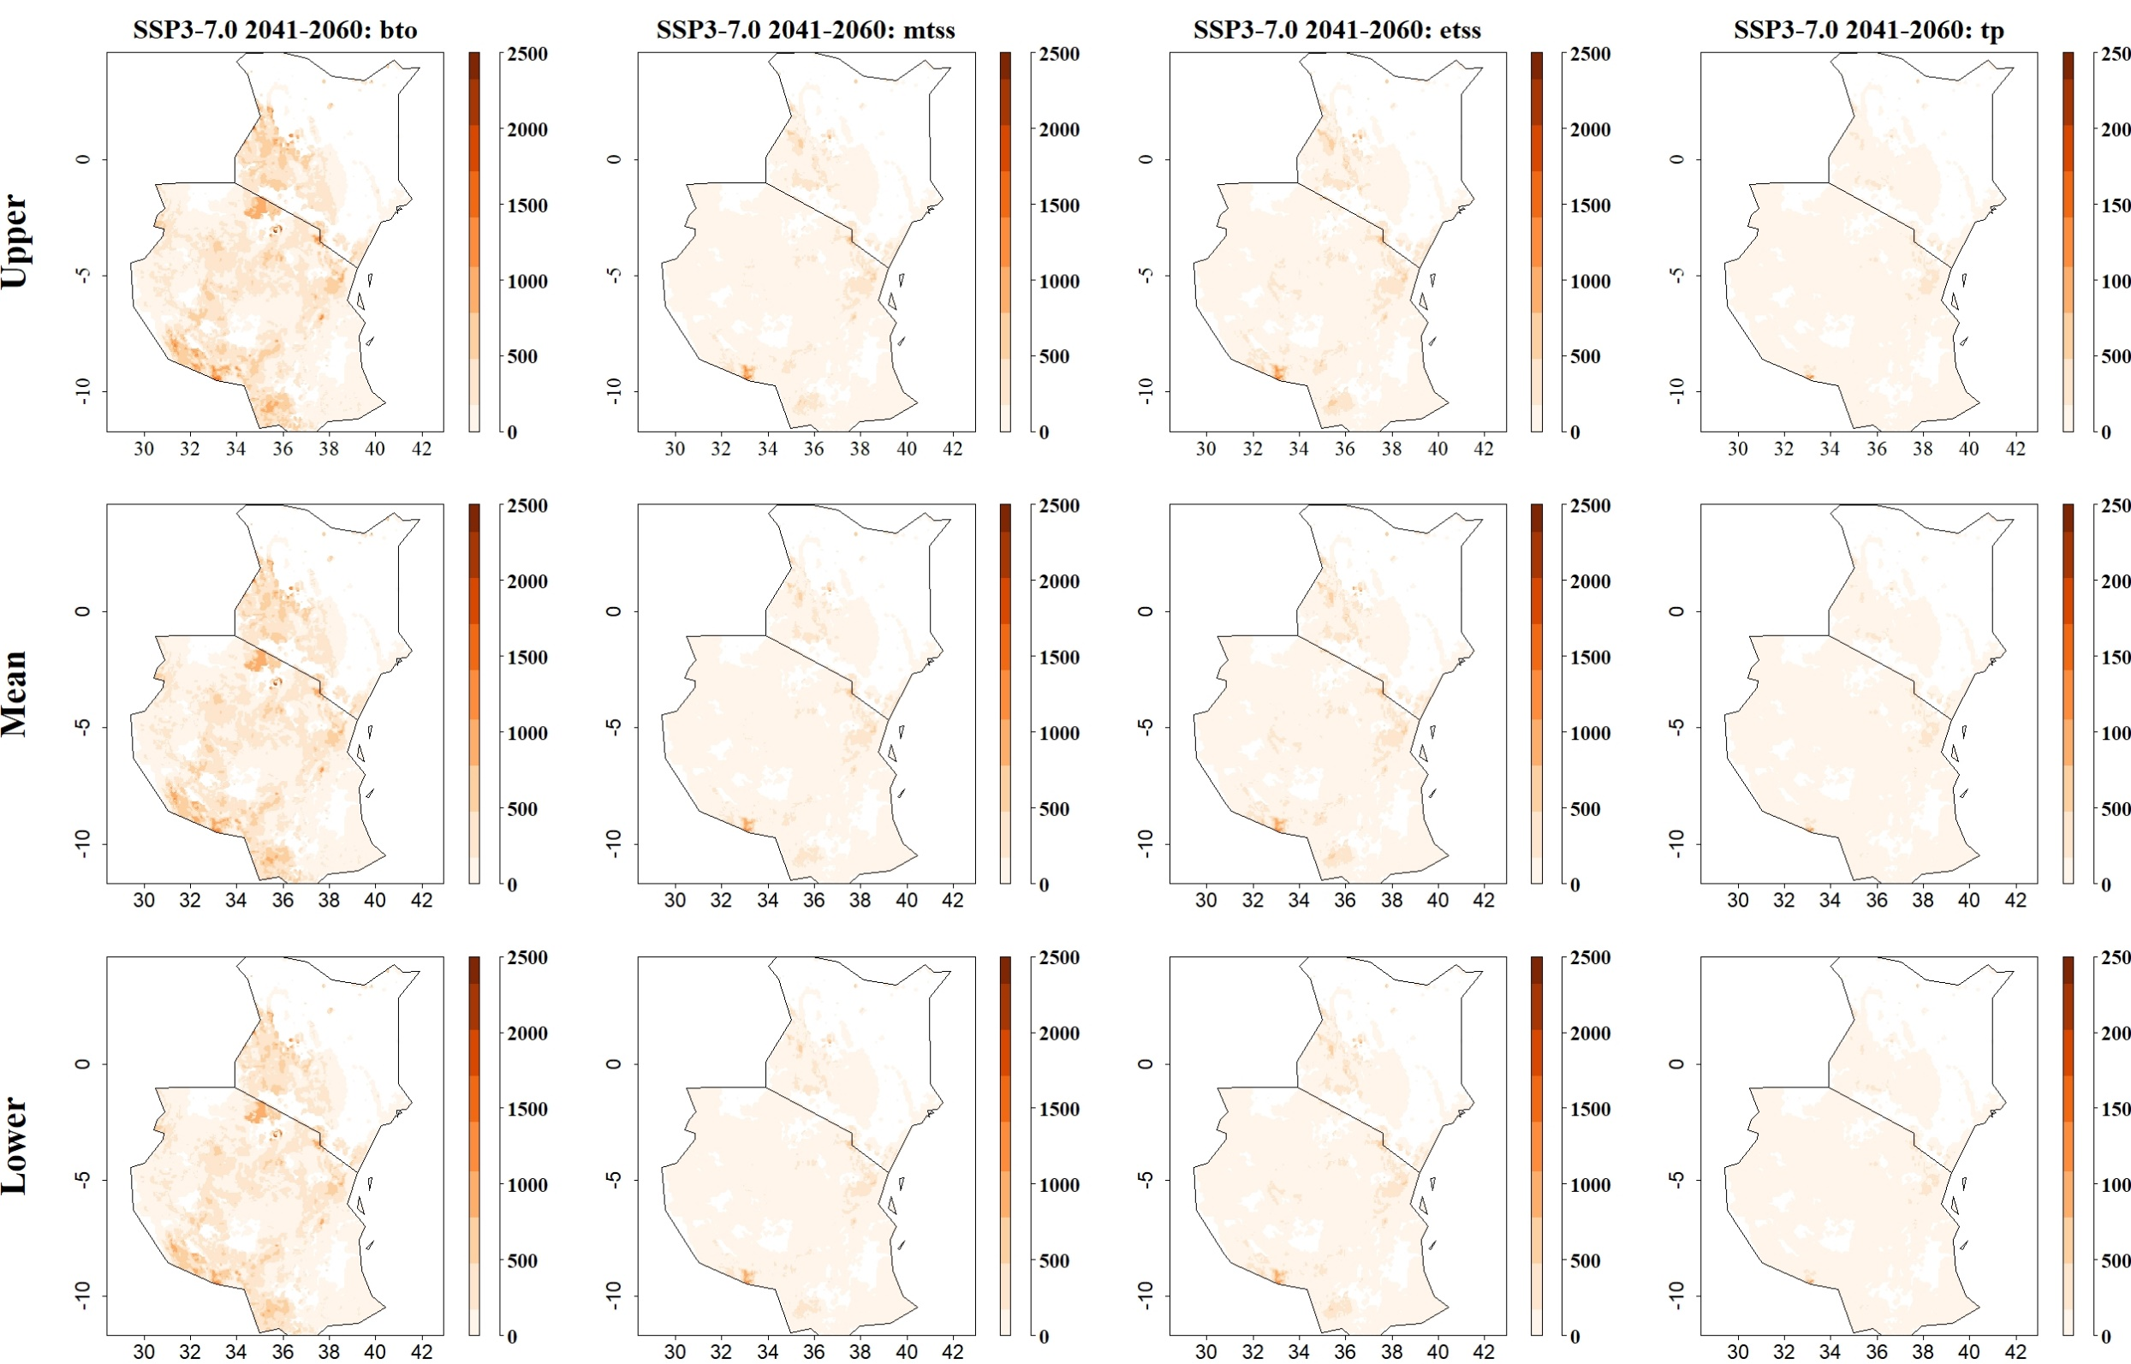
Fig: Predicted maize yield losses (in kg/ha) by the stem borer S. calamistis for SSP3-7.0 in 2041–2060 and thresholds Balance training omission, predicted area and threshold values Cloglog (bto), Maximum training sensitivity plus specificity Cloglog threshold (mtss), Equal training sensitivity and specificity Cloglog threshold (etss) and 10th percentile training presence Cloglog threshold (tp). Grid cells with high predicted yield losses are colored in darker orange to brown, whereas cells where maize yield losses by the species are low are colored in lighter orange and white
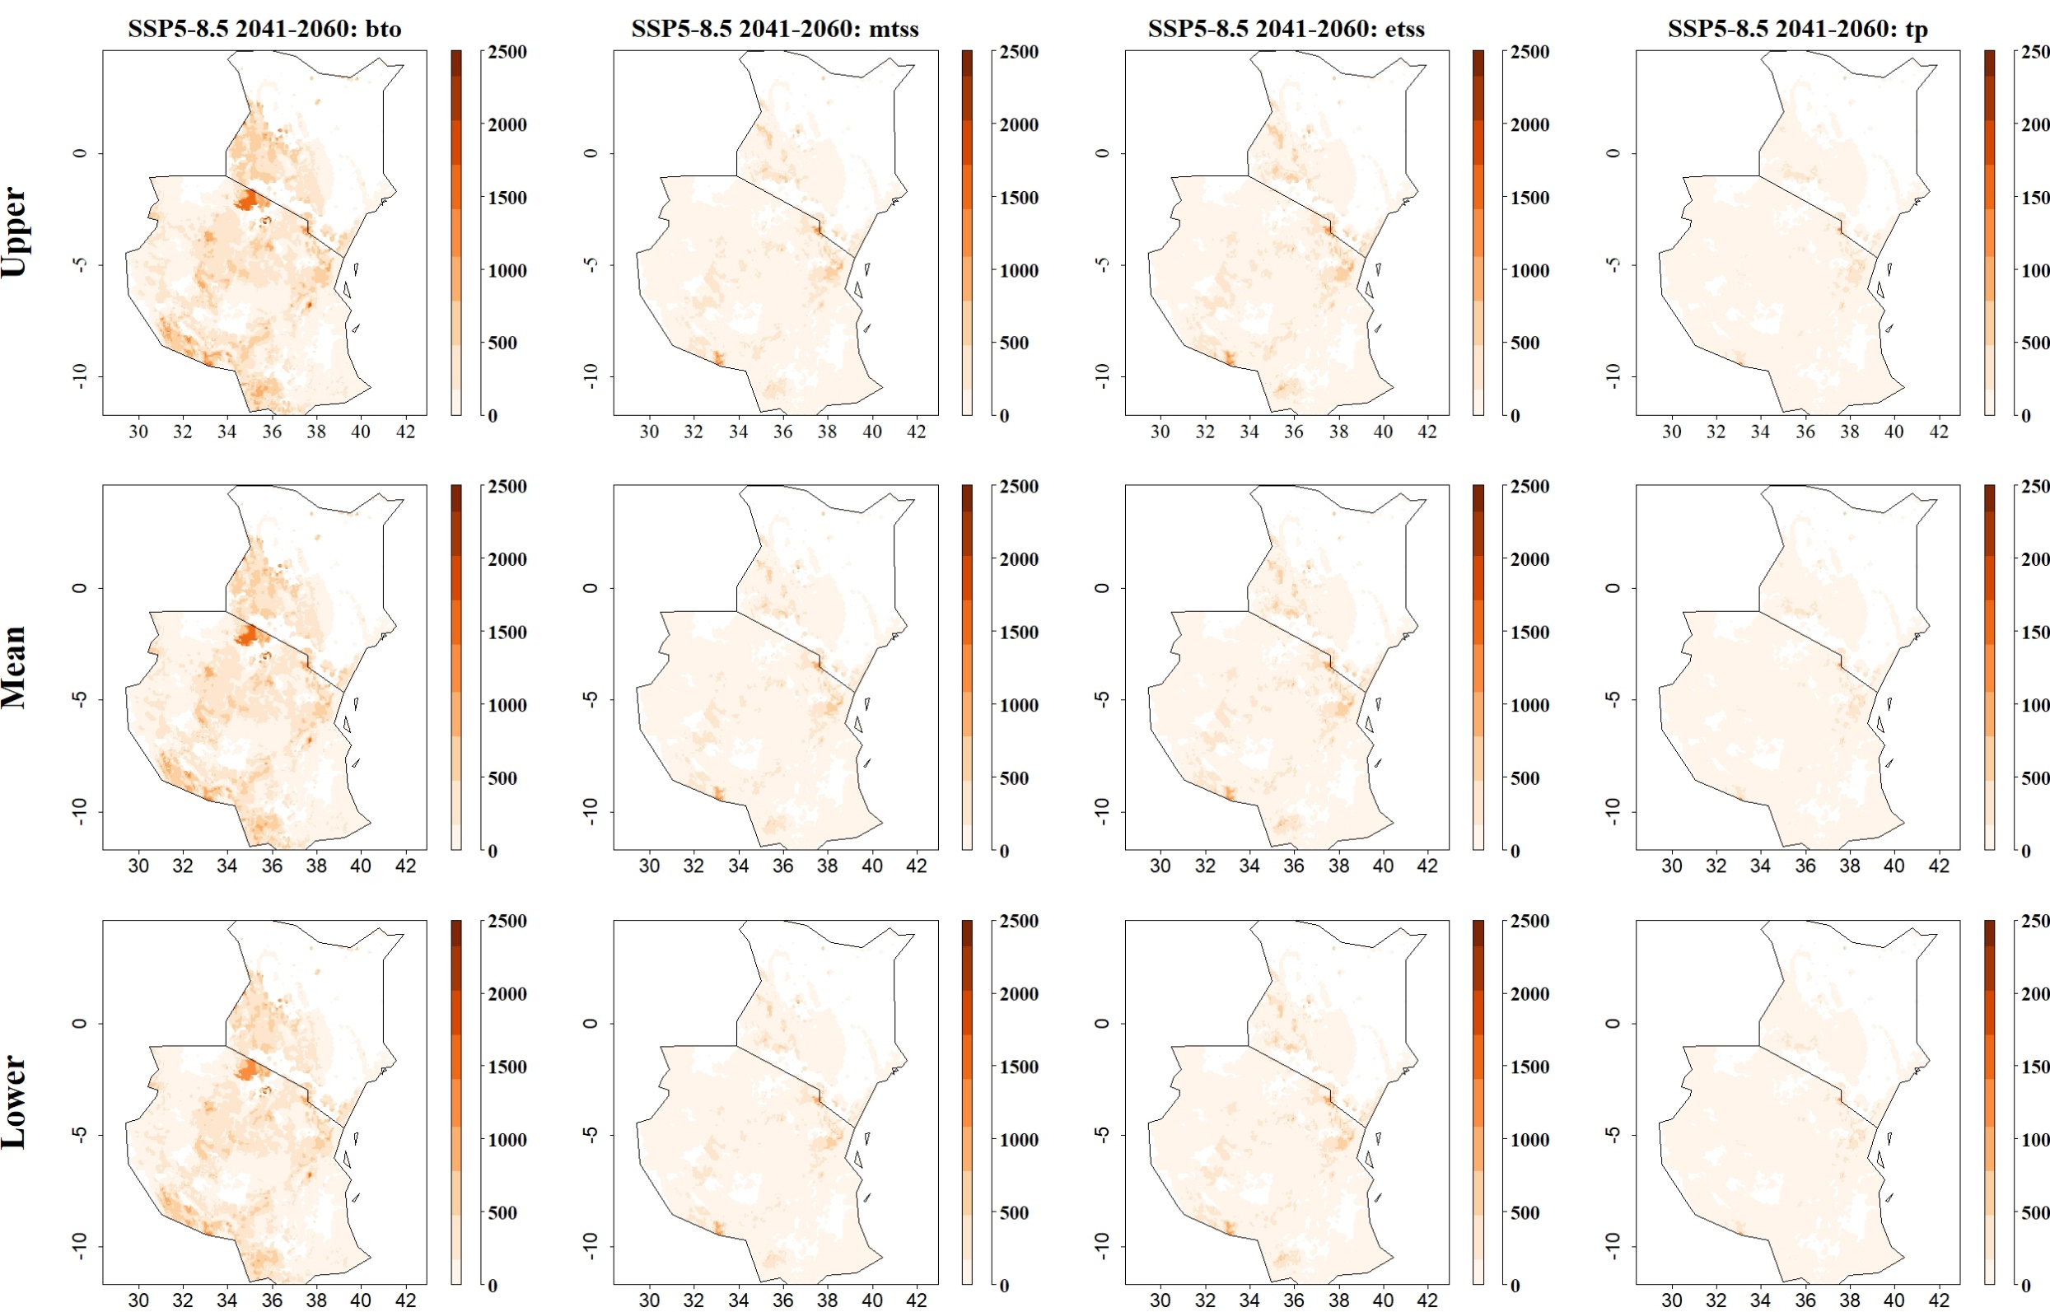
Fig: Predicted maize yield losses (in kg/ha) by the stem borer S. calamistis for SSP5-8.5 in 2041–2060 and thresholds Balance training omission, predicted area and threshold values Cloglog (bto), Maximum training sensitivity plus specificity Cloglog threshold (mtss), Equal training sensitivity and specificity Cloglog threshold (etss) and 10th percentile training presence Cloglog threshold (tp). Grid cells with high predicted yield losses are colored in darker orange to brown, whereas cells where maize yield losses by the species are low are colored in lighter orange and white
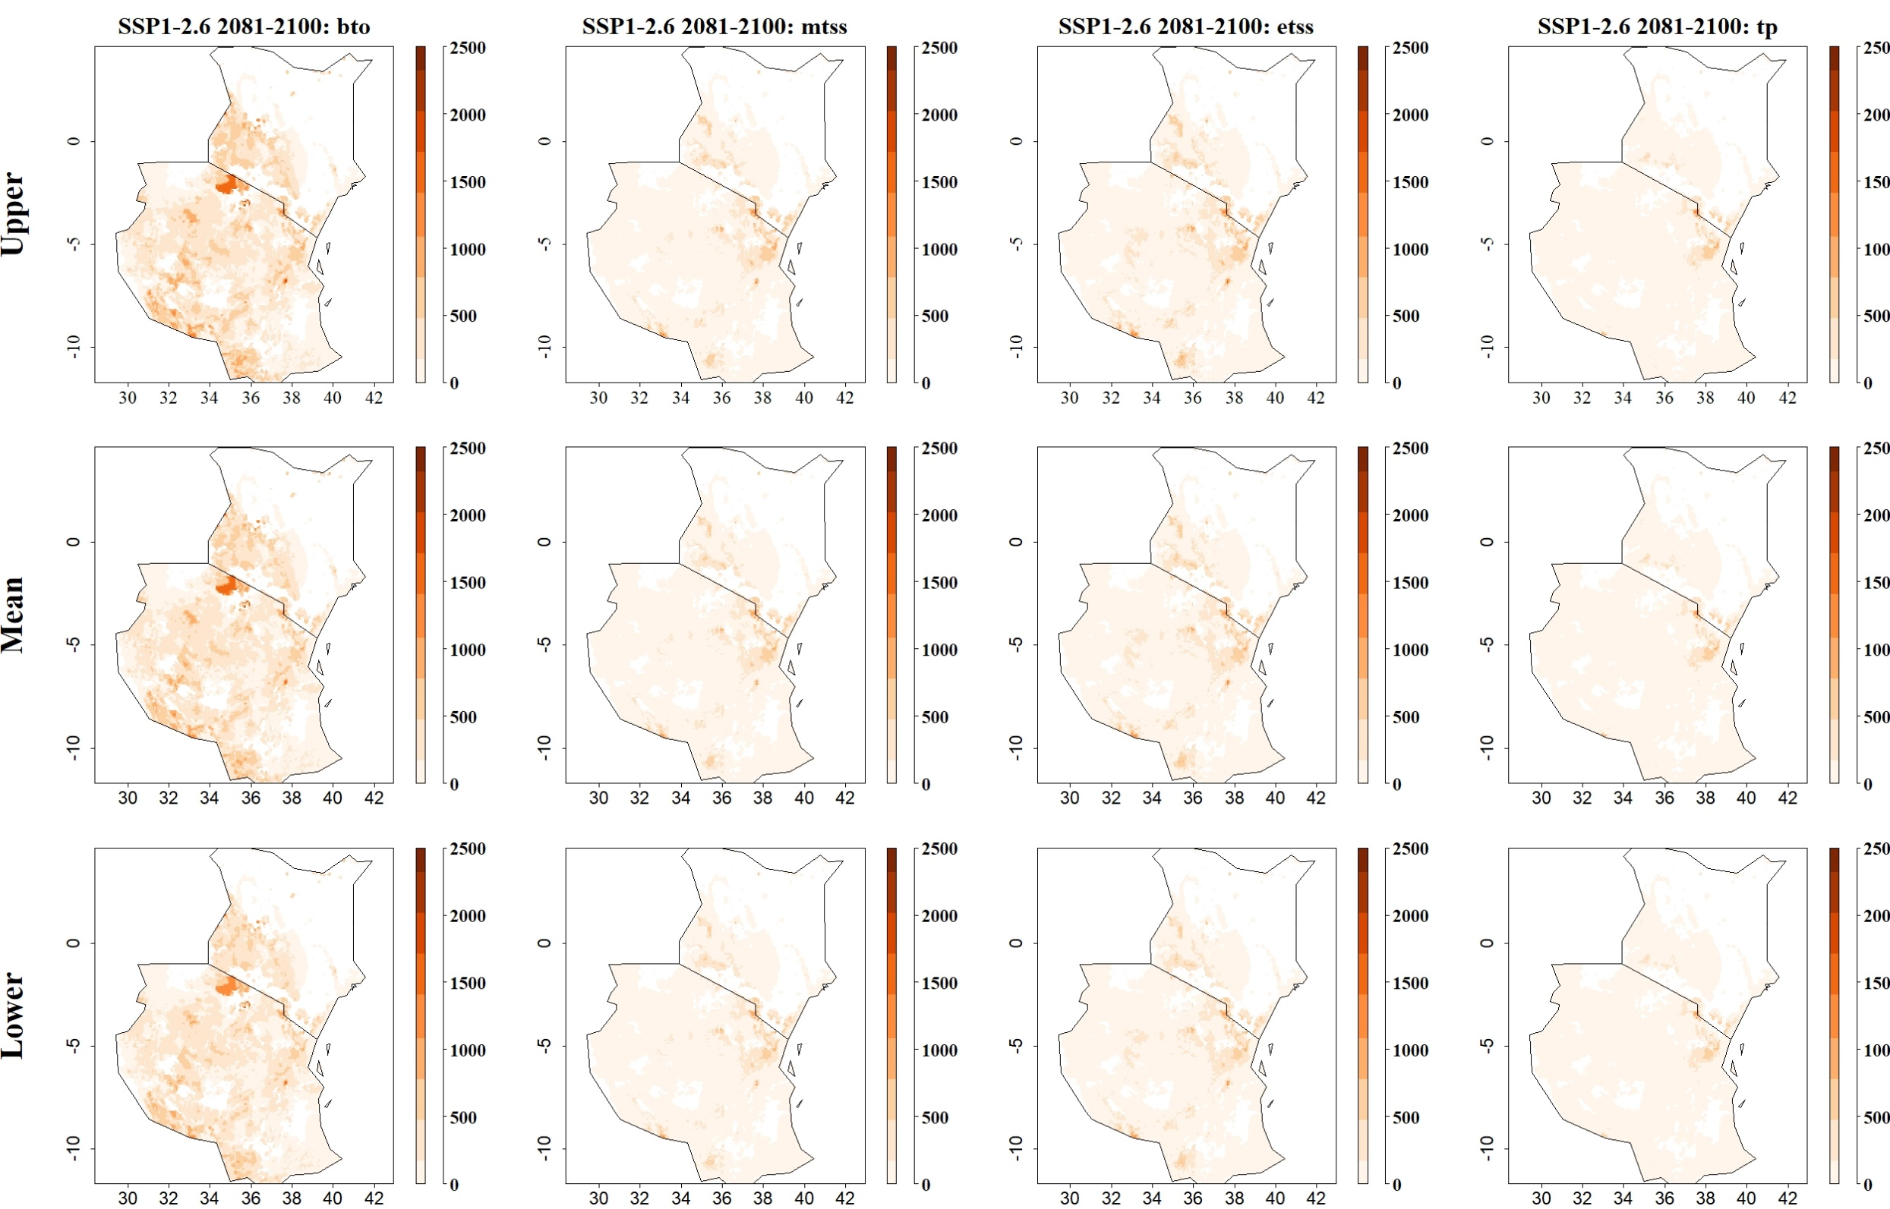

Fig: Predicted maize yield losses (in kg/ha) by the stem borer S. calamistis for SSP1-2.6 in 2081–2100 and thresholds Balance training omission, predicted area and threshold values Cloglog (bto), Maximum training sensitivity plus specificity Cloglog threshold (mtss), Equal training sensitivity and specificity Cloglog threshold (etss) and 10th percentile training presence Cloglog threshold (tp). Grid cells with high predicted yield losses are colored in darker orange to brown, whereas cells where maize yield losses by the species are low are colored in lighter orange and white
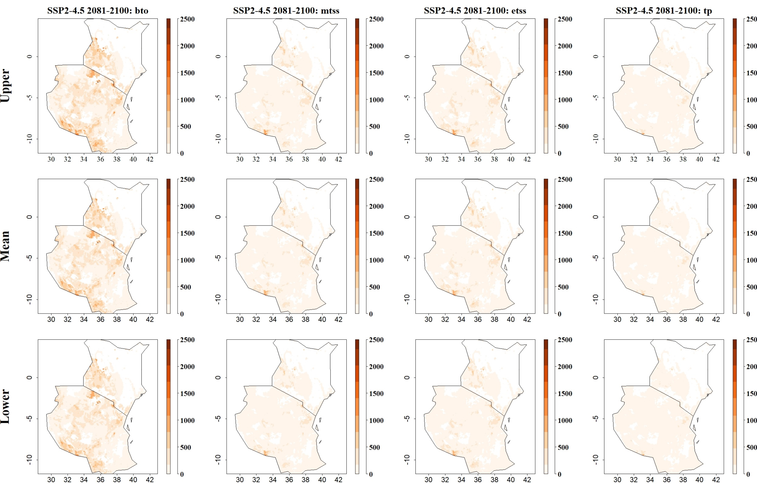
Fig: Predicted maize yield losses (in kg/ha) by the stem borer S. calamistis for SSP2-4.5 in 2081–2100 and thresholds Balance training omission, predicted area and threshold values Cloglog (bto), Maximum training sensitivity plus specificity Cloglog threshold (mtss), Equal training sensitivity and specificity Cloglog threshold (etss) and 10th percentile training presence Cloglog threshold (tp). Grid cells with high predicted yield losses are colored in darker orange to brown, whereas cells where maize yield losses by the species are low are colored in lighter orange and white
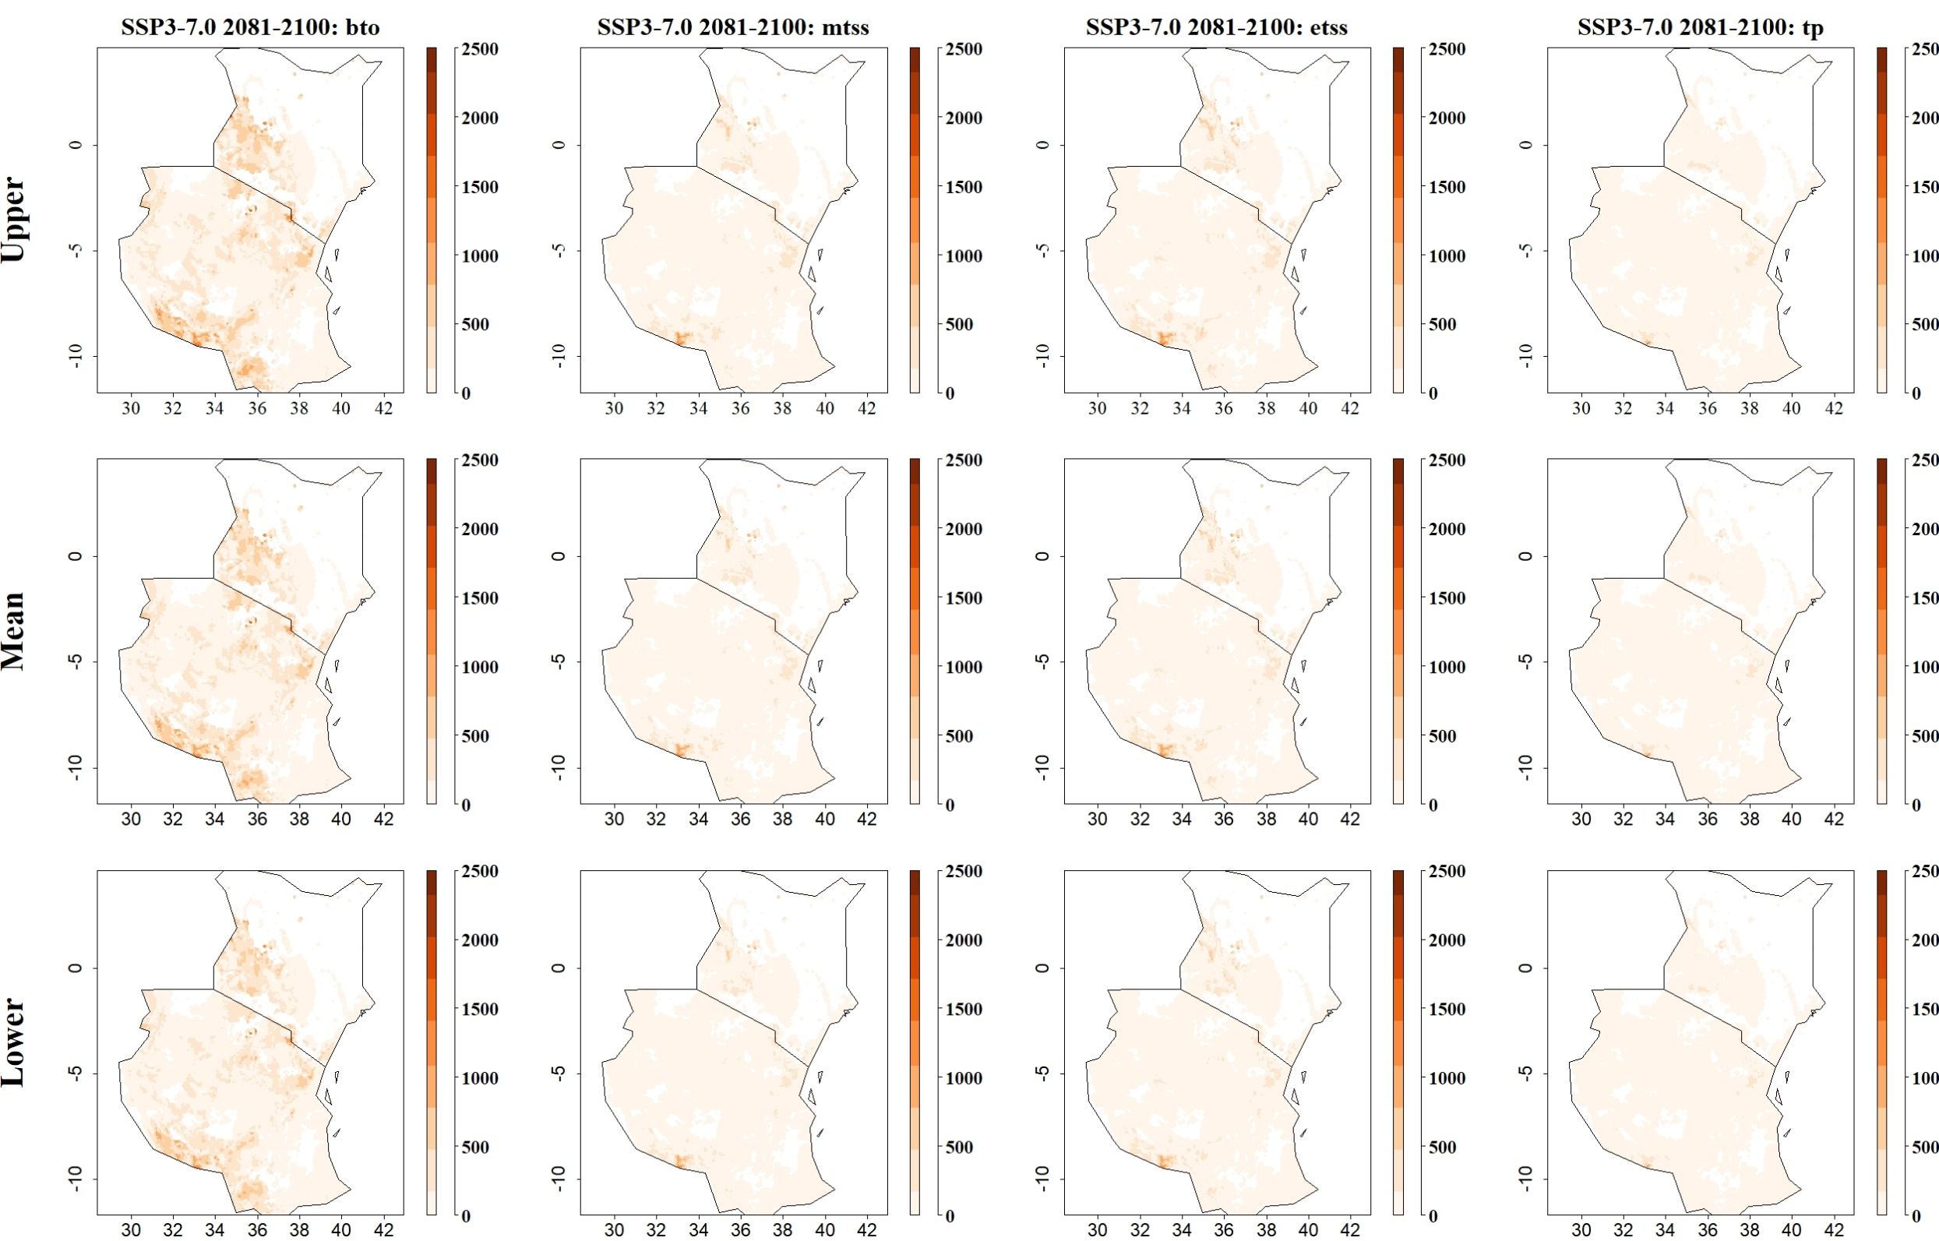
Fig: Predicted maize yield losses (in kg/ha) by the stem borer S. calamistis for SSP3-7.0 in 2081–2100 and thresholds Balance training omission, predicted area and threshold values Cloglog (bto), Maximum training sensitivity plus specificity Cloglog threshold (mtss), Equal training sensitivity and specificity Cloglog threshold (etss) and 10th percentile training presence Cloglog threshold (tp). Grid cells with high predicted yield losses are colored in darker orange to brown, whereas cells where maize yield losses by the species are low are colored in lighter orange and white
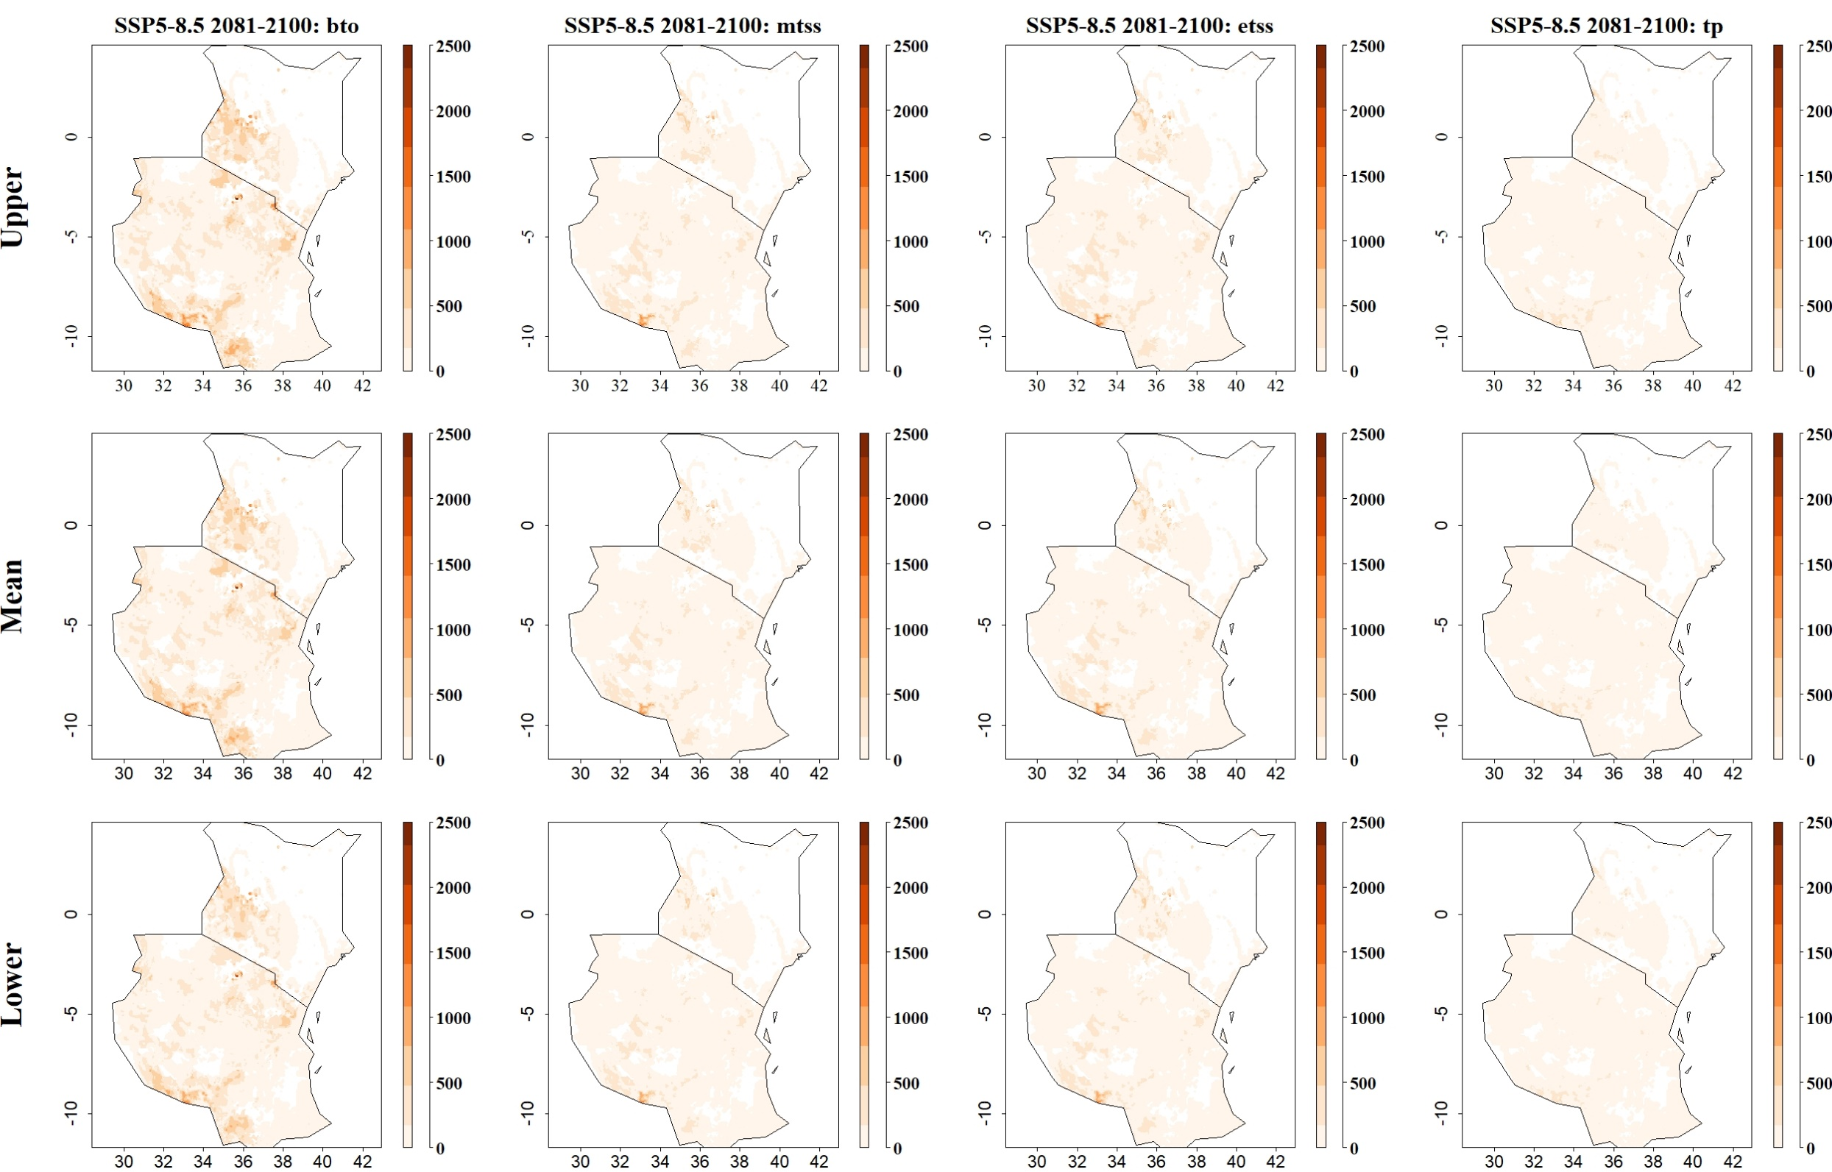
Fig: Predicted maize yield losses (in kg/ha) by the stem borer S. calamistis for SSP5-8.5 in 2081–2100 and thresholds Balance training omission, predicted area and threshold values Cloglog (bto), Maximum training sensitivity plus specificity Cloglog threshold (mtss), Equal training sensitivity and specificity Cloglog threshold (etss) and 10th percentile training presence Cloglog threshold (tp). Grid cells with high predicted yield losses are colored in darker orange to brown, whereas cells where maize yield losses by the species are low are colored in lighter orange and white

