Article title: Uncertainties in the effectiveness of biological control of stem borers under different climate change scenarios in Eastern Africa
Journal name: Climatic Change
Author names: Ines Jendritzki, Henri E. Z. Tonnang, Paul-André Calatayud, Christian Borgemeister, Tino Johansson, Lisa Biber-Freudenberger
Affiliation and e-mail address of the corresponding author: Center for Development Research, Department of Ecology and Natural Resources Management, University of Bonn, ijendrit@uni-bonn.de

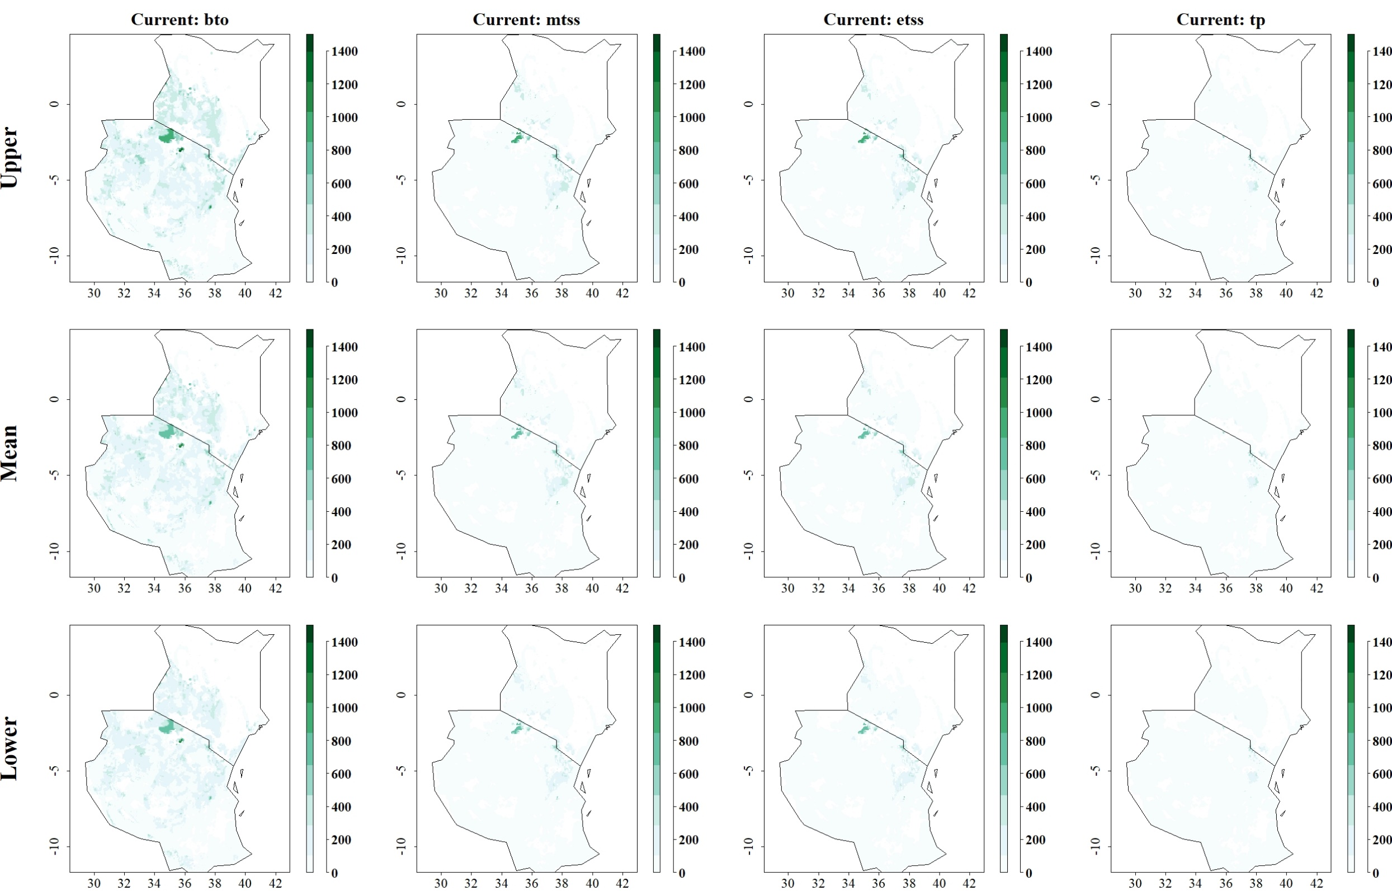
Fig: Predicted reduction of maize yield losses (in kg/ha) by B. fusca through use of C. flavipes under current climatic conditions for thresholds Balance training omission, predicted area and threshold values Cloglog (bto), Maximum training sensitivity plus specificity Cloglog threshold (mtss), Equal training sensitivity and specificity Cloglog threshold (etss) and 10th percentile training presence Cloglog threshold (tp). Grid cells where parasitoid application significantly reduces the amount of maize yield losses caused by the stem borer are colored in darker green, whereas grid cells where the reduction of maize yield losses by the species are limited are colored in lighter shades of green and white.
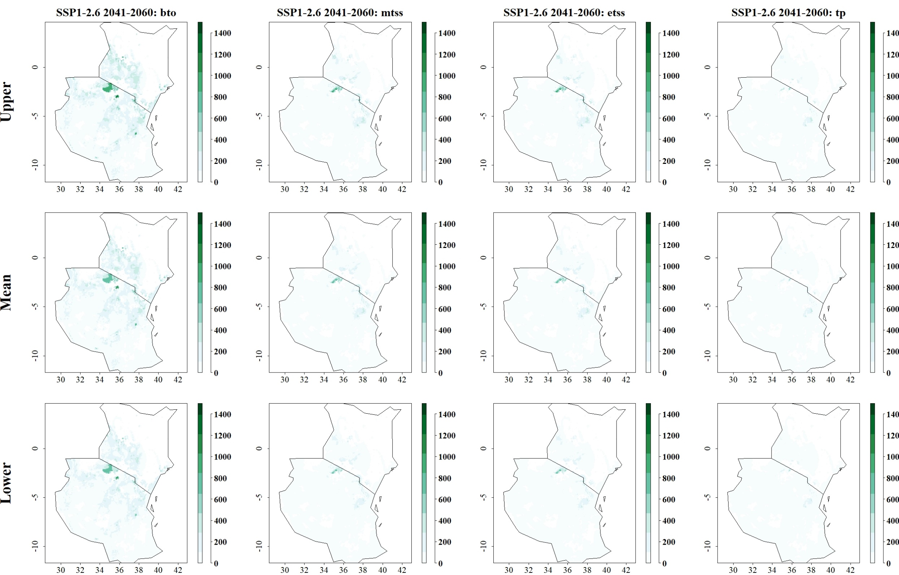
Fig: Predicted reduction of maize yield losses (in kg/ha) by B. fusca through use of C. flavipes for SSP1-2.6 in 2041–2060 and thresholds Balance training omission, predicted area and threshold values Cloglog (bto), Maximum training sensitivity plus specificity Cloglog threshold (mtss), Equal training sensitivity and specificity Cloglog threshold (etss) and 10th percentile training presence Cloglog threshold (tp). Grid cells where parasitoid application significantly reduces the amount of maize yield losses caused by the stem borer are colored in darker green, whereas grid cells where the reduction of maize yield losses by the species are limited are colored in lighter shades of green and white.
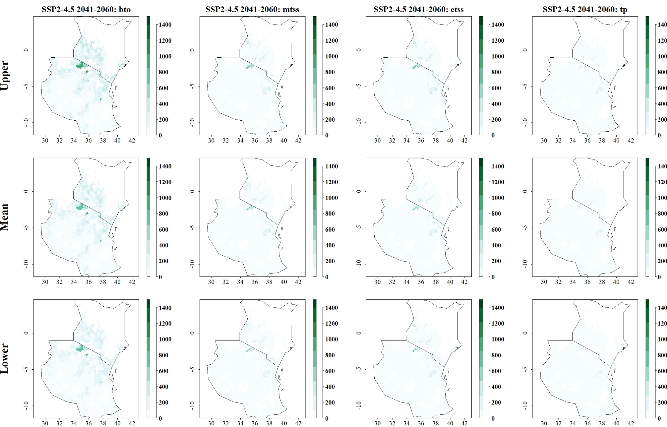
Fig: Predicted reduction of maize yield losses (in kg/ha) by B. fusca through use of C. flavipes for SSP2-4.5 in 2041–2060 and thresholds Balance training omission, predicted area and threshold values Cloglog (bto), Maximum training sensitivity plus specificity Cloglog threshold (mtss), Equal training sensitivity and specificity Cloglog threshold (etss) and 10th percentile training presence Cloglog threshold (tp). Grid cells where parasitoid application significantly reduces the amount of maize yield losses caused by the stem borer are colored in darker green, whereas grid cells where the reduction of maize yield losses by the species are limited are colored in lighter shades of green and white.
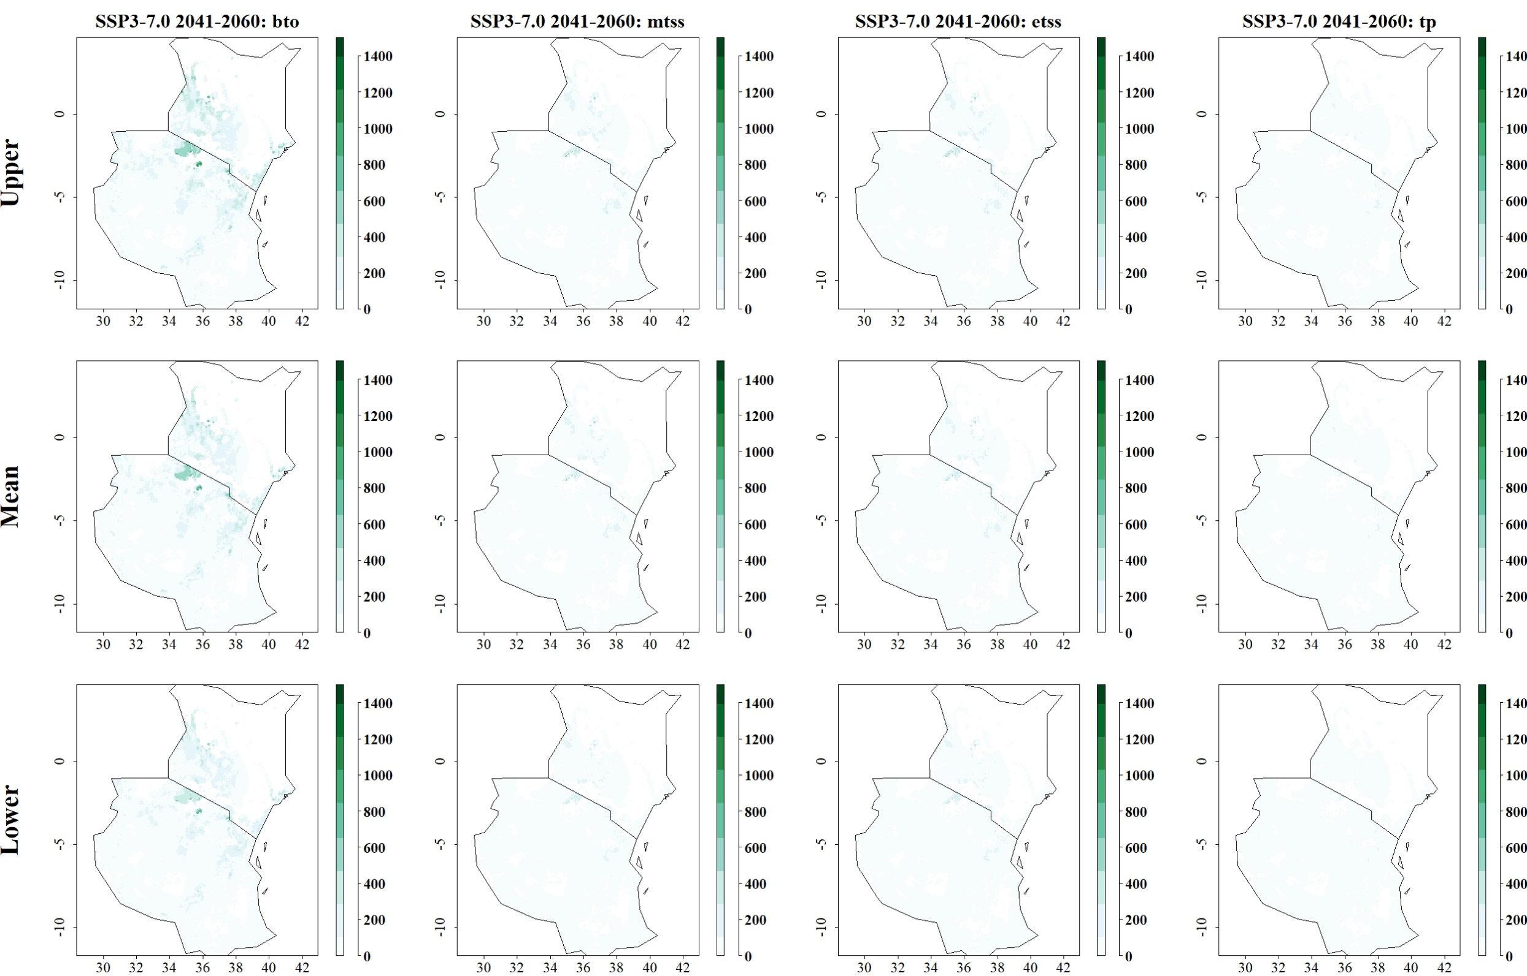
Fig: Predicted reduction of maize yield losses (in kg/ha) by B. fusca through use of C. flavipes for SSP3-7.0 in 2041–2060 and thresholds Balance training omission, predicted area and threshold values Cloglog (bto), Maximum training sensitivity plus specificity Cloglog threshold (mtss), Equal training sensitivity and specificity Cloglog threshold (etss) and 10th percentile training presence Cloglog threshold (tp). Grid cells where parasitoid application significantly reduces the amount of maize yield losses caused by the stem borer are colored in darker green, whereas grid cells where the reduction of maize yield losses by the species are limited are colored in lighter shades of green and white.
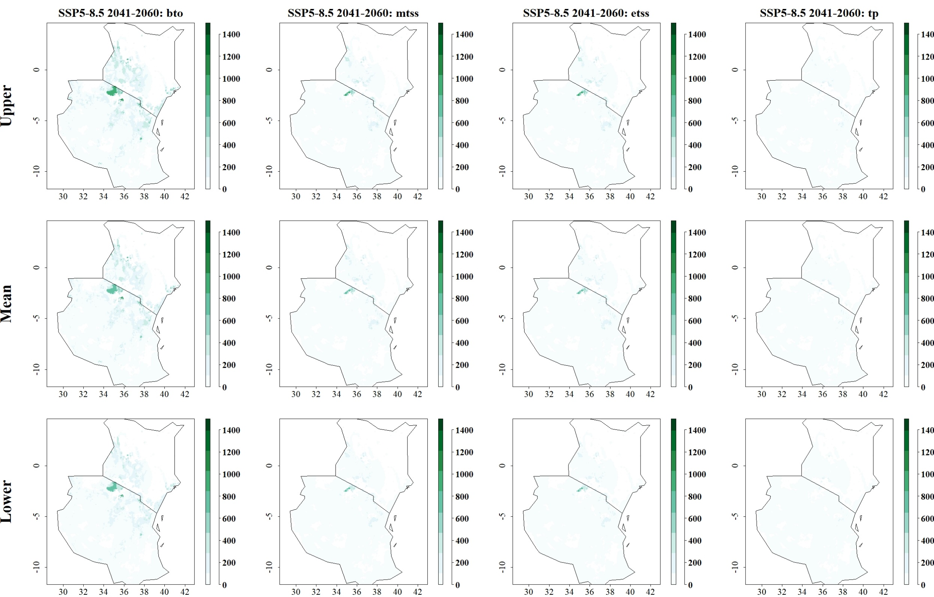
Fig: Predicted reduction of maize yield losses (in kg/ha) by B. fusca through use of C. flavipes for SSP5-8.5 in 2041–2060 and thresholds Balance training omission, predicted area and threshold values Cloglog (bto), Maximum training sensitivity plus specificity Cloglog threshold (mtss), Equal training sensitivity and specificity Cloglog threshold (etss) and 10th percentile training presence Cloglog threshold (tp). Grid cells where parasitoid application significantly reduces the amount of maize yield losses caused by the stem borer are colored in darker green, whereas grid cells where the reduction of maize yield losses by the species are limited are colored in lighter shades of green and white.
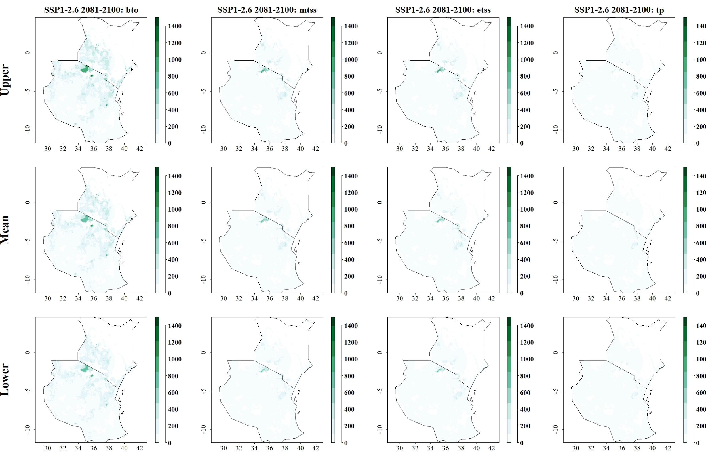
Fig: Predicted reduction of maize yield losses (in kg/ha) by B. fusca through use of C. flavipes for SSP1-2.6 in 2081–2100 and thresholds Balance training omission, predicted area and threshold values Cloglog (bto), Maximum training sensitivity plus specificity Cloglog threshold (mtss), Equal training sensitivity and specificity Cloglog threshold (etss) and 10th percentile training presence Cloglog threshold (tp). Grid cells where parasitoid application significantly reduces the amount of maize yield losses caused by the stem borer are colored in darker green, whereas grid cells where the reduction of maize yield losses by the species are limited are colored in lighter shades of green and white.
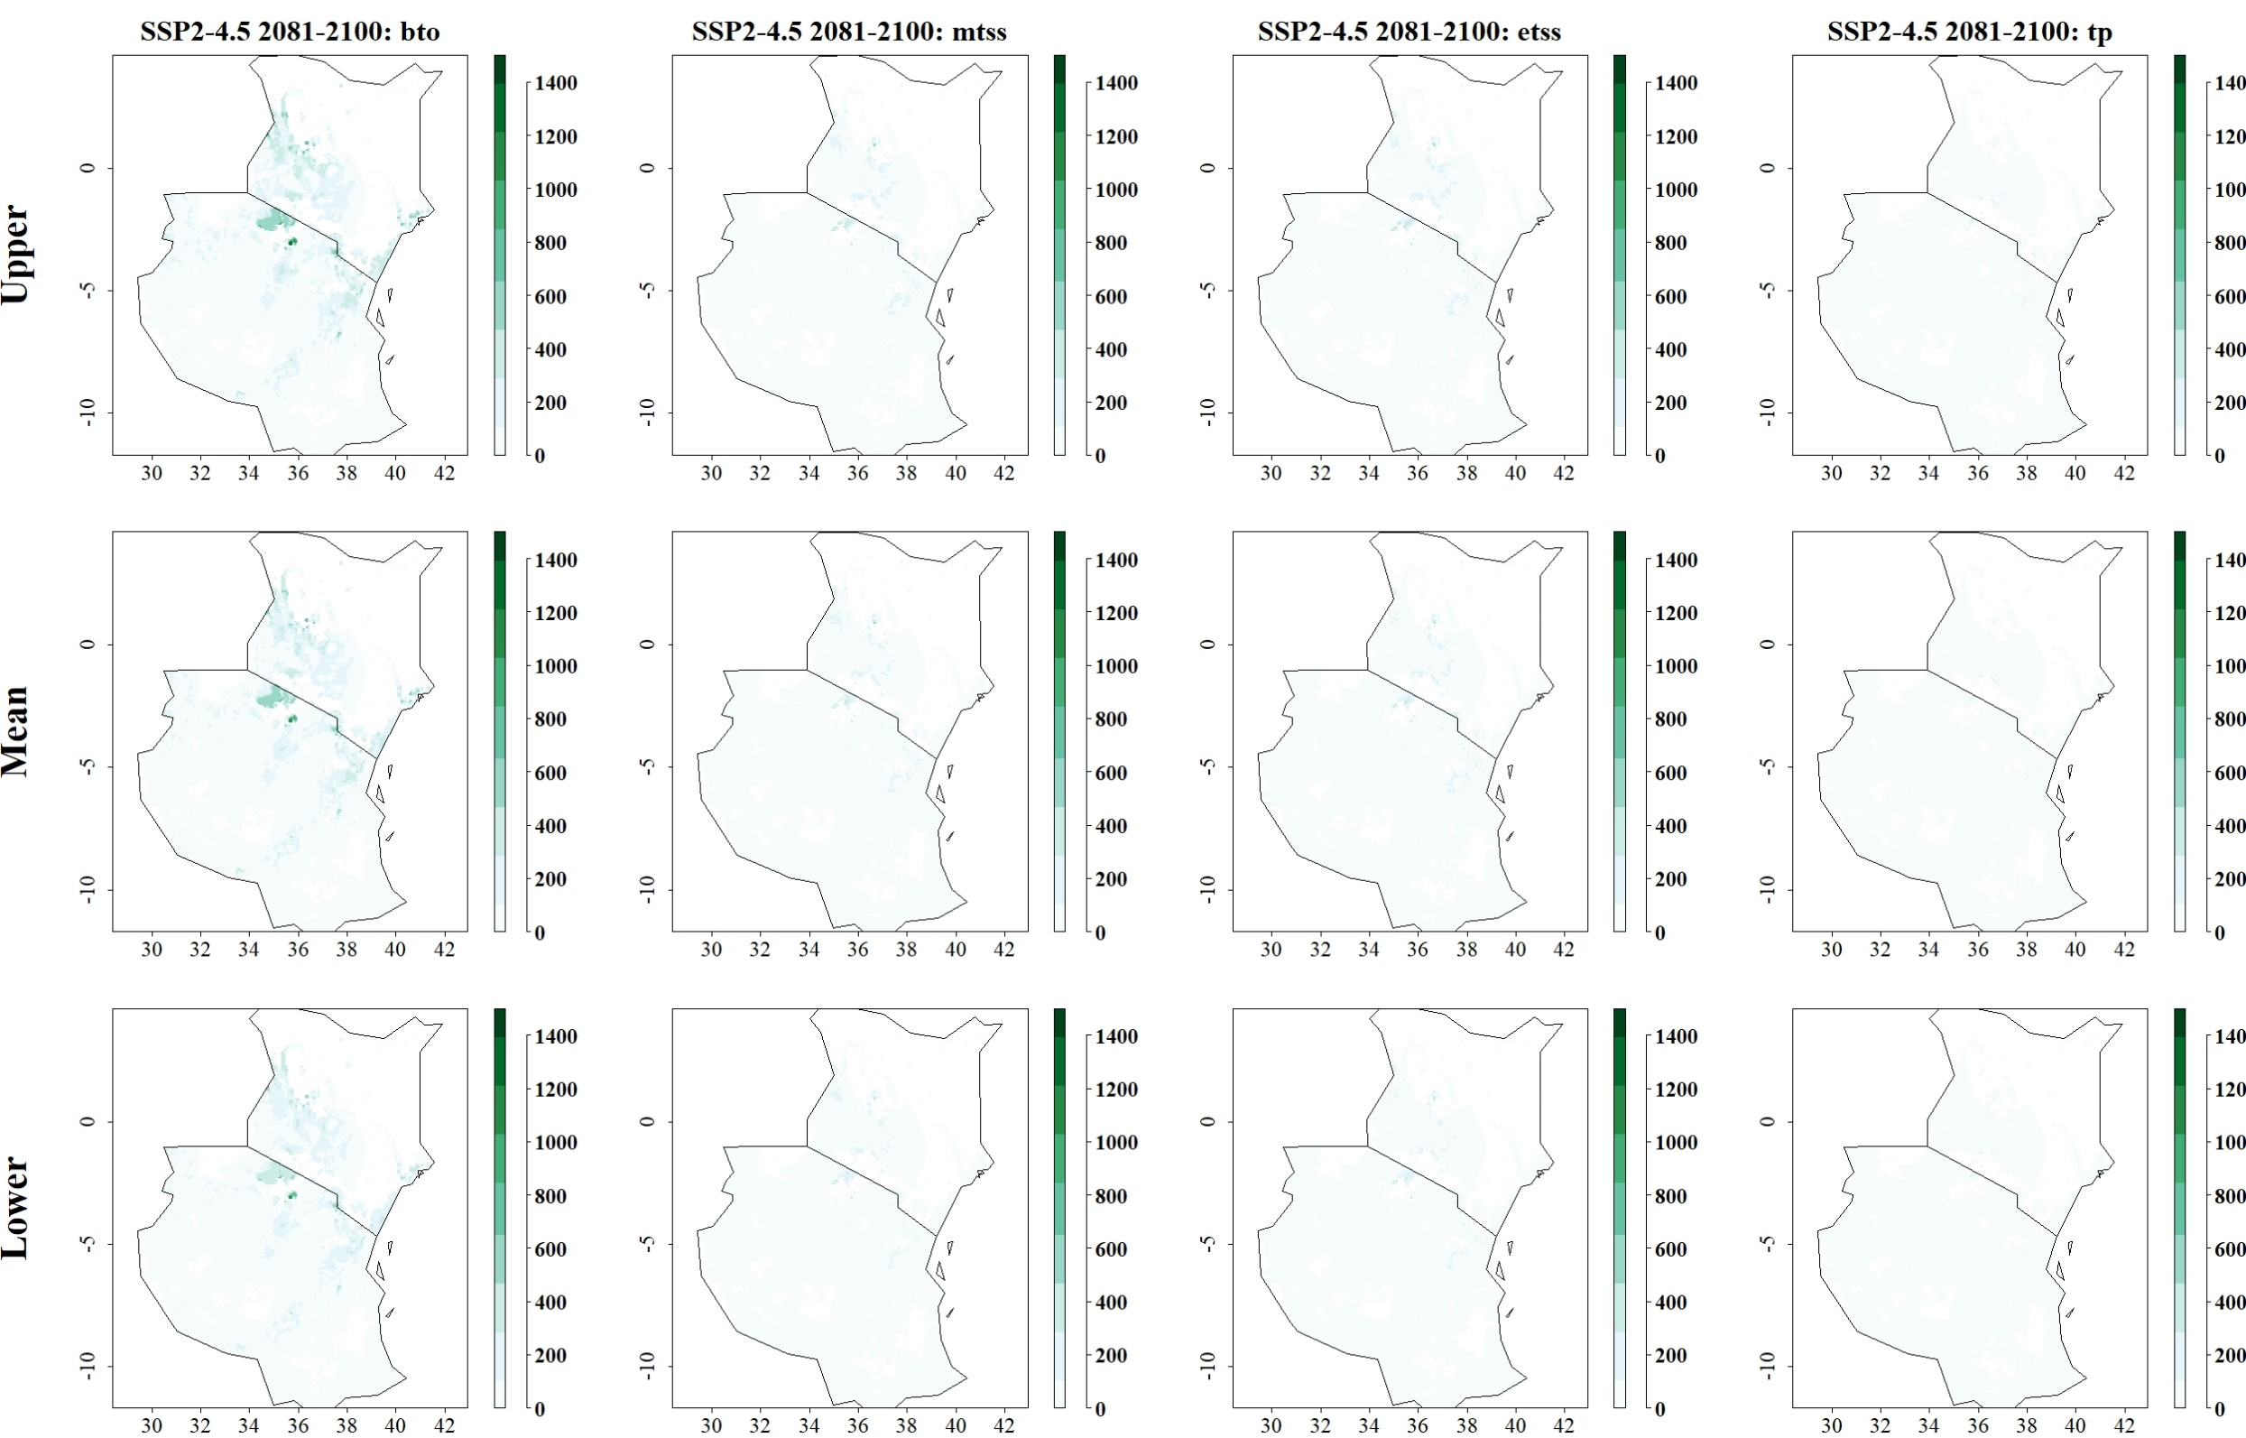
Fig: Predicted reduction of maize yield losses (in kg/ha) by B. fusca through use of C. flavipes for SSP2-4.5 in 2081–2100 and thresholds Balance training omission, predicted area and threshold values Cloglog (bto), Maximum training sensitivity plus specificity Cloglog threshold (mtss), Equal training sensitivity and specificity Cloglog threshold (etss) and 10th percentile training presence Cloglog threshold (tp). Grid cells where parasitoid application significantly reduces the amount of maize yield losses caused by the stem borer are colored in darker green, whereas grid cells where the reduction of maize yield losses by the species are limited are colored in lighter shades of green and white.
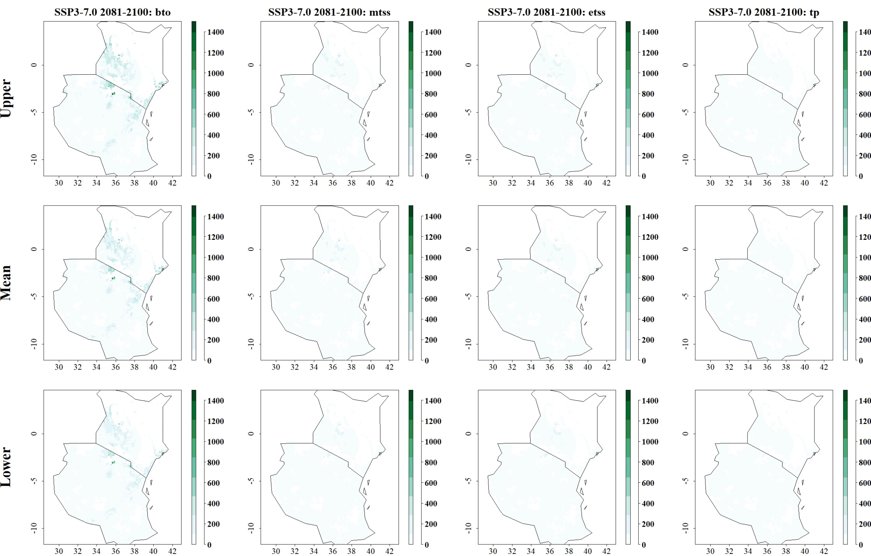
Fig: Predicted reduction of maize yield losses (in kg/ha) by B. fusca through use of C. flavipes for SSP3-7.0 in 2081–2100 and thresholds Balance training omission, predicted area and threshold values Cloglog (bto), Maximum training sensitivity plus specificity Cloglog threshold (mtss), Equal training sensitivity and specificity Cloglog threshold (etss) and 10th percentile training presence Cloglog threshold (tp). Grid cells where parasitoid application significantly reduces the amount of maize yield losses caused by the stem borer are colored in darker green, whereas grid cells where the reduction of maize yield losses by the species are limited are colored in lighter shades of green and white.
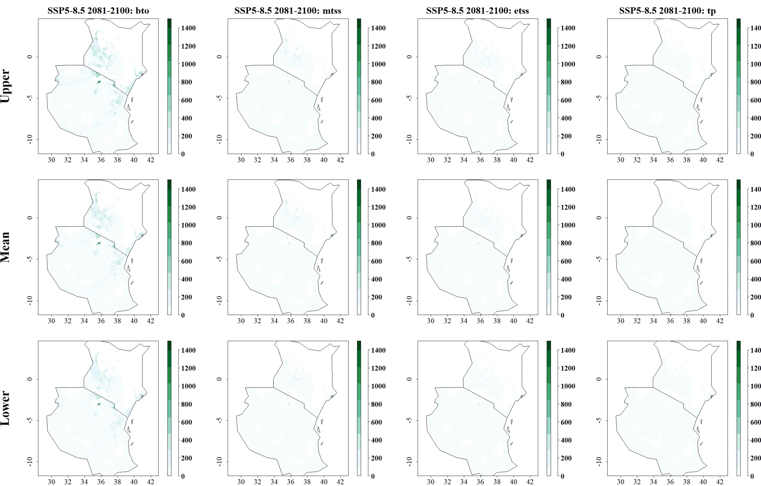
Fig: Predicted reduction of maize yield losses (in kg/ha) by B. fusca through use of C. flavipes for SSP5-8.5 in 2081–2100 and thresholds Balance training omission, predicted area and threshold values Cloglog (bto), Maximum training sensitivity plus specificity Cloglog threshold (mtss), Equal training sensitivity and specificity Cloglog threshold (etss) and 10th percentile training presence Cloglog threshold (tp). Grid cells where parasitoid application significantly reduces the amount of maize yield losses caused by the stem borer are colored in darker green, whereas grid cells where the reduction of maize yield losses by the species are limited are colored in lighter shades of green and white.
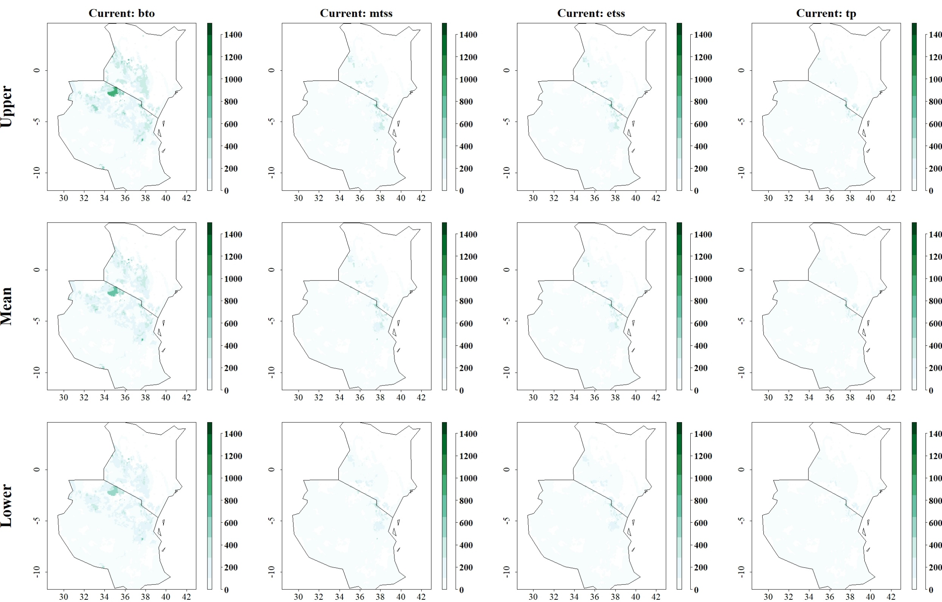

Fig: Predicted reduction of maize yield losses (in kg/ha) by B. fusca through use of C. sesamiae under current climatic conditions for thresholds Balance training omission, predicted area and threshold values Cloglog (bto), Maximum training sensitivity plus specificity Cloglog threshold (mtss), Equal training sensitivity and specificity Cloglog threshold (etss) and 10th percentile training presence Cloglog threshold (tp). Grid cells where parasitoid application significantly reduces the amount of maize yield losses caused by the stem borer are colored in darker green, whereas grid cells where the reduction of maize yield losses by the species are limited are colored in lighter shades of green and white.
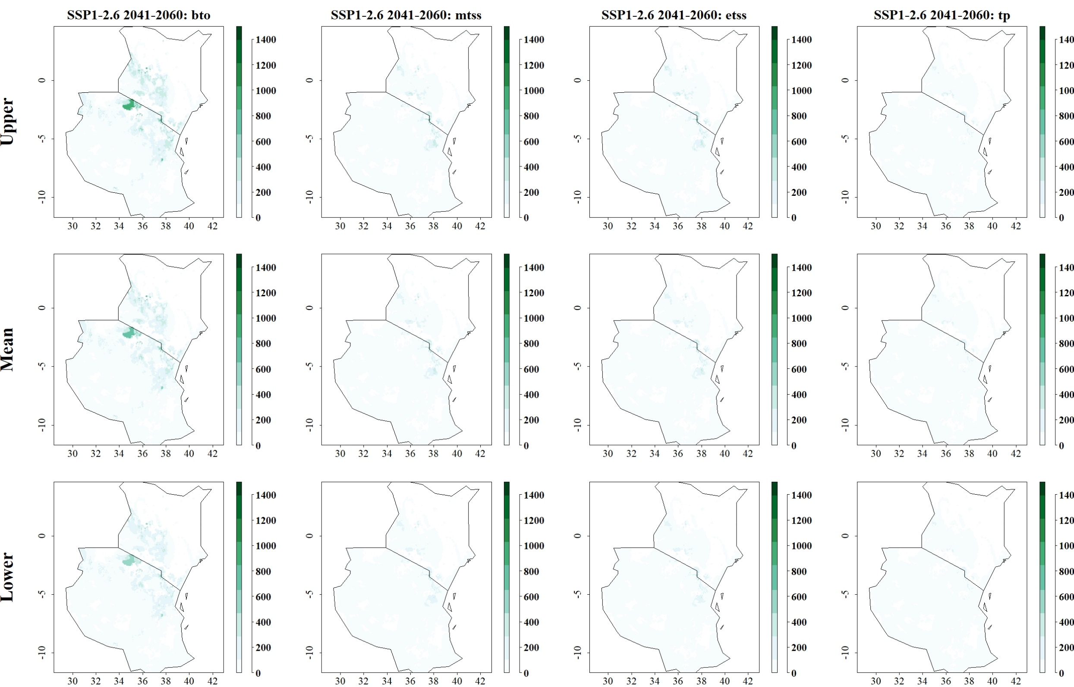
Fig: Predicted reduction of maize yield losses (in kg/ha) by B. fusca through use of C. sesamiae for SSP1-2.6 in 2041–2060 and thresholds Balance training omission, predicted area and threshold values Cloglog (bto), Maximum training sensitivity plus specificity Cloglog threshold (mtss), Equal training sensitivity and specificity Cloglog threshold (etss) and 10th percentile training presence Cloglog threshold (tp). Grid cells where parasitoid application significantly reduces the amount of maize yield losses caused by the stem borer are colored in darker green, whereas grid cells where the reduction of maize yield losses by the species are limited are colored in lighter shades of green and white.
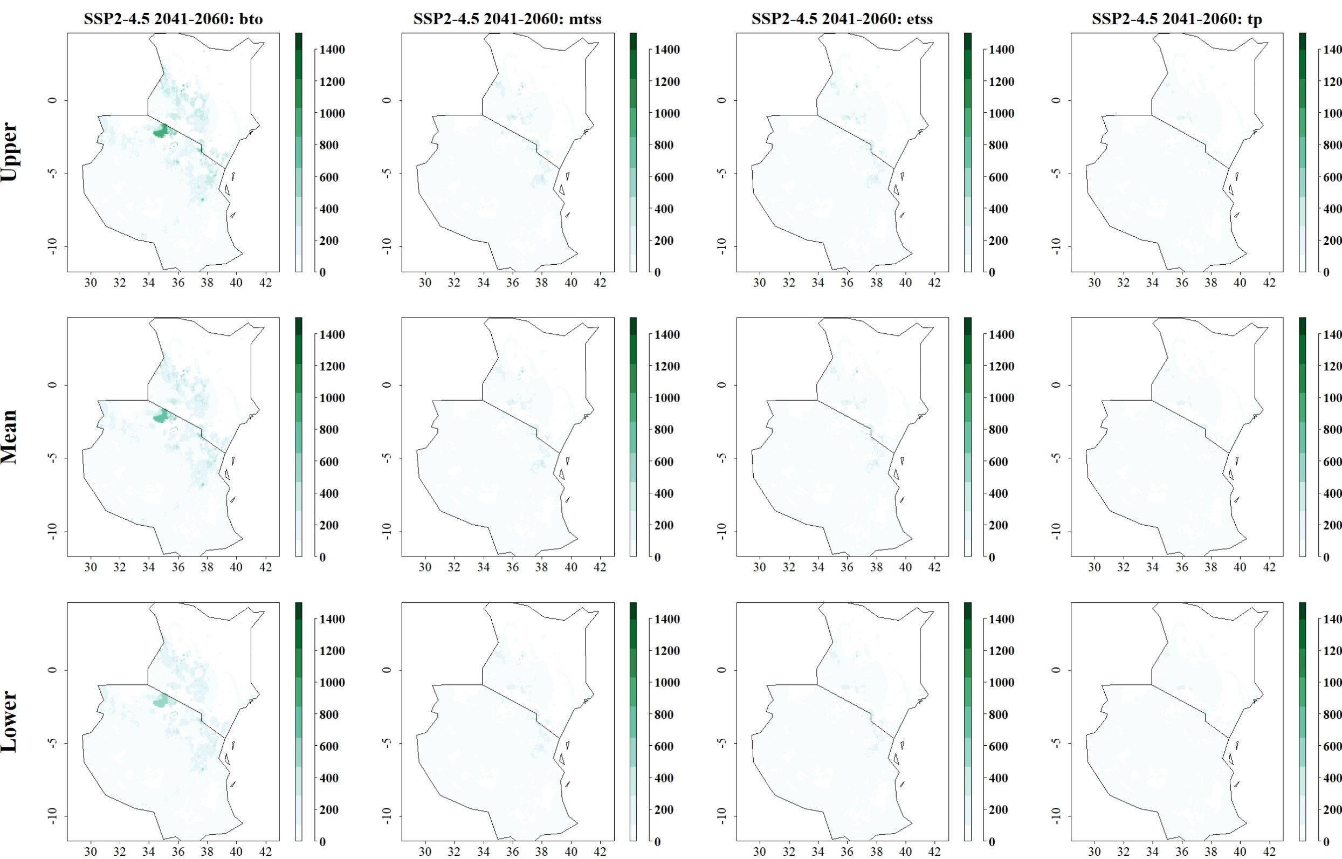
Fig: Predicted reduction of maize yield losses (in kg/ha) by B. fusca through use of C. sesamiae for SSP2-4.5 in 2041–2060 and thresholds Balance training omission, predicted area and threshold values Cloglog (bto), Maximum training sensitivity plus specificity Cloglog threshold (mtss), Equal training sensitivity and specificity Cloglog threshold (etss) and 10th percentile training presence Cloglog threshold (tp). Grid cells where parasitoid application significantly reduces the amount of maize yield losses caused by the stem borer are colored in darker green, whereas grid cells where the reduction of maize yield losses by the species are limited are colored in lighter shades of green and white.
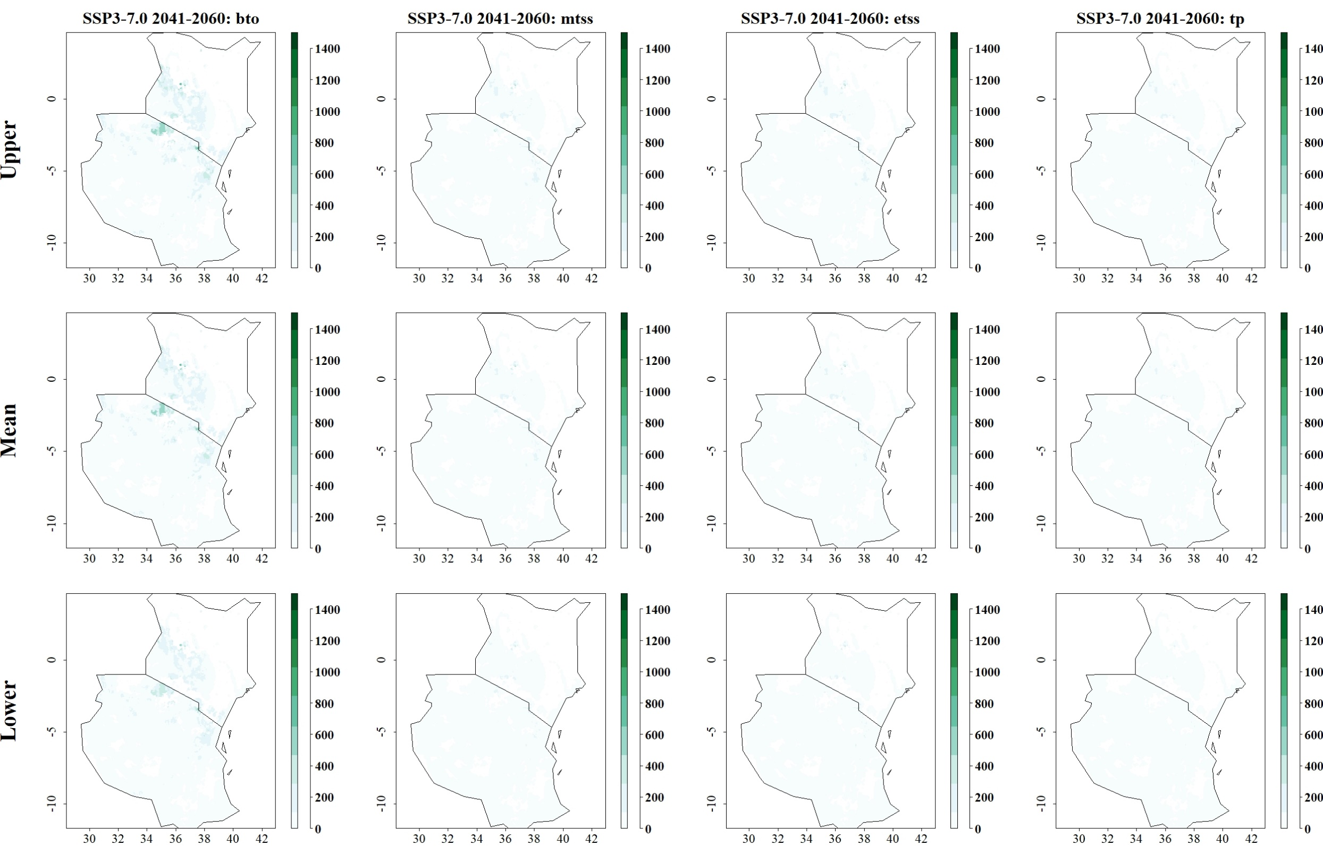
Fig: Predicted reduction of maize yield losses (in kg/ha) by B. fusca through use of C. sesamiae for SSP3-7.0 in 2041–2060 and thresholds Balance training omission, predicted area and threshold values Cloglog (bto), Maximum training sensitivity plus specificity Cloglog threshold (mtss), Equal training sensitivity and specificity Cloglog threshold (etss) and 10th percentile training presence Cloglog threshold (tp). Grid cells where parasitoid application significantly reduces the amount of maize yield losses caused by the stem borer are colored in darker green, whereas grid cells where the reduction of maize yield losses by the species are limited are colored in lighter shades of green and white.
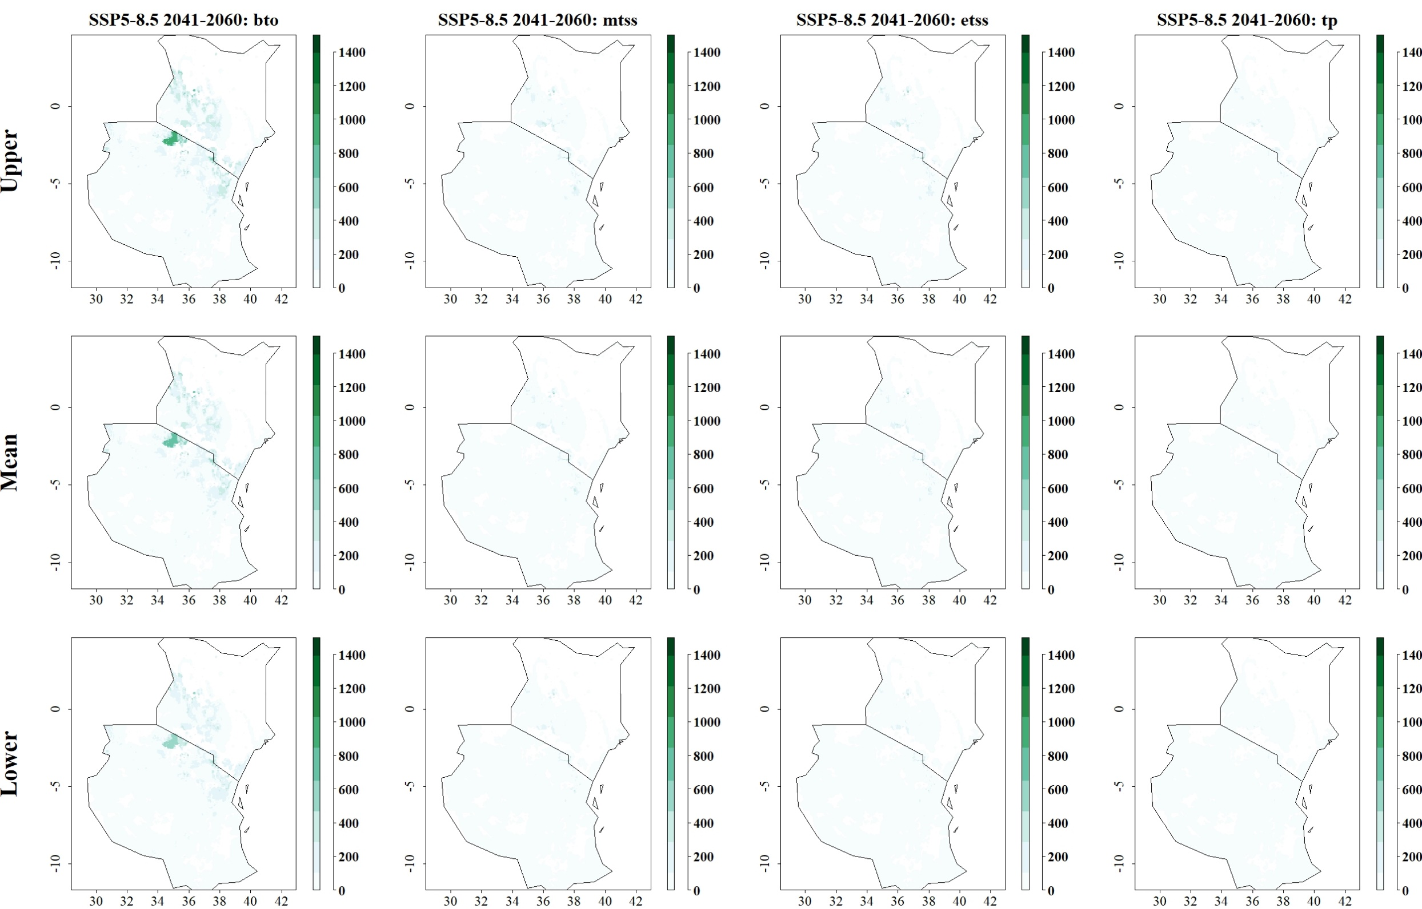
Fig: Predicted reduction of maize yield losses (in kg/ha) by B. fusca through use of C. sesamiae for SSP5-8.5 in 2041–2060 and thresholds Balance training omission, predicted area and threshold values Cloglog (bto), Maximum training sensitivity plus specificity Cloglog threshold (mtss), Equal training sensitivity and specificity Cloglog threshold (etss) and 10th percentile training presence Cloglog threshold (tp). Grid cells where parasitoid application significantly reduces the amount of maize yield losses caused by the stem borer are colored in darker green, whereas grid cells where the reduction of maize yield losses by the species are limited are colored in lighter shades of green and white.
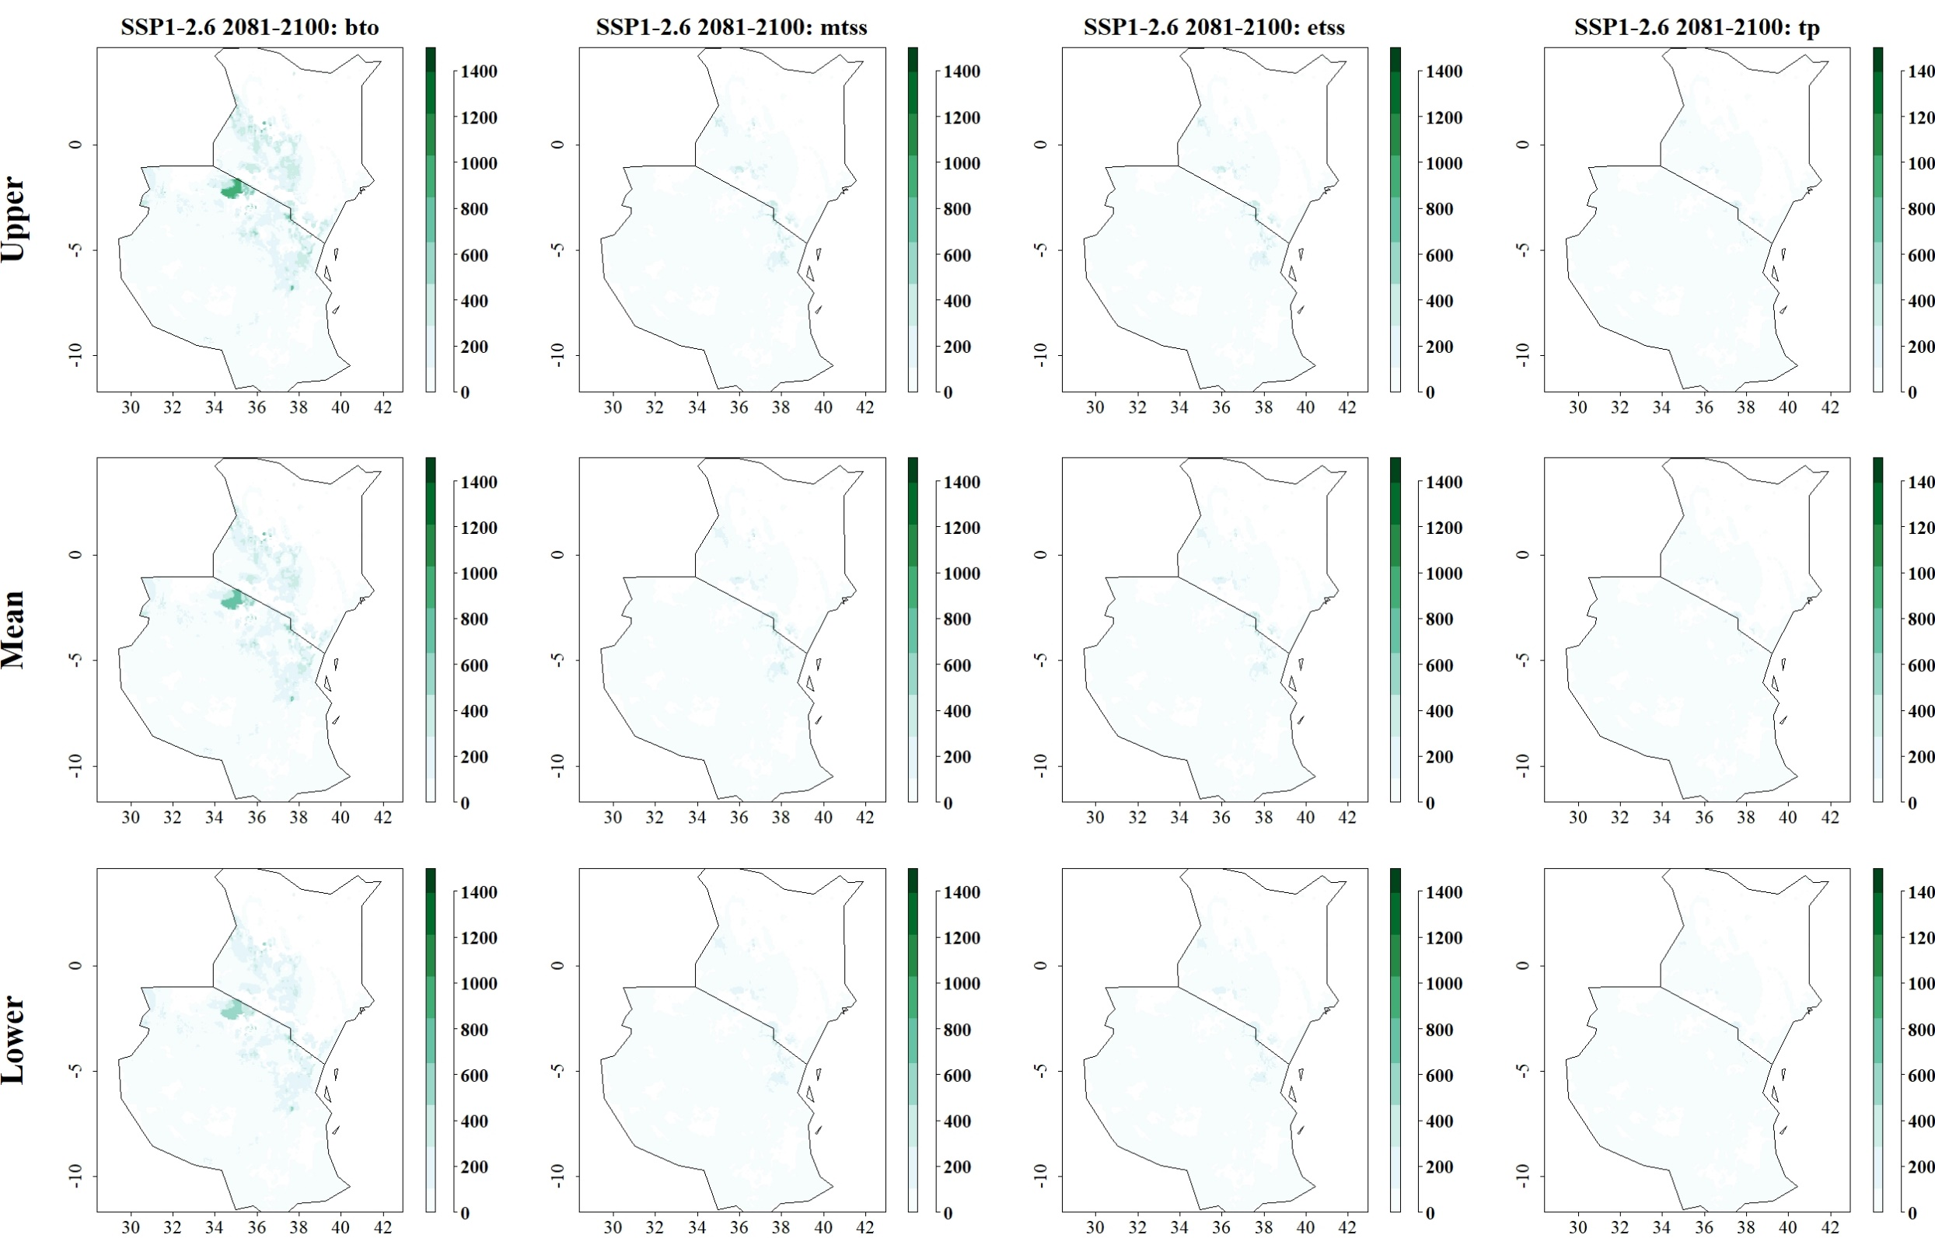
Fig: Predicted reduction of maize yield losses (in kg/ha) by B. fusca through use of C. sesamiae for SSP1-2.6 in 2081–2100 and thresholds Balance training omission, predicted area and threshold values Cloglog (bto), Maximum training sensitivity plus specificity Cloglog threshold (mtss), Equal training sensitivity and specificity Cloglog threshold (etss) and 10th percentile training presence Cloglog threshold (tp). Grid cells where parasitoid application significantly reduces the amount of maize yield losses caused by the stem borer are colored in darker green, whereas grid cells where the reduction of maize yield losses by the species are limited are colored in lighter shades of green and white.
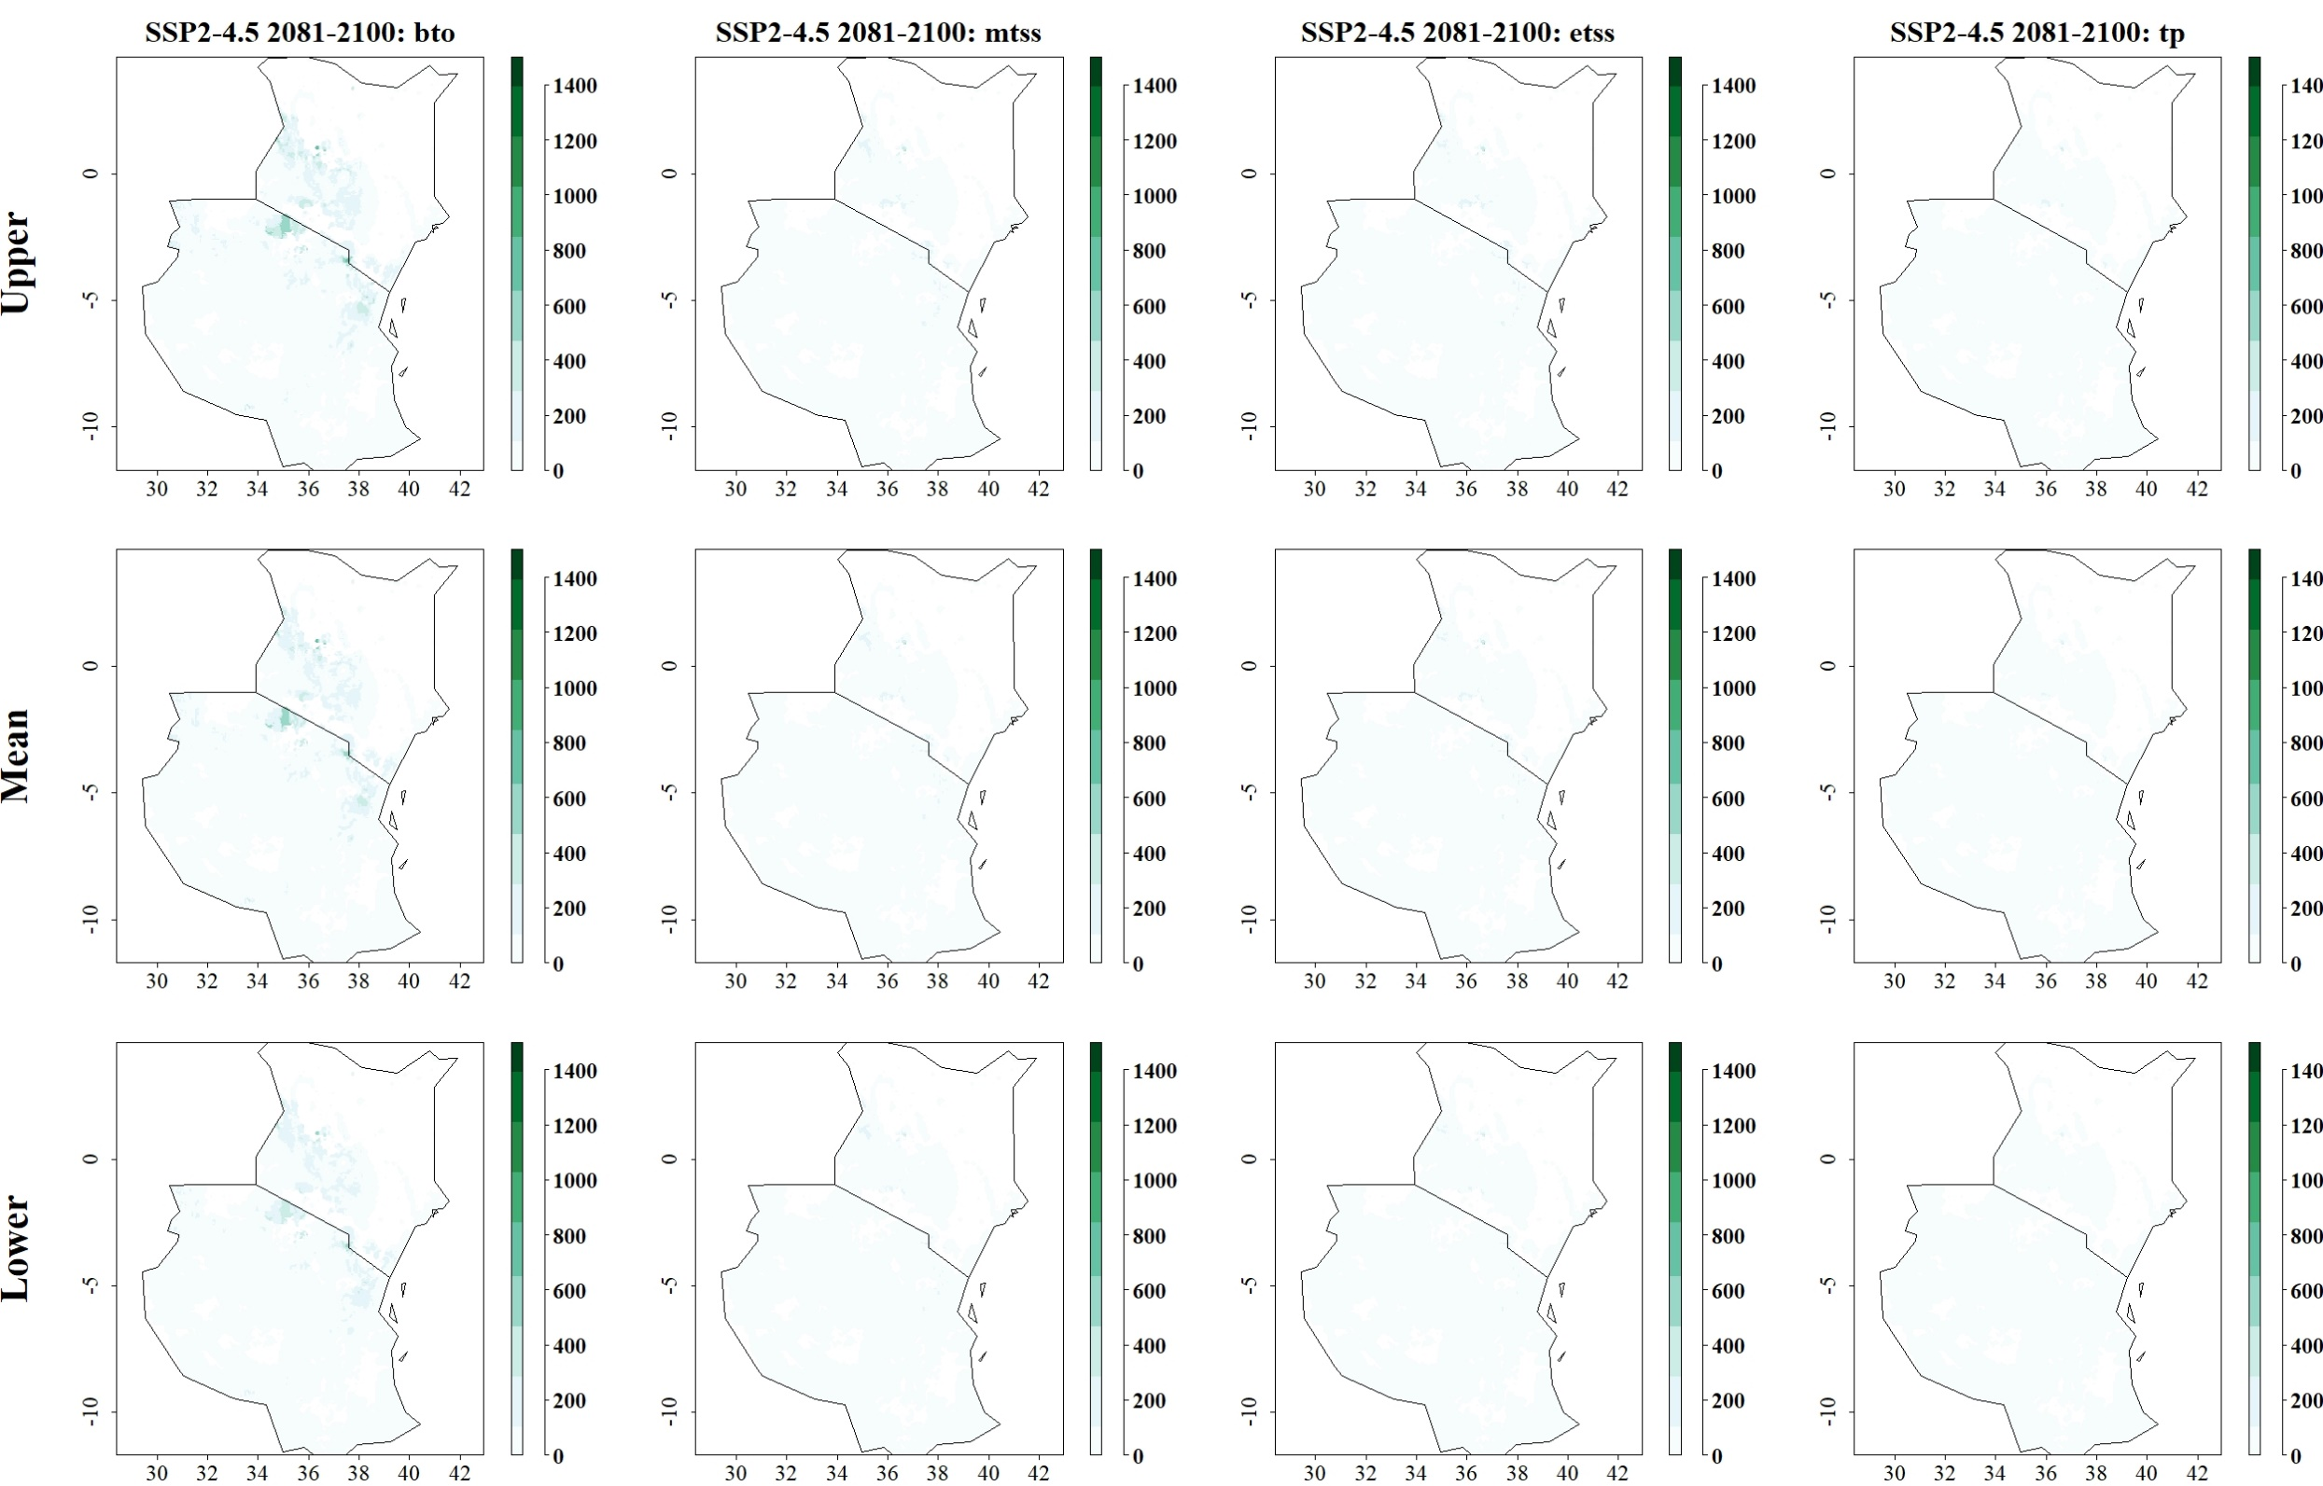
Fig: Predicted reduction of maize yield losses (in kg/ha) by B. fusca through use of C. sesamiae for SSP2-4.5 in 2081–2100 and thresholds Balance training omission, predicted area and threshold values Cloglog (bto), Maximum training sensitivity plus specificity Cloglog threshold (mtss), Equal training sensitivity and specificity Cloglog threshold (etss) and 10th percentile training presence Cloglog threshold (tp). Grid cells where parasitoid application significantly reduces the amount of maize yield losses caused by the stem borer are colored in darker green, whereas grid cells where the reduction of maize yield losses by the species are limited are colored in lighter shades of green and white.
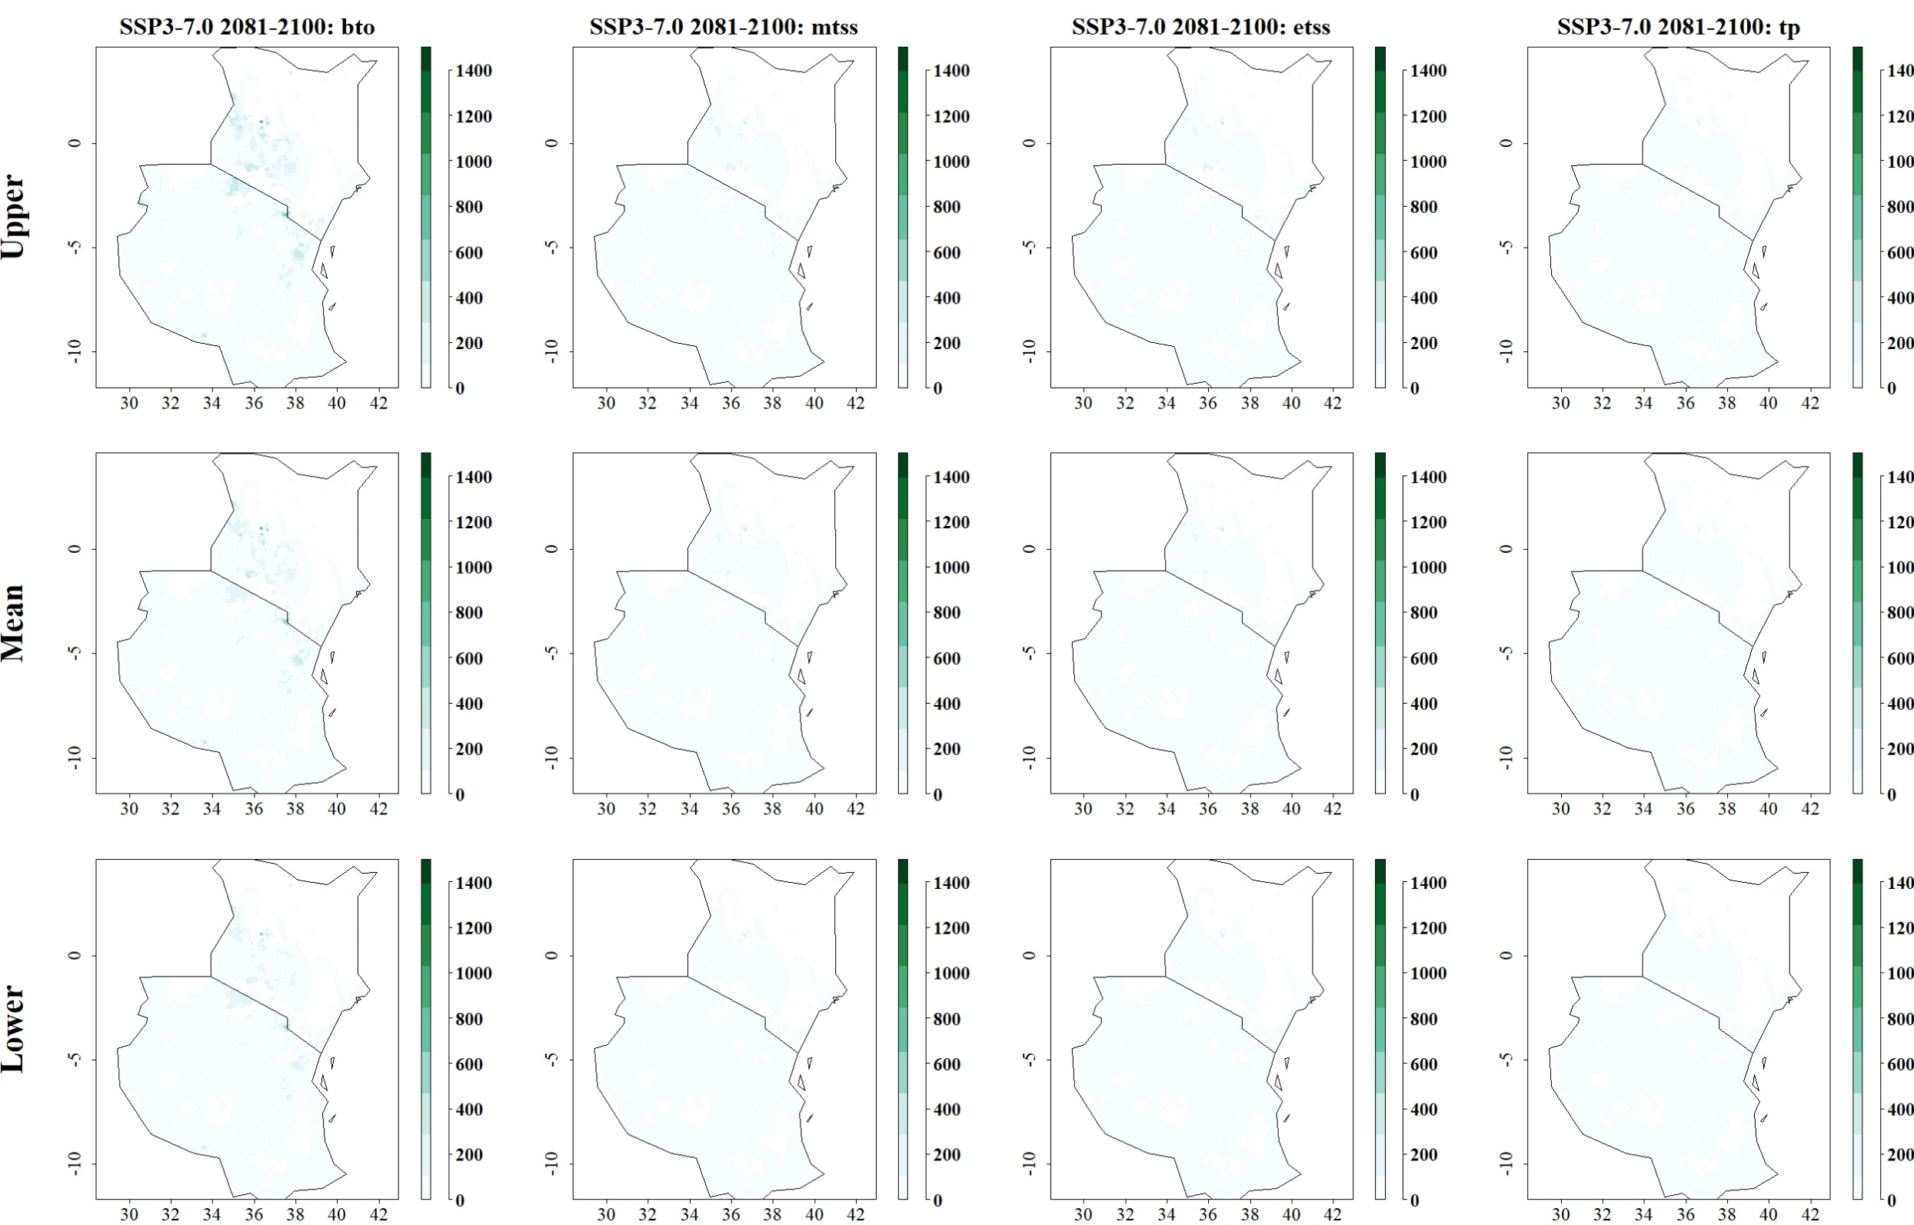
Fig: Predicted reduction of maize yield losses (in kg/ha) by B. fusca through use of C. sesamiae for SSP3-7.0 in 2081–2100 and thresholds Balance training omission, predicted area and threshold values Cloglog (bto), Maximum training sensitivity plus specificity Cloglog threshold (mtss), Equal training sensitivity and specificity Cloglog threshold (etss) and 10th percentile training presence Cloglog threshold (tp). Grid cells where parasitoid application significantly reduces the amount of maize yield losses caused by the stem borer are colored in darker green, whereas grid cells where the reduction of maize yield losses by the species are limited are colored in lighter shades of green and white.
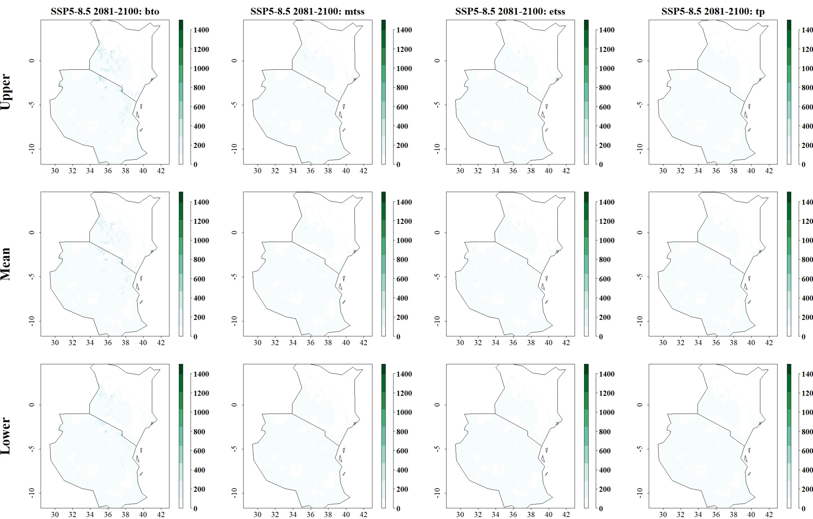
Fig: Predicted reduction of maize yield losses (in kg/ha) by B. fusca through use of C. sesamiae for SSP5-8.5 in 2081–2100 and thresholds Balance training omission, predicted area and threshold values Cloglog (bto), Maximum training sensitivity plus specificity Cloglog threshold (mtss), Equal training sensitivity and specificity Cloglog threshold (etss) and 10th percentile training presence Cloglog threshold (tp). Grid cells where parasitoid application significantly reduces the amount of maize yield losses caused by the stem borer are colored in darker green, whereas grid cells where the reduction of maize yield losses by the species are limited are colored in lighter shades of green and white.
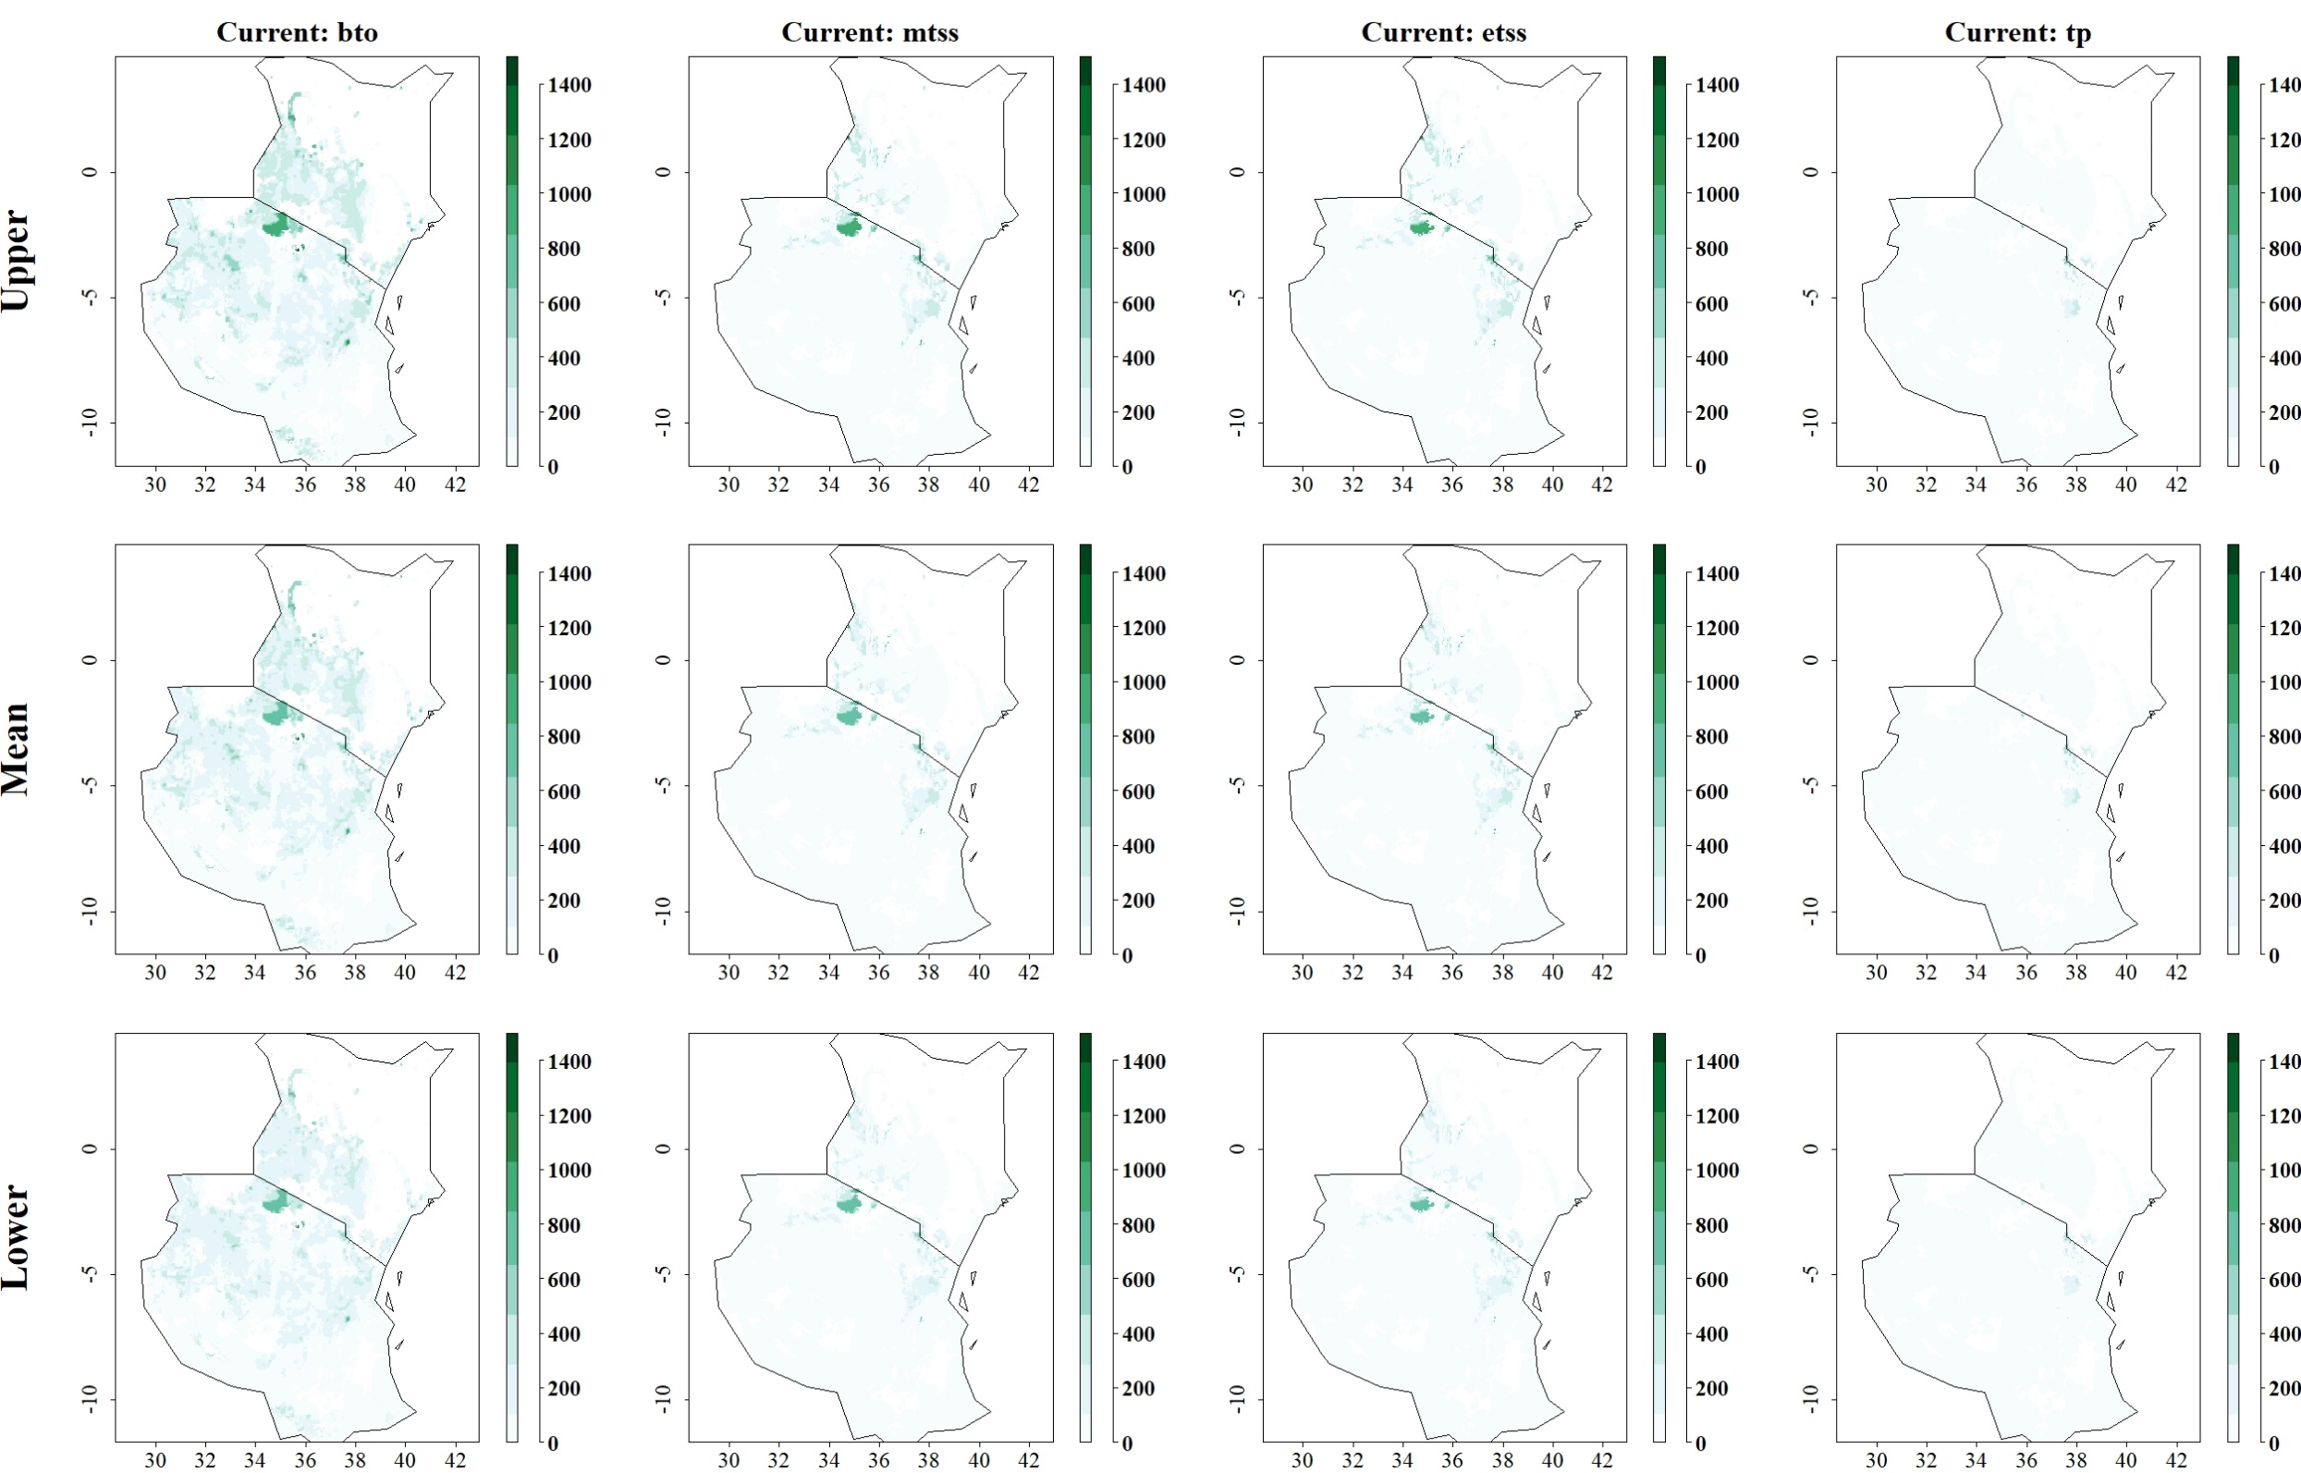
Fig: Predicted reduction of maize yield losses (in kg/ha) by C. partellus through use of C. flavipes under current climatic conditions for thresholds Balance training omission, predicted area and threshold values Cloglog (bto), Maximum training sensitivity plus specificity Cloglog threshold (mtss), Equal training sensitivity and specificity Cloglog threshold (etss) and 10th percentile training presence Cloglog threshold (tp). Grid cells where parasitoid application significantly reduces the amount of maize yield losses caused by the stem borer are colored in darker green, whereas grid cells where the reduction of maize yield losses by the species are limited are colored in lighter shades of green and white.
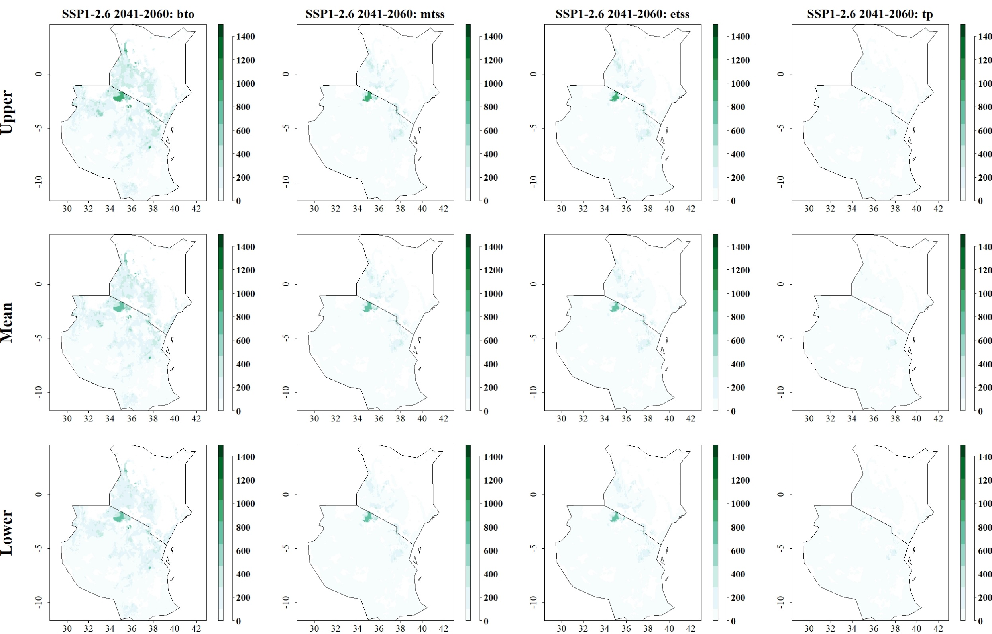
Fig: Predicted reduction of maize yield losses (in kg/ha) by C. partellus through use of C. flavipes for SSP1-2.6 in 2041–2060 and thresholds Balance training omission, predicted area and threshold values Cloglog (bto), Maximum training sensitivity plus specificity Cloglog threshold (mtss), Equal training sensitivity and specificity Cloglog threshold (etss) and 10th percentile training presence Cloglog threshold (tp). Grid cells where parasitoid application significantly reduces the amount of maize yield losses caused by the stem borer are colored in darker green, whereas grid cells where the reduction of maize yield losses by the species are limited are colored in lighter shades of green and white.
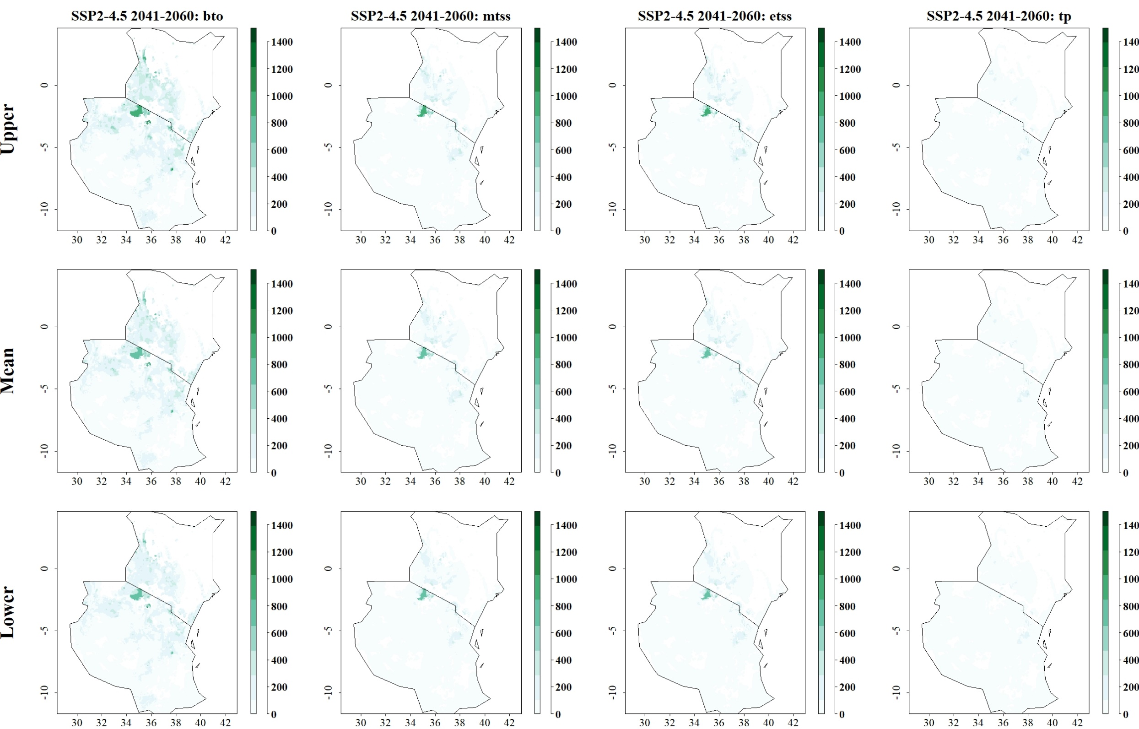
Fig: Predicted reduction of maize yield losses (in kg/ha) by C. partellus through use of C. flavipes for SSP2-4.5 in 2041–2060 and thresholds Balance training omission, predicted area and threshold values Cloglog (bto), Maximum training sensitivity plus specificity Cloglog threshold (mtss), Equal training sensitivity and specificity Cloglog threshold (etss) and 10th percentile training presence Cloglog threshold (tp). Grid cells where parasitoid application significantly reduces the amount of maize yield losses caused by the stem borer are colored in darker green, whereas grid cells where the reduction of maize yield losses by the species are limited are colored in lighter shades of green and white.
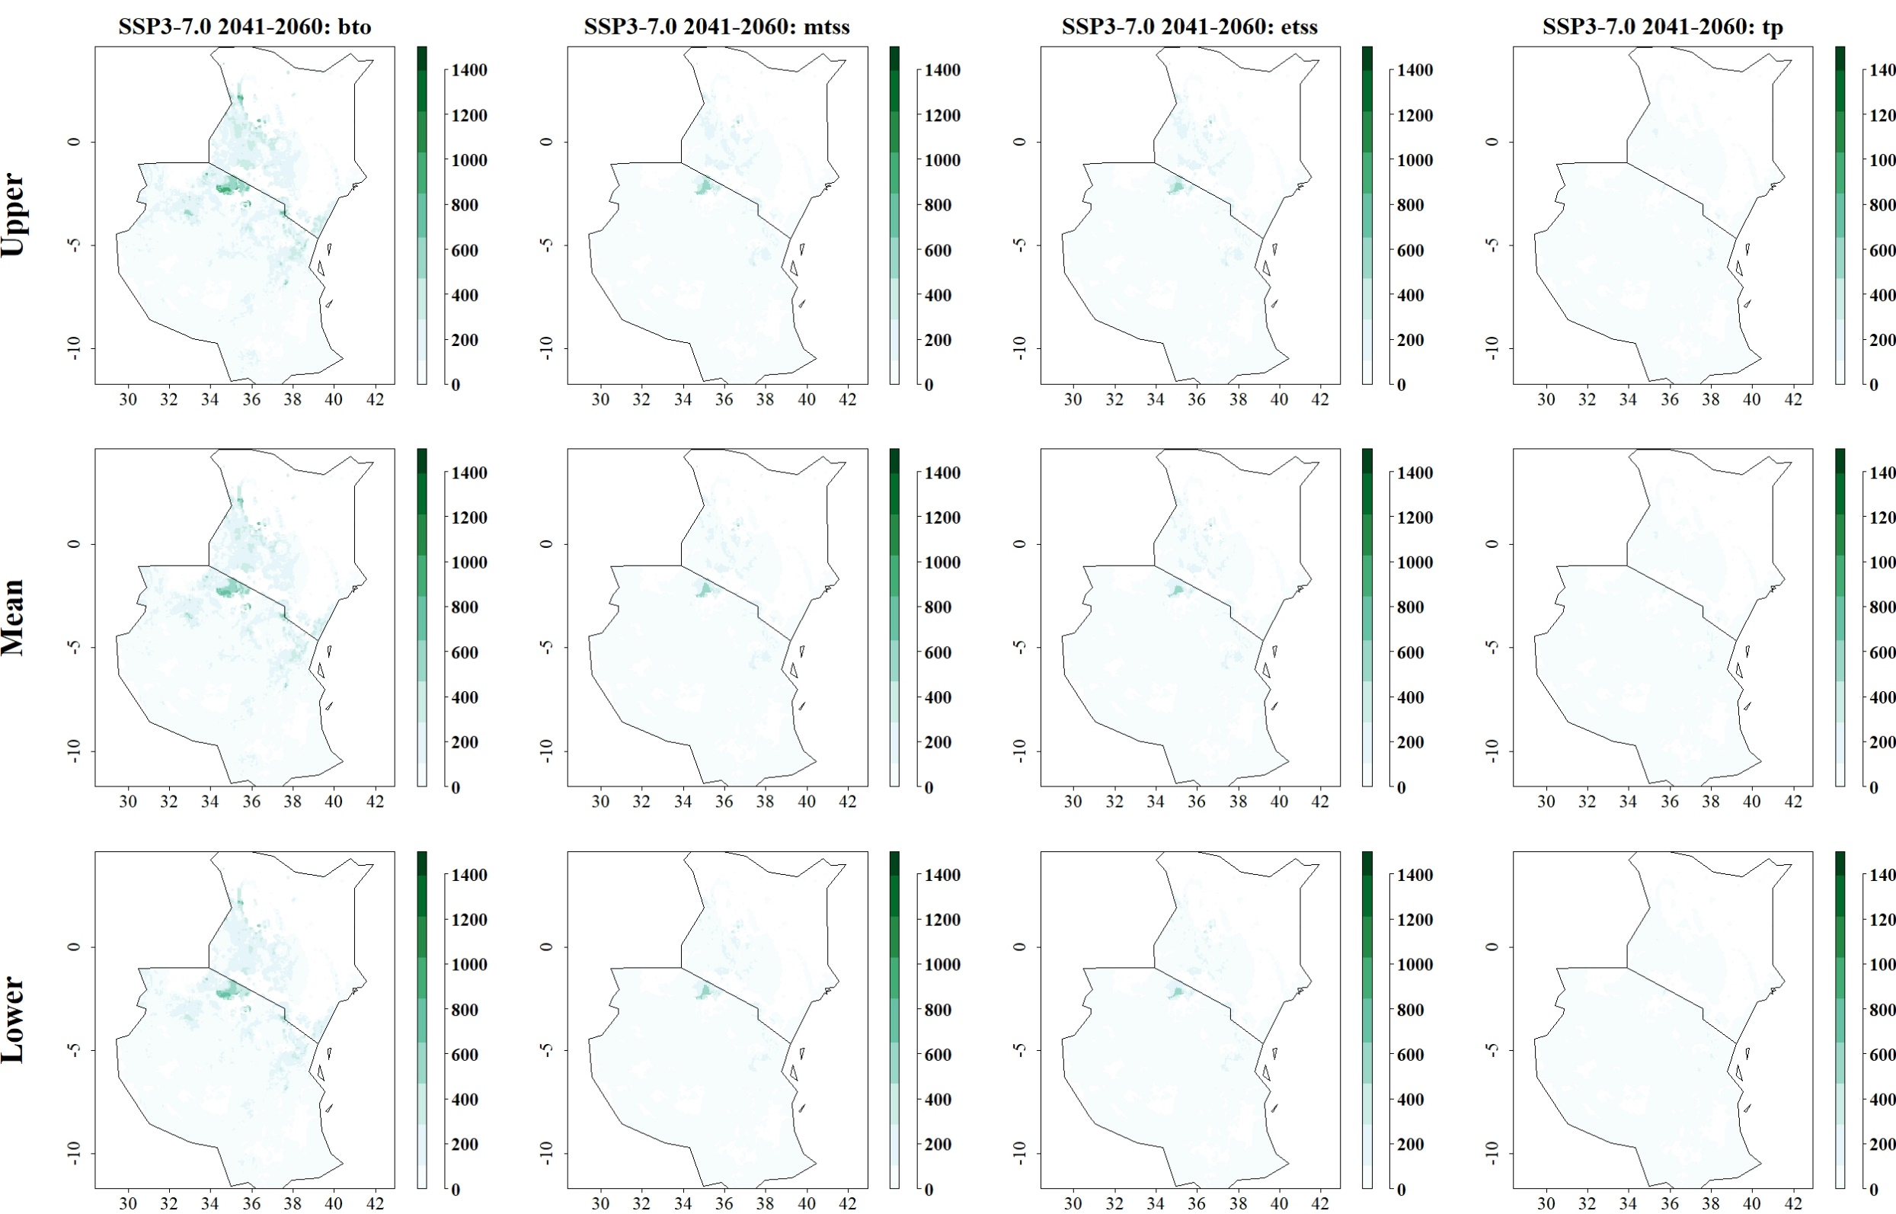
Fig: Predicted reduction of maize yield losses (in kg/ha) by C. partellus through use of C. flavipes for SSP3-7.0 in 2041–2060 and thresholds Balance training omission, predicted area and threshold values Cloglog (bto), Maximum training sensitivity plus specificity Cloglog threshold (mtss), Equal training sensitivity and specificity Cloglog threshold (etss) and 10th percentile training presence Cloglog threshold (tp). Grid cells where parasitoid application significantly reduces the amount of maize yield losses caused by the stem borer are colored in darker green, whereas grid cells where the reduction of maize yield losses by the species are limited are colored in lighter shades of green and white.
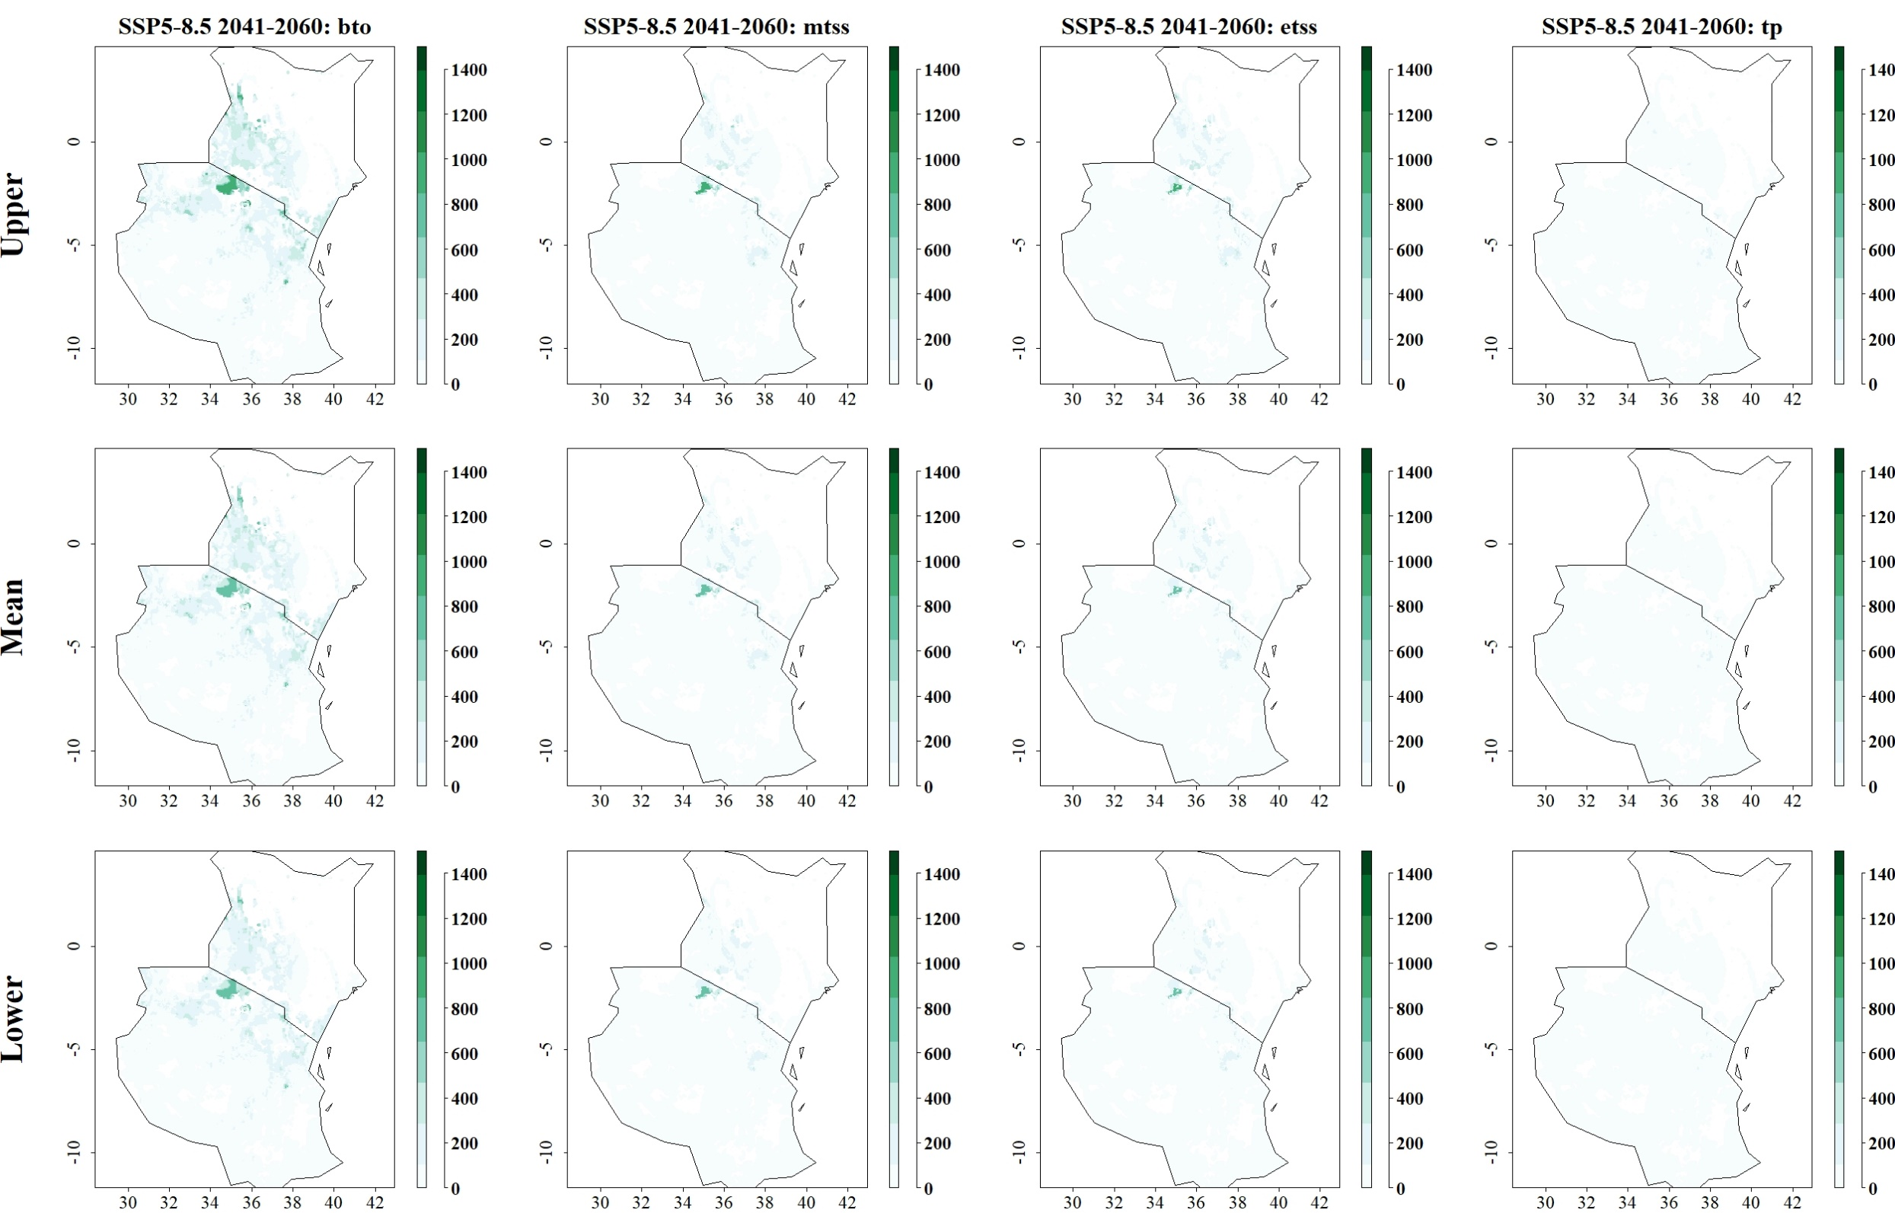
Fig: Predicted reduction of maize yield losses (in kg/ha) by C. partellus through use of C. flavipes for SSP5-8.5 in 2041–2060 and thresholds Balance training omission, predicted area and threshold values Cloglog (bto), Maximum training sensitivity plus specificity Cloglog threshold (mtss), Equal training sensitivity and specificity Cloglog threshold (etss) and 10th percentile training presence Cloglog threshold (tp). Grid cells where parasitoid application significantly reduces the amount of maize yield losses caused by the stem borer are colored in darker green, whereas grid cells where the reduction of maize yield losses by the species are limited are colored in lighter shades of green and white.
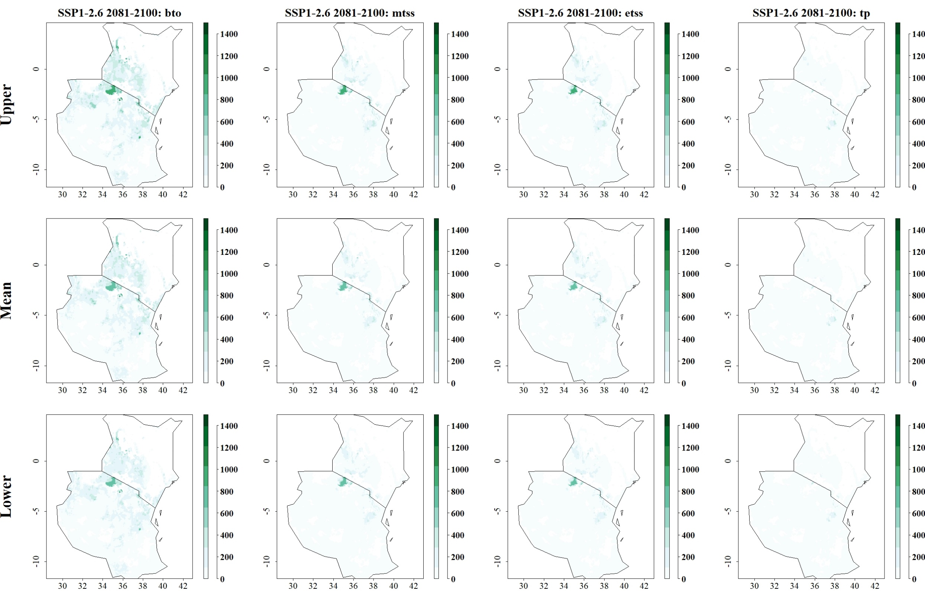
Fig: Predicted reduction of maize yield losses (in kg/ha) by C. partellus through use of C. flavipes for SSP1-2.6 in 2081–2100 and thresholds Balance training omission, predicted area and threshold values Cloglog (bto), Maximum training sensitivity plus specificity Cloglog threshold (mtss), Equal training sensitivity and specificity Cloglog threshold (etss) and 10th percentile training presence Cloglog threshold (tp). Grid cells where parasitoid application significantly reduces the amount of maize yield losses caused by the stem borer are colored in darker green, whereas grid cells where the reduction of maize yield losses by the species are limited are colored in lighter shades of green and white.
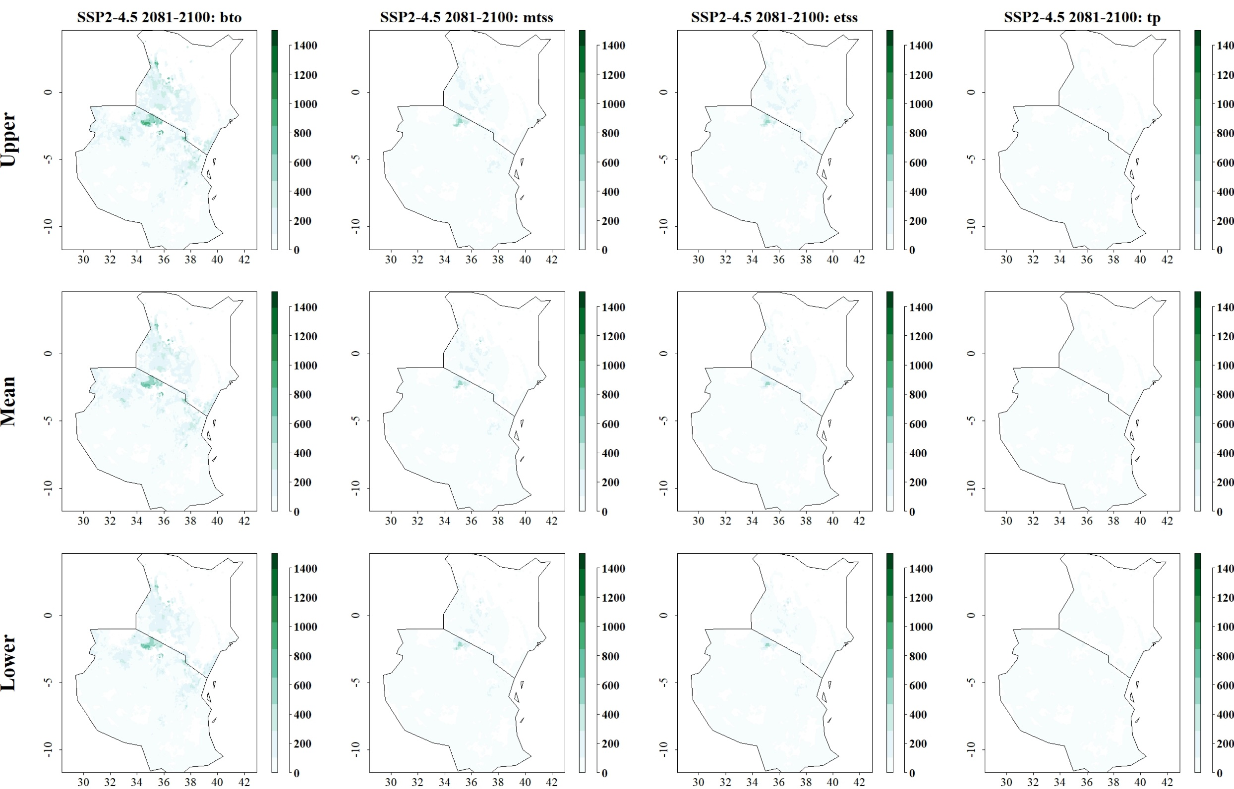
Fig: Predicted reduction of maize yield losses (in kg/ha) by C. partellus through use of C. flavipes for SSP2-4.5 in 2081–2100 and thresholds Balance training omission, predicted area and threshold values Cloglog (bto), Maximum training sensitivity plus specificity Cloglog threshold (mtss), Equal training sensitivity and specificity Cloglog threshold (etss) and 10th percentile training presence Cloglog threshold (tp). Grid cells where parasitoid application significantly reduces the amount of maize yield losses caused by the stem borer are colored in darker green, whereas grid cells where the reduction of maize yield losses by the species are limited are colored in lighter shades of green and white.
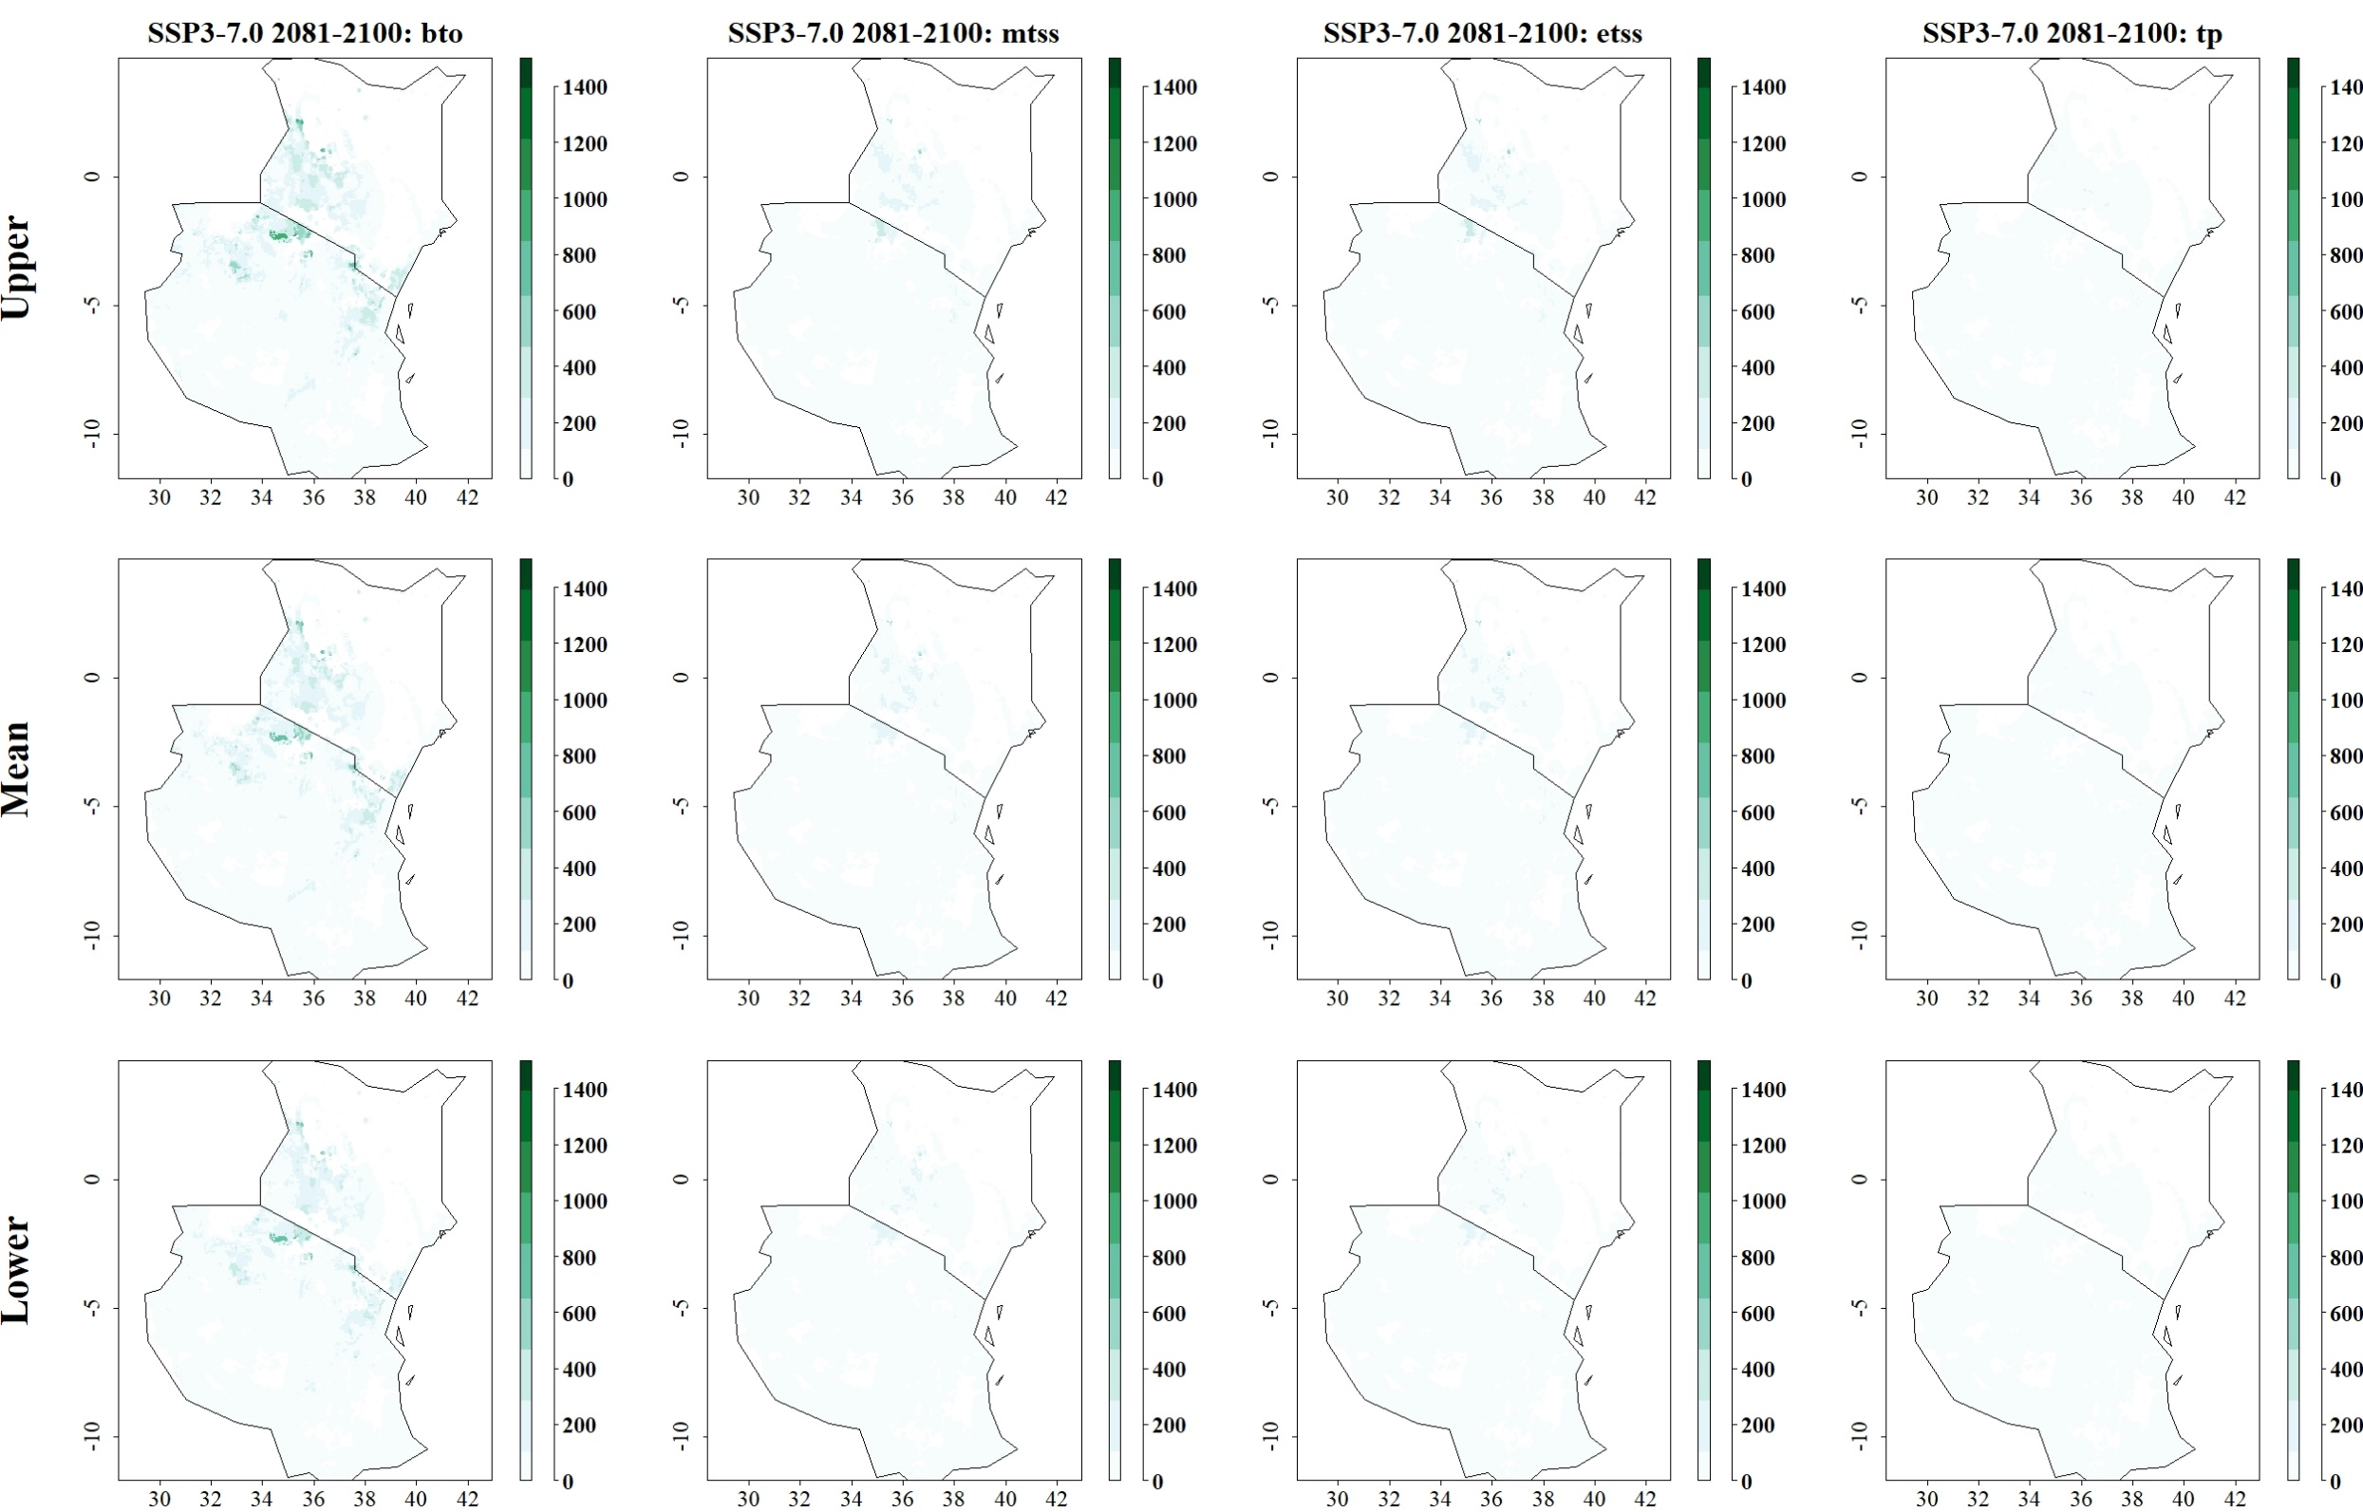
Fig: Predicted reduction of maize yield losses (in kg/ha) by C. partellus through use of C. flavipes for SSP3-7.0 in 2081–2100 and thresholds Balance training omission, predicted area and threshold values Cloglog (bto), Maximum training sensitivity plus specificity Cloglog threshold (mtss), Equal training sensitivity and specificity Cloglog threshold (etss) and 10th percentile training presence Cloglog threshold (tp). Grid cells where parasitoid application significantly reduces the amount of maize yield losses caused by the stem borer are colored in darker green, whereas grid cells where the reduction of maize yield losses by the species are limited are colored in lighter shades of green and white.
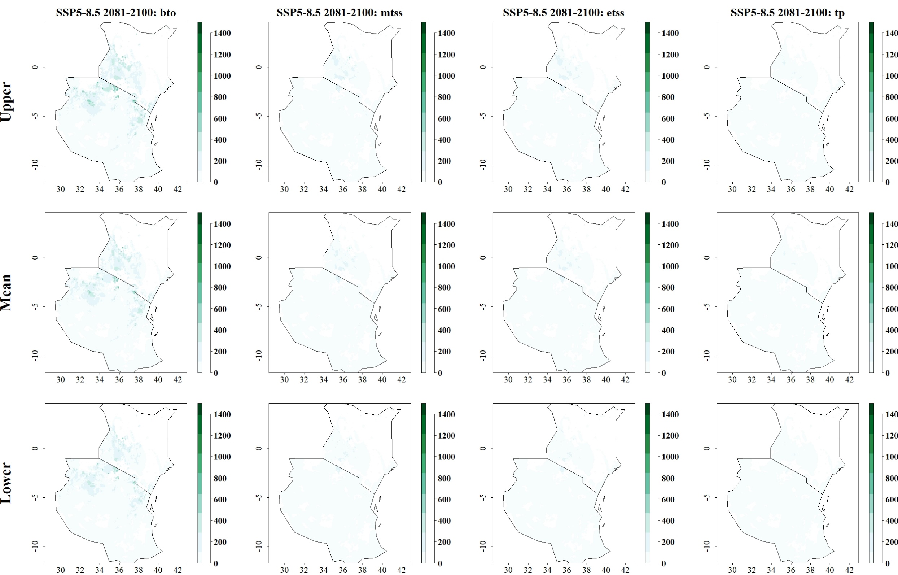
Fig: Predicted reduction of maize yield losses (in kg/ha) by C. partellus through use of C. flavipes for SSP5-8.5 in 2081–2100 and thresholds Balance training omission, predicted area and threshold values Cloglog (bto), Maximum training sensitivity plus specificity Cloglog threshold (mtss), Equal training sensitivity and specificity Cloglog threshold (etss) and 10th percentile training presence Cloglog threshold (tp). Grid cells where parasitoid application significantly reduces the amount of maize yield losses caused by the stem borer are colored in darker green, whereas grid cells where the reduction of maize yield losses by the species are limited are colored in lighter shades of green and white.
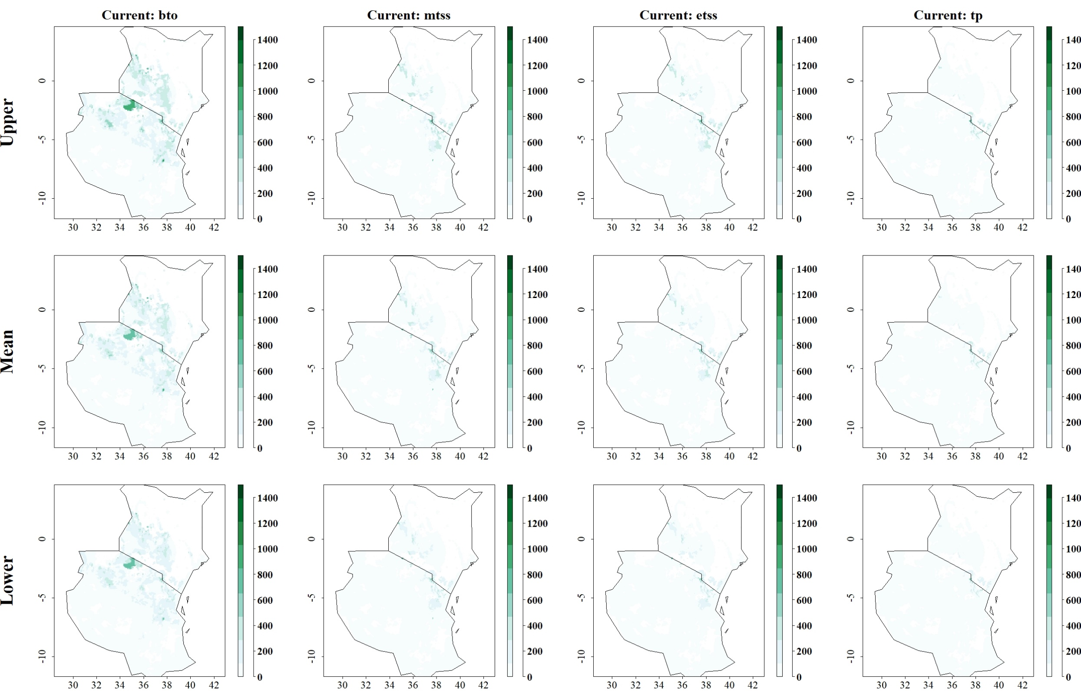

Fig: Predicted reduction of maize yield losses (in kg/ha) by C. partellus through use of C. sesamiae under current climatic conditions for thresholds Balance training omission, predicted area and threshold values Cloglog (bto), Maximum training sensitivity plus specificity Cloglog threshold (mtss), Equal training sensitivity and specificity Cloglog threshold (etss) and 10th percentile training presence Cloglog threshold (tp). Grid cells where parasitoid application significantly reduces the amount of maize yield losses caused by the stem borer are colored in darker green, whereas grid cells where the reduction of maize yield losses by the species are limited are colored in lighter shades of green and white.
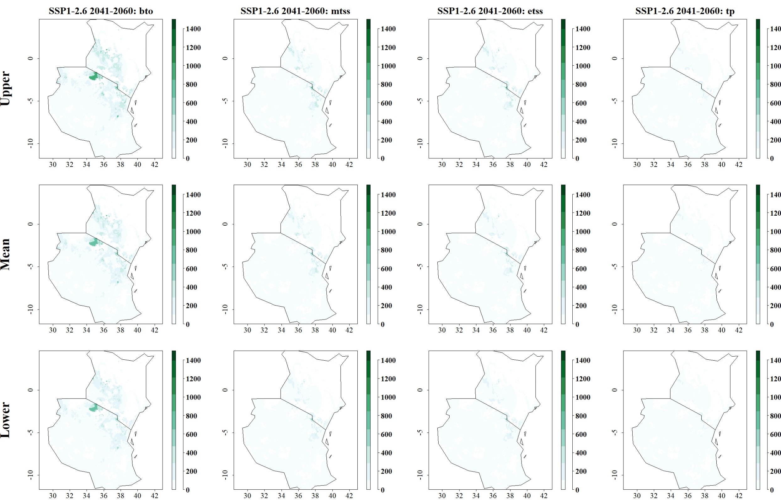
Fig: Predicted reduction of maize yield losses (in kg/ha) by C. partellus through use of C. sesamiae for SSP1-2.6 in 2041–2060 and thresholds Balance training omission, predicted area and threshold values Cloglog (bto), Maximum training sensitivity plus specificity Cloglog threshold (mtss), Equal training sensitivity and specificity Cloglog threshold (etss) and 10th percentile training presence Cloglog threshold (tp). Grid cells where parasitoid application significantly reduces the amount of maize yield losses caused by the stem borer are colored in darker green, whereas grid cells where the reduction of maize yield losses by the species are limited are colored in lighter shades of green and white.
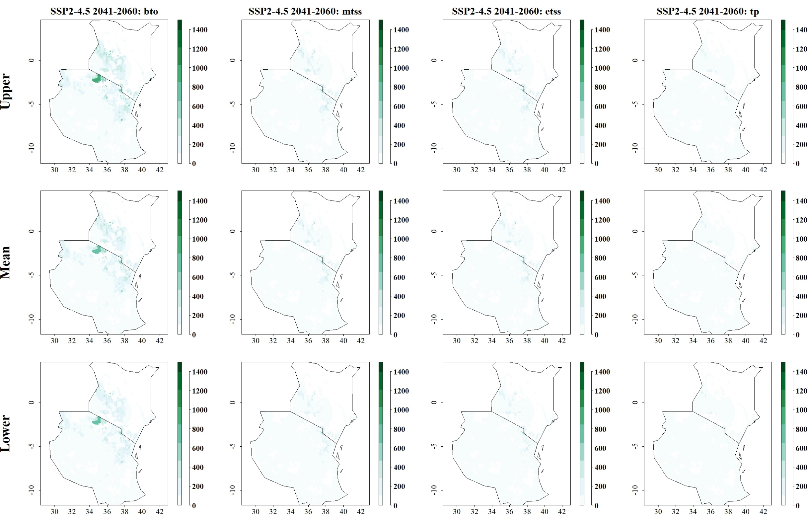
Fig: Predicted reduction of maize yield losses (in kg/ha) by C. partellus through use of C. sesamiae for SSP2-4.5 in 2041–2060 and thresholds Balance training omission, predicted area and threshold values Cloglog (bto), Maximum training sensitivity plus specificity Cloglog threshold (mtss), Equal training sensitivity and specificity Cloglog threshold (etss) and 10th percentile training presence Cloglog threshold (tp). Grid cells where parasitoid application significantly reduces the amount of maize yield losses caused by the stem borer are colored in darker green, whereas grid cells where the reduction of maize yield losses by the species are limited are colored in lighter shades of green and white.
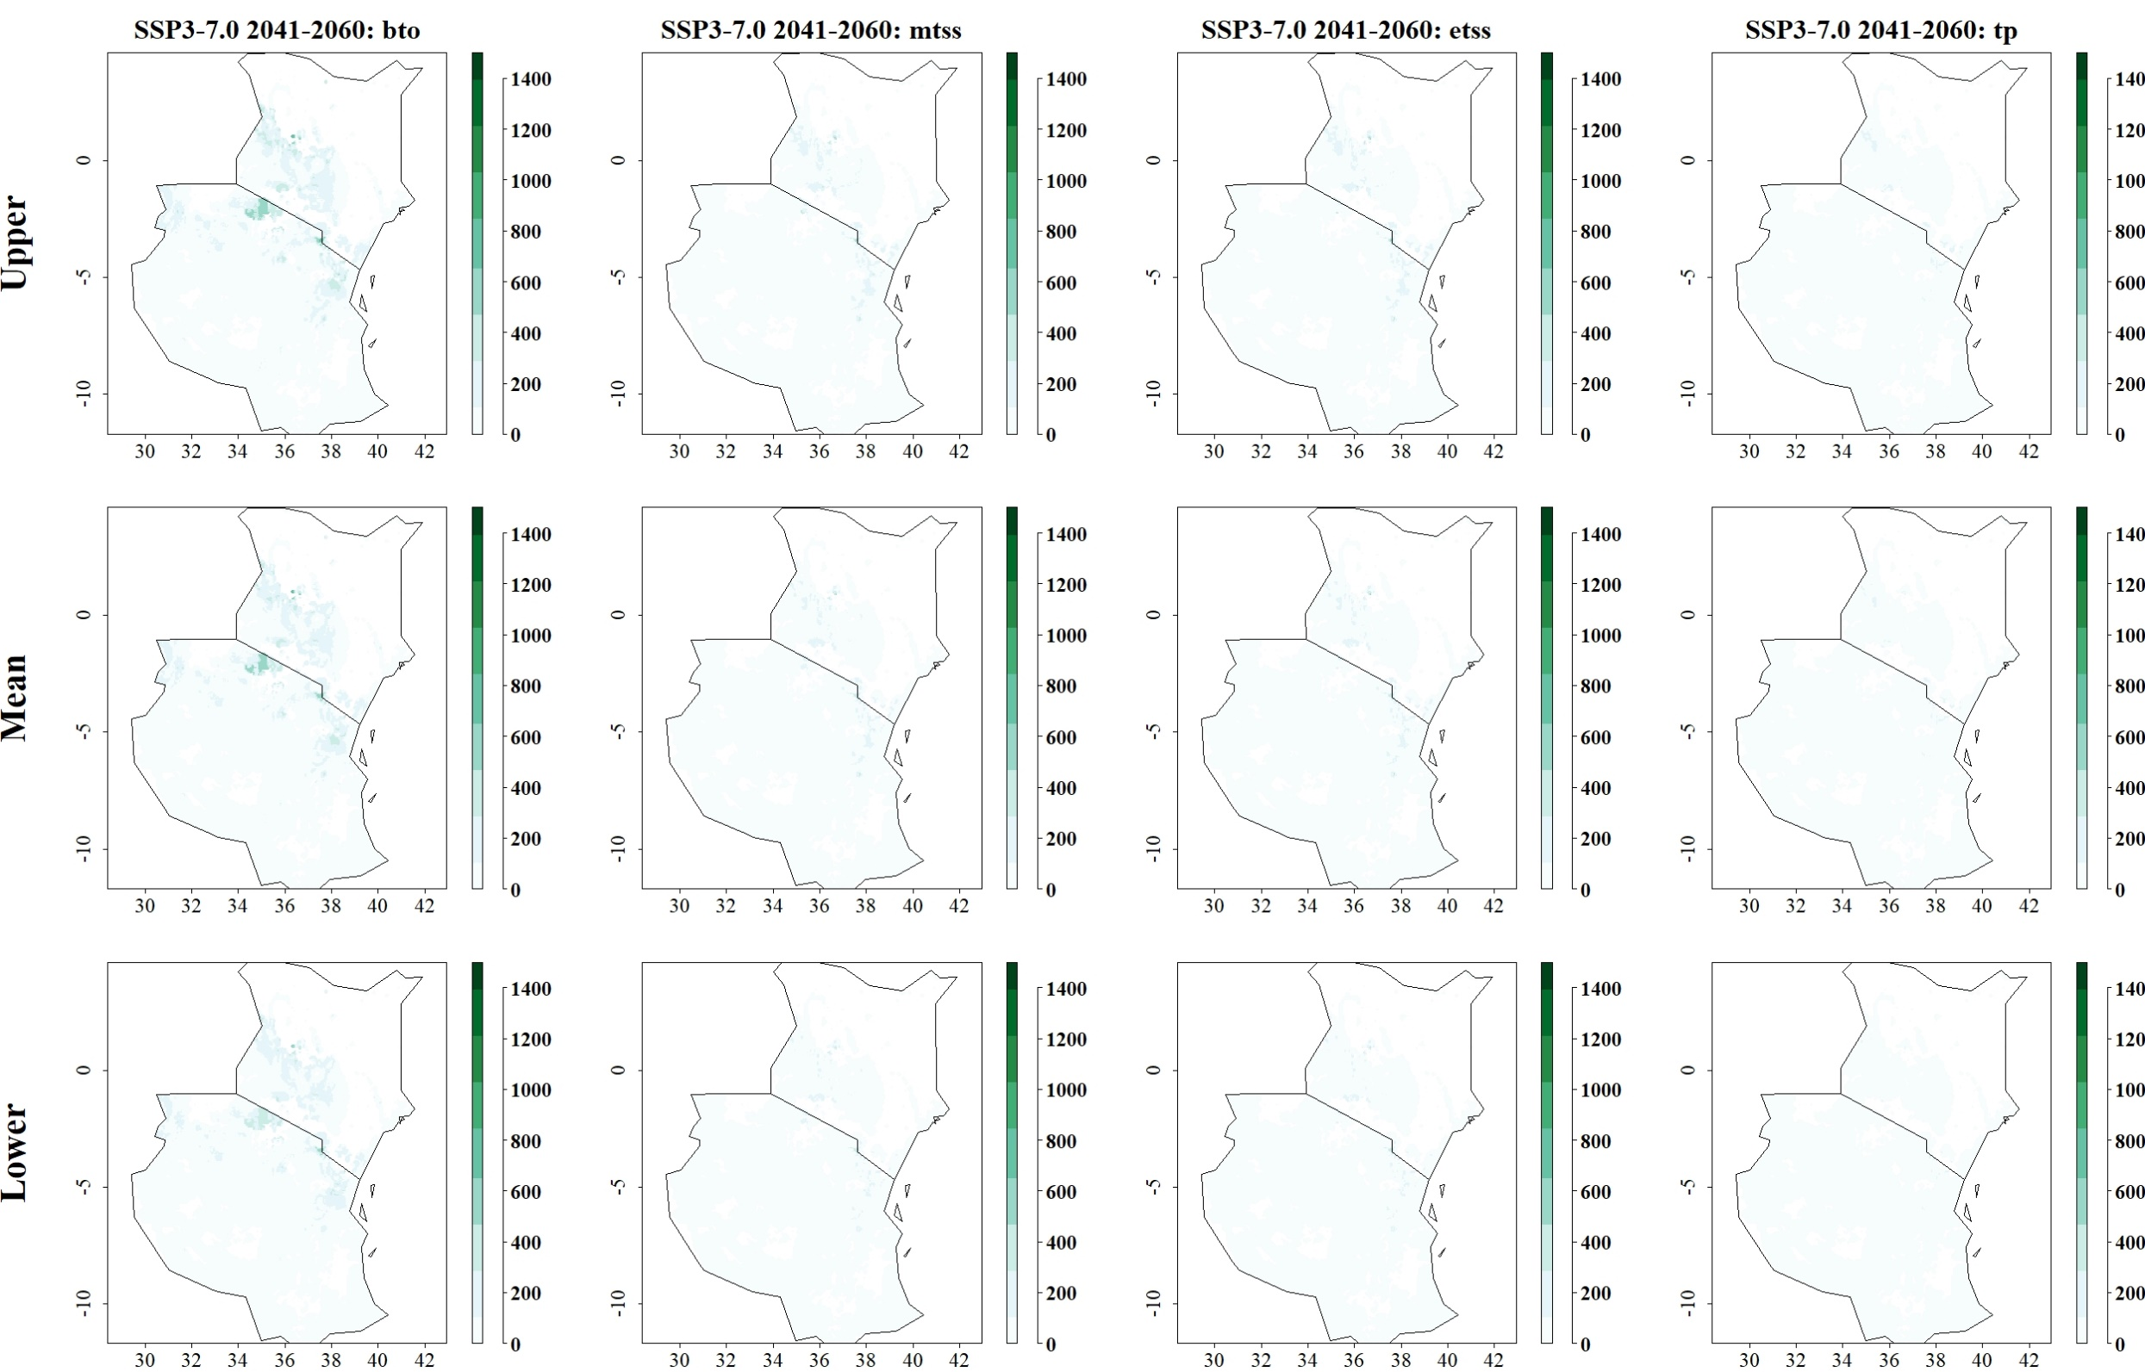
Fig: Predicted reduction of maize yield losses (in kg/ha) by C. partellus through use of C. sesamiae for SSP3-7.0 in 2041–2060 and thresholds Balance training omission, predicted area and threshold values Cloglog (bto), Maximum training sensitivity plus specificity Cloglog threshold (mtss), Equal training sensitivity and specificity Cloglog threshold (etss) and 10th percentile training presence Cloglog threshold (tp). Grid cells where parasitoid application significantly reduces the amount of maize yield losses caused by the stem borer are colored in darker green, whereas grid cells where the reduction of maize yield losses by the species are limited are colored in lighter shades of green and white.
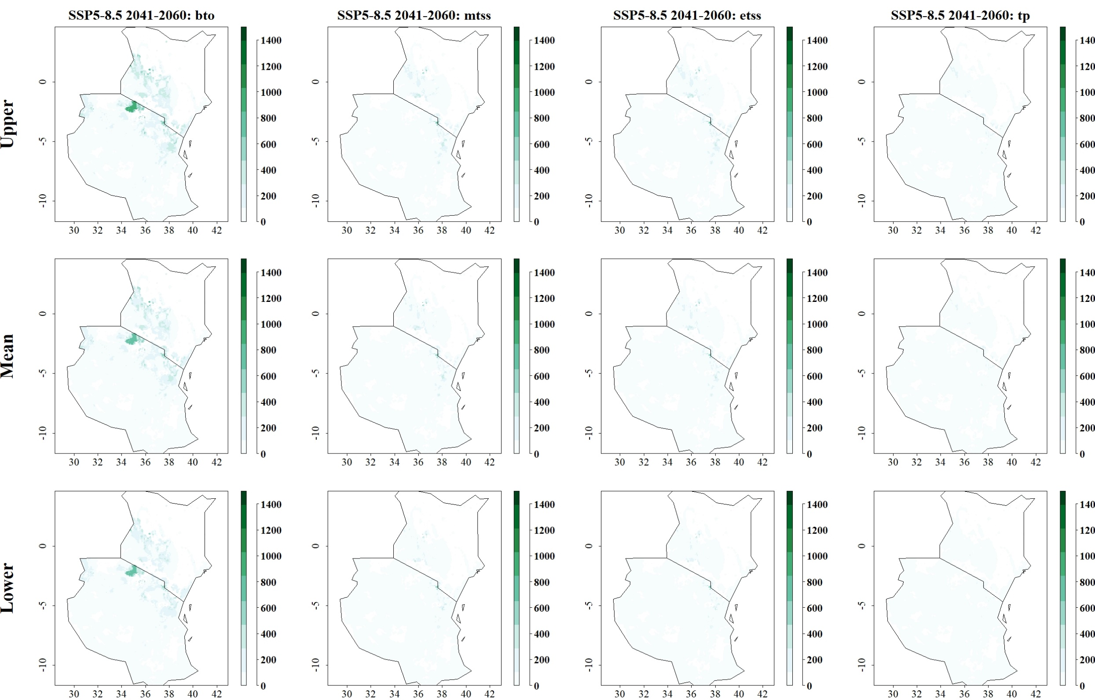
Fig: Predicted reduction of maize yield losses (in kg/ha) by C. partellus through use of C. sesamiae for SSP5-8.5 in 2041–2060 and thresholds Balance training omission, predicted area and threshold values Cloglog (bto), Maximum training sensitivity plus specificity Cloglog threshold (mtss), Equal training sensitivity and specificity Cloglog threshold (etss) and 10th percentile training presence Cloglog threshold (tp). Grid cells where parasitoid application significantly reduces the amount of maize yield losses caused by the stem borer are colored in darker green, whereas grid cells where the reduction of maize yield losses by the species are limited are colored in lighter shades of green and white.
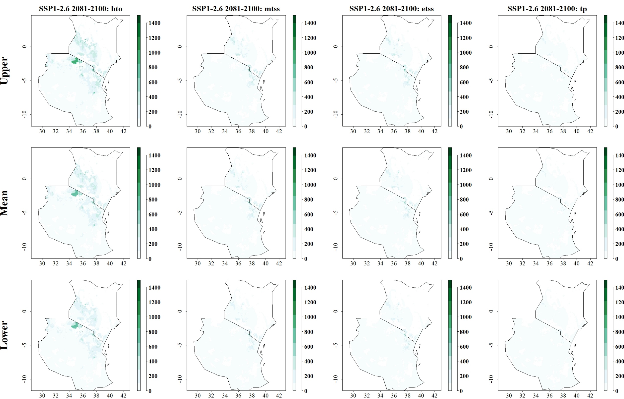
Fig: Predicted reduction of maize yield losses (in kg/ha) by C. partellus through use of C. sesamiae for SSP1-2.6 in 2081–2100 and thresholds Balance training omission, predicted area and threshold values Cloglog (bto), Maximum training sensitivity plus specificity Cloglog threshold (mtss), Equal training sensitivity and specificity Cloglog threshold (etss) and 10th percentile training presence Cloglog threshold (tp). Grid cells where parasitoid application significantly reduces the amount of maize yield losses caused by the stem borer are colored in darker green, whereas grid cells where the reduction of maize yield losses by the species are limited are colored in lighter shades of green and white.
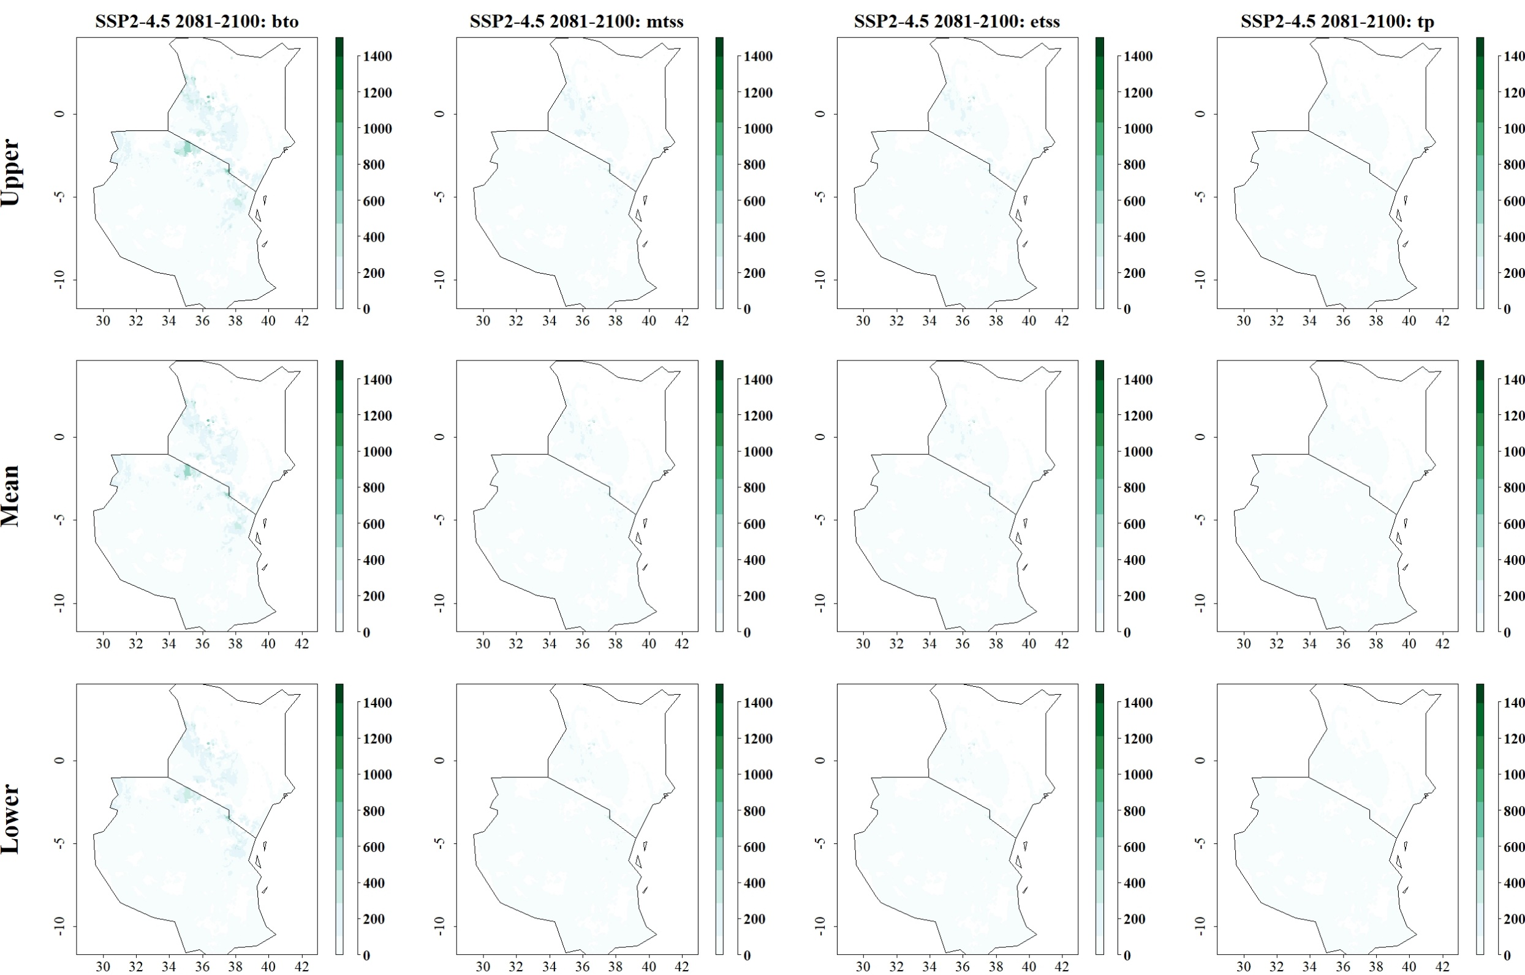
Fig: Predicted reduction of maize yield losses (in kg/ha) by C. partellus through use of C. sesamiae for SSP2-4.5 in 2081–2100 and thresholds Balance training omission, predicted area and threshold values Cloglog (bto), Maximum training sensitivity plus specificity Cloglog threshold (mtss), Equal training sensitivity and specificity Cloglog threshold (etss) and 10th percentile training presence Cloglog threshold (tp). Grid cells where parasitoid application significantly reduces the amount of maize yield losses caused by the stem borer are colored in darker green, whereas grid cells where the reduction of maize yield losses by the species are limited are colored in lighter shades of green and white.
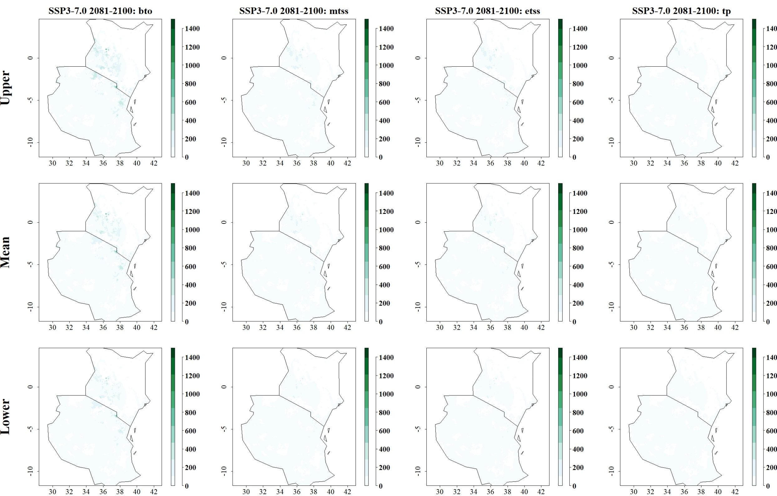
Fig: Predicted reduction of maize yield losses (in kg/ha) by C. partellus through use of C. sesamiae for SSP3-7.0 in 2081–2100 and thresholds Balance training omission, predicted area and threshold values Cloglog (bto), Maximum training sensitivity plus specificity Cloglog threshold (mtss), Equal training sensitivity and specificity Cloglog threshold (etss) and 10th percentile training presence Cloglog threshold (tp). Grid cells where parasitoid application significantly reduces the amount of maize yield losses caused by the stem borer are colored in darker green, whereas grid cells where the reduction of maize yield losses by the species are limited are colored in lighter shades of green and white.
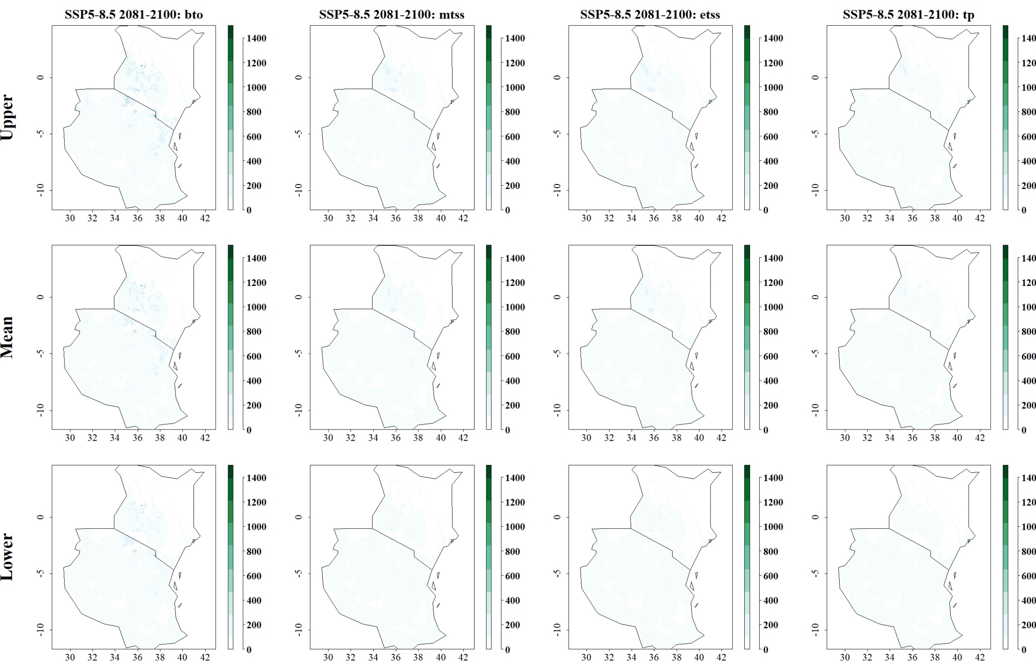
Fig: Predicted reduction of maize yield losses (in kg/ha) by C. partellus through use of C. sesamiae for SSP5-8.5 in 2081–2100 and thresholds Balance training omission, predicted area and threshold values Cloglog (bto), Maximum training sensitivity plus specificity Cloglog threshold (mtss), Equal training sensitivity and specificity Cloglog threshold (etss) and 10th percentile training presence Cloglog threshold (tp). Grid cells where parasitoid application significantly reduces the amount of maize yield losses caused by the stem borer are colored in darker green, whereas grid cells where the reduction of maize yield losses by the species are limited are colored in lighter shades of green and white.
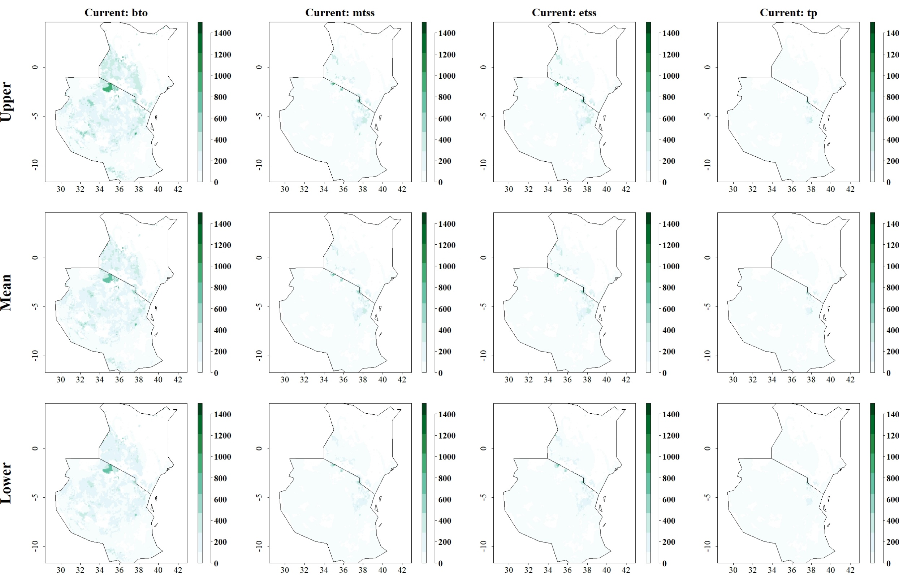
Fig: Predicted reduction of maize yield losses (in kg/ha) by S. calamistis through use of C. flavipes under current climatic conditions for thresholds Balance training omission, predicted area and threshold values Cloglog (bto), Maximum training sensitivity plus specificity Cloglog threshold (mtss), Equal training sensitivity and specificity Cloglog threshold (etss) and 10th percentile training presence Cloglog threshold (tp). Grid cells where parasitoid application significantly reduces the amount of maize yield losses caused by the stem borer are colored in darker green, whereas grid cells where the reduction of maize yield losses by the species are limited are colored in lighter shades of green and white.
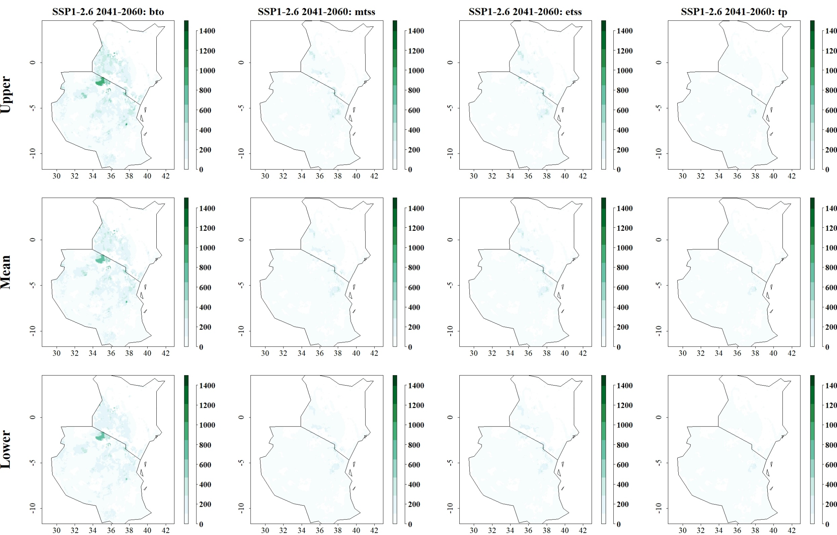
Fig: Predicted reduction of maize yield losses (in kg/ha) by S. calamistis through use of C. flavipes for SSP1-2.6 in 2041–2060 and thresholds Balance training omission, predicted area and threshold values Cloglog (bto), Maximum training sensitivity plus specificity Cloglog threshold (mtss), Equal training sensitivity and specificity Cloglog threshold (etss) and 10th percentile training presence Cloglog threshold (tp). Grid cells where parasitoid application significantly reduces the amount of maize yield losses caused by the stem borer are colored in darker green, whereas grid cells where the reduction of maize yield losses by the species are limited are colored in lighter shades of green and white.
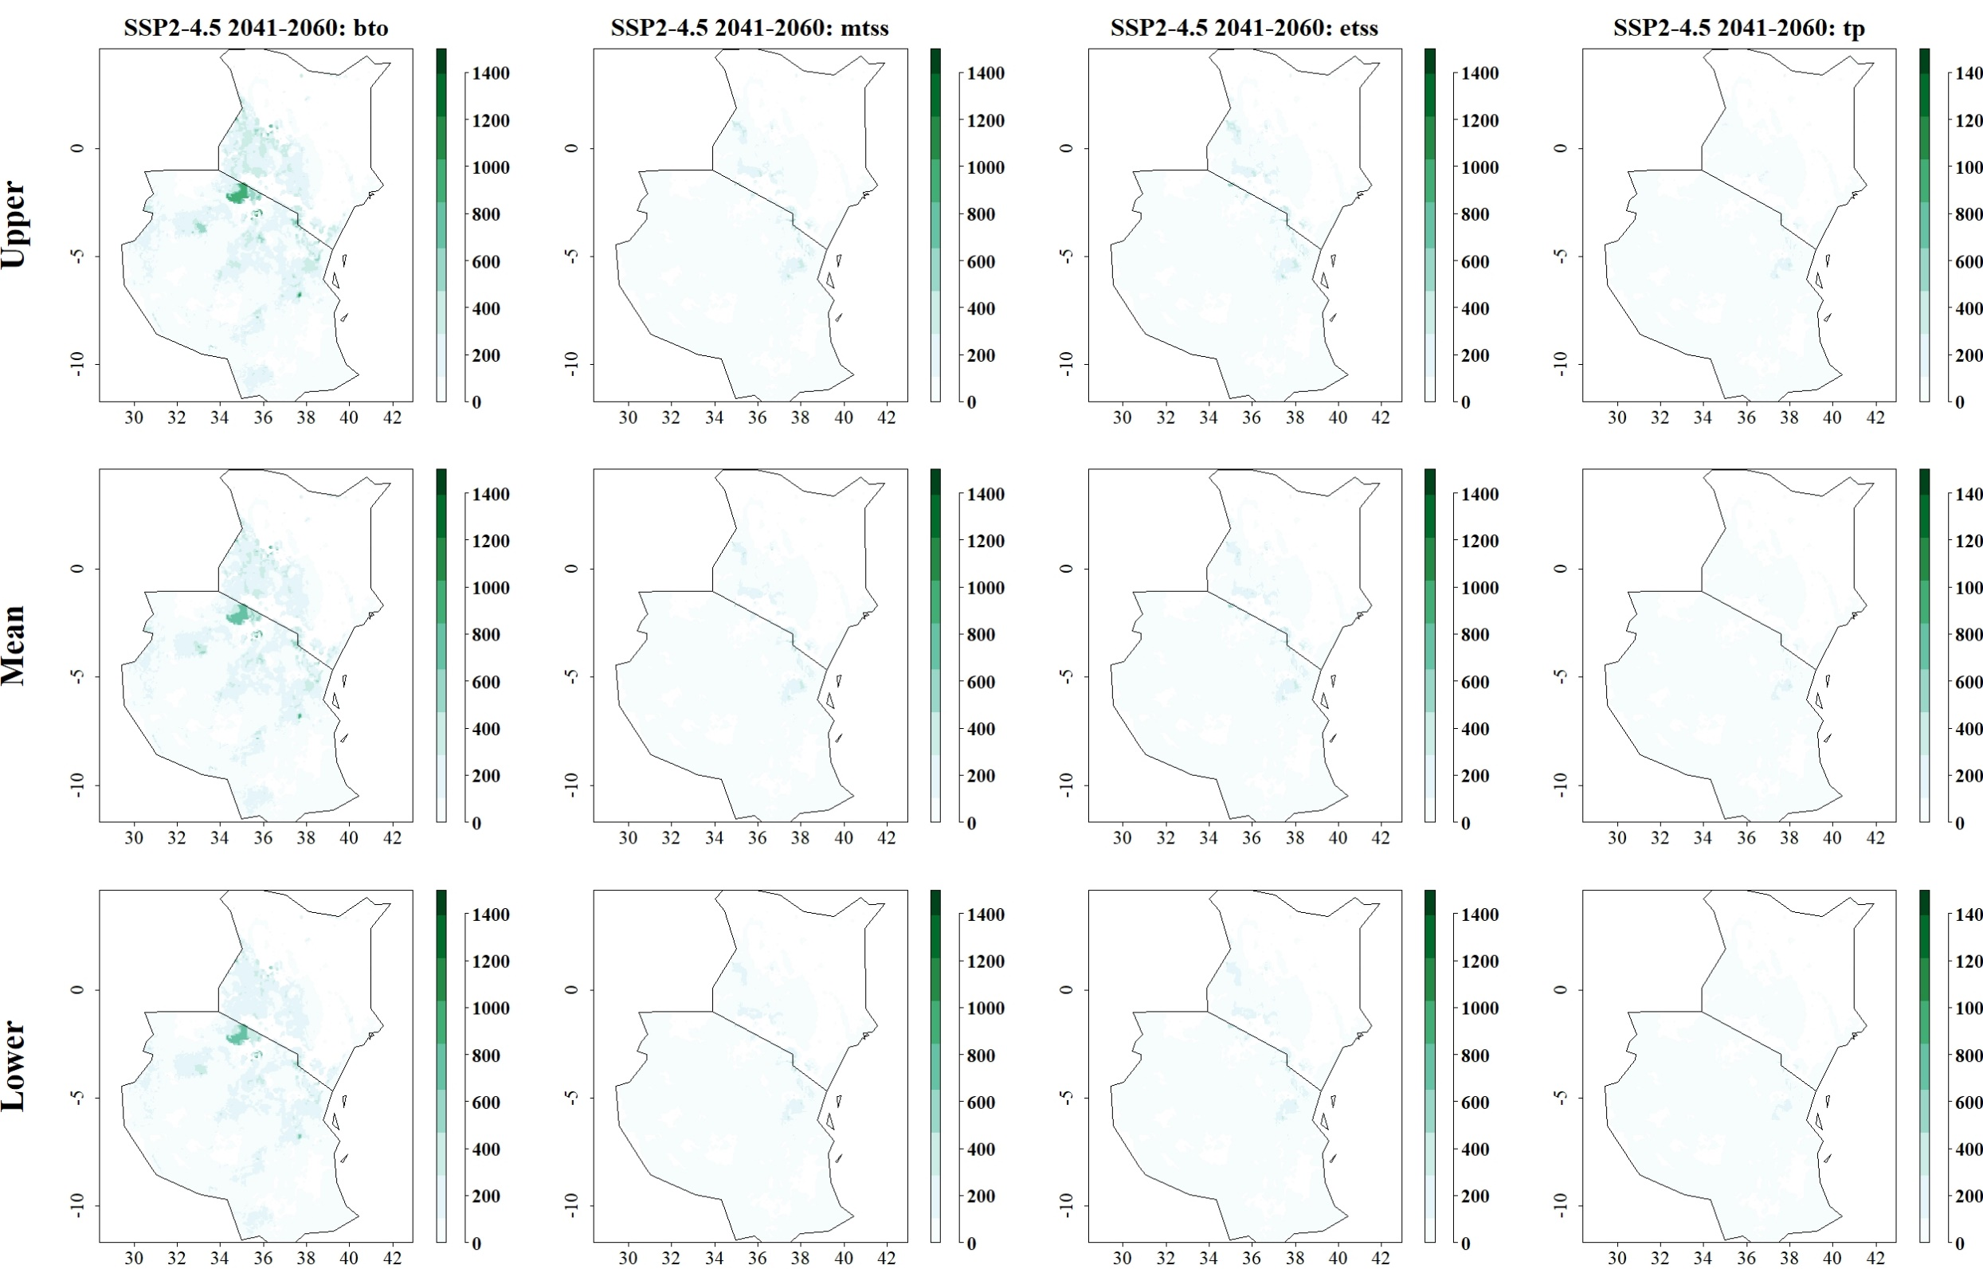
Fig: Predicted reduction of maize yield losses (in kg/ha) by S. calamistis through use of C. flavipes for SSP2-4.5 in 2041–2060 and thresholds Balance training omission, predicted area and threshold values Cloglog (bto), Maximum training sensitivity plus specificity Cloglog threshold (mtss), Equal training sensitivity and specificity Cloglog threshold (etss) and 10th percentile training presence Cloglog threshold (tp). Grid cells where parasitoid application significantly reduces the amount of maize yield losses caused by the stem borer are colored in darker green, whereas grid cells where the reduction of maize yield losses by the species are limited are colored in lighter shades of green and white.
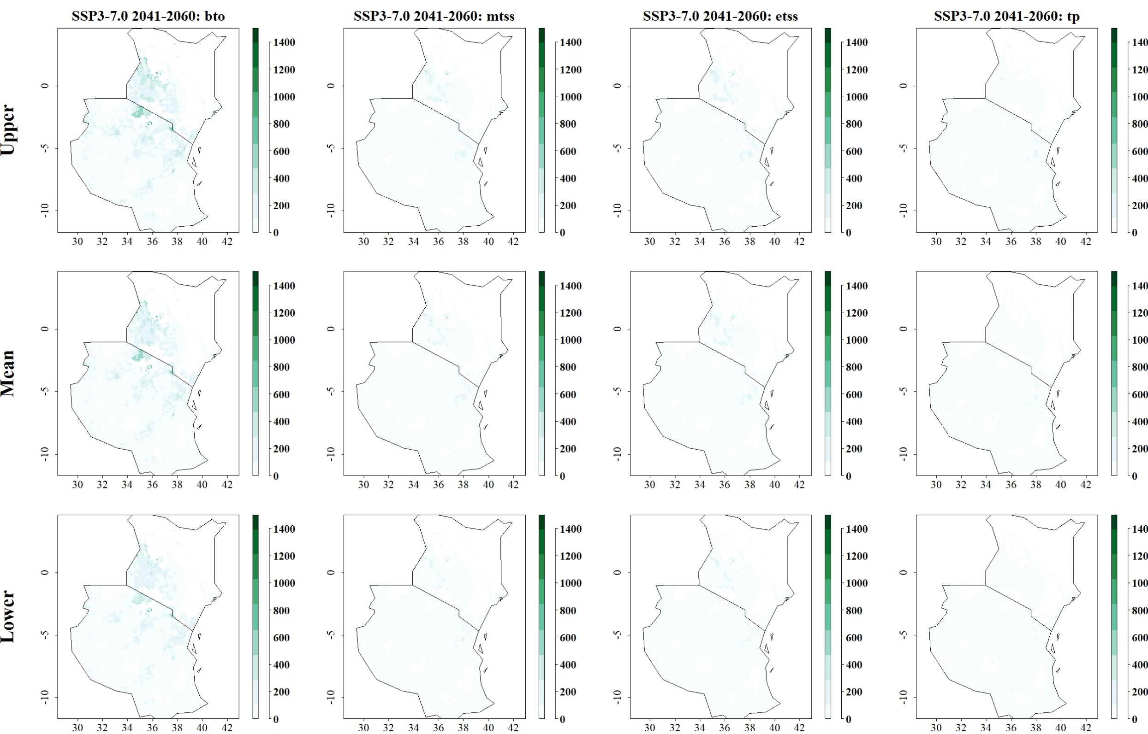
Fig: Predicted reduction of maize yield losses (in kg/ha) by S. calamistis through use of C. flavipes for SSP3-7.0 in 2041–2060 and thresholds Balance training omission, predicted area and threshold values Cloglog (bto), Maximum training sensitivity plus specificity Cloglog threshold (mtss), Equal training sensitivity and specificity Cloglog threshold (etss) and 10th percentile training presence Cloglog threshold (tp). Grid cells where parasitoid application significantly reduces the amount of maize yield losses caused by the stem borer are colored in darker green, whereas grid cells where the reduction of maize yield losses by the species are limited are colored in lighter shades of green and white.
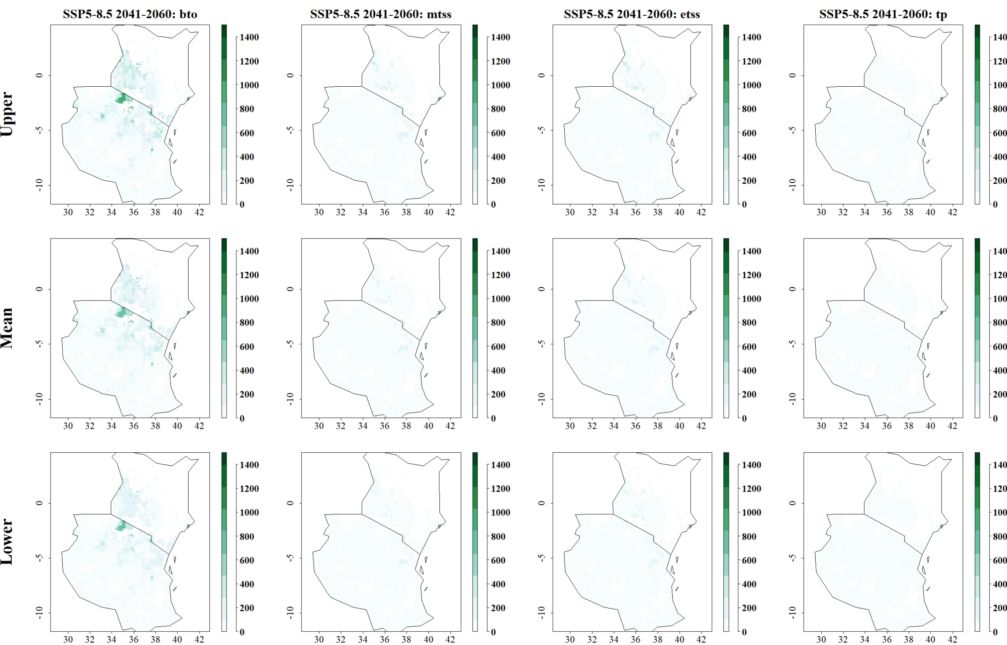
Fig: Predicted reduction of maize yield losses (in kg/ha) by S. calamistis through use of C. flavipes for SSP5-8.5 in 2041–2060 and thresholds Balance training omission, predicted area and threshold values Cloglog (bto), Maximum training sensitivity plus specificity Cloglog threshold (mtss), Equal training sensitivity and specificity Cloglog threshold (etss) and 10th percentile training presence Cloglog threshold (tp). Grid cells where parasitoid application significantly reduces the amount of maize yield losses caused by the stem borer are colored in darker green, whereas grid cells where the reduction of maize yield losses by the species are limited are colored in lighter shades of green and white.
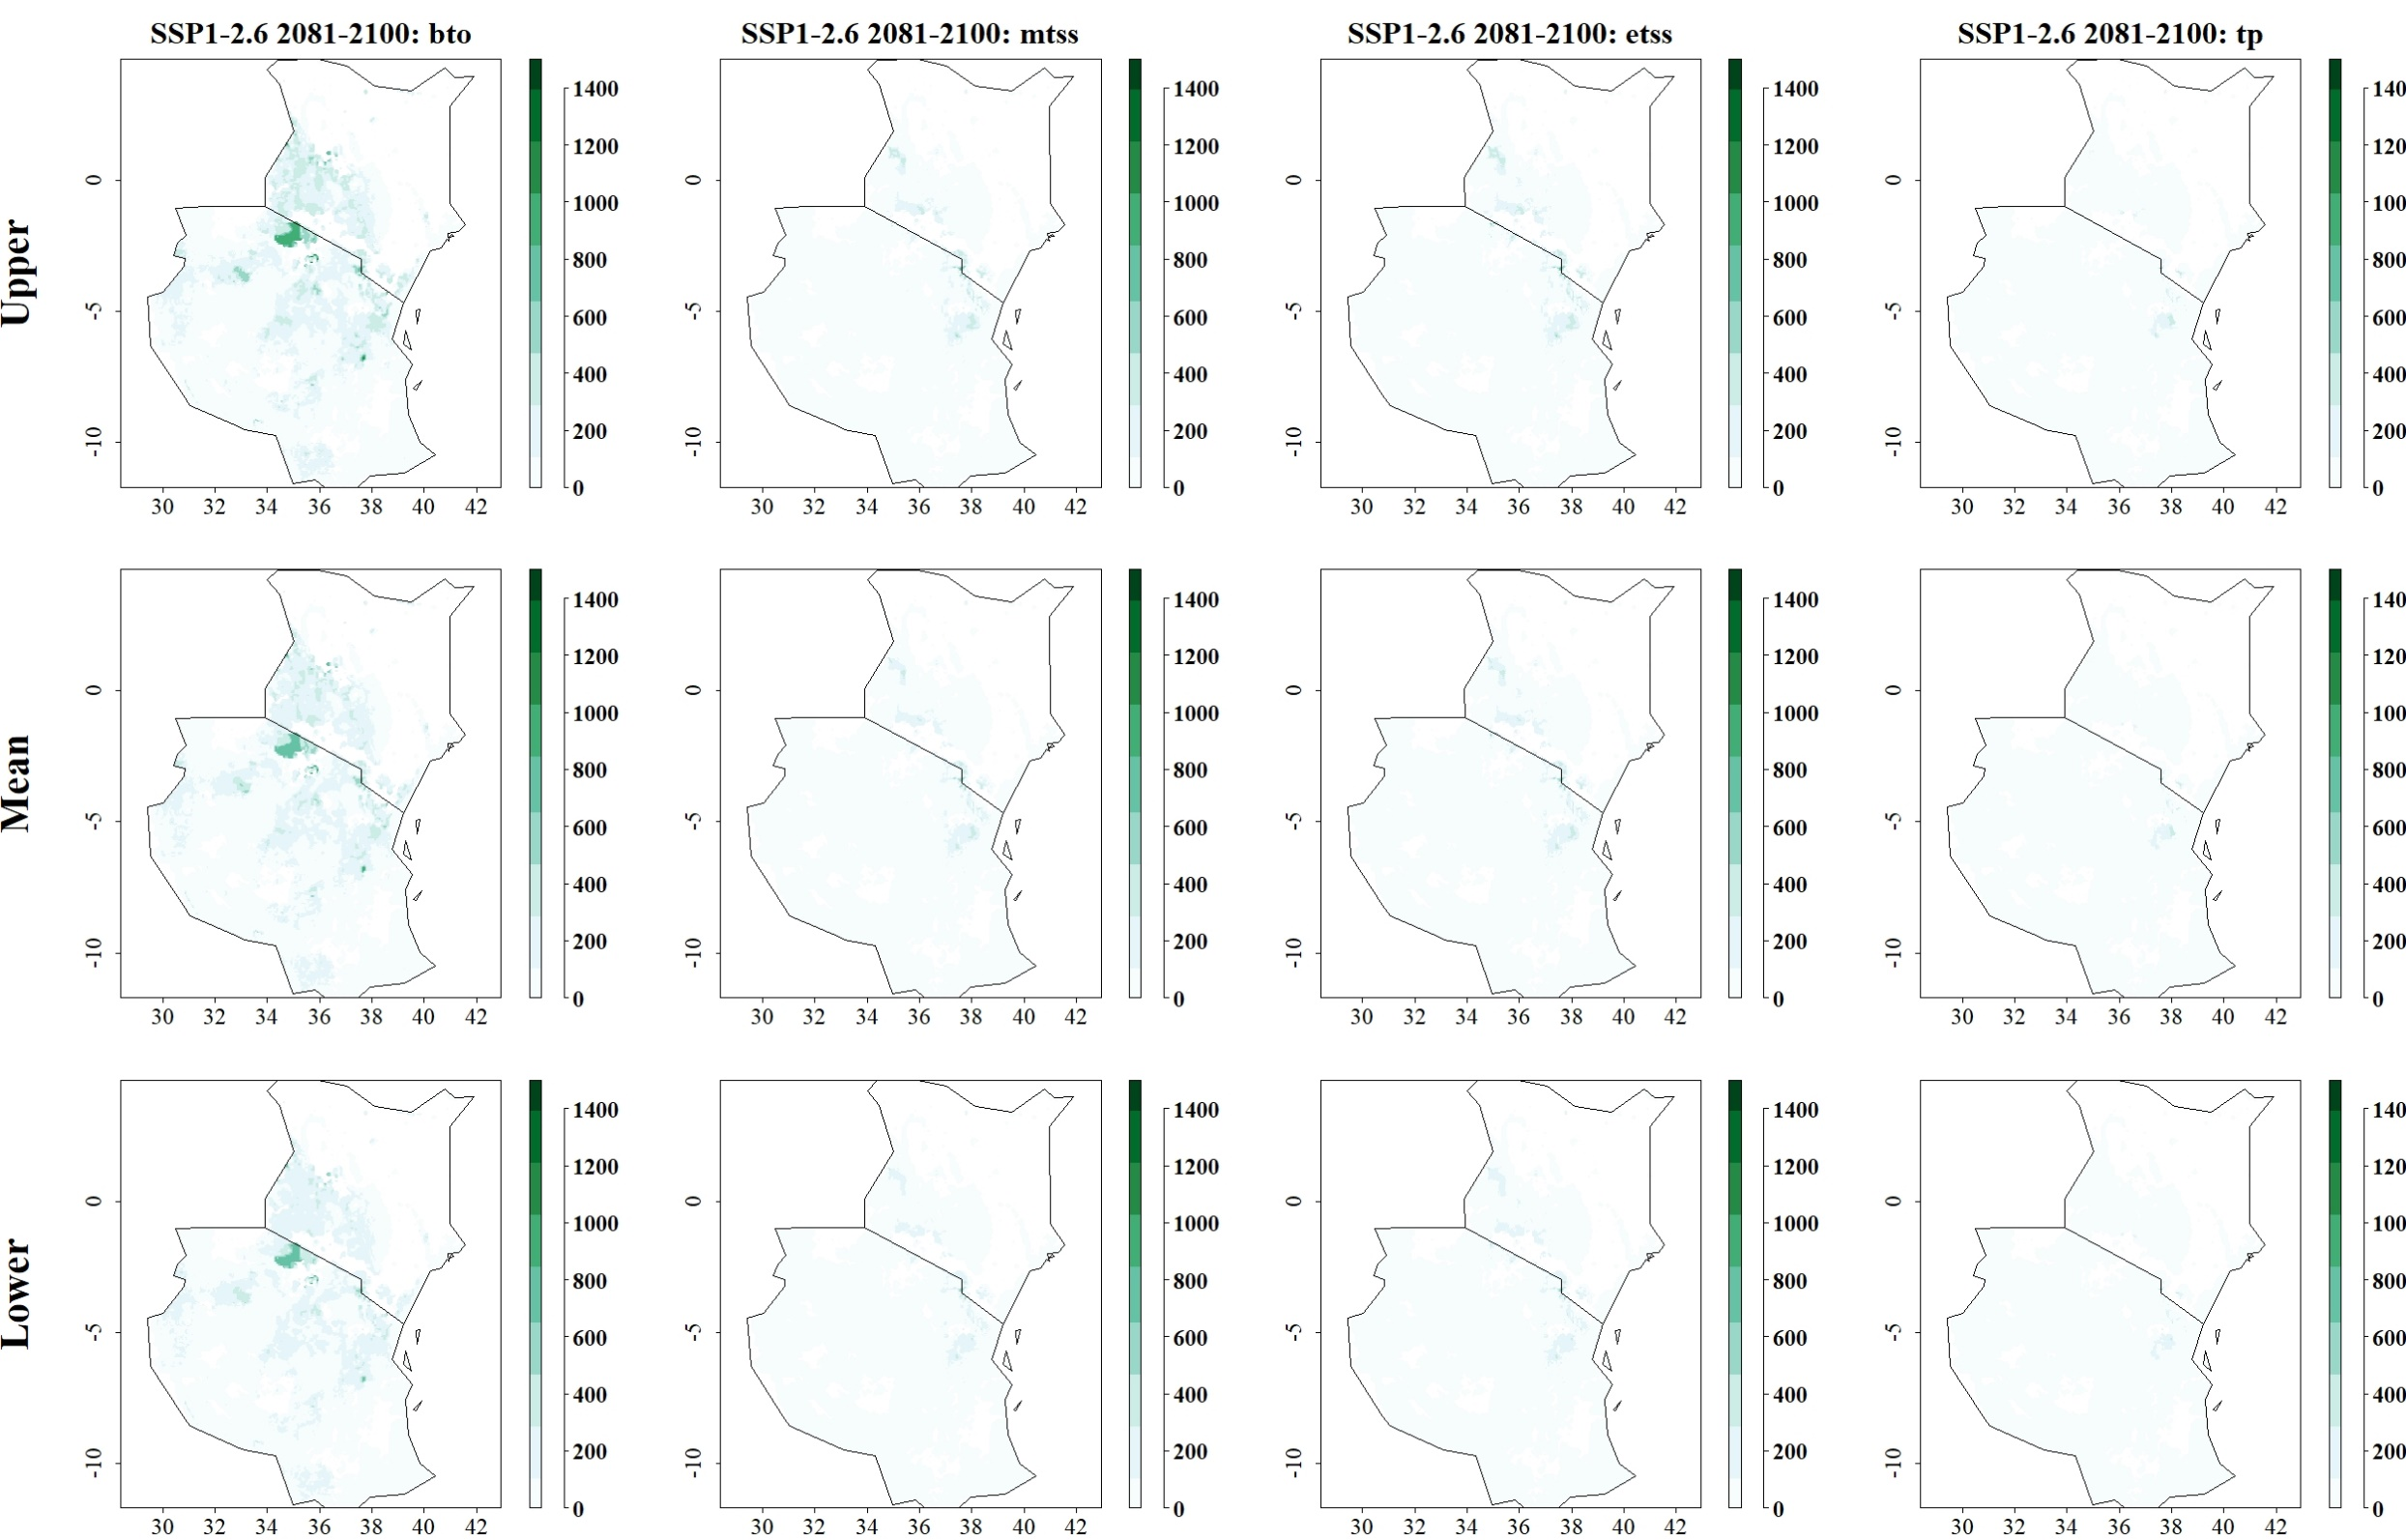
Fig: Predicted reduction of maize yield losses (in kg/ha) by S. calamistis through use of C. flavipes for SSP1-2.6 in 2081–2100 and thresholds Balance training omission, predicted area and threshold values Cloglog (bto), Maximum training sensitivity plus specificity Cloglog threshold (mtss), Equal training sensitivity and specificity Cloglog threshold (etss) and 10th percentile training presence Cloglog threshold (tp). Grid cells where parasitoid application significantly reduces the amount of maize yield losses caused by the stem borer are colored in darker green, whereas grid cells where the reduction of maize yield losses by the species are limited are colored in lighter shades of green and white.
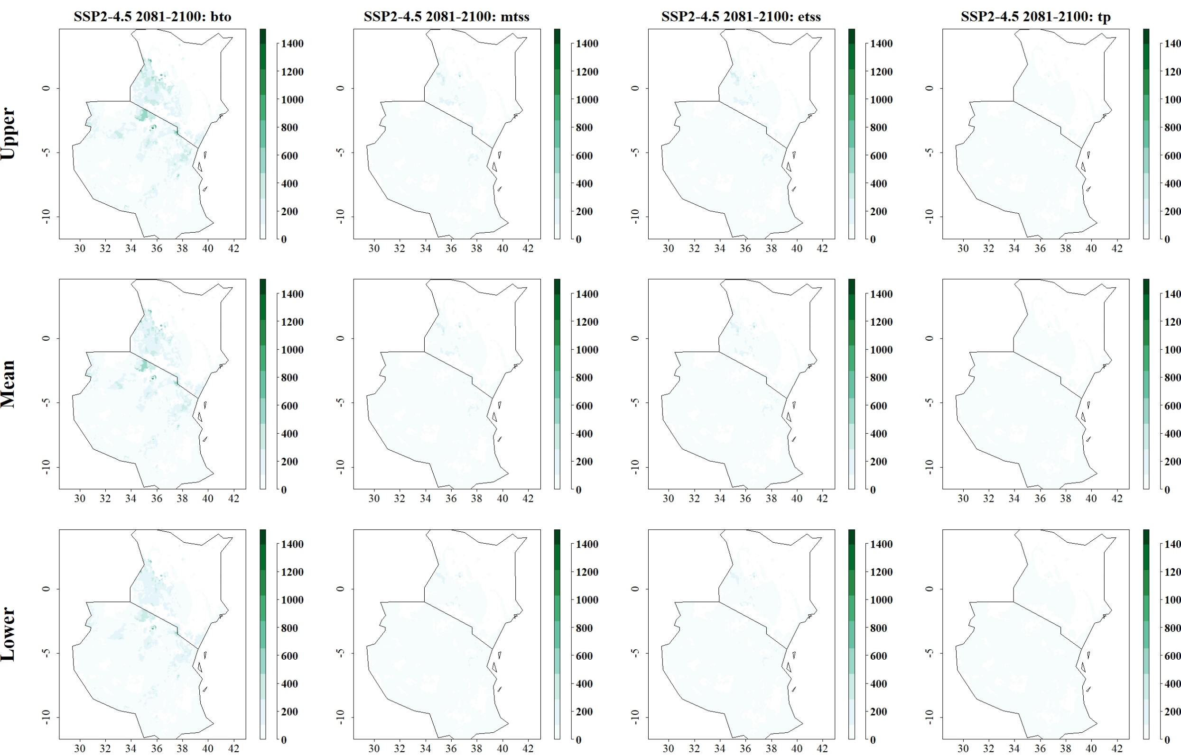
Fig: Predicted reduction of maize yield losses (in kg/ha) by S. calamistis through use of C. flavipes for SSP2-4.5 in 2081–2100 and thresholds Balance training omission, predicted area and threshold values Cloglog (bto), Maximum training sensitivity plus specificity Cloglog threshold (mtss), Equal training sensitivity and specificity Cloglog threshold (etss) and 10th percentile training presence Cloglog threshold (tp). Grid cells where parasitoid application significantly reduces the amount of maize yield losses caused by the stem borer are colored in darker green, whereas grid cells where the reduction of maize yield losses by the species are limited are colored in lighter shades of green and white.
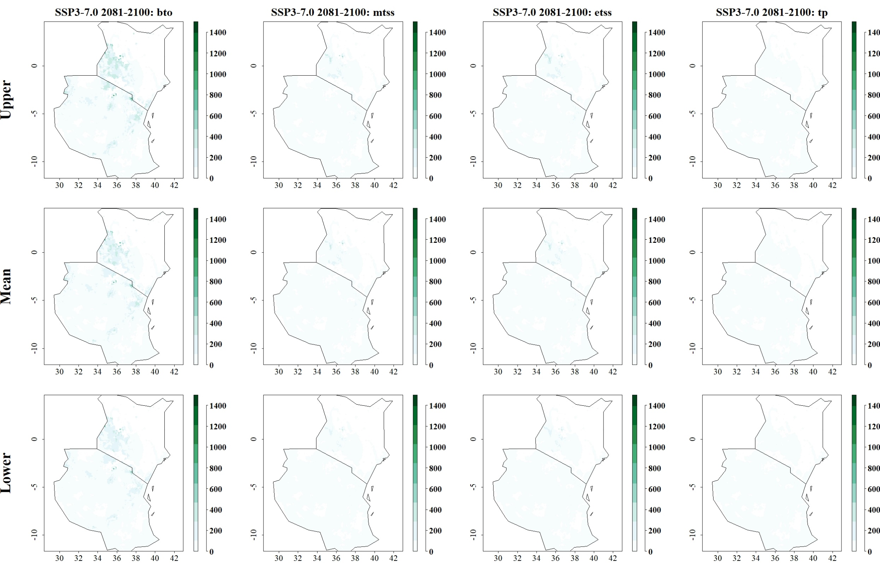
Fig: Predicted reduction of maize yield losses (in kg/ha) by S. calamistis through use of C. flavipes for SSP3-7.0 in 2081–2100 and thresholds Balance training omission, predicted area and threshold values Cloglog (bto), Maximum training sensitivity plus specificity Cloglog threshold (mtss), Equal training sensitivity and specificity Cloglog threshold (etss) and 10th percentile training presence Cloglog threshold (tp). Grid cells where parasitoid application significantly reduces the amount of maize yield losses caused by the stem borer are colored in darker green, whereas grid cells where the reduction of maize yield losses by the species are limited are colored in lighter shades of green and white.
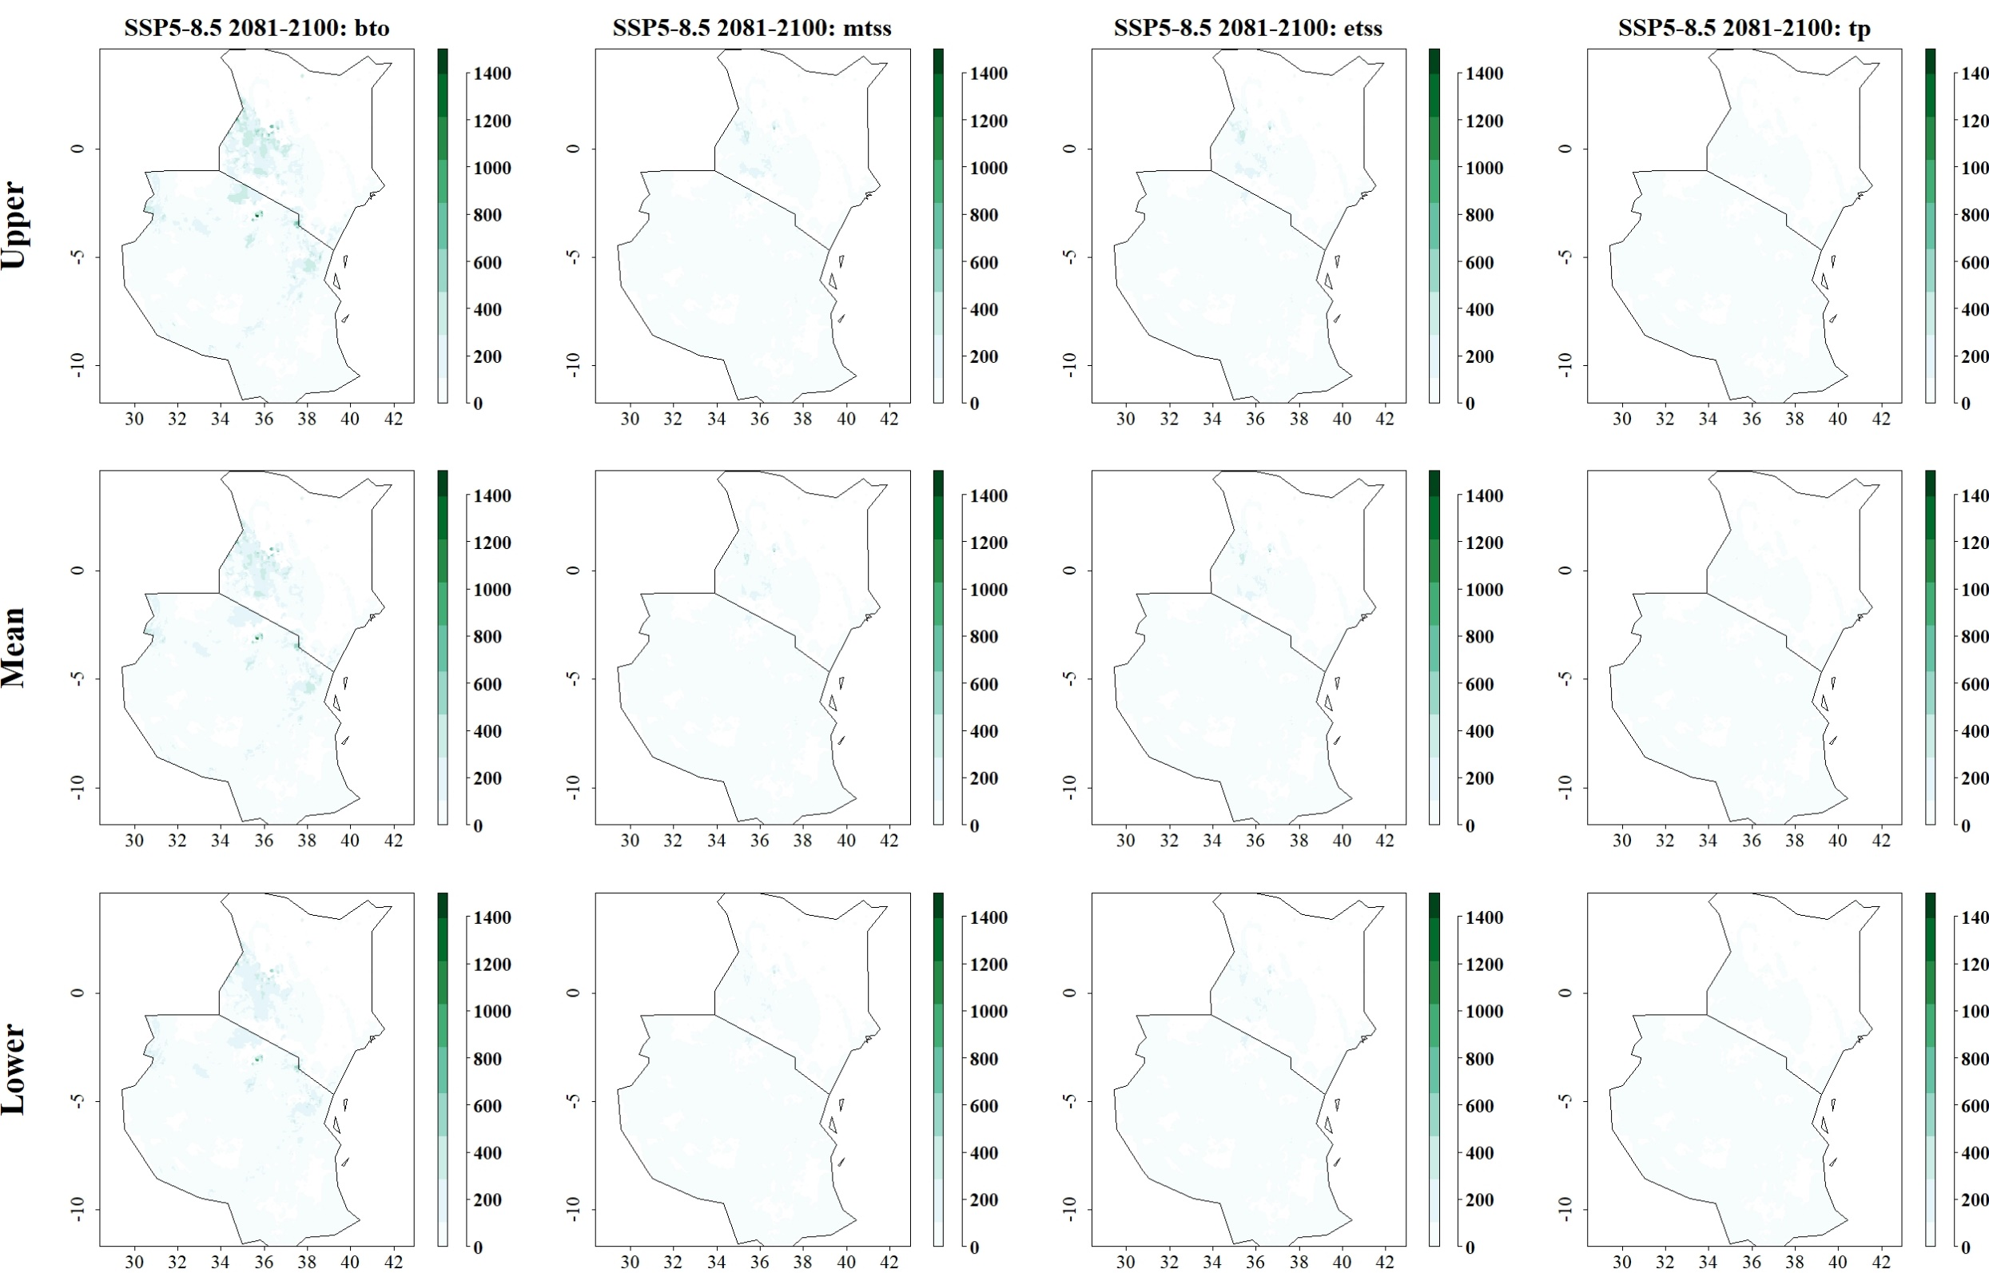
Fig: Predicted reduction of maize yield losses (in kg/ha) by S. calamistis through use of C. flavipes for SSP5-8.5 in 2081–2100 and thresholds Balance training omission, predicted area and threshold values Cloglog (bto), Maximum training sensitivity plus specificity Cloglog threshold (mtss), Equal training sensitivity and specificity Cloglog threshold (etss) and 10th percentile training presence Cloglog threshold (tp). 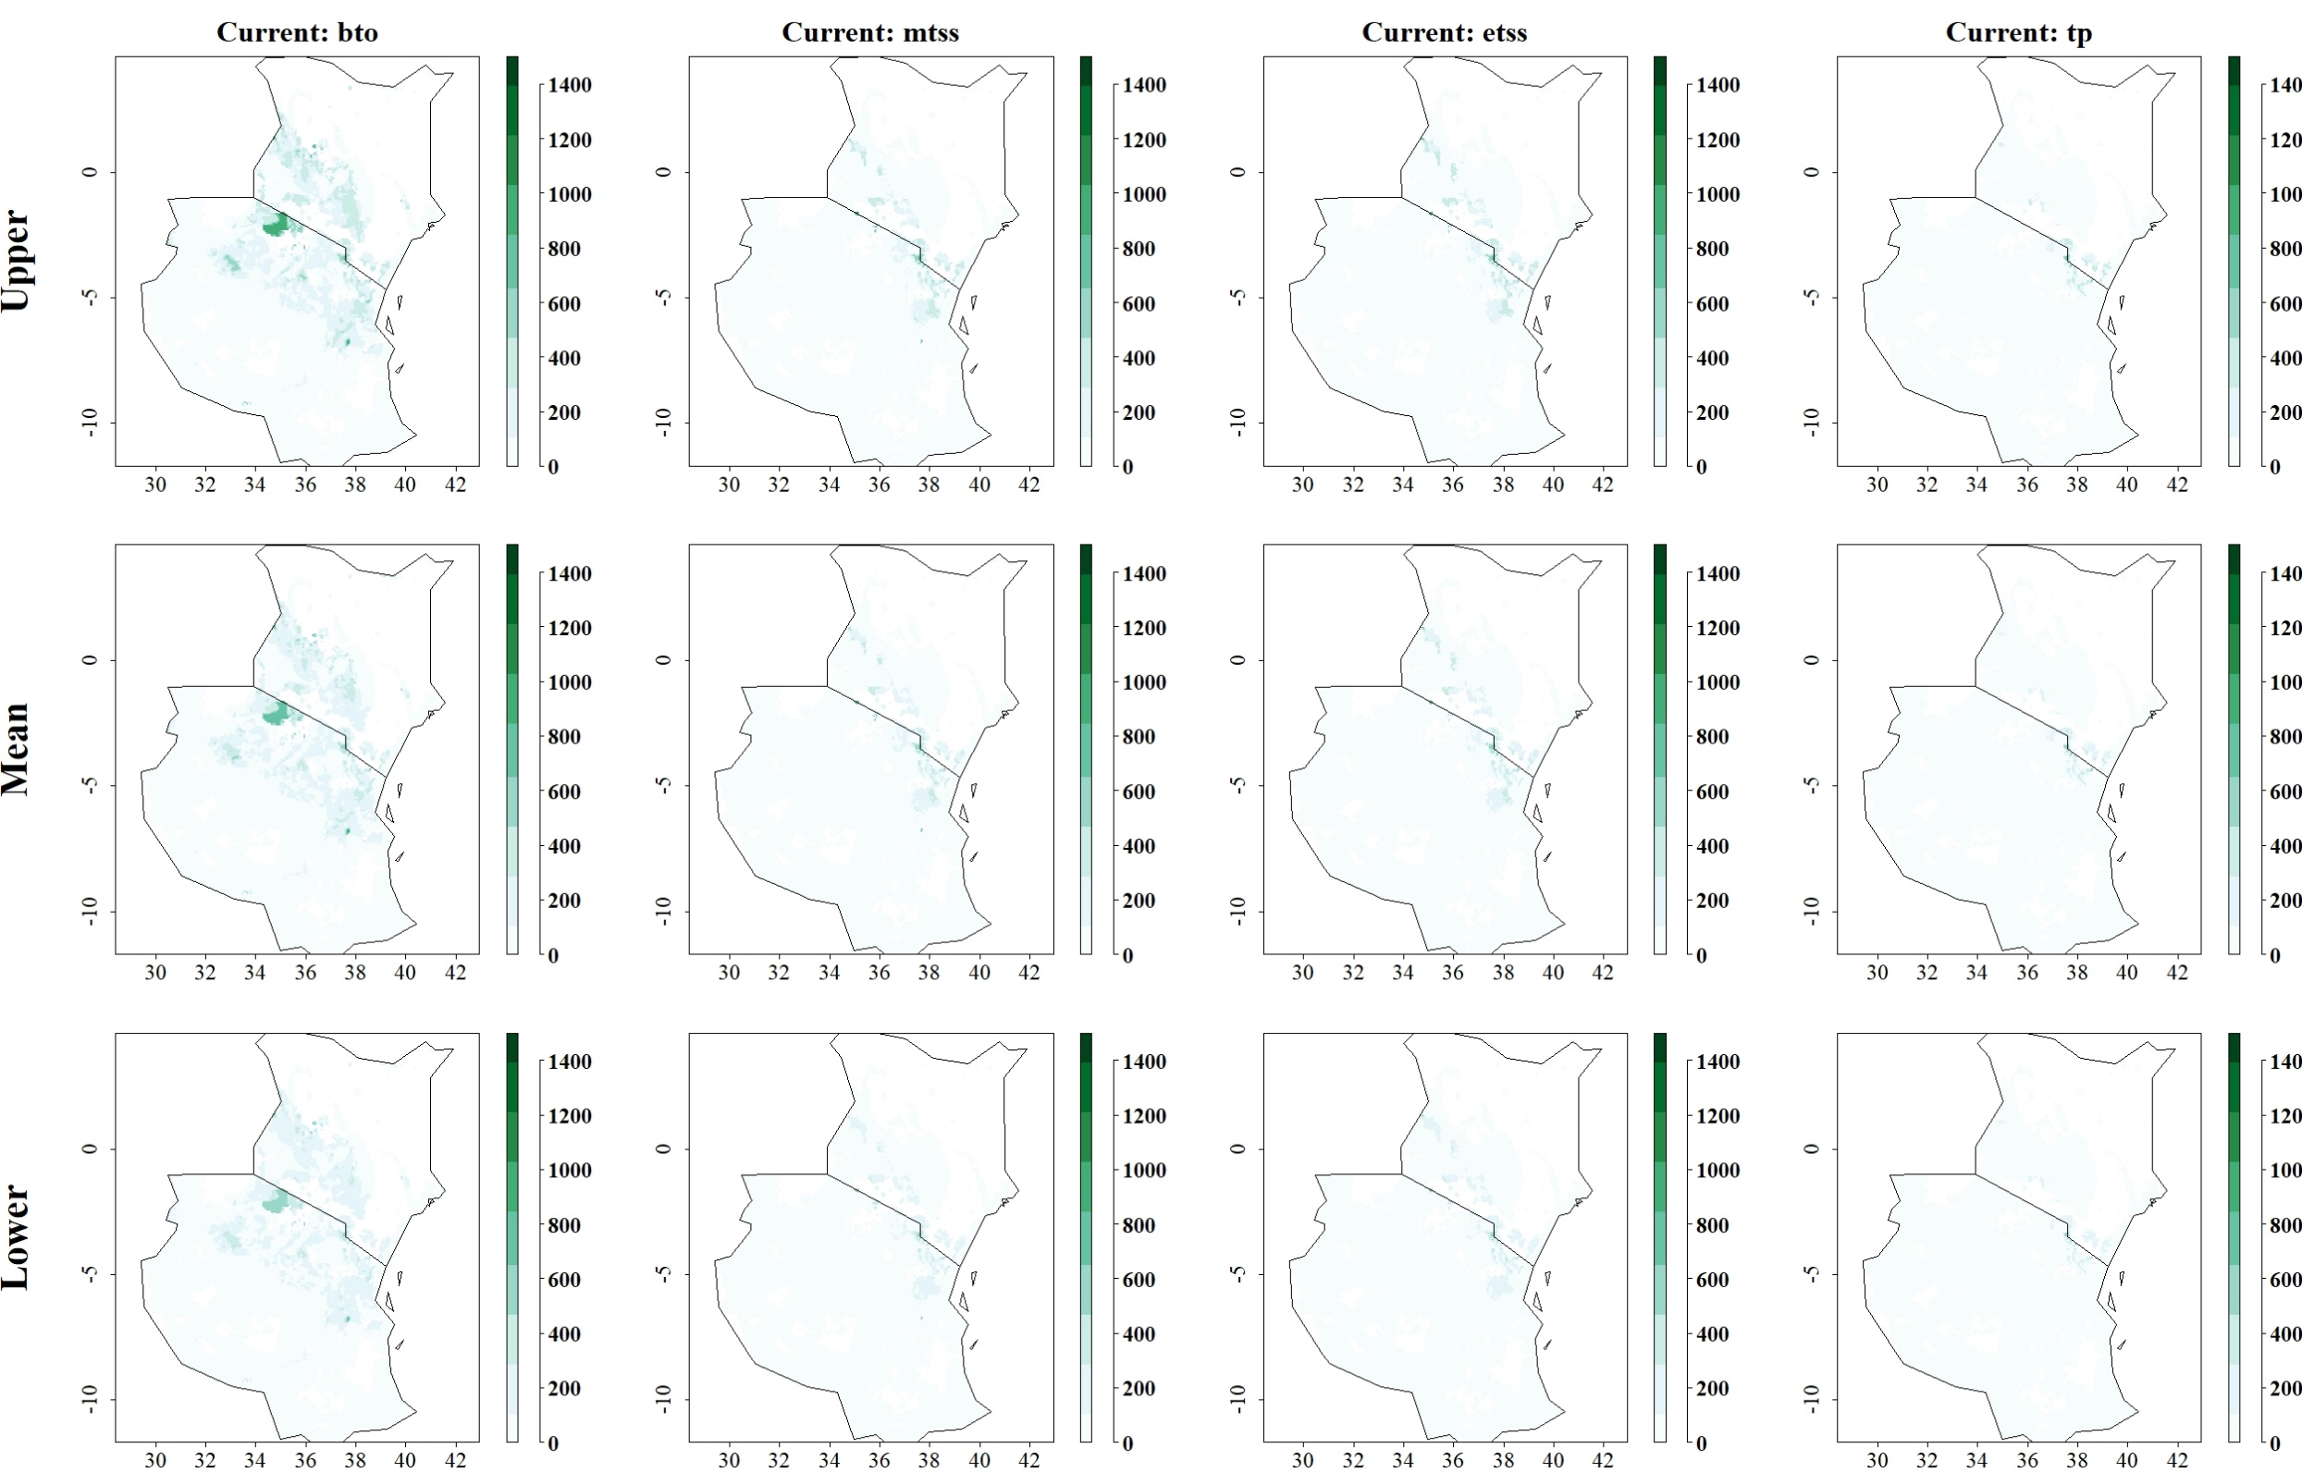

Fig: Predicted reduction of maize yield losses (in kg/ha) by S. calamistis through use of C. sesamiae under current climatic conditions for thresholds Balance training omission, predicted area and threshold values Cloglog (bto), Maximum training sensitivity plus specificity Cloglog threshold (mtss), Equal training sensitivity and specificity Cloglog threshold (etss) and 10th percentile training presence Cloglog threshold (tp). Grid cells where parasitoid application significantly reduces the amount of maize yield losses caused by the stem borer are colored in darker green, whereas grid cells where the reduction of maize yield losses by the species are limited are colored in lighter shades of green and white.
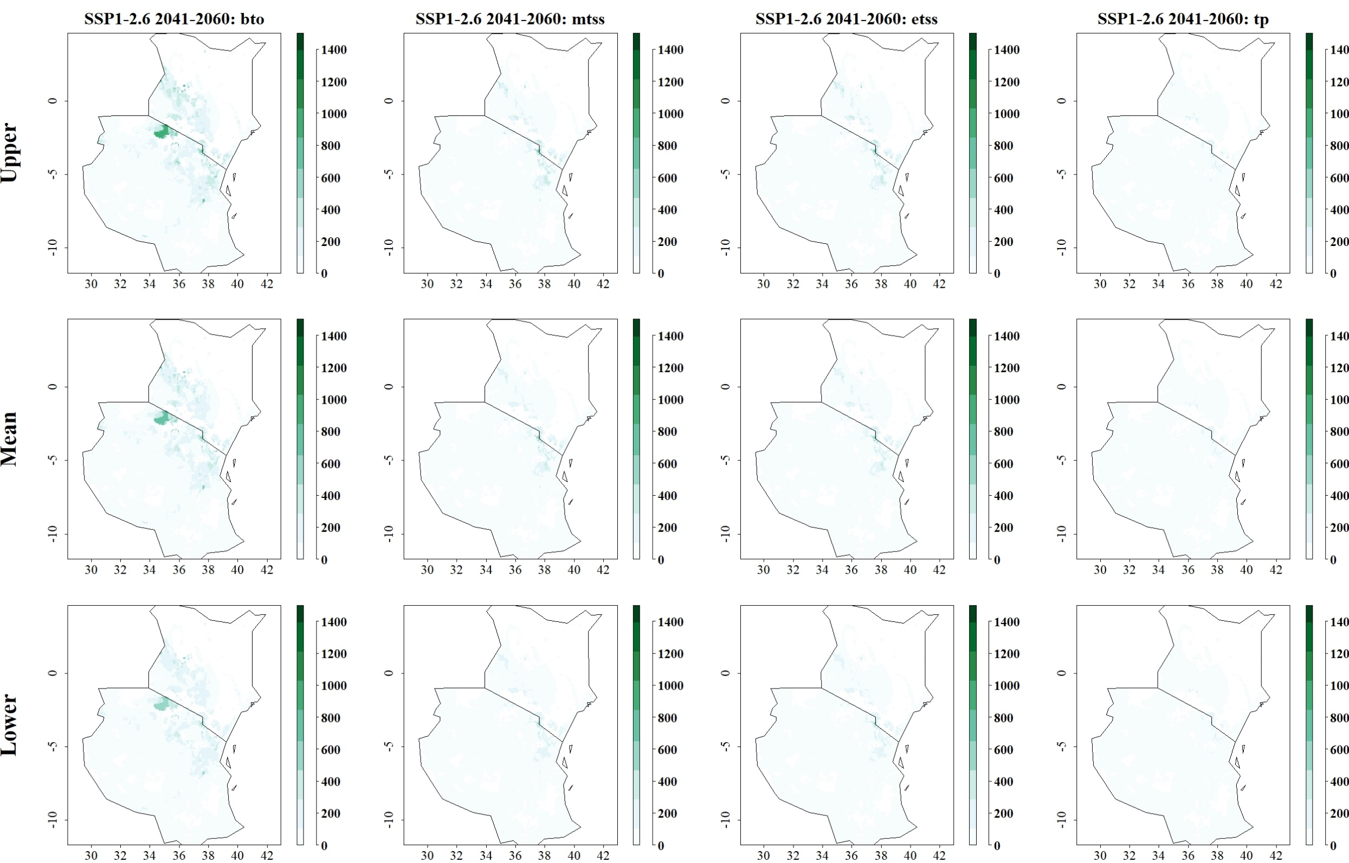
Fig: Predicted reduction of maize yield losses (in kg/ha) by S. calamistis through use of C. sesamiae for SSP1-2.6 in 2041–2060 and thresholds Balance training omission, predicted area and threshold values Cloglog (bto), Maximum training sensitivity plus specificity Cloglog threshold (mtss), Equal training sensitivity and specificity Cloglog threshold (etss) and 10th percentile training presence Cloglog threshold (tp). Grid cells where parasitoid application significantly reduces the amount of maize yield losses caused by the stem borer are colored in darker green, whereas grid cells where the reduction of maize yield losses by the species are limited are colored in lighter shades of green and white.
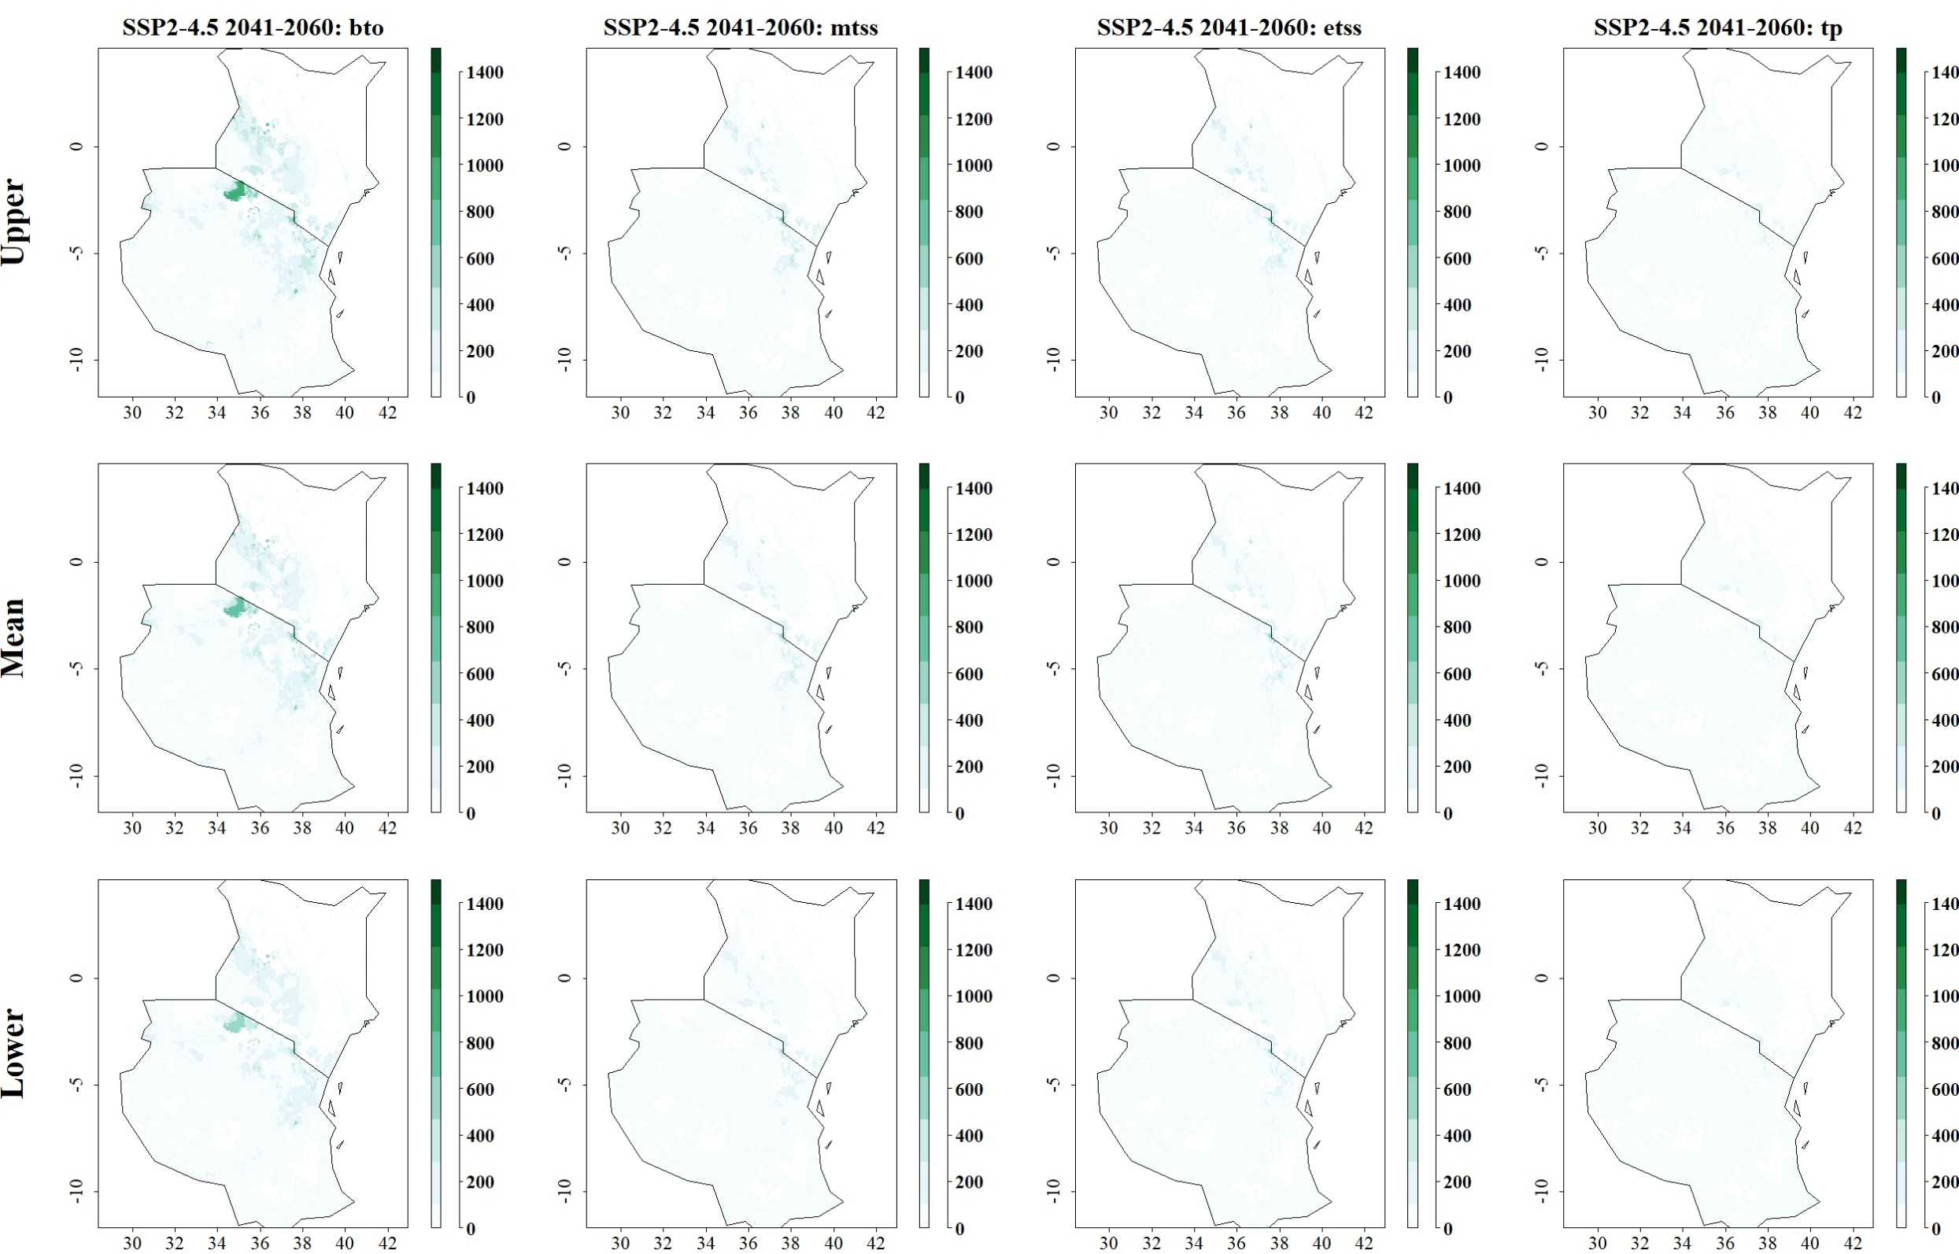
Fig: Predicted reduction of maize yield losses (in kg/ha) by S. calamistis through use of C. sesamiae for SSP2-4.5 in 2041–2060 and thresholds Balance training omission, predicted area and threshold values Cloglog (bto), Maximum training sensitivity plus specificity Cloglog threshold (mtss), Equal training sensitivity and specificity Cloglog threshold (etss) and 10th percentile training presence Cloglog threshold (tp). Grid cells where parasitoid application significantly reduces the amount of maize yield losses caused by the stem borer are colored in darker green, whereas grid cells where the reduction of maize yield losses by the species are limited are colored in lighter shades of green and white.
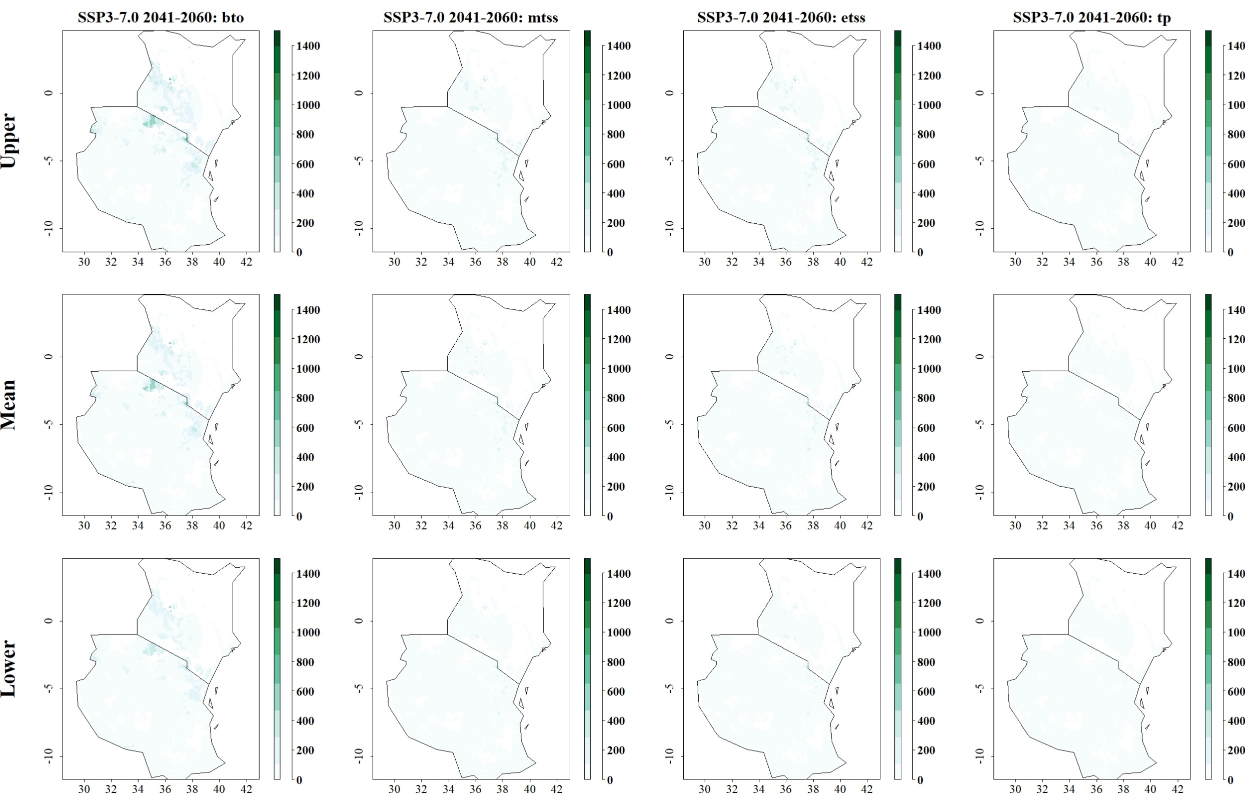
Fig: Predicted reduction of maize yield losses (in kg/ha) by S. calamistis through use of C. sesamiae for SSP3-7.0 in 2041–2060 and thresholds Balance training omission, predicted area and threshold values Cloglog (bto), Maximum training sensitivity plus specificity Cloglog threshold (mtss), Equal training sensitivity and specificity Cloglog threshold (etss) and 10th percentile training presence Cloglog threshold (tp). Grid cells where parasitoid application significantly reduces the amount of maize yield losses caused by the stem borer are colored in darker green, whereas grid cells where the reduction of maize yield losses by the species are limited are colored in lighter shades of green and white.
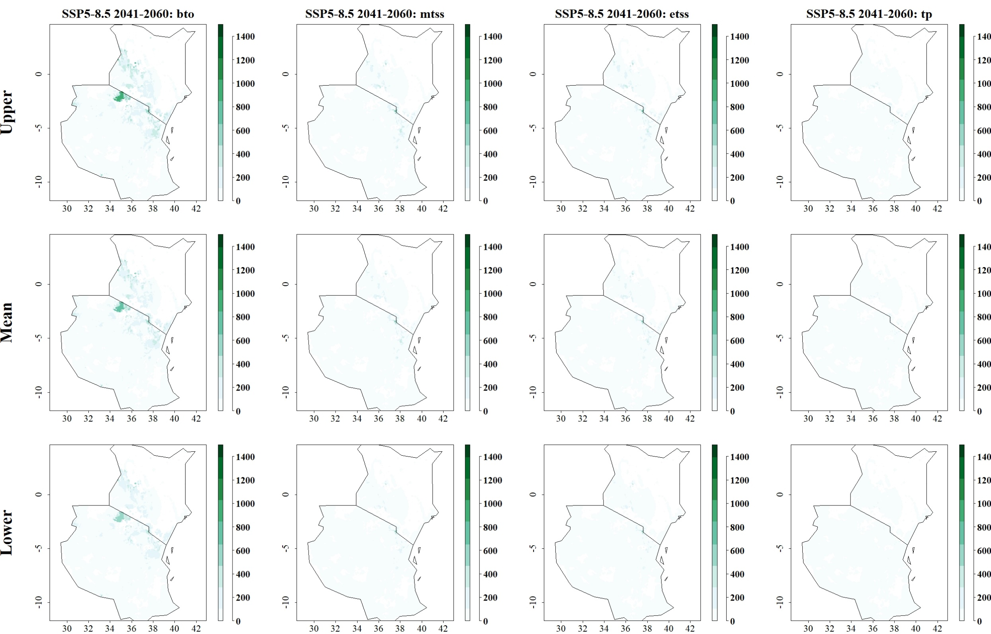
Fig: Predicted reduction of maize yield losses (in kg/ha) by S. calamistis through use of C. sesamiae for SSP5-8.5 in 2041–2060 and thresholds Balance training omission, predicted area and threshold values Cloglog (bto), Maximum training sensitivity plus specificity Cloglog threshold (mtss), Equal training sensitivity and specificity Cloglog threshold (etss) and 10th percentile training presence Cloglog threshold (tp). Grid cells where parasitoid application significantly reduces the amount of maize yield losses caused by the stem borer are colored in darker green, whereas grid cells where the reduction of maize yield losses by the species are limited are colored in lighter shades of green and white.
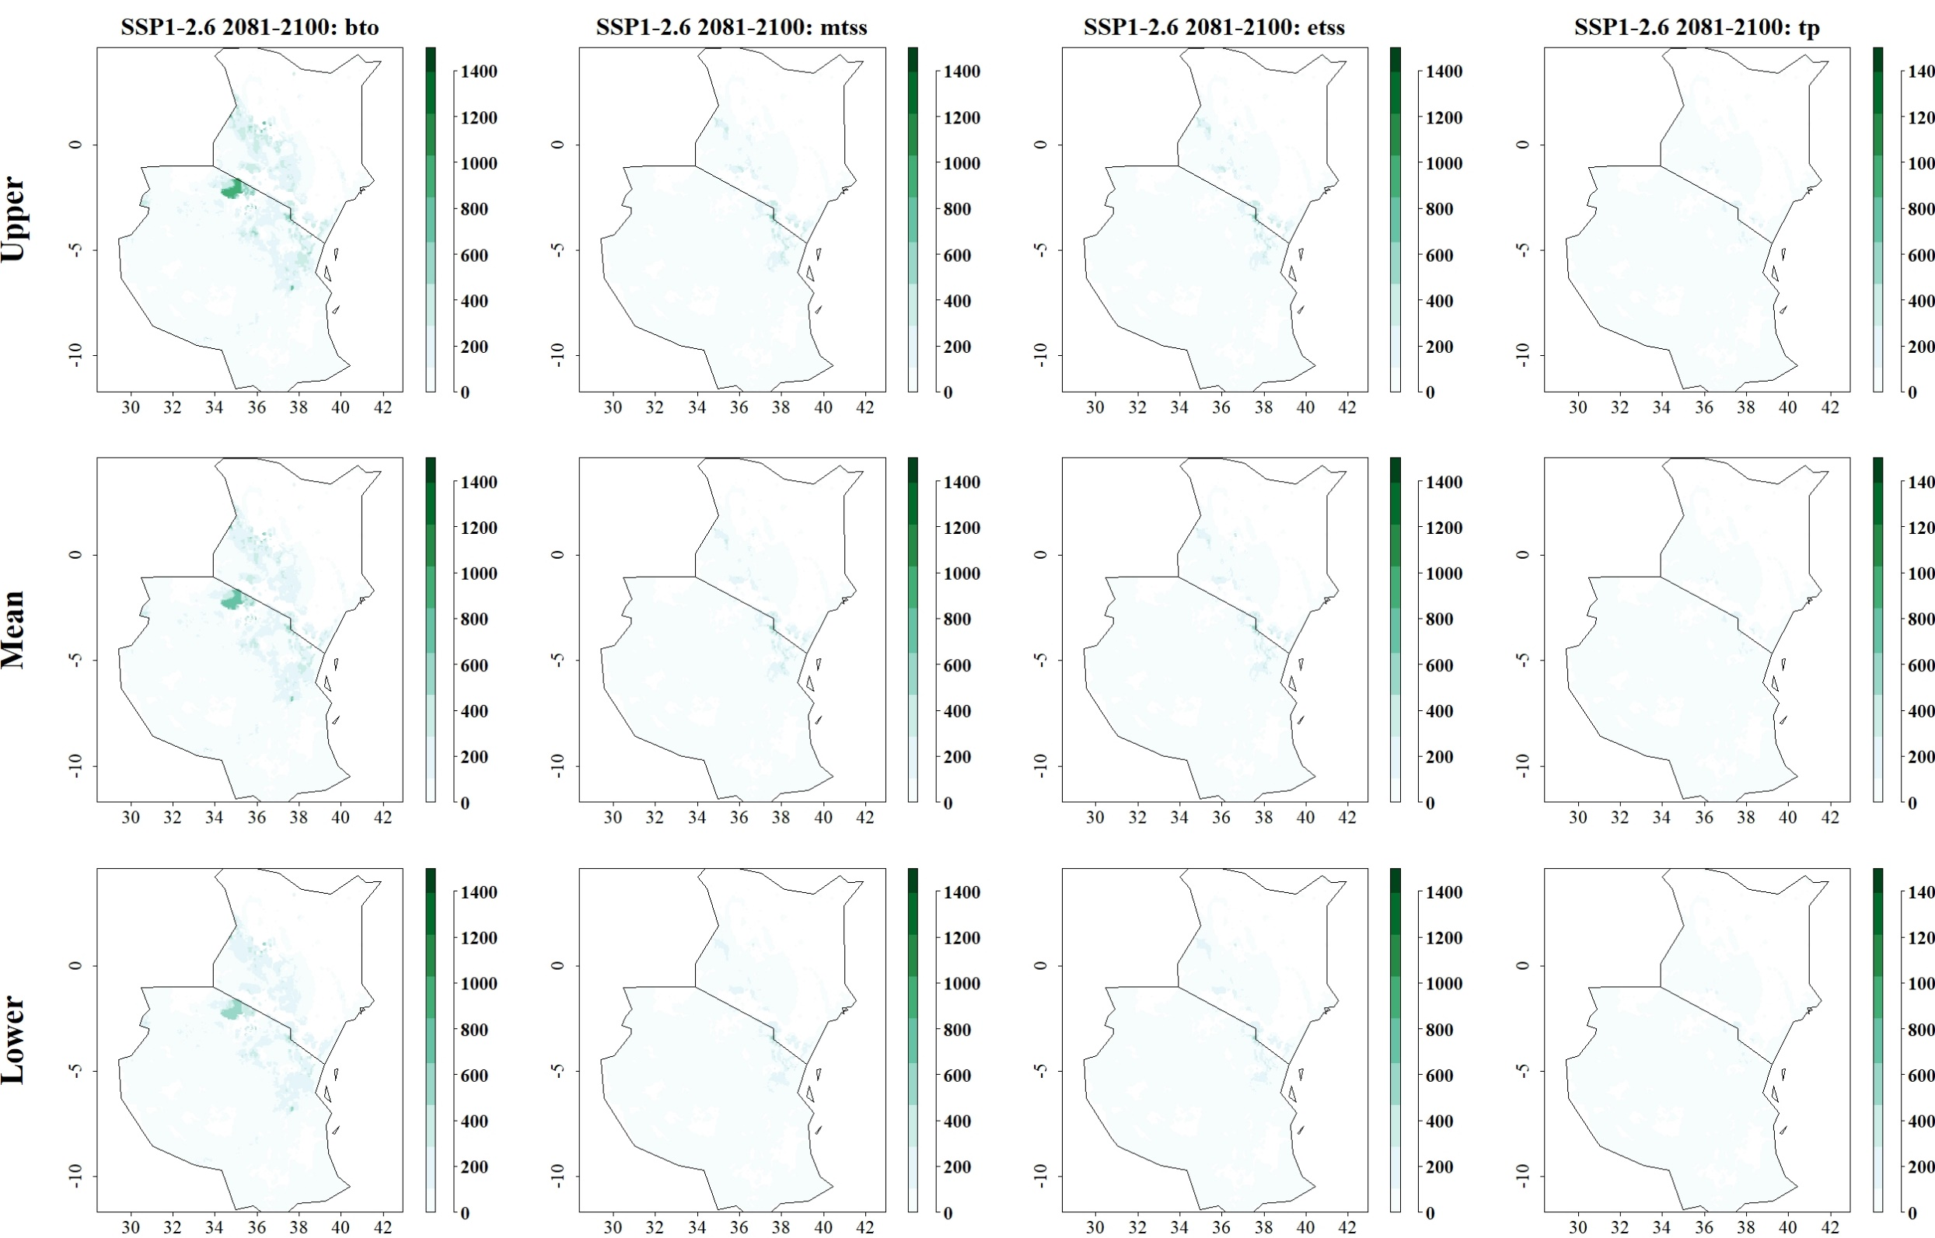
Fig: Predicted reduction of maize yield losses (in kg/ha) by S. calamistis through use of C. sesamiae for SSP1-2.6 in 2081–2100 and thresholds Balance training omission, predicted area and threshold values Cloglog (bto), Maximum training sensitivity plus specificity Cloglog threshold (mtss), Equal training sensitivity and specificity Cloglog threshold (etss) and 10th percentile training presence Cloglog threshold (tp). Grid cells where parasitoid application significantly reduces the amount of maize yield losses caused by the stem borer are colored in darker green, whereas grid cells where the reduction of maize yield losses by the species are limited are colored in lighter shades of green and white.
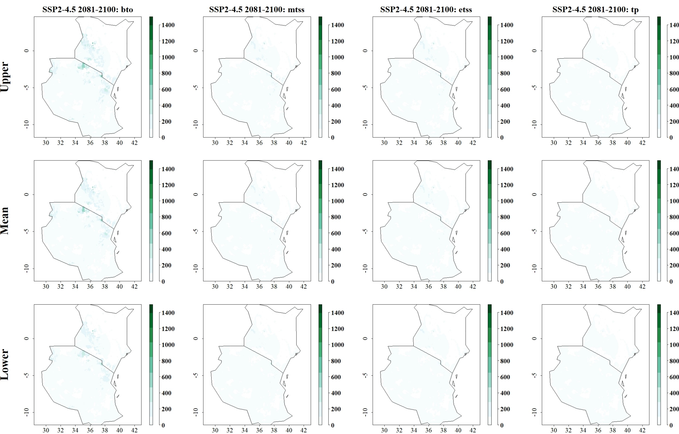
Fig: Predicted reduction of maize yield losses (in kg/ha) by S. calamistis through use of C. sesamiae for SSP2-4.5 in 2081–2100 and thresholds Balance training omission, predicted area and threshold values Cloglog (bto), Maximum training sensitivity plus specificity Cloglog threshold (mtss), Equal training sensitivity and specificity Cloglog threshold (etss) and 10th percentile training presence Cloglog threshold (tp). Grid cells where parasitoid application significantly reduces the amount of maize yield losses caused by the stem borer are colored in darker green, whereas grid cells where the reduction of maize yield losses by the species are limited are colored in lighter shades of green and white.
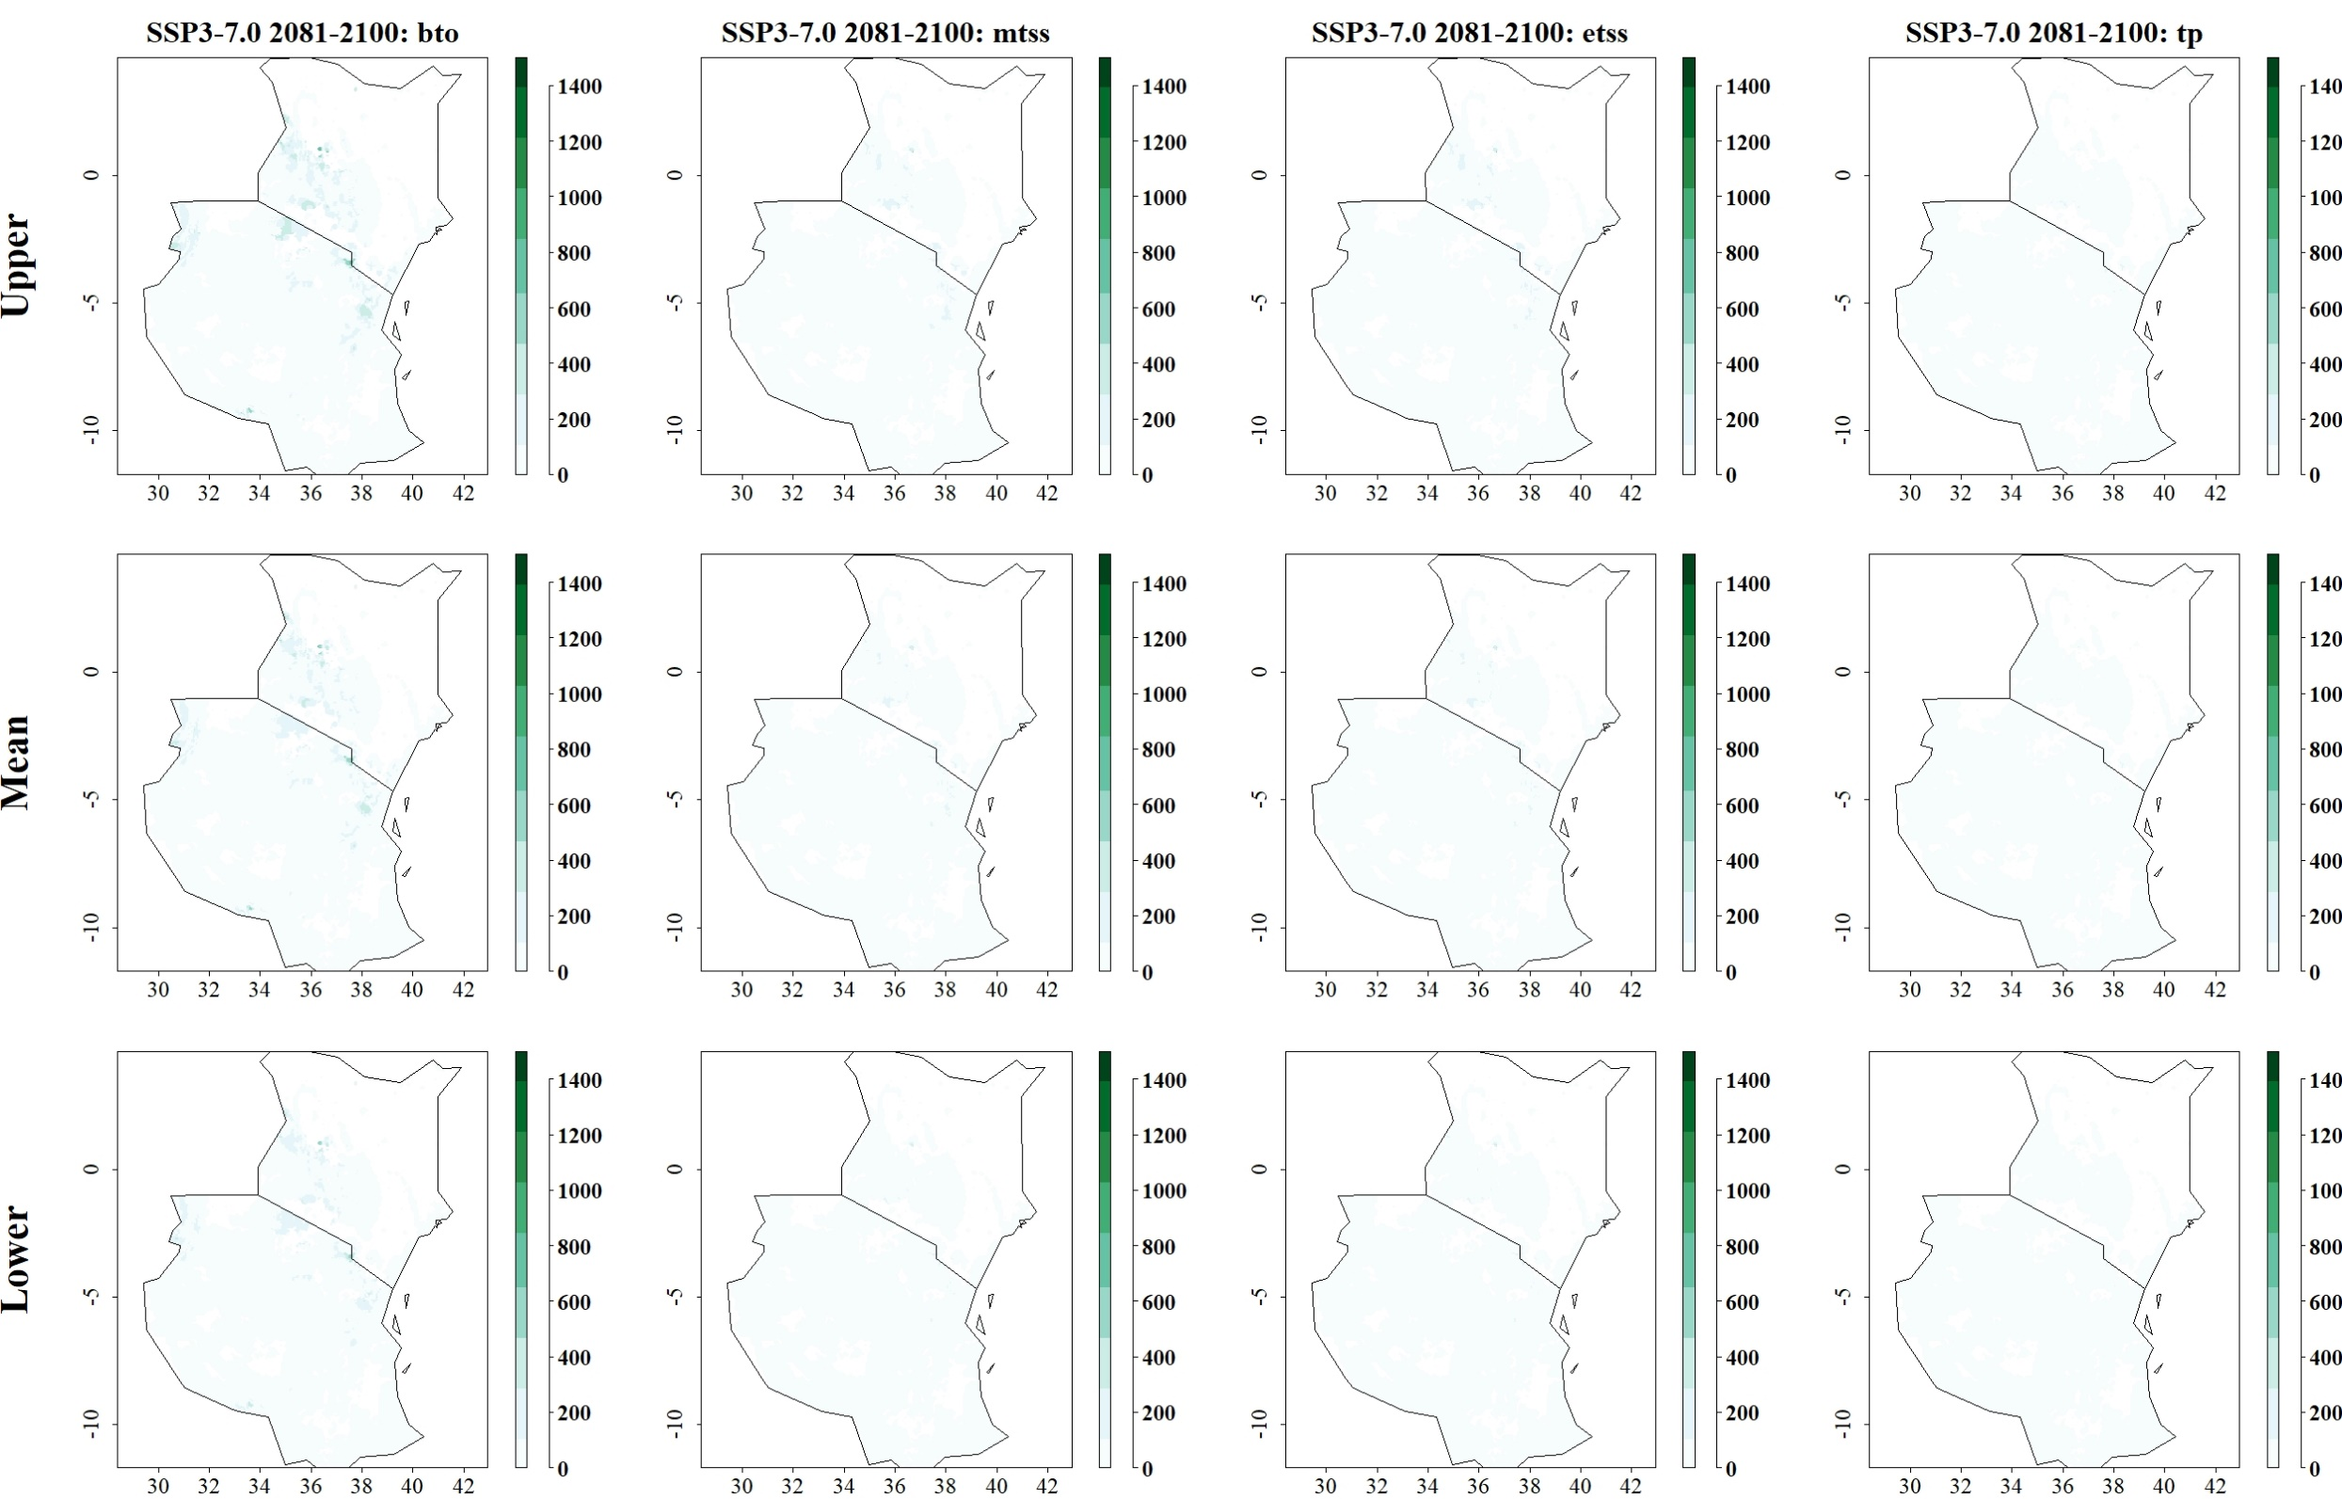
Fig: Predicted reduction of maize yield losses (in kg/ha) by S. calamistis through use of C. sesamiae for SSP3-7.0 in 2081–2100 and thresholds Balance training omission, predicted area and threshold values Cloglog (bto), Maximum training sensitivity plus specificity Cloglog threshold (mtss), Equal training sensitivity and specificity Cloglog threshold (etss) and 10th percentile training presence Cloglog threshold (tp). Grid cells where parasitoid application significantly reduces the amount of maize yield losses caused by the stem borer are colored in darker green, whereas grid cells where the reduction of maize yield losses by the species are limited are colored in lighter shades of green and white.
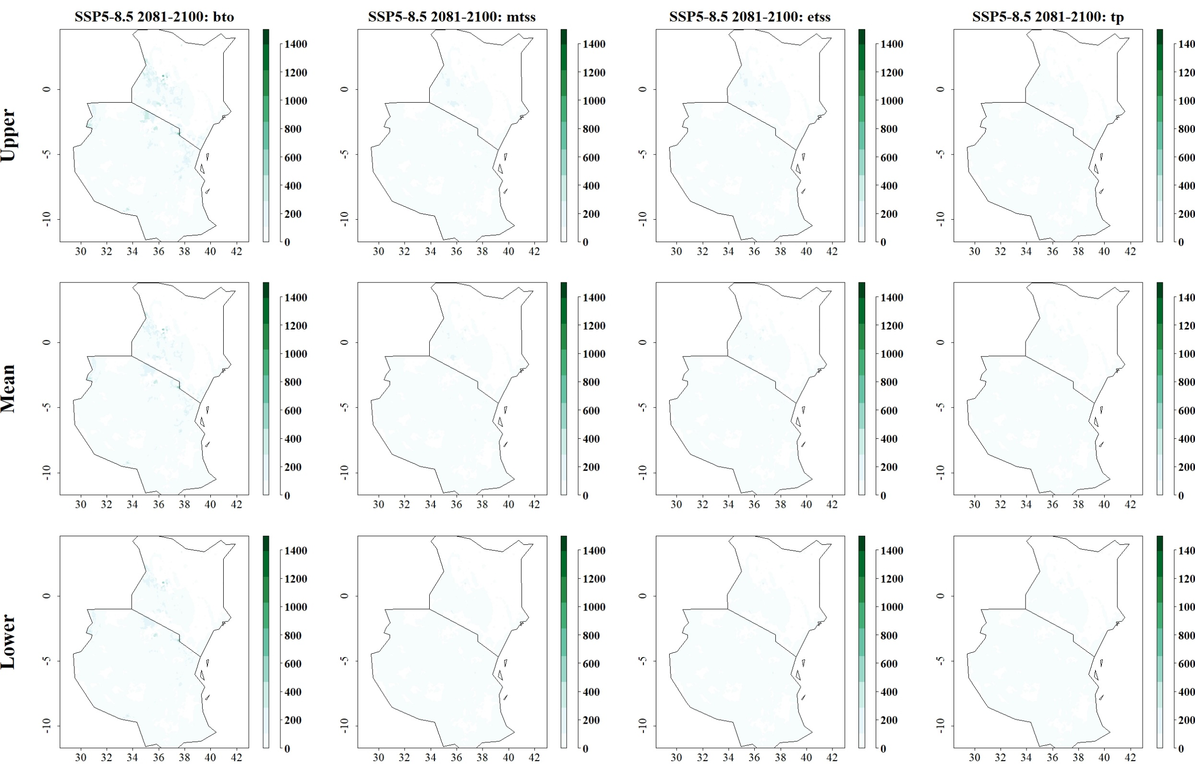
Fig: Predicted reduction of maize yield losses (in kg/ha) by S. calamistis through use of C. sesamiae for SSP5-8.5 in 2081–2100 and thresholds Balance training omission, predicted area and threshold values Cloglog (bto), Maximum training sensitivity plus specificity Cloglog threshold (mtss), Equal training sensitivity and specificity Cloglog threshold (etss) and 10th percentile training presence Cloglog threshold (tp). Grid cells where parasitoid application significantly reduces the amount of maize yield losses caused by the stem borer are colored in darker green, whereas grid cells where the reduction of maize yield losses by the species are limited are colored in lighter shades of green and white.

