Article title: Uncertainties in the effectiveness of biological control of stem borers under different climate change scenarios in Eastern Africa
Journal name: Climatic Change
Author names: Ines Jendritzki, Henri E. Z. Tonnang, Paul-André Calatayud, Christian Borgemeister, Tino Johansson, Lisa Biber-Freudenberger
Affiliation and e-mail address of the corresponding author: Center for Development Research, Department of Ecology and Natural Resources Management, University of Bonn, ijendrit@uni-bonn.de

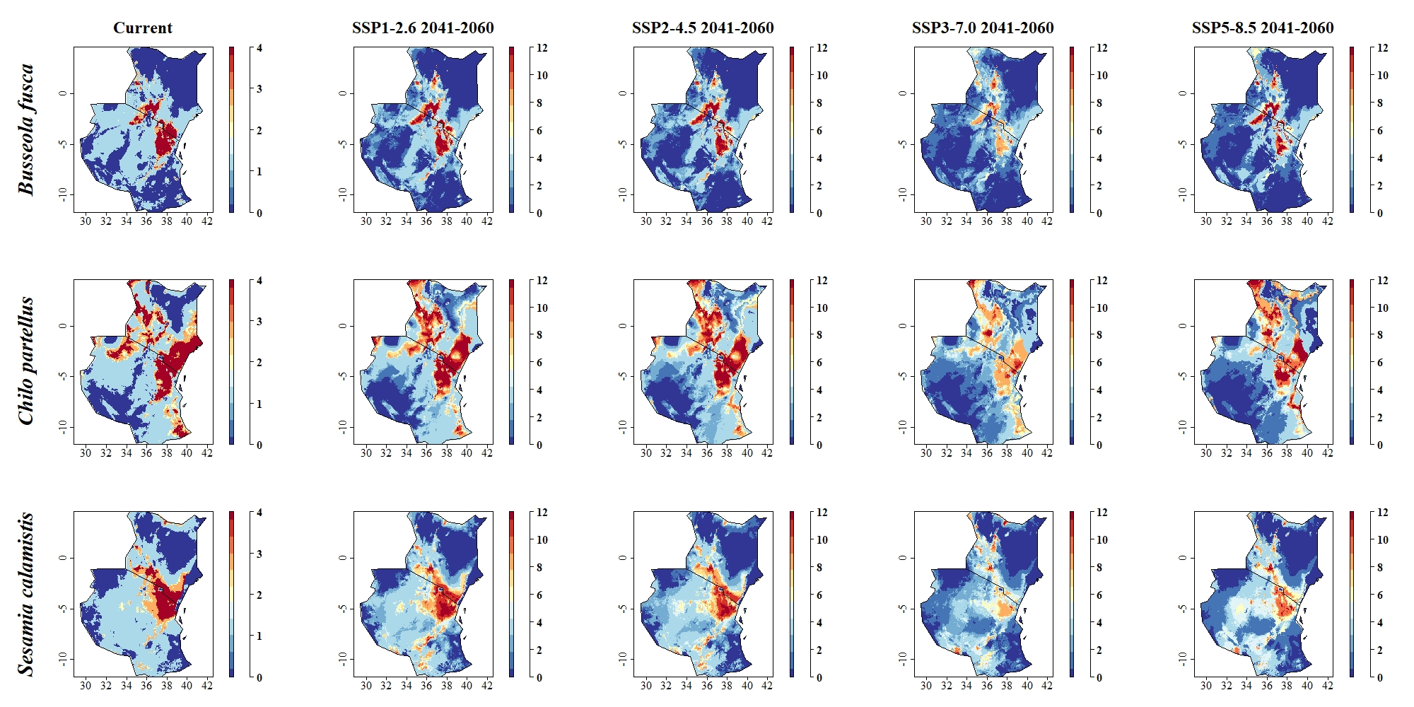
Fig: Predicted distribution of the stem borer pests B. fusca, C. partellus and S. calamistis under current climatic conditions and in period 2041–2060 for pathways SSP1-2.6, SSP2-4.5, SSP3-7.0 and SSP5-8.5. Sum of 4 binary range maps (current distribution) and 12 binary range maps (future distribution) obtained by application of 4 threshold levels, with each binary layer showing either species presence (1) or absence (0). Grid cells where predicted species presence is likely are colored in red and orange, whereas grid cells where presence is less likely are colored in blue

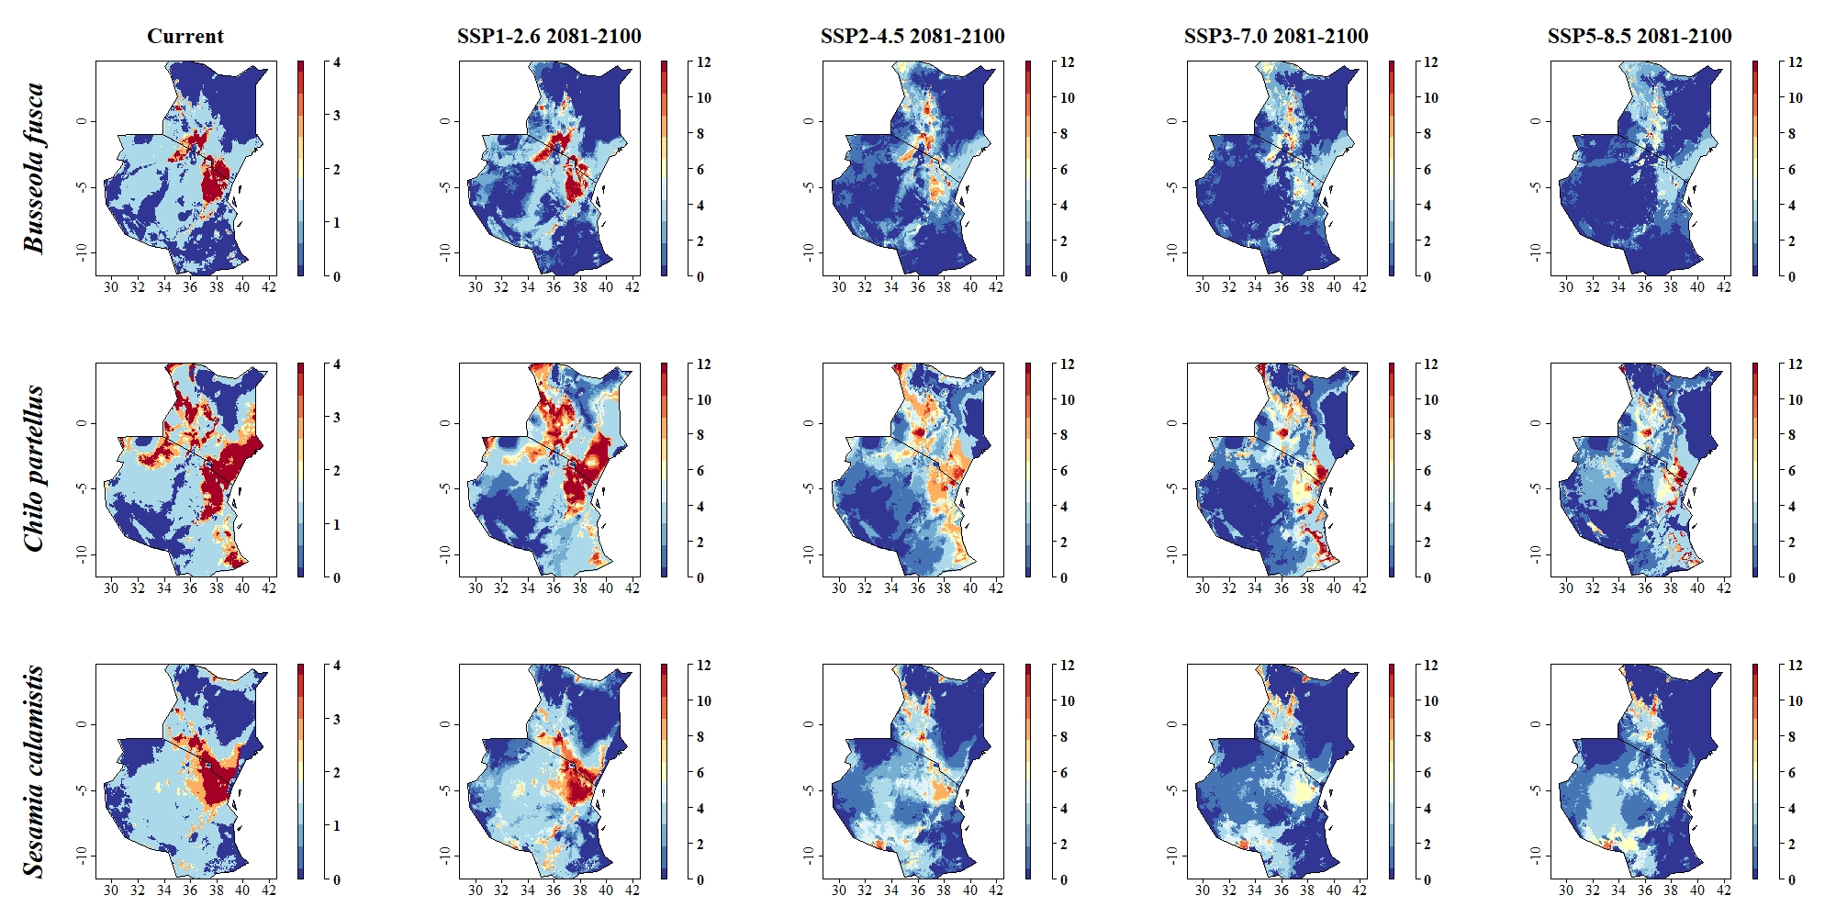
Fig: Predicted distribution of the stem borer pests B. fusca, C. partellus and S. calamistis under current climatic conditions and in period 2081–2100 for pathways SSP1-2.6, SSP2-4.5, SSP3-7.0 and SSP5-8.5. Sum of 4 binary range maps (current distribution) and 12 binary range maps (future distribution) obtained by application of 4 threshold levels, with each binary layer showing either species presence (1) or absence (0). Grid cells where predicted species presence is likely are colored in red and orange, whereas grid cells where presence is less likely are colored in blue

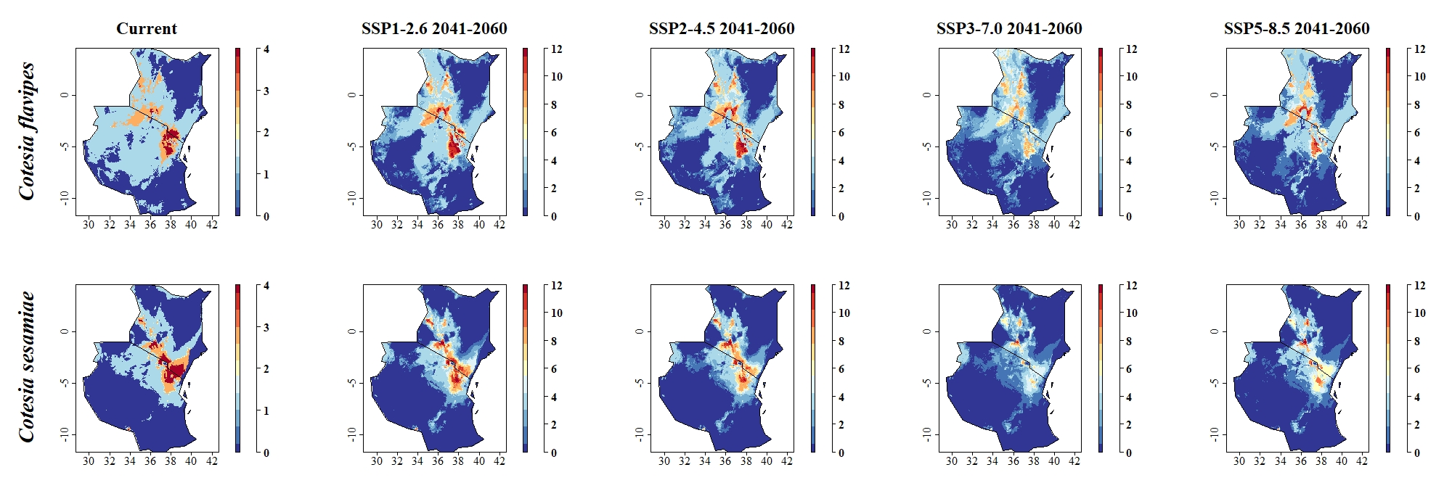Fig: Predicted distribution of the parasitoid C. flavipes and C. sesamiae under current climatic conditions and in period 2041–2060 for pathways SSP1-2.6, SSP2-4.5, SSP3-7.0 and SSP5-8.5. Sum of 4 binary range maps (current distribution) and 12 binary range maps (future distribution) obtained by application of 4 threshold levels, with each binary layer showing either species presence (1) or absence (0). Grid cells where predicted species presence is likely are colored in red and orange, whereas grid cells where presence is less likely are colored in blue

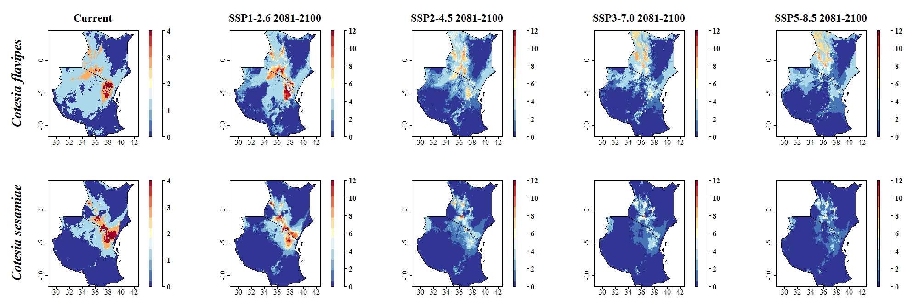Fig: Predicted distribution of the parasitoid C. flavipes and C. sesamiae under current climatic conditions and in period 2081–2100 for pathways SSP1-2.6, SSP2-4.5, SSP3-7.0 and SSP5-8.5. Sum of 4 binary range maps (current distribution) and 12 binary range maps (future distribution) obtained by application of 4 threshold levels, with each binary layer showing either species presence (1) or absence (0). Grid cells where predicted species presence is likely are colored in red and orange, whereas grid cells where presence is less likely are colored in blue

