Article title: Uncertainties in the effectiveness of biological control of stem borers under different climate change scenarios in Eastern Africa
Journal name: Climatic Change
Author names: Ines Jendritzki, Henri E. Z. Tonnang, Paul-André Calatayud, Christian Borgemeister, Tino Johansson, Lisa Biber-Freudenberger
Affiliation and e-mail address of the corresponding author: Center for Development Research, Department of Ecology and Natural Resources Management, University of Bonn, ijendrit@uni-bonn.de

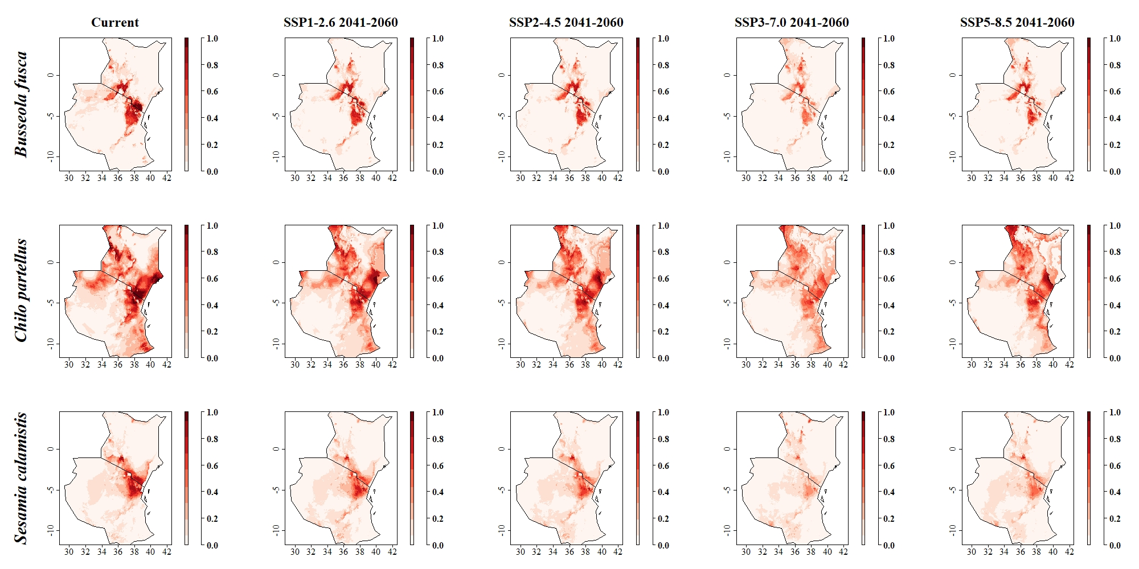
Fig: Probability of habitat suitability for the pests B. fusca, C. partellus and S. calamistis under current climatic conditions and in 2041–2060 for SSP1-2.6, SSP2-4.5, SSP3-7.0 and SSP5-8.5 calculated as multi-model average from GCMs CanESM5, CNRM-CM6-1 and MIROC6. Probability of habitat suitability ranges between 0 (low probability of suitable habitat) and 1 (perfectly suitable habitat). Grid cells with great suitability carry high probability values and are displayed in dark red, whereas cells with low suitability show low probability values and are colored in lighter red and white

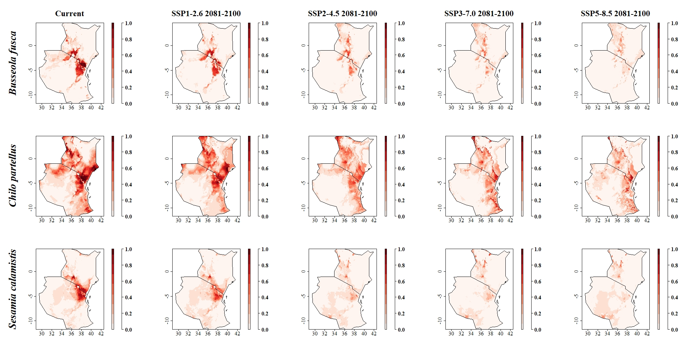
Fig: Probability of habitat suitability for the pests B. fusca, C. partellus and S. calamistis under current climatic conditions and in 2081–2100 for SSP1-2.6, SSP2-4.5, SSP3-7.0 and SSP5-8.5 calculated as multi-model average from GCMs CanESM5, CNRM-CM6-1 and MIROC6. Probability of habitat suitability ranges between 0 (low probability of suitable habitat) and 1 (perfectly suitable habitat). Grid cells with great suitability carry high probability values and are displayed in dark red, whereas cells with low suitability show low probability values and are colored in lighter red and white

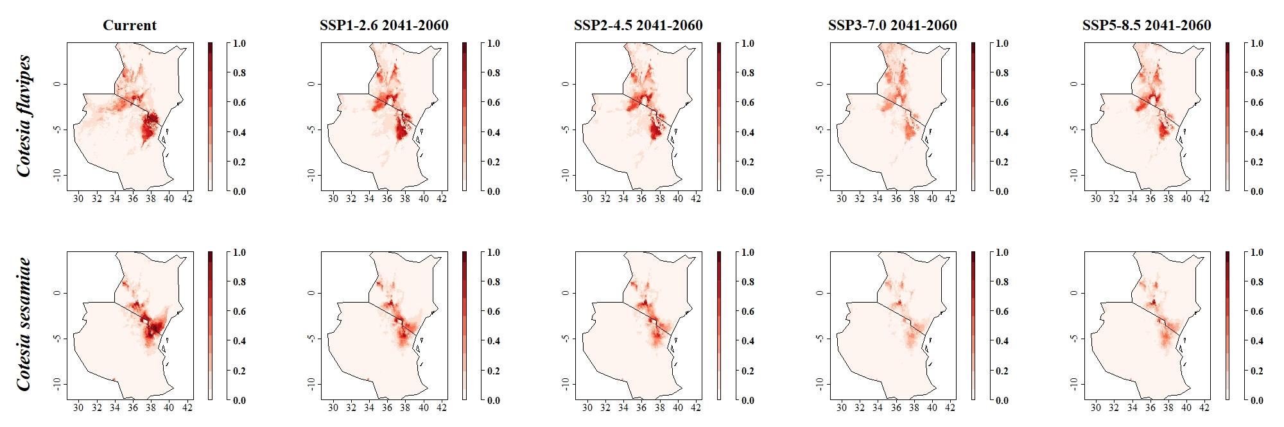Fig: Probability of habitat suitability for the parasitoids C. flavipes and C. sesamiae under current climatic conditions and in 2041–2060 for SSP1-2.6, SSP2-4.5, SSP3-7.0 and SSP5-8.5 calculated as multi-model average from GCMs CanESM5, CNRM-CM6-1 and MIROC6. Probability of habitat suitability ranges between 0 (low probability of suitable habitat) and 1 (perfectly suitable habitat). Grid cells with great suitability carry high probability values and are displayed in dark red, whereas cells with low suitability show low probability values and are colored in lighter red and white

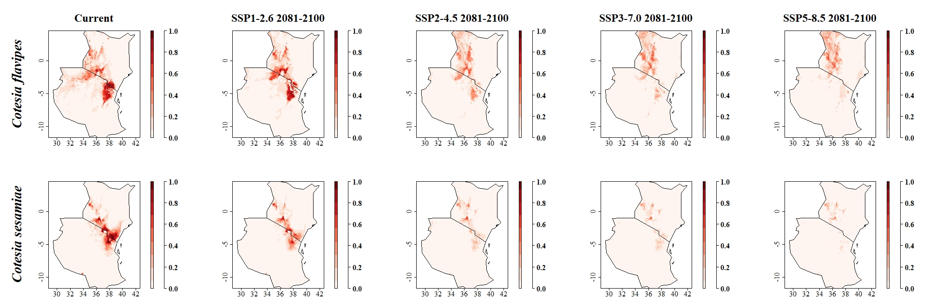Fig: Probability of habitat suitability for the parasitoids C. flavipes and C. sesamiae under current climatic conditions and in 2081–2100 for SSP1-2.6, SSP2-4.5, SSP3-7.0 and SSP5-8.5 calculated as multi-model average from GCMs CanESM5, CNRM-CM6-1 and MIROC6. Probability of habitat suitability ranges between 0 (low probability of suitable habitat) and 1 (perfectly suitable habitat). Grid cells with great suitability carry high probability values and are displayed in dark red, whereas cells with low suitability show low probability values and are colored in lighter red and white

