Supplementary information
Spatiotemporal Defect Dynamics and Microstructural Hierarchy under Extreme Shear
Arun Devaraj^{1, 2*}, Tingkun Liu¹, Changyong Park³, Stanislav Sinogeikin⁴, Matthew Olszta⁵, Bharat Gwalani⁶, Lei Li⁵, Nanjun Chen¹, Qin Pang¹, Wenkai Fu¹, Semanti Mukhopadhyay¹, Suveen Mathaudhu^{2, 5}, Yulan Li¹, Ayoub Soulami⁵, Shenyang Hu⁵, Peter V. Sushko¹, Cynthia Powell⁵
¹Physical and Computational Science Directorate, Pacific Northwest National Laboratory
²Metallurgical Engineering, Colorado School of Mines
³High Pressure Collaborative Access Team, X-ray Science Division, Argonne National Laboratory
⁴DAC Tools LLC
⁵Energy and Environment Directorate, Pacific Northwest National Laboratory
⁶Department of Material Science and Engineering, North Carolina State University
*Corresponding author: arun.devaraj@pnnl.gov

Materials and Methods
Cu-Ni material
Cu (99.5%) and Ni (99.99%) powder used for the high-speed rotational diamond anvil cell (HSRDAC) experiments were purchased from Alpha Aeser. The average particle size of Cu was 7.65 μm and Ni was 5.7 μm, measured using scanning electron microscopy (Supplementary figure 1). The grain size of Cu and Ni was then measured using electron backscattered diffraction of particle cross sections. Cu particles were polycrystalline with an average 1.6 μm equiaxed grain size. Ni grains on the other hand were elongated with an aspect ratio of ~2 and average major axis of 3.1 μm and minor axis of 1.8 μm.
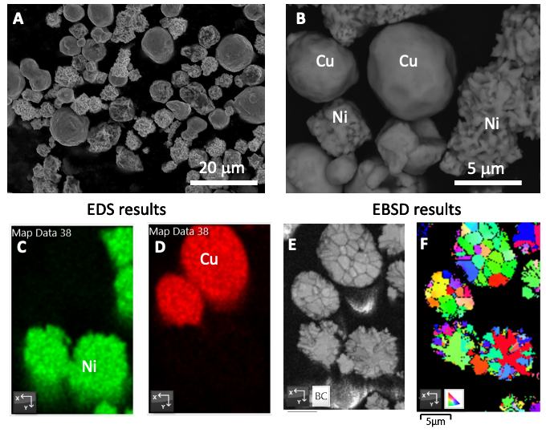
Supplementary Figure 1: Details of the Cu-Ni powder mixture particle morphology and grain sizes: A) low-magnification SEM image, B) high-magnification SEM image, EDS maps of C) Ni and D) Cu, E) band contrast map and F) IPF-z map.
High speed rotational diamond anvil cell
The HSRDAC has a programable servo motor that is coupled to a hollow rotating piston on which a 500 μm culet diamond is mounted. Opposite to this rotating diamond, there is another 500 μm culet fixed diamond and the sample in the form of a powder mixture of 50 weight % Cu and 50 weight % Ni was loaded in between these fixed and rotating diamonds. An indented and predrilled 301 stainless-steel gasket was prepared using the procedure described in supplementary figure 2 to confine the Cu-Ni powder mixture within a 240 μm diameter cavity in between the two diamonds. A stainless-steel pressure controlling membrane was then used to apply a 0.5 GPa pressure to consolidate the powder. The rotational speed and time were remotely controlled. The shear experiment was conducted at 10 RPM for 5 minutes at beamline 16-BM-D with ~1% bandwidth double-multilayer monochromator at 30 keV at High-Pressure Collaborative Access Team (HPCAT), Advanced Photon Source, Argonne National Laboratory. The x-ray beam was focused to 4 μm x 4 μm by using table-top Kirkpatrick-Baez-type Pt mirrors. The dynamic measurements (i.e., during the rotational shear) were conducted by collecting X-ray diffraction spectra repeatedly along the entire diameter of the sample using a line scan with 25 data points per line and 0.4 second acquisition time per point. The 2-dimensional x-ray scanning diffraction was conducted before and after the dynamic measurement and the images were remapped using the XDI software¹. From the six dynamic line scans during each minute the data point at ¼ diameter and the center was extracted and plotted to quantify the lattice strain, change in FWHM and dislocation density.
The modified Williamson-hall (m-WH) method was applied for the calculation of dislocation density, $ρ$ ². The fundamental equation for the m-WH plot is given:
 | $$∆K≅ \frac{0.9}{D}+\sqrt{\frac{πM^{2}b^{2}}{2}}\sqrt{ρ}\left(K{\overline{C}}^{0.5}\right)$$ | (1)
where $K={2\sin{θ}}/λ$ and $∆K={2\cos{θ}\left(∆θ\right)}/λ$. Here,$∆θ$,$θ$, and $λ$ represent the FWHM, diffraction angle, and wavelength of the X-rays, respectively. The FWHM was corrected by subtracting the instrumental broadening with a near-perfect (broadening-free) CeO₂ sample (Gaussian peak shape is assumed here). $D$ and $b$ indicate the average crystalline size, and the magnitude of the Burgers vector, respectively. M is a constant (M=2) depending on both the effective outer cut-off radius of dislocations. $\overline{C}$ is the average contrast factor calculated from individual contrast factor $C_{hkl}$ ³. The $C_{hkl}$ values for {111} <110> edge and {111} screw dislocations can be calculated using the ANIZC software ⁴, with elastic constants of c11 = 169.6 GPa, c12 = 122.4 GPa, c44 = 75.4 GPa for Cu⁵ and c11 = 253 GPa, c12 = 152 GPa, c44 = 124 GPa for Ni⁶. To find the optimum $\overline{C}$, the m-WH fitting using the${ C}_{hkl}$ with the screw/edge ratio ranging from 0 to 1 was performed with a 0.01 step size, and the optimum $\overline{C}$ that gave the highest R-square value was selected ^{7,8}.
After the in situ experiments, the gaskets with consolidated Cu-Ni powders were extracted and brought to PNNL for ex situ characterization. The HS-RDAC processed Cu-Ni disk after $T=$ 5 min shearing at 10 RPM had a final sample thickness of $t=$ 22 $μ$m as measured by cross sectional SEM imaging and a radius of $r$ = 120 $μ$m. A total revolution of $N$ = 50 were performed on the disk sample. Since all ex situ analyses of the sample were carried out at about ½ radius of the disk, $r=$ 60 $μ$m was used to calculate the strain rate and total strain. We assumed complete shearing of the sample with the rotating diamond and no slippage of diamond for simplifying the calculation. A strain rate of 2.856 s⁻¹ and total shear strain of 856.80 were computed by substituting above parameters into Eq. (2) and (3),
$ε=\frac{2πrN}{t}$ (2)
$\dot{ε}=\frac{ε}{T}$ (3)

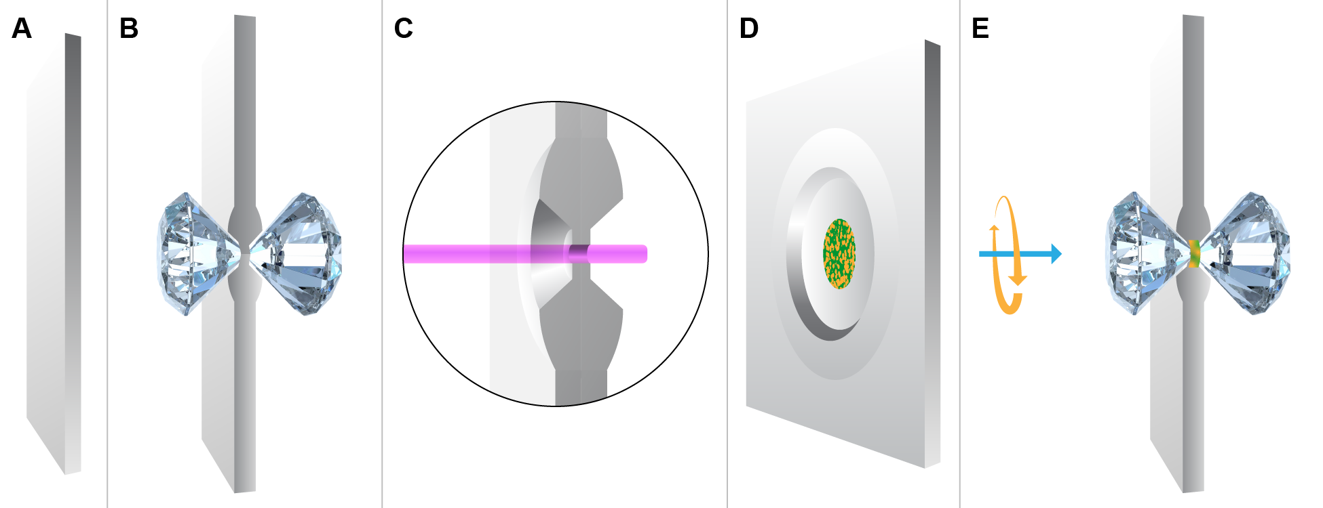
Supplementary Figure 2: Procedure of sample loading in HSRDAC. A) A 301 stainless sheet was used to prepare the gasket. B) The diamond anvil cell was used to indent a 500 mm diameter thin region. C) Laser drilling was used to machine a 240 mm diameter hole at the center of this thin region. D) The drilled gasket was assembled over the fixed diamond and powder was loaded in the cavity. E) The rotating diamond was inserted and the sample was captured between the fixed and rotating diamond within the sample cavity with the stainless steel gasket as a confinement.
FIB preparation of site-specific samples for scanning electron microscopy, transmission electron microscopy and atom probe tomography
Site specific samples for SEM cross sectional EDS analysis, TEM and APT was lifted out using standard liftout procedures from the extracted gasket with the shear deformed Cu-Ni sample in the middle using either a thermofisher quanta 3D FEG or Helios 600 dual beam focused ion beam scanning electron microscope. A through thickness cross section sample of the Cu-Ni disk was lifted out from 60 μm radius using FIB to analyze the microstructural evolution from the top surface close to the rotating diamond to the bottom surface in contact with the fixed diamond.
Transmission electron microscopy and energy dispersive spectroscopy
FIB sample was cleaned in a Fischione Ar nanomill at 900 V and 500 V prior to detailed characterization. An aberration, Cs corrected JEOL ARM 200CF transmission electron microscope operated at 200 keV was used for the transmission and scanning transmission electron microscopy (S/TEM) imaging. The microscope is equipped with a JEOL Centurio energy dispersive spectrometer (EDS) with a collection angle of 0.9 sR.
Additional STEM-EDS was performed using Thermo Fisher Scientific Themis equipped with a Super-X EDS detector operated at 300 kV. All imaging was carried out at screen current of 60 pA and analyzed using Velox software. EDS was conducted at 500 pA screen current using 20 μs dwell time until sufficient counts could be acquired (approximately 600 frames).
Atom probe tomography
A CAMECA LEAP4000 XHR was used for 3D nanoscale compositional analysis of the shear deformed Cu-Ni alloy. APT analysis was conducted in laser assisted mode with 40pJ laser pulse energy, 200KHz pulse repetition rate while keeping the specimen temperature at 40K and evaporation rate maintained at 0.005 atoms/pulse. The APT results were reconstructed and analyzed using AP suit.
Finite element simulation. The finite element model used in this paper were implemented based on the Lagrangian thermo-mechanical marker-and-cell code MVEP2. originally developed to simulate large strain deformation in geodynamic processes.
For the problem we consider in this paper, we closely follow the method in⁹, in which conservation of mass and momentum are used as the governing equations. Direct solver is used to solve the weak form of the governing equations with convergence tolerance of ${10}^{-3}$. Temperature field is ignored in the simulation because experiment was done under constant room temperature. Inertia effect is also not considered as the metals deform relatively slow. In all simulations in this paper, a domain size of 44 $μ$m $×$22 $μ$m is considered, which is discretized into 400$×$200 cells. Each cell is occupied with 3$×$3 particles (markers). An effective viscosity cutoff of 10 Pa·s (lower) and 10⁷ Pa·s (upper) is employed.
The material flow is assumed to follow the power-law relationship:
$η_{eff}=η_{ref}{\left[\frac{{\text{J}}_{2}\left(\dot{ε}\right)}{{\dot{ε}}_{0}}\right]}^{\left(\frac{1}{n}-1\right)}$ (1)
where $η_{ref}$ (Pa·s) is the reference viscosity, ${\text{J}}_{2}\left(\dot{ε}\right)={\left(0.5{\dot{ε}}_{ij}{\dot{ε}}_{ij}\right)}^{0.5}$ is the second invariant of strain rate tensor $\dot{ε}$, ${\dot{ε}}_{0}$ is the reference strain rate (set as 1 s⁻¹ here), and $n$ is the power-law exponent
Since the accurate VC and $n$ values are challenging to calibrate or obtain from literature, we carried out a series of simulations to better understand the material mixing mechanisms with different parameter combinations and initial configurations. For a given power-law exponent $n$, smaller VC results in smaller wavelength of folds and earlier material mixture at lower shear strains. Obvious vortex-like structures are observed with intermediate VC values, while folds are dominating with high VC values because folds are more difficult to roll with higher material viscosity (Supplementary Fig.3). Similarly, for a given viscosity contrast VC, smaller $n$ value leads to smaller fold wavelengths. Vortex-like structures with different sizes are obtained with different $n$ values (Supplementary Fig. 4). By carrying out simulations on an isolated high viscous particle embedded in a lower viscous matrix, it is shown that ($VC,n$) combination determines the material mixing behavior. With smaller ($VC,n$), the particle mainly elongates and forms folds and small vortexes in a relatively smaller region. With intermediate ($VC,n$), the elongated particle starts to fold and roll at smaller strains and forms more vortex-like structures throughout the entire domain at larger strain. When ($VC,n$) is large, the elongated particle folds slowly at higher shear strain and delaminates into smaller particles, which then result in vortexes at different layers at high strain (Supplementary Fig. 5). Simulation results also show that the particle size have a direct impact on the morphological evolution (Supplementary Fig.6) in terms of elongation, fold, delamination, and vortex.
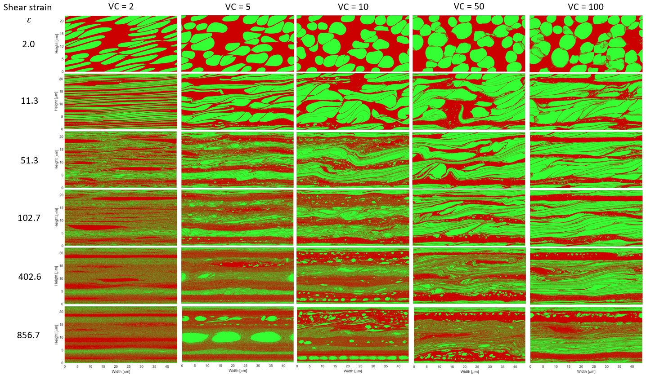
Supplementary Figure 3. Effect of viscosity contrast (VC) on morphological evolution with constant power-law exponent $n$ = 3. Folds with smaller wavelengths are generated with lower VC. Vortex-like structures are prone to occur at intermediate VC. No vortex-like structures develop in case of VC = 2.
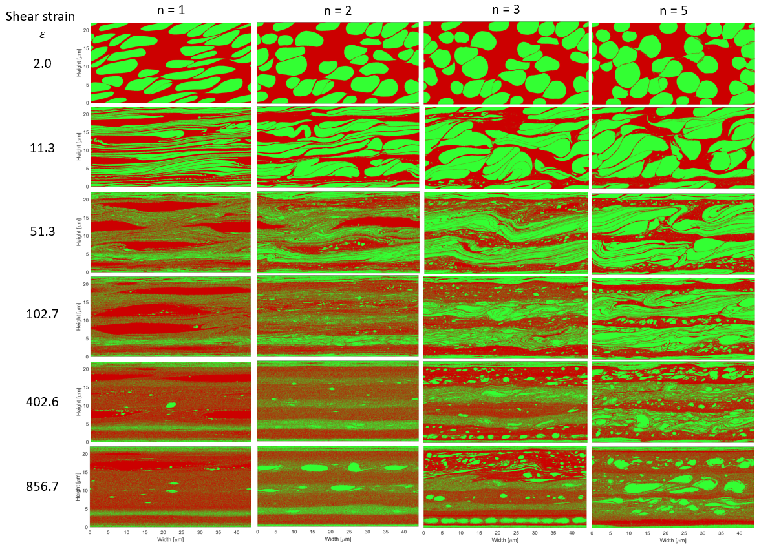
Supplementary Figure 4. Effect of power-law component $n$ on morphological evolution with constant VC = 10. Smaller $n$ results in smaller wavelength of the folds. Vortex-like structures are generated with all $n$ values, different $n$ values lead to different vortex sizes.

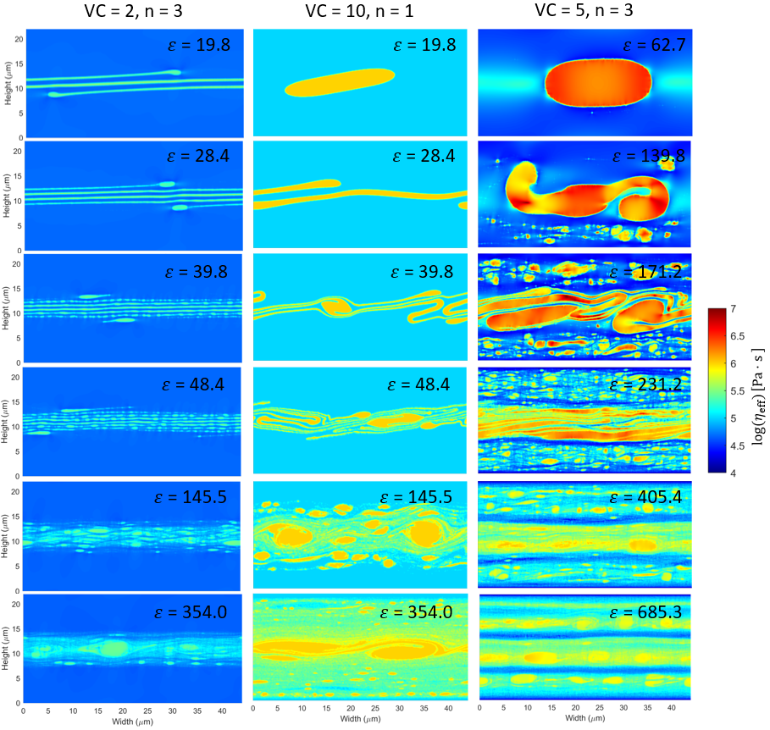
Supplementary Figure 5. Effective viscosity evolution of a single high viscous particle embedded within a lower viscous matrix (identical to Supplementary Fig.4a) with different (VC, $n$) combinations. Note that vortexes are easier to form with intermediate (VC, $n$) values (VC = 10, $n$ = 1). Smaller vortexes are generated with small (VC, $n$) values (VC = 2 $n$ = 3) in a narrower band. With high (VC, $n$) values (VC = 5, $n$ = 3), material folds and form vortex-like structure at a much higher strain.

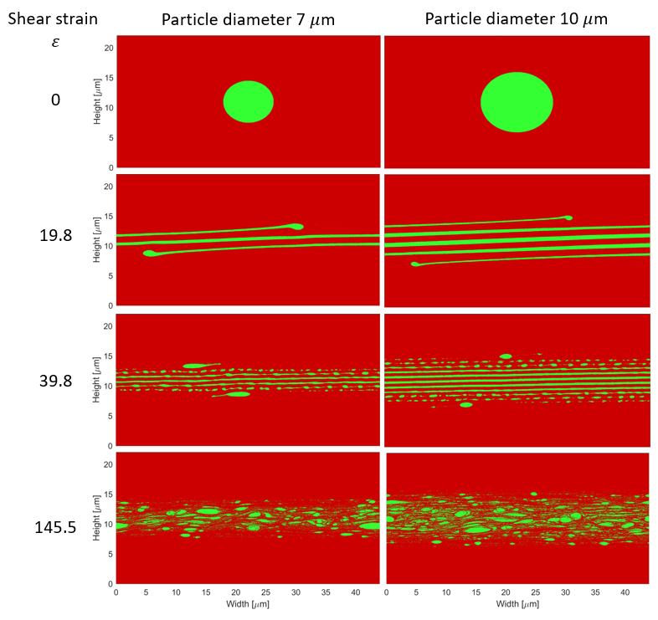
G
H
F
E
C
D
B
A
Supplementary Figure 6. Morphological evolution of two single particles with different initial diameters. Matrix material has less viscosity and the simulations are for VC = 2, $n$ = 3. From top to bottom show the morphologies at strains of 0, 19.8, 39.8, and 145.5, respectively. Larger particle has experienced severer elongation, which then delaminates and results in more vortex-like structures in a relatively large region in the center of the domain.
Crystal plasticity simulations
A three-dimensional (3D) representative volume element (RVE) of equiaxed Cu-Ni with no intermixing as shown in Supplementary figure 7 was used to analyze the influence of shear deformation on geometrically necessary dislocation (GND) density evolution. The volume fractions of Cu grains and Ni grains are 50% by 50%. The RVE was generated by using a phase-field model of grain growth¹⁰. Uniform compressive stress P and shear strain rate ${\dot{F}}_{0}$ were applied at the top of the RVE and periodic boundary condition was used. The grain orientations were random and the average grain size was about 400 $μ$m. Two shear strain rates of ${\dot{F}}_{0}=$2.86/s and 8.49/s to achieve 40% shear strain were considered. The compressive pressure was P=0.5 GPa. This boundary condition was setup to simulate the RDAC experiment.

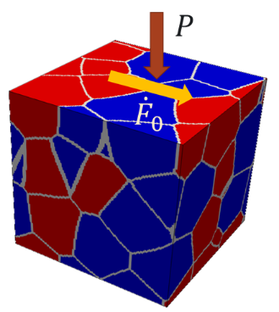
Supplementary Figure 7. A 3D cell of equiaxed Cu-Ni polycrystal structure where Cu is in red and Ni is in blue. P and ${\dot{F}}_{0}$ are the applied uniformed compressive stress and shear strain rate, respectively.
The crystal plasticity of finite strain ¹¹ implemented in the Düsseldorf Advanced Material Simulation Kit (DAMASK) ¹² was employed to simulate the shear deformation of Cu-Ni polycrystalline. Based on the crystal plasticity results, the spatiotemporal evolutions of the GND densities inside Cu and Ni grains were computed. Specifically, the evolution rate of the GND density for the $α$ slip system, ${\dot{ρ}}_{GND}^{α}$, is decomposed into one screw (${\dot{ρ}}_{GNDs}^{α}$) and two edge components (${\dot{ρ}}_{GNDet}^{α}$ and ${\dot{ρ}}_{GNDen}^{α}$). These three components were computed by
${\dot{ρ}}_{GNDs}^{α}=\frac{1}{b}\left[∇_{X}×\left({\dot{γ}}^{α}F_{p}^{T}n^{α}\right)\right]⋅s^{α},$ (S1)
${\dot{ρ}}_{GNDet}^{α}=\frac{1}{b}\left[∇_{X}×\left({\dot{γ}}^{α}F_{p}^{T}n^{α}\right)\right]⋅t^{α},$ (S2)
${\dot{ρ}}_{GNDen}^{α}=\frac{1}{b}\left[∇_{X}×\left({\dot{γ}}^{α}F_{p}^{T}n^{α}\right)\right]⋅n^{α},$ (S3)
respectively ¹³. In the equations, $b$ is the Burger vector magnitude.$∇_{X}×$ represents the curl operation in the reference configuration. ${\dot{γ}}^{α}$ is the shear strain rate of the $α$ slip system. $F_{p}^{T}$ denotes the transpose of the plastic deformation gradient. $n^{α}$ and $s^{α}$ are the unit vectors along the shear plane normal and shear direction of the $α$ slip system, respectively. $t^{α}$ is defined by $t^{α}=n^{α}×s^{α}$. By an integration over time of these three component rates, their corresponding GND densities ($ρ_{GNDs}^{α}$, $ρ_{GNDet}^{α}$, and $ρ_{GNDen}^{α}$) can be computed. Then, the GND density of the $α$ slip system can be calculated by
$ρ_{GND}^{α}=\sqrt{{\left(ρ_{GNDs}^{α}\right)}^{2}+{\left(ρ_{GNDet}^{α}\right)}^{2}+{\left(ρ_{GNDen}^{α}\right)}^{2}}.$ (S4)
A sum over the $N_{s}$ slip systems gives the total GND density, that is
$ρ_{GND}=\sum_{α=1}^{N_{s}}{ρ_{GND}^{α}}.$ (S5)
For Cu and Ni with face-centered cubic (FCC) crystal structure, $N_{s}$ is 12.
The opensource DAMASK of crystal plasticity with the FFT-based spectral solver ¹¹ was employed to solve the shear strain rate and plastic deformation gradient under the given boundary condition. The phenomenological plastic constitutive law (or power law) was used in this work,
${\dot{γ}}^{α}={\dot{γ}}_{0}{\left|\frac{τ^{α}}{ξ^{α}}\right|}^{n}\text{sgn}\left(τ^{α}\right)$, (S6)
where the reference strain rate ${\dot{γ}}_{0}$ and stress exponent $n$ are material parameters. $ξ^{α}$ is the slip resistance and evolves following
${\dot{ξ}}^{α}=h_{0}Σ_{α^{'}=1}^{N_{s}}\left|{\dot{γ}}^{α^{'}}\right|{\left|1-\frac{ξ^{α^{'}}}{ξ_{∞}^{α^{'}}}\right|}^{a}\text{sgn}\left(1-\frac{ξ^{α^{'}}}{ξ_{∞}^{α^{'}}}\right)h^{αα^{'}}$, (S7)
$ξ^{α}=ξ_{0}+\int_{0}^{t}{{\dot{ξ}}^{α}}dt$. (S8)
Here, $h_{0},a,ξ_{∞}^{α^{'}}=ξ_{∞}, \text{and} h^{αα^{'}}$ are material parameters. $h_{0}$ and $a$ are model-specific fitting parameters. $ξ_{∞}^{α^{'}}$ bounds the resistance evolution. $h^{αα^{'}}$ is the component of the slip-slip interaction matrix between slip systems $α$ and $α^{'}$ that describes crystal hardening. $α=α^{'}$ refers to self-hardening $α≠α^{'}$ for latent hardening. The used materials properties are listed in supplementary table.
Supplementary Table 1. Material properties used in the simulation¹⁴.
Property | Cu | Ni
$C_{11}$ (GPa), Stiffness | 168.0 | 251.0
$C_{12}$ (GPa) | 121.0 | 150.0
$C_{44}$ (GPa) | 75.4 | 124.0
${\dot{γ}}_{0}$ ($s^{-1}$) | 0.001 | 0.001
$ξ_{0}$ (MPa) | 16.0 | 26.1
$ξ_{∞}$ (MPa) | 148.0 | 240.0
$h_{0}$ (MPa) | 180.0 | 365.0
A | 2.25 | 1.0
N | 83.3 | 83.3
Burgers b (nm) | 0.2556 | 0.2492

Molecular dynamic simulations
Large-scale Atomic/Molecular Massively Parallel Simulator (LAMMPS) package ¹⁵ was used to simulate the deformation and defect evolution in two phase polycrystalline CuNi structures under HSRDAC tests. Embedded atom method (EAM) ^{16,17}, which was widely used to simulate deformation and thermodynamic and kinetic properties of defects in metals, is used to describe the atomic interaction in CuNi. The interatomic potential parameters can be found in Ref ¹⁸. During HSRDAC tests, the material is subjected to continuous shear deformation so that the shear strain could be very large. However, in MD simulations, large deformation dramatically changes the simulation cell shape so it will need large volume of communication to acquire ghost atoms around processors resulting in inefficient calculations, even fails with the loss of atoms. To solve this problem, we developed an on-the-fly PBC adjustment scheme. Particularly, we map atoms in the deformed simulation cell back to a rectangle/cubic simulation cell using the periodic boundary conditions once the shear strain increment reaches $∆γ=0.3$as shown in supplementary figure 8. With the on-the-fly PBC, the continue shear deformation can be any large value.
Set up of MD simulations
A two phase polycrystalline CuNi structure with 14 Cu and 14 Ni grains with an average size of 17 nm shown in Supplementary figure 8 is generated by using Voronoi tessellation technique implemented in Atomsk ¹⁹. The phase and grain orientation are assigned randomly. The simulation cell has dimensions of 50.843 nm $×$ 50.843 nm $×$ 50.843 nm³ with a total of 11,473,795 atoms including 42.8% Cu and 57.2% Ni. In the simulations, the two-phase polycrystalline structure is first relaxed with constant temperature and pressure at 600 K for 50 ps and quench to 300 K. Then, atoms inside the top and bottom slabs with a thickness of 1.3nm are frozen as shown in supplementary figure 8 Atoms inside the bottom slab has zero velocity to describe no slide boundary condition. The shear deformation simulation starts with a compress in z direction by moving the top slab with a velocity of 0.1 m/s to a pressure of 0.5GPa which is estimated from the HSRDAC test. Then continuous shear deformation is applied by holding the pressure and shearing the center cell at strain rate 1$×$10¹⁰ s⁻¹ with top slab moving along. On-the-fly periodic boundary conditions are applied to x and y directions, and the temperature is maintained at 300K. When the shear strain reaches 2 the deformation is switched off to perform annealing under the same temperature for 240ps. The visualization of deformation is performed by Ovito ²⁰. By using common neighbor analysis (CNA) ²¹, different local structures corresponding to HCP, BCC, and FCC, and Other (disordered) are indicated with grey, cyan, red (Cu fcc), green (Ni fcc), and blue, respectively, throughout the study unless specified. The dislocation analysis is by following dislocation extraction algorithm (DXA)²². To track the evolution of point defect density within the deformed cell, we define defect tracers as atoms with FCC lattice or Other local structures (disordered) which has coordination number less than 12. For example, around a vacancy in a fcc lattice there are 12 atoms which has 11 nearest neighbors. Then, there are 12 defect tracers around a vacancy. Therefore, the defect tracer density will be about one order of magnitude higher than that of vacancies. But it is proportional to the point defect density.

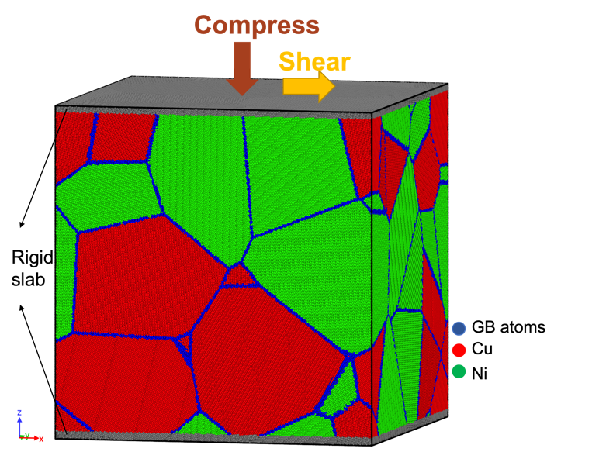
Supplementary Figure 8 Molecular dynamic model setup. Initial polycrystalline structure of CuNi contains a total of 28 grains with orientation assigned randomly. Here, color red indicates Cu atoms, green stands for Ni atoms, and blue denotes grain boundary atoms. Rigid slabs of 1.3nm thick in z direction for both top and bottom were introduced to accompany the deformation.

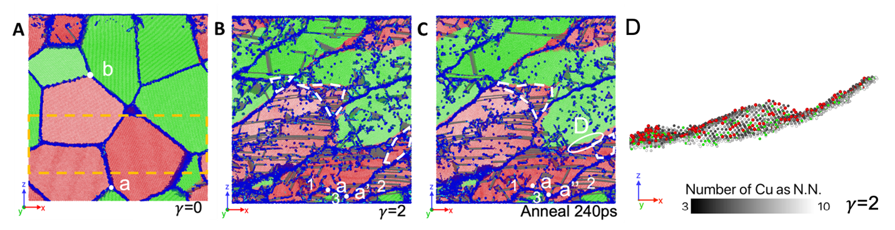
Supplementary Figure 9 Defect evolution under continuous shear deformation. (A) CuNi structure at shear strain 0% with triple point denoted as a; (B) shear deformed cell at strain 200%. The point a’ shows the triple points locations after sliding; (C) structure after annealing. Point a” indicate the location of triple point a after annealing. The white dashed lines show the sub-grain boundaries formed through deformation twinning. (D) Phase boundary after deformation where the red atoms stand for Cu atoms with more than seven nearest Ni atoms, while green atoms are Ni with more than seven Cu neighbors. Grey scale atoms highlight the interface.
Partial dislocations and deformation twins have been observed in both simulations ^{23,24} and past experiments ²⁵⁻²⁷ in nanocrystalline materials even with high stacking fault energies under constraints²⁸ or high strain rate deformation ^{29,30}. The MD simulation results also revealed sub-grain structure formation (denoted by white dashed lines in supplementary Figure 9 (B) and (C)). From these MD results it was found that most partial dislocations nucleate on triple junction and grain boundaries. Successive nucleation and emission of partial dislocations and nano deformation twins was observed to lead to sub-grain boundary formation and grain rotation. The white dashed lines in supplementary figure 9 (B) and (C) show the typical sub-grain boundaries which form by partial dislocations (or deformation twins) emitted from the interfaces. Point a marked in supplementary Figure. 9 (A) show the grain boundary triple points. The position change of initial location of triple point from a to a’ and a’’ during deformation and subsequent annealing clearly show interface and grain boundary sliding. The grain boundary sliding was effectively accommodated with the emission of dislocations from the triple junction to the grain interior. Particularly, the partial dislocations nucleated on the interface between grain 2 and 3 emit into grain 2. As a result, the interface area of these two grains shown in supplementary figure 9(B) shrank as the triple junction moved towards grain 2 away from the grain 1. The dislocation sliding across phase boundaries causes an interfacial roughening, which would extend only to a few lattice spacings even under applied strain of 2 as shown in supplementary figure 9(D).
DFT calculations
The Cu-Ni multilayer structure was modeled using a periodic supercell with total 10 atomic planes (5 Cu planes followed by 5 Ni planes) in the a₃ ([001]) direction, with 50 atoms in each plane. The interfacial Cu and Ni planes are labeled as C1 and N1, respectively (Supplementary Figure 10A). Shear strain (γ) was applied by varying the shape of the supercell under the constant volume constraint. For example, shear strain γ_{a3}[110] was applied by varying the cell vector a₃ from (0,0,c) to (x,x,c) with x increasing gradually.
All density functional theory (DFT) ^{31,32} calculations were conducted using Vienna Ab initio Simulation Package (VASP) ³³⁻³⁶ with the Perdew-Burke-Ernzerhof (PBE) functional ^{37,38} and the projector augmented wave potential (PAW) ³⁹. The plane wave basis set cutoff was set to 296.4 eV. Since we consider disordered configurations, simulations were conducted for the Gamma point only. The energy-vs-strain dependencies calculated using 2×2×2 k-mesh and Gamma point only (Supplementary Table 2) show the same trend. However, the computational cost of using the 2×2×2 mesh is increased by 700%.
Finally, the atomic scale changes during shear-induced Cu-Ni intermixing are investigated using an idealized model of the Cu/Ni interface and ab initio simulations. To reveal the effect of the magnitude and direction of the shear on the stability of the Cu/Ni interface depending on their relative orientation, we applied the shear along the [001] and [011] directions corresponding to the angles between the interface and shear direction of 90° and 45°, respectively. The system energy increases slower with increasing γ_{a1}[011] than with γ_{a1}[001], resulting in the plastic deformation (PD) occurring at different γ magnitudes (supplementary Figure 10B) with different energy costs: 0.15 and 0.13 eV/atom for γ_{a1}[011] and γ_{a1}[001], respectively. The characters of the PDs are qualitatively different. Shear strain γ_{a1}[011] (γ_{c}=0.22) leads to formation of stacking faults (HCP phase) followed by Cu-Ni intermixing and restoration of the FCC lattice. Further applying shear γ_{a1}[011] leads to the second PD event at the total γ=0.43 with further Cu-Ni intermixing at the interface. Similar to the first PD event, the formation of transient HCP phase and subsequent restoration of FCC lattice occur in this process as well. We notice that the second PD event required an additional strain of only γ=0.20 and occurred with a lower energy cost of 0.07 eV/atom than the first PD event (see supplementary Figure 10B). This suggests that the abruptness of the Cu/Ni interface provides an additional contribution to the barrier of PD, while interfacial intermixing lowers the barrier for the PD events and, accordingly, facilitates further intermixing. In turn, this suggests that partially intermixed Cu/Ni regions are more susceptible to further intermixing under shear, leading to inhomogeneous concentration profile.
In contrast, the γ_{a1}[001] (γ_{c}=0.20) causes a slip in the Cu layer and elongation of the atomic planes along the a₁ supercell vector, resulting in the rotation of the interface plane accompanied by the in-plane strain (ε) of 0.02. As γ increases, the interface orientation continues to change and ε increases reaching 0.1 at γ=0.46, which contributes to destabilization of the interface against the lattice site exchange. Indeed, γ_{a1}[001]=0.47 causes Cu-Ni intermixing with the formation of stacking faults. We note that the angle between the shear in [001] direction and the interface plane decreases from 90° (γ=0.0) to ~66° (γ=0.46). We decomposed the effect of the shear displacement vector into the components normal (D_{n}) and tangential (D_{t}) to the plane of the interface (see supplementary Figure. 10 B). At the 1st PD event (Cu slip), D_{n}=3.5 Å and D_{t}=0.7 Å, while at the 2nd PD event (intermixing), D_{n} and D_{t} components due to the additional shear are: 4.4 Å and 2.0 Å, respectively. This analysis suggests that shear stress normal to the interface results predominantly in its reorientation, while shear that has a significant tangential component promotes intermixing. We propose that at larger shear, further interface rotation, accompanied by thinning out of the Cu and Ni layers and Cu-Ni intermixing, would continue. However, since shear parallel to the interface does not affect it because of the efficient strain release via slips in the Cu layers alone, the direct effect of shear on the interface would decrease. This model is consistent with an observed formation of laminar structures with diffuse interfaces parallel to the shear direction prior to complete Cu-Ni intermixing. The established dependence of the deformation mechanisms on the local relative orientation of the shear stress vector and the interface allows us to create spatially resolved models of PD in realistic systems.
To reveal signatures of shear-induced deformations, we investigated the dependence of structural parameters, such as M-N (M, N=Cu, Ni) neighbor distances, on the shear strain γ in the elastic and plastic regimes. In the elastic regime, we observed continuous changes, as expected. The larger change in Cu-Cu distances than Ni-Ni distances with applied shear strain γ is consistent with the smaller shear modulus of Cu than Ni. In the PD that causes slip in Cu planes and rotation of the interface (γ_{a1}[001]=0.20), Cu-Cu distances decrease and Ni-Ni distances increase, indicating an abrupt release of the tensile and compressive strain, respectively. For comparison, in the PD causing intermixing (γ_{a1}[001]=0.47, γ_{a1}[011]=0.22, 0.43), Cu-Cu and Ni-Ni distances decrease, while the Cu-Ni distances increase for only a small interval of γ in order to accommodate the transient formation of the HCP phase and Cu-Ni intermixing at the interface. The different response of the Cu-Ni and Ni-Ni distances to shear leading to distinct outcomes suggest characteristic signatures of the onset of PDs in epitaxial multilayers.
Vacancies were found to decrease the magnitude of shear corresponding to PD γ_{c} for both shear directions (supplementary Figure 10C) from over 0.2 in the defect-free systems to approximately 0.16 in the vacancy systems. This suggests that the vacancies at the grain boundaries and the excess vacancies introduced by deformations facilitate the intermixing process and the shear direction relative to the interface is the key for interfacial intermixing.
Supplementary Figure 10. (A) Illustration of the Cu-Ni multilayer structure and shear directions. Green and red spheres show Ni and Cu atoms, respectively. For γ=0, supercell vectors a₁, a₂, and a₃ correspond to [100], [010], and [001] crystal directions. Blue and purple arrows represent shear applied in the [001] (γ_{a1}[001]) and [011] (γ_{a1}[011]) directions, respectively. N1, N2, N3 show the atomic planes containing Ni vacancies at the interface, and one and two atomic planes away from the interface, respectively. Planes containing Cu vacancies with similar arrangements are shown as C1, C2, C3. (B) Dependence of Cu-Ni multilayer stability ΔE and the Cu-Cu, Cu-Ni and Ni-Ni neighbor distances (M-N) on the shear strain γ. (C) The energy cost of plastic deformation events ΔE(γ_{c}⁻) and the critical shear strain γ_{c} for defect-free and vacancy-containing (panel A) systems.
The self-consistent field energy convergence criterion was set to 10⁻⁵ eV. Static energy minimization was conducted until the energy changes were below 10⁻⁴ eV. The diffusion barrier was calculated using the climbing image nudged elastic band (CI-NEB) method ^{40,41}. The shear strain γ was increased by 0.01 every 400 timesteps (400 fs).
Supplementary Table 2. Comparison of the energies calculated using different k-meshes. Here ΔE(γ) (ΔE(γ) = (E(γ) – E(0))/500) is the energy change induced by shear strain for defect-free Cu-Ni system. E_{diff}(γ) is the diffusion energy of Ni vacancy (V_{Ni}) between the N1 and N2 layers (N2N1).

k-mesh | ΔE(γ) (meV) |  |  |  | E_{diff}(γ) (eV)
k-mesh | γ = 0.02 | γ = 0.11 | γ = 0.23 | γ = 0.24 | γ = 0.00 | γ = 0.11
1×1×1 | 0.2 | 39.4 | 25.4 | 0.9 | -0.073 | -0.085
2×2×2 | 1.0 | 42.6 | 32.5 | 6.3 | -0.084 | -0.095

Reference
1 Hrubiak, R., Smith, J. S. & Shen, G. Multimode scanning X-ray diffraction microscopy for diamond anvil cell experiments. Review of Scientific Instruments 90, 025109 (2019). https://doi.org/10.1063/1.5057518
2 Ungar, T. & Borbely, A. The effect of dislocation contrast on x-ray line broadening: A new approach to line profile analysis. Appl Phys Lett 69, 3173-3175 (1996). https://doi.org/Doi 10.1063/1.117951
3 Ungár, T., Dragomir, I., Révész, Á. & Borbély, A. The contrast factors of dislocations in cubic crystals: the dislocation model of strain anisotropy in practice. Journal of applied crystallography 32, 992-1002 (1999).
4 Borbely, A., Dragomir-Cernatescu, J., Ribarik, G. & Ungar, T. Computer program ANIZC for the calculation of diffraction contrast factors of dislocations in elastically anisotropic cubic, hexagonal and trigonal crystals. Journal of Applied Crystallography 36, 160-162 (2003). https://doi.org/10.1107/S0021889802021581
5 Ledbetter, H. M. Elastic-Constants of Polycrystalline Copper at Low-Temperature - Relationship to Single-Crystal Elastic-Constants. Phys Status Solidi A 66, 477-484 (1981). https://doi.org/DOI 10.1002/pssa.2210660209
6 Neighbours, J. R., Bratten, F. W. & Smith, C. S. The Elastic Constants of Nickel. J Appl Phys 23, 389-393 (1952). https://doi.org/Doi 10.1063/1.1702218
7 Zhang, M. et al. In situ high-energy X-ray diffraction mapping of Lüders band propagation in medium-Mn transformation-induced plasticity steels. Materials Research Letters 6, 662-667 (2018).
8 Zhang, M. H. et al. Temperature-dependent micromechanical behavior of medium-Mn transformation-induced-plasticity steel studied by in situ synchrotron X-ray diffraction. Acta Mater 141, 294-303 (2017). https://doi.org/10.1016/j.actamat.2017.09.030
9 Pouryazdan, M., Kaus, B. J. P., Rack, A., Ershov, A. & Hahn, H. Mixing instabilities during shearing of metals. Nature Communications 8, 1611 (2017). https://doi.org/10.1038/s41467-017-01879-5
10 Chen, L.-Q. & Yang, W. Computer simulation of the domain dynamics of a quenched system with a large number of nonconserved order parameters: The grain-growth kinetics. Physical Review B 50, 15752-15756 (1994). https://doi.org/10.1103/PhysRevB.50.15752
11 Eisenlohr, P., Diehl, M., Lebensohn, R. A. & Roters, F. A spectral method solution to crystal elasto-viscoplasticity at finite strains. International Journal of Plasticity 46, 37-53 (2013). https://doi.org/10.1016/j.ijplas.2012.09.012
12 Roters, F. et al. DAMASK - The Dusseldorf Advanced Material Simulation Kit for modeling multi-physics crystal plasticity, thermal, and damage phenomena from the single crystal up to the component scale. Computational Materials Science 158, 420-478 (2019). https://doi.org/10.1016/j.commatsci.2018.04.030
13 Roters, F., Eisenlohr, P., Bieler, T. R. & Raabe, D. Crystal plasticity finite element methods: in materials science and engineering. (John Wiley & Sons, 2011).
14 Edalati, K. & Horita, Z. High-pressure torsion of pure metals: Influence of atomic bond parameters and stacking fault energy on grain size and correlation with hardness. Acta Materialia 59, 6831-6836 (2011). https://doi.org/10.1016/j.actamat.2011.07.046
15 Thompson, A. P., Plimpton, S. J. & Mattson, W. General formulation of pressure and stress tensor for arbitrary many-body interaction potentials under periodic boundary conditions. Journal of Chemical Physics 131, 154107 (2009). https://doi.org/10.1063/1.3245303
16 Daw, M. S. & Baskes, M. I. Semiempirical, Quantum Mechanical Calculation of Hydrogen Embrittlement in Metals. Physical Review Letters 50, 1285 (1983). https://doi.org/10.1103/PhysRevLett.50.1285
17 Daw, M. S. & Baskes, M. I. Embedded-atom method: Derivation and application to impurities, surfaces, and other defects in metals. Physical Review B 29, 6443 (1984). https://doi.org/10.1103/PhysRevB.29.6443
18 Fischer, F., Schmitz, G. & Eich, S. M. A systematic study of grain boundary segregation and grain boundary formation energy using a new copper–nickel embedded-atom potential. Acta Materialia 176, 220-231 (2019). https://doi.org/10.1016/J.ACTAMAT.2019.06.027
19 Hirel, P. Atomsk: A tool for manipulating and converting atomic data files. Computer Physics Communications 197, 212-219 (2015). https://doi.org/10.1016/J.CPC.2015.07.012
20 Stukowski, A. Visualization and analysis of atomistic simulation data with OVITO-the Open Visualization Tool. Modelling and Simulation in Materials Science and Engineering 18, 015012 (2010). https://doi.org/10.1088/0965-0393/18/1/015012
21 Stukowski, A. Structure identification methods for atomistic simulations of crystalline materials. Modelling and Simulation in Materials Science and Engineering 20, 045021 (2012). https://doi.org/10.1088/0965-0393/20/4/045021
22 Stukowski, A. & Albe, K. Extracting dislocations and non-dislocation crystal defects from atomistic simulation data. Modelling and Simulation in Materials Science and Engineering 18, 085001 (2010). https://doi.org/10.1088/0965-0393/18/8/085001
23 Yamakov, V., Wolf, D., Phillpot, S. R. & Gleiter, H. Deformation twinning in nanocrystalline Al by molecular-dynamics simulation. Acta Mater. 50, 5005-5020 (2002). https://doi.org/10.1016/S1359-6454(02)00318-X
24 Schiøtz, J. & Jacobsen, K. W. A Maximum in the Strength of Nanocrystalline Copper. Science 301, 1357-1359 (2003). https://doi.org/10.1126/SCIENCE.1086636
25 Liao, X. Z., Zhou, F., Lavernia, E. J., He, D. W. & Zhu, Y. T. Deformation twins in nanocrystalline Al. Applied Physics Letters 83, 5062-5064 (2003). https://doi.org/10.1063/1.1633975
26 Chen, M. et al. Deformation twinning in nanocrystalline aluminum. Science 300, 1275-1277 (2003). https://doi.org/10.1126/science.1083727
27 Zhu, Y. T., Liao, X. Z. & Wu, X. L. in Progress in Materials Science Vol. 57 1-62 (Pergamon, 2012).
28 Chen, N. et al. Formation and Dissociation of Shear-Induced High-Energy Dislocations: Insight from Molecular Dynamics Simulations. https://doi.org/unpublished
29 Zhao, F. et al. Macro deformation twins in single-crystal aluminum. Physical Review Letters 116 (2015). https://doi.org/10.1103/PhysRevLett.116.075501
30 Zhao, F., Zhu, Y. & Xie, J. Deformation twinning in pure aluminum under ultrahigh strain rate: Dependence of strain rate and crystallographic orientation. Materials Letters 285, 129181 (2021). https://doi.org/10.1016/j.matlet.2020.129181
31 Hohenberg, P. & Kohn, W. Inhomogeneous Electron Gas. Physical Review 136, B864-B871 (1964). https://doi.org/10.1103/PhysRev.136.B864
32 Kohn, W. & Sham, L. J. Self-Consistent Equations Including Exchange and Correlation Effects. Physical Review 140, A1133-A1138 (1965). https://doi.org/10.1103/PhysRev.140.A1133
33 Kresse, G. & Furthmüller, J. Efficient iterative schemes for ab initio total-energy calculations using a plane-wave basis set. Phys Rev B Condens Matter 54, 11169-11186 (1996). https://doi.org/10.1103/physrevb.54.11169
34 Kresse, G. & Furthmüller, J. Efficiency of ab-initio total energy calculations for metals and semiconductors using a plane-wave basis set. Phys Rev B Condens Matter 54, 11169-11186 (1996). https://doi.org/https://doi.org/10.1016/0927-0256(96)00008-0
35 Kresse, G. & Hafner, J. Ab initio molecular dynamics for liquid metals. Phys Rev B Condens Matter 47, 558-561 (1993). https://doi.org/10.1103/physrevb.47.558
36 Kresse, G. & Hafner, J. Ab initio molecular-dynamics simulation of the liquid-metal-amorphous-semiconductor transition in germanium. Phys Rev B Condens Matter 49, 14251-14269 (1994). https://doi.org/10.1103/physrevb.49.14251
37 Perdew, J. P., Burke, K. & Ernzerhof, M. Generalized Gradient Approximation Made Simple. Phys Rev Lett 77, 3865-3868 (1996). https://doi.org/10.1103/PhysRevLett.77.3865
38 Perdew, J. P., Burke, K. & Ernzerhof, M. Generalized Gradient Approximation Made Simple [Phys. Rev. Lett. 77, 3865 (1996)]. Physical Review Letters 78, 1396-1396 (1997). https://doi.org/10.1103/PhysRevLett.78.1396
39 Blöchl, P. E. Projector augmented-wave method. Phys Rev B Condens Matter 50, 17953-17979 (1994). https://doi.org/10.1103/physrevb.50.17953
40 Henkelman, G. & Jónsson, H. Improved tangent estimate in the nudged elastic band method for finding minimum energy paths and saddle points. The Journal of Chemical Physics 113, 9978-9985 (2000). https://doi.org/10.1063/1.1323224
41 Henkelman, G., Uberuaga, B. P. & Jónsson, H. A climbing image nudged elastic band method for finding saddle points and minimum energy paths. The Journal of Chemical Physics 113, 9901-9904 (2000). https://doi.org/10.1063/1.1329672

