Bulletin of Volcanology
Supporting Information for

Morphological evolution of the 2021 Tajogaite cone (Cumbre Vieja, La Palma, Spain) between January 2022 and July 2024: a quantitative UAS study

R. Civico^{1*}, T. Ricci¹, U. Kueppers^{2*}, V. Ortega-Ramos³, M. Przeor^{3,4}, J. Taddeucci¹, I. Cabrera-Pérez^{3,5}, W. Stoiber², P. Scarlato¹, L. D’Auria^{3,6}
¹ Istituto Nazionale di Geofisica e Vulcanologia, Sezione Roma 1, Roma, Italy
² Department of Earth and Environmental Sciences, Ludwig-Maximilians-Universität München, Munich, Germany
³ Instituto Volcanológico de Canarias (INVOLCAN), Puerto de la Cruz, Tenerife, Canary Islands, Spain
⁴ Invert Sàrl, Echichens, Switzerland
⁵ Department of Earth Sciences, University of Geneva, Rue des Maraîchers 13, 1205, Geneva, Switzerland
⁶ Instituto Tecnológico y de Energías Renovables (ITER), Granadilla de Abona, Tenerife, Canary Islands, Spain

Contents of this file

Figures and captions S1, S2 and S4
Caption for S3 (movie)

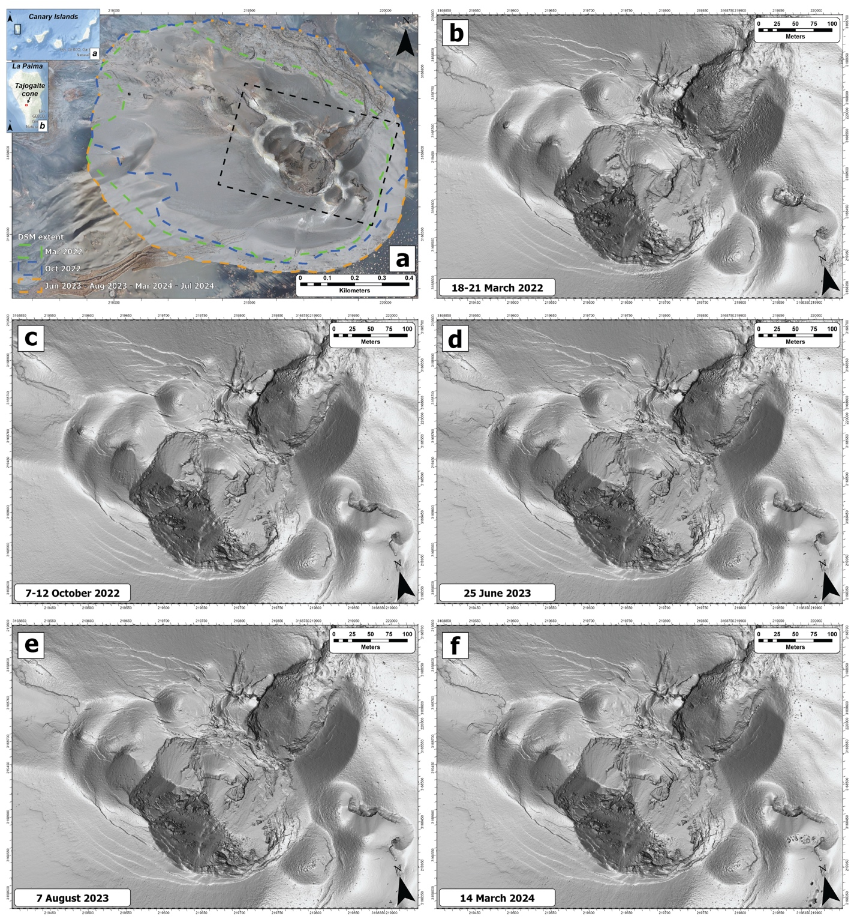
Figure S1 - a) Location of La Palma within the Canary Islands archipelago; b) La Palma Island and location of the Tajogaite cone; c) View of the Tajogaite cone in July 2024 and extent of the area covered by six subsequent UAS surveys. Dashed-line boxe indicates the position of figure S1 b,c,d,e,f. B,c,d,e and f) Multidirectional hillshades of the DSMs of the Tajogaite cone.

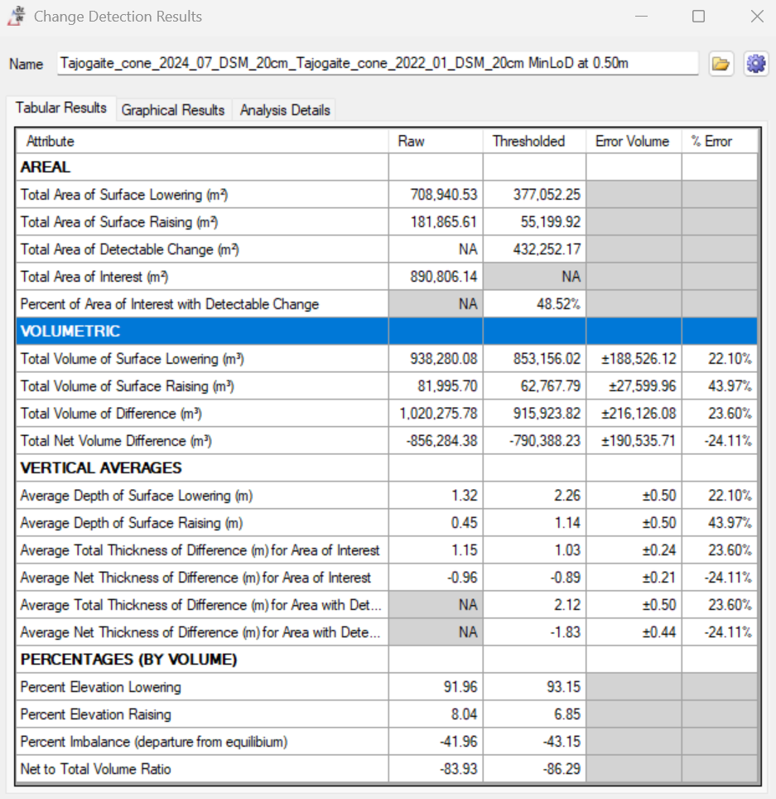
Figure S2 - Change detection results for the period January 2022 - July 2024.
Movie S3 – Animation of the multidirectional DSMs’ hillshades of the Tajogaite cone. At both the beginning and the end of the animation the volcano-tectonic feature of Fig. 5 is shown.

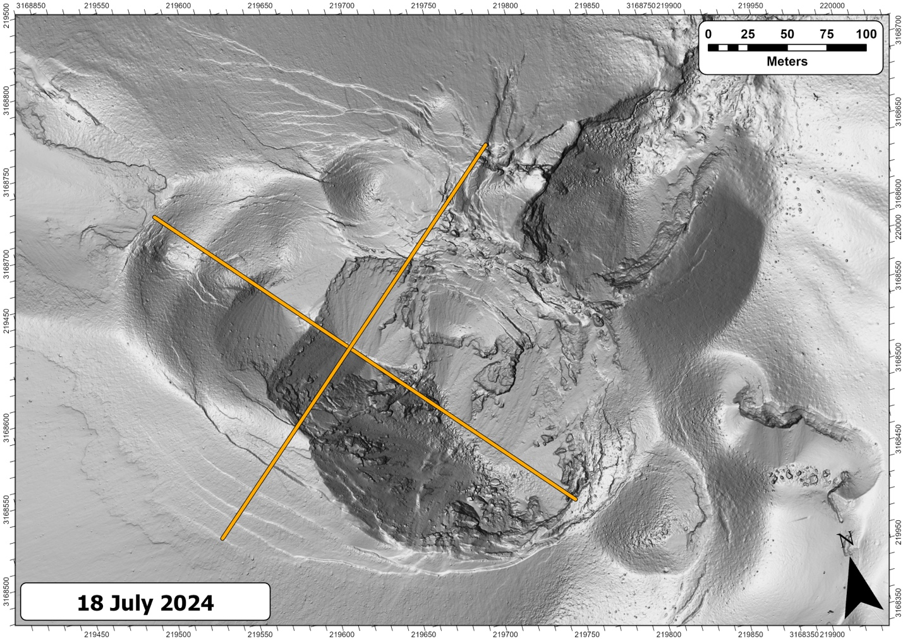
Figure S4 - Long (NW-SE - 320m) and short (SW-NE - 300m) axis of the elliptic horizontal area described in Section 4.4.

