Supplemental information
Competitive Confrontation or Cooperative Coexistence? Environmental Drivers Shaping Interactions Between Endophyte Bacillus atrophaeus and Epiphyte Pseudomonas chlororaphis O6 in Wheat Rhizosphere
Anagha Wankhade¹, Ashlynn Clark ¹, David Britt¹
¹Department of Biological Engineering, Utah State University, Logan, UT 84322, USA

List of Contents
SI Figure 1 | Controls for ZOI assays on LB and minimal medium
SI Figure 2 | Loss of PcO6 – JunSE1L antagonism at elevated temperature
SI Figure 3 | Absence of self-inhibition in side-by-side biofilm assays
SI Figure 4 | Elevated temperature suppression of PcO6 antagonism against JunSE1L
SI Figure 5 | AFM characterization of control PcO6 and JunSE1L cells
SI Figure 6 | Controls for distance-dependent inhibition and siderophore involvement
SI Methods 1 | Estimation of the Diffusion Coefficient of the PcO6-derived inhibitory compound
SI Figure 7 | Effect of proteinase K and heat treatment on the inhibitory activity of PcO6 cell-free supernatant against JunSE1L

Supplemental Data 1: Controls for ZOI assays on LB and minimal medium
To control for possible physical displacement of the bacterial background lawn by depositing the challenge bacteria solution on top of the lawn, controls were conducted where the central drop of challenge bacteria was replaced with sterile water. Both bacteria were grown in either LB or MM broth to 0.5 OD₆₀₀ and dilution series of the washed cell suspensions were prepared in sterile water. Next, 100 µl of either PcO6 or JunSE1L bacterial suspension was spread uniformly onto LB or MM (2% agar) plates, maintaining the same plate media as that used for liquid growth. After 30 minutes of drying at room temperature, a 10 µl drop of sterile D/W was placed at the center of each plate. Plates were incubated for 72 h at 22 ˚C before imaging. A final control for central colony size changes was performed with a 10 µl drop of either 0.5 OD₆₀₀ of PcO6 or JunSE1L on blank plates without an opposing background lawn.
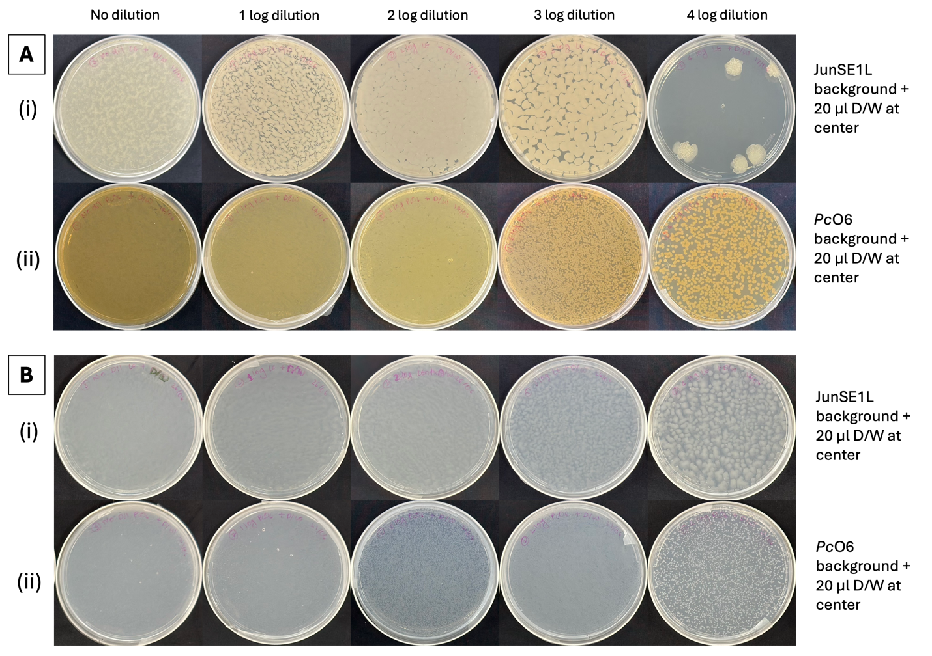
SI Figure 1. Control ZOI assays performed on 2% LB agar and MM following 72 h of co-incubation at 22 ˚C. (Ai) Lawns of serially diluted JunSE1L (initially grown to OD₆₀₀ = 0.5) overlaid with a 20 µL central drop of sterile distilled water (D/W) on LB agar. (Bi) Identical control assay performed on MM agar. (Aii) Reciprocal control assay on LB, with lawns of PcO6 overlaid with a 10 µL central drop of D/W. (Bii) Reciprocal control assay on MM. No effects are seen, as expected, for the placement of a water droplet on top of the background inoculum.

Supplemental Data 2: Temperature-dependent modulation of PcO6 – JunSE1L antagonism in ZOI assays
To assess whether PcO6 – JunSE1L antagonism observed at 22 °C persists at elevated temperature, ZOI assays were performed at 37 °C. PcO6 and JunSE1L were grown in LB broth to an OD₆₀₀ of 0.5, washed, and resuspended in sterile water. A series of five log dilutions was prepared, and 100 µL of either PcO6 or JunSE1L suspension was spread uniformly onto LB (2% agar) plates to generate a background lawn. Plates were allowed to dry at room temperature for 30 min, after which a 10 µL drop of the opposing strain (or sterile water control) was placed at the center of each plate. Plates were incubated for 72 h at 37 °C prior to imaging.
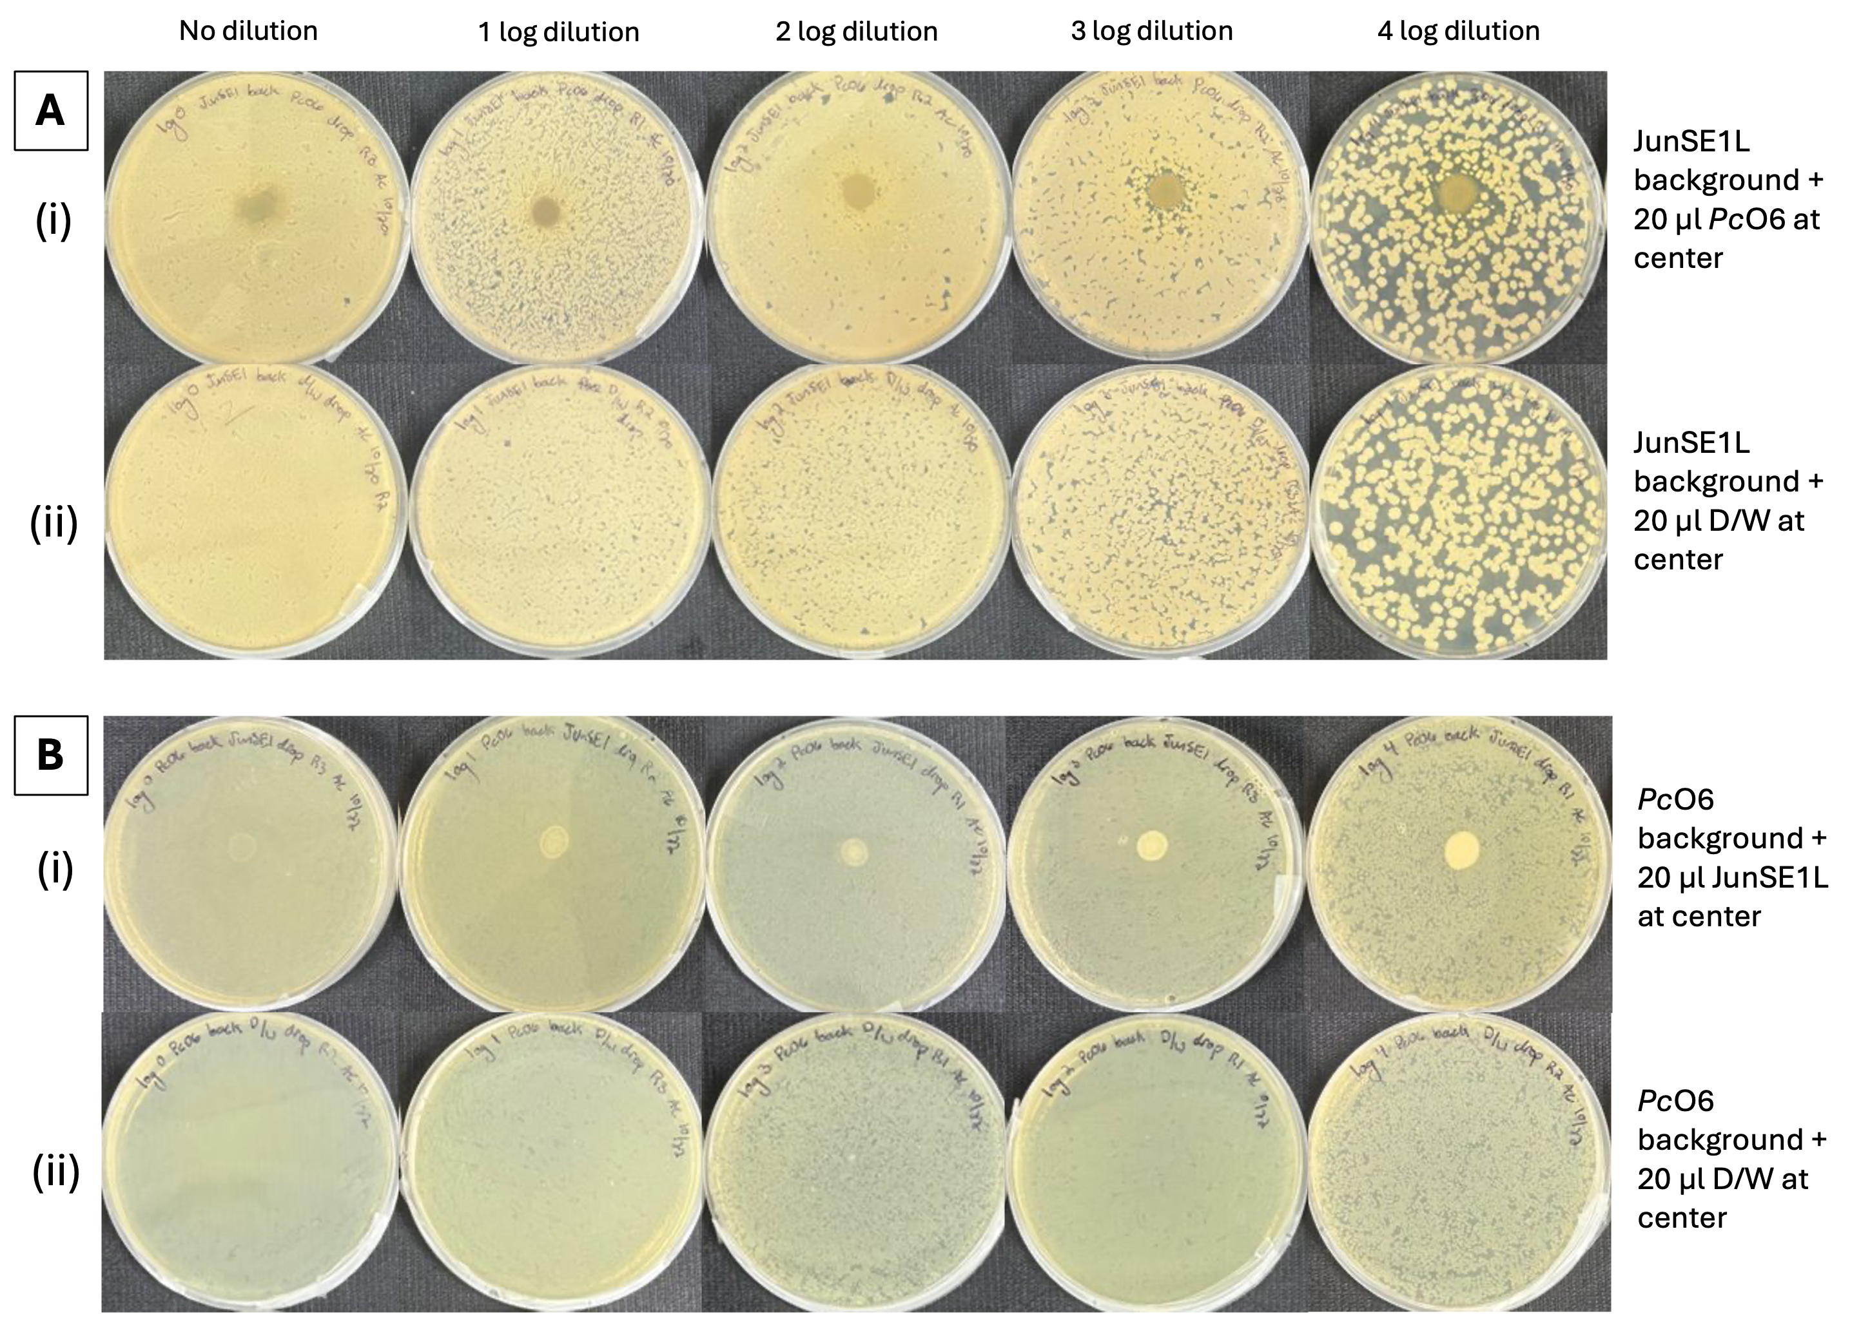
SI Figure 2. ZOI assays performed on 2% LB agar after 72 h of co-incubation at 37 °C. (Ai) Lawns of serially diluted JunSE1L (starting OD₆₀₀ = 0.5) overlaid with a 20 µL central inoculum of PcO6 (OD600 = 0.5) showing no detectable zone of inhibition. (Aii) Control lawns of JunSE1L overlaid with a 20 µL central drop of D/W. (Bi) Reciprocal assay with lawns of PcO6 overlaid with a 20 µL central inoculum of JunSE1L, showing no inhibition. (Bii) Control lawns of PcO6 overlaid with a 20 µL central drop of D/W. Whether PcO6 ceases to produce the inhibitory compound(s) at elevated temperature or JunSE1L has more defenses at elevated temperature is unknown.

Supplemental Data 3: Controls for self-inhibition in side-by-side biofilm assays
To determine whether either strain exhibits self-inhibition under side-by-side biofilm assay conditions, dual inoculations were performed using the same bacterial strain. PcO6 or JunSE1L cultures were grown to an OD₆₀₀ of 0.5, washed, and resuspended in sterile water. Two 10 µL droplets of the same strain were placed 0.5 cm apart on MM (1% agar) plates. After allowing droplets to absorb into the agar, plates were incubated at 22 °C. Colony growth and spatial interactions were assessed visually over the incubation period to confirm the absence of self-inhibitory effects.
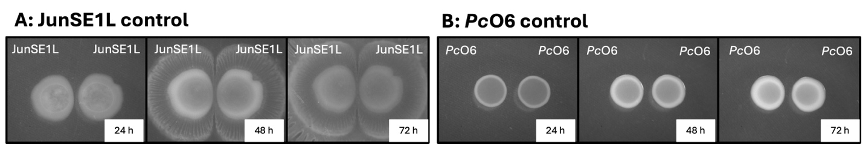
SI Figure 3. Side-by-side antagonism assays performed on 1% MM agar. (A) Simultaneous inoculation of JunSE1L adjacent to a JunSE1L colony showing no inhibition between colonies. (B) Simultaneous inoculation of PcO6 adjacent to a PcO6 colony showing no inhibition between colonies. Starting inoculations all OD600 = 0.5. Although not actively inhibiting, the colony boundaries are not overlapping, indicating a recognition of the neighboring colony.

Supplemental Data 4: Elevated-temperature effects on PcO6-mediated inhibition of JunSE1L
To evaluate the impact of elevated temperature on PcO6-mediated antagonism against JunSE1L, side-by-side dual inoculation assays were conducted at 37 °C. PcO6 and JunSE1L were grown to an OD₆₀₀ of 0.5, washed, and resuspended in sterile water. Two 10 µL droplets of each strain were placed 0.5 cm apart on LB or MM (1% agar) plates. After drying, plates were incubated at 37 °C and monitored for changes in colony growth and inhibition patterns.
To assess whether inhibitory metabolites could accumulate in the absence of immediate interspecies contact, a staggered inoculation assay was performed. In this modified assay, one strain was inoculated and allowed to grow for 48 h prior to the introduction of the second strain at the designated distance. Plates were incubated under the same temperature conditions (37 ˚C) and evaluated for inhibitory effects following secondary inoculation.

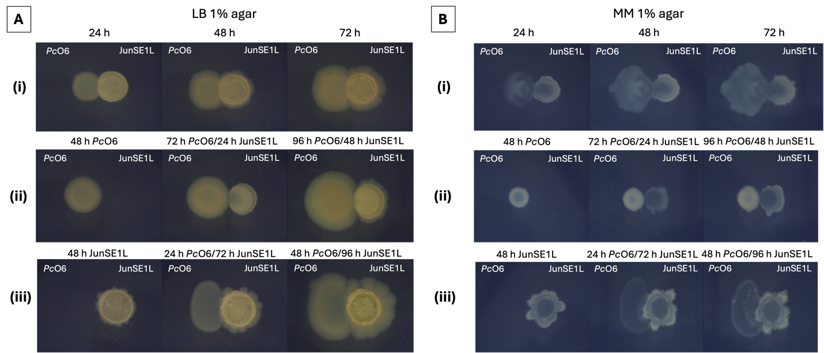
SI Figure 4. Nutrient- and timing-dependent interaction assays performed at 37 °C on 1% agar LB (A) and MM (B). (Ai, Bi) Simultaneous inoculation of PcO6 and JunSE1L (both at OD600) showing no inhibition on either medium. (Aii, Bii) Pre-growth of PcO6 for 48 h prior to JunSE1L inoculation resulted in no detectable inhibition of JunSE1L on LB or MM. (Aiii, Biii) Pre-growth of JunSE1L for 48 h did not inhibit subsequent PcO6 growth on either medium. On MM agar, PcO6 exhibited enhanced surface spreading with diffuse, “ghost-like” colony morphology, potentially reflecting altered surface properties by JunSE1L surfactants.

Supplemental Data 5: AFM-based morphological characterization of control PcO6 and JunSE1L cells
To establish baseline cellular morphology for both strains, control PcO6 and JunSE1L cells were analyzed using AFM. Cells were gently scraped from agar plates and transferred onto clean glass slides prior to imaging. AFM was performed using a Nanoscope III Bioscope (Digital Instruments, Inc.) operated in tapping mode. Budget Sensors Tap300Al-G cantilevers (tip radius < 10 nm; length 125 µm; width 30 µm; thickness 4 µm; nominal force constant 40 N/m) were used. Images were collected at a resolution of 256 × 256 pixels and a scan rate of 1 Hz across multiple scan sizes and angles to assess cell surface features and morphology.
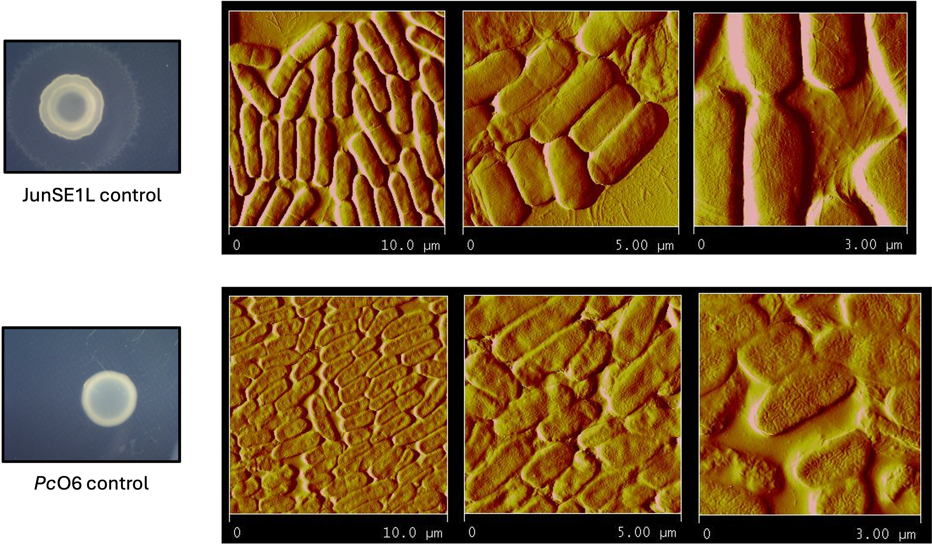
SI Figure 5. AFM amplitude images of control JunSE1L and PcO6 cells grown on separate MM 2% agar plates for 3 days at 22 ˚C. PcO6 cells shows elongated rod-shaped morphology with stippled surface features, whereas JunSE1L cells appeared block-like and smoother.

Supplemental Data 6: Controls for distance-dependent inhibition and siderophore-mediated effects
To control for distance- and timing-dependent effects independent of PcO6 antagonism, JunSE1L was inoculated at the center of MM (1% agar) plates and incubated at 22 °C for 48 h. Following this pre-growth period, 10 µL droplets of either JunSE1L or PcO6 (OD₆₀₀ = 0.5) were placed at defined radial distances (1.0 ± 0.1, 1.2 ± 0.0, 2.1 ± 0.2, 3.1 ± 0.3, and 3.8 ± 0.2 cm) from the central JunSE1L colony. Colony growth and inhibition patterns were assessed visually three days after challenge inoculation.
Additional controls were performed by inoculating PcO6 adjacent to a 48 h pre-grown PcO6 colony at equivalent distances on MM agar to evaluate self-interaction effects. To determine whether distance-dependent inhibition was specific to minimal medium, parallel assays were conducted on LB (1% agar) plates, with JunSE1L inoculated at increasing distances from a 48 h pre-grown PcO6 colony under identical incubation conditions.

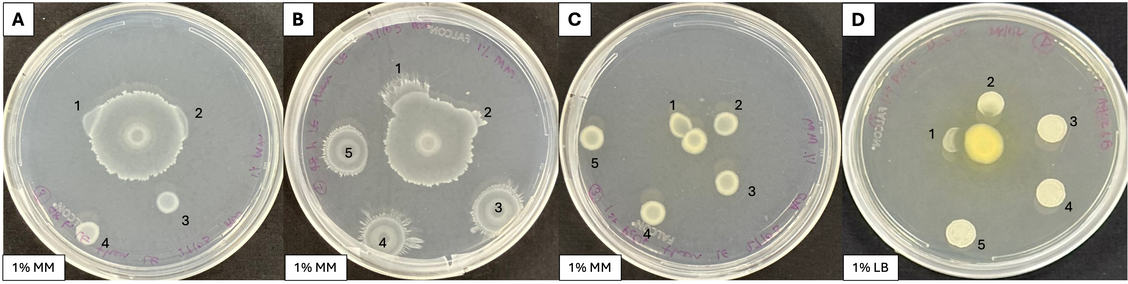SI Figure 6. Controls for distance-dependent spiral inhibition assays examining JunSE1L growth and siderophore-associated effects. (A) PcO6 inoculated at increasing distances from a JunSE1L colony pre-grown for 48 h at the center of the MM 1% agar plate. Growth was observed at all sites. Colonies at sites 1 and 2 merged with the central colony, likely due to reduced surface tension consistent with surfactant released during the first 48 hours of growth without any neighboring colonies. (B) JunSE1L inoculated at increasing distances from a JunSE1L colony pre-grown for 48 h at the center of the MM 1% agar plate. Growth was observed at all sites. The same results were observed where colonies at sites 1 and 2 merged with the central colony. (C) PcO6 inoculated at increasing distances from a PcO6 colony pre-grown for 48 h at the center of the MM 1% agar plate. Growth was observed at all sites. (D) JunSE1L inoculated at increasing distances from a PcO6 colony pre-grown for 48 h on LB 1% agar. This control was performed to assess whether the strong proximal inhibition of JunSE1L by PcO6 observed on MM was observed on LB medium. The presence of JunSE1L at all inoculation distances demonstrates an absence of inhibition between the bacteria on the rich medium. All colonies of JunSE1L and PcO6 at the same OD₆₀₀ of 0.5.

Supplementary Methods 1: Estimation of the Diffusion Coefficient of the PcO6-derived inhibitory compound
The apparent diffusion coefficient of the inhibitory compound produced by PcO6 was estimated using a one-dimensional diffusion model described by the equation:
x²=2Dt
where x is the distance traveled by the compound, t is time, and D is the diffusion coefficient.

Assumptions
Diffusion was assumed to be passive and isotropic within a homogeneous 1% (w/v) agar matrix at 22 °C. Because PcO6 colonies were pre-grown for 48 h prior to the introduction of JunSE1L at defined distances, it was assumed that inhibitory compounds had sufficient time to diffuse into the surrounding agar before challenge inoculation. Inhibition of JunSE1L at the closest distances was therefore attributed to the presence of diffusible PcO6-derived metabolites rather than direct cell-cell contact. The model does not account for continued metabolite production, compound degradation, or binding interactions with the agar matrix.

Diffusion Coefficient of the PcO6-Derived Inhibitory Compound
The maximum distance over which JunSE1L growth was inhibited was measured as 1.3 ± 0.1 cm after 48 h.
- x = 1.3 cm
- t = 48 h = 2 × 24 × 3600 s = 172,800 s

D = x²/2t = (1.3)² / 2 × 172,800
D ≈ 4.9×10⁻⁶ cm² s⁻¹
This value represents an apparent diffusion coefficient under agar-based assay conditions.

Comparison with Crystal Violet Diffusion
To contextualize the diffusion rate of the inhibitory compound, crystal violet (molecular weight 407.99 Da) was used as a reference dye. Crystal violet diffused 1.5 ± 0.1 cm over 48 h in 1% agar at 22 °C.
- x = 1.5 cm
- t = 172,800 s

D = x²/2t = (1.6)² / 2 × 172,800
D ≈ 6.5×10⁻⁶ cm² s⁻¹

Interpretation
The diffusion coefficient of the PcO6-derived inhibitory compound is of the same order of magnitude as that of crystal violet but modestly lower. This suggests that the inhibitory factor is diffusible and likely not a large macromolecule (e.g., protein or polysaccharide). The reduced diffusion rate relative to crystal violet may reflect a higher molecular weight, differences in charge or hydrophobicity, partial binding to the agar matrix, or compound instability. These findings are consistent with inhibition mediated by a small to moderately sized secondary metabolite rather than direct physical interaction or iron sequestration alone.

Supplemental Data 7: Effect of proteinase K and heat treatment on the inhibitory activity of PcO6 cell-free supernatant against JunSE1L
PcO6 cell-free supernatant was treated with Proteinase K (20 µg mL⁻¹) by incubating 0.5 mL enzyme with 4.5 mL supernatant at 37 °C for 2 h, followed by heat inactivation at 100 °C for 10 min. Treated samples were cooled to room temperature and tested for inhibitory activity against JunSE1L using 24-well plate assays. Controls included heat-treated PcO6 supernatant without enzyme and Proteinase K alone processed identically.
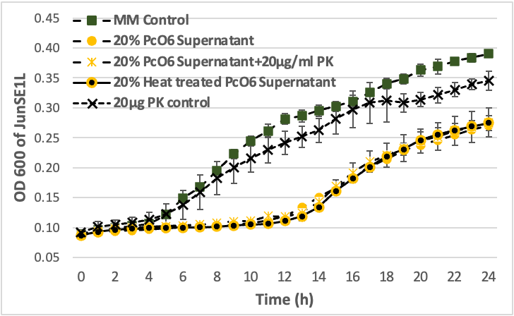
SI Figure 8. Stability of PcO6 supernatant inhibitory activity following proteinase K and heat treatment. Growth curves of JunSE1L in MM broth supplemented with 20% (v/v) PcO6 cell-free supernatant, untreated or treated with proteinase K (20 µg mL⁻¹) followed by heat inactivation, or heat treatment alone (100 °C for 10 min), compared with MM-only controls. Treatment of PcO6 supernatant with proteinase K did not reduce its inhibitory effect on JunSE1L growth relative to untreated supernatant. Heat-treated PcO6 supernatant retained comparable inhibitory activity.

