Supporting information

Optically-induced electrical nano-patterning

Hyungmok Joh¹, Bin Lian¹, Nolan Cummins², Jiazheng Bao², Jang-Hwan Han^{3, 4}, Peer Fischer^{3, 4, 5, 6}, and Donglei Emma Fan^{1, 2*}

¹ Materials Science and Engineering Program, Texas Materials Institute, The University of Texas at Austin

² Walker Department of Mechanical Engineering, University of Texas at Austin, Austin, TX 78712, USA

³ Institute for Molecular Systems Engineering and Advanced Materials, Heidelberg University, INF 255, 69120 Heidelberg, Germany

⁴ Max Planck Institute for Medical Research, Jahnstrasse 29, 69120 Heidelberg, Germany

⁵ Center for Nanomedicine, Institute for Basic Science (IBS), Seoul 03722, Republic of Korea

⁶ Department of Nano Biomedical Engineering (NanoBME), Advanced Science Institute, Yonsei University, Seoul, 03722, Republic of Korea

*Author to whom correspondence should be addressed.

Materials and Methods
Materials
200 nm carboxylate-terminated fluorescent PS spheres, with a surface charge of 0.3699 meq/g (technical data sheet), Sodium sulfate (anhydrous), glycerol, Salmon sperm DNA solution (UltrapureTM), IL-6 monoclonal antibody (MP5-20F3), P53 monoclonal antibody (6C4B6) was purchased from Thermofisher Scientific. Bacillus subtilis (6051) was purchased from ATCC. Polydimethylsiloxane (Sylgard 184 silicone elastomer kit) was purchased from Dow Corning Corporation. Poly(diallyldimethylammonium chloride) (average Mw 200,000-350,000, 20 wt.% in H₂O), Polyvinylpyrrolidone (average Mw 40,000) was purchased from Sigma Aldrich. All chemicals were used without further purification. Sodium chloride was purchased from Macron Chemicals. FTO (Fluorine-doped Tin Oxide) glass (0.7 mm thickness and 13 – 15 Ohm/Sq sheet resistance) used as the counter electrode were purchased from MSE Supplies (Product TEC 15). Glass–FTO–α-Si:H substrates used in this work were fabricated at the University of Stuttgart.

Experimental Setup
A 100 μm-thick PDMS well (1.5 mm in diameter) is placed on a surface-treated α-Si:H, which houses a Na₂SO₄ solution (0.18 μL) mixed with the nanoparticles to be deposited. An FTO glass is placed above the PDMS well, which serves as the counter-electrode, while the FTO beneath the α-Si:H serves as the working electrode. An AC E-field is applied to both FTO electrodes and the E-field is applied to the light-illumated α-Si:H.
In an experiment, we pair a digital light projector with a 532 nm continuous wave laser to project images onto a photoconductive α-Si:H substrate (Fig. S1). Here, the substrate is surface-treated with charged polyelectrolyte layers applied by layer-by-layer (LbL) assembly, with alternating layers of positively charged PDDA and negatively charged PSS driven by charge overcompensation growth. The terminating layer is determined by the surface charge (negative or positive) of the particle that is to be deposited. A PDMS well, applied on top of the α-Si:H substrate, houses a sodium sulfate (Na₂SO₄) / nanoparticle solution and covered with a second FTO substrate as the counter electrode. When an AC E-field is applied while the Si surface is illuminated with a 532 nm laser (Fig. S2a), corresponding particle deposition is observed and characterized after the E-field and laser is removed (Fig. S2b).

Characterization of ACCESS
Unless specified otherwise, A 18 μm × 18 μm square (30 px × 30 px) laser pattern, a 0.75 M Na₂SO₄ solution in a 100 μm PDMS well, with an ~800 mW/cm² laser intensity and a 12 Vpp, 1.5 kHz AC E- field applied for 200 ms was used as the standard condition for the characterization of the deposition efficiency. The AC E-field time was controlled by the number of cycles in the function generator. The electrolyte solutions were prepared before use from a 1.0 M Na₂SO₄ stock solution and mixed with colloidal particles to get the desired particle and salt concentration.

Sample Preparation
Particle deposition first starts by functionalizing the surface with PDDA or PDDA/PSS, depending on the type of surface charge of the material to be deposited. The functionalization follows standard layer-by-layer deposition processes. To summarize, the sample is first treated with UV-O for 1 h to remove any organic material and to form hydroxyl ligands at the surface. Then, 4 wt% PDDA is applied for 3 m, washed with DI water and gently dried with N₂ gas, followed by 4 wt% PSS with the same washing and drying procedure. Depending on the type of experiment done, up to 3 layers of PDDA and PSS each were applied to the surface, respectively. After a 100 μm PDMS well is applied to the surface to define the working area and filled with a salt solution containing the particles to deposit. While a light pattern controlled by the DLP is applied, an AC electric field is applied to selectively change the surface state. After a minimum of 30 m has passed to ensure maximum particle deposition, the solution is removed and the surface is gently washed with DI water to remove any leftover particles.
For simple 2D images, the E-field is applied up to 30 times, based on the desired DDP and corresponding shade of the overall image. For shaded images, the original image is first converted into grayscale and divided into 7 separated images depending on the brightness value. The 7 images are uploaded onto the DLP, where an E-field is applied once for each image, with a 3-minute time delay between each burst to differentiate the DDP.

Silver nanowire synthesis
For silver nanowire synthesis, two stock solutions were prepared: solution 1 consists of 1.25g of PVP (Mw=40k) in 50mL glycerol mixed under gentle stirring at 90℃ until complete dissolution. Solution 2 was prepared by dissolving 37.5 mg of NaCl into 6.25 mL of glycerol and 0.3125 mL of DI water and adding 0.6375g of AgNO₃. Solution 2 was added to solution 1 under gentle stirring, followed with heating at 160℃ for 16 hours. After removing the solution from the flask, the resulting solution was mixed 1:1 with ethanol to decrease the viscosity. The solution was then washed 3 times at 2000 RPM, and one additional time at 1000 RPM with ethanol.

Bacillus subtilis preparation
Bacillus subtilis cells were prepared and used according to handling procedures provided by the company, with some modifications. First, a nutrient broth was prepared by mixing broth powder at a ratio of 8 g:1000 mL of DI water, put in a glass vial, and autoclaved to ensure sterilization. A single tube of broth (5 to 6 mL) was prepared, and 0.5 to 1 mL of broth was first used to rehydrate a freeze-dried vial of Bacillus subtilis provided by ATCC. The aliquot was transferred back to the original tube and mixed well. Several drops of the suspension (~0.5 mL) were mixed with other broth tubes as needed and incubated at 30℃ for 24 hours, while shaking with a vortex mixer. The tubes were removed and stored in a fridge for use, usually within a few days. The cells are used by first centrifugation with DI water for 5 times, with 4000 RPM for 20 m.

Multi-material deposition
For the deposition of graphene oxide (GO) nanosheets, B. Subtilis bacteria cells and 100 nm Au nanospheres, as well as salmon sperm DNA, P53 and IL-6 antibodies the surface was first treated with 3 PDDA/PSS layers before applying E-field bursts. For GO nanosheets, 5 E-field bursts (1.5 kHz, 200 ms, 12 Vpp, 30s wait time) were applied for the deposition process, with a 1 GO wt% - 0.5 M Na₂SO₄ solution. For B. Subtilis deposition, 10 E-field bursts (1.5 kHz, 200 ms, 12 Vpp, 3m wait time) were applied with a concentrated bacterium (1.075x10⁸ cells/mL) - 0.75 M Na₂SO₄ solution. For 100 nm Au nanoparticle deposition, 40 E-field bursts (3 kHz, 200ms, 10 Vpp, 30s wait time) were applied, with a 0.05 wt% - 0.5 M Na₂SO₄ solution. For salmon sperm DNA, P53, and IL-6 antibodies, 30 E-field bursts (1.5 kHz, 200ms, 10 Vpp, 30s wait time) were applied. The original solutions were mixed with a 2x PBS solution 1:1 to create a 1x PBS solution before use.

Fabrication of PDDA and PDDA/PSS coated PS spheres
For the fabrication of PDDA and PDDA/PSS coated PS spheres, we use a modified method used in other works.¹ Briefly, we prepare a 0.2 wt% PS sphere solution, as well as a 20% PDDA wt% / 0.5 M NaCl solution. We mix the PS sphere solution with the PDDA/NaCl solution with a ratio of 3:1 and mix it using a shaker for 24 h. Afterwards, we collect the coated spheres via centrifugation and wash it with DI water for 3 times. The process is repeated for the coating of an additional PSS coating, using a 20% PSS wt% / 0.5 M NaCl solution.

SI Note 1
The effect requires detailed investigation. It is likely due to the structural change of the polyelectrolyte layers with more accumulated charges, resulting in the loss of functionality. It could also be caused by polymer stripping off with the increase of the E-field bursts. Both are supported by the observation that no particles can be reassembled on such areas.

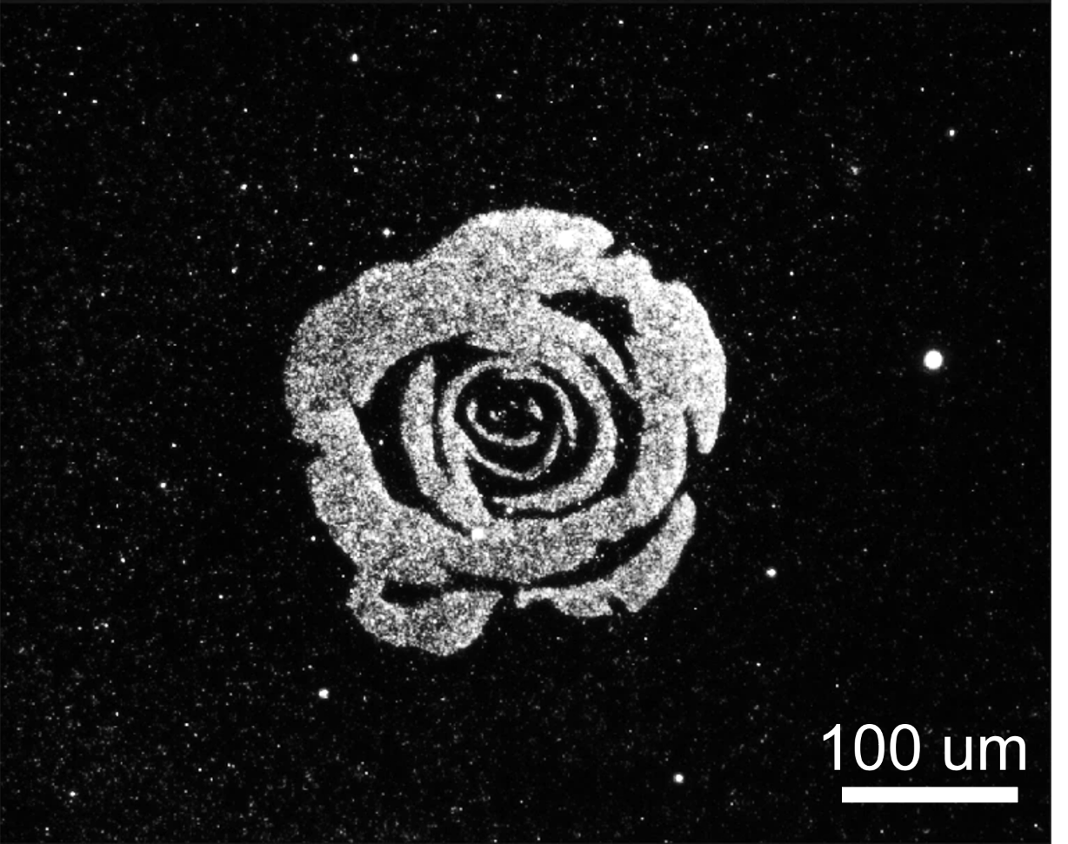

Fig. S1.
Positive particle deposition on a PDDA-treated surface.

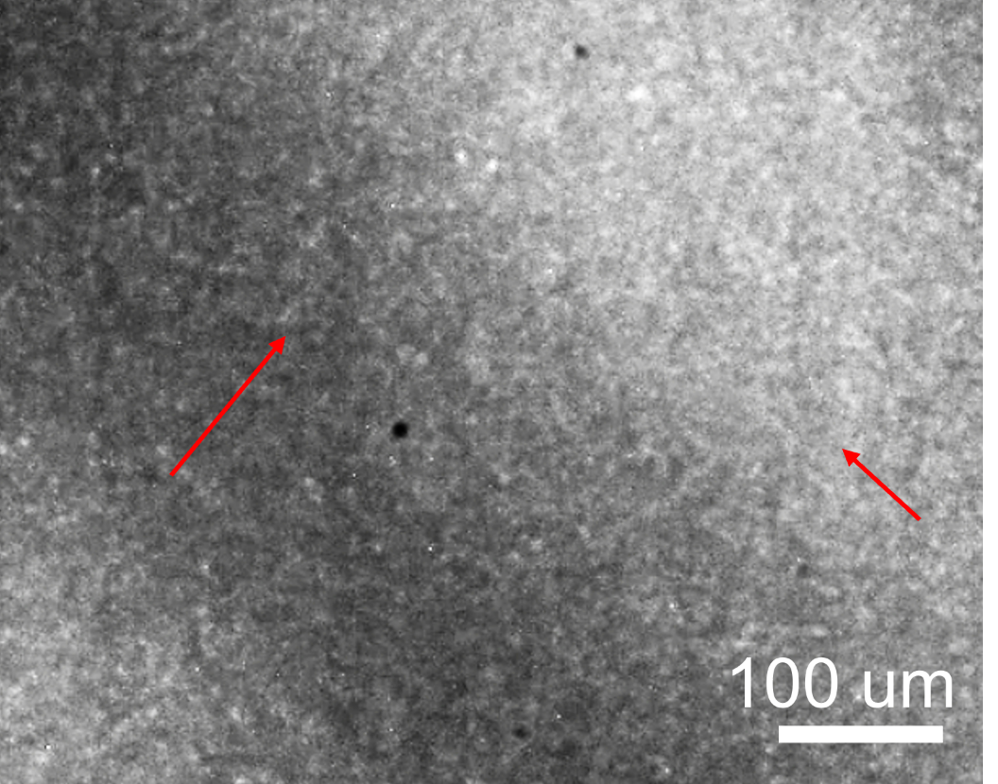

Fig. S2.
When the particles in the solution and the terminating polyelectrolyte layer has opposite charge, the particles are immediately attracted and deposited to the surface. This is reversed when an E-field is applied.

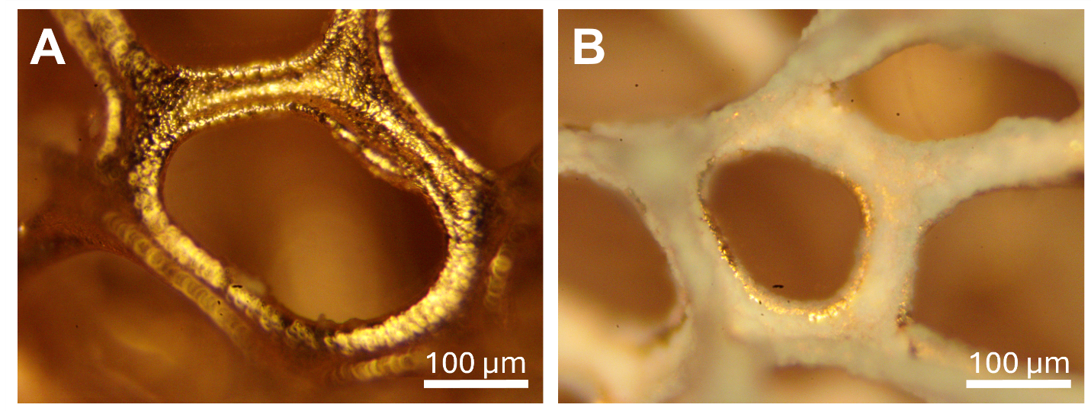

Fig. S3.
Deposition of Na₂SO₄ on a Cu foam substrate, (A) without and (B) with PDDA/PSS polyelectrolyte functionalization.

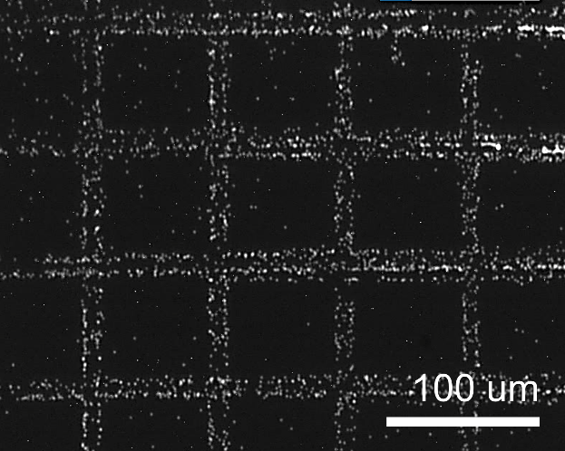

Fig. S4.
Deposition of particles at the edge of the light pattern, when salt is not added to the solution.

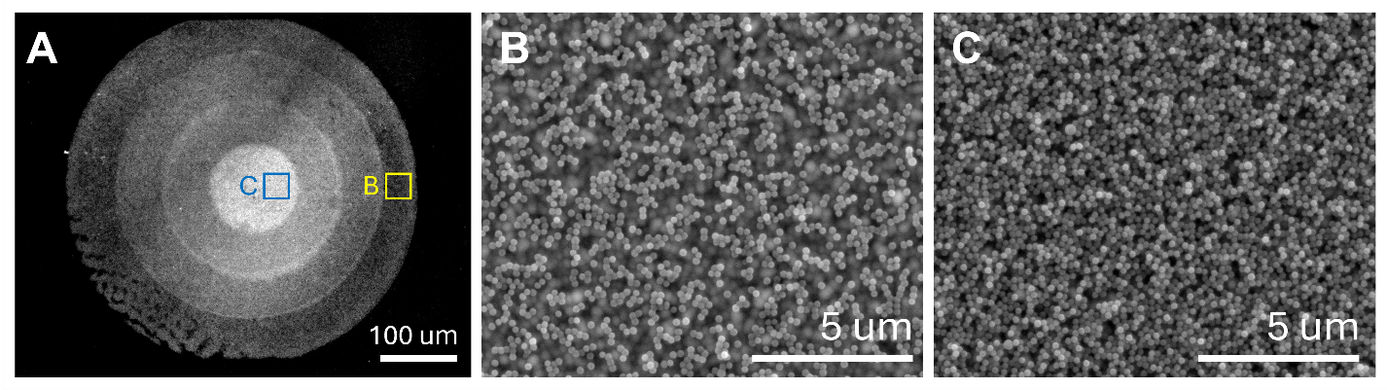

Fig. S5.
(A) Semi-3D particle assembly through additional PDDA/PSS functionalization on top of already-deposited particles. The particle density is lower for (B) the outermost area, where only one deposition session was applied, compared to (C) the innermost area, where four deposition sessions were applied.

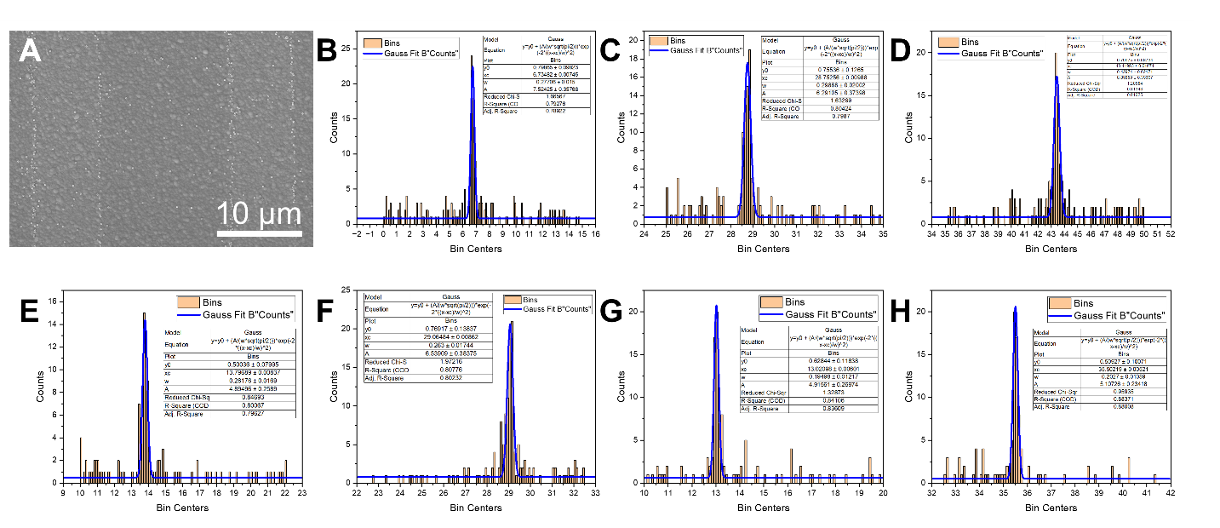

Fig. S6.
(A) Single line particle printing and (B-H) its analysis using a gaussian fit analysis. The bin size is 100 nm, and the average was calculated using data points with >0.79 (~0.8) R² values.

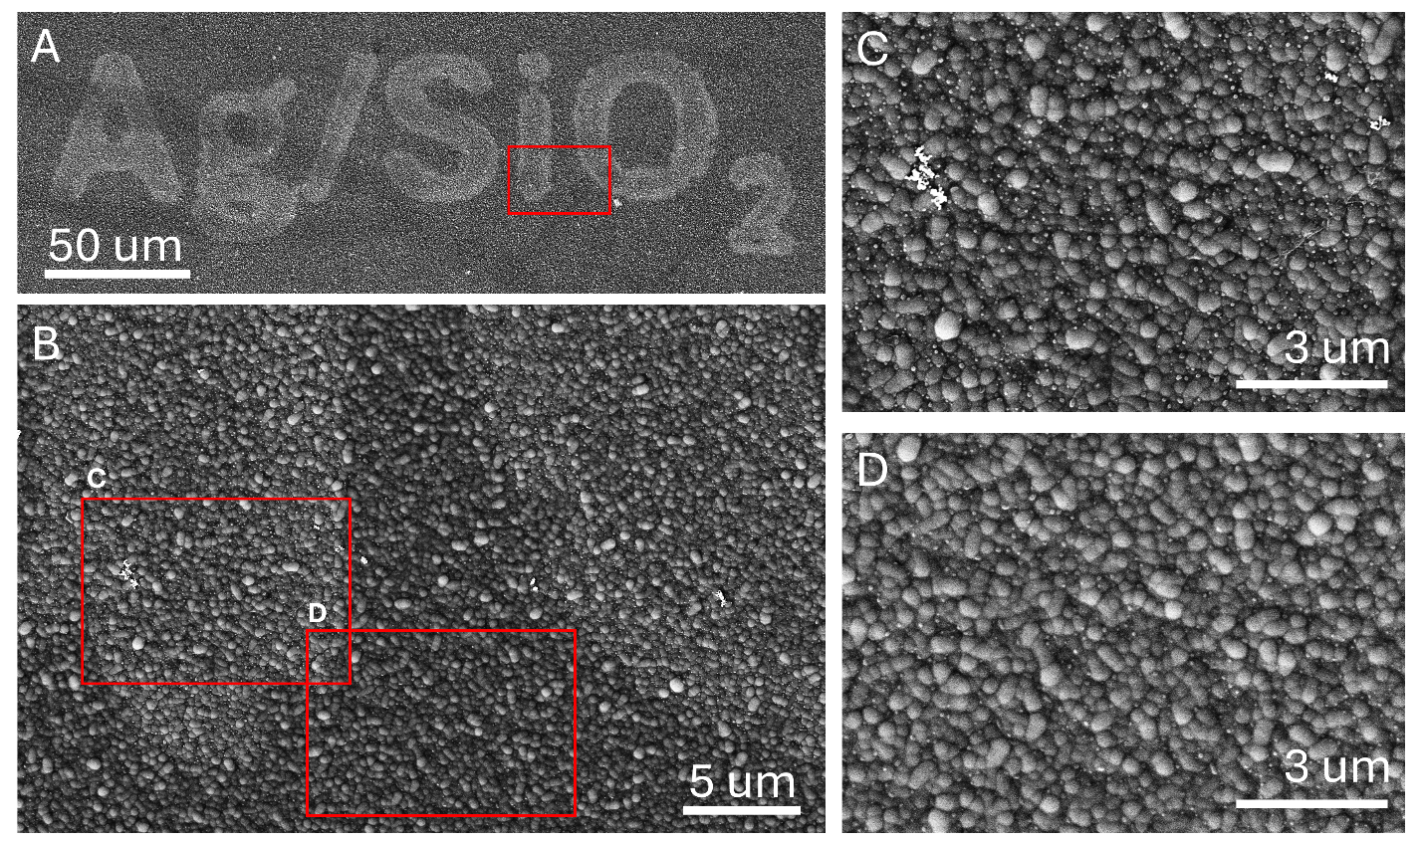

Fig. S7.
(A) Deposition of Ag/SiO₂ nanoparticle composites under SEM. (B) When magnified, there is a clear difference in particle density (C) within (16.4 particles / um²) and (D) outside (7.6 particles / um²) of the particle pattern.

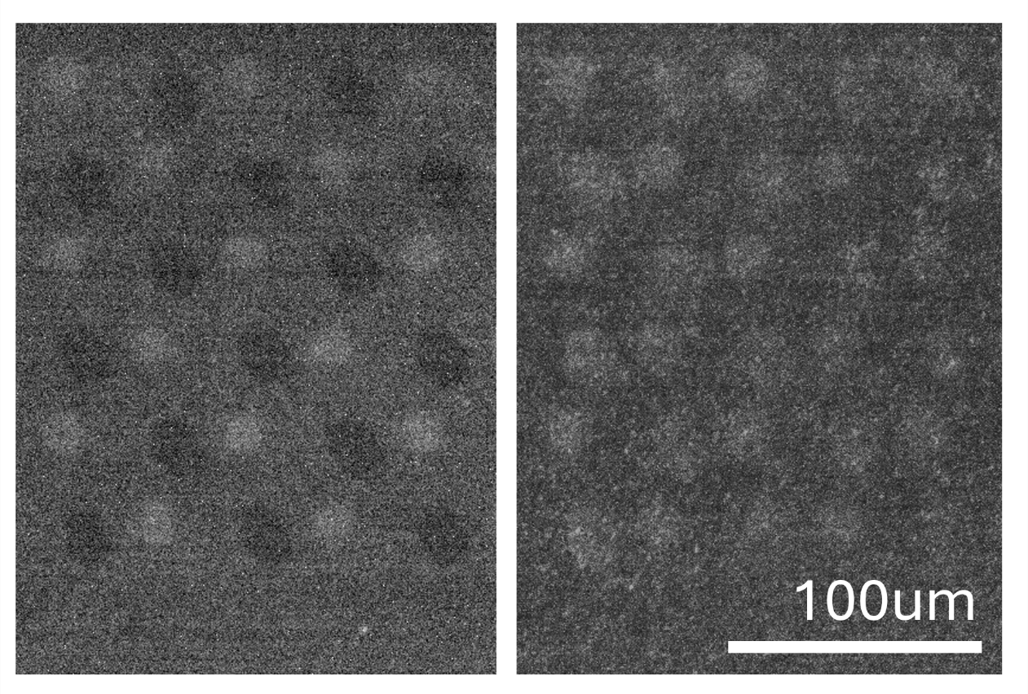

Fig. S8.
Deposition of alternating arrays of P53 (Fluorescence: CoraLite 488) and IL-6 (Fluorescence: PE). When (left) using a 500 nm shortpass as the excitation filter and 535/50 bandpass as the emission filter, only P53 show fluorescence, while when using (right) the 535/50 bandpass as the excitation filter and a 610/75 bandpass filter as the emission filter both P53 and IL-6 show excitation.

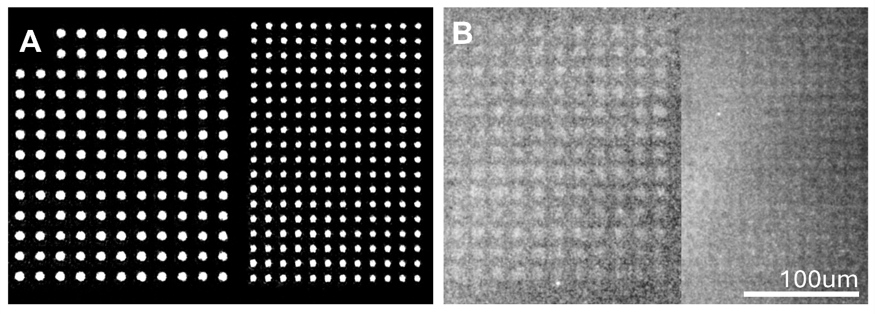

Fig. S9.
Deposition high density arrays of IL-6. (A) Applied light pattern and (B) fluorescence of deposited IL-6.

Table S1.
Comparison between widely used deposition techniques in both industry and academia and this work.^{2–12}

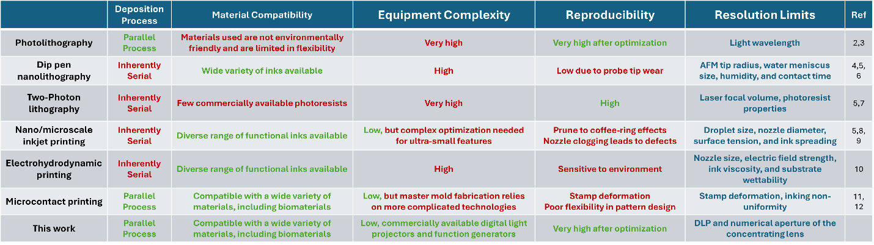

References:
1. Yin, Y., Chen, M., Zhou, S. & Wu, L. A general and feasible method for the fabrication of functional nanoparticles in mesoporous silica hollow composite spheres. J Mater Chem 22, 11245 (2012).
2. del Barrio, J. & Sánchez‐Somolinos, C. Light to Shape the Future: From Photolithography to 4D Printing. Adv Opt Mater 7, (2019).
3. Sharma, E. et al. Evolution in Lithography Techniques: Microlithography to Nanolithography. Nanomaterials 12, 2754 (2022).
4. Liu, G., Petrosko, S. H., Zheng, Z. & Mirkin, C. A. Evolution of Dip-Pen Nanolithography (DPN): From Molecular Patterning to Materials Discovery. Chem Rev 120, 6009–6047 (2020).
5. Muldoon, K., Song, Y., Ahmad, Z., Chen, X. & Chang, M.-W. High Precision 3D Printing for Micro to Nano Scale Biomedical and Electronic Devices. Micromachines (Basel) 13, 642 (2022).
6. Bhagoria, P., Mathew Sebastian, E., Kumar Jain, S., Purohit, J. & Purohit, R. Nanolithography and its alternate techniques. Mater Today Proc 26, 3048–3053 (2020).
7. Jaiswal, A. et al. Two decades of two-photon lithography: Materials science perspective for additive manufacturing of 2D/3D nano-microstructures. iScience 26, 106374 (2023).
8. von Bojnicic‐Kninski, C. et al. Combinatorial Particle Patterning. Adv Funct Mater 27, (2017).
9. Du, X. et al. A review of inkjet printing technology for personalized-healthcare wearable devices. J Mater Chem C Mater 10, 14091–14115 (2022).
10. Zhang, B., He, J., Li, X., Xu, F. & Li, D. Micro/nanoscale electrohydrodynamic printing: from 2D to 3D. Nanoscale 8, 15376–15388 (2016).
11. Reinhoudt, D. N. & Huskens, J. Microcontact Printing : Limitations and Achievements. 2257–2268 (2009) doi:10.1002/adma.200801864.
12. Alom Ruiz, S. & Chen, C. S. Microcontact printing: A tool to pattern. Soft Matter 3, 168–177 (2007).

