SUPPLEMENTARY MATERIALS
Participants. Nineteen healthy adult participants [13 (62%) female; Mean age=25.38 years; SD = 5.99 years] ages 18-50 were recruited from the community using flyers or social media advertisements and completed all study procedures with good data quality. Two additional participants had been recruited but were excluded from analyses [one due to drop out at their second visit (discomfort from the stimulation) and one due to outlier EEG data (7.6 SDs above the mean)]. Participants completed three study visits. During the first visit they provided informed consent, completed study questionnaires, and underwent a structural MRI scan. Following this visit, participants completed two single-blind stimulation sessions with active and sham TI on separate dates (detailed below). Stimulation order (active TI or sham TI first) was counterbalanced using a randomized cross-over design. Prior to participation, all volunteers underwent screening for potential contraindications for MRI or TI, which included presence of metal implants or other MR-unsafe medical devices, claustrophobia, irremovable body jewelry, history of epilepsy or medications that may increase the risk of seizures or tinnitus. They were also screened for significant history of head trauma (with loss of consciousness > 5 minutes) and history of fainting. Participants with current or history of serious or unstable medical illnesses, drug abuse, psychotropic medications or psychiatric illness were also excluded for data quality purposes. Participants received a fixed compensation rate of $30 per hour along with an additional task bonus (see Task Design). All procedures were approved by the Emory University Institutional Review Board.
TI Protocol. We applied TI using two DS5 Isolated Bipolar Constant Current Stimulators (Digitimer, Hertfordshire, UK). A Keysight waveform generator (Keysight Technologies Inc., Santa Rosa, CA) was employed to create a stimulation signal delivered to each stimulator. To generate an active TI envelope of 8 Hz, we set frequencies to 5000 Hz (f1) for one stimulator and 5008 Hz (f2) for the second stimulator, resulting in a TI envelope frequency of 8 Hz (f1-f2 = Δf); we utilized high carrier frequencies (> than 1 kH) similar to prior research (56). Square waves were utilized over sine waves as pulse-width modulated TI has shown evidence for significantly stronger subthreshold modulation(57). The amplitude for each pair was standardized at ±4mA (8mA peak-to-peak) resulting in an estimated E-Field nonzero average of 3.18 V/m for the VS target. E-field simulations were run using the Sim4Life (ZMT Zurich MedTech AG, Switzerland) platform for computational life science based upon each participant’s structural MRI data. Full details of the electromagnetic field computation methodology are detailed in Supplement. High frequency sham TI stimulation consisted of two envelope-free carriers, i.e. 5000 and 5000 Hz, at the same coordinates and amplitude as active TI. At the stimulation visits, Cartesian coordinates from the MRI-guided stimulations were used in tandem with a Brainsight TMS-MRI co-registration system (Rogue Research, Quebec, Canada) with a Polaris stereo camera. 10 mm disposable adhesive Ag/AgCl electrodes were utilized. Electroconductive gel was applied to these stimulation electrodes to facilitate current transfer and improve participant comfort. After electrode placement, participants underwent a stimulation test, gradually increasing to 4 mA for each electrode pair, to ensure comfort and tolerance without discomfort during the stimulation process. Note that the stimulation for three participants was lowered to 3.5 mA while another was lowered to 2.2 mA due to participant discomfort with higher amplitudes; amplitude was tested as a covariate in exploratory analyses. To assess effectiveness of participant blinding, participants were given an open-ended questionnaire at the conclusion of each visit to report when they thought the stimulation was on, off, and where they felt the effects.
During each TI stimulation session, participants were instructed to mindfully focus their attention on their breath (i.e., breath-focused mindfulness meditation) for a total of 15 minutes, an abbreviated version of the breath-focused mindfulness meditation protocol employed in our current clinical trial (58). Stimulation lasted for the entire duration, and participants completed subjective ratings of their emotional experience at both the midpoint (7.5 minutes) and the end (15 minutes) of stimulation. Participants rated their levels of positive emotions (happy), negative emotions (anxious, angry), emotional numbness, their ability to regulate their emotions, and meditative effort.
Doors Task Design. We employed a widely-used task of reward responsivity, the Doors task (Figure 1A) to probe VS-mediated reward function, similar to prior studies (59, 60). In this task, participants were shown a fixation cross (500 ms) followed by an image of two identical doors, which remained until participants selected by clicking either the left or right mouse button. Participants were told that they would either win or lose money on each trial and to guess which door would result in monetary gain. After another fixation cross (interstimulus interval: 1000 ms), feedback indicating monetary gain (green upward arrow) or loss (red downward arrow) was presented (2000 ms). Because monetary losses are experienced as twice as valuable as monetary gains (61), participants were told that they could either win $0.50 or lose $0.25 on each trial and that they would get to keep their winnings. Finally, a fixation cross (intertrial interval) was presented for 1500 ms, followed by a prompt indicating participants should push the spacebar once they were ready for the next trial. The task consists of 20 win trials and 20 loss trials, presented in pseudorandom order such that participant choices had no actual bearing upon outcomes (participants were debriefed on this after study completion). Participants were compensated $5 for each completion of the task for pre- and post-stimulation at each stimulation visit ($20 over four task administrations). The task was administered using PsychoPy (Version 2023.2.3).
EEG Processing. EEG data were analyzed using EEGLab, version 2024.2 (62). Data were re-referenced offline to the average of the left and right mastoids and bandpass filtered (0.1–20 Hz). Data were segmented into feedback-locked epochs from -200 to 1000 ms, with -200 to 0 ms serving as the baseline. Data were epoched to the onset of the Doors task stimuli and the win/loss stimuli separately to independently assess attentional orienting and reward sensitivity ERPs. Ocular artifacts or other aberrant noise were corrected using independent components analysis (63, 64). Additionally, automatic artifact rejection is conducted utilizing 20-40 Hz spectrum thresholding in 500ms data epochs. Feedback event-related potential epochs were averaged separately for win and loss trials as well as the Doors cue. The RewP was quantified by contrasting the average signal between 250 and 350 ms at FCz following win and loss feedback as done previously (26, 35). For the Doors cue, we quantified the N2 as the average signal between 200 and 350 ms at FCz following the Doors cue [Cue-N2; (65)]. The Cue-N2 was extracted as a comparator ERP at the same location and similar time as the RewP (66). Given that the windowed average for these ERP responses may obscure the contributions of multiple components (67), we also extracted the peak positivity of the RewP and the peak negativity of the Cue-N2 between 200 and 400 ms after stimulus onset for supplemental confirmatory analyses, consistent with prior recommendations and meta-analysis (67, 68). Following data cleaning procedures, one participant’s data was excluded from all analyses due to excessively noisy EEG data at their first stimulation visit.

TI Head Modeling, Electromagnetic Field Computation, and Electrode Placement. For each participant, tetrahedral head mesh models were reconstructed from T1- and T2-weighted structural MRI scans using the CHARM pipeline from the SimNIBS framework (50), and segmented with iSEG by structure (e.g., skin, spongy bone, compact bone, cerebrospinal fluid, blood, gray matter, white matter). Electromagnetic field computations were generated using the Sim4Life platform to simulate TI stimulation, which utilized ohmic-current-dominated electro-quasistatic finite-element-method solver to solve Maxwell’s equation, a four partial differential equation that describes electromagnetic fields. Two electromagnetic physics solvers were generated to simulate TI envelope. Dirichlet boundary conditions with an 8 V peak-to-peak constant potential were applied to two pairs of modeled electrodes within each simulation. Tissue-specific electrical conductivity values and density properties were applied to each segment to ensure accurate electrophysiology and 0.5 x 0.5 x 0.5 mm voxels were generated for a high-resolution simulation. Once both fields were calculated, maximum modulation of the two calculated fields were computed. fMRI activation maps were imported and overlayed to guide electrode placement and to verify electric field strength is maximal at target VS regions (See Figure S1 for individual example).
Precise head registration and electrode placement were performed using the Polaris Vicra 3D tracking system (NDI, Ontario, Canada) integrated with Brainsight neuronavigation software (Rogue Research, Quebec, Canada). Participants wore a facial tracker with reflective markers, allowing real-time tracking of head position. Individual T1-weighted MRI scans were imported into Brainsight, and anatomical registration was achieved by co-registering fiducial landmarks (nasion, nose tip, left and right tragus) using a tracked stylus. Predefined electrode coordinates were overlaid onto the MRI, enabling real-time visual guidance for accurate electrode placement targeting specific brain regions.

Figure S1. Example for Individual E-Field Simulation
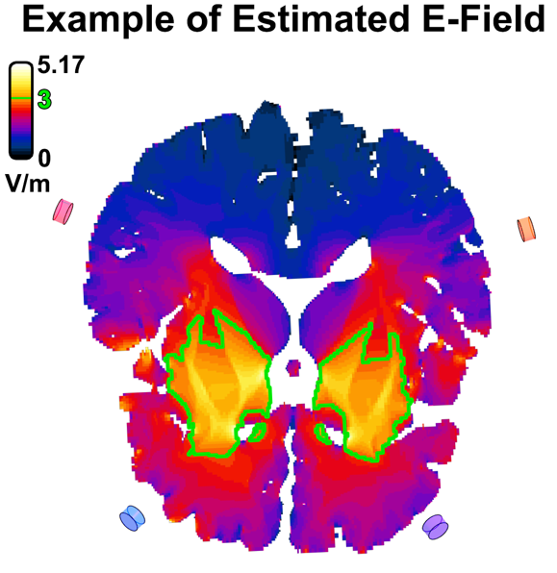
Region of brain determined to have received over 3.0 V/m based on individual E-field simulation enclosed in green, M = 3.18 V/m (SD = 0.50 V/m). Stimulation pairs are represented by blue-purple and red-orange.
Figure S2. E-field simulations of TI stimulation across carrier frequencies.
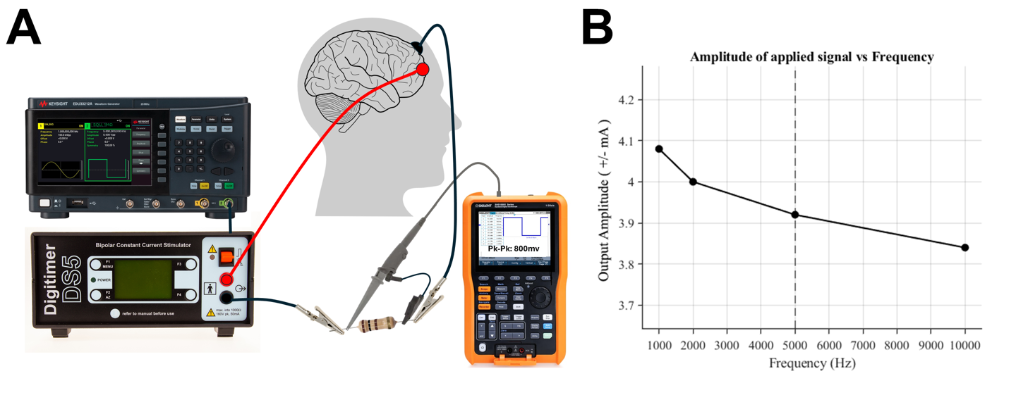
(A) ‎Current output was measured with an isolated channel oscilloscope across a 100 Ω resistor as a function of frequency using the Keysight and DS5 systems. (B) The results show applied current between lower carrier frequencies (1 kHz) and higher carrier frequencies (10 kHz) for a biological load (participant's head) with a measurement of ±3.92 mA for the carrier frequency utilized in the study (5 kHz). This demonstrates reliable performance utilizing the stimulation setup and that participants received the expected stimulation intensity.

Time Frequency Analysis on Reward Outcome
Time frequency analysis on reward outcome was conducted using the same EEGLab processing steps as ERP analyses, with the addition of pop_newtimeref function to compute event-related spectral perturbations (ERSPs) following reward outcomes. Time–frequency decompositions were performed on epoched EEG data from –1000 ms to 1500 ms relative to the outcome stimuli, using Morlet wavelets with a cycles setting of [3 0.8]. Power changes from 1 to 20 Hz were examined relative to a –1000 to 0 ms pre-outcome baseline. Grand average spectral power maps of Win-Loss difference between Sham and Active trials were generated to identify timepoints interest within the 8 Hz frequency (i.e., 100-200 ms) and then averaged by subject, timepoint and outcome. Visual inspection of averaged spectral power maps indicated increased power in the 7-9 Hz range (Figure S1), and a repeated measures ANOVA of the average spectral powers between 100-200 ms within the 7.2-9.4 Hz range revealed a significant time × stimulation interaction, F(1,18)=7.03, p=.016 revealing increased high-theta / low-alpha power differences in pre/post-active trials relative to pre/post-sham trials (Figure S3). Full model shown in Table S7.
Figure S3. Time-frequency Results
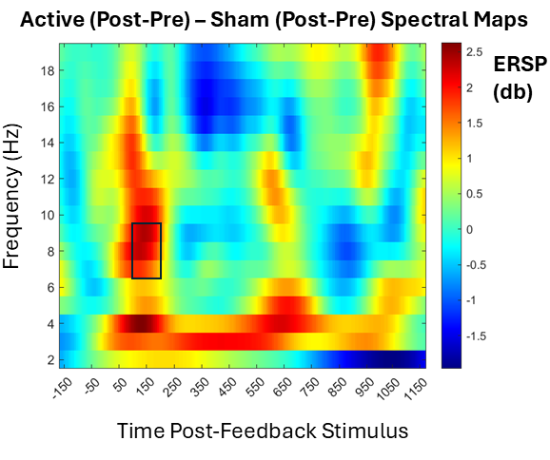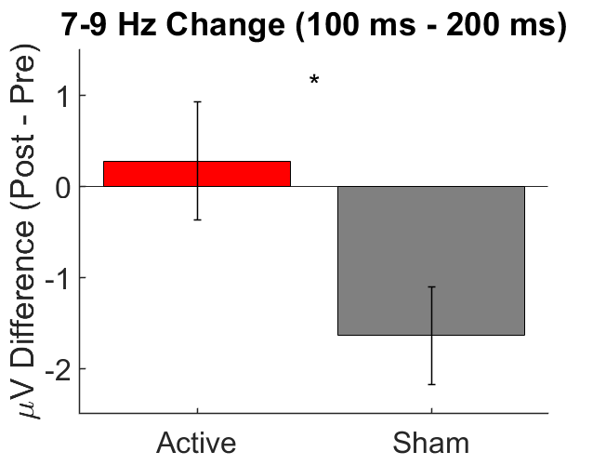
Time frequency map (left) showing pronounced 7-9 Hz power difference when looking at post-stimulation win-loss differences between stimulation visits. Bar graph showing significant post-stimulation minus pre-stimulation difference dependent on stimulation type (active, sham). Error bars are standard error of the mean. * denotes < .05

Table S1. ANOVA Models Testing Effects of TI on ERPs
Effect | F | p | η_{p}²
RewP (Wins-Losses)
Stimulation | 0.33 | 0.57 | 0.019
Stimulation*Order | 0.24 | 0.63 | 0.014
Time | 0.56 | 0.46 | 0.032
Time*Order | 0.59 | 0.45 | 0.034
Stimulation*Time | 27.0 | <0.001*** | 0.614
Stimulation*Time*Order | 6.16 | 0.024* | 0.266
Cue-N2
Stimulation | 0.28 | 0.61 | 0.016
Stimulation*Order | 1.97 | 0.18 | 0.104
Time | 0.06 | 0.81 | 0.003
Time*Order | 0.07 | 0.80 | 0.004
Stimulation*Time | 0.01 | 0.93 | <0.001
Stimulation*Time*Order | 6.16 | 0.49 | 0.028
RewP (Wins)
Stimulation | 0.37 | 0.55 | 0.022
Stimulation*Order | 1.98 | 0.18 | 0.104
Time | 2.29 | 0.15 | 0.119
Time*Order | 0.96 | 0.34 | 0.054
Stimulation*Time | 10.8 | 0.004** | 0.389
Stimulation*Time*Order | 2.11 | 0.16 | 0.110
RewP (Losses)
Stimulation | 0.89 | 0.36 | 0.050
Stimulation*Order | 1.15 | 0.30 | 0.063
Time | 0.28 | 0.60 | 0.016
Time*Order | 0.001 | 0.98 | <.001
Stimulation*Time | 1.47 | 0.24 | 0.079
Stimulation*Time*Order | 0.47 | 0.50 | 0.027

Table S2. Estimated Marginal Means for Effects of TI on Subjective Experience Ratings
Subjective Ratings | Mean | Standard Error |  |  | 95% Confidence Interval
Happy
Active (8 Hz) TI
Pre-stimulation | 3.30 | 0.16 |  |  | [2.97, 3.63]
Post-stimulation | 3.12 | 0.22 |  |  | [2.67, 3.58]
Sham (0 Hz) TI
Pre-Stimulation | 2.96 | 0.23 |  |  | [2.49, 3.43]
Post-Stimulation | 2.91 | 0.22 |  |  | [2.45, 3.37]
Anxious*
Active (8 Hz) TI
Pre-stimulation | 1.60 | 0.20 |  |  | [1.18, 2.03]
Post-stimulation | 1.41 | 0.12 |  |  | [1.15, 1.67]
Sham (0 Hz) TI
Pre-Stimulation | 1.35 | 0.09 |  |  | [1.15, 1.67]
Post-Stimulation | 1.51 | 0.14 |  |  | [1.22, 1.55]
Angry
Active (8 Hz) TI
Pre-stimulation | 1.18 | 0.08 |  |  | [1.00, 1.35]
Post-stimulation | 1.16 | 0.07 |  |  | [1.01, 1.30]
Sham (0 Hz) TI
Pre-Stimulation | 1.10 | 0.04 |  |  | [1.02, 1.19]
Post-Stimulation | 1.18 | 0.08 |  |  | [1.01, 1.36]
Regulate
Active (8 Hz) TI
Pre-stimulation | 3.83 | 0.19 |  |  | [3.44, 4.22]
Post-stimulation | 3.78 | 0.15 |  |  | [3.47, 4.08]
Sham (0 Hz) TI
Pre-Stimulation | 3.83 | 0.15 |  |  | [3.51, 4.14]
Post-Stimulation | 3.45 | 0.17 |  |  | [3.09, 3.82]
Effortful
Active (8 Hz) TI
Pre-stimulation | 2.75 | 0.23 |  |  | [2.26, 3.24]
Post-stimulation | 2.97 | 0.22 |  |  | [2.51, 3.44]
Sham (0 Hz) TI
Pre-Stimulation | 3.02 | 0.23 |  |  | [2.53, 3.51]
Post-Stimulation | 3.09 | 0.25 |  |  | [2.51, 3.61]
Numb
Active (8 Hz) TI
Pre-stimulation | 2.05 | 0.19 |  |  | [1.64, 2.46]
Post-stimulation | 2.22 | 0.29 |  |  | [1.61, 2.82]
Sham (0 Hz) TI
Pre-Stimulation | 2.47 | 0.29 |  |  | [1.87, 3.08]
Post-Stimulation | 2.40 | 0.30 |  |  | [1.76, 3.03]
Statistically significant stimulation*Timepoint effect at: *p<.05

Table S3. MANOVA Model Testing Effects of TI Stimulation
Multivariate Effects | F | p | η_{p}²
Happy, Anxious, Angry, Regulate, Effortful, Numb
Stimulation | 1.17 | 0.38 | 0.369
Stimulation*Order | 0.94 | 0.50 | 0.320
Timepoint | 1.16 | 0.39 | 0.367
Timepoint*Order | 1.07 | 0.43 | 0.349
Stimulation*Timepoint | 3.20 | 0.041* | 0.615
Stimulation*Timepoint*Order | 0.18 | 0.98 | 0.084
Statistically significant effect at: *p<.05

Table S4. MANOVA Model Individual Effects of TI Stimulation
Subjective Ratings | F | p | η_{p}²
Happy
Stimulation | 2.24 | 0.15 | 0.117
Stimulation*Order | 0.44 | 0.51 | 0.025
Time | 2.18 | 0.16 | 0.114
Time*Order | 0.13 | 0.91 | 0.001
Stimulation*Time | 0.47 | 0.50 | 0.027
Stimulation*Time*Order | 0.05 | 0.83 | 0.003
Anxious
Stimulation | 0.30 | 0.59 | 0.017
Stimulation*Order | 0.46 | 0.51 | 0.026
Time | 0.02 | 0.89 | 0.001
Time*Order | 0.84 | 0.37 | 0.047
Stimulation*Time | 4.71 | 0.044* | 0.217
Stimulation*Time*Order | 0.35 | 0.85 | 0.002
Angry
Stimulation | 1.14 | 0.30 | 0.063
Stimulation*Order | 1.57 | 0.23 | 0.085
Time | 2.67 | 0.12 | 0.136
Time*Order | 0.92 | 0.35 | 0.051
Stimulation*Time | 2.19 | 0.16 | 0.114
Stimulation*Time*Order | 0.14 | 0.91 | 0.001
Regulate
Stimulation | 0.81 | 0.38 | 0.045
Stimulation*Order | 0.75 | 0.40 | 0.042
Time | 6.23 | 0.023* | 0.268
Time*Order | 0.07 | 0.80 | 0.004
Stimulation*Time | 2.55 | 0.13 | 0.130
Stimulation*Time*Order | 0.53 | 0.48 | 0.030
Effortful
Stimulation | 0.98 | 0.34 | 0.054
Stimulation*Order | 0.38 | 0.55 | 0.022
Time | 1.25 | 0.28 | 0.068
Time*Order | 1.84 | 0.19 | 0.098
Stimulation*Time | 0.61 | 0.44 | 0.035
Stimulation*Time*Order | 0.73 | 0.40 | 0.041
Numb
Stimulation | 1.58 | 0.23 | 0.085
Stimulation*Order | 1.23 | 0.28 | 0.067
Time | 0.22 | 0.64 | 0.013
Time*Order | 0.89 | 0.36 | 0.050
Stimulation*Time | 1.59 | 0.22 | 0.086
Stimulation*Time*Order | 0.03 | 0.86 | 0.002
Statistically significant effect at: *p<.05

Table S5. Partial Least Squares Regression Results
Multivariate Associations | Mean Squared Error | Permuted p | Cross-validated r
RewP (Wins)
Happy, Anxious, Angry, Regulate, Effortful, Numb | 64.20# | 0.016* | 0.526
RewP (Losses) | 64.20#
Happy, Anxious, Angry, Regulate, Effortful, Numb | 64.20# | 0.367 | -0.145
Ratings were differences between pre/post TI & active/sham TI
Statistically significant effect at: *p<.05, (10,000 permutations)
#Single mean squared error value is for Wins/Losses combined

Table S6. Participant Stimulation Debriefing
Participant | Visit # | Visit Type | Q1) Could you feel the stimulation turn on at the beginning? | Q2) When do you think the stimulation was on? | Q3) When do you think the stimulation was off? | Q4) Where on your head do you think you were being stimulated?
1 | 1 | Sham | yes | Throughout the entire testing | N/A | Ventro-medial parietal lobe
1 | 2 | Active | yes | I feel like it's always on | N/A | Lower right occipital lobe
2 | 1 | Sham | a little | when I meditate | I have no clue | top left
2 | 2 | Active | sometimes | when I feel some tangling | when I have no feelings | the front, right above my forehead
3 | 1 | Sham | yes | I figured it was on the whole time, though I stopped feeling it after a few seconds | I assumed maybe in between tasks | I feel some tightness around my forehead
3 | 2 | Active | I felt some buzzing or tingling at certain points | It seemed like I could feel it when it turned on at the beginning | I never noticed it go away, I simply stopped noticing it | I felt it on my forehead on the left side and on the back right side
4 | 1 | Active | no | I do not remember | I did not feel | Did not feel
4 | 2 | Sham | no | Not sure | Not sure | Somewhere the side top
5 | 1 | Sham | no | when they told me it was | when they told me it was | nowhere
5 | 2 | Active | yes | could feel faint Stimulation on one electrode | i didn't | forehead
6 | 1 | Active | not after it was fixed | during the meditation | during the task | through the four initial points and where they intersect
6 | 2 | Sham | yes | during meditation | during task | where the four electrodes intersect
7 | 1 | Active | yes | It is very sensible. RIght after we started I could feel | When the session was over and I hear the sound or announcements from the experimenters | Cannot really feel when we enter into the experiment
7 | 2 | Sham | yes | when it started to hurt a bit on my scalp | when all the tasks were over | front and back
8 | 1 | Sham | slightly | Beginning with the first meditation session | At the very beginning | on the top and especially my left temple, which is where I feel a tired sensation either after a long, stressful day or when I have a cold
8 | 2 | Active | yes | the whole time since the assistant turned it on | not at all | upper right forehead and left jaw bone, but stronger in the upper right forehead
9 | 1 | Sham | yes | When I felt a sharp, tingling sensation | Could not tell | Could not tell specifically
9 | 2 | Active | yes | Slight tingling | Cannot tell | Upper Right
10 | 1 | Sham | not really, maybe a little | once the first doors exercise began | when the last doors exercise ended | above my forehead
10 | 2 | Active | yes | throughout the tasks | I'm not sure | right temple
11 | 1 | Sham | yes | During the meditation and tests | during the 3 minute intervals with eyes closed | Temporal
11 | 2 | Active | no | meditation and 2nd questionnare | rest and 1st questionnare | back
12 | 1 | Active | yes | yes | First trial | Left forehead
12 | 2 | Sham | yes | First meditation | Second meditation | back left side
13 | 1 | Active | just a top front tingle for a brief moment. | Only for a short moment at the start. | Most of the time. | only top front of head.
13 | 2 | Sham | yes | just at the start | Not sure. | front middle forehead
14 | 1 | Sham | no | Not sure. Maybe the whole time? | I don't know because I didn't feel the stimulation on. | Front and back of my head
14 | 2 | Active | no | Maybe. I couldn't tell. | Not sure. | lower back of my head on each side
15 | 1 | Active | yes | during the task | not sure | the front and the back
15 | 2 | Sham | a little bit | During the meditation and the door task | not sure, perhaps during the break | right front and left front head
16 | 1 | Active | yes | when they told me | when they told me | the temple (front) and the back
16 | 2 | Sham | yes | when they told me it was on | when they told me they turned it off | where the patches were (like front and back)
17 | 1 | Sham | yes | i felt pressure on my scalp | Not sure. | on the top middle back
17 | 2 | Active | not really there was no discomfort | I felt like a little buzz | I couldn't really tell specifically if it was on or off | the front toward my forehead more than the back
18 | 1 | Active | yes | At the very beginning | I couldn't tell | I couldn't tell
18 | 2 | Sham | no | I don't know | I don't know | not sure
19 | 1 | Active | yes | I only felt the stimulation on at the beginning when it was first turned on and then for the other trials I didn't really feel anything. | I think the second time while I was doing the meditation the stimulation seemed to be off but I'm not sure. | I mostly felt the stimulation on the right front part of my brain and the back parts.
19 | 2 | Sham | yes | For the first meditation task and the first door task | The second meditation task and the second door task | The back right side of my head and the frontal lobes

Table S7. ANOVA Model Testing Effects of TI Stimulation on Time Frequency
Effect | F | p | η_{p}²
Timepoint | 2.111 | .163 | .105
Stimulation | .007 | .937 | .000
Stimulation*Timepoint | 7.003 | .016* | .280
Statistically significant effect at: *p<.05

