Table 2. Color changes of dried T. fuciformis via different pretreatments.
Groups |  | L* | a* | b* | ΔE | C | Appearance
Temperature | Time
CG |  | 53.50±1.40 | 4.28±0.27 | 15.68±0.92 | - | 16.25±0.91
70℃ | 3 min | 58.12±1.11b | 1.41±0.28a | 12.22±1.40a | 6.94±0.35b | 12.30±1.42a
70℃ | 5 min | 55.38±2.72c | 0.97±0.16b | 9.62±1.29b | 6.48±1.13b | 10.33±0.94b
70℃ | 7 min | 62.47±1.97a | 0.96±0.41b | 12.13±1.41a | 11.06±1.77a | 11.51±0.48a | 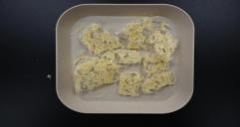  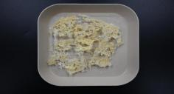  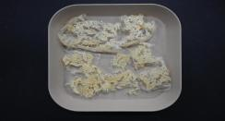  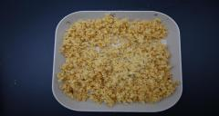  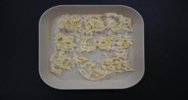  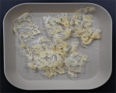  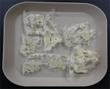  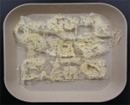  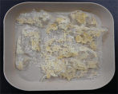  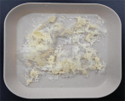
80℃ | 3 min | 52.60±1.21c | 1.51±0.07a | 10.67±0.76a | 4.67±0.64c | 10.77±0.75a
80℃ | 5 min | 57.72±2.01b | 0.99±0.10b | 9.06±1.04b | 8.44±0.86b | 9.12±1.02b
80℃ | 7 min | 61.40±3.08a | 0.07±0.19c | 7.39±0.79c | 12.41±1.77a | 7.40±0.79c
90℃ | 3 min | 57.54±0.30c | 0.77±0.03a | 9.07±0.51a | 8.16±0.53c | 9.10±0.51a
90℃ | 5 min | 64.66±1.78a | -0.04±0.04c | 8.55±0.97a | 14.36±1.12a | 8.55±0.91a
90℃ | 7 min | 61.76±2.56b | 0.01±0.03b | 6.86±1.89b | 13.08±0.82b | 6.86±1.89b
Note: Data are mean ± SD (n = 9), analyzed by t-test. Different letters within a column indicate significant differences at the same temperature but different times (p < 0.05).

